Supplementary information for
Identifying and tuning coordinated water molecules for efficient electrocatalytic water oxidation
Zhang et al.

Table of Contents
Supplementary Methods
Supplementary Crystal Structure Description
Supplementary Figures
Figure S1. Molecular structure of Ni-tPBA⁰, and the twisted octahedral geometries around Ni²⁺ ions.
Figure S2. Molecular structure of Ni-tPBA¹, and the twisted octahedral geometry around Ni²⁺ ion.
Figure S3. Molecular structure of Ni-tPBA², and the twisted octahedral geometries around Ni²⁺ ions.
Figure S4. The π-stacking Ni-tPBA⁰ leading to the constitution of 1D supramolecular structure with violet-green connection.
Figure S5. The π-stacking Ni-tPBA⁰ leading to the constitution of 1D supramolecular structure with red-yellow connection.
Figure S6. The π-stacking Ni-tPBA⁰ leading to the constitution of 1D supramolecular structure with red-yellow-violet-green-red-yellow connection.
Figure S7. (a) The π-stacking (marked with different color) leading to the constitution of 2D supramolecular structure in Ni-tPBA¹. (b) The 1D supramolecular chain of Ni-tPBA⁰ constituted by OH···N.
Figure S8. The polyporous 2D supramolecular model of Ni-tPBA¹.
Figure S9. (a) The ellipsoidal simplest structure of Ni-tPBA². (b) The extension by Ni1 under the synergistic linkage of tPBA and TPA. (c) The extension by Ni2. (d) The polyporous 2D coordination polymer model of Ni-tPBA². (e) The π-stacking between 2D layers leading to the constitution of 3D supramolecular structure in Ni-tPBA².
Figure S10. (a) Mortise and tenon structure in Ni-tPBA³. (b) Anti-helical symmetry mode on both sides of the θ ring.
Figure S11. The channel model of Ni-tPBA⁰.
Figure S12. The channel model of Ni-tPBA¹.
Figure S13. The channel model of Ni-tPBA².
Figure S14. The channel model of Ni-tPBA³.
Figure S15. (a) Simulation of the pore structure parameters of Ni-tPBA². (b) The actual arrangement of water molecules in the crystal structure of Ni-tPBA².
Figure S16. The CO₂ isothermal adsorption curves for Ni-tPBA³. The illustration is the actual arrangement of water molecules in the crystal structure of Ni-tPBA³.
Figure S17. TGA curves of Ni-tPBA^{0~3} under dinitrogen atmosphere.
Figure S18. Electrocatalytic OER performance in 1 M KOH. (a) LSV polarization curves of Ni-tPBA^{0~3}/CP, RuO₂/CP with nafion and pure CP recorded at the scan rate of 5 mV/s with iR-compensation. (b) Tafel plots. (c) C_{dl} values. (d) LSV polarization curves normalized by ECSA.
Figure S19. LSV polarization curves of Ni-tPBA³/GC recorded at the scan rate of 5 mV/s with iR-compensation.
Figure S20. CV curves of Ni-tPBA^{0~3}/CP with nafion in 1.0 M KOH solution at different scan rates (20 – 100 mV/s with 0.05 – 0.15 V vs. Ag/AgCl).
Figure S21. Synthesis scheme for self-growing Ni-tPBA^{0~3}/CP.
Figure S22. SEM images of Ni-tPBA⁰/CP.
Figure S23. SEM images of Ni-tPBA¹/CP.
Figure S24. SEM images of Ni-tPBA²/CP.
Figure S25. SEM images of Ni-tPBA³/CP.
Figure S26. PXRD patterns of Ni-tPBA^{0~3}/CP.
Figure S27. FT-IR spectra of tPBA and Ni-tPBA^{0~3} in the single crystal state.
Figure S28. DRIFT spectra of Ni-tPBA^{0~3}/CP.
Figure S29. CV activation curves of Ni-tPBA^{0~3}/CP in 1.0 M KOH solution at 0.15 – 0.65 V vs. Ag/AgCl.
Figure S30. (a) The overpotentials of Ni-tPBA^{0~3}/CP at 10 mA cm^{–2} and 100 mA cm^{–2}. (b) TOF value of Ni-tPBA^{0~3}/CP at the overpotential of 300 mV.
Figure S31. CV curves of Ni-tPBA^{0~3}/CP in 1.0 M KOH solution at different scan rates (20 – 100 mV/s with 0.05 – 0.15 V vs. Ag/AgCl).
Figure S32. LSV polarization curves of Ni-tPBA^{0~3}/CP normalized by ECSA.
Figure S33. DRIFT spectra of Ni-tPBA^{0~3}/CP after OER testing.
Figure S34. (a) Microscopic photograph of the test area on Ni-tPBA³/CP. (b) In-situ Raman contour maps for Ni-tPBA³/CP accompanied by second LSV processes with applied potentials range from 1.1 to 1.8 V vs. RHE and (c) the corresponding in-situ Raman spectra of Ni-tPBA³/CP at different representative voltages.
Figure S35. Comparison of XPS pattern for Ni-tPBA⁰/CP and Ni-tPBA⁰/CP after OER testing.
Figure S36. Comparison of XPS pattern for Ni-tPBA¹/CP and Ni-tPBA¹/CP after OER testing.
Figure S37. Comparison of XPS pattern for Ni-tPBA²/CP and Ni-tPBA²/CP after OER testing.
Figure S38. Comparison of XPS pattern for Ni-tPBA³/CP and Ni-tPBA³/CP after OER testing.
Figure S39. Optimization models for Intermediates 2 and 3 in catalytic cycles 1 and 2.
Supplementary Tables
Table S1. Crystal data and numbers pertinent to data collection and structure refinement of Ni-tPBA^{0~3}.
Table S2. Bond lengths (Å) and bond angles (deg) of Ni-tPBA^{0~3}.
Supplementary References

Supplementary Methods
Chemicals and Materials. Nickel(II) nitrate hexahydrate (Ni(NO₃)₂·6H₂O) was purchased from Xilong Scientific Co., Ltd. o-Phenylenediamine, 4-chloromethyl pyridine hydrochloride and tetrabutylammonium bromide (TBAB) were purchased from Macklin. Nitrilotriacetic acid, terephthalic acid (p-C₆H₄(COOH)₂, TPA), isophthalic acid (m-C₆H₄(COOH)₂, IPA) and trimesic Acid (C₆H₃(COOH)₃, BTC) were purchased from Aladin. Acetone, 1,2-ethandiol (EG), methanol (MeOH), ethanol (EtOH), N,N-dimethylformamide (DMF)，N,N-dimethylacetamide (DMAc), dimethyl sulfoxide (DMSO), toluene, potassium hydroxide (KOH) and sodium hydroxide (NaOH) were purchased from Sinopharm. Nafion (5%) was purchased from Sigma-Aldrich. All the reagents were used as received without further purification. Carbon fiber paper (CP) was purchased from Toray Industries, Inc. The CP was cut into 0.5 cm × 1 cm and 2 cm × 3 cm for further use.
Fabrication of Ni-tPBA^{0~3}/CP with Nafion, RuO₂/CP and Ni-tPBA³/GC electrodes. The synthesis of Ni-tPBA^{0~3}/CP with Nafion electrodes was conducted via a modified procedure according to the previous reported.^{1,2} To prepare the catalyst ink, 5 mg of completely ground Ni-tPBA^{0~3} was dispersed into a mixed solution of water, EtOH and 0.5% Nafion solution (0.25: 0.7: 0.05 mL), followed by ultrasonication for 1 h. The mixed catalyst ink is evenly dripped onto 1 × 0.5 carbon paper and dried at room temperature and with a load of about 0.2 mg cm^{–2}. The RuO₂/CP electrode was fabricated by replacing only the catalyst with RuO₂, and the Ni-tPBA³/GC was fabricated by replacing only the CP with a glassy carbon electrode.
Synthesis of Ni-tPBA^{0~3}/CP electrodes. Adding Ni(NO₃)₂·6H₂O and CP to H₂O, tPBA and aromatic carboxylic acids to organic solvent gives liquids a and b. After heating liquids a and b to 90°C until dissolution, liquid b was added into liquid a to initiate further reaction at 90°C for a certain time, and then cool down to room temperature naturally. The yielding Ni-tPBA⁰ was cleaned with ultra-pure water, while Ni-tPBA^{1~3} were cleaned with DMF and ethanol to obtain Ni-tPBA^{0~3}/CP with a loading of about 5 mg/cm^{–2}, respectively. The specific reaction conditions are as follows:
Ni-tPBA⁰/CP: Ni(NO₃)₂·6H₂O (116.31 mg, 0.4 mmol), tPBA(272.33 mg, 0.4 mmol), DMF:H₂O (0.5: 19 mL), and the reaction time was 20 h.
Ni-tPBA¹/CP: Ni(NO₃)₂·6H₂O (116.31 mg, 0.4 mmol), tPBA (136.16 mg, 0.2 mmol), TPA (66.45 mg, 0.4 mmol), DMF:H₂O (1.5: 18 mL), and the reaction time was 15 h.
Ni-tPBA²/CP: Ni(NO₃)₂·6H₂O (116.31 mg, 0.4 mmol), tPBA(136.16 mg, 0.2 mmol), IPA(66.45 mg, 0.4 mmol), DMAc:H₂O (2: 17 mL), and the reaction time was 17 h.
Ni-tPBA³/CP: Ni(NO₃)₂·6H₂O (116.31 mg, 0.4 mmol), tPBA(136.16 mg, 0.2 mmol), BTC(63.04 mg, 0.3 mmol), DMF: H₂O (6: 12 mL), and the reaction time was 12 h.
Characterization. The as-made materials were characterized by field emission SEM (FEI Verios G4), PXRD (Cu–Kα, λ=0.15406 nm), XPS (Kratos AXIS Ultra DLD), FT–IR (Bruker Tensor 27, KBr), diffuse reflectance infrared Fourier transform spectroscopy (iS20 FTIR), and TGA (Mettler Toledo TGA 1). In-situ Raman measurements of Ni-tPBA³/CP were performed from 1.105–1.805 V vs. RHE at a rate of 1 mV s^{–1} with 532 nm excitation from an argon ion laser.
Single-Crystal X-ray Crystallography. A suitable single crystal was mounted on a glass fiber, and the intensity data was collected on a Bruker Apex II area detector with graphite-monochromatized MoKa radiation (λ = 0.71073 Å) at T = 193 K. Data reduction and cell refinement were performed using the programs Smart and Saint.^{3,4} The absorption corrections were carried out by an empirical method.⁵ The crystal structure was analyzed by Direct Methods and refined by full-matrix least-squares against F² using the program Olex2.^{6,7} Hydrogen atoms were located geometrically and treated with the riding model.
Computational Methods. We have employed the first-principles^{8,9} to perform density functional theory (DFT) calculations within the generalized gradient approximation (GGA) using the Perdew-Burke-Ernzerhof (PBE)¹⁰ formulation. We have chosen the projected augmented wave (PAW) potentials^{11,12} to describe the ionic cores and take valence electrons into account using a plane wave basis set with a kinetic energy cutoff of 520 eV. The GGA+U method was adopted in our calculations. The value of the effective Hubbard U was set as 4.669 eV for Ni. Partial occupancies of the Kohn−Sham orbitals were allowed using the Gaussian smearing method with a width of 0.1 eV. The electronic energy was considered self-consistent when the energy change was smaller than 10⁻⁵ eV. A geometry optimization was considered convergent when the energy change was smaller than 0.05 eV Å⁻¹. The Brillouin zone integration is performed using 1×1×1 Monkhorst-Pack k-point sampling for a structure. Finally, the adsorption energies (E_{ads}) were calculated as Eads= Ead/sub -Ead -Esub, where Ead/sub, Ead, and Esub are the total energies of the optimized adsorbate/substrate system, the adsorbate in the structure, and the clean substrate, respectively. The free energy was calculated using the equation:
G = E_{ads}+ZPE–TS
where G, E_{ads}, ZPE and TS are the free energy, total energy from DFT calculations, zero-point energy and entropic contributions, respectively, where T is set to 300 K.

Supplementary Crystal Structure Description
X-ray crystallography, crystallographic table and crystallographic data in CIF format for the structures with CCDC 2353500 ~ 2353503. These data can be obtained free of charge via www.ccdc.cam.ac.uk/data_request/cif, or by emailing data_request@ccdc.cam.ac.uk, or by contacting The Cambridge Crystallographic Data Centre, 12 Union Road, Cambridge CB21EZ, UK; fax: +44 1223 336033.
Single-crystal structure analyses of Ni-tPBA⁰: The carboxylate anion-free Ni-tPBA⁰ crystallizes in monoclinic space group Cc. As shown in Figure S1, the asymmetric unit consists of two six-coordinated Ni²⁺ atoms, two tNBP ligands, four free nitrate anions, three coordinated water molecules and a large number of free water molecules. Both Ni1 and Ni2 are chelated in the pocket of tPBA, which are connected by N2-pyridine on [Ni₂L₂] unit to form a binuclear structure. Since the electronic configuration of Ni²⁺ ions tend to form a six-coordinated octahedral ligand environment, the vacant OCSs of Ni1 and Ni2 are liganded with one and two water molecules, respectively. The temporarily occupied OCSs may be used as potential catalytically active sites (labelled in yellow). As shown in Figure S4~6, there are weak π-stacking interaction between the four crystallographically independent benzimidazole groups in two tPBA on [Ni₂L₂] (labelled in different colors). The purple-green stacking of two ligands on adjacent units allows the structure to form a more stable one-dimensional chain. The non-translational character of the neighboring units on the chain leads to the chain of yellow-red alternately stacked on the unit's two ligands to extend in different directions, and therefore this outcome leads to the red-yellow-violet-green-red-yellow connection is not equal to the red-yellow-red-yellow connection direction, which ultimately leads to the composition of the special 3D supramolecular pore structure. The outer surface of the pore is shown as cyan, and the inner interface of the pore is shown as yellow (Figure S11).
Single-crystal structure analyses of Ni-tPBA¹: Ni-tPBA¹ crystallizes in triclinic space group $P\overline{1}$, compared to Ni-tPBA⁰, only two free nitrates in the main structure are replaced by a completely deprotonated TPA (Figure S2). The two crystallographic symmetries [NiL] chelate units are connected by the carboxylate oxygens at the ends of the terephthalic acid. The Ni²⁺ center still constituting stable six-coordinated octahedral space configuration and the vacant OCSs are occupied by water molecules. The tripodal ligand is twisted into T-shape, and two benzimidazole of the T-shape stacking with the neighboring symmetric benzimidazole with π–π stacking to form a 2-dimensional layer in 110 crystalline surface (Figure S7a). However, coordinated water molecules as potential active sites help the formation of three-dimensional structures through hydrogen bonding with neighboring N7-pyridine (Figure S7b). Although this is conducive to the stable construction of the overall structure, it may be unfavorable to the separation of intermediate products in the electrochemical process.
Single-crystal structure analyses of Ni-tPBA²: The two-dimensional layered structure of Ni-tPBA² also crystallizes in $P\overline{1}$. The structure of the symmetry unit contains a chelated Ni²⁺ ion center, two Ni²⁺ in symmetry region, an IPA, a tNBP ligand, and some separable coordination solvent in symmetry region (Figure S3). The chelated Ni3 of the two symmetry units constitutes a binuclear cluster primary structural unit due to strong π-π conjugation between N8-benzimidazole rings of the crystallographic symmetrically tNBP (Figure S9a). As shown in Figures S9b, Ni3 of the metal-chelating unit is doubly connected to Ni1 of the adjacent unit by the carboxyl groups on TPA and N4 pyridine, thus forming a one-dimensional chain. N2 pyridine on the primary unit is connected head-to-head by Ni2 at the symmetric interface, and the main structure is stretched in different directions to form a stable 2D porous coordination polymer (Figures S9c~d). In addition, the benzimidazole branches of the uncoordinated pyridine ends of the adjacent layer also produce π–π stacking effects on each other, making Ni-tPBA² constitute a more stable supramolecular 3D structure (Figure S9e). The obvious pore structure not only contributes to the rapid transport of gases in electrochemical processes, but also a potential adsorptive separation material (Figures S13).

Supplementary Figures
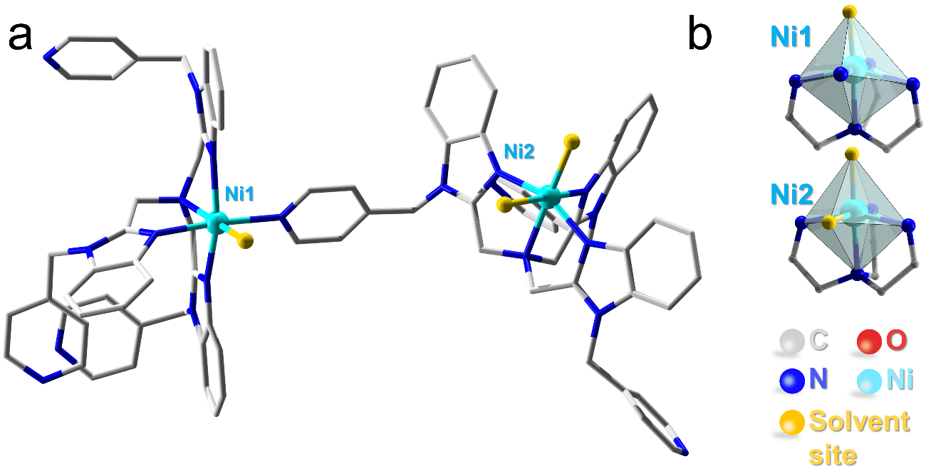
Figure S1. Molecular structure of Ni-tPBA⁰, and the twisted octahedral geometries around Ni²⁺ ions.
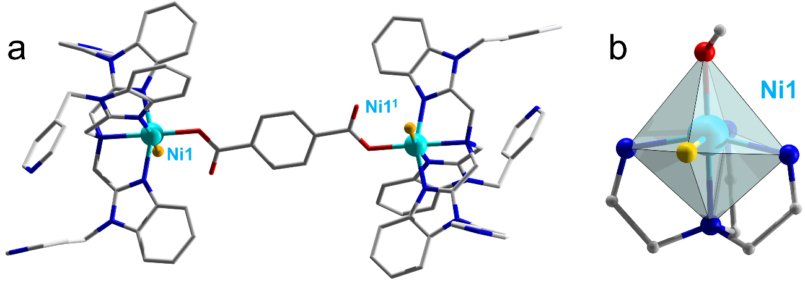
Figure S2. Molecular structure of Ni-tPBA¹, and the twisted octahedral geometry around Ni²⁺ ion.
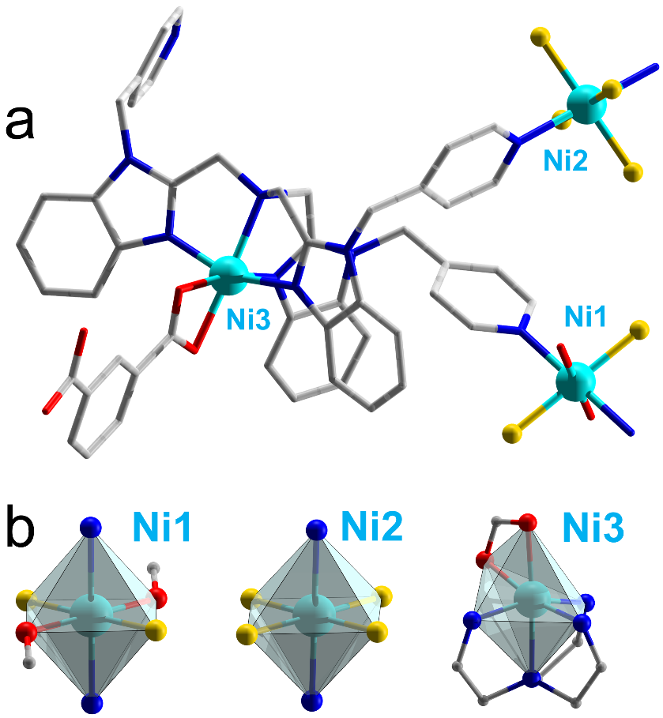
Figure S3. Molecular structure of Ni-tPBA², and the twisted octahedral geometries around Ni²⁺ ions.
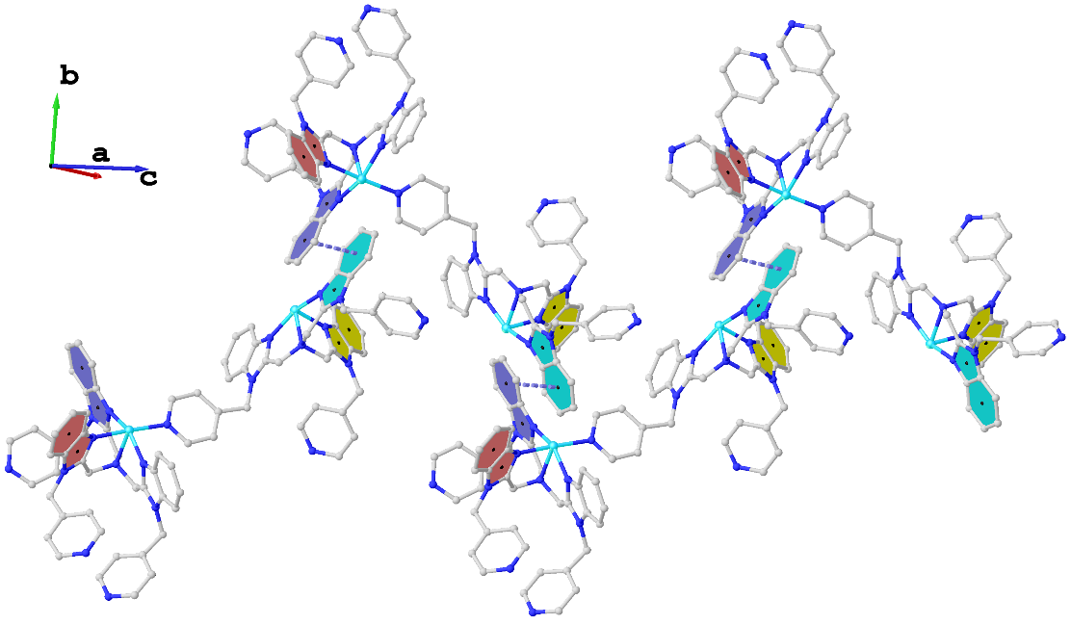
Figure S4. The π-stacking Ni-tPBA⁰ leading to the constitution of 1D supramolecular structure with violet-green connection.
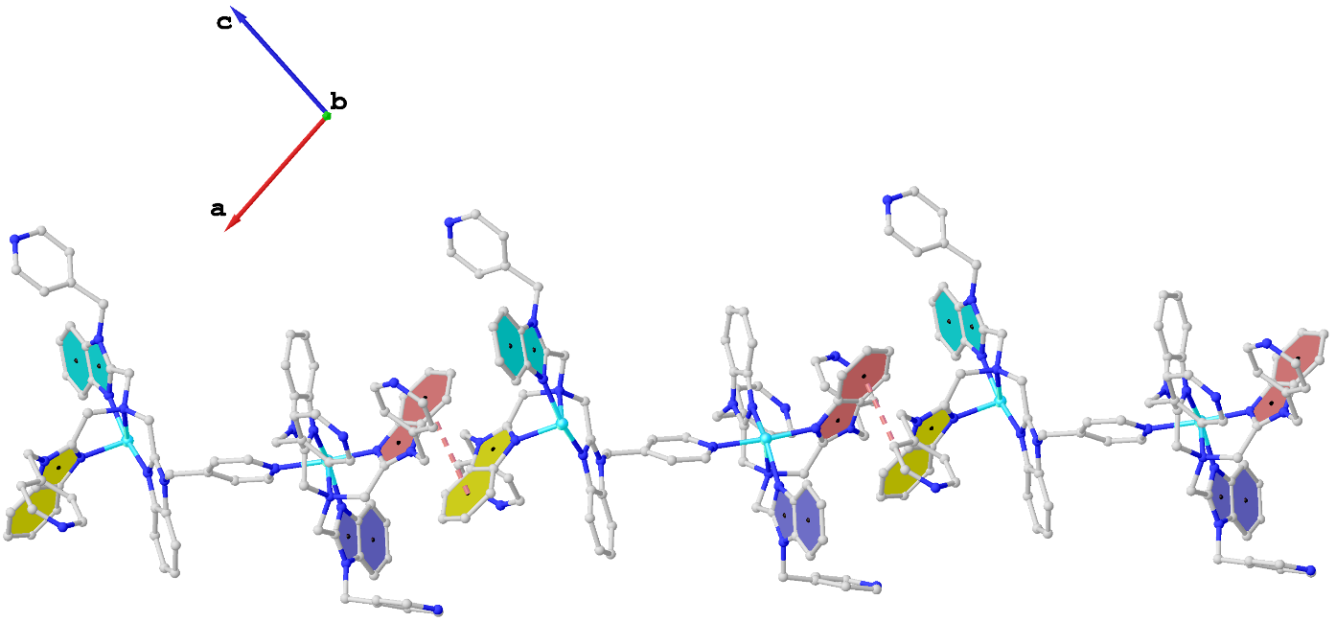
Figure S5. The π-stacking Ni-tPBA⁰ leading to the constitution of 1D supramolecular structure with red-yellow connection.
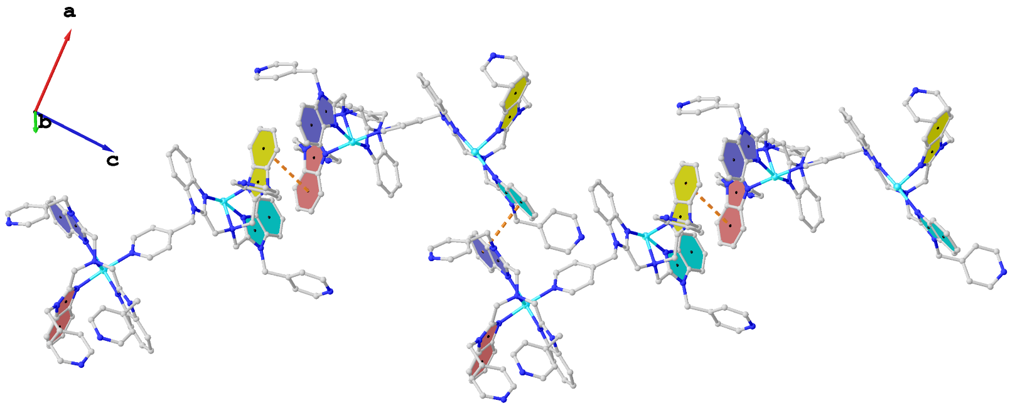
Figure S6. The π-stacking Ni-tPBA⁰ leading to the constitution of 1D supramolecular structure with red-yellow-violet-green-red-yellow connection.
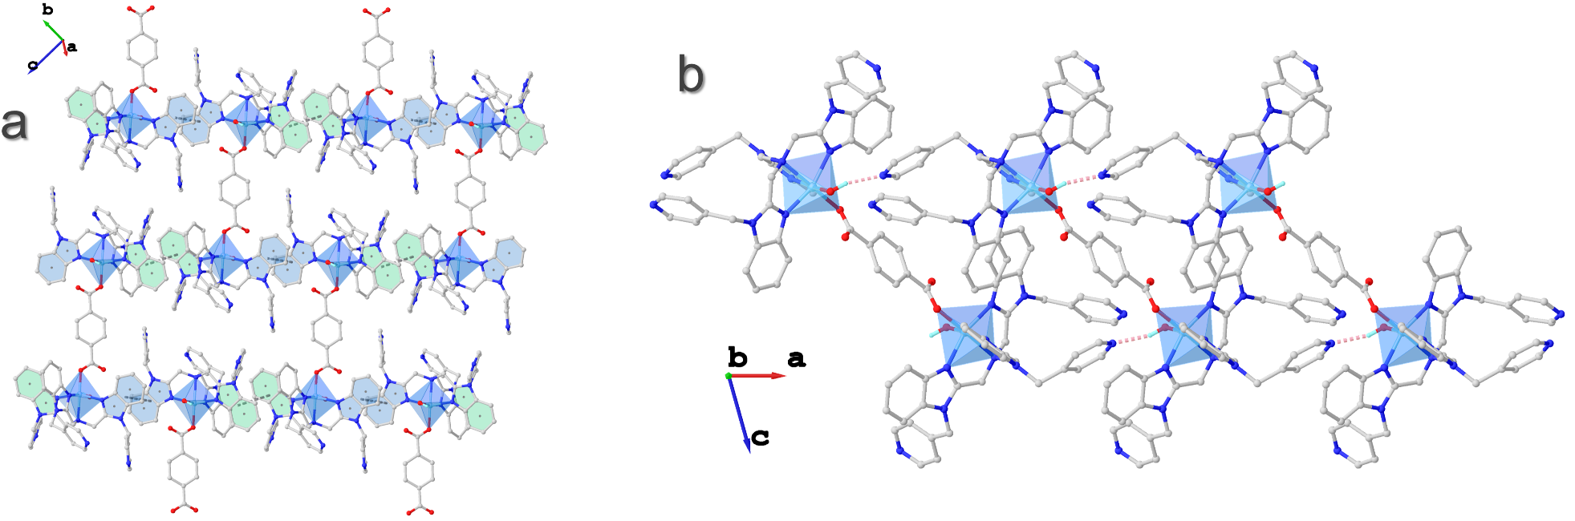
Figure S7. (a) The π-stacking (marked with different color) leading to the constitution of 2D supramolecular structure in Ni-tPBA¹. (b) The 1D supramolecular chain of Ni-tPBA⁰ constituted by OH···N.
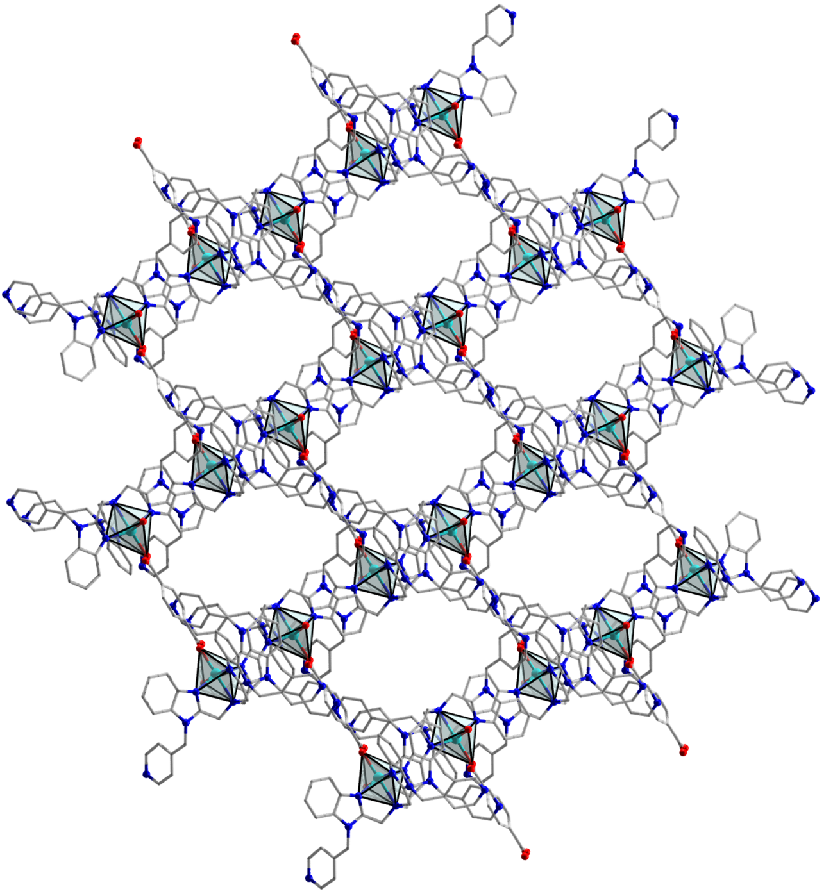
Figure S8. The polyporous 2D supramolecular model of Ni-tPBA¹.
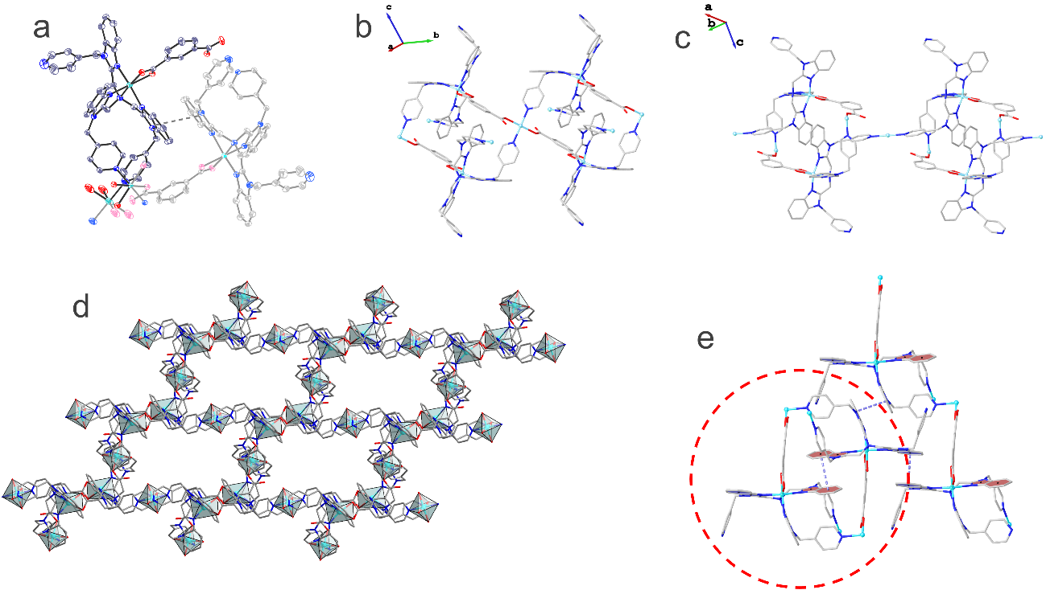
Figure S9. (a) The ellipsoidal simplest structure of Ni-tPBA². (b) The extension by Ni1 under the synergistic linkage of tPBA and TPA. (c) The extension by Ni2. (d) The polyporous 2D coordination polymer model of Ni-tPBA². (e) The π-stacking between 2D layers leading to the constitution of 3D supramolecular structure in Ni-tPBA².
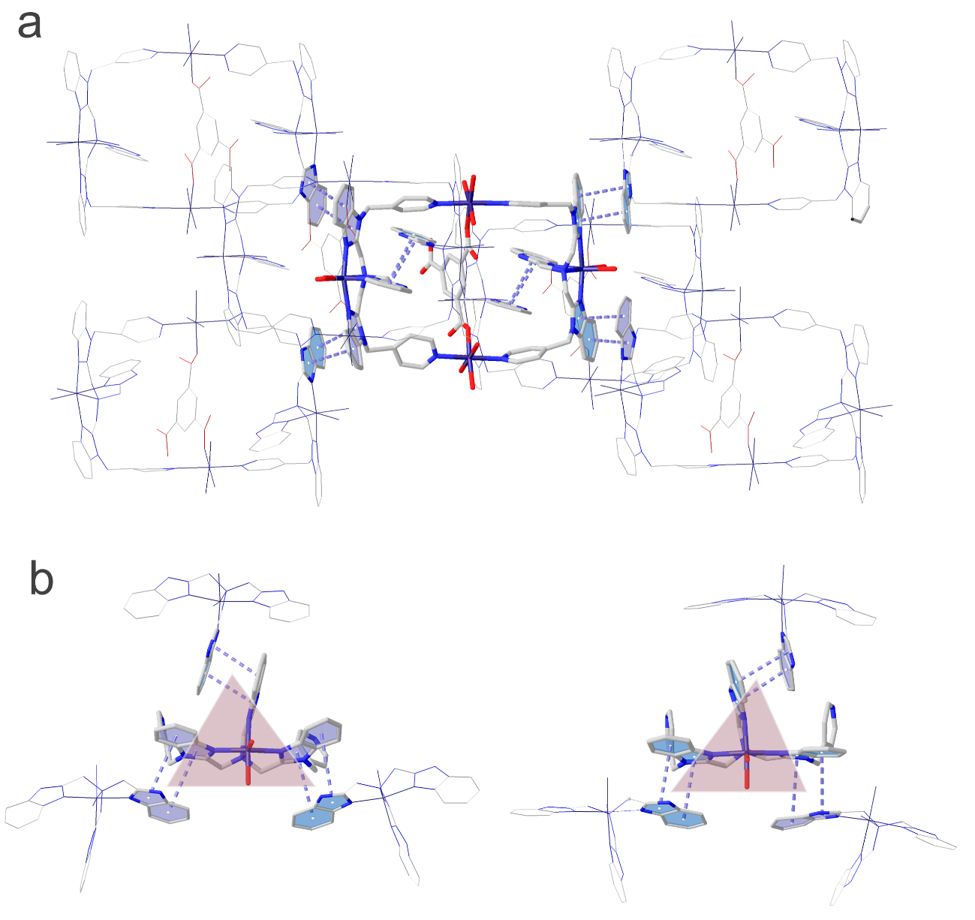
Figure S10. (a) Mortise and tenon structure in Ni-tPBA³. (b) Anti-helical symmetry mode on both sides of the θ ring.

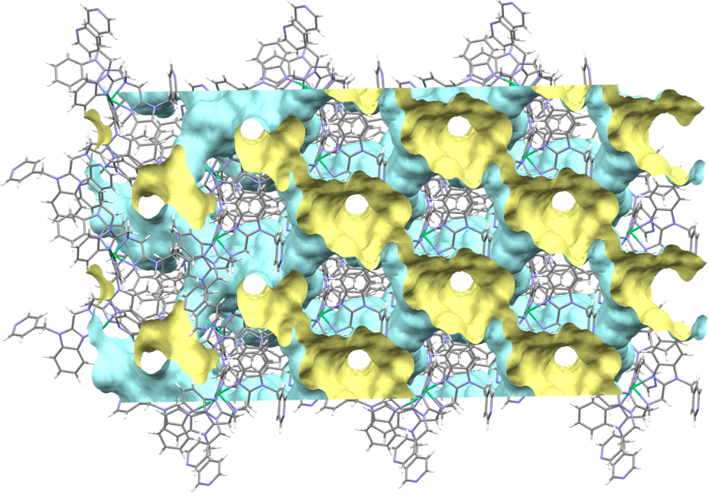
Figure S11. The channel model of Ni-tPBA⁰.

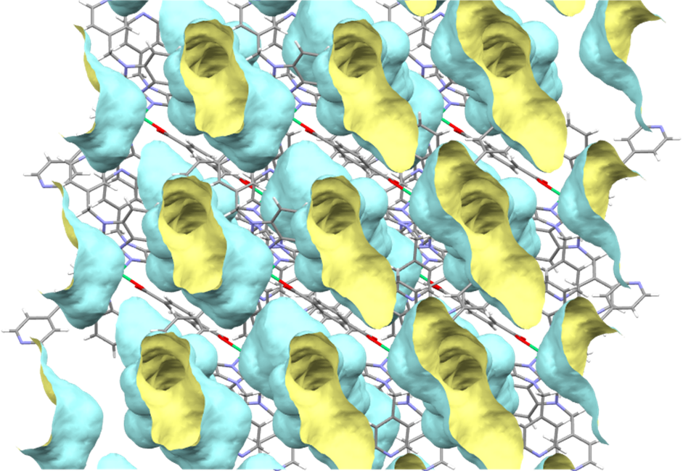
Figure S12. The channel model of Ni-tPBA¹.

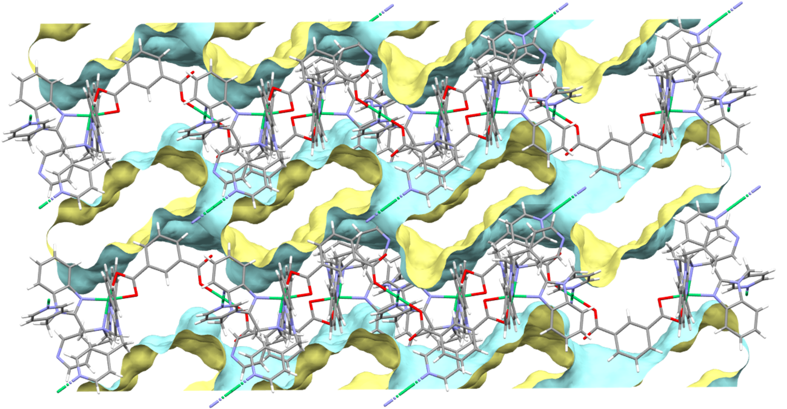
Figure S13. The channel model of Ni-tPBA².
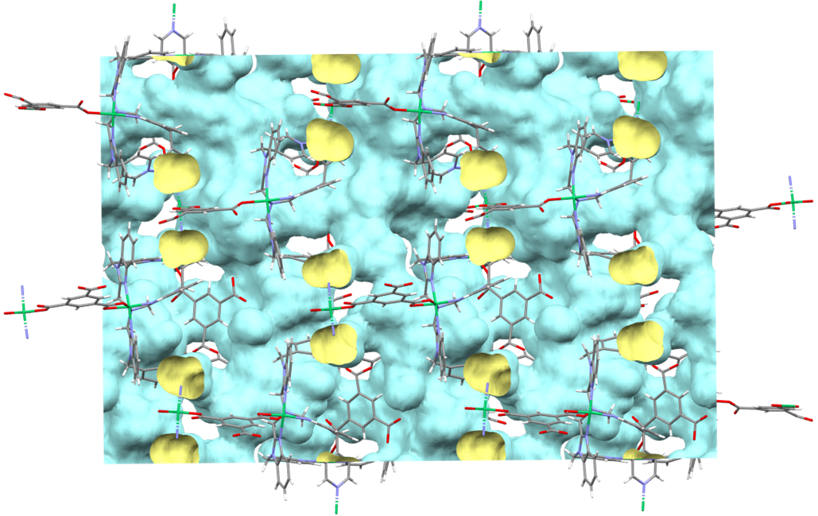
Figure S14. The channel model of Ni-tPBA³.

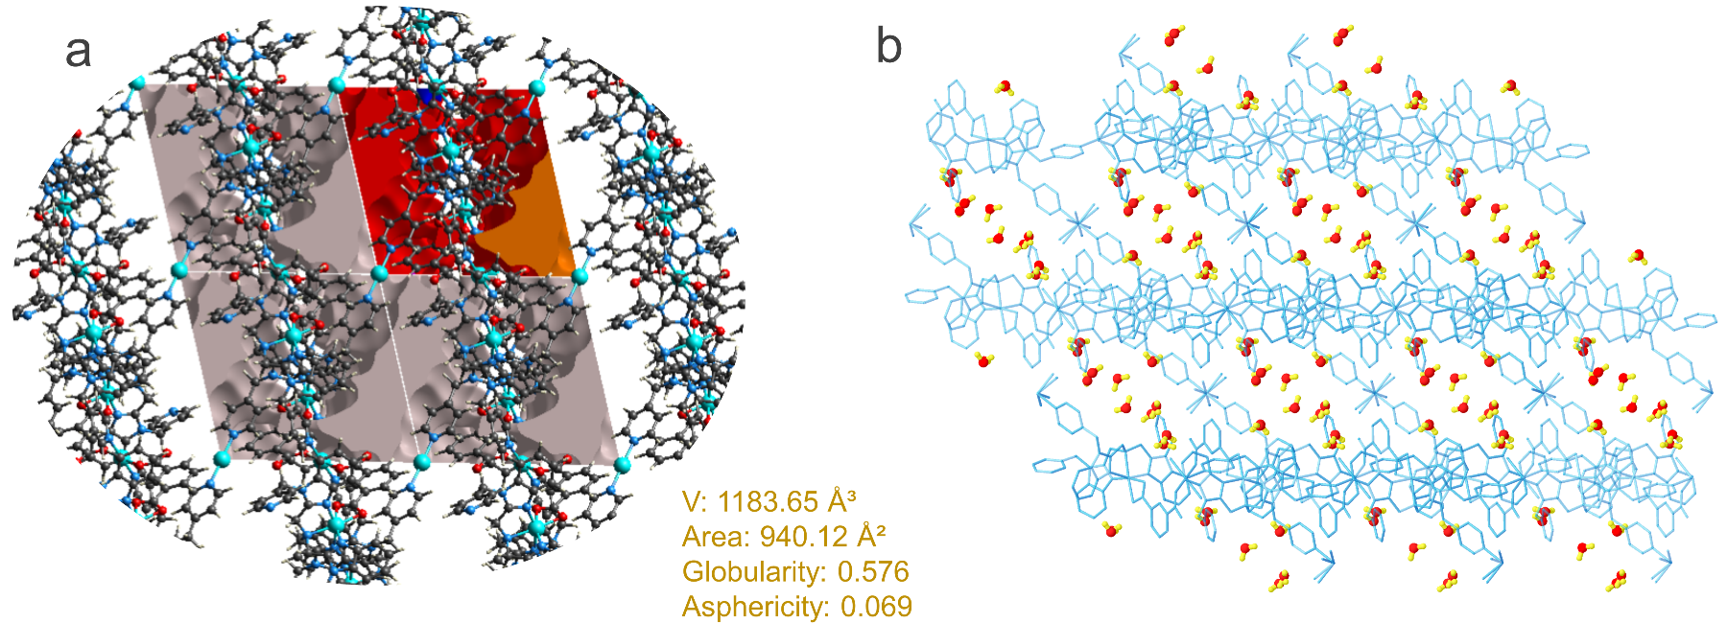
Figure S15. (a) Simulation of the pore structure parameters of Ni-tPBA². (b) The actual arrangement of water molecules in the crystal structure of Ni-tPBA².
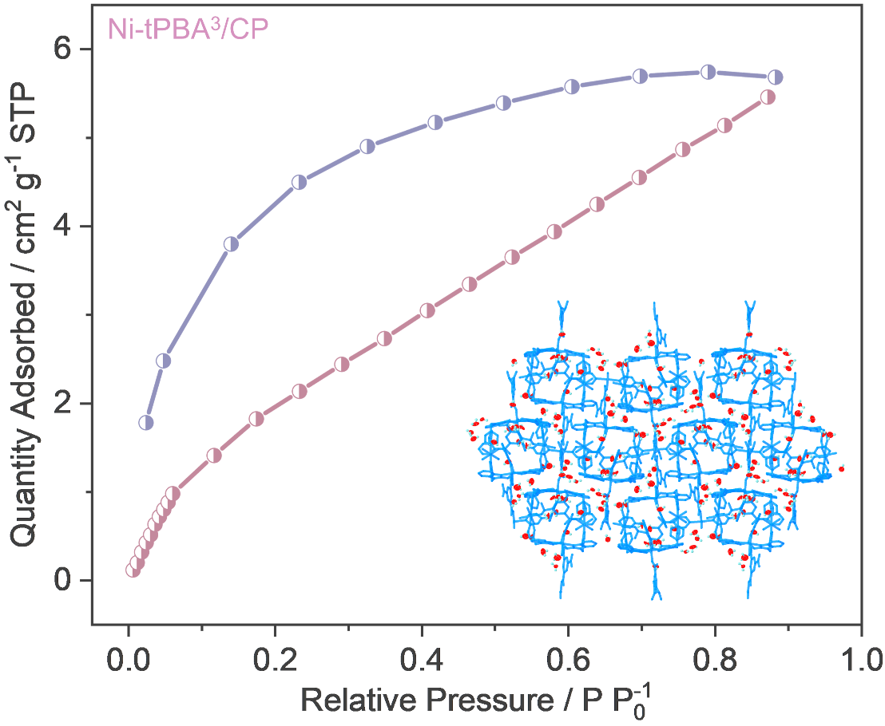
Figure S16. The CO₂ isothermal adsorption curves for Ni-tPBA³. The illustration is the actual arrangement of water molecules in the crystal structure of Ni-tPBA³.
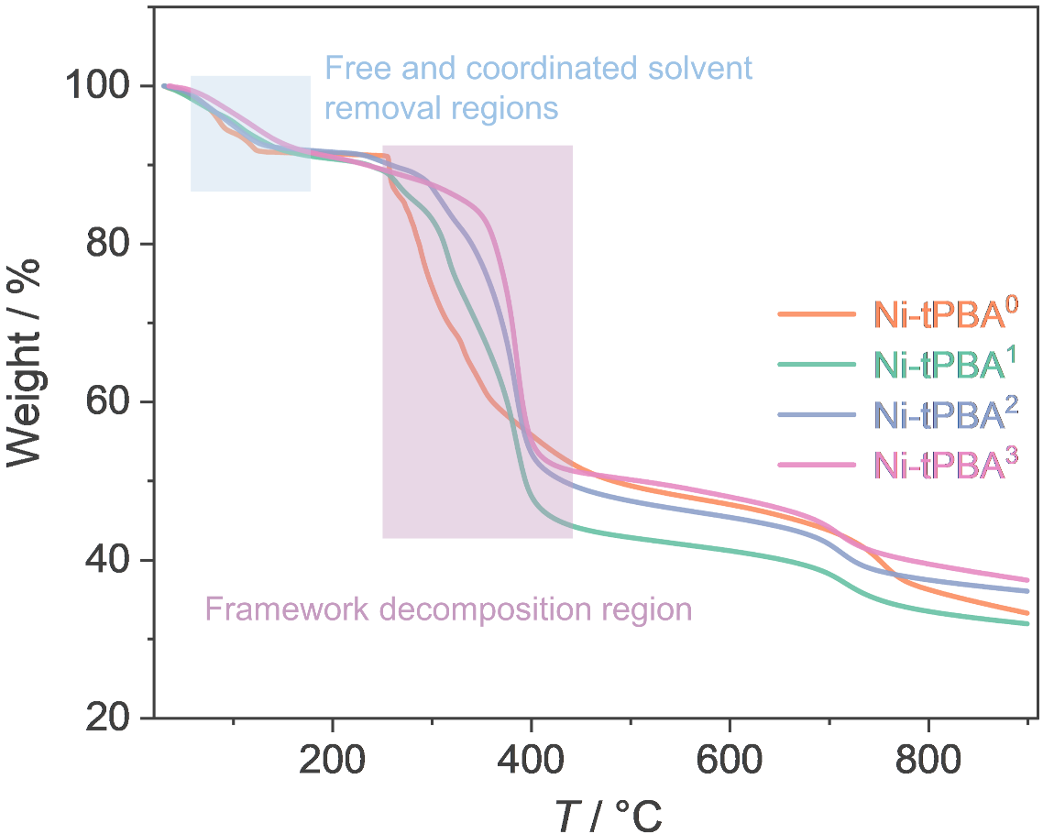
Figure S17. TGA curves of Ni-tPBA^{0~3} under dinitrogen atmosphere.
Supplementary Note 1:
The fully milled and ultrasonically dispersed Ni-tPBA^{0~3} were bonded to carbon paper (CP) with nafion to evaluate the electrocatalytic OER performance. As shown in Figure S18a, CP with 0.2 mg Ni-tPBA^{1~3} exhibited η₁₀ overpotential of about 350 mV comparable to RuO₂. Ni-tPBA³ was also loaded on the bare glassy carbon electrode, which demonstrates an overpotential of 370 mV that is much better than that of pure CP and Ni-tPBA⁰ (Figure S19). This excludes that the electrochemical OER activity may be derived from pure CP. Moreover, polarization curves after quantification by electrochemical active surface area (ECSA) exhibited that Ni-tPBA³ has the best intrinsic OER activity (Figure S18b~d, Figure S20).

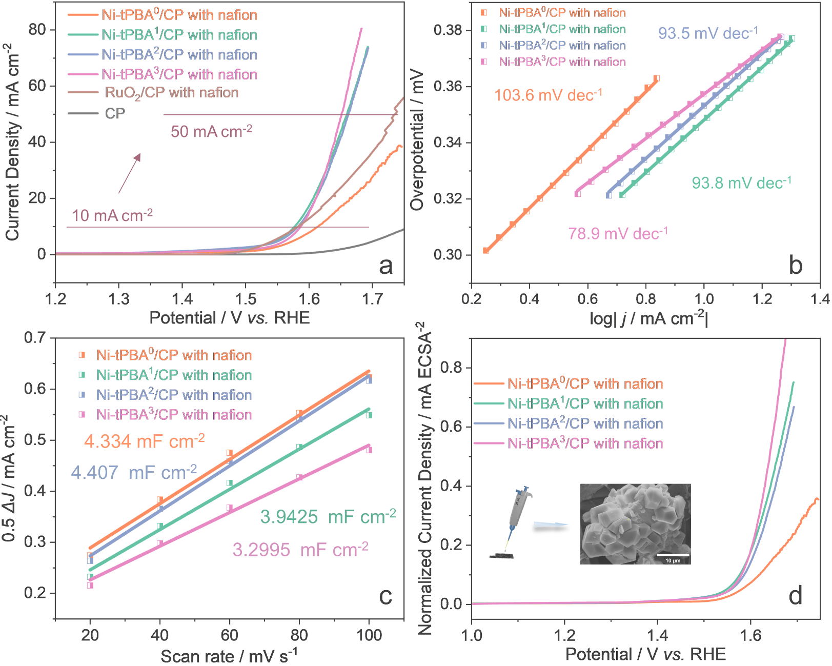
Figure S18. Electrocatalytic OER performance in 1 M KOH. (a) LSV polarization curves of Ni-tPBA^{0~3}/CP, RuO₂/CP with nafion and pure CP recorded at the scan rate of 5 mV/s with iR-compensation. (b) Tafel plots. (c) C_{dl} values. (d) LSV polarization curves normalized by ECSA.
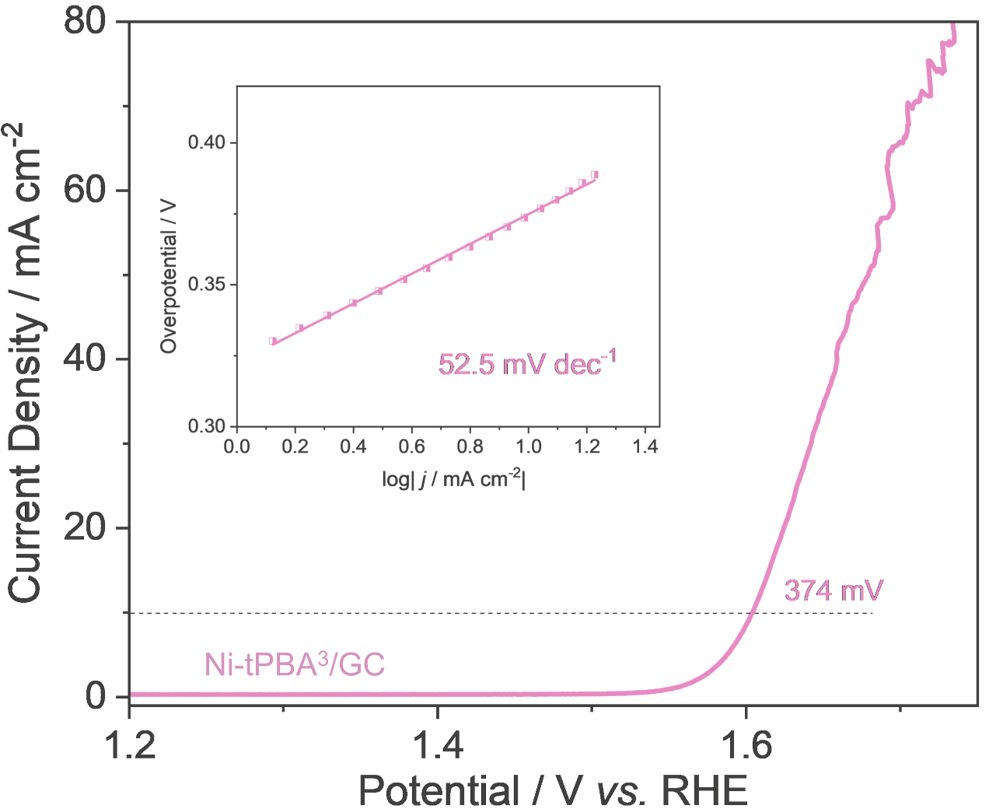
Figure S19. LSV polarization curves of Ni-tPBA³/GC recorded at the scan rate of 5 mV/s with iR-compensation.
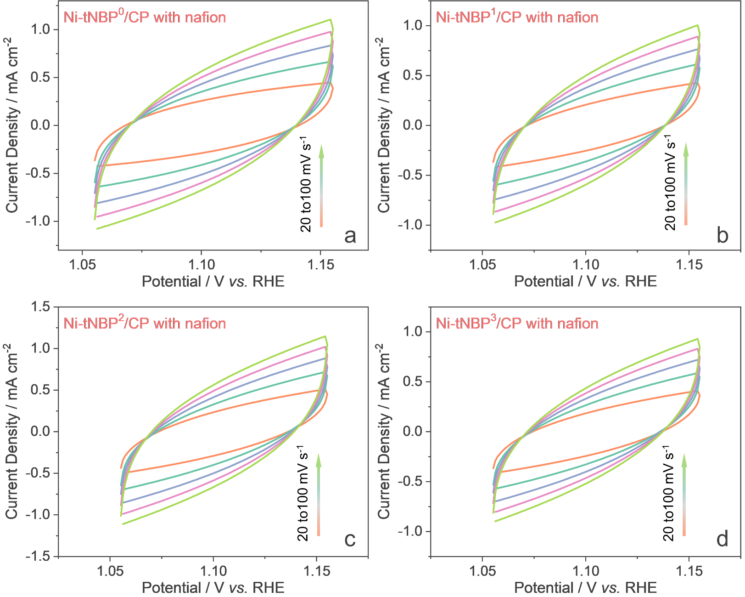
Figure S20. CV curves of Ni-tPBA^{0~3}/CP with nafion in 1.0 M KOH solution at different scan rates (20 – 100 mV/s with 0.05 – 0.15 V vs. Ag/AgCl).
Supplementary Note 2:
Ni-tPBA^{0~3} were further integrated on CP by self-growing method (Figure S21). Scanning electron microscopy (SEM) showed that Ni-tPBA^{0~3} still retained the rod, block, layered, and plate morphology and the material size of Ni-tPBA^{0~3} was regulated to be around 50 ~ 100 nm (Figure S22~25). The PXRD analysis showed that the peak position of Ni-tPBA^{0~3}/CP was almost unchanged than that of the single crystal state, substantiating the successful construction of the pristine structure on CP (Figure S26). Besides, the diffuse reflectance infrared Fourier transform spectroscopy (DRIFT) results demonstrated that the characteristic peaks of the ligand are still present for Ni-tPBA^{0~3}/CP when compared to the original Ni-tPBA^{0~3} (Figure S27~28), further evidencing that their similar chemical composition.
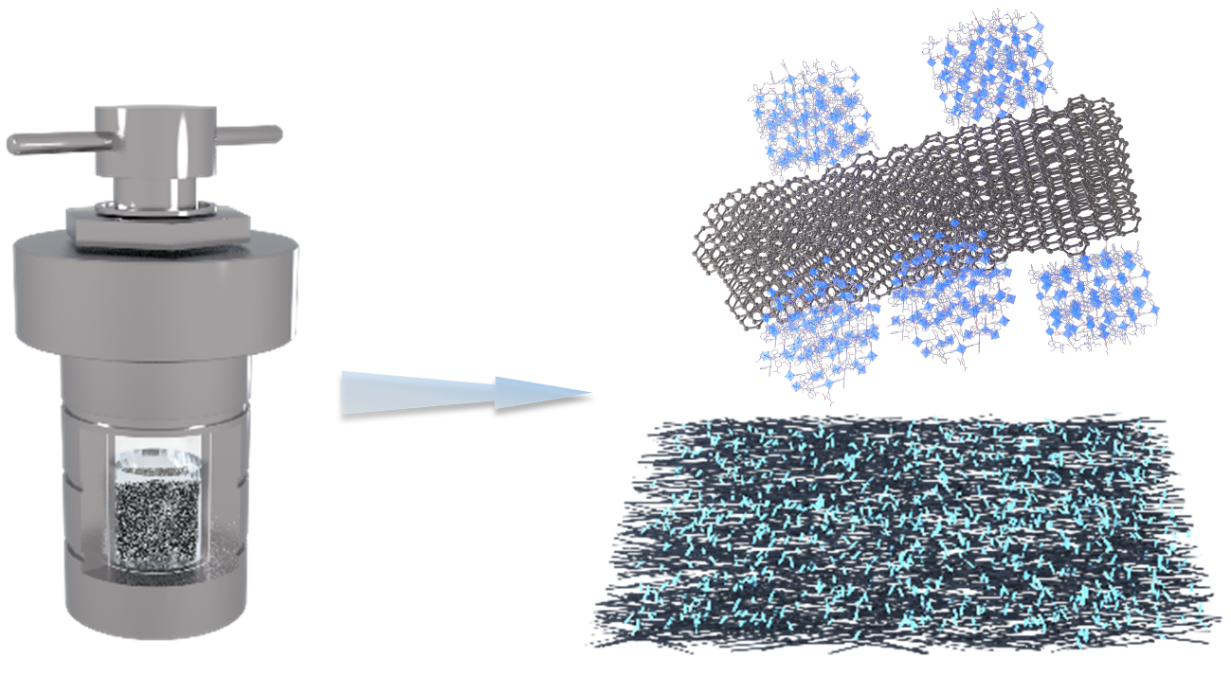
Figure S21. Synthesis scheme for self-growing Ni-tPBA^{0~3}/CP.
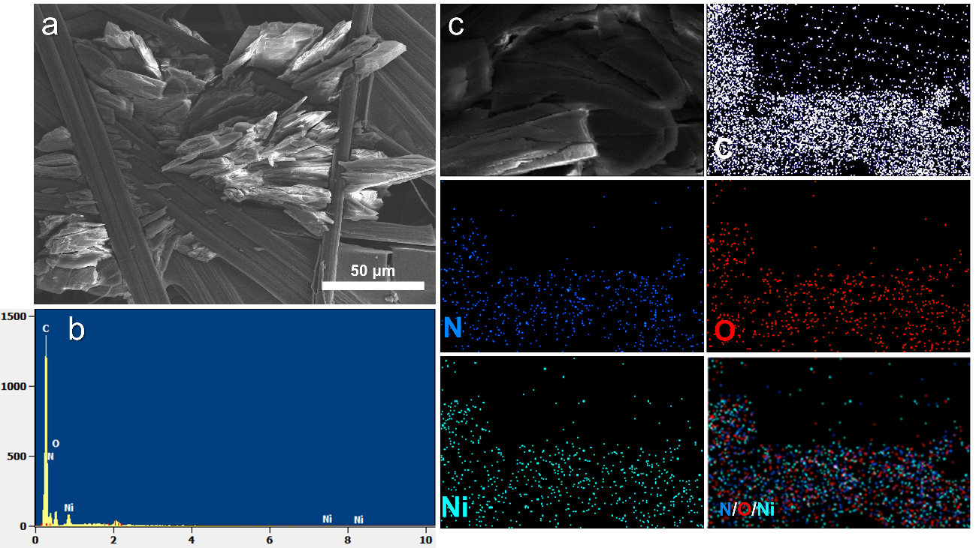
Figure S22. SEM images of Ni-tPBA⁰/CP.
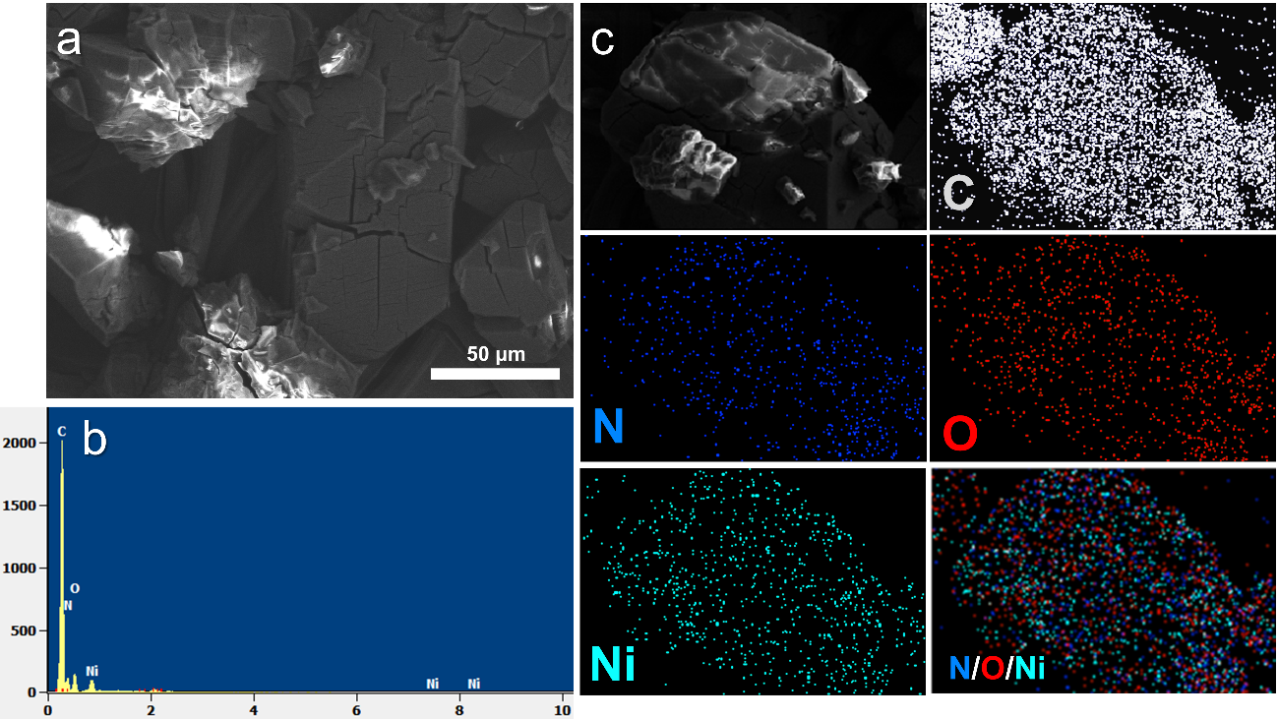
Figure S23. SEM images of Ni-tPBA¹/CP.
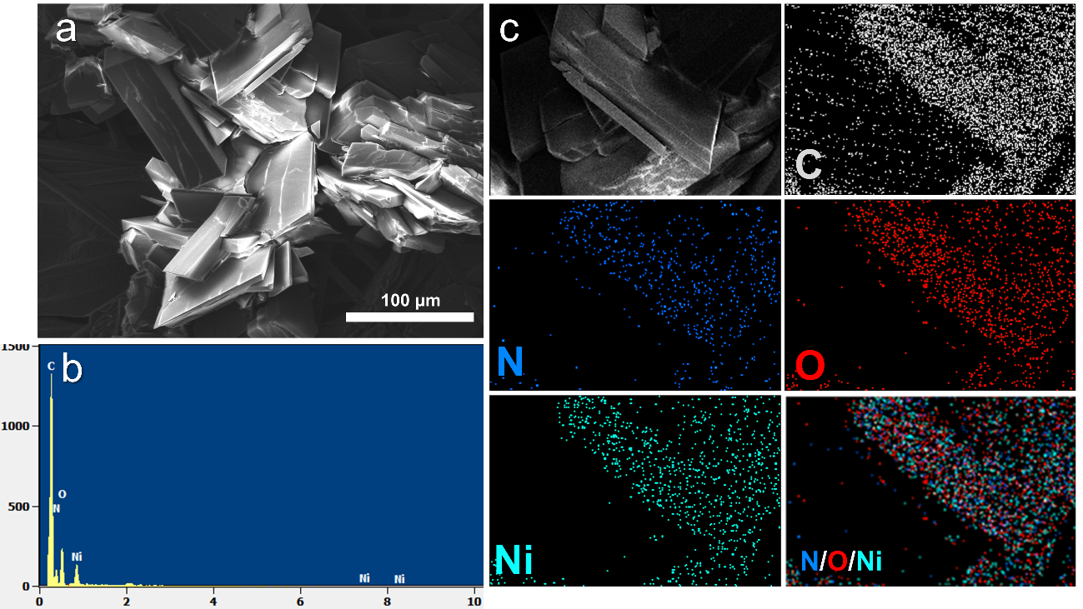
Figure S24. SEM images of Ni-tPBA²/CP.
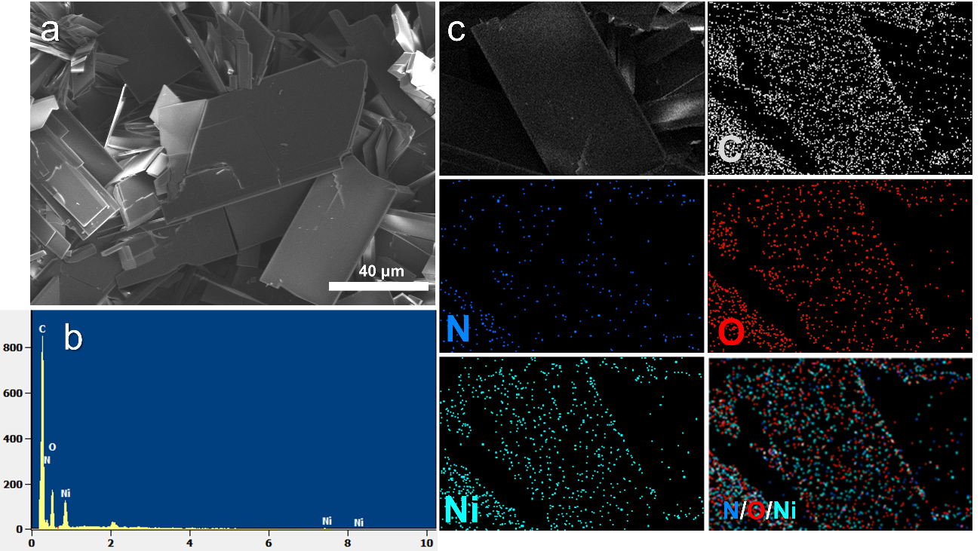
Figure S25. SEM images of Ni-tPBA³/CP.
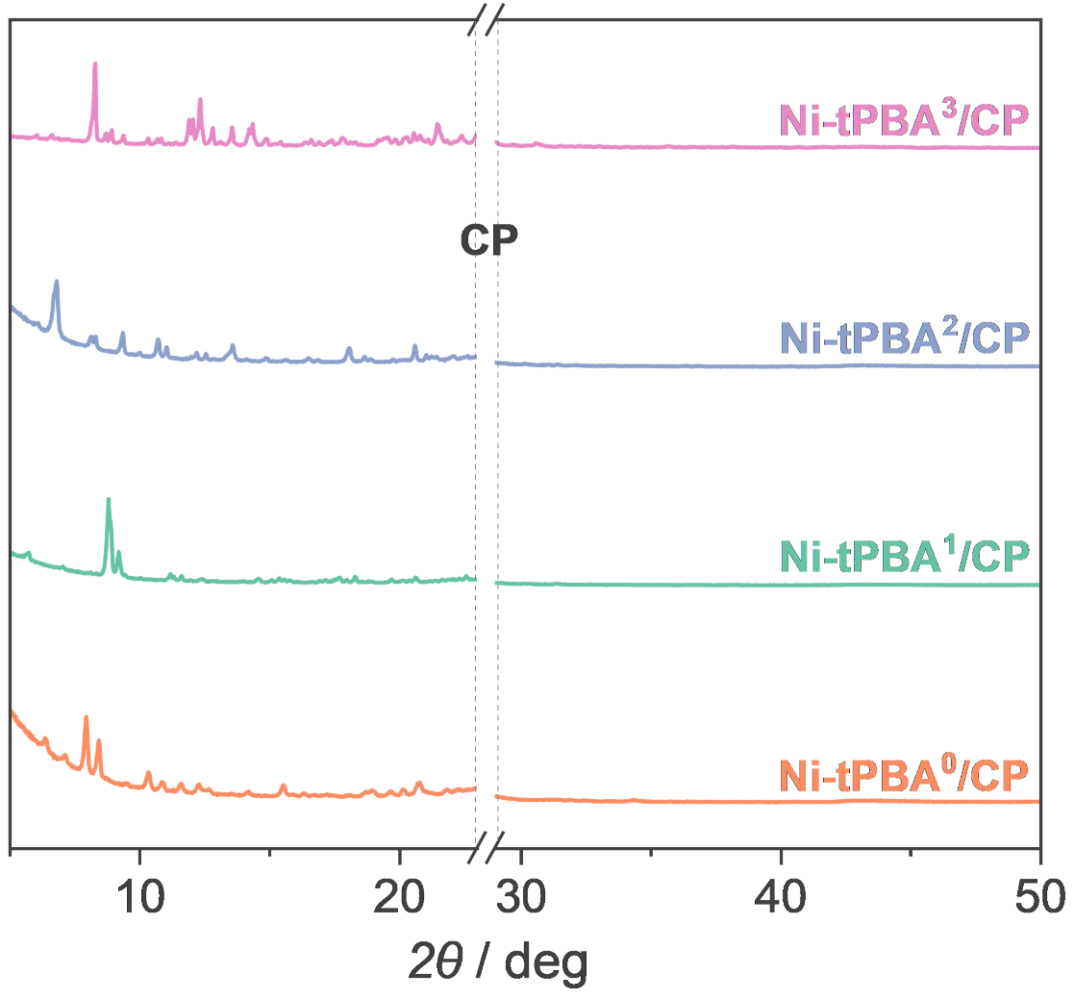
Figure S26. PXRD patterns of Ni-tPBA^{0~3}/CP.
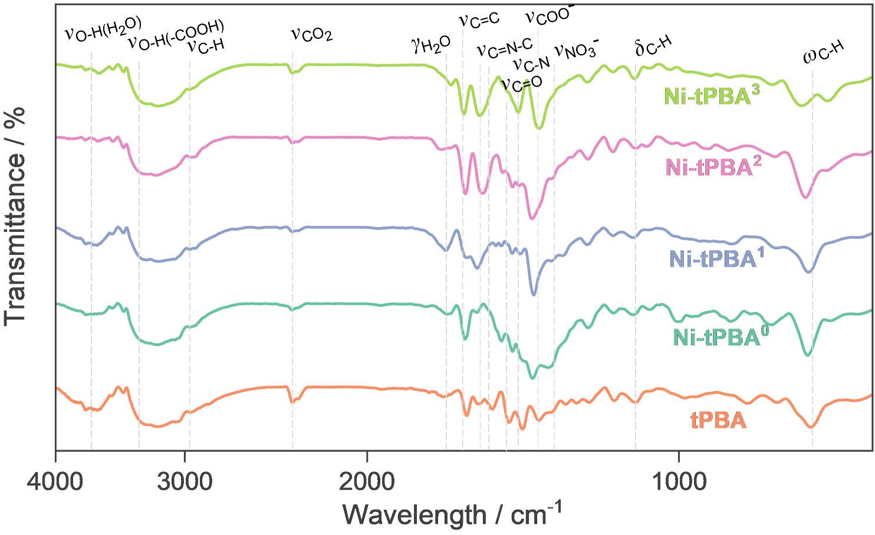
Figure S27. FT-IR spectra of tPBA and Ni-tPBA^{0~3} in the single crystal state.
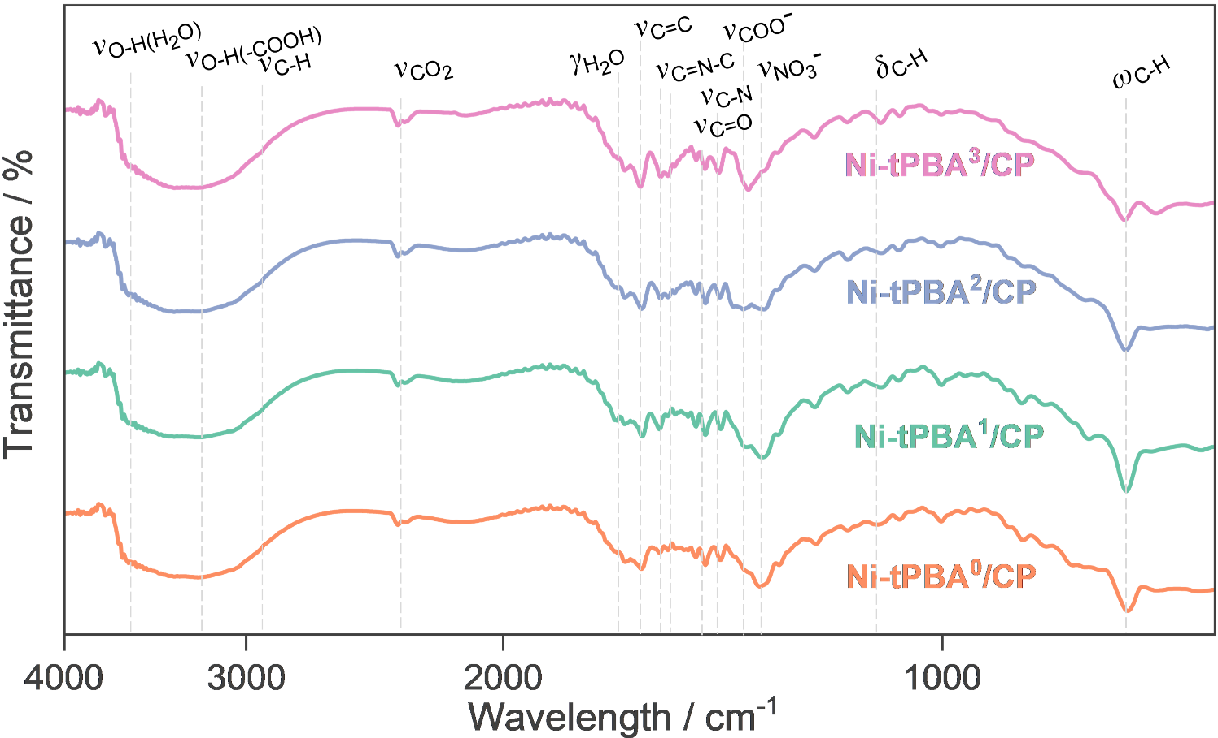
Figure S28. DRIFT spectra of Ni-tPBA^{0~3}/CP.
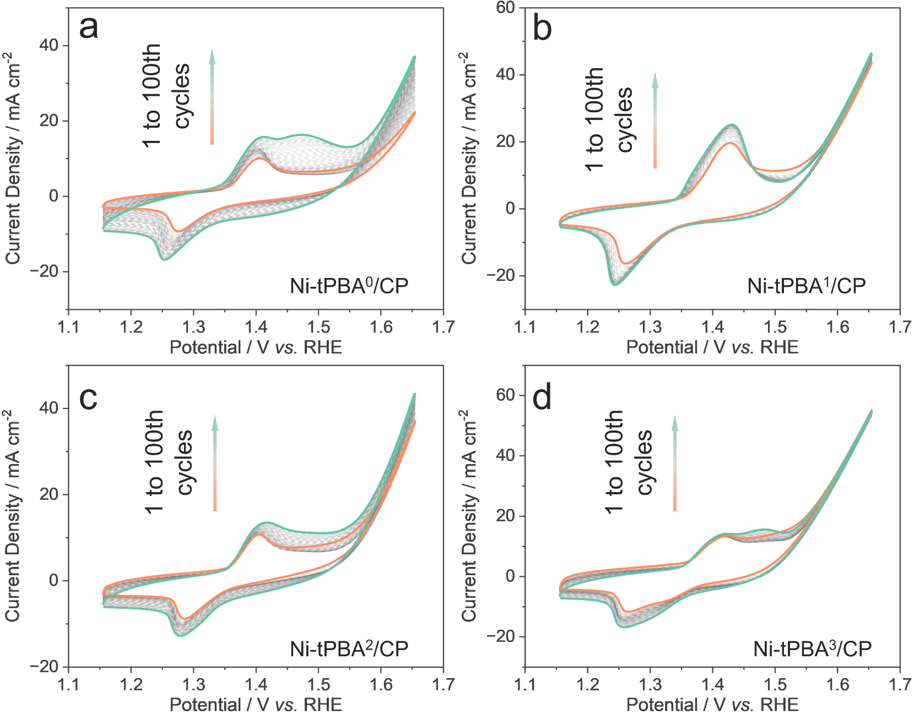
Figure S29. CV activation curves of Ni-tPBA^{0~3}/CP in 1.0 M KOH solution at 0.15 – 0.65 V vs. Ag/AgCl.
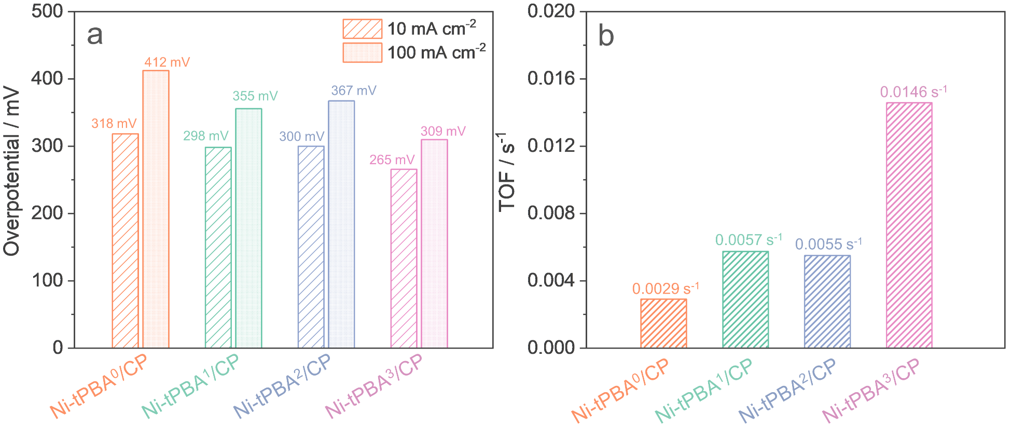
Figure S30. (a) The overpotentials of Ni-tPBA^{0~3}/CP at 10 mA cm^{–2} and 100 mA cm^{–2}. (b) TOF value of Ni-tPBA^{0~3}/CP at the overpotential of 300 mV.
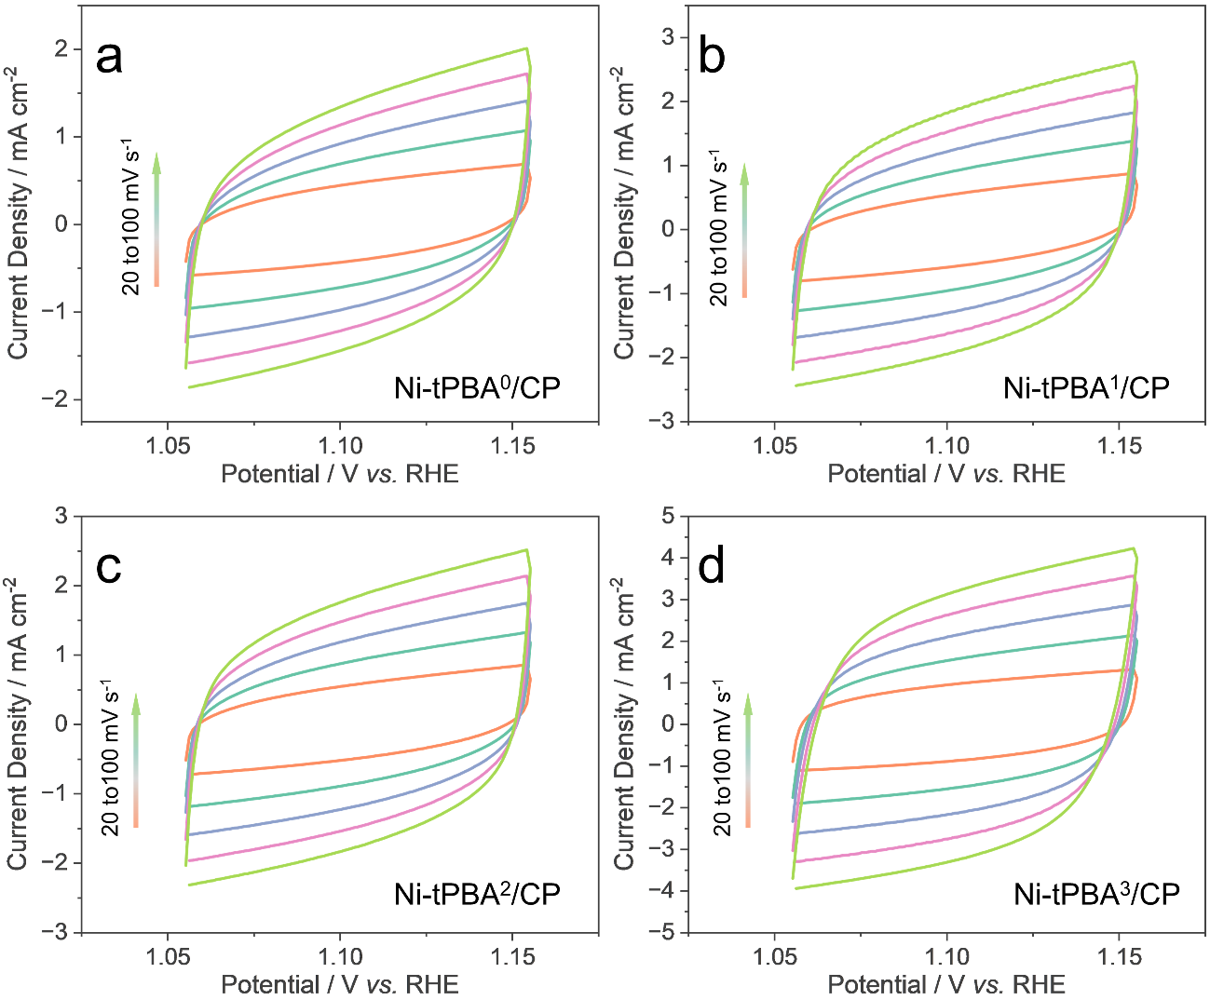
Figure S31. CV curves of Ni-tPBA^{0~3}/CP in 1.0 M KOH solution at different scan rates (20 – 100 mV/s with 0.05 – 0.15 V vs. Ag/AgCl).
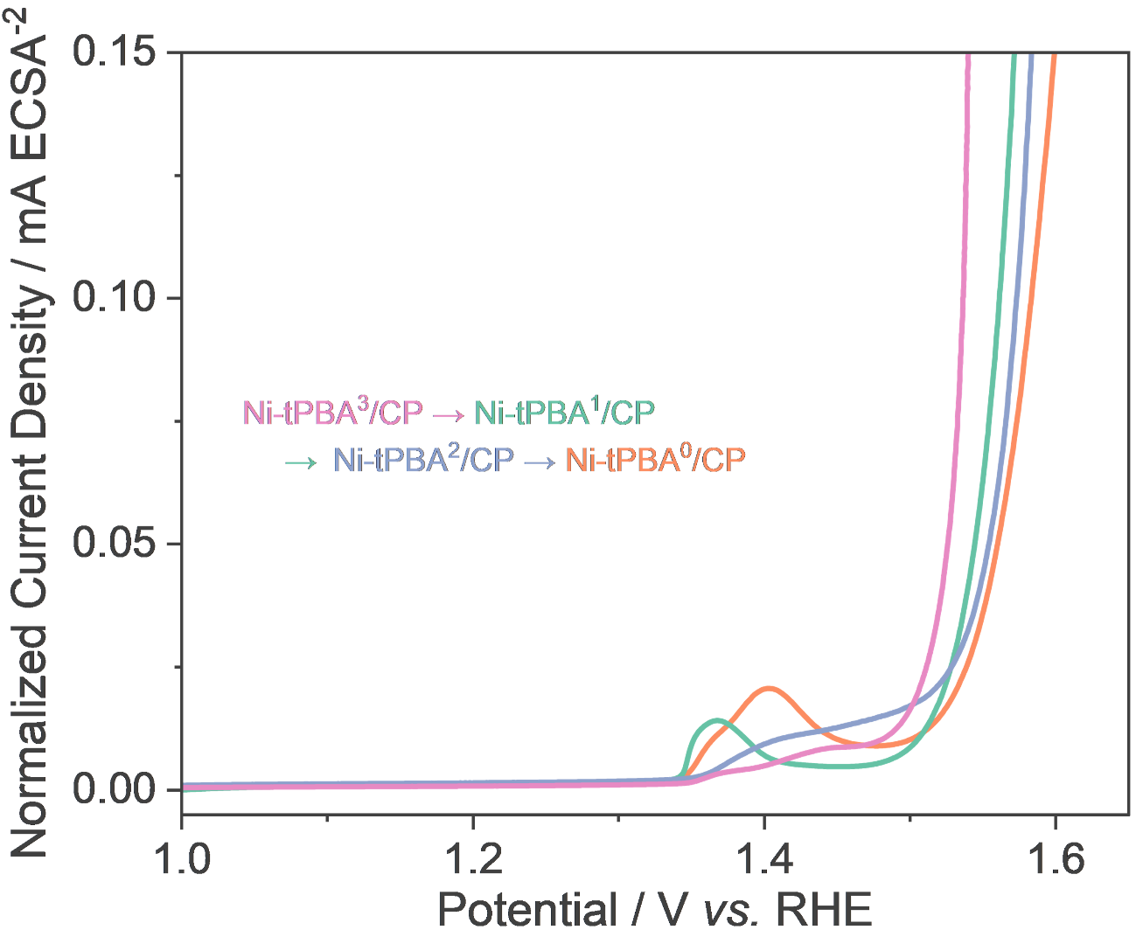
Figure S32. LSV polarization curves of Ni-tPBA^{0~3}/CP normalized by ECSA.
Supplementary Note 3:
The ligand characteristic peaks in Ni-tPBA^{0~3} remained, evidenced by DRIFT analysis (Figure S33), with the characteristic peaks of tPBA shifting slightly. These results finely confirm that Ni-tPBAs well keeps the pristine structure and composite, yet the periodic unit underwent distortion due to the strong oxygen release process. The obvious enhancement of the –OH characteristic region in the low wavelength region implies the effective adsorption of water molecules and the production of intermediates.
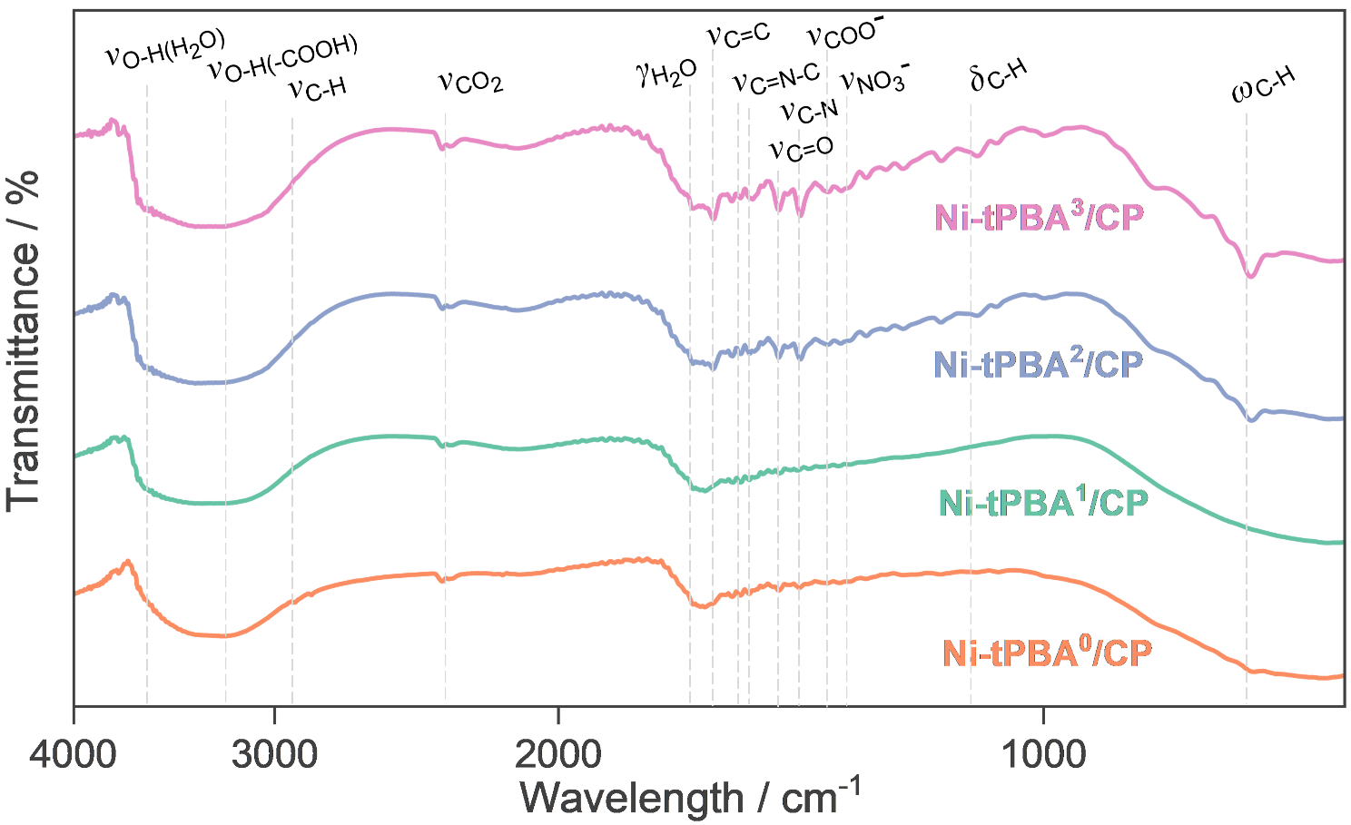
Figure S33. DRIFT spectra of Ni-tPBA^{0~3}/CP after OER testing.
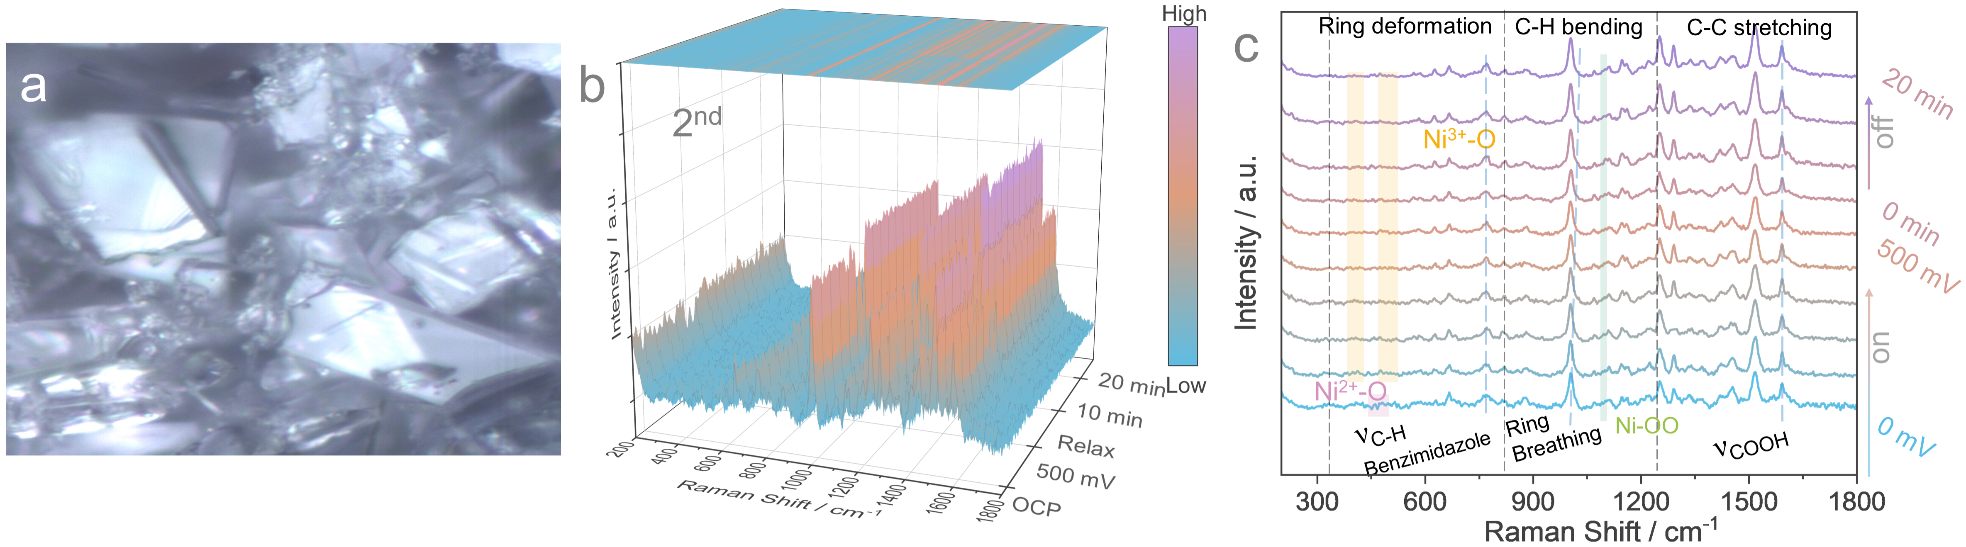
Figure S34. (a) Microscopic photograph of the test area on Ni-tPBA³/CP. (b) In-situ Raman contour maps for Ni-tPBA³/CP accompanied by second LSV processes with applied potentials range from 1.1 to 1.8 V vs. RHE and (c) the corresponding in-situ Raman spectra of Ni-tPBA³/CP at different representative voltages.
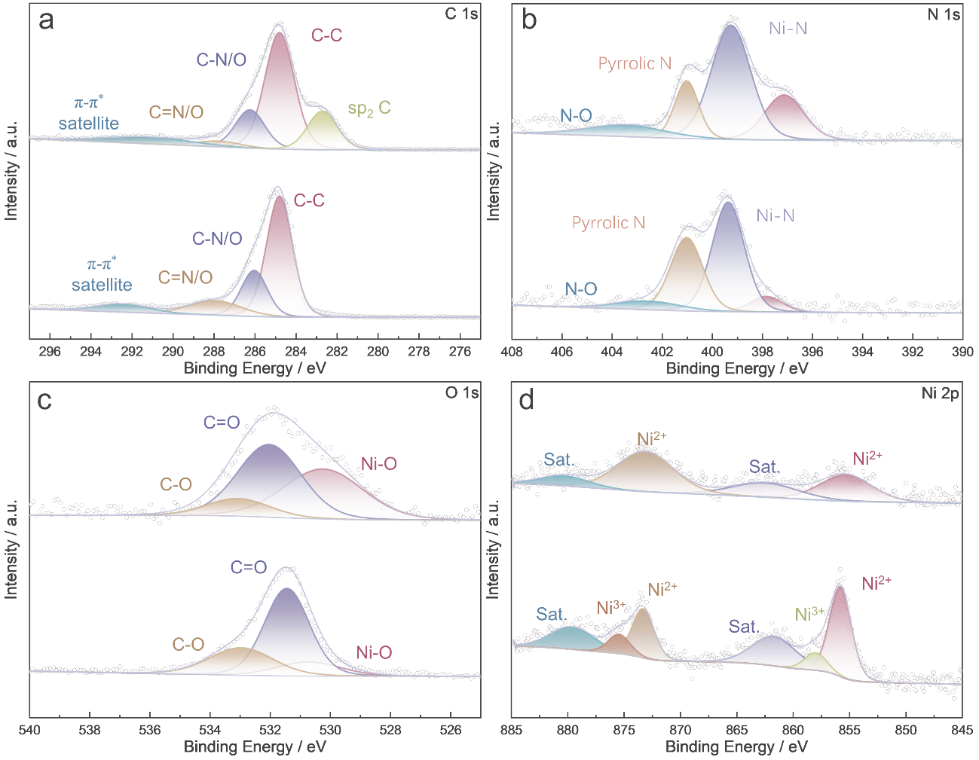
Figure S35. Comparison of XPS pattern for Ni-tPBA⁰/CP and Ni-tPBA⁰/CP after OER testing.
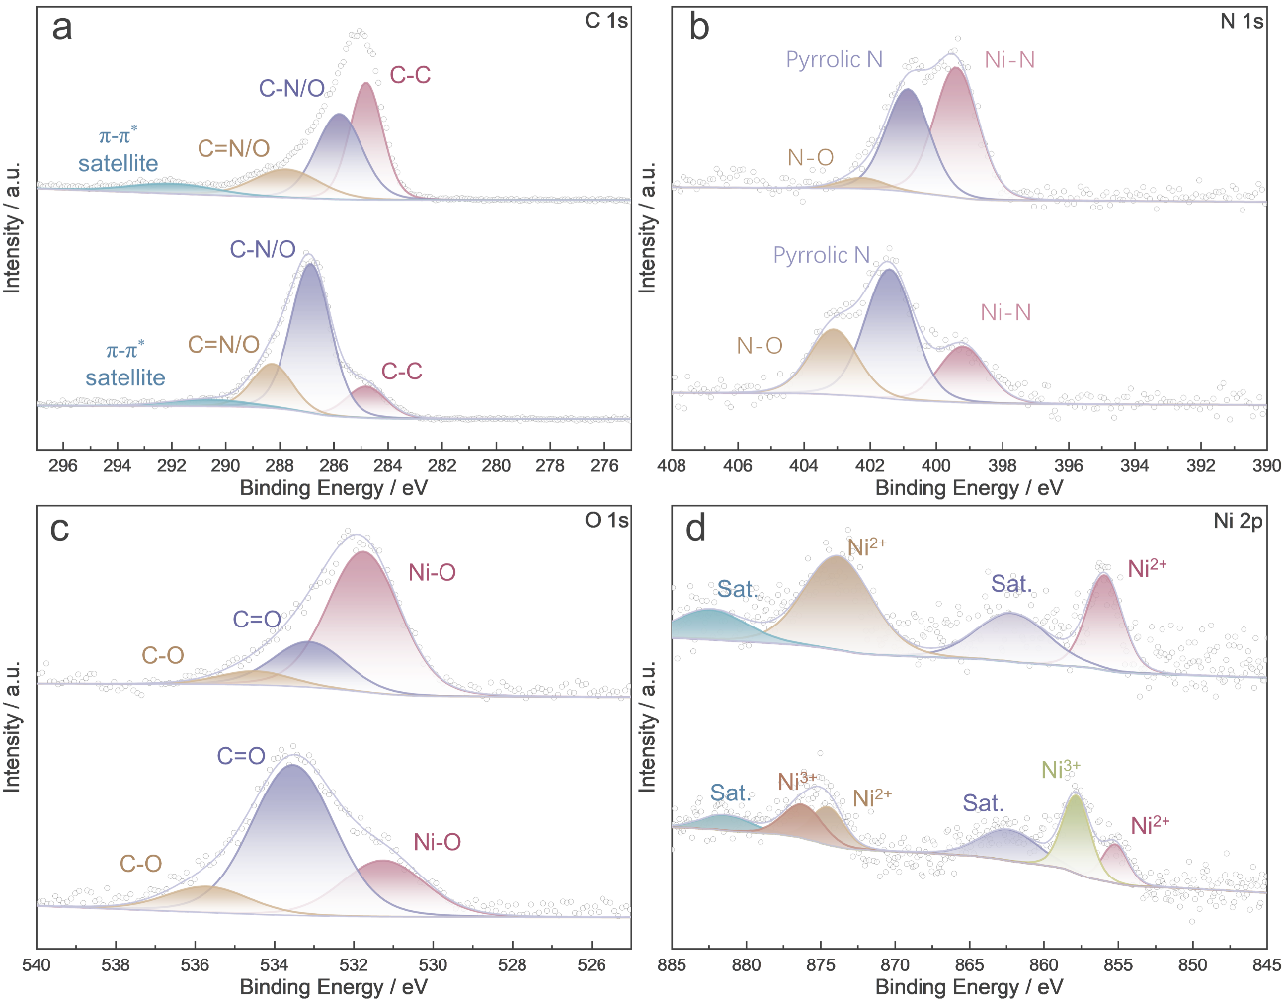
Figure S36. Comparison of XPS pattern for Ni-tPBA¹/CP and Ni-tPBA¹/CP after OER testing.
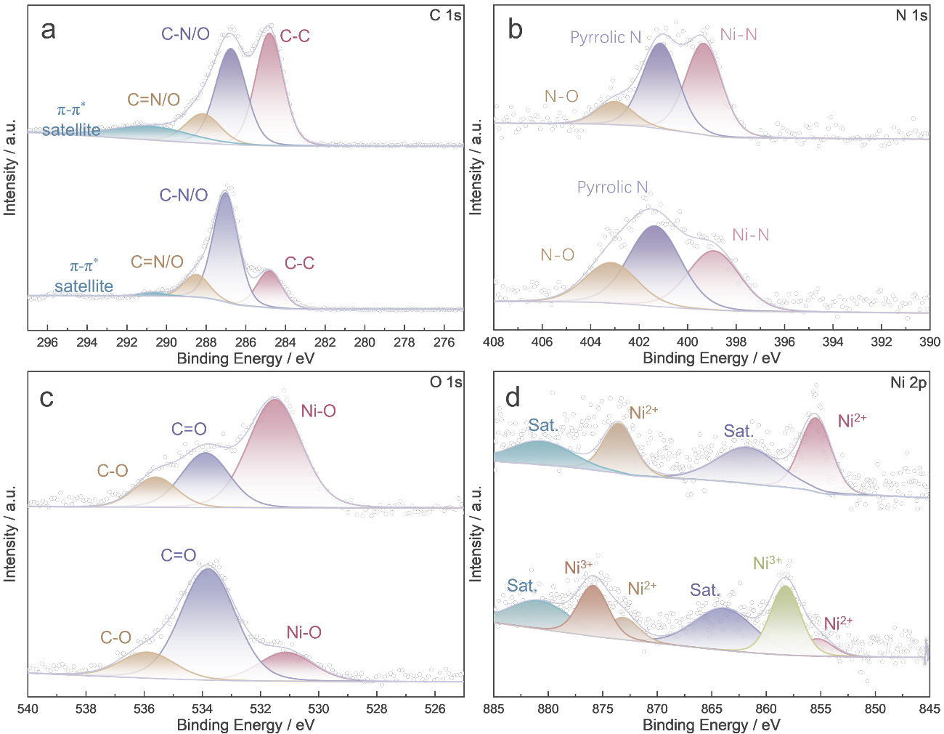
Figure S37. Comparison of XPS pattern for Ni-tPBA²/CP and Ni-tPBA²/CP after OER testing.
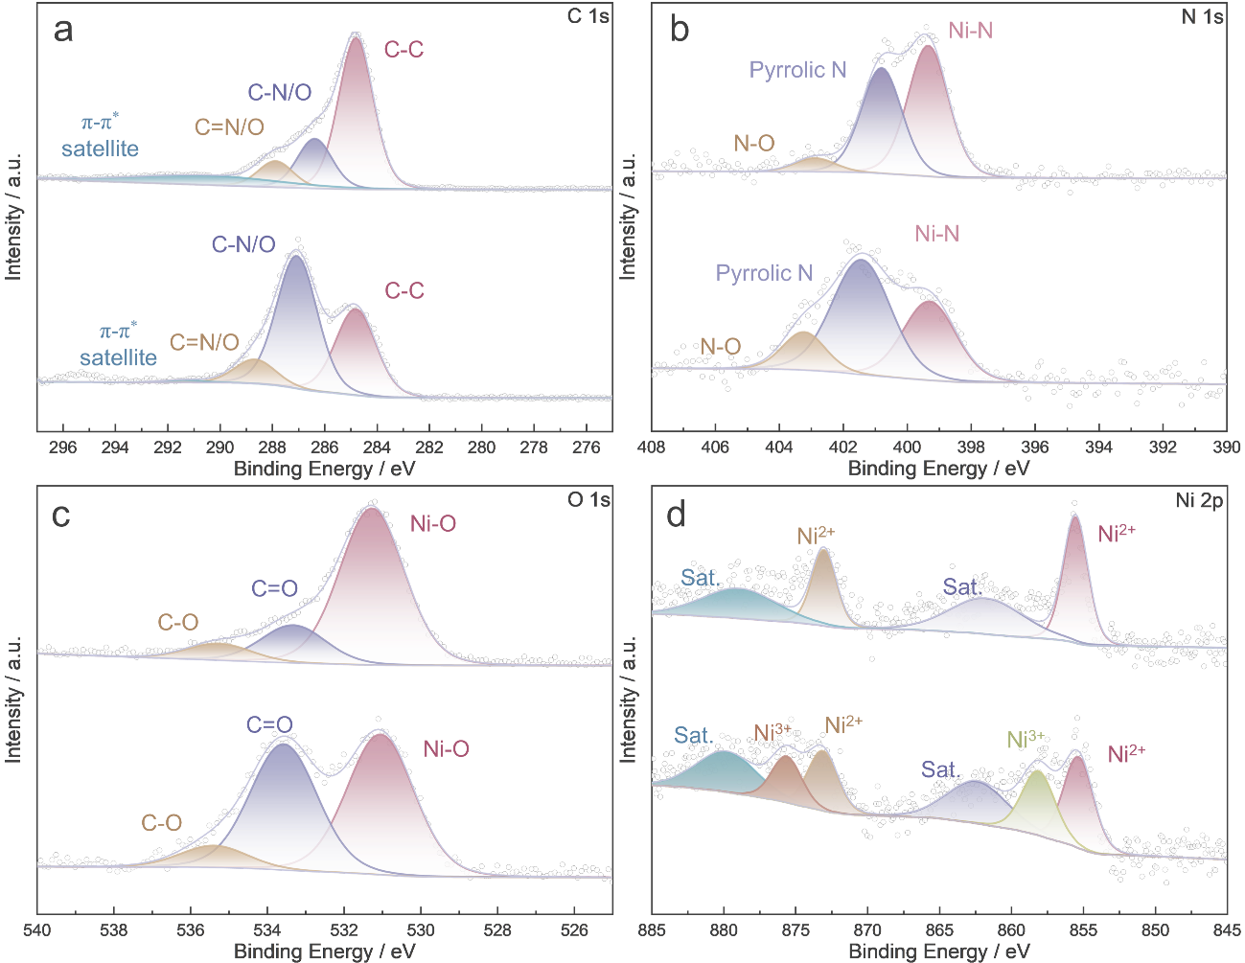
Figure S38. Comparison of XPS pattern for Ni-tPBA³/CP and Ni-tPBA³/CP after OER testing.

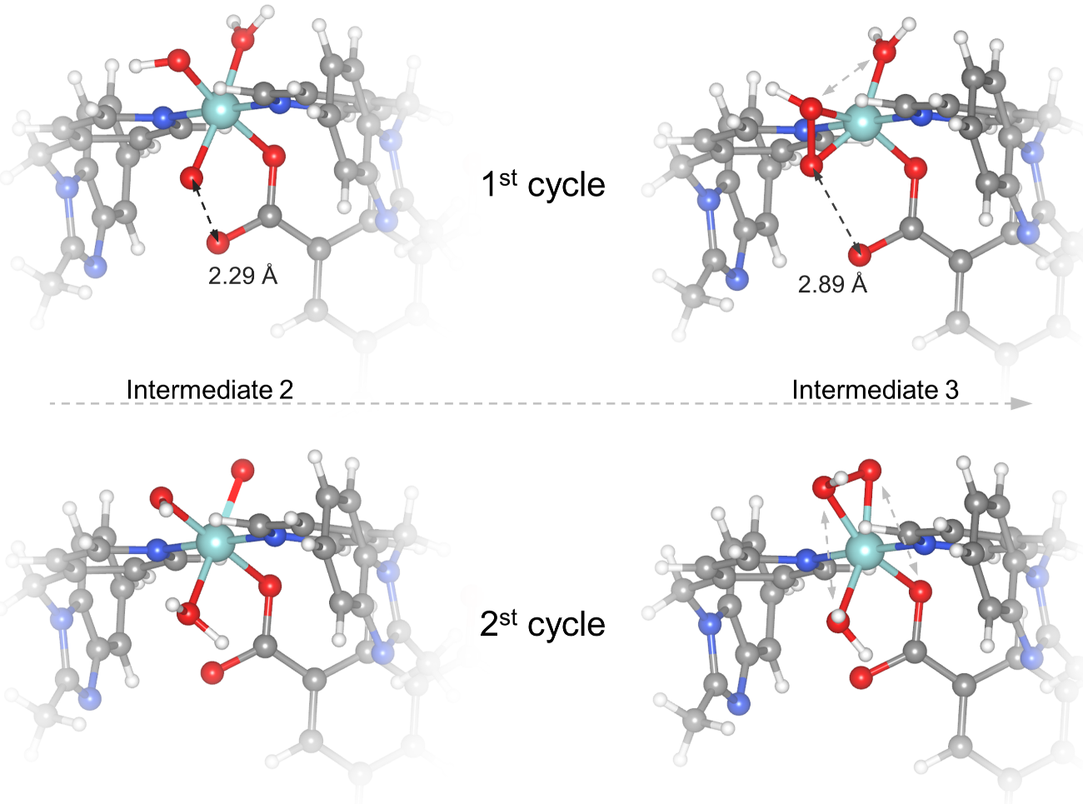
Figure S39. Optimization models for Intermediates 2 and 3 in catalytic cycles 1 and 2.

Supplementary Tables
Table S1. Crystal data and numbers pertinent to data collection and structure refinement of Ni-tPBA^{0~3}.
Ni-tPBA | 0 | 1
Empirical formula | C₈₄H₉₉N₂₄Ni₂O₂₄ | C₉₈H₁₀₂N₂₄Ni₂O₁₈
Formula weight | 1946.29 | 2021.45
Temperature / K | 193 | 193
Crystal system | monoclinic | triclinic
Space group | Cc | $$\text{P}\overline{\text{1}}$$
a / Å | 26.5925(15) | 11.9791(3)
b / Å | 14.3498(8) | 13.1918(4)
c / Å | 24.683(2) | 16.7653(6)
α / deg | 90 | 88.0710(10)
β / deg | 96.818(2) | 74.7930(10)
γ / deg | 90 | 68.4960(10)
Volume / Å³ | 9352.2(11) | 2372.86(13)
Z | 4 | 1
ρ_{calc} / g cm^{–3} | 1.382 | 1.415
μ / mm^{–1} | 0.488 | 0.480
F(000) / e | 4076.0 | 1058.0
Radiation; wavelength λ / Å | MoKα; 0.71073 | MoKα; 0.71073
2θ range for data collection / deg | 3.548–49.998 | 3.794–55.164
Index ranges hkl | –31 → 31, –17 → 17, –29→ 21 | –15 → 15, –17 → 17, –21 → 17
Reflections collected | 32091 | 22573
Independent refl.; R_{int}; R_{σ} | 12946; 0.0591; 0.0763 | 10903; 0.0500; 0.0710
Data; ref. parameters | 12946; 1093 | 10903; 696
Final R₁; wR₂ [I ≥ 2 σ(I)] | 0.0896; 0.2320 | 0.0574; 0.1493
Final R indexes (all data) | 0.1265; 0.2595 | 0.0807; 0.1673
Goodness–of–fit on F² | 1.033 | 1.046
Largest diff. peak; hole / e Å^{–3} | 0.68; –0.40 | 0.65; –0.53
Table S1. (continued)
Ni-tPBA | 2 | 3
Empirical formula | C₅₀H₄₈N₁₀Ni₂O₉ | C₁₁₁H₁₀₈N₂₀Ni₅O₃₂
Formula weight | 1050.40 | 2527.72
Temperature / K | 193 | 296.15
Crystal system | triclinic | monoclinic
Space group | $$\text{P}\overline{\text{1}}$$ | P2₁/c
a / Å | 14.1267(6) | 15.6056(10)
b / Å | 14.8028(6) | 33.349(2)
c / Å | 16.4261(7) | 25.7256(17)
α / deg | 113.1500(10) | 90
β / deg | 94.1040(10) | 103.263(2)
γ / deg | 100.8470(10) | 90
Volume / Å³ | 3061.4(2) | 13031.4(15)
Z | 2 | 4
ρ_{calc} / g cm^{–3} | 1.140 | 1.288
μ / mm^{–1} | 0.669 | 0.787
F(000) / e | 1092.0 | 5240.0
Radiation; wavelength λ / Å | MoKα; 0.71073 | MoKα; 0.71073
2θ range for data collection / deg | 3.7–50 | 3.628–50
Index ranges hkl | –15 → 16, –17 → 17, –19→ 19 | –18 → 16, –39 → 39, –30 → 30
Reflections collected | 23440 | 98215
Independent refl.; R_{int}; R_{σ} | 10755; 0.0599; 0.0896 | 22924; 0.0791; 0.0682
Data; ref. parameters | 10755; 693 | 22924; 1794
Final R₁; wR₂ [I ≥ 2 σ(I)] | 0.0775; 0.2236 | 0.0875; 0.2582
Final R indexes (all data) | 0.1170; 0.2440 | 0.1317; 0.2830
Goodness–of–fit on F² | 1.023 | 1.105
Largest diff. peak; hole / e Å^{–3} | 1.18; –0.35 | 0.92; –0.91

Table S2. Bond lengths (Å) and bond angles (deg) of Ni-tPBA^{0~3}.
Ni-tPBA⁰
Bond lengths (Å)
Ni1–O1 | 2.055(8) | Ni1–N24 | 2.065(11) | Ni2–O8 | 2.032(9)
Ni1–N10 | 2.144(11) | Ni1–N2 | 2.131(6) | Ni2–N16 | 2.179(10)
Ni1–N14 | 2.108(12) | Ni2–N1 | 2.034(10) | Ni2–N22 | 2.077(12)
Ni1–N20 | 2.160(10) | Ni2–O4 | 2.061(10) | Ni2–N3 | 2.094(12)
Bond angles (deg)
O1–Ni1–N10 | 105.6(4) | N24–Ni1–N14 | 93.3(4) | O4–Ni2–N22 | 87.0(4)
O1–Ni1–N14 | 99.2(4) | N24–Ni1–N20 | 82.9(4) | O4–Ni2–N3 | 89.1(4)
O1–Ni1–N20 | 175.0(4) | N24–Ni1–N2 | 174.7(4) | O8–Ni2–N1 | 96.0(4)
O1–Ni1–N24 | 93.2(4) | N2–Ni1–N10 | 90.1(4) | O8–Ni2–O4 | 89.4(4)
O1–Ni1–N2 | 85.8(3) | N2–Ni1–N20 | 98.3(4) | O8–Ni2–N16 | 178.9(5)
N10–Ni1–N20 | 77.3(4) | N1–Ni2–O4 | 172.2(4) | O8–Ni2–N22 | 101.4(5)
N14–Ni1–N10 | 155.2(4) | N1–Ni2–N16 | 83.6(4) | O8–Ni2–N3 | 100.6(4)
N14–Ni1–N20 | 77.9(4) | N1–Ni2–N22 | 86.4(4) | N22–Ni2–N16 | 79.6(4)
N14–Ni1–N2 | 92.0(4) | N1–Ni2–N3 | 95.5(4) | N22–Ni2–N3 | 157.6(4)
N24–Ni1–N10 | 85.0(4) | O4–Ni2–N16 | 91.2(4) | N3–Ni2–N16 | 78.5(4)
Ni-tPBA¹
Bond lengths (Å)
Ni1–O1 | 2.0260(18) | Ni1–N1 | 2.051(2) | Ni1–N6 | 2.066(2)
Ni1–O4 | 2.1353(19) | Ni1–N4 | 2.054(2) | Ni1–N3 | 2.204(2)
Bond angles (deg)
O1–Ni1–O4 | 90.75(8) | O4–Ni1–N3 | 89.86(8) | N4–Ni1–O4 | 89.59(8)
O1–Ni1–N1 | 97.52(8) | N1–Ni1–O4 | 171.59(8) | N4–Ni1–N6 | 157.79(9)
O1–Ni1–N4 | 99.28(8) | N1–Ni1–N4 | 87.60(9) | N4–Ni1–N3 | 79.84(9)
O1–Ni1–N6 | 102.41(8) | N1–Ni1–N6 | 94.21(9) | N6–Ni1–O4 | 85.43(8)
O1–Ni1–N3 | 178.93(8) | N1–Ni1–N3 | 81.84(9) | N6–Ni1–N3 | 78.51(9)
Ni-tPBA²
Bond lengths (Å)
Ni1–O1¹ | 2.039(3) | Ni2–O12 | 2.061(18) | Ni3–O4 | 2.119(3)
Ni1–O1 | 2.039(3) | Ni2–O12⁴ | 2.061(17) | Ni3–O6 | 2.073(4)
Ni1–O8¹ | 2.090(3) | Ni2–O14⁴ | 2.151(17) | Ni3–N1 | 1.996(4)
Ni1–O8 | 2.090(3) | Ni2–O14 | 2.151(17) | Ni3–N6 | 2.021(4)
Ni1–N4² | 2.106(4) | Ni2–O3 | 2.127(14) | Ni3–N8 | 2.093(4)
Ni1–N4³ | 2.106(4) | Ni2–O3⁴ | 2.127(14) | Ni3–N3 | 2.180(5)
Ni2–N2⁴ | 2.107(5) | Ni2–O13 | 2.010(15) | Ni3–C26 | 2.413(5)
Ni2–N2 | 2.107(5) | Ni2–O13⁴ | 2.010(15)
Bond angles (deg)
O1¹–Ni1–O1 | 180 | N2–Ni2–O3⁴ | 91.2(3) | O13–Ni2–O13⁴ | 180
O1¹–Ni1–O8 | 91.37(14) | N2⁴–Ni2–O3 | 91.2(3) | O4–Ni3–N3 | 109.15(15)
O1–Ni1–O8 | 88.63(14) | O12–Ni2–N2 | 84.8(4) | O4–Ni3–C26 | 30.86(14)
O1¹–Ni1–O8¹ | 88.63(14) | O12⁴–Ni2–N2 | 95.2(4) | O6–Ni3–O4 | 62.94(13)
O1–Ni1–O8¹ | 91.37(14) | O12⁴–Ni2–O12 | 180.0(8) | O6–Ni3–N8 | 99.84(16)
O1–Ni1–N4² | 91.25(15) | O12–Ni2–O14 | 89.0(6) | O6–Ni3–N3 | 171.94(15)
O1¹–Ni1–N4³ | 91.25(15) | O12⁴–Ni2–O14 | 91.0(6) | O6–Ni3–C26 | 32.08(15)
O1–Ni1–N4³ | 88.75(15) | O3–Ni2–O14⁴ | 155.5(4) | N1–Ni3–O4 | 168.68(16)
O11–Ni1–N4² | 88.75(15) | O3⁴–Ni2–O14⁴ | 24.5(4) | N1–Ni3–O6 | 105.99(16)
O8–Ni1–O8¹ | 180 | O3⁴–Ni2–O3 | 180.0(7) | N1–Ni3–N6 | 94.49(16)
O8–Ni1–N4³ | 92.68(15) | O13–Ni2–N2 | 87.6(4) | N1–Ni3–N8 | 91.51(17)
O8¹–Ni1–N4² | 92.68(15) | O13⁴–Ni2–N2 | 92.4(4) | N1–Ni3–N3 | 81.83(17)
O8¹–Ni1–N4³ | 87.32(15) | O13⁴–Ni2–N2⁴ | 87.6(4) | N1–Ni3–C26 | 138.04(19)
O8–Ni1–N4² | 87.32(15) | O13–Ni2–N2⁴ | 92.4(4) | N6–Ni3–O4 | 89.98(15)
N4²–Ni1–N4³ | 180 | O13⁴–Ni2–O12⁴ | 23.4(6) | N6–Ni3–O6 | 99.47(17)
N2⁴–Ni2–N2 | 180 | O13–Ni2–O12⁴ | 156.6(6) | N6–Ni3–N8 | 157.3(2)
N2⁴–Ni2–O14⁴ | 91.5(3) | O13⁴–Ni2–O14⁴ | 112.2(5) | N6–Ni3–N3 | 81.56(18)
N2⁴–Ni2–O14 | 88.5(3) | O13–Ni2–O14⁴ | 67.8(5) | N6–Ni3–C26 | 95.18(17)
N2–Ni2–O14⁴ | 88.5(3) | O13⁴–Ni2–O3 | 92.3(5) | N8–Ni3–O4 | 88.31(14)
N2–Ni2–O14 | 91.5(3) | O13–Ni2–O3 | 87.7(5) | N8–Ni3–N3 | 77.68(17)
N2⁴–Ni2–O3⁴ | 88.8(3) | O13–Ni2–O3⁴ | 92.3(5) | N8–Ni3–C26 | 94.88(17)
N2–Ni2–O3 | 88.8(3) | O13⁴–Ni2–O3⁴ | 87.7(5) | N3–Ni3–C26 | 140.01(17)
Ni-tPBA³
Bond lengths (Å)
Ni1–O8 | 2.120(4) | Ni2–N3 | 2.187(6) | Ni4–N20 | 2.087(6)
Ni1–O10 | 2.099(4) | Ni2–N17 | 2.050(7) | Ni4–N21 | 2.091(6)
Ni1–N1 | 1.994(5) | Ni2–N19 | 2.149(6) | Ni4–O38 | 2.079(7)
Ni1–N10 | 2.068(5) | Ni3–O32 | 2.042(6) | Ni4–O44 | 2.073(6)
Ni1–N12 | 2.025(5) | Ni3–O34 | 2.041(6) | Ni5–O1 | 2.041(4)
Ni1–N11 | 2.193(5) | Ni3–N15 | 2.157(7) | Ni5–O4¹ | 2.116(4)
Ni1–C14 | 2.435(5) | Ni3–O42 | 2.056(7) | Ni5–O6¹ | 2.114(4)
Ni2–O12 | 2.073(4) | Ni3–O3 | 1.975(8) | Ni5–O14 | 2.035(4)
Ni2–O18 | 2.056(4) | Ni3–N5 | 2.185(7) | Ni5–N4² | 2.117(5)
Ni2–N8 | 2.068(5) | Ni4–O20 | 2.068(5) | Ni5–N14³ | 2.098(5)
Ni2–N24 | 2.035(5) | Ni4–O26 | 2.055(6) | Ni5–C16¹ | 2.439(6)
Bond angles (deg)
O8–Ni1–N11 | 107.85(18) | N24–Ni2–O18 | 94.9(2) | O26–Ni4–N21 | 92.3(2)
O8–Ni1–C14 | 31.98(16) | N24–Ni2–N8 | 91.3(2) | O26–Ni4–O38 | 177.2(2)
O10–Ni1–O8 | 62.96(14) | N24–Ni2–N3 | 83.0(2) | O26–Ni4–O44 | 89.1(3)
O10–Ni1–N11 | 170.57(18) | N24–Ni2–N17 | 84.8(6) | N20–Ni4–N21 | 175.5(3)
O10–Ni1–C14 | 31.00(16) | N24–Ni2–N19 | 86.5(4) | O38–Ni4–N20 | 87.4(3)
N1–Ni1–O8 | 168.17(18) | N17–Ni2–O12 | 91.3(6) | O38–Ni4–N21 | 88.6(3)
N1–Ni1–O10 | 105.76(18) | N17–Ni2–O18 | 98.6(4) | O44–Ni4–N20 | 92.8(3)
N1–Ni1–N10 | 88.4(2) | N17–Ni2–N8 | 161.6(4) | O44–Ni4–N21 | 89.6(3)
N1–Ni1–N12 | 93.79(19) | N17–Ni2–N3 | 82.8(4) | O44–Ni4–O38 | 93.4(3)
N1–Ni1–N11 | 83.3(2) | N19–Ni2–N3 | 73.9(3) | O1–Ni5–O41 | 163.69(14)
N1–Ni1–C14 | 136.6(2) | O32–Ni3–N15 | 91.8(3) | O1–Ni5–O61 | 101.32(14)
N10–Ni1–O8 | 89.98(17) | O32–Ni3–O42 | 178.9(3) | O1–Ni5–N42 | 88.85(17)
N10–Ni1–O10 | 99.22(18) | O32–Ni3–N5 | 90.5(3) | O1–Ni5–N143 | 89.19(17)
N10–Ni1–N11 | 78.0(2) | O34–Ni3–O32 | 89.9(3) | O1–Ni5–C161 | 132.32(16)
N10–Ni1–C14 | 94.71(18) | O34–Ni3–N15 | 87.4(3) | O41–Ni5–N42 | 87.77(17)
N12–Ni1–O8 | 92.32(17) | O34–Ni3–O42 | 89.3(3) | O41–Ni5–C161 | 31.47(16)
N12–Ni1–O10 | 102.5(2) | O34–Ni3–N5 | 92.7(2) | O61–Ni5–O41 | 62.57(14)
N12–Ni1–N10 | 156.7(2) | N15–Ni3–N5 | 177.8(3) | O61–Ni5–N42 | 86.88(17)
N12–Ni1–N11 | 79.2(2) | O42–Ni3–N15 | 89.0(3) | O61–Ni5–C161 | 31.13(16)
N12–Ni1–C14 | 99.48(19) | O42–Ni3–N5 | 88.8(3) | O14–Ni5–O1 | 96.97(16)
N11–Ni1–C14 | 139.7(2) | O3–Ni3–O32 | 92.2(3) | O14–Ni5–O41 | 99.04(15)
O12–Ni2–N3 | 90.75(18) | O3–Ni3–O34 | 176.5(4) | O14–Ni5–O61 | 161.56(16)
O12–Ni2–N19 | 88.7(4) | O3–Ni3–N15 | 89.8(3) | O14–Ni5–N42 | 91.17(17)
O18–Ni2–O12 | 91.46(17) | O3–Ni3–O42 | 88.6(3) | O14–Ni5–N143 | 93.69(19)
O18–Ni2–N8 | 99.7(2) | O3–Ni3–N5 | 90.1(3) | O14–Ni5–C161 | 130.45(18)
O18–Ni2–N3 | 177.4(2) | O20–Ni4–N20 | 90.8(2) | N42–Ni5–C161 | 85.90(19)
O18–Ni2–N19 | 107.5(3) | O20–Ni4–N21 | 86.8(2) | N143–Ni5–O41 | 92.82(18)
N8–Ni2–O12 | 90.53(18) | O20–Ni4–O38 | 87.8(2) | N143–Ni5–O61 | 88.94(18)
N8–Ni2–N3 | 78.9(2) | O20–Ni4–O44 | 176.2(2) | N143–Ni5–N42 | 174.95(18)
N8–Ni2–N19 | 152.8(3) | O26–Ni4–O20 | 89.7(2) | N143–Ni5–C161 | 92.0(2)
N24–Ni2–O12 | 173.02(18) | O26–Ni4–N20 | 91.5(2)

Supplementary References
1. Cheng, W., Zhang, H., Luan, D. & Lou, X. W. (David). Exposing unsaturated Cu₁ -O₂ sites in nanoscale Cu-MOF for efficient electrocatalytic hydrogen evolution. Sci. Adv. 7, eabg2580 (2021).
2. Wu, Z.-P. et al. Manipulating the local coordination and electronic structures for efficient electrocatalytic oxygen evolution. Adv. Mater. 33, (2021).
3. Smasmart, Saint. Bruker AXS Inc. (2007).
4. Sheldrick, G. M. Crystal structure refinement with Shelxl. Acta Crystallogr. C Struct. Chem. 71, 3–8 (2015).
5. SADABS. Bruker AXS Inc. (2000).
6. Dolomanov, O. V., Bourhis, L. J., Gildea, R. J., Howard, J. A. K. & Puschmann, H. Olex2: a complete structure solution, refinement and analysis program. J. Appl. Crystallogr. 42, 339–341 (2009).
7. Burla, M. C. et al. IL MILIONE: a suite of computer programs for crystal structure solution of proteins. J. Appl. Crystallogr. 40, 609–613 (2007).
8. Kresse, G. & Furthmüller, J. Efficiency of ab-initio total energy calculations for metals and semiconductors using a plane-wave basis set. Comput. Mater. Sci. 6, 15–50 (1996).
9. Kresse, G. & Furthmüller, J. Efficient iterative schemes for ab initio total-energy calculations using a plane-wave basis set. Phys. Rev. B 54, 11169–11186 (1996).
10. Perdew, J. P., Burke, K. & Ernzerhof, M. Generalized gradient approximation Made simple. Phys. Rev. Lett. 77, 3865–3868 (1996).
11. Kresse, G. & Joubert, D. From ultrasoft pseudopotentials to the projector augmented-wave method. Phys. Rev. B 59, 1758–1775 (1999).
12. Blöchl, P. E. Projector augmented-wave method. Phys. Rev. B 50, 17953–17979 (1994).

