The Impact of the EU-Turkey Agreement on the
Number of Lives Lost at Sea ( SUPPLEMENTARY INFORMATION)

Table S0: List of Treated nationalities' crossings on the Eastern Route.
Pre-treatment = 2011-01 - 2016-03
Post-treatment = 2016-04 - 2017-02

Treated nationalities | Pre-treatment | Post-treatment | Sum
Afghanistan | 300241 | 4410 | 304651
Albania | 529 | 167 | 696
Algeria | 8366 | 1676 | 10042
Armenia | 54 | 8 | 62
Bangladesh | 12525 | 358 | 12883
Burkina Faso | 142 | 5 | 147
Cameroon | 1600 | 323 | 1923
Central African Republic | 118 | 7 | 125
China | 263 | 18 | 281
Comoros | 747 | 17 | 764
Congo (Brazzaville) | 3183 | 636 | 3819
Congo (Kinshasa) | 1196 | 122 | 1318
Côte d'Ivoire | 1470 | 52 | 1522
Dominica | 226 | 0 | 226
Dominican Republic | 1173 | 210 | 1383
Egypt | 1649 | 261 | 1910
Equatorial Guinea | 2 | 0 | 2
Eritrea | 4143 | 411 | 4554
Ethiopia | 268 | 127 | 395
Gambia | 381 | 54 | 435
Georgia | 707 | 62 | 769
Ghana | 1141 | 73 | 1214
Guinea | 239 | 59 | 298
Guinea-Bissau | 10 | 0 | 10
India | 1205 | 70 | 1275
Iran | 29033 | 1046 | 30079
Iraq | 120803 | 3477 | 124280
Jordan | 130 | 29 | 159
Lao People's Democratic Republic | 61 | 0 | 61
Lebanon | 2649 | 111 | 2760
Libya | 683 | 8 | 691
Mali | 1291 | 98 | 1389
Mauritania | 162 | 11 | 173
Moldova | 38 | 1 | 39
Mongolia | 68 | 0 | 68
Morocco | 11068 | 430 | 11598
Myanmar | 431 | 25 | 456
Nepal | 409 | 81 | 490
Niger | 53 | 8 | 61
Nigeria | 1646 | 169 | 1815
Pakistan | 46304 | 4202 | 50506
Palestine^ | 11101 | 816 | 11917
Papua New Guinea | 0 | 0 | 0
Russia | 65 | 5 | 70
Rwanda | 168 | 1 | 169
Senegal | 881 | 31 | 912
Sierra Leone | 282 | 45 | 327
Somalia | 9857 | 193 | 10050
South Sudan | 13 | 0 | 13
Sri Lanka | 788 | 70 | 858
Stateless | 96 | 14 | 110
Sudan | 1043 | 40 | 1083
Syria | 624763 | 9498 | 634261
Togo | 109 | 5 | 114
Tunisia | 1164 | 78 | 1242
Turkey | 804 | 247 | 1051
Uganda | 244 | 12 | 256
Ukraine | 57 | 13 | 70
Unknown | 144 | 1 | 145
Vietnam | 66 | 10 | 76
Yemen | 479 | 21 | 500

Table S1: List of Control nationalities' crossings on the Eastern Route.
Pre-treatment = 2011-01 - 2016-03
Post-treatment = 2016-04 - 2017-02

Control nationalities | Pre-treatment | Post-treatment | Sum
Angola | 36 | 9 | 45
Argentina | 0 | 0 | 0
Australia | 1 | 0 | 1
Azerbaijan | 5 | 2 | 7
Belarus | 1 | 0 | 1
Benin | 16 | 1 | 17
Bhutan | 1 | 0 | 1
Bolivia | 3 | 1 | 4
Bosnia and Herzegovina | 0 | 0 | 0
Brazil | 4 | 1 | 5
Burkina Faso | 142 | 14 | 156
Cambodia | 1 | 0 | 1
Canada | 1 | 1 | 2
Chad | 1 | 0 | 1
Colombia | 13 | 2 | 15
Cuba | 17 | 2 | 19
Djibouti | 1 | 1 | 2
Ecuador | 8 | 0 | 8
French Guiana | 0 | 0 | 0
Gabon | 22 | 4 | 26
Guyana | 0 | 1 | 1
Haiti | 38 | 23 | 61
Hong Kong | 6 | 0 | 6
Indonesia | 2 | 0 | 2
Israel | 2 | 0 | 2
Jamaica | 7 | 2 | 9
Japan | 0 | 1 | 1
Kazakhstan | 7 | 0 | 7
Kenya | 37 | 1 | 38
Kiribati | 1 | 0 | 1
Kosovo* | 25 | 0 | 25
Kuwait | 79 | 94 | 173
Kyrgyzstan | 1 | 0 | 1
Liberia | 59 | 3 | 62
Macao | 0 | 0 | 0
Madagascar | 0 | 0 | 0
Malawi | 1 | 0 | 1
Malaysia | 6 | 0 | 6
Maldives | 2 | 0 | 2
Mauritius | 17 | 0 | 17
Mexico | 0 | 1 | 1
Montenegro | 0 | 0 | 0
North Korea | 5 | 0 | 5
North Macedonia | 16 | 4 | 20
Oman | 1 | 0 | 1
Panama | 0 | 1 | 1
Paraguay | 0 | 0 | 0
Peru | 3 | 0 | 3
Philippines | 18 | 0 | 18
Saint Helena | 0 | 0 | 0
Sao Tome and Principe | 0 | 0 | 0
Saudi Arabia | 35 | 10 | 45
Serbia | 13 | 10 | 23
Seychelles | 0 | 0 | 0
South Africa | 23 | 1 | 24
South Korea | 2 | 0 | 2
Suriname | 0 | 0 | 0
Swaziland | 0 | 0 | 0
Taiwan | 1 | 0 | 1
Tajikistan | 13 | 0 | 13
Tanzania | 55 | 1 | 56
Thailand | 2 | 0 | 2
Turkmenistan | 9 | 0 | 9
United Arab Emirates | 2 | 0 | 2
United Kingdom | 0 | 0 | 0
United States | 2 | 0 | 2
Unspecified sub-Saharan nationals | 1 | 0 | 1
Uruguay | 0 | 0 | 0
Uzbekistan | 35 | 1 | 36
Venezuela | 1 | 0 | 1
Virgin Islands, British | 0 | 0 | 0
Western Sahara | 27 | 7 | 34
Zambia | 9 | 0 | 9
Zimbabwe | 2 | 15 | 17

Full Table

Time period: 2011.01.01 - 2017.02.01
Treatment threshold : median
Nationalities: No syrians

Table S2: Summary of Average Treatment Effects (ATT) on Migration Routes

 | ATT | S.E. | CI.lower | CI.upper | p.value
Central Mediterranean Route | 189.318946 | 57.176314 | 77.2554296 | 301.382463 | 0.0009291575
Eastern Borders Route | 1.325483 | 1.223554 | -1.0726382 | 3.723604 | 0.2786727027
Eastern Mediterranean Route | -63.418110 | 37.430971 | -136.7814653 | 9.945246 | 0.0902143021
Western African Route | 1.943015 | 1.172826 | -0.3556811 | 4.241711 | 0.0975810742
Western Mediterranean Route | 6.549187 | 3.189235 | 0.2983999 | 12.799973 | 0.0400213294

Placebo in-time 3 months

We test whether the estimated ATT in this range (the blue dots) differs significantly from zero. If the p-value is not significant, then the placebo test is passed.

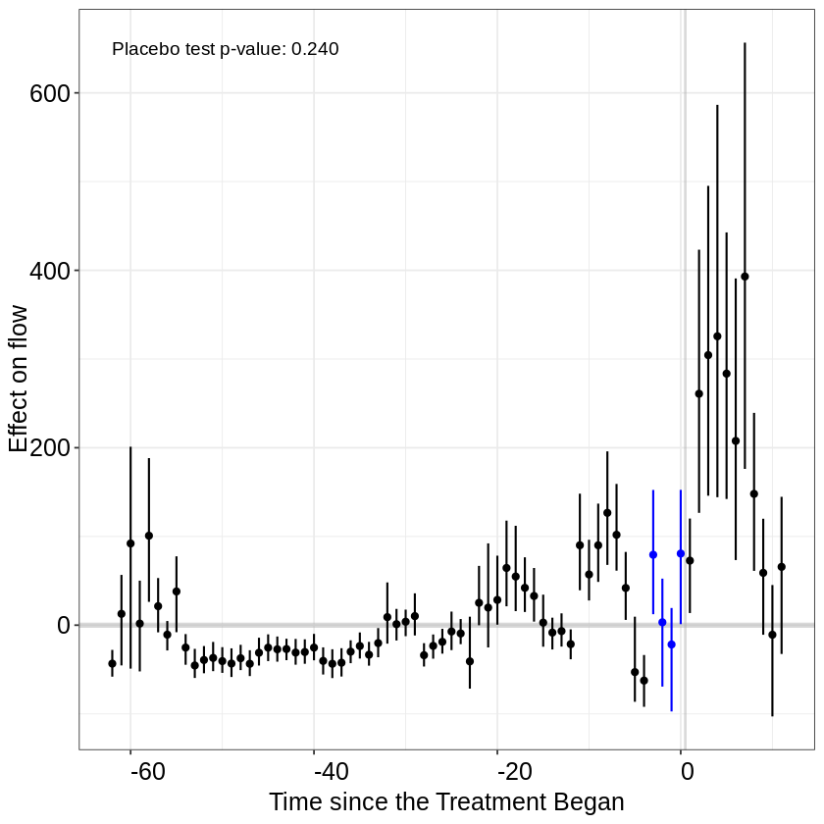
Figure S1: Placebo in time

Robustness checks

Time period: 2011.01.01 - 2017.02.01
Treatment threshold : median
Nationalities: Yes syrians

Table S3: Summary of Average Treatment Effects (ATT) on Migration Routes with Syrians

 | ATT | S.E. | CI.lower | CI.upper | p.value
Central Mediterranean Route | 164.677424 | 62.520584 | 42.1393314 | 287.215516 | 0.008439262
Eastern Borders Route | 1.855160 | 2.130734 | -2.3210008 | 6.031322 | 0.383935758
Eastern Mediterranean Route | -137.938432 | 87.864976 | -310.1506211 | 34.273757 | 0.116440480
Western African Route | 2.516083 | 2.068780 | -1.5386511 | 6.570817 | 0.223902714
Western Mediterranean Route | 7.060781 | 3.551359 | 0.1002453 | 14.021316 | 0.046790539

Time period: 2011.01.01 - 2018.02.01
Treatment threshold : median
Nationalities: Yes syrians

Table S4: Summary of Average Treatment Effects (ATT) on Migration Routes with Syrians

 | ATT | S.E. | CI.lower | CI.upper | p.value
Central Mediterranean Route | 111.9225683 | 39.697074 | 34.1177338 | 189.727403 | 0.004811111
Eastern Borders Route | 0.6859203 | 1.258373 | -1.7804450 | 3.152286 | 0.585694965
Eastern Mediterranean Route | -135.8014735 | 75.229657 | -283.2488923 | 11.645945 | 0.071049845
Western African Route | 1.4999232 | 1.171969 | -0.7970936 | 3.796940 | 0.200604238
Western Mediterranean Route | 12.0445408 | 5.016552 | 2.2122792 | 21.876802 | 0.016352126

Time period: 2011.01.01 - 2018.02.01
Treatment threshold : median
Nationalities: No syrians

Table S5: Summary of Average Treatment Effects (ATT) on Migration Routes

 | ATT | S.E. | CI.lower | CI.upper | p.value
Central Mediterranean Route | 125.8608372 | 36.592841 | 54.1401870 | 197.581487 | 0.0005828039
Eastern Borders Route | 0.9454155 | 1.309195 | -1.6205594 | 3.511390 | 0.4702114761
Eastern Mediterranean Route | -62.3830014 | 33.551346 | -128.1424317 | 3.376429 | 0.0629804752
Western African Route | 1.7118325 | 1.249488 | -0.7371187 | 4.160784 | 0.1706783785
Western Mediterranean Route | 12.4578619 | 4.625428 | 3.3921898 | 21.523534 | 0.0070739542

Time period: 2011.01.01 - 2017.02.01
Treatment threshold: TOP 20
Nationalities: Syrians

Table S6: Summary of Average Treatment Effects (ATT) on Migration Routes with Syrians

 | ATT | S.E. | CI.lower | CI.upper | p.value
Central Mediterranean Route | 193.974931 | 144.109527 | -88.47455 | 476.4244135 | 0.17829467
Eastern Borders Route | -9.184839 | 3.929336 | -16.88620 | -1.4834824 | 0.01941298
Eastern Mediterranean Route | -360.958967 | 203.163648 | -759.15240 | 37.2344670 | 0.07561914
Western African Route | -7.411715 | 4.039538 | -15.32906 | 0.5056338 | 0.06653640
Western Mediterranean Route | -1.732973 | 6.071217 | -13.63234 | 10.1663941 | 0.77530644

Time period: 2011.01.01 - 2017.02.01
Treatment threshold: Top 20 nationalities
Nationalities: No Syrians

Table S7: Summary of Average Treatment Effects (ATT) on Migration Routes

 | ATT | S.E. | CI.lower | CI.upper | p.value
Central Mediterranean Route | 245.531710 | 128.992021 | -7.288006 | 498.351427 | 0.05697998
Eastern Borders Route | -8.981083 | 3.103548 | -15.063925 | -2.898240 | 0.00380597
Eastern Mediterranean Route | -177.930319 | 99.423162 | -372.796136 | 16.935498 | 0.07351399
Western African Route | -7.227120 | 3.076971 | -13.257873 | -1.196367 | 0.01883517
Western Mediterranean Route | -1.220138 | 5.663615 | -12.320618 | 9.880343 | 0.82942863

Time period: 2011.01.01 - 2018.02.01
Treatment threshold: Top 20 nationalities
Nationalities: Syrians

Table S8: Summary of Average Treatment Effects (ATT) on Migration Routes with Syrians
 | ATT | S.E. | CI.lower | CI.upper | p.value
Central Mediterranean Route | 116.573401 | 96.673716 | -72.90360 | 306.050403 | 0.2278777228
Eastern Borders Route | -7.439211 | 2.163569 | -11.67973 | -3.198693 | 0.0005851683
Eastern Mediterranean Route | -378.570845 | 213.907202 | -797.82126 | 40.679567 | 0.0767621165
Western African Route | -5.824881 | 2.076017 | -9.89380 | -1.755963 | 0.0050192364
Western Mediterranean Route | 10.302522 | 10.543979 | -10.36330 | 30.968341 | 0.3285196477

Time period: 2011.01.01 - 2018.02.01
Treatment threshold: TOP20
Nationalities: No Syrians

Table S9: Summary of Average Treatment Effects (ATT) on Migration Routes

 | ATT | S.E. | CI.lower | CI.upper | p.value
Central Mediterranean Route | 161.697619 | 91.256346 | -17.161533 | 340.556771 | 0.0764102499
Eastern Borders Route | -7.247597 | 2.118440 | -11.399663 | -3.095532 | 0.0006234638
Eastern Mediterranean Route | -186.888536 | 100.236098 | -383.347677 | 9.570606 | 0.0622538574
Western African Route | -5.726677 | 2.010385 | -9.666959 | -1.786396 | 0.0043919218
Western Mediterranean Route | 11.466924 | 11.041958 | -10.174916 | 33.108763 | 0.2990436304

Generalized Synthetic Control Method

In our analysis, we employed two distinct methodologies to explore causal inference: Matrix Completion (MC) and the Generalized Synthetic Control Method (SC) proposed by Xu Y. (2017).
Matrix Completion has been widely utilized for imputation tasks and causal inference in various domains. We found that MC consistently provided coherent results across both unstandardized and standardized data. This method offered robust estimations and yielded insightful findings in our study.
Conversely, our application of the Generalized Synthetic Control Method (SC) initially yielded contrasting results. SC, known for its efficacy in causal inference, demonstrated sensitivity to high variation within our dataset. Specifically, the pronounced spike in flows observed in 2015 led SC to overestimate the average treatment effect, consequently generating misleading conclusions.
However, upon standardizing the data, SC converged to results aligning with those obtained through Matrix Completion. This convergence underscores the importance of data preprocessing techniques in mitigating methodological limitations, particularly in cases of high variability, and lead us to opt for the MC method as it was found to be more robust.

Reference:
Xu, Y. (2017). Generalized Synthetic Control Method: Causal Inference with Interactive Fixed Effects Models. Political Analysis, 25(1), 57-76. doi:10.1017/pan.2016.2

Synthetic control unstandardized
Average Treatment Effect on the Treated:
Estimate S.E. CI.lower CI.upper p.value
ATT.avg -59.01 40.61 -138.6 20.57 0.1461

Synthetic control standardized
Average Treatment Effect on the Treated:
Estimate S.E. CI.lower CI.upper p.value
ATT.avg 0.1051 0.1862 -0.2598 0.47 0.5723

Matrix completion standardized
Average Treatment Effect on the Treated:
Estimate S.E. CI.lower CI.upper p.value
ATT.avg 0.1043 0.009116 0.08639 0.1221 0

Matrix completion unstandardized
Average Treatment Effect on the Treated:
Estimate S.E. CI.lower CI.upper p.value
ATT.avg 6.553 0.3994 5.77 7.336 0

Figure S1: Treated nationalities crossing trends