Appendix A
The aquaculture suitability analysis was conducted in a GIS environment and consisted of four stages: (a) development of conceptual framework; (b) collection of secondary data; (c) development and resampling of layers, (d) estimation of overall aquaculture suitability.

First, we conducted a literature review to identify important dimensions and indicators of aquaculture suitability. Following the critical reading of the literature we identified three dimensions, namely water quality, soil quality and geographical characteristics^{45–47}. For these three dimensions, we selected ten indicators, namely: (a) phosphate content (in mg/l), (b) water hardness (in mg/l), (c) soil pH, (d) soil texture (in % clay content), (e) soil organic matter (in % of carbon content), (f) distance to water sources (in m), (g) distance to road (in m), (h) elevation (in m), (i) slope (in %), and (j) population density (in persons/km²). Based on information from the literature^{45–50}, for each of these indicators we identify ranges and cut-off points that indicate whether a location has no suitability, moderate suitability, or high suitability for aquaculture (Table A1). At the same time, we designated land use types such as built-up land and forest/conservation areas as constraints for aquaculture operations.

Second, we identified and collected secondary spatially-explicit datasets for all ten indicators for the entire country (Table A1). Values for the water quality-related indicators (i.e. phosphate concentration, water hardness) were from the Bangladesh National Drinking Water Quality Survey⁵¹. Values for the soil quality indicators (i.e. soil pH, soil texture, organic matter) were from the from Harmonized World Soil Database⁵². Values for the geographical characteristics indicators were from The Humanitarian Data Exchange^{53–55} (for distance to water and distance to road) and the WorldPop project⁵⁶ (for population density), and a global geological database⁵⁷(for elevation). To set the constraints we used data from a global study on land use⁵⁸.

Third, we created in a GIS environment (ArcGIS 10.3) we created individual layers for each of the ten indicators. As the underlying spatially-explicit datasets had different spatial resolutions (Table A1), we resampled all indicator maps into maps with 30×30 m resolution, georeferenced with the projection system for WGS 1984 Transverse Mercator. Then, as each indicator is measured in different units of measurements, in order to make them comparable we reclassified in each of these pixels the original indicator values in a range of 1-3; where a value of 1 indicates “no suitability”, a value of 2 indicates “moderate suitability”, and a value of 3 indicates “high suitability”.
Table A1. Indicators and suitability levels for aquaculture suitability analysis.
Suitability dimensions and indicators | Unit | Cut-off levels |  |  | Sources of cut-off levels | Data format | Data source
Suitability dimensions and indicators | Unit | High suitability | Moderate suitability | No suitability |  | Data format
Water quality
Phosphate content | mg/l | < 0.25 | 0.25-0.50 | > 0.50 | ⁴⁶ | polygon (shapefile) | Bangladesh National Drinking Water Quality Survey⁵¹
Water hardness | mg/l | 50-200 | 20-50 or  200-500 | < 20 or  > 500 | ⁴⁶ | polygon (shapefile) | Bangladesh National Drinking Water Quality Survey⁵¹
Soil quality
Soil pH |  | 6-8 | 4-6 or 8-9 | < 4 or > 9 | ⁴⁵ | 1000m ×1000m grid | Harmonized World Soil Database⁵²
Soil texture | % clay | > 35 | 18-35 | < 18 | ⁴⁶ | 1000m ×1000m grid | Harmonized World Soil Database⁵²
Soil organic matter | % of carbon | < 1 | 1-2 | > 2 | ⁴⁵ | 1000m ×1000m grid | Harmonized World Soil Database⁵²
Geographical
Distance to water source | m | < 500 | 500-1000 | > 1000 | ⁴⁸  ⁴⁶ | Polygon and line (shapefile) | Humanitarian Data Exchange⁵³
Distance to road | m | < 500 | 500-1000 | > 1000 | ⁴⁵  ⁴⁹ | line (shapefile) | Humanitarian Data Exchange⁵⁴
Elevation | m | < 150 | 150-1200 | > 2000 | ⁴⁷ | 1000m ×1000m grid | Domisch et al., 2015⁵⁷
Slope | % | < 5 | 5-15 | > 15 | ⁴⁷ | 1000m ×1000m grid | Domisch et al., 2015⁵⁷
Population density | Inhabitants per km² | 150-300 | 1-149 | 1< or >300 | ⁵⁰ | 100m ×100m grid | WorldPop project⁵⁶
Constraints
Land cover | Land class |  |  | Built-up land, forest | ^{46,49} | 30m × 30m grid | Global land cover in 2017⁵⁸
Note: Suitability levels for water quality, soil quality, and geographical characteristics were sourced from previous studies^{45–50}. Datasets for each indicator were obtained from multiple sources^{51–56}. Soil pH, soil texture and organic matter were collected at the topsoil (0-30 cm). Roads of Bangladesh include regional highways, upazilla roads and union roads.

Fourth, we developed a final layer through a weighted sum overlay technique. Here we overlapped the ten individual layers to create an overall suitability map (Figure A1a). We assigned equal weights for each indicator/layer, multiplying the reclassified values for each pixel by 0.1 (equal weight for each of the ten indicator). We then added the values of each pixel to create the output raster, rounding up or down to the closest whole number (Figure A1b). Built up and forest/conservation areas were automatically excluded from the analysis.

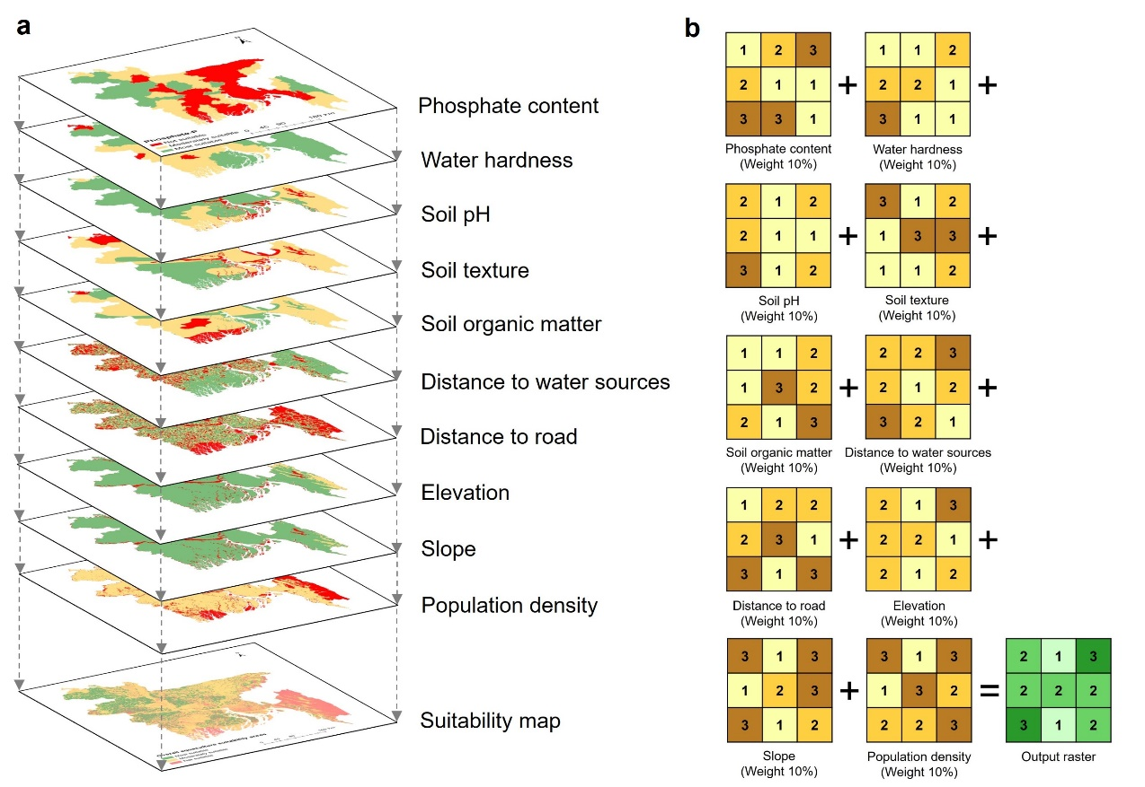
Figure A1: Schematic representation of the weighted sum overlay analysis. Panel (a) shows the ten individual indicator layers following the resampling, application of cut-off suitability levels for each indicator and the re-classification. Panel (b) shows an example of the weighted sum overlay analysis. The yellow/brown matrices indicate suitability values for different cells. The green matrix indicates the output raster after the weighed summations for each pixel. Averages were rounded up or down to the closest whole number. Average values of <1.4 were rounded down to “1=no suitability”, average values of 1.5 to 2.4 were rounded up or down to “2=moderate suitability”; average values of >2.5 were rounded up to “3=high suitability”.

