Supporting information for

Degradability and remineralization of peat-derived terrestrial dissolved organic carbon in the Sunda Shelf Sea

Yuan Chen^{1,*}, Moritz Müller², Alexander R. Cobb³, Rahayu Sukmaria Sukri⁴, Jens Zinke⁵, R. Nagarajan⁶, R. Sharveen⁶, Abdulmajid Muhammad Ali⁶, Patrick Martin^{1,*}
¹Asian School of the Environment, Nanyang Technological University, Singapore
²Faculty of Engineering, Computing and Science, Swinburne University of Technology Sarawak Campus, Kuching, Malaysia
³Center for Environmental Sensing and Modelling, Singapore-MIT Alliance for Research and Technology, Singapore
⁴Institute for Biodiversity and Environmental Research, Universiti Brunei Darussalam, Brunei Darussalam
⁵School of Geography, Geology and the Environment, Centre for Palaeobiology and Biosphere Evolution, University of Leicester, United Kingdom
⁶Department of Applied Sciences (Applied Geology), Faculty of Engineering and Science, Curtin University, Malaysia

*Corresponding author:
Yuan Chen (yuan006@e.ntu.edu.sg) and Patrick Martin (pmartin@ntu.edu.sg)

Contents of this file

Text S1
Figures S1 to S5
Table S1

Text S1. tDOC remineralization model
Our model for tDOC remineralization extends the 1-dimensional model of Zhou et al., 2023 for pure photo-mineralization by also taking pure biodegradation and photo-influenced biodegradation into consideration. We aim to reconstruct the cumulative tDOC remineralization from these three pathways over the course of residence time up to 2 years in the Sunda Shelf Sea and reveal their relative contribution.

S1.1 Model calculations
S1.1.1 Model simulation on photodegradation and biodegradation
The amount of DOC and CDOM removed from photodegradation between day T-1 and T (PDloss_{T-1}) was calculated by:
$\begin{aligned}{PDloss}_{T-1}=\int_{T-1}^{T}{r_{PD}\left(t\right)dt S }\#Eq. S1\end{aligned}$
where r_{PD}(t) is the areal rate of photomineralization of tDOC (mol C m⁻² s⁻¹) or volume-integrated absorption coefficients and S is the surface area of the simulated water column (i.e., 1 m²). The r_{PD}(t) was calculated from the mean AQY spectrum (φ_{DOC}(λ), mol C mol^{–1} photons nm^{–1} or φ_{CDOM}(λ), L m^{–1} m^{–2} s^{–1}) and the amount of photons absorbed by CDOM (Q_{abs}(λ,t), mol photons) in the water column:
$$\begin{aligned}r_{PD}=\int_{300nm}^{700nm}{ϕ\left(λ\right){ Q}_{abs}\left(λ,t\right) dλ}\#Eq.S2\end{aligned}$$

The calculations of r_{PD} are provided in detail in Zhou et al., 2023.
The amount of tDOC degraded and the concentration of CDOM decreased from pure microbial processes between day T-1 and T was calculated by:
$$\begin{aligned}{BDloss}_{T-1}=C_{T-1}-C_{T-1} e^{-k_{bio} \left(T-\left(T-1\right)\right)}\#Eq. S3\end{aligned}$$
where C_{T-1} is the amount of tDOC (mol) or the wavelength-specific absorption coefficient on day T-1 (m^{–1}) and k_{bio} is the mean decay constants for biodegradation of tDOC or CDOM (250–700 nm) derived from laboratory incubations.
Then, the amount of tDOC or the concentration of CDOM on day T is estimated from:
$$\begin{aligned}C_{T}=C_{T-1}-{PDloss}_{T-1}-{BDloss}_{T-1}\#Eq.S4\end{aligned}$$

Because we attempt to reconstruct the tDOC remineralization over the residence time up to 2 years, the total tDOC remineralization from PD (REM_{photo}), BD (REM_{bio}) and both of the processes was obtained by summing up the corresponding daily tDOC removal from day 0 to day 730:
$$\begin{aligned}{REM}_{photo}=\int_{0d}^{730d}{PDloss\left(t\right)}dt\#Eq.S5\end{aligned}$$
$$\begin{aligned}{REM}_{bio}=\int_{0d}^{730d}{BDloss\left(t\right)}dt\#Eq.S6\end{aligned}$$
S1.1.2 Model simulation of photodegradation and photo-influenced biodegradation
The amount of DOC and CDOM removed from photodegradation between day T-1 and T (PDloss_{T-1}) was calculated as described above.
The amount of tDOC degraded and the concentration of CDOM decreased from photo-influenced biodegradation between day T-1 and T was calculated by:
$$\begin{aligned}{PIBloss}_{T-1}=C_{T-1}-C_{T-1} e^{-k_{PIB} \left(T-\left(T-1\right)\right)}\#Eq. S7\end{aligned}$$
where C_{T-1} is the amount of tDOC (mol) or the wavelength-specific absorption coefficient on day T-1 (m^{–1}), k_{PIB-tDOC} on day T was calculated from its linear relationship with DOC-normalized photon absorption between 300–440 nm (AP_{300–440}/DOC₀, mol photons μmol^{–1} C) from day T-1 as shown in Fig. 6 in the main manuscript:
$$\begin{aligned}k_{PIB_{DOC}}(T)=0.47 {AP}_{300-440}(T-1)/{tDOC}_{0}+0.00044\#Eq. S8\end{aligned}$$
The photons absorbed during day T-1 was calculated following the details of absorbed photon dose during photodegradation but applying the wavelength range of 300–440 nm (Zhou et al., 2023). tDOC₀ is the initial amount of tDOC estimated from the two-endmember mixing model as model input (see S1.2).
Then, the tDOC removed from photo-influenced biodegradation can be expressed as:
$$\begin{aligned}{REM}_{P+B}=\int_{0d}^{730d}{PIBloss\left(t\right)}dt\#Eq.S9\end{aligned}$$
Because the photo-influenced biodegradation also contains the degradation from pure micrbial processes, the net enhanced effect of prior irradiation (REM_{netP+B}) was calculated by:
$$\begin{aligned}{REM}_{netP+B}={REM}_{P+B}-{REM}_{bio}\#Eq. S10\end{aligned}$$
However, as there was no photo-enhanced effect for CDOM biodegradation, k_{PIB-CDOM} was thus entirely attributed to pure microbial processes, i.e., equal to k_{bio-CDOM}.
S1.2 Model input
The hourly above-water solar irradiance for each month from Jan 2019 to Dec 2021 was obtained from the Tropospheric Ultraviolet and Visible Radiation Model (TUV model, National Center for Atmospheric Research, US), and then was converted to the irradiance right below the water surface following Fichot and Miller, 2010. The mean water depth in the Southern Malacca Strait is 19.7 m based on GEBCO bathymetry (Gebco Bathymetric Compilation Group, 2020). The initial values (i.e., the tDOC concentration and CDOM absorption on day 0) were calculated using the same two-endmember mixing model as Zhou et al., 2023 with riverine endmember values from Wit et al., 2018 (tDOC concentration = 890 μM, a₃₅₀ = 5.6 m^{–1}), which simulating the salinity of 29 when river water mixed with marine water (salinity 33). The light attenuation coefficient in the water column was calculated following Zhou et al., 2023 based on CDOM and water absorption, and in-situ measurements of particulate absorption and backscattering by Martin et al., 2021.

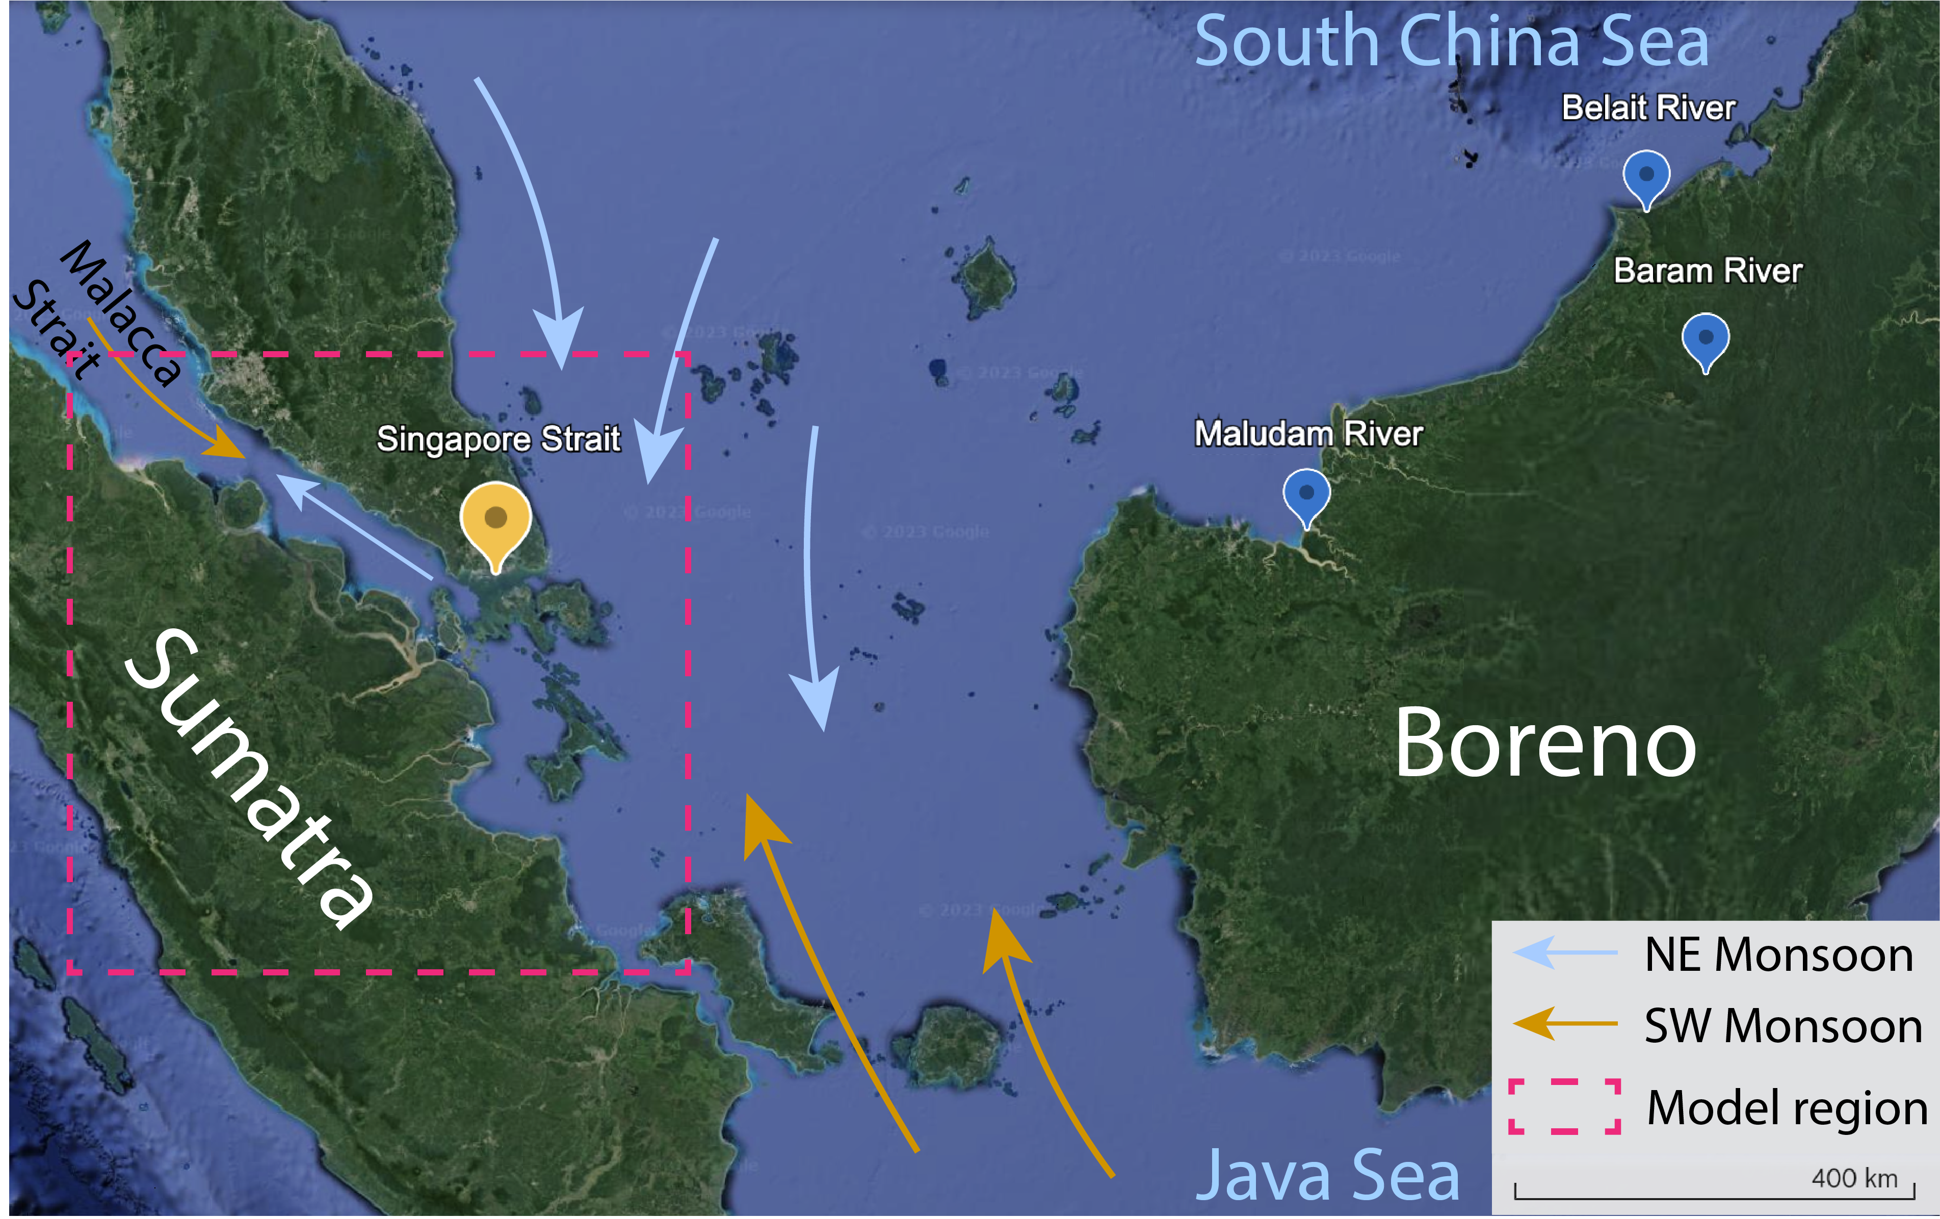
Figure S1. Regional map and the sampling locations.

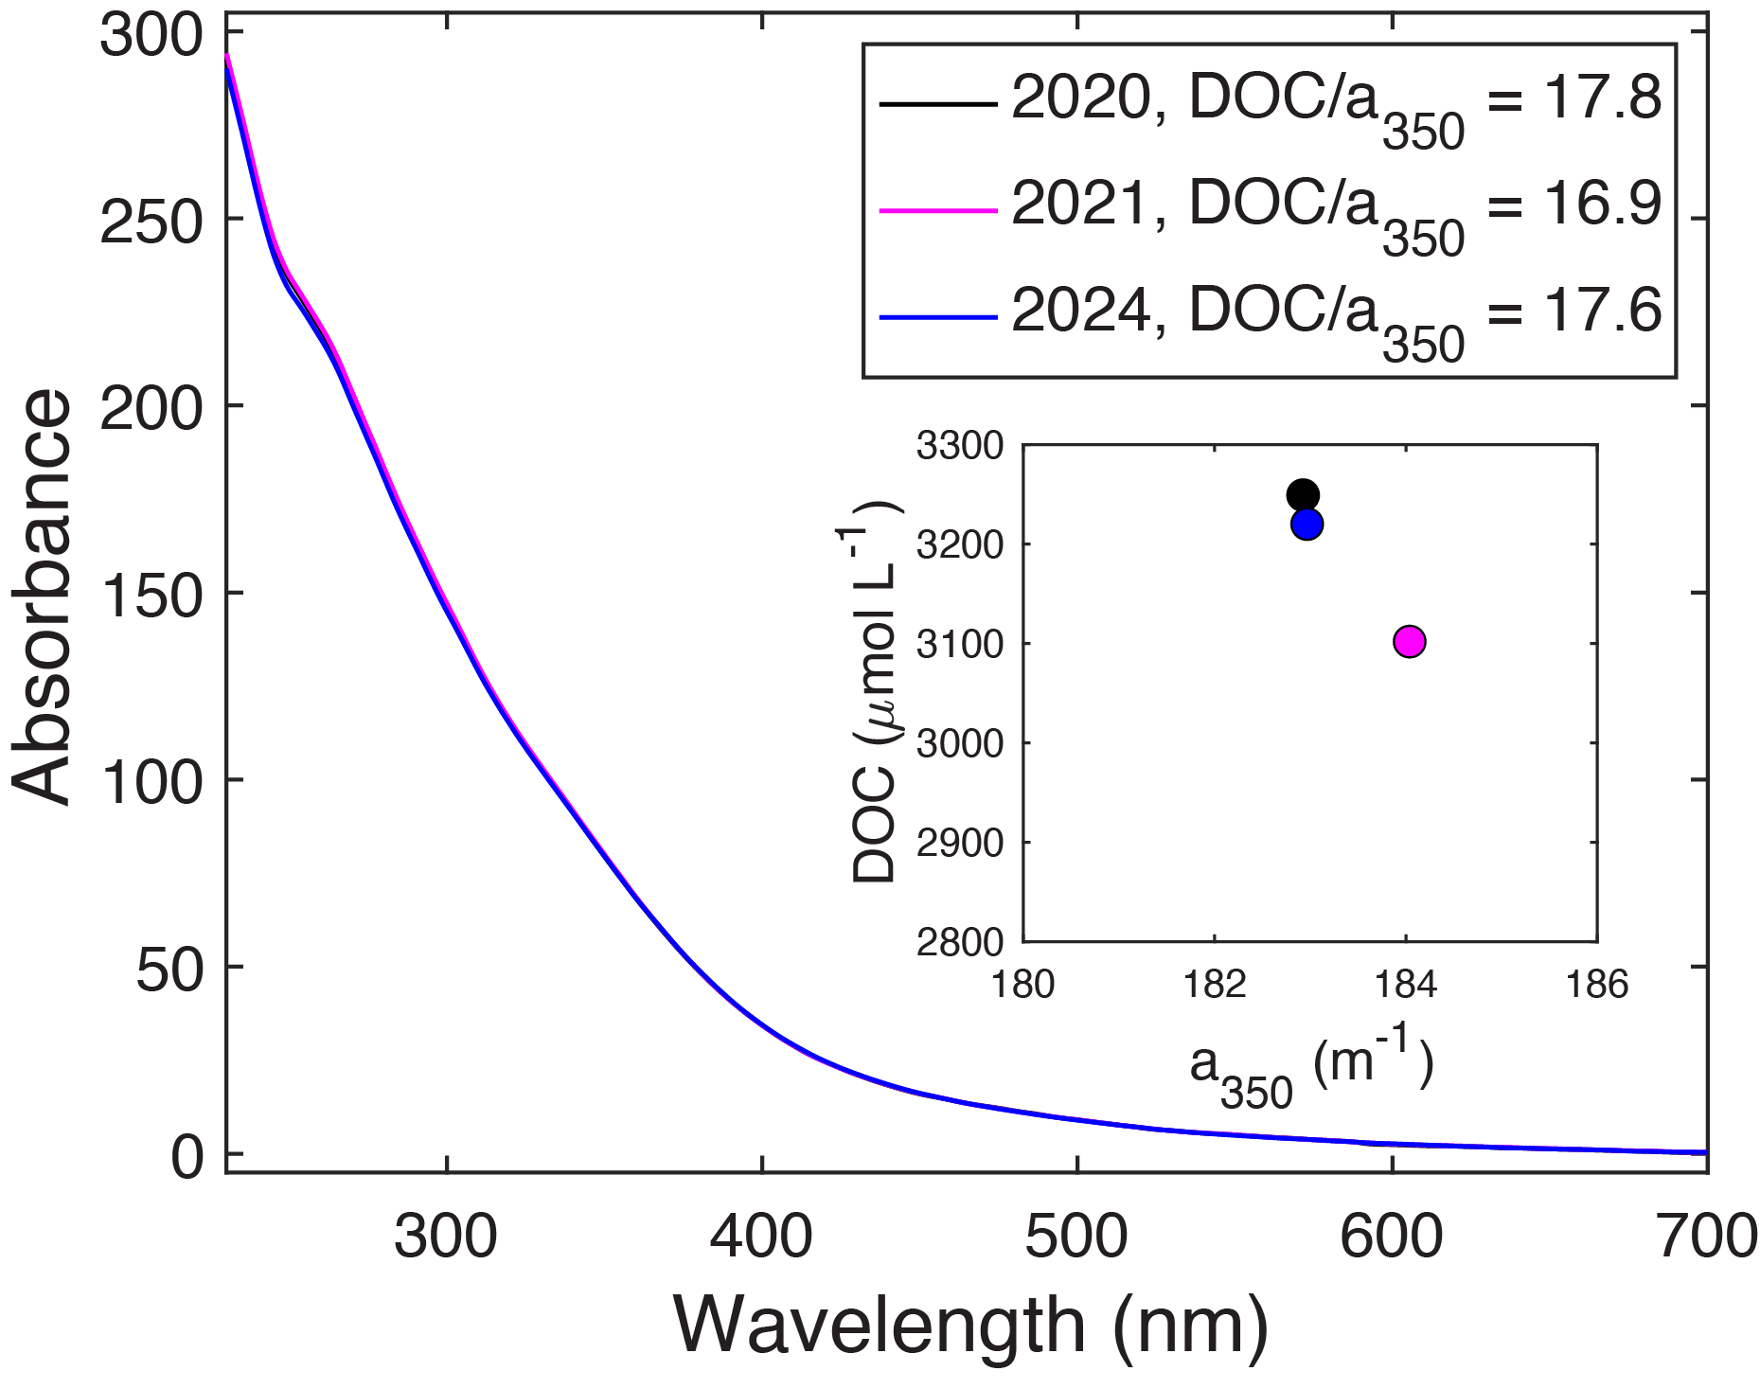
Figure S2. Comparison of the DOC and CDOM for Maludam water freshly collected and stored in cold and dark environment for 3 years.

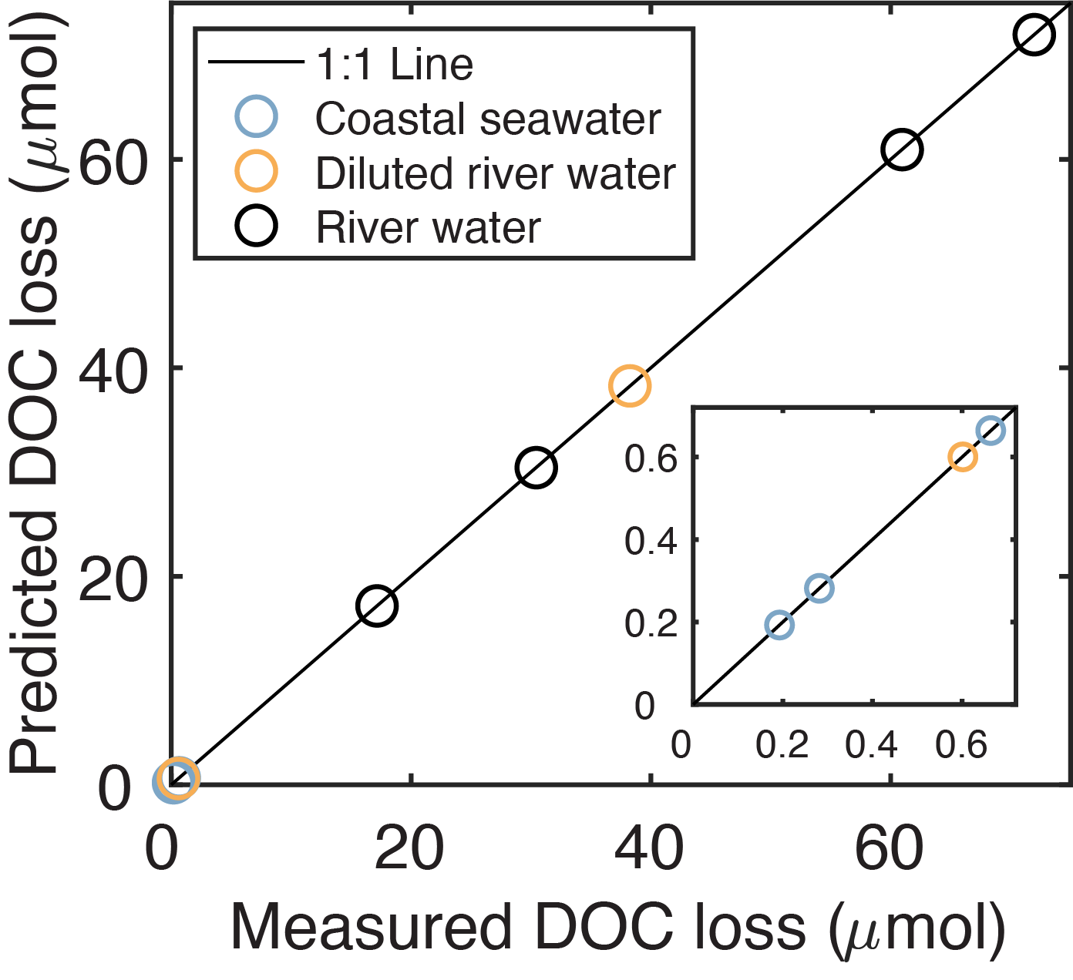
Figure S3. Comparison of measured DOC loss to the predicted values from the optimization process of parameters for spectrally resolved AQY. The high consistency validated the optimized AQY spectra obtained from timeseries photodegradation.

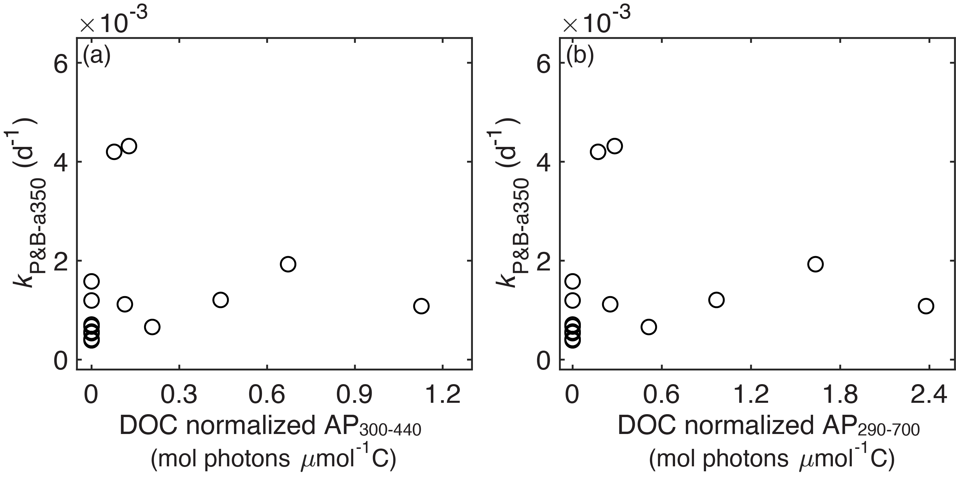
Figure S4. The comparison between decay constants for terrestrial a₃₅₀ during photo-influenced biodegradation (k_{P&B-a350}) and the prior photons absorbed after DOC normalization. There was no specific trend of k_{P&B-a350} along with the amount of photons absorbed in advance.
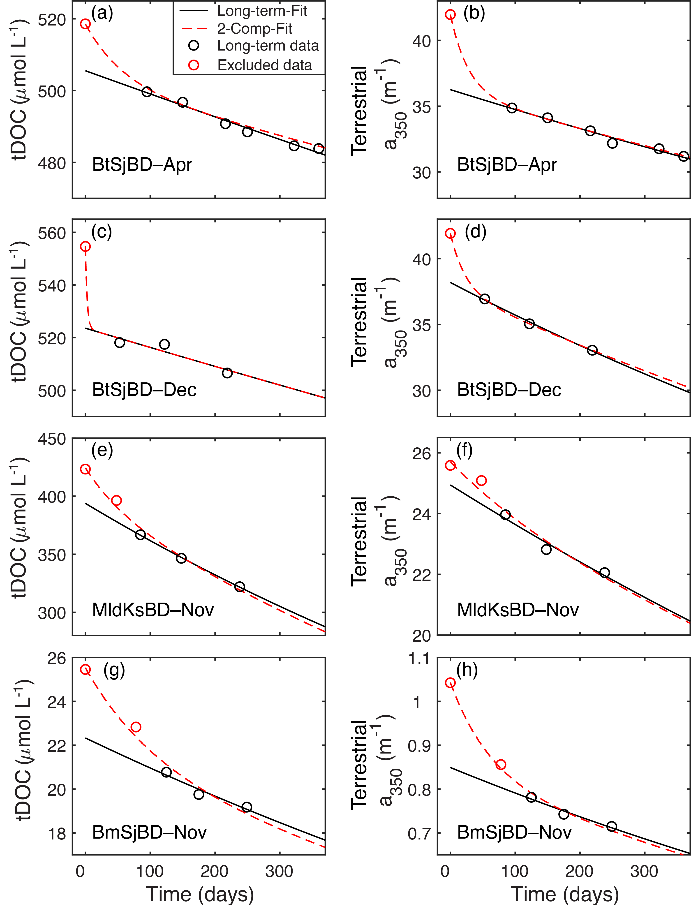
Figure S5. Comparison between obtaining biodegradation decay rates (k_{bio}) for tDOC and terrestrial a₃₅₀ from 1-component exponential fit using only long-term experimental data (from 50–100 days onwards) and from 2-component exponential fit using the entire experimental data. The concentration of tDOC and terrestrial CDOM was calculated by subtracting the pure seawater control data from the biodegradation with river-seawater mixture (see Methods). The statistical information of 2-comp fit are provided in Table S1 and shows that the proportion of the initial fast lost fraction is fairly small.

Table S1. Statistical information about 2-component fit of the entire timeseries data for tDOC biodegradation, following formula c_{t} = f₁ e^{-k1 t} + f₂ e^{-k2 t}, where t is the time and c_{t} is the concentration of tDOC or terrestrial a₃₅₀ at time t. The proportion of the rather labile component (f₁) is small.
Experiment code |  | BtSjBD–Apr | BtSjBD–Dec | MldKsBD–Nov | BmSjBD–Nov
tDOC | f₁ | 16.32 | 31.06 | 33.96 | 4.00
 | k₁ | 0.0172 | 0.3991 | 0.0157 | 0.0100
 | f₂ | 502.24 | 523.58 | 390.45 | 21.53
 | k₂ | 0.0001 | 0.0001 | 0.0008 | 0.0006
 | r², RMSE | 0.99, 1.07 | 0.99, NA | 0.98, 5.79 | 0.96, 0.51
 | Proportion | 3.15% | 5.60% | 8.00% | 15.68%
a₃₅₀ | f₁ | 5.89 | 0.98 | 4.24 | 0.21
 | k₁ | 0.0360 | 0.0091 | 0.0431 | 0.0167
 | f₂ | 36.07 | 24.73 | 37.68 | 0.84
 | k₂ | 0.0004 | 0.0005 | 0.0006 | 0.0007
 | r², RMSE | 0.99, 0.26 | 0.94, 0.36 | 0.99, NA | 0.99, 0.01
 | Proportion | 14.03% | 3.80% | 10.10% | 14.03%

References
Fichot, C. G., & Miller, W. L. (2010). An approach to quantify depth-resolved marine photochemical fluxes using remote sensing: Application to carbon monoxide (co) photoproduction. Remote Sensing of Environment, 114(7), 1363-1377. https://doi.org/https://doi.org/10.1016/j.rse.2010.01.019
Gebco Bathymetric Compilation Group. (2020). The gebco_2020 grid - a continuous terrain model of the global oceans and land British Oceanographic Data Centre, National Oceanography Centre, NERC, UK. https://doi.org/doi:10.5285/a29c5465-b138-234d-e053-6c86abc040b9
Martin, P., Sanwlani, N., Lee, T. W. Q., et al. (2021). Dissolved organic matter from tropical peatlands reduces shelf sea light availability in the singapore strait, southeast asia. Marine Ecology Progress Series, 672, 89-109. https://www.int-res.com/abstracts/meps/v672/p89-109/
Wit, F., Rixen, T., Baum, A., et al. (2018). The invisible carbon footprint as a hidden impact of peatland degradation inducing marine carbonate dissolution in sumatra, indonesia. Scientific Reports, 8(1), 17403. https://doi.org/10.1038/s41598-018-35769-7
Zhou, Y., Müller, M., Cherukuru, N., et al. (2023). Quantifying photodegradation of peatland-derived dissolved organic carbon in the coastal ocean of southeast asia. Journal of Geophysical Research: Oceans, 128(12), e2023JC019741. https://doi.org/https://doi.org/10.1029/2023JC019741

