Supplementary Information

A physics-informed cluster graph neural network enables generalizable and interpretable prediction for material discovery
Hao Cheng^{1, †}, Tong Yang^{1, †}, Minggang Zeng², Hao Wu¹, Zhengzhong Wang³, Haokai Hong³, Cheng Chen⁴, Bing Li⁵, Zhongrui Wang⁶, Shu Ping Lau¹, Wanyu Lin^{3, *}, Kay Chen Tan^{3, *}, and Ming Yang^{1, 7, 8, *}
¹ Department of Applied Physics, The Hong Kong Polytechnic University, Kowloon, Hong Kong SAR, China
² Institute of High-Performance Computing, A∗STAR, 1 Fusionopolis Way, Singapore 138632, Singapore
³ Department of Data Science and Artificial Intelligence, The Hong Kong Polytechnic University, Kowloon, Hong Kong SAR, China
⁴ Department of Computing, The Hong Kong Polytechnic University, Kowloon, Hong Kong SAR, China
⁵ School of Chemistry and Chemical Engineering, Harbin Institute of Technology, Harbin 150011, China.
⁶ School of Microelectronics, Southern University of Science and Technology, Shenzhen 518055, China
⁷ Research Centre on Data Sciences & Artificial Intelligence, The Hong Kong Polytechnic University, Kowloon, Hong Kong SAR, China
⁸ Research Centre for Nanoscience and Nanotechnology, The Hong Kong Polytechnic University, Kowloon, Hong Kong SAR, China
† These authors contributed equally to this work.
*Correspondence and requests for materials should be addressed to Ming Yang (kevin.m.yang@polyu.edu.hk), Wanyu Lin (wan-yu.lin@polyu.edu.hk), or Kan Chen Tan (kaychen.tan@polyu.edu.hk).

1. The architecture of CG-NET
Supplementary Figure 1. Schematic of the CG-NET model architecture.

The architecture of CG-NET, as shown in Supplementary Fig. 1, starts from building a cluster graph characterized by a cluster center, denoted as $G=\{V,E,C_{cluster},u\}$. Herein, $v_{i}∈V$ is the node representing atom $i$; $e_{ij}∈E$ is the edge that encapsulates the interactions between atoms $i$ and $j$; and $u$ is the local structural property of the system that is predominantly influenced by short-range interactions induced by the local structure of materials. A key difference from the preceding materials graph frameworks lies in the incorporation of $C_{cluster}$, which defines the center of the cluster graph. Subsequently, the material graph is passed to the cluster graph computation module. This module calculates the cluster graph with the cluster center designated as $C_{cluster}$ and the cluster size determined by the cluster radius $R_{cluster}$. The original material graph undergoes partitioning, delineating nodes and edges $V_{cluster}$, $E_{cluster}$ within the cluster graph, accompanied by the introduction of pseudo nodes $V_{pseudo}^{'}$ that exclusively serve as a neighboring list to the nodes within the cluster graph. A graph featurizer is then employed to embed the pair atom distance $r_{ij}$, up to a cutoff of $R_{neighbor}$, into edge features while integrating element-specific atomic attributes into node features. The standard graph convolution scheme iteratively updates the node and edge features. In the readout phase, node features within the cluster graph are aggregated to obtain the local structural properties. To ensure equitable evaluation against the established CGCNN model, our CG-NET adopts the identical graph featurizer, graph convolution, and readout phase modules as in CGCNN.
2. The high-entropy alloys dataset
To generate the high-entropy alloy (HEA) dataset, a series of density functional theory (DFT) calculations were carried out using the open-source GPAW package^{1,2}, which is based on the projector-augmented-wave (PAW) method. For geometry visualization and analysis, the atomic simulation environment (ASE) package³ was employed. The revised Perdew–Burke–Ernzerhof (RPBE) functional⁴ was used to calculate the exchange and correlation energies. All calculations were performed with a plane-wave basis set and an energy cutoff of 500 eV. The Fermi-level smearing width was set to 0.1 eV. The HEAs model consisted of a face-centered cubic lattice with 36 atoms, using average compositions of AgAuAlCuPt, AgAuCuPdPt, and CoCuGaNiZn. Initially, the lattice parameters of each element in HEAs were calculated using a primitive fcc unit cell and a Monkhorst-Pack k-point sampling of at least 12×12×12, as detailed in Supplementary Table 1. Based on Vegard’s law⁵, a lattice parameter of 3.7 Å, 4.0 Å, and 3.8 Å was subsequently adopted for each unit cell of AgAuAlCuPt, AgAuCuPdPt, and CoCuGaNiZn HEAs throughout the study. The atomic positions and lattice parameters were optimized until the force components were reduced to less than 0.05 eV/Å.
To explore the electrocatalytic properties of the surface, a four-layer HEAs slab with dimensions of 3×4 on the fcc (111) surface was generated. The bottom two layers were constrained to bulk positions, while the top two layers were allowed to relax. Monkhorst-Pack 4×4×1 k-point grids were used to sample the Brillouin zone. To prevent spurious interactions between periodic images, a vacuum of 10 Å was added on both sides of the slab, and a dipole correction were employed. The energies of gas-phase reference molecules, including $\text{C}{\text{O}}_{\text{2}}$ and ${\text{H}}_{\text{2}}$, were calculated in identical supercells with the same DFT parameters as the slabs. The adsorption binding energies of $\text{CO}$, $\text{COOH}$, $\text{CHO}$, $\text{COH}$, and $\text{H}$ were calculated as follows:
$$\begin{matrix} & E_{b}\left(CO\right)=E\left(*CO\right)+ΔE_{sol}\left(CO\right)-E\left(*\right)-E\left({CO}_{\left(g\right)}\right) \\ & E_{b}\left(COOH\right)=E\left(*COOH\right)+ΔE_{sol}\left(COOH\right)-E\left(*\right)-E\left({CO_{2}}_{\left(g\right)}\right)-1/2E\left({H_{2}}_{\left(g\right)}\right) \\ & E_{b}\left(CHO\right)=E\left(*CHO\right)+ΔE_{sol}\left(CHO\right)-E\left(*\right)-E\left({CO}_{\left(g\right)}\right)-1/2E\left({H_{2}}_{\left(g\right)}\right) \\ & E_{b}\left(COH\right)=E\left(*COH\right)+ΔE_{sol}\left(COH\right)-E\left(*\right)-E\left({CO}_{\left(g\right)}\right)-1/2E\left({H_{2}}_{\left(g\right)}\right) \\ & E_{b}\left(H\right)=E\left(*H\right)-E\left(*\right)-1/2E\left({H_{2}}_{\left(g\right)}\right)\end{matrix}$$
where $ΔE_{sol}$ indicates a solvation correction to the calculated adsorbate energy, with $ΔE_{sol}\left(COOH\right)=ΔE_{sol}\left(COH\right)=-0.25 eV$ and $ΔE_{sol}\left(CO\right)=ΔE_{sol}\left(CHO\right)=-0.1 eV$. ^{6,7} The linear scaling relationships for the CO₂RR and HER intermediates on the fcc (111) surface of pristine metals are shown in Supplementary Fig. 3.
There are numerous potential local environments for on-top and fcc hollow sites on the surface of HEAs. The nearest neighbors of an on-top site, for instance, consist of six atoms on the surface and three subsurface atoms (as shown in Supplementary Fig. 9a, left), leading to an immense total of ${\text{5}}^{\text{10}}\text{=9,765,625}$ different local environments. However, many of these sites are symmetrically equivalent. Similarly, the fcc hollow site (as shown in Supplementary Fig. 9a, right) comprises three metal atoms, whose nearest neighbors could be classified into different zones based on their coordination to the adsorption site, resulting in an even larger number of potential configurations. The sheer number of these structures is too vast for comprehensive DFT computations. Nonetheless, a smaller subset of DFT calculations can still yield statistically significant results. By applying these calculated energies to the machine learning model, we can theoretically predict the adsorption energies of all possible local environments. In this study, we primarily focus on the catalytic properties of AgAuAlCuPt HEAs. We also include AgAuCuPdPt and CoCuGaNiZn HEAs, which have previously been investigated as promising CO₂RR electrocatalysts in earlier studies.^{8,9} To this end, all HEA slabs in the dataset are generated at random. For each HEA system, a total of 500 adsorption energies are calculated for the *CO, *COOH, and *COH species on on-top sites. A total of 1000 adsorption energies for the $\text{*COH}$ and $\text{*H}$ species on fcc hollow sites are calculated, given the greater number of possible nearest neighbor sites. All initial and final structures from the relaxed trajectories, along with their corresponding adsorption energies from these calculations, are included in the generation of HEA datasets, resulting in 16,033 samples.
3. Model training
We employ three distinct datasets to evaluate the performance of the CG-NET: the high-entropy alloy (HEA), two-dimensional impurity (2D-impurity) datasets, the Open Catalyst 2020 (OC20) dataset, and the open DAC 2023 (ODAC23) dataset. The HEA dataset is constructed in-house, as detailed in the previous section. For the OC20 dataset, we utilize the 200K split dataset of the S2EF task, consisting of 200,000 samples with both atomic configurations and corresponding adsorption energies. We filter the OC20 dataset to exclude any potential anomalies such as dissociation, desorption of adsorbate, or surface reconstruction. Additionally, we impose a restriction on the adsorption energy, limiting it to values between -10 eV and 10 eV to exclude unreasonable results and prevent significant deviations within the dataset. As a result, the modified OC20 dataset consists of 130,758 samples. For the 2D-impurity dataset, we also restrict the formation energies of impurities to values between -10 eV and 10 eV, yielding 9,962 samples. The ODAC23 dataset initially contains 162,220 structures. Due to the large crystal structures involved in each sample and the need to avoid excessive training time, we randomly select 20,000 datapoints from the original dataset for training. We confirmed that this sample size is sufficient to achieve reliable results by training the model with similar subsets of 10,000, 30,000, and 40,000 samples, as illustrated in Supplementary Fig. 4. Initially, these Four datasets are subjected to a random partition, with allocation into a training set (60%), validation set (20%) and test set (20%). Next, we proceed with the training and supervision of the CG-NET model, as illustrated in Supplementary Fig. 1, utilizing the training and validation datasets. The training process involves minimizing the mean squared error (MSE) as the loss function with the stochastic gradient descent (SGD) optimizer¹⁰. The mean absolute error (MAE) serves as the evaluation metric for assessing the prediction performance of the model. The hyperparameters of CG-NET are listed in Supplementary Table 2. Unlike the weights, which are trained using an optimizer, these hyperparameters are non-trainable variables that affect the prediction performance of the model. These hyperparameters include graph variables for cluster graph generation, architecture variables for defining the convolutional neural network on top of the cluster graph, and training-related variables for the training process. An extensive hyperparameter optimization study is conducted that considers the graph, architecture, and training-related variables. The hyperparameters that yield the lowest MAEs in the validation set are selected as the optimum hyperparameters. Following the training process, we calculate the MAE of CG-NET for predicting the adsorption energies of molecules and the formation energies of impurities within the test dataset. The results are then compared with those of the conventional CGCNN model, as shown in Fig. 3.
4. Computational Cost of CG-NET
We estimate the computational cost of CGCNN and CG-NET in terms of the floating-point operations (FLOPs) required to generate embeddings for a single convolution layer across the HEA, 2D-impurity, OC20, and ODAC23 datasets. For each graph $G(V,E)$, the number of nodes and edges are $\left|V\right|$ and $\left|E\right|$, respectively. Each node and edges have feature embedding vectors $v_{i}^{t}∈R^{d_{v}×1}$ and $e_{i,j}∈R^{d_{e}×1}$, which are concatenated into an input vector $z_{i,j}^{t}=v_{i}^{t}⨁v_{j}^{t}⨁e_{i,j}^{t}$ for the $t$-th layer of the convolution function. In the CGCNN and CG-NET, the convolution layer uniformly averages the features of the neighbors and their corresponding edges to update the embeddings of the target node. Formally, the updated embedding for node $i$ at layer $t$ is defined as
$$v_{i}^{t+1}=v_{i}^{t}+\frac{1}{\deg_{i}}\sum_{j∈N_{i}}{{σ(z}_{i,j}^{t}W_{f}^{t}+b_{f}^{t})}⨀g(z_{i,j}^{t}W_{s}^{t}+b_{s}^{t})$$
where $W_{f}^{t}$ and $W_{s}^{t}$ are learnable weight matrices, $b_{f}^{t}$ and $b_{s}^{t}$ are the biases of the $t$-th layer. The functions $σ$ and $g$ represent the activation functions. $N_{i}$ denotes the neighbors of node $i$ and $\deg_{i}$ is the degree of node $i$. This operation results in $8d_{v}^{2}\deg_{i}+4d_{v}d_{e}{\deg_{i}{+4d_{v}\deg_{i}+d}}_{v}$ FLOPs per node for a single convolution layer. Aggregating the FLOPs over all nodes yields the total FLOPs for the entire graph as
$$FLOPs =16d_{v}^{2}\left|E\right|+8d_{v}d_{e}\left|E\right|+8d_{v}\left|E\right|+d_{v}|V|$$
For the CG-NET, $\left|V\right|$ and $\left|E\right|$ are largely reduced with the cluster graph representation, which makes FLOPs required by the entire graph datasets largely reduced. Additionally, pseudo node in the cluster graph only serves as neighboring coordinates but are not integrated into the convolution operation. Consequently, they do not increase the FLOPs for each convolution layer. In the FLOPs equation above, $\left|V\right|$ and $\left|E\right|$ for the original graph are replaced by |$\left|V_{cluster}\right|$ and $\left|E_{cluster}\right|$, representing the reduced number of cluster nodes and edges in the cluster graph, resulting in significantly lower computational costs.
The statistical comparison of graph datasets generated using crystal graph and cluster graph representations is presented in Table 1. Note that, for demonstration purposes, the ODAC23 dataset was filtered to a relatively small sample size. However, when using the complete dataset, the estimated FLOPs of a single convolution layer for the ODAC23 dataset (162,219 structures, including 32,824,409 atoms) with the crystal graph representation are 71.31 TFLOPs (32,824,409 nodes, 393,892,892 edges), which decrease to 8.71 TFLOPs (2,919,942 nodes, 48,102,152 edges) with the cluster graph representation. This demonstrates the significant efficiency improvements achieved by CG-NET.
5. The pseudo neighboring nodes in the CG-NET
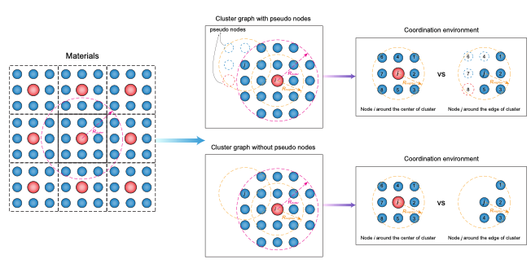
Supplementary Figure 2. Illustration of the CG-NET models with and without pseudo neighboring nodes.

To highlight the significance of pseudo neighboring nodes in the CG-NET, we construct a version of CG-NET without pseudo neighboring nodes and compare the cluster graph with and without pseudo neighboring nodes, as illustrated in Supplementary Fig. 2. The prediction performance of these models across different datasets are shown in Figs. 2(d–f). In the absence of pseudo neighboring nodes, the coordination descriptions of nodes within the cluster graph become inconsistent. Nodes located at the edge of the cluster experience a different coordination environment than those near the center. This discontinuity of the coordination environment leads to misinterpretations by the GNNs. The pseudo neighboring nodes are embedded with feature vectors based on their element species. However, the feature vectors are not updated iteratively through graph convolution, as they only propagate information to the nodes within the cluster graph and not in the reverse direction. It is important to note that the utilization of fixed embedding feature vectors for pseudo neighboring nodes may reduce the efficacy of the cluster graph, with the degree of this reduction depending on the quality of the initial embedding feature vectors. Nevertheless, since pseudo neighboring nodes merely serve as coordinates for nodes within the cluster graph and are not included in the final readout phase, their overall impact on the model is somewhat mitigated. In the main text, we have explored potential solutions to these issues, including the influence of higher-order pseudo nodes, as discussed in Fig. 4.
6. Convergence of the hyperparameters $N_{node}$ and $N_{neighbor}$
Supplementary Fig. 9a illustrates the on-top and fcc hollow binding sites of the HEA surface for $\text{*CO}$ and $\text{*H}$ adsorption, respectively. Notably, the local atomic environment surrounding these two binding sites varies, which can be assessed by evaluating their nearest-neighbor coordination. The neighboring atoms around the binding site can be categorized into different regions based on their relative positions. For example, at ${\text{R}}_{\text{cluster}}\text{ = 5Å}$, the on-top site for $\text{*CO}$ adsorption has 12 neighboring metal atoms, while the fcc hollow site for $\text{*H}$ adsorption has 14 neighboring metal atoms. The construction of the cluster graph thoughtfully considers the number of nodes $N_{node}$ within the cluster, a factor that directly influences the prediction capability of GNNs. This enables us to identify the difference in the local atomic environment of materials. In Supplementary Figs. 9b and 8c, the variation in the validation MAE is depicted as a function of $N_{node}$ and $N_{neighbor}$ for the predicted $\text{*CO}$ and $\text{*H}$ adsorption energies on the HEA surface, respectively. The validation MAE decreases as $N_{node}$ increases, eventually converging when $N_{node}$ surpasses 21 and 19 for $\text{*CO}$ and $\text{*H}$ adsorption, respectively, which correspond to average $R_{cluster}$ values of around 5.5 Å and 4.7 Å for the on-top and fcc hollow sites, respectively. This indicates that atoms within this cluster radius predominantly contribute to the short-range interaction with the binding site and thus determine the prediction performance of the cluster graph. The slope of the validation MAE with respect to $N_{node}$ shows an obvious variation for $\text{*CO}$ and $\text{*H}$ adsorption, signifying the capacity of the cluster graph to identify the local structure of materials. With a small value of $N_{node}$, $\text{*H}$ adsorption on the fcc hollow site yields a smaller validation MAE than $\text{*CO}$ adsorption on the on-top site. This is because the fcc hollow site, given the same cluster radius, accommodates more nodes within the cluster than the on-top site does. As $N_{node}$ increases, the validation MAE for on-top site adsorption decreases more rapidly than that for fcc hollow site adsorption, eventually converging to comparable values. On the other hand, $N_{neighbor}$ exhibits a similar fluctuation in the validation MAE for both on-top and fcc hollow site adsorption, eventually achieving convergence at $N_{neighbor}$=12 for the HEA dataset.
Supplementary Figure 3. Linear scaling relationships for the CO₂RR and HER intermediates on the fcc (111) surface of pristine metals.
Supplementary Figure 4. The (a) training and (b) validation MAEs as a function of the number of epochs for 10,000, 20,000, 30,000, and 40,000 samples randomly selected from the ODAC23 dataset.

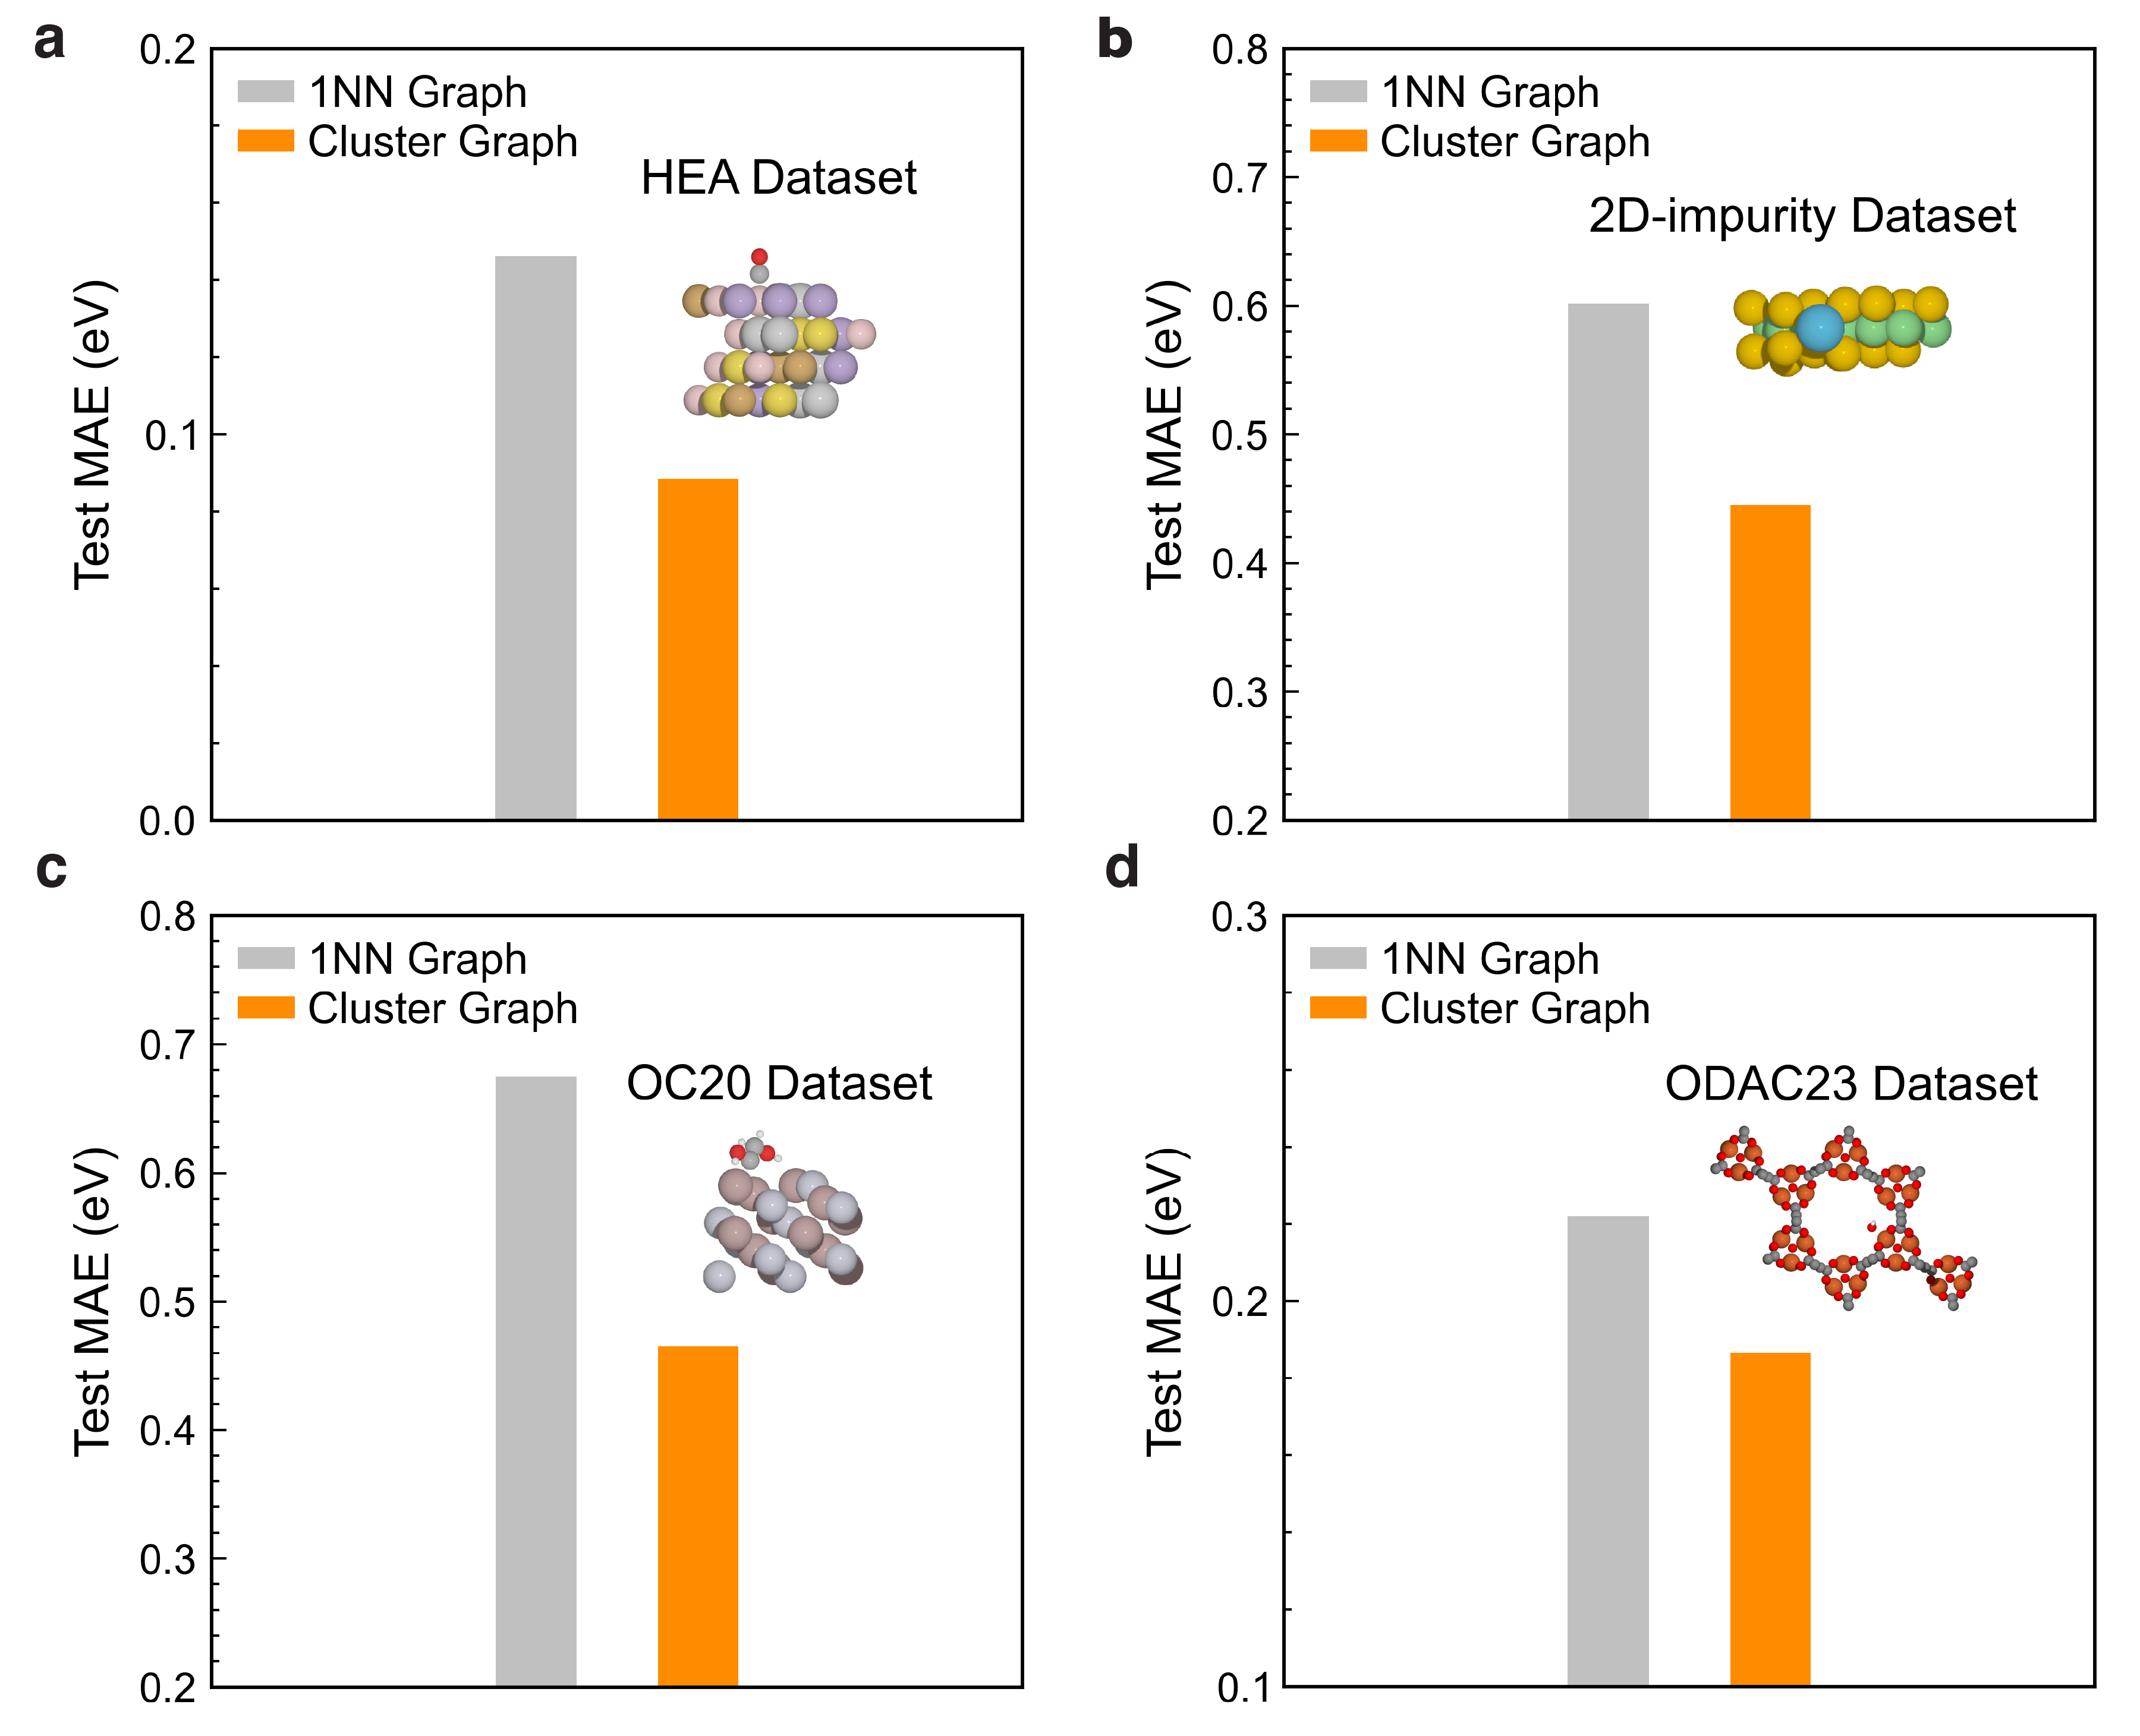
Supplementary Figure 5. A performance comparison between graphs considering only the first nearest neighbors (1NN) and cluster graphs including additional neighboring atoms on the (a) HEA, (b) 2D-impurity, (c) OC20 and (d) ODAC23 datasets.
Supplementary Figure 6. Principal component analysis (PCA) of embedding features of the CGCNN trained on the CO adsorption of the HEA dataset. (a) Two-dimensional visualization of element-dependent adsorption sites on the HEA surface; (b-f) Corresponding representation of the local atomic environment. Triangle symbols denote the atomic features of the binding site, and circles denote the other surrounding atoms in the cluster graph.

Supplementary Figure 7. Stochastic Neighbor Embedding (t-SNE) of embedding features of the CG-NET trained on the CO adsorption of the HEA dataset. (a) Two-dimensional visualization of element-dependent adsorption sites on the HEA surface; (b-f) Corresponding representation of the local atomic environment. Triangle symbols denote the atomic features of the binding site, and circles denote the other surrounding atoms in the cluster graph.
Supplementary Figure 8. Stochastic Neighbor Embedding (t-SNE) analysis of embedding features of the CGCNN trained on the CO adsorption of the HEA dataset. (a) Two-dimensional visualization of element-dependent adsorption sites on the HEA surface; (b-f) Corresponding representation of the local atomic environment. Triangle symbols denote the atomic features of the binding site, and circles denote the other surrounding atoms in the cluster graph.

Supplementary Figure 9: Illustration of the local structure of *CO and *H adsorption and the convergence of the hyperparameters $N_{node}$ and $N_{neighbor}$. (a) The adsorption site of *CO (on-top site, left) and *H (fcc hollow site, right) adsorbates on the HEA surface, with numbered nearest neighbors indicating their distinctive zones within the surface configuration; (b) Variation in the validation MAE as a function of the number of nodes $N_{node}$; (c) the number of neighbors $N_{neighbor}$ for predicting the adsorption energy.

Supplementary Table 1. The fcc lattice parameters of pristine metals determined via DFT calculations.
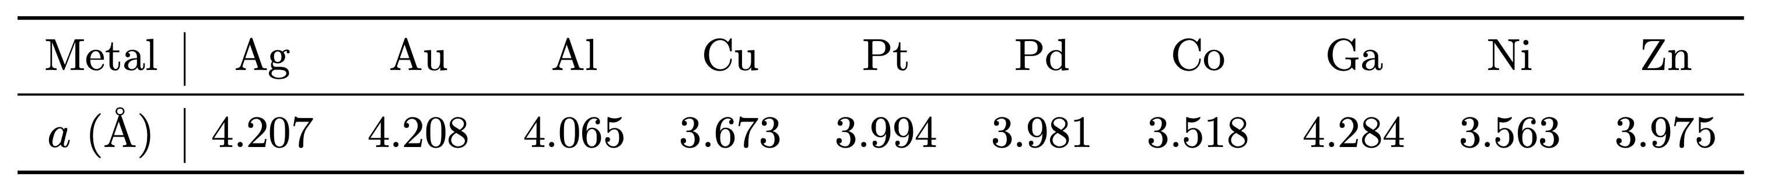

Supplementary Table 2. List of hyperparameter values for the CG-NET model.
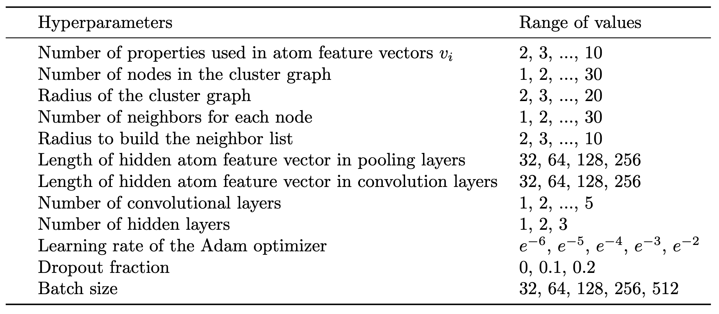
References
1. Mortensen, J. J., Hansen, L. B. & Jacobsen, K. W. Real-space grid implementation of the projector augmented wave method. Phys. Rev. B 71, 035109 (2005).
2. Enkovaara, J. et al. Electronic structure calculations with GPAW: a real-space implementation of the projector augmented-wave method. J. Phys.: Condens. Matter 22, 253202 (2010).
3. Larsen, A. H. et al. The atomic simulation environment—a Python library for working with atoms. J. Phys.: Condens. Matter 29, 273002 (2017).
4. Hammer, B., Hansen, L. B. & Nørskov, J. K. Improved adsorption energetics within density-functional theory using revised Perdew-Burke-Ernzerhof functionals. Physical Review B 59, 7413–7421 (1999).
5. Denton, A. R. & Ashcroft, N. W. Vegard’s law. Phys. Rev. A 43, 3161–3164 (1991).
6. Peterson, A. A. & Nørskov, J. K. Activity descriptors for CO2 electroreduction to methane on transition-metal catalysts. J. Phys. Chem. Lett. 3, 251–258 (2012).
7. Chan, K., Tsai, C., Hansen, H. A. & Nørskov, J. K. Molybdenum sulfides and selenides as possible electrocatalysts for CO2 Reduction. ChemCatChem 6, 1899–1905 (2014).
8. Pedersen, J. K., Batchelor, T. A. A., Bagger, A. & Rossmeisl, J. High-entropy alloys as catalysts for the CO2 and CO reduction reactions. ACS Catalysis 10, 2169–2176 (2020).
9. Nellaiappan, S. et al. High-entropy alloys as catalysts for the CO2 and CO reduction reactions: experimental realization. ACS Catalysis 10, 3658–3663 (2020).
10. Robbins, H. & Monro, S. A stochastic approximation method. The Annals of Mathematical Statistics 22, 400–407 (1951).

