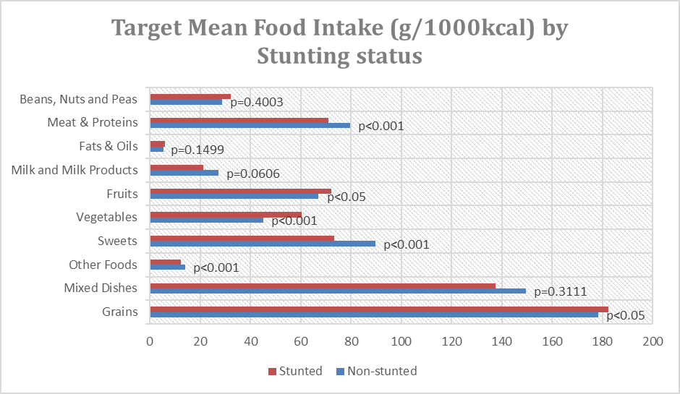
Figure 1. Target mean intake of food groups (g/1000 kcal) by stunting status among 6-12 yo children.

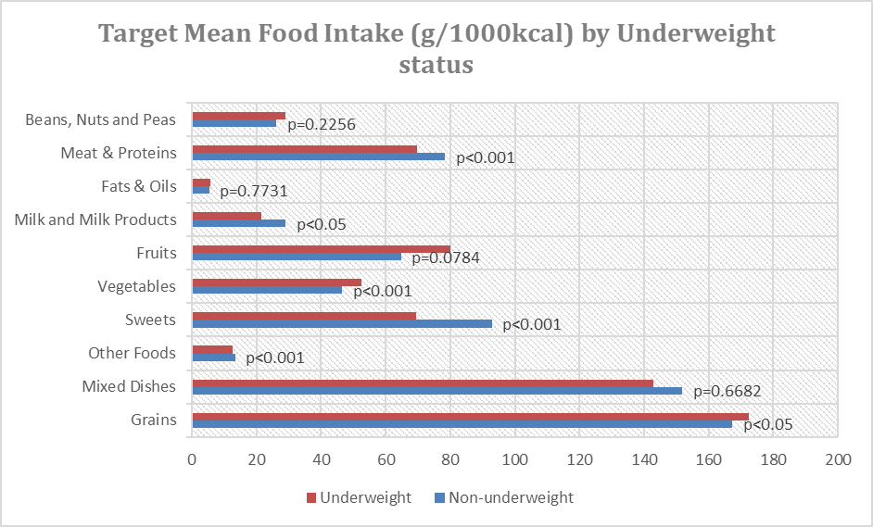
Figure 2. Target mean intake of food groups by underweight status among 6-12 yo children.

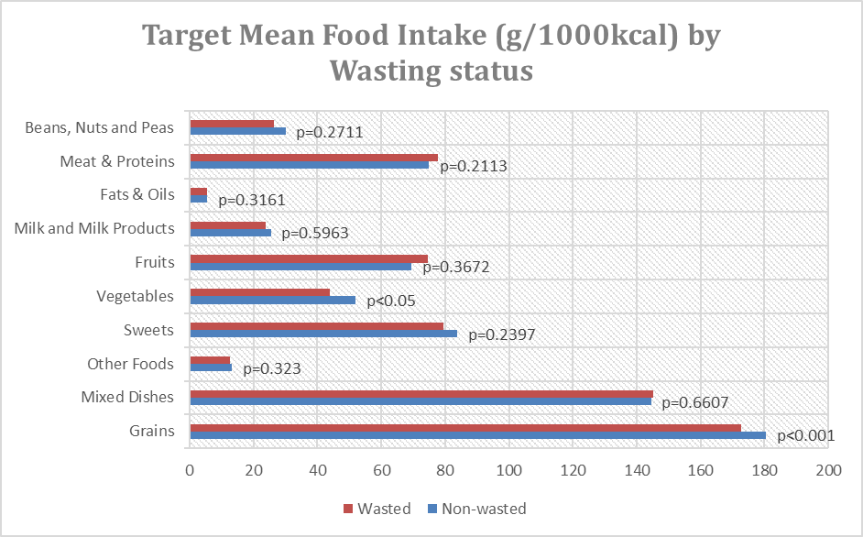
Figure 3. Target mean intake of food groups by wasting status among 6-12 yo children.

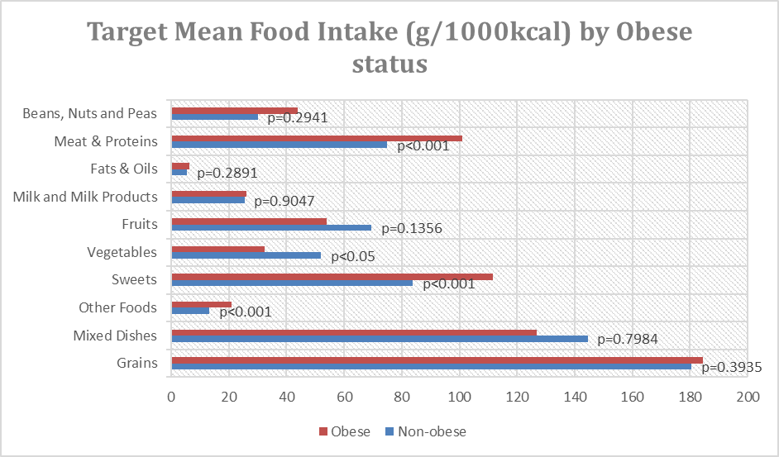
Figure 4. Target mean intake of food groups (g/1000 kcal) by obesity status among 6-12 yo children.

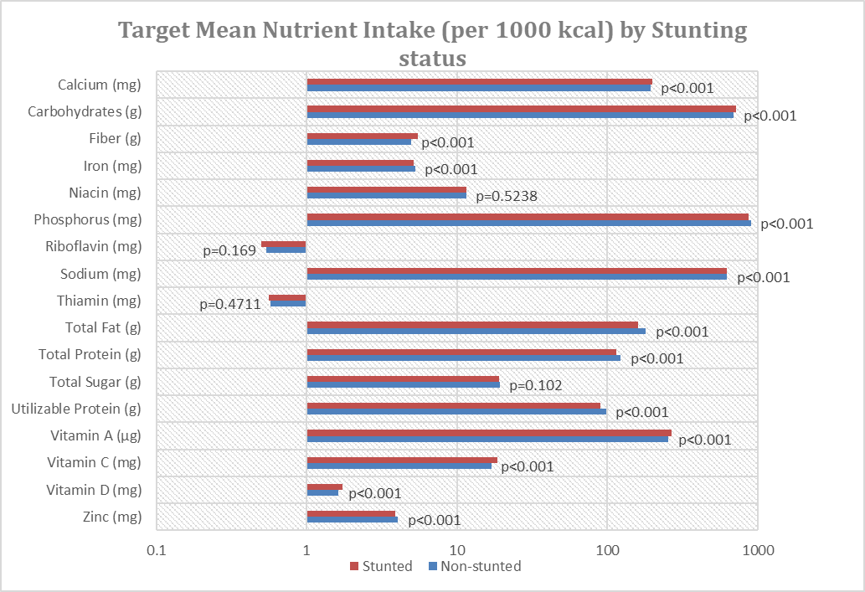
Figure 5. Target mean intake of nutrients by stunting status among 6-12 yo children.
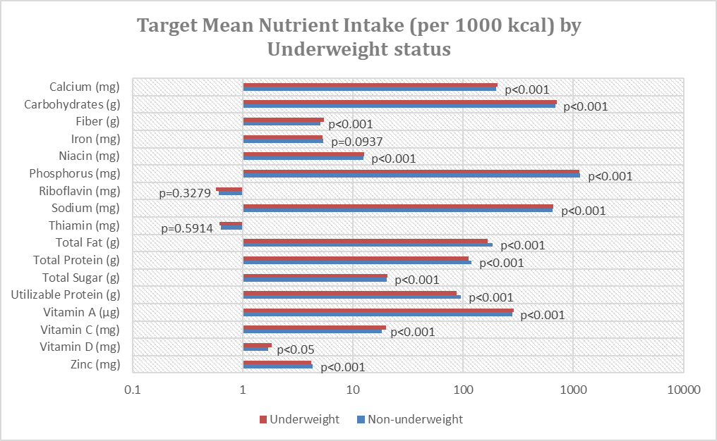
Figure 6. Target mean intake of nutrients by underweight status among 6-12 yo children.
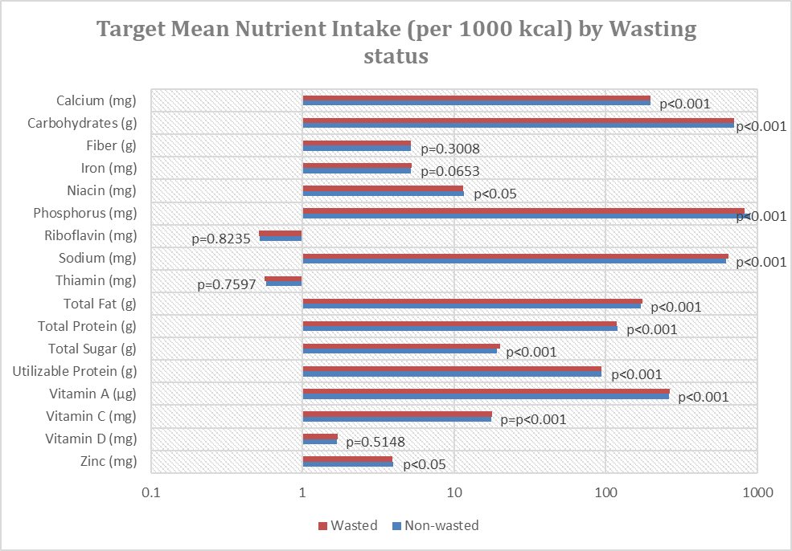
Figure 7. Target mean intake of nutrients by wasting status among 6-12 yo children.
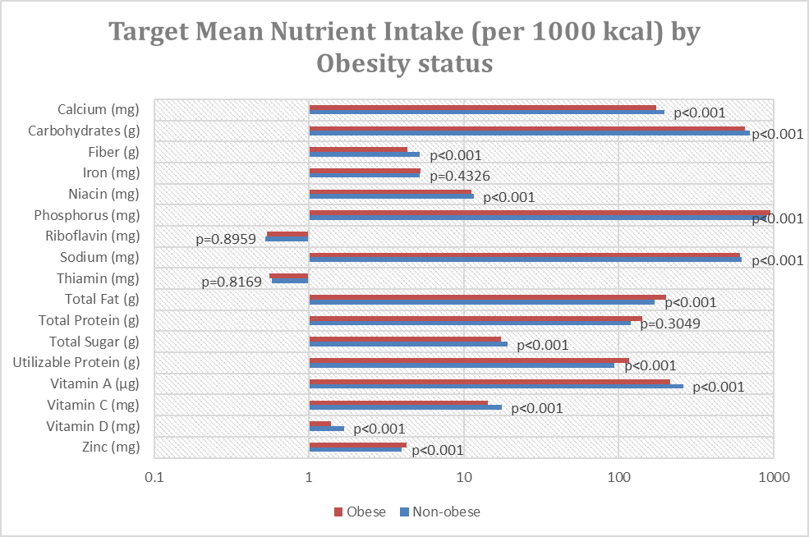
Figure 8. Target mean intake of nutrients by obese status, among 6-12 yo children.

