Supplementary appendix

Impact of social isolation on mental health amid COVID-19 pandemic: A nationwide survey
Md Ashrafur Rahman⁺¹, Richa Tambi⁺², Tarif Mahmud¹, Atiqur Rahman¹, Mehedi Hasan¹, Bakhrom Berdiev², Hosneara Akter³, Tamannyat Binte Eshaque³, Md Omar Faruk³, Easna Shanjana⁴, Marc Woodbury-Smith⁵, Mohammad Ghaziuddin⁶, Hasan Mahmud Reza^{1,*}, Mohammed Uddin^{*2,7}
1. Department of Pharmaceutical Sciences, School of Health & Life Sciences, North South University, Dhaka, Bangladesh
2. College of Medicine, Mohammed Bin Rashid University of Medicine and Health Sciences, Dubai, UAE
3. Genetics and Genomic Medicine Centre (GGMC), NeuroGen Children’s Healthcare, Dhaka, Bangladesh
4. Department of Environmental Science, NSU, Dhaka, Bangladesh
5. Biosciences Institute, Newcastle University, Newcastle upon Tyne, UK
6. Department of Psychiatry, University of Michigan Hospitals, Ann Arbor, MI, USA.
7. Cellular Intelligence (Ci) Lab, GenomeArc Inc., Toronto, Canada

+ Contributed equally
* Correspondence:
Corresponding Author
Hasan Mahmud Reza PhD, Department of Pharmaceutical Sciences, School of Health & Life Sciences, North South University, Dhaka, Bangladesh
E-mail address: hasan.reza@northsouth.edu
Mohammed Uddin PhD, 2College of Medicine, Mohammed Bin Rashid University of Medicine and Health Sciences, Dubai, UAE; The Centre for Applied Genomics, The Hospital for Sick Children, Toronto, Canada E-mail address: mohammed.uddin@mbru.ac.ae

Supplementary Table1: Survey questionnaire
Sl. No. | Questions | Response type
1 | Age | 11-20/21-30/31-40/41-50/51-60/61-70/Above 70
2 | Gender | Male/Female
3 | Occupation | Business/Service holder/Student/Retired/None
4 | Income | 10-20K BDT/20-30K BDT/ 30-40K BDT/ 40-50K BDT/ 50-60K BDT/ 60-70K BDT/ Above 70K BDT
5 | Have you been familiar with the word ‘Quarantine’ previously? | Yes/No
6 | Do you think that Quarantine can help to fight against COVID-19? | Yes/No
7 | Do you think that Quarantine increases the social communication gap? | Yes/No
8 | Where do you spend maximum time during Quarantine period? | Cooking/Browsing/Exercising/Family/Sleeping/Studying/Virtual hangout/Watching TV/Movie
9 | Which mental problem are you commonly facing during Quarantine life? | Anger or Mood Swing/ Fear or Panic/ Anxiety and Depression/ None
10 | Do you have any health related risks? | Diabetes/ Hypertension/Kidney disorder/ Mental stress/ Respiratory disfunction/None
11 | Are you engaged working from home during Quarantine life? | Yes/No
12 | What type of food you mostly preferred during quarantine? | Balanced diet/ Cookies/ Junk food/ Fatty food/ Vegetables
13 | Do you find any problems in decision and thinking during Quarantine? | Yes/No
14 | How long do you sleep during Quarantine time? | 3-4hrs/5-6hrs/7-8hrs/9-10 hrs/ Above 11 hrs
15 | Are you involved in some household activities, that you never did before | Yes/No
16 | Do you think you can easily come back to the normal life after Quarantine | Yes/No
17 | Do you think Quarantine time should be extended? | Yes/No
18 | Do you think quarantine life hampers your daily life? | Yes/No
19 | Do you face insomnia (sleep disorder) during Quarantine life? | Yes/No
20 | Do you face mental stress during Quarantine life? | Yes/No
21 | Location | Inside/Outside Dhaka

Supplementary Figure1: Mosaic plot illustrating the relation between initial health state of individuals and prevalence of insomnia during quarantine.
The plot was built using R where area of boxes of the plot are proportional to the number of respondents belonging to each group. ‘Type of health-related risk’ is defined on the x-axis and ‘response to presence/absence of insomnia’ on the y-axis, where ‘no’ is color-coded in red and ‘yes’ is color-coded in yellow.

Supplementary Figure2: Mosaic plot illustrating the relation between initial health state of individuals and prevalence of mental stress during quarantine.
The plot was built using R where area of boxes of the plot are proportional to the number of respondents belonging to each group. ‘Type of health-related risk’ is defined on the x-axis and ‘response to presence/absence of mental stress’ on the y-axis, where ‘no’ is color-coded in red and ‘yes’ is color-coded in yellow.

Supplementary Figure3: Mosaic plot illustrating the relation between employment state of individuals and prevalence of insomnia during quarantine.
The plot was built using R where area of boxes of the plot are proportional to the number of respondents belonging to each group. ‘Type of employment’ is defined on the x-axis and ‘response to presence/absence of insomnia’ on the y-axis, where ‘no’ is color-coded in red and ‘yes’ is color-coded in yellow.

Supplementary Figure4: Mosaic plot illustrating the relation between employment state of individuals and prevalence of mental stress during quarantine.
The plot was built using R where area of boxes of the plot are proportional to the number of respondents belonging to each group. ‘Type of employment’ is defined on the x-axis and ‘response to presence/absence of mental stress’ on the y-axis, where ‘no’ is color-coded in red and ‘yes’ is color-coded in yellow.

Supplementary Figure5: Mosaic plot illustrating the relation between income range of individuals and prevalence of insomnia during quarantine.
The plot was built using R where area of boxes of the plot are proportional to the number of respondents belonging to each group. ‘Income range’ is defined on the x-axis and ‘response to presence/absence of insomnia’ on the y-axis, where ‘no’ is color-coded in red and ‘yes’ is color-coded in yellow.

Supplementary Figure6: Mosaic plot illustrating the relation between income range of individuals and prevalence of mental stress during quarantine.
The plot was built using R where area of boxes of the plot are proportional to the number of respondents belonging to each group. ‘Income range’ is defined on the x-axis and ‘response to presence/absence of mental stress’ on the y-axis, where ‘no’ is color-coded in red and ‘yes’ is color-coded in yellow.

Supplementary Figure7: Mosaic plot illustrating the relation between location of individuals and prevalence of insomnia during quarantine.
The plot was built using R where area of boxes of the plot are proportional to the number of respondents belonging to each group. ‘Location’ is defined on the x-axis and ‘response to presence/absence of insomnia’ on the y-axis, where ‘no’ is color-coded in red and ‘yes’ is color-coded in yellow.

Supplementary Figure8: Mosaic plot illustrating the relation between location of individuals and prevalence of mental stress during quarantine.
The plot was built using R where area of boxes of the plot are proportional to the number of respondents belonging to each group. ‘Location’ is defined on the x-axis and ‘response to presence/absence of mental stress’ on the y-axis, where ‘no’ is color-coded in red and ‘yes’ is color-coded in yellow.

Supplementary Figure9: Mosaic plot illustrating the relation between sleep duration and age of individuals.
The respondents were grouped as children and young adults (11-40 years), middle age (40-60 years) and old above 60 years of age. The plot was built using R where area of boxes of the plot are proportional to the number of respondents belonging to each group. ‘Age’ is defined on the x-axis and ‘sleep duration’ on the y-axis.

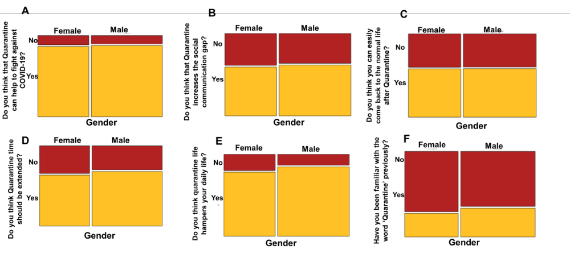
Supplementary Figure10: Overall outlook towards COVID-19 quarantine of the male and female respondents.
Gender-wise respondent’s view regarding A) the positive effect of quarantine for impeding the spread of COVID-19. B) the correlation between communication gap and quarantine C) reverting back to normal life after finishing the social isolation period D) extending the duration of mandatory quarantine E) the negative effect of quarantine on day-to-day activities and F) prior familiarity with the term ‘quarantine’. The mosaic plot was built using R where area of boxes of the plot are proportional to the number of respondents belonging to each group. ‘Gender’ is defined on the x-axis and ‘yes/no response’ on the y-axis.

