Prioritising Patients for Publicly Funded Bariatric Surgery in Queensland, Australia

Supplementary material
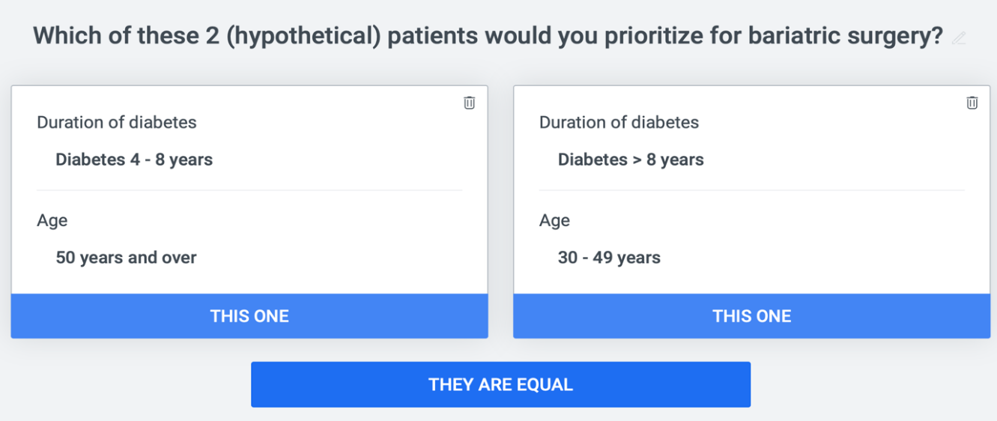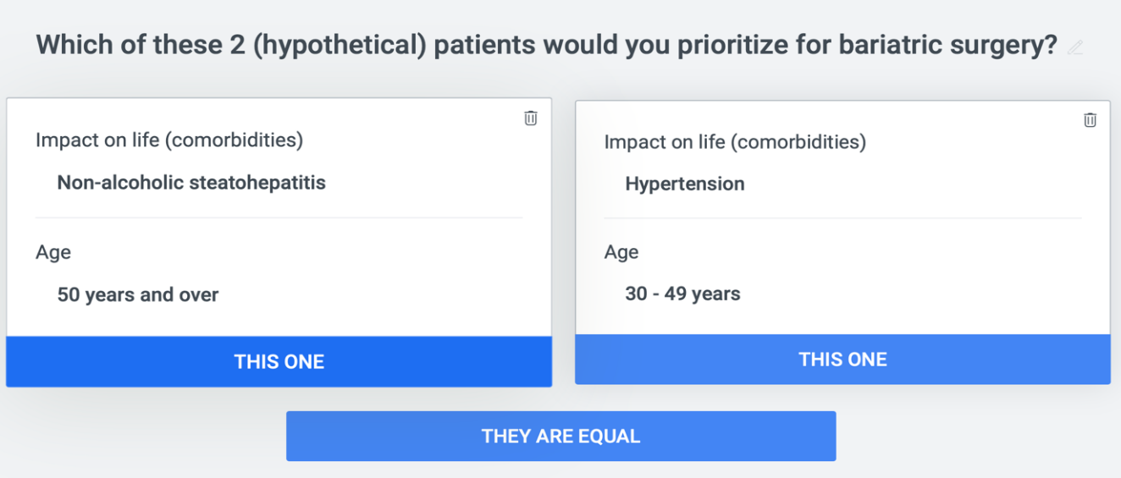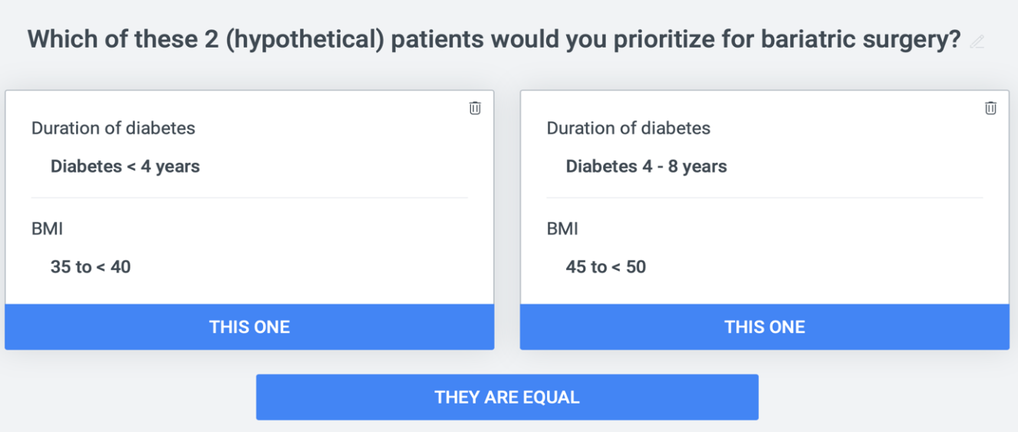
Figure S1. Examples of participant choices during development of the BAPT scoring framework
Scoring was developed using the web-based 1000Minds software (www.1000minds.com).

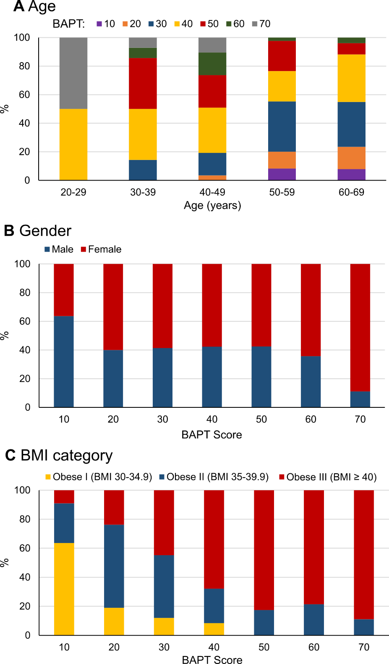
Figure S2. Patient age, BMI and sex distribution across BAPT scores
Patients (N = 292) were grouped according to their BAPT scores. Those with scores of 10–19 are in BAPT Score 10; those with 20–29 are in BAPT Score 20, and so on. The number of patients in each BAPT score group from 10 to 70 was 13, 34, 77, 74, 56, 27, and 11, respectively.

Table S1. Comparison of quality of life outcomes (AQoL-4D) across BAPT score quartiles, pre and post-surgery

 | BAPT score deciles
Quality of Life measures  (AQoL-4D) | BAPT score  10-19 | BAPT score 20-29 | BAPT score  30-39 | BAPT score  40-49 | BAPT score  50-59 | BAPT score 60 or above | p-value
N | 8 | 12 | 37 | 36 | 25 | 12
Independent living
pre-surgery | 0.971 ± 0.071 | 0.904 ± 0.140 | 0.825 ± 0.239 | 0.827 ± 0.174 | 0.918 ± 0.126 | 0.755 ± 0.120 | 0.331
6-months | 1.000 ± 0.000 | 0.915 ± 0.146 | 0.898 ± 0.172 | 0.927 ± 0.130 | 0.932 ± 0.098 | 0.910 ± 0.182 | 0.688
12-months | 1.000 ±0.000 | 0.944 ± 0.129 | 0.908 ± 0.191 | 0.880 ± 0.171 | 0.969 ± 0.076 | 0.938 ± 0.091 | 0.899
Relationships
pre-surgery | 0.809 ± 0.137 | 0.918 ± 0.126 | 0.843 ± 0.199 | 0.845 ± 0.156 | 0.784 ± 0.228 | 0.802 ± 0.116 | 0.210
6-months | 0.949 ± 0.061 | 0.896 ± 0.126 | 0.890 ± 0.169 | 0.898 ± 0.117 | 0.899 ± 0.240 | 0.890 ± 0.210 | 0.707
12-months | 0.882 ± 0.121 | 0.854 ± 0.211 | 0.828 ± 0.256 | 0.874 ± 0.160 | 0.911 ± 0.209 | 0.893 ± 0.143 | 0.359
Senses
pre-surgery | 0.945 ± 0.052 | 0.925 ± 0.078 | 0.890 ± 0.108 | 0.878 ± 0.147 | 0.909 ± 0.089 | 0.917 ± 0.053 | 0.622
6-months | 0.980 ± 0.031 | 0.890 ± 0.131 | 0.917 ± 0.082 | 0.919 ± 0.104 | 0.952 ± 0.053 | 0.939 ± 0.088 | 0.549
12-months | 0.934 ± 0.090 | 0.937 ± 0.054 | 0.923 ± 0.079 | 0.930 ± 0.078 | 0.951 ± 0.064 | 0.929 ± 0.069 | 0.653
Mental health
pre-surgery | 0.863 ± 0.108 | 0.830 ± 0.124 | 0.814 ± 0.178 | 0.785 ± 0.155 | 0.799 ± 0.120 | 0.820 ± 0.098 | 0.386
6-months | 0.908 ± 0.112 | 0.857 ± 0.129 | 0.843 ± 0.178 | 0.872 ± 0.132 | 0.878 ± 0.128 | 0.891 ± 0.099 | 0.642
12-months | 0.876 ± 0.131 | 0.832 ± 0.152 | 0.819 ± 0.212 | 0.855 ± 0.153 | 0.892 ± 0.124 | 0.868 ± 0.111 | 0.390
Total score
pre-surgery | 0.657 ± 0.149 | 0.662 ± 0.264 | 0.560 ± 0.267 | 0.526 ± 0.236 | 0.553 ± 0.231 | 0.488 ± 0.168 | 0.115
6-months | 0.845 ± 0.111 | 0.673 ± 0.250 | 0.645 ± 0.240 | 0.702 ± 0.241 | 0.713 ± 0.238 | 0.739 ± 0.265 | 0.879
12-months | 0.738 ± 0.196 | 0.643 ± 0.289 | 0.604 ± 0.311 | 0.649 ± 0.259 | 0.764 ± 0.236 | 0.708 ± 0.241 | 0.332

