Behavioral biometric optical tactile sensor that instantaneously decouples dynamic touch signals in real time

Contents

Supplementary Methods
Supplementary Notes 1 to 15
Supplementary Figs. 1 to 75
Supplementary Tables 1 to 9
Captions for Supplementary Movies 1 to 7
References (01-12)

Other Supplementary contents for this manuscript include the following

Supplementary Movies 1 to 7
Supplementary Methods
Synthesis of rod-shaped β-NaREF₄ (RE = Gd, Y, Yb, Er, Tm) upconversion nanocrystals (UCNs). Hexagonal rod-shaped UCNs were synthesized using a hydrothermal method¹. Briefly, NaOH (0.2 g mL^{–1}), ethanol (10 mL), oleic acid (10 mL), a solution of the lanthanide mixture (0.2 M RECl₃, RE = Gd, Y, Yb, Er, and Tm, 4 mL), and 2 M ammonium fluoride (NH₄F, 2 mL) were mixed by stirring for 10 min and transferred into a Teflon-lined hydrothermal device. Next, the premixed solution was heated at 200 °C for 3 h. Subsequently, the hydrothermal device was naturally cooled to room temperature (26 °C). The resulting product was collected via centrifugation and washed several times with ethanol and water. Finally, the resulting powder was dispersed in ethanol.
Stamps and screws information. Triangle, rectangle, pentagon, hexagon, alphabet letters, and braille stamps were fabricated using a 3D printer (Form2, Formlabs). The length of one side of the triangle, rectangle, pentagon, and hexagon was 5 mm, and the width of the alphabet stroke on stamps was 400 μm. The diameter and pitch of the dots in braille were 500 and 833.33 μm, respectively. Four types of screw (1/4-20; SS25S050, Thorlabs, M6; SS6MS12, Thorlabs, 8-32; SS8S050, Thorlabs, and M3; SS3S6, Thorlabs) were used for the screening of thread pitches (1/4-20; 1.27 mm, M6; 1.00 mm, 8-32; 0.79 mm, M3; 0.50 mm). Additionally, a golf ball (Titleist Pro V1) was used for surface profiling.
Optical imaging. Optical images for micro-hemisphere structure deformation were captured by a microscopic camera (HA010, Gasworld). To capture these microscopic images through the thick dove prism used for generating TIR, we utilized a long working distance objective lens (Mitutoyo 10X, 0.28NA) in combination with a macro camera lens (Nikkor 105mm f/2.8) that served as the tube lens with sCMOS camera (C14440-20UP, Hamamatsu photonics). Luminescence images were captured using a 10-fps CCD camera (DCC3260C, Thorlabs) and a 30-fps CMOS camera (DigiRetina16, Tucsen). Luminescence images were converted to color map contours of the pressure distribution using Origin and MATLAB. The luminescence intensity profile along the centerline was plotted using the ImageJ software.
Measurement of friction force and coefficient of friction using surface forces apparatus (SFA). The friction forces were measured using piezoelectric 3D sensor (upper surface) and biomorph slider (lower surface) attachments in the SFA system (SFA2000, Surforce LLC, USA)². Supplementary Fig. 14 shows a schematic of the friction-force measurement setup. For the upper surface, a PDMS sample with an optical tactile sensor (10 mm × 10 mm) taped onto a flat glass disk was used. For the lower surface, a hemispherical brass with a radius of curvature of 2 cm radius was used. Friction was measured while increasing the load stepwise, at two different driving velocities (11.6, and 58.0 μm/s). The kinetic coefficient of friction was then obtained from the slope of the friction vs. load curve. A constant shear distance (sliding amplitude) (116 μm) and triangular wave signal determined by a function generator were applied during all measurements. The frictional force was measured at least five times for each load.
Characterization of optical signals. Luminescence images of the UMs were taken with a Nikon D810 digital camera on an inverted microscope (Ti-E, Nikon) under irradiation with a 980 nm NIR laser (MDL-F-980-5W, Dragon laser). The UMs were excited using a 980 nm NIR laser. The NIR reflection was removed using a 950 nm cut-on filter (Semrock Inc.). The upconversion luminescence spectra of the UCNs were measured using a modular spectrometer (QE Pro-FL, Ocean Optics). Image frames were extracted using the Adobe Premiere Pro CC.
Characterization of UCNs-embedded micro-hemispheres integrated with the stress concentration layer. The geometry of the optical tactile sensor was characterized by field-emission scanning electron microscopy (FE-SEM; S-4800, Hitachi) and high-resolution transmission electron microscopy (HR-TEM; JEM-1400, JEOL).
Supplementary Notes
Supplementary Note 1. Optimizing the shape of micro-structures for UCN/PDMS layer. Supplementary Fig. 5 described luminescence change according to the force-applying processes with different shapes of micro-structures in UCN/PDMS layer. To prevent excessive deformation and subsequent adhesion by the conformal contact between the UCN/PDMS layer and the TIR prism when subjected to vertical normal forces, proper micro-structures with ideal dimensions and shapes are necessary for UCN/PDMS layer. As shown in Supplementary Fig. 5a, we fabricated two types of tactile sensor pads with micro-structured UCN/PDMS layers like micro-hemisphere and micro-pillars, and we controlled the size of micro-hemisphere structures (Supplementary Fig. 5b). In the case of 90 µm micro-hemispheres with a pitch of 100 µm, it revealed luminescence only upon the applied pressure, while a micro-hemisphere array with a diameter of 20 µm and a pitch of 40 µm still exhibited luminescence even at the removal of the vertical normal forces. We believed that is due to the excessive deformation caused by the applied force on the smaller and more densely packed micro-hemispheres, which resulted in a stronger adhesion to the prism and prevented them from returning to their original state, maintaining a certain degree of conformal contact. In addition, before applying the force to the sensor pad, micro-pillars of 10 µm and a pitch of 15 µm with a flat top surface caused a planar contact interface with the TIR prism. As a result, the luminescence was maintained even in the absence of vertical normal forces. This phenomenon could be attributed to the efficient conformal contact achieved by the flat top surface of the micro-pillars. Thus, to ensure the best performance of the tactile sensor, 90 µm with a pitch of 100 µm was used for UCN/PDMS layer.
Supplementary Note 2. Working principle elucidation.
To clarify the observed enhancement in emitted fluorescence from the UCNs-embedded micro-hemispheres, we acquired higher-resolution fluorescence microscopy images to visualize luminescence from individual micro-hemispheres (Supplementary Figs. 9, and 10). To capture microscopic images through the thick dove prism utilized for generating TIR, we employed a long working distance objective lens (Mitutoyo 10X, 0.28NA) in combination with a macro camera lens (Nikkor 105mm f/2.8) serving as the tube lens.
Upon conducting microscopic imaging, we discovered that the luminescence emission from individual UCNs-embedded micro-hemispheres spanned the entire width of each micro-hemisphere (90 µm). This is attributed to frustrated TIR, which causes the entire height of each micro-hemisphere to be excited by the frustrated propagating farfields. In contrast, evanescent nearfields would be unable to excite the full width (or height) of the micro-hemispheres, resulting in emitted luminescence covering a smaller area, constrained by the height of the evanescent nearfield.
Supplementary Note 3. Optimizing the thickness of the tactile sensor pad.
Static normal force analysis
Supplementary Fig. 17 shows a luminescence profile and a pressure distribution according to the thickness of the tactile sensor pad. As the thickness of the sensor pad including the stress concentration layer decreased, the sensitivity of the static normal force measured by the optical sensor decreased to 0.04 N. In the absence of a power amplifier layer, the optical sensor could measure a normal force of 0.02 N at a thickness of 200 μm (Supplementary Figs. 18, and 59-61).
Dynamic shear force and hand-writing analysis
Supplementary Fig. 18 described the optimization of the stress concentration layer by varying the modulus and thickness of the layers and undulating interface. The optical tactile sensor pad with the stress concentration layer consisting of a high modulus TPU top and low modulus PDMS bottom layer produces higher luminescence intensity of signal than the optical tactile sensor pad with low modulus PDMS top and low modulus PDMS bottom layer. In addition, the undulating interface in a stress concentration layer increases the asymmetric luminescence profile for shear force. To maximize the asymmetric luminescence profile and ensure the highest luminescence intensity, a 1000 μm thickness of tactile sensor pad with 200 μm thickness of the stress concentration layer (80 μm for TPU and 120 μm for PDMS layer) was used for the dynamic shear force and hand-writing analysis.
Object screening and braille-to-speech system
Supplementary Fig. 62 describes a change in spatial resolution according to the thickness of a tactile sensor pad. When the sensor pad was pressed with a 5 mm triangular stamp, the spatial resolution of the luminescence image increased as the thickness of the sensor pad decreased. To ensure the best spatial resolution, a tactile sensor pad of 200 μm thickness was used without the stress concentration layer.
Supplementary Note 4. Dynamic shear force analysis with different velocity and acceleration.
To analyze the dynamic force on the optical tactile sensor, a spherical indenter with a preload of 1.0 N was applied and subsequently moved 5 mm in the lateral direction. Because of the slippery micro-hemisphere array applied dynamic forces, a PDMS holder with PI tape (3M, 35 μm thickness) was implemented on the optical tactile sensor. The frames from the video were obtained at 0.1 s intervals (frames per second (fps) of the CCD camera is 10). The frames were extracted from the video to effectively exhibit the different dynamic forces during acceleration (Fig. 3a). To express the stress distribution of the dynamic forces, luminescence images were converted into the intensity of gray values. The intensity plot was measured along the centerline of the luminescence images, which facilitated the calculation of the skewness of the dynamic forces. In the initial state, the skewness was 0; however, it increased by 0.58 at 1.0 s.
Supplementary Fig. 27b shows the skewness profile values during the movement of the indenter by 5 mm at 1.0 mm/s velocity and 1.0 mm/s² acceleration with oil (Krytox greases, Chemours) coated sensor. This result describes the relationship between the friction force and the shear force. The difference in skewness ratio was observed according to the velocity and acceleration (velocity: 1.5 mm/s with acceleration: 1.5 mm/s², velocity: 1.0 mm/s with acceleration: 1.0 mm/s², and velocity: 0.5 mm/s with acceleration: 0.5 mm/s², respectively). Supplementary Fig. 24 shows the luminescence images, pressure distribution, and intensity profile when the indenter moved to 1 mm with different velocities and accelerations. As the velocity and acceleration decreased, the skewness also decreased because the shear force decreased (Supplementary Fig. 25).
Supplementary Figs. 30 to 32 describe the relationship between the shear force and skewness during the spherical indenter moving at different velocities and accelerations at the same initial normal force. Regardless of the amount of the initial normal force, the skewness and shear force increased from 0 to 1.0 s and the skewness increased proportional to shear force.
Supplementary Note 5. MATLAB-based skewness extraction: skew-Gaussian distribution fitting and calculation of skewness using median and mean of intensity profile.
MATLAB based skewness extraction
The measured luminescence intensity distributions and the simulated contact width distributions were normalized and fitted to a least-square skew-Gaussian distribution to determine the skewness of the distributions. The probability density function of the skew-Gaussian distribution f is expressed as:
$$\left(1\right) f\left(x\right)=\frac{2}{ω}ϕ\left(\frac{x-ξ}{ω}\right)Φ\left(α(\frac{x-ξ}{ω})\right),$$

$$\left(2\right) ϕ\left(x\right)=\frac{1}{\sqrt{2π}}\exp\left(-\frac{x^{2}}{2}\right),$$

$$\left(3\right) Φ\left(x\right)=\int_{∞}^{x}{ϕ(t)dt}=\frac{1}{2}\operatorname{erf}\left(\frac{x}{\sqrt{2}}\right),$$
where α, ξ, and ω represent the shape, location, and scale of distribution, respectively. Skewness γ was calculated using α, as follows.
$$\left(4\right) γ=\frac{4-π}{2}\frac{{\left(δ\sqrt{2/ π}\right)}^{3}}{{\left(1-2δ^{2}/π\right)}^{3/2}},$$
where $δ=\frac{α}{\sqrt{1+α^{2}}}$; $γ$ ranges between –1 and 1, and a larger $\left|γ\right|$ indicates a more asymmetric distribution.
Fisher–Pearson coefficient for skewness calculation
The intensity profile of the major axis was extracted from the tip contact area of the video frame, and the Fisher–Pearson coefficient of the distribution was calculated using scipy.stats.skew. The third Fisher–Pearson coefficient of the random distribution X is expressed as:
$$\left(5\right) \tilde{μ_{3}}=E\left[{( \frac{X-μ}{σ} )}^{3}\right]= \frac{m_{3}}{{m_{2}}^{3/2}},$$
where μ is the mean; σ the standard deviation; and E is the expectation operator. This can also be expressed as the ratio of the third cumulant, $m_{3}$ to $m_{2}$to the 1.5th power.
Supplementary Note 6. Prediction of the normal force applied by the sensor.
In this section, the working process and machine-learning framework for normal-force prediction are described in detail.
Data preprocessing and feature extraction
To predict the normal force in real-time from the handwritten videos, RGB histograms were extracted from the tip moving frames with constant force (0.5–1.5 N for the indenter and 0.1–1.4 N for the pen) and velocity (0.5, 1.0, 1.5 m/s). To remove the background intensity noise, a reference image with no pressed tip was used. Eight features from the green channel profile and ten from the red channel profile were extracted (Supplementary Table 1). Supplementary Fig. 34a and Supplementary Fig. 69a show the reduced feature dimensions by PCA for the indenter and the pen, respectively.
Machine learning model for normal force prediction
SVR was used to predict the normal force by feeding 18 features from Supplementary Table 1. The model performances were $r^{2}$= 0.965, RMSE = 0.061, and MAPE = 4.885 for the indenter, and $r^{2}$= 0.943, RMSE = 0.105, and MAPE = 6.724 for the pen (Supplementary Table 2).
Supplementary Note 7. Prediction of the shear force applied by the sensor.
In this section, the working process and machine learning framework for the prediction of the shear force are described in detail.
Data preprocessing
To estimate the shear force, extracting the area in which the shear force is applied is essential. The shear-force region exhibited a weaker intensity compared with the normal-force region. Therefore, after assuming that the area of the normal force was constant, the light intensity threshold corresponding to the area was determined (Supplementary Fig. 68b for pen). At this point, an SVR model was trained to predict the normal threshold with a normal force, as shown in Supplementary Fig. 34b for the indenter), and a region with half of the predicted intensity threshold was extracted as the shear force region.
Additionally, by applying a skewed moving tip intensity profile, the skewness of the shear force region was used to predict the shear force. The intensity profile was preprocessed as an x-axis distribution by repeating the intensity of each coordinate as much as the index, and the skewness was calculated using the skew function of scipy.stats.
Machine learning model for normal force prediction
To estimate the shear force for each frame, the normal force and skewness of each frame in the acceleration section were fed into the SVR model. The model for shear force prediction had $r^{2}$= 0.947, RMSE = 0.0715, and MAPE = 5.433 for the indenter, and $r^{2}$= 0.826, RMSE = 0.054, and MAPE = 4.219 for the pen (Supplementary Table 3).
Supplementary Note 8. Finite element analysis (FEA) of the tactile sensor system.
A commercial finite element analysis (FEA) software (COMSOL Multiphysics 5.4) was used to simulate our sensor system. To reduce the simulation load, a two-dimensional (2D) model system with plane strain approximation was constructed. The 3D hexagonal micro-hemisphere array at the bottom of the sensor system was transformed in the model system as a 2D cut plane, which passes through the centers of the micro-hemispheres located in the middle of each hexagonal repeating unit (Supplementary Fig. 40). Therefore, the bottom of the model system was engraved two-dimensionally by a series of semicircles of diameter 90 μm and pitch 173 μm. At the top of the model system, the interface between the TPU layer and PDMS was engraved by a series of semicircles of diameter 20 μm and pitch 40 μm. The details of the geometry and dimensions of the model system, which resemble those of the sensor system, are shown in (Supplementary Fig. 25).
Boundary loads were applied to the surface of the model system to simulate the forces exerted by the indenter on the sensor. In the experiments, the indenter initially applied downward pressure to the sensor surface and moved laterally at a constant speed (1.0 mm/s) while maintaining the pressure. Thus, a downward normal force (F_{n}) was applied, and an additional shear force (F_{s}) was applied in a stepwise manner to the surface of the model system. These forces were applied over a length corresponding to the width of the hemispherical indenter in contact with the surface of the sensor (approximately 1 mm). Next, F_{n} was incrementally increased until the center of the surface experiencing the maximum deformation was depressed by 200 μm, which is the depth at which the indenter pressed the sensor system. F_{s} was also applied concurrently with F_{n}, and the magnitude of F_{s} applied to the model system was estimated using the model indenter. Briefly, a model indenter consisting of a 5 mm-diameter round-shaped indenter was pressed into the model system (down to 200 μm) (Supplementary Fig. 42). At the contact between the indenter and model system, a frictional force $T_{t}$ was applied using the Coulomb friction model.
$$\left(6\right) T_{t}≤μ_{d}T_{n},$$
where $μ_{d}$is the dynamic friction coefficient, which is roughly estimated to be 2 (6); and $T_{n}$is the contact pressure. Next, the model indenter migrated laterally at V_{in}, and the magnitude of F_{s} averaged over the contact areas between the indenter and model surface, which were used as the boundary load (F_{s}) for the original simulation, was obtained.
The micro-hemisphere array of the sensor at the bottom was in contact with the TIR prism. Note that if the indenter applies forces on the surface of the sensor, the contact areas made by the micro-hemisphere with the TIR prism are locally varied, thereby changing the size and intensity of the luminescence. Therefore, $T_{t}$ was applied to the contact areas.
$$\left(7\right) T_{t}≤μ_{s}T_{n},$$
where $μ_{s}$, the static friction coefficient, is 2, which is a typical value for the contact between rubber and glass (7). For the model system, a steady-state equation of motion and a constitutive equation with geometric nonlinearity are given as
$$\left(8\right) 0=∇ ∙P^{T},$$
,
$$\left(9\right) P=FC:εF^{T}$$
where P is the first Piola–Kirchhoff stress; F is the deformation gradient tensor; C is the elasticity matrix composed of Young’s modulus and Poisson's ratio (0.49); and ε is the total strain. The Young’s moduli for the TPU layer, PDMS, and UMs array layer were measured to be 52.5 MPa, 1.76 MPa, and 2.81 MPa, respectively, and were used for the simulations. With the boundary loads applied to the surface of the model system, $P=F_{s}\hat{x}-F_{n}\hat{y}$ where $\hat{x}$ and $\hat{y}$ are unit vectors, Equations (7)–(9) were solved to determine the spatial distributions of the first Piola–Kirchhoff stress components, the Von Mises stress, and the pressure and width of the contact made at the bottom interface with the TIR prism. The contact width was defined using a threshold contact pressure (400 kPa) (Supplementary Fig. 43).
Supplementary Note 9. Skewness observation with oval, square, and triangle shape indenters.
As an initial approach to investigate the impact of tip shape on the decoupled force, we constructed a deep learning model that classifies tip shape. We extracted interest regions from videos featuring eleven different types of indenters: standard sphere, elliptical with a 3 mm of long axis and 1.5 mm of short axis, rectangle with a 3 mm of side length, triangle with a 3mm of side length, spherical with 0.28, 0.38, 0.53, and 0.69 mm⁻¹ of curvature, and cut cone with 0.5, 1.0, and 1.5 mm diameter. These regions were then fed into a CNN model comprising structure (Supplementary Fig. 55a). During the training process with a total of 50 epochs, a remarkable level of accuracy was observed without any evidence of overfitting in the loss function (Supplementary Fig. 55b).
Supplementary Note 10. Screw classification system using MATLAB.
Screw images captured in tagged image file format (TIFF) were transformed to Lab color space, where L represents brightness, and a and b represent colors. With the brightness threshold, images were binarized, and point features were extracted via the speed-up robust features (SURF) algorithm employing the computer vision (CV) MATLAB toolbox. The screw spots were assumed to be oval, and the area, center points, length of the long and short axes, and angle between the X- and long-axes were extracted. To specify the screw, the thread pitch, which was calculated by the center-to-center distance of each spot, was used. Spots at the edges of the images were removed because the center point of the spot was not accurate, and the average center-to-center distance between each spot was used as the thread pitch.
Supplementary Note 11. Machine learning algorithm for braille-to-speech translation system.
To implement the braille translation system that converts sound files in real-time, we were inspired by the actual braille stroke method, and image processing was confirmed to design it. This system was implemented using the following five steps (Supplementary Fig. 66).
Thresholding based on light intensity
In image processing, binarizing an image is the simplest way to split it. The input image can be converted to grayscale and then binarized. A specific light intensity could be a threshold, and pixels with a value greater than the threshold were classified as white, and pixels with smaller values were classified as black.
Contour
Contour is an OpenCV technique used to detect contours by analyzing successive dots and colors in an image. It considers points with a light intensity equal to a given threshold constant. After binarization of the input image, a closed curve was filled with white in the area where braille was detected. Contours were drawn to cover these closed white curves.
Braille region extraction
After preprocessing the image frame, a rectangular area that can cover all closed curves was extracted. This is the area where only the braille appears, and the surrounding noise is removed; this is the area of interest. Contours can sometimes be found in areas where braille is not detected. This occurs when noise is present in an input image. To solve this, an area smaller than a certain constant value among the detected contours can be ignored to obtain a slightly clearer area of interest.
Braille coordinate extraction
Braille has six dots arranged in rows of two columns and three rows of rectangles. It is written in the order of 1, 2, and 3 from top right to bottom, and 4, 5, and 6 from top left to bottom. Braille coordinate extraction was applied to convert contour center point coordinates to alphabets (Supplementary Fig. 67).
First, the coordinates of the center points of each detected point were received in a list format. Subsequently, the list was converted into a number corresponding to the position of each coordinate. Finally, the converted list was compared with the corresponding alphabet to analyze the detected braille.
Output as sound
The detected alphabet list was saved in the mp3 file format and played with the gTTS and pygame library. If the same alphabet as the previous frame is detected, the storage process is omitted.
Supplementary Note 12. Extraction of normal force related features.
In this section, the working process and machine-learning framework for predicting the maximum intensity and radius with features related to the normal force are described in detail.
Data preprocessing and feature extraction
To extract the normal force-related features, the intensity profiles pressed by a stationary tip with a constant force (0–5.0 N) were grouped into five clusters, as presented in Supplementary Table 5. The maximum value and width of the cluster containing that maximum value were extracted as features related to the normal force (Supplementary Table 6 and Supplementary Fig. 68c).
Machine learning model for normal force prediction
Two SVR models were used to predict the maximum intensity and radius of the normal force from the predicted normal force. The model for maximum intensity prediction had a performance of $r^{2}$ = 0.954, RMSE = 2.563, and MAPE = 1.905, and the model for radius prediction had a performance of $r^{2}$ = –0.00916, RMSE = 25.324, and MAPE = 20.963 (Supplementary Table 7 and Supplementary Fig. 69).
Supplementary Note 13. Extraction of shear force related features.
The contour method of OpenCV was used to identify the major and minor axes of the shear force area, which had an elliptical shape. Additionally, the calculated length of the axes, the ratio of the major to the minor axis, and the angle of the major axis were all used as shear-force-related features.
Supplementary Note 14. Extraction of velocity-related features.
To extract velocity-related shear force features, the center of the pen was identified as the center of the area at a threshold of 20 using OpenCV. Velocity and acceleration were calculated using the center-movement distance and frame intervals.
Supplementary Note 15. Handwriting analysis.
In this section, the working process and machine learning framework for handwriting analyses that distinguish the handwriting of the three individuals are described in detail (Supplementary Fig. 70).
Data preprocessing and Linear Discriminator Analysis
For handwriting analysis, features related to normal and shear force were extracted from the letter ‘e’ videos written differently by three individuals. The dataset was constructed by calculating the mean, variance, standard deviation, kurtosis, and skewness of each feature (Supplementary Table 8). The scaled dataset, using the StandardScaler() function of Scikit learn, was fed into LDA with dimensionality reduction.
Performance evaluation
To verify the influence of features related to shear force, both the LDA using only normal force and the LDA using both normal and two frame-based velocities were compared with the LDA using both normal and shear forces (Fig. 5e and Supplementary Fig. 72). For quantitative comparison, the density of each cluster, distances between clusters (Fig. 5f and Supplementary Fig. 73), the Silhouette coefficient, and Calinski–Harabasz index, which are methods for evaluating clustering performance, were calculated. The silhouette_score() and calinski_harabaz_score() functions of Scikit Learn were used (Fig. 5g, Supplementary Fig. 74, and Supplementary Table 9).
Independence of the pen tilt
To further investigate the effects of pen tilt on handwriting analysis, a skewness tendency analysis was conducted based on the tilt angle of the pen. A dataset consisting of pen tilts at 10-degree intervals ranging from 50º to 90º was prepared. For each angle, the pen was moved at speeds of 0.5, 1.0 and 1.5 mm/s, and the normal force was applied at 0.1 N intervals from 0.1 N to 1.5 N. The skewness was calculated by extracting the pen area from each frame of the videos, and the result observed negligible differences from 60º to 90º. To confirm this finding, a violin plot analysis, which revealed the distribution of skewness, was almost indistinguishable between 70º to 90º (Supplementary Fig. 71).
Supplementary Figures
Supplementary Fig. 1 Schematic of the trajectories and instantaneous velocities of two real motion (tangent vectors) measured at each time point (yellow dots) for completely different two trajectories (left and middle). The time-averaged velocities calculated using two consecutive time points, however, remain identical for the two trajectories (right).
Supplementary Fig. 2 Photograph of UCNs-based optical tactile sensor system. (Inset: UCNs-embedded tactile sensor pad with the stress concentration layer) (Scale bar, 10 mm)
Supplementary Fig. 3 a, b, Stress–strain curve (a) and modulus (b) of each layer of optical tactile sensor pad.
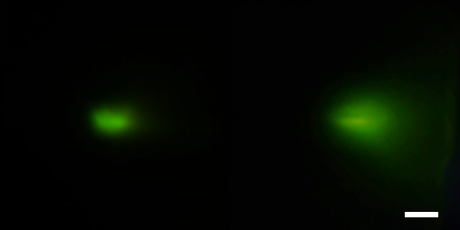
Supplementary Fig. 4 The dimension of indenter for observing the effect of Pt layer. Luminescence image of normal force: with (left) and without (right) Pt layer between UMs layer and the stress concentration layer. (Scale bar, 2 mm)
Supplementary Fig. 5 a, SEM images of the 20 µm micro-hemisphere structures (left) and the 10 µm micro-pillar structures (right) (Scale bar, 50 µm). b, Luminescence images before and after applied normal force (Scale bar, 2 mm).
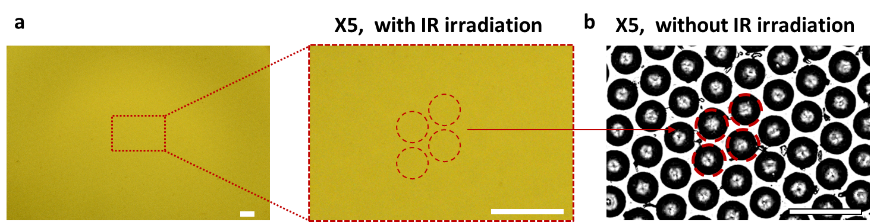
Supplementary Fig. 6 a, Luminescence images representing dispersion quality of UCNs in PDMS micro-hemisphere layer (Scale bar, 200 µm). Upon being exposed to NIR irradiation, each micro-hemisphere exhibits a consistent luminescence. b, Optical images of micro-hemisphere without IR irradiation.
Supplementary Fig. 7 Luminescence spectra of blue, green, and red luminescent UCNs (Blue: Y³⁺/Yb³⁺/Tm³⁺/Gd³⁺; 51.8/18/0.2/30 mol%, green: Y³⁺/Yb³⁺/Er³⁺/Gd³⁺; 50/18/2/30 mol%, and red: Yb³⁺/Er³⁺/Gd³⁺; 69.9/0.1/30 mol%).
Supplementary Fig. 8 Luminescence images of red, green, and blue luminescence Ums. (Scale bar, 500 μm)
Supplementary Fig. 9 An optical imaging setup designed to acquire microscopic luminescence images of the micro-hemisphere array as a function of applied normal force.
Supplementary Fig. 10 Microscopic luminescence images of individual UCN/PDMS micro-hemisphere structures were obtained as a function of applied force. The excitation of the entire height of the micro-hemisphere suggests the presence of frustrated TIR and the generation of propagating excitation light due to the PDMS/prism contact interface. (Scale bar, 400 mm)

Supplementary Fig. 11 Consistent luminescence signals and intensity of tactile sensor under 1 N normal force. a, UCNs Luminescence signals captured using a CCD camera at 25 distinct locations. b, Corresponding intensity plots demonstrating uniform response across the sensor surface (Scale bar: 2 mm).
Supplementary Fig. 12 a, b, Luminescence optimization process under 1.0 N applied using (a) images, (b) spectrum. (scale bar, 2 mm)
Supplementary Fig. 13 a-e, Upconversion luminescence stability of the tactile sensor pad under continuous laser excitation. Luminescence intensity (a) images and (b) spectra, (c) thermal camera image, and (d) spectral analysis at 530 and 660 nm when 1.0 N normal force applied under continuous irradiation of 980 nm laser light for 1 hour (scale bar, 2 mm). (e) Symmetrical luminescence intensity remained unchanged across an indented area of the tactile sensor pad under continuous irradiation of 980 nm laser light for 1 hour
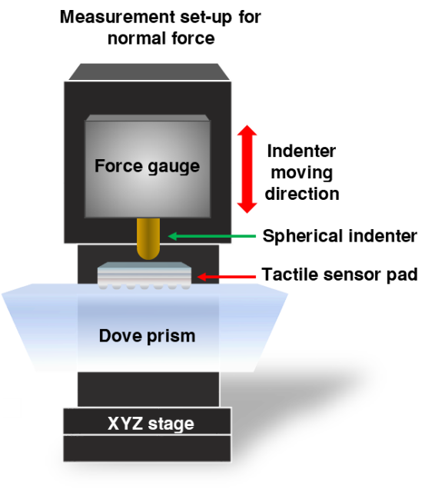
Supplementary Fig. 14 Schematic illustration of normal force application setup.
Supplementary Fig. 15 Stepwise representation of color map image conversion from luminescence image.
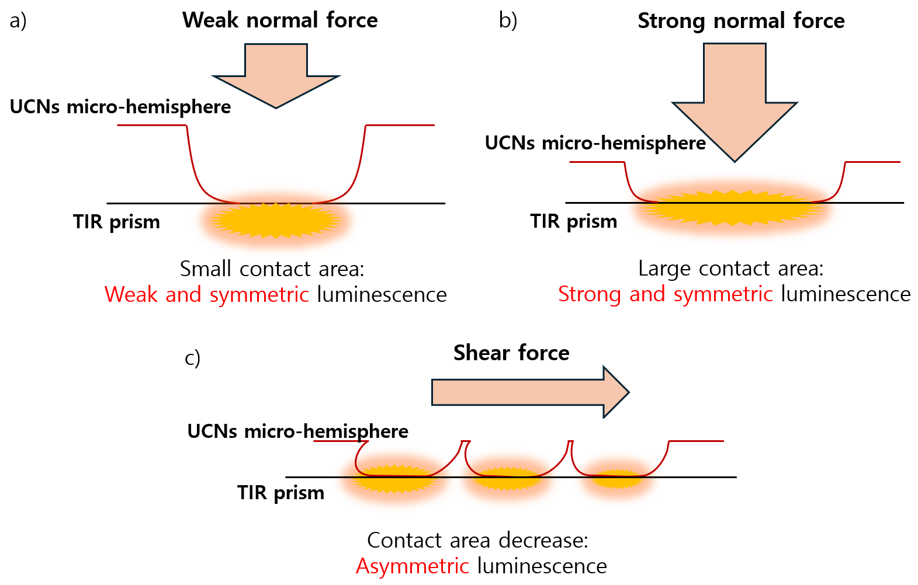 Supplementary Fig. 16 a-c, Schematic representation of luminescence change in response to applied (a) weak normal, (b) strong normal, and (c) shear forces.
Supplementary Fig. 17 a, Optical images while normal force applied at the sensor with the stress concentration layer. (Scale bar, 2 mm) b, Optical images while normal force applied at the sensor without the stress concentration layer. (Scale bar, 2 mm) c, Contact area and luminescence area differences while normal force applied at the optical sensor with the stress concentration layer.
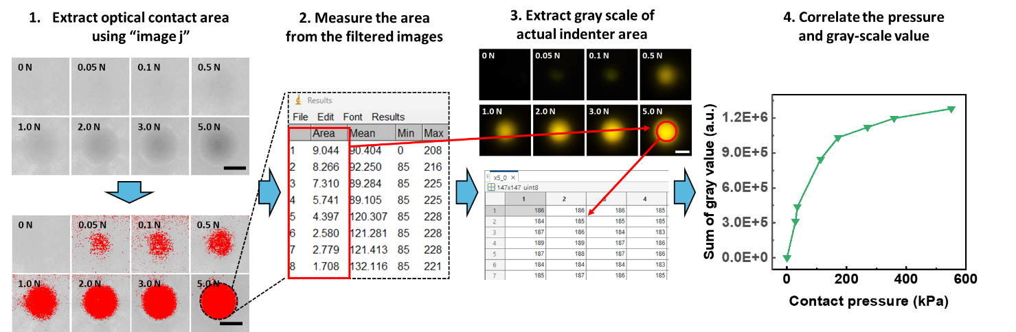
Supplementary Fig. 18 The process which the contact area is extracted from optical image. (Scale bar, 2 mm)
Supplementary Fig. 19 Symmetrical change in luminescence (top) and pressure distribution profile (bottom) according to the thickness of the optical tactile sensor pad including the stress concentration layer when normal force is increased from 0 to 5 N. (Scale bar, 2 mm)
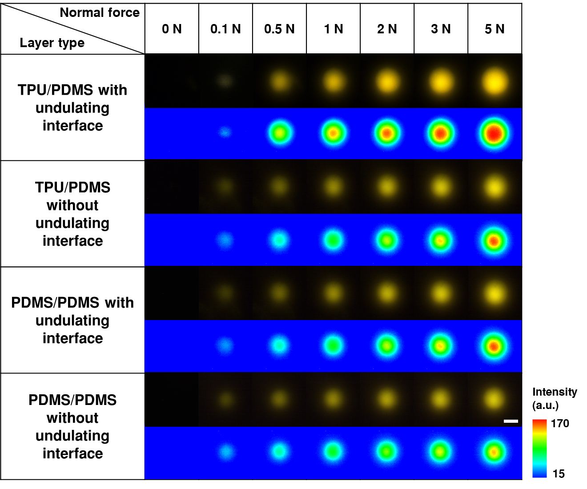
Supplementary Fig. 20 Symmetrical change in luminescence and pressure distribution profile according to the variation of modulus and the presence of undulating interface of the stress concentration layer when normal force is increased from 0 to 5 N. (Scale bar, 2 mm)

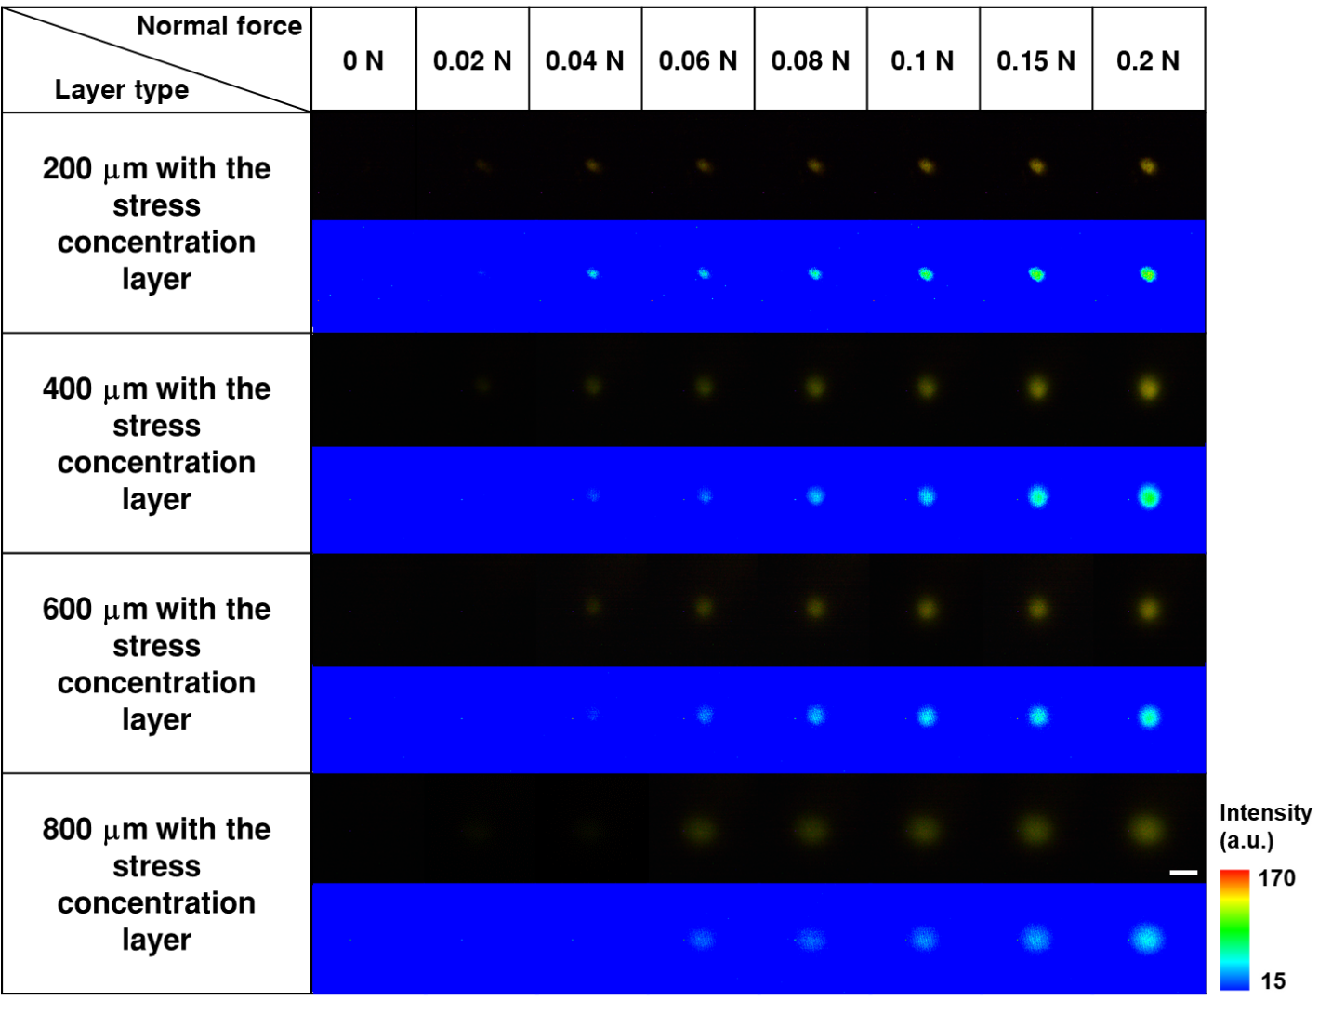
Supplementary Fig. 21 Symmetrical change in luminescence (top) and pressure distribution profile (bottom) according to the thickness of the optical tactile sensor with the stress concentration layer when normal force is increased from 0 to 0.2 N. (Scale bar, 2 mm)

Supplementary Fig. 22 Double y-axis graph of integration luminescence intensity from 630 to 690 nm wavelength, and gray value of luminescence image.
Supplementary Fig. 23 a, b, Luminescence stability and mechanical properties of tactile sensor at 100 °C. (a) Luminescence signal images and (b) corresponding spectral analysis of the tactile sensor under a 1.0 N normal force at 100 °C (scale bar, 2 mm). (c) Stability of intensity peaks at 530 nm and 660 nm observed from 0 to 60 min. d, e, Stress-strain curves of (d) UCNs-embedded layer only and (e) tactile sensor pad, respectively. f, modulus of UCN/PDMS layer and optical sensor before and after heating, illustrating the material's resilience and mechanical integrity.

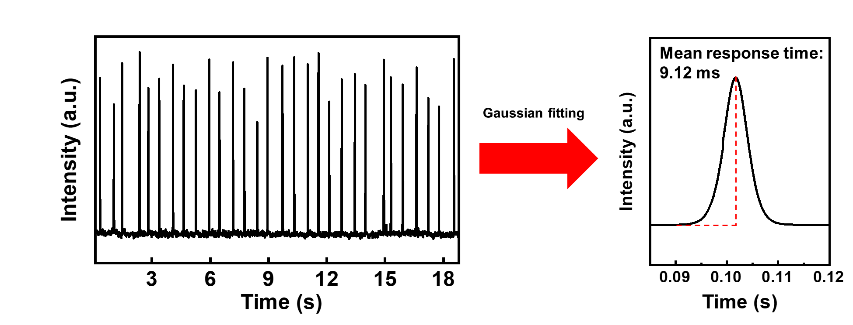
Supplementary Fig. 24 Response time of our tactile sensor with Gaussian fitting.
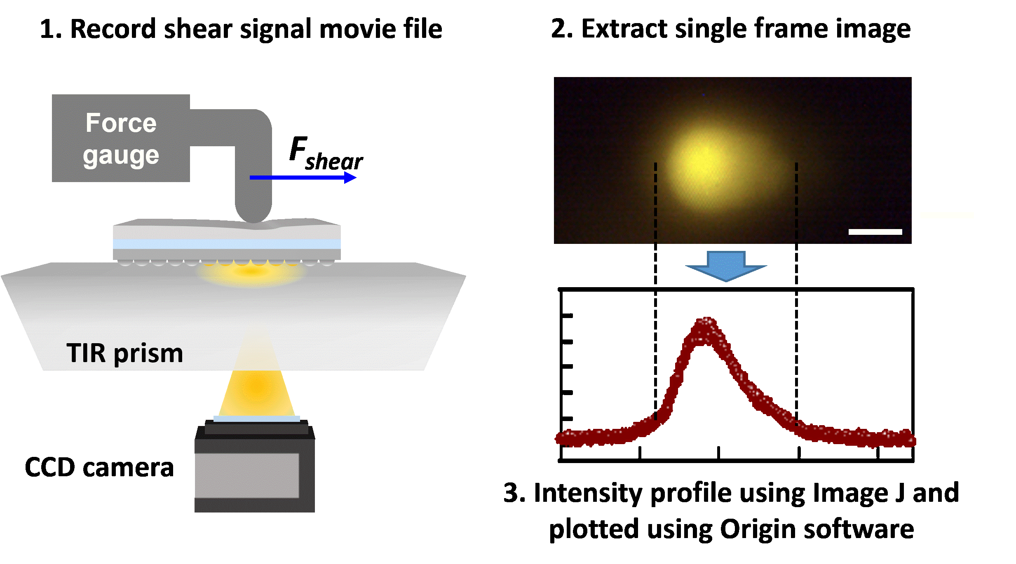
Supplementary Fig. 25 Stepwise representation of extraction luminescence intensity profile. (Scale bar, 2 mm)
Supplementary Fig. 26 (i), (ii) Luminescence images (left), pressure distribution profile (middle) and luminescence intensity plots (right) show quantitative changes in the shape of the luminescence signal according to the change of velocity and acceleration at 1.0 N of initial normal force. (Scale bar, 2 mm)
Supplementary Fig. 27 a, b, Luminescence images (left), pressure distribution profile (right), and luminescence intensity plots (bottom) at 0 and 0.5 s according to the velocity change of the indenter at 1.0 N of initial normal force. (Scale bar, 2 mm)
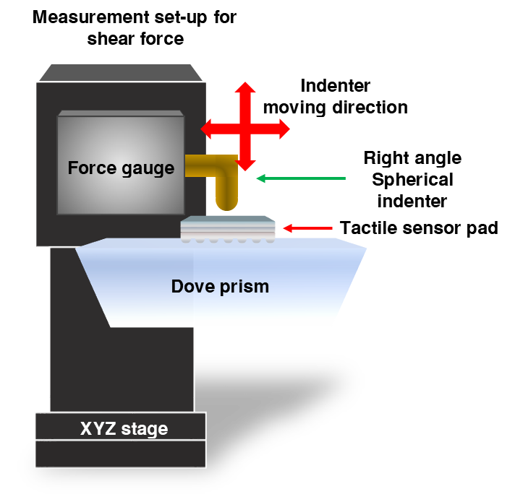
Supplementary Fig. 28 Schematic illustration of shear force application setup.
Supplementary Fig. 29 a, Luminescence images (top), pressure distribution profile (middle), and luminescence intensity plots (bottom) change when oil is applied to the surface of sensor pad at 1.0 N of initial normal force. (Scale bar, 2 mm) b, Skewness change with and without oil at the surface of sensor pad.
Supplementary Fig. 30 Schematic of SFA friction force measurement setup.
Supplementary Fig. 31 Correlation profile of surface friction in response to velocities.
Supplementary Fig. 32 Overlay of calculated skewness with measured shear force upon increasing acceleration and velocity (normal force: 1.5 N).
Supplementary Fig. 33 Overlay of calculated skewness with measured shear force upon increasing acceleration and velocity (normal force: 1.0 N).
Supplementary Fig. 34 Overlay of calculated skewness with measured shear force upon increasing acceleration and velocity (normal force: 0.5 N).
Supplementary Fig. 35 Skewness change when increasing the normal force (shear force is fixed at 1000 (a.u.)).
Supplementary Fig. 36 a, Results of dimensionality reduction of features extracted from the RGB profile of indenter by PCA. b, Scatter plot of the threshold of normal region versus normal force.
Supplementary Fig. 37 a, b, Hysteresis of (a) skewness and (b) shear force. Note that loading and unloading represents the moving directions of the indicator as forward and backward, respectively.
Supplementary Fig. 38 Skewness and shear forces plot using 30-fps camera.
Supplementary Fig. 39 Schematic of three types of the stress concentration layers. a, High modulus hard TPU/low modulus soft PDMS without undulating interface. b, Low modulus soft PDMS/PDMS with undulating interface. c, Low modulus soft PDMS/PDMS without undulating interface.
Supplementary Fig. 40 Luminescence images (left), pressure distribution profile (middle), and luminescence intensity plots (right) change according to the type of the stress concentration layers at 1.0 N of initial normal force. (Scale bar, 2 mm)
Supplementary Fig. 41 Skewness change of four types of the stress concentration layers at 1.0 N of initial normal force.
Supplementary Fig. 42 Schematic showing the hexagonal micro-hemisphere array at the bottom of the sensor system. A characteristic cut line used to generate the 2D model system is indicated as a red dotted line.
Supplementary Fig. 43 Schematic illustrating the geometry of the 2D model sensor system used in the study.
Supplementary Fig. 44 Colormap of F_{s} calculated at the surface of the model sensor system in contact with the indenter moving laterally at a constant speed (1.0 mm/s). Indentation of a 200 mm-depth is maintained throughout the lateral movement.
Supplementary Fig. 45 Calculated contact pressure changes at the surface of a micro-hemisphere.
Supplementary Fig. 46 a, b, Theoretical calculation of contact width under F_{n}, and F_{s} without (a) undulating interface, and (b) with undulating interface. c, Calculated contact width with F_{s}. d, Static force comparison of experimental intensity profile, calculated contact width, and fitted profile from calculated skewness. e, Theoretical estimation of stresses (Ds_{yx} and Ds_{xx}) under F_{s} applied on the sensor.
Supplementary Fig. 47 a, Profile of F_{n} applied at the surface of the sensor (left) and measured 300 mm below the surface (right). b, c, Contact width profiles for different values of F_{n} (b) and their comparison (c) with experimental results. Contact width profiles and experimental results were normalized by their maximum values calculated and measured, respectively, at the maximum normal force.
Supplementary Fig. 48 Normalized plot of First Piola-Kirchhoff stresses of each shear (red) and normal (gray) direction and comparison of contact width to experimental intensity. Experimental data was collected from a sensor with undulating interface subjected to 0.49 N and 0.22 N F_{s}.
Supplementary Fig. 49 a, FEA calculation of First Piola-Kirchhoff stress distribution between TPU and PDMS interfaces show regions below the interface (black dotted line) is on average 50% higher for the undulated interface. b, Comparison plot of first Piola–Kirchhoff stress difference with and without the stress concentration layers at 10 μm below the interface between TPU and PDMS.
Supplementary Fig. 50 FEA calculation of local stress distribution under a, applying only normal force (F_{n}) and b, applying normal and shear force (F_{s}) with flat tip indenter. c, Color map shows the difference in First Piola-Kirchhoff stress in the shear direction(σ_{xy}) with and without shear force applied. The red dotted box area shows the effective propagation of shear force.
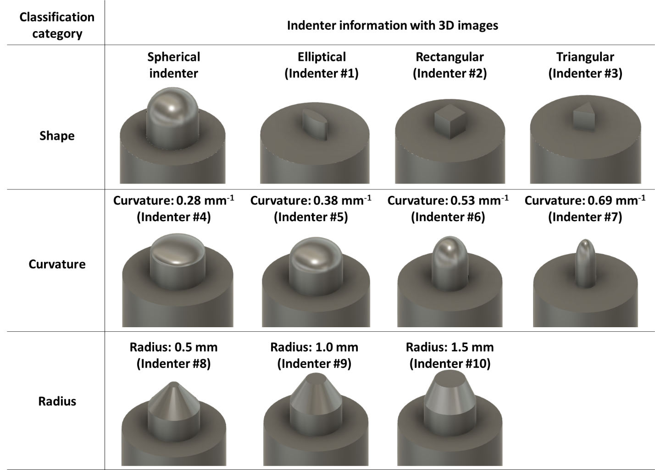
Supplementary Fig. 51 3D images of indenters applied velocity (Intender #1: elliptical with a 3 mm of long axis and 1.5 mm of short axis, indenter #2: rectangle with a 3 mm of side length, indenter #3: triangle with a 3 mm of side length, indenter #4-7: spherical with 0.28, 0.38, 0.53, and 0.69 mm⁻¹ of curvature, and indenter #8-10: cut cone with 0.5, 1.0, and 1.5 mm diameter).
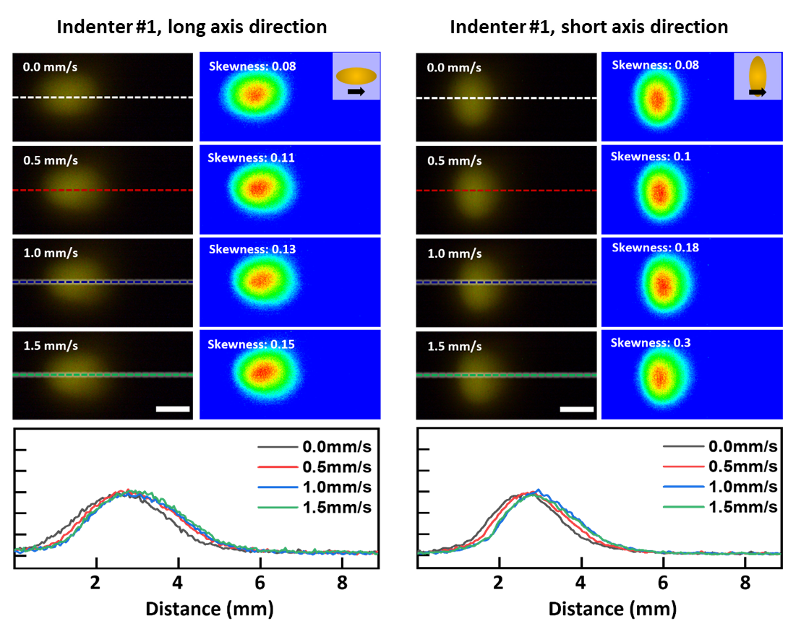Supplementary Fig. 52 Luminescence images (left), pressure distribution profile (right), and luminescence intensity plots (bottom) change according to velocity and accelerations at 1.0 N of initial normal force applied to an indenter #1. (Scale bar, 2 mm)
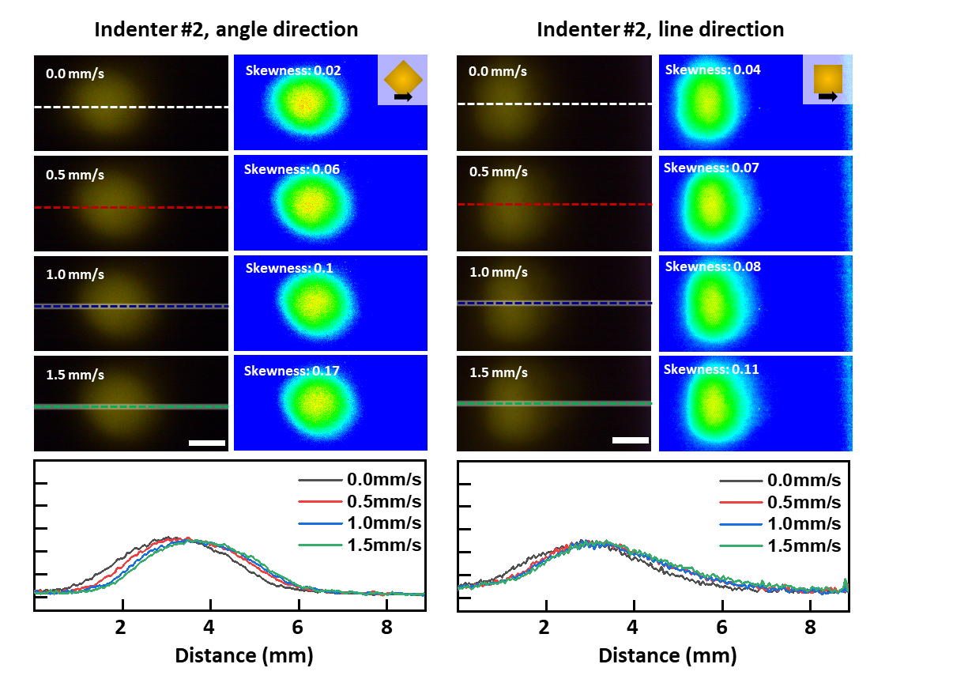
Supplementary Fig. 53 Luminescence images (left), pressure distribution profile (right), and luminescence intensity plots (bottom) change according to velocity and accelerations at 1.0 N of initial normal force applied to an indenter #2. (Scale bar, 2 mm)
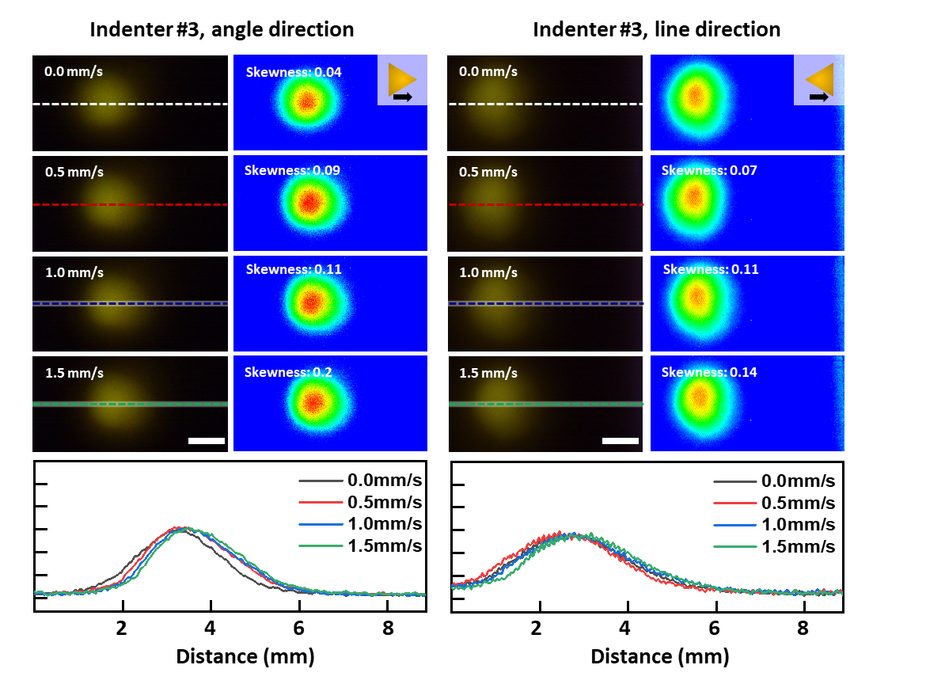
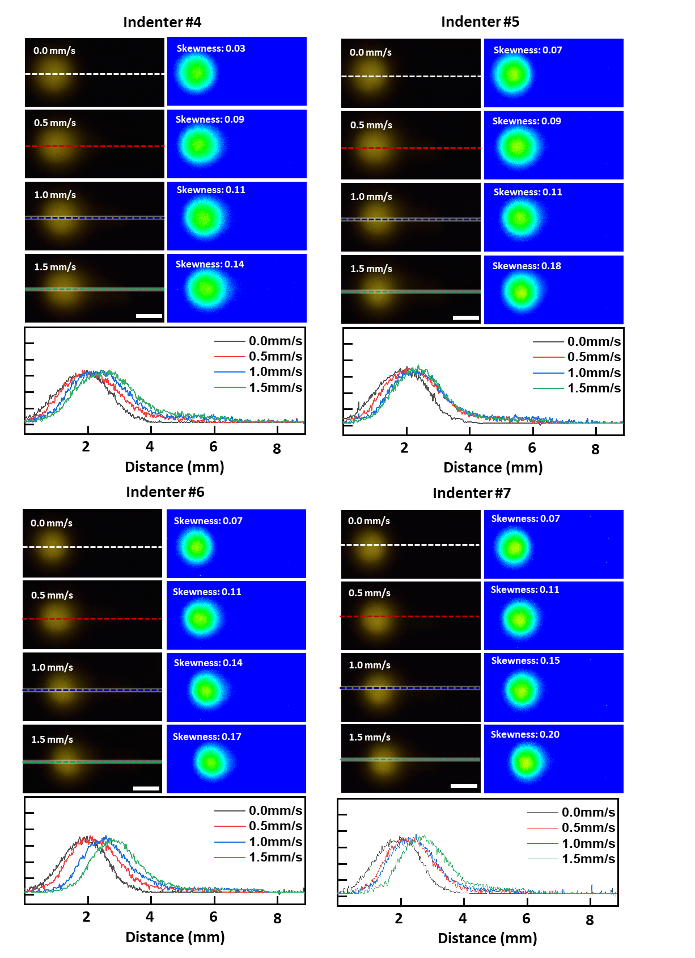
Supplementary Fig. 54 Luminescence images (left), pressure distribution profile (right), and luminescence intensity plots (bottom) change according to velocity and accelerations at 1.0 N of initial normal force applied to an indenter #3. (Scale bar, 2 mm)
Supplementary Fig. 55 Luminescence images (left), pressure distribution profile (right), and luminescence intensity plots (bottom) change according to velocity and accelerations at 1.0 N of initial normal force applied to indenters #4-7. (Scale bar, 2 mm)
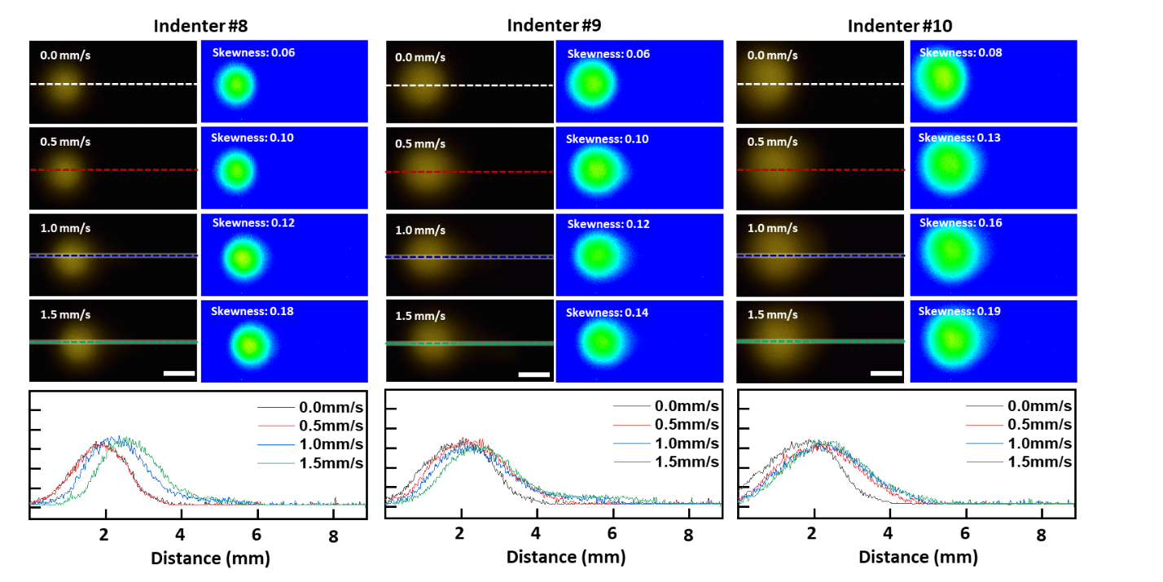
Supplementary Fig. 56 Luminescence images (left), pressure distribution profile (right), and luminescence intensity plots (bottom) change according to velocity and accelerations at 1.0 N of initial normal force applied to indenters #8-10. (Scale bar, 2 mm)
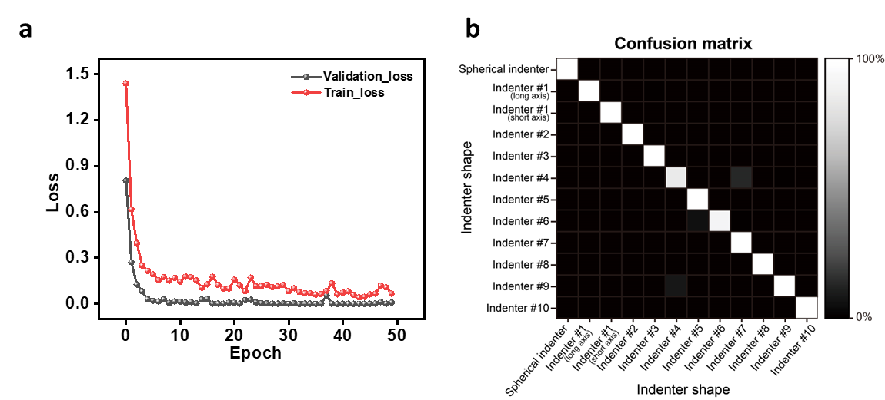
Supplementary Fig. 57 a, A loss plot showing the performance of a trained CNN model for classifying indenter shapes. b, A confusion matrix showing the performance of a trained CNN model for classifying indenter shapes.
Supplementary Fig. 58 Axisymmetric luminescence observation in the objects in laboratory. (Scale bar, 2 mm)
Supplementary Fig. 59 a-c, Optical images of micro-hemisphere deformation (a) without force, (b) with 2.0 N, and (c) with 5.0 N (Scale bar, 100 µm).
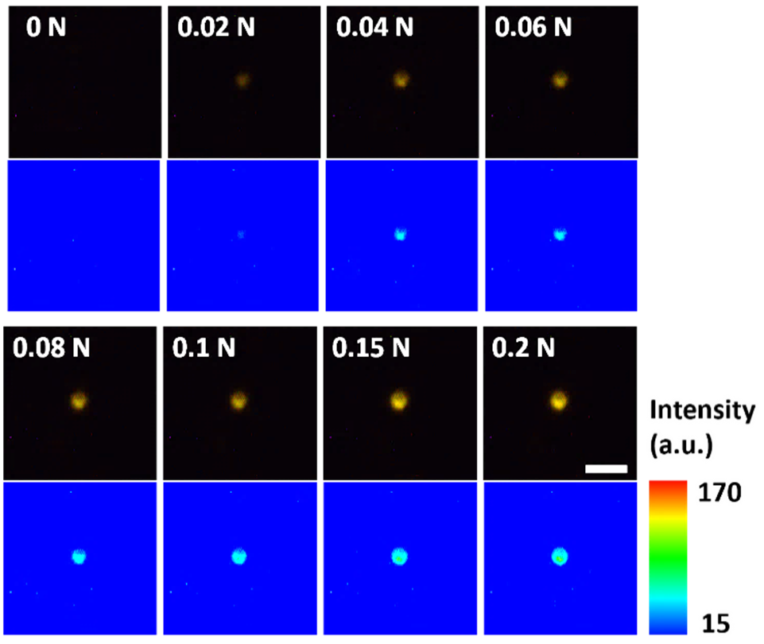
Supplementary Fig. 60 Luminescence intensity (Top) and pressure distribution profile (bottom) increase axisymmetrically when the normal force applied by a spherical indenter on the 200 µm tactile sensor pad without a stress concentration layer. (Scale bar, 2 mm)
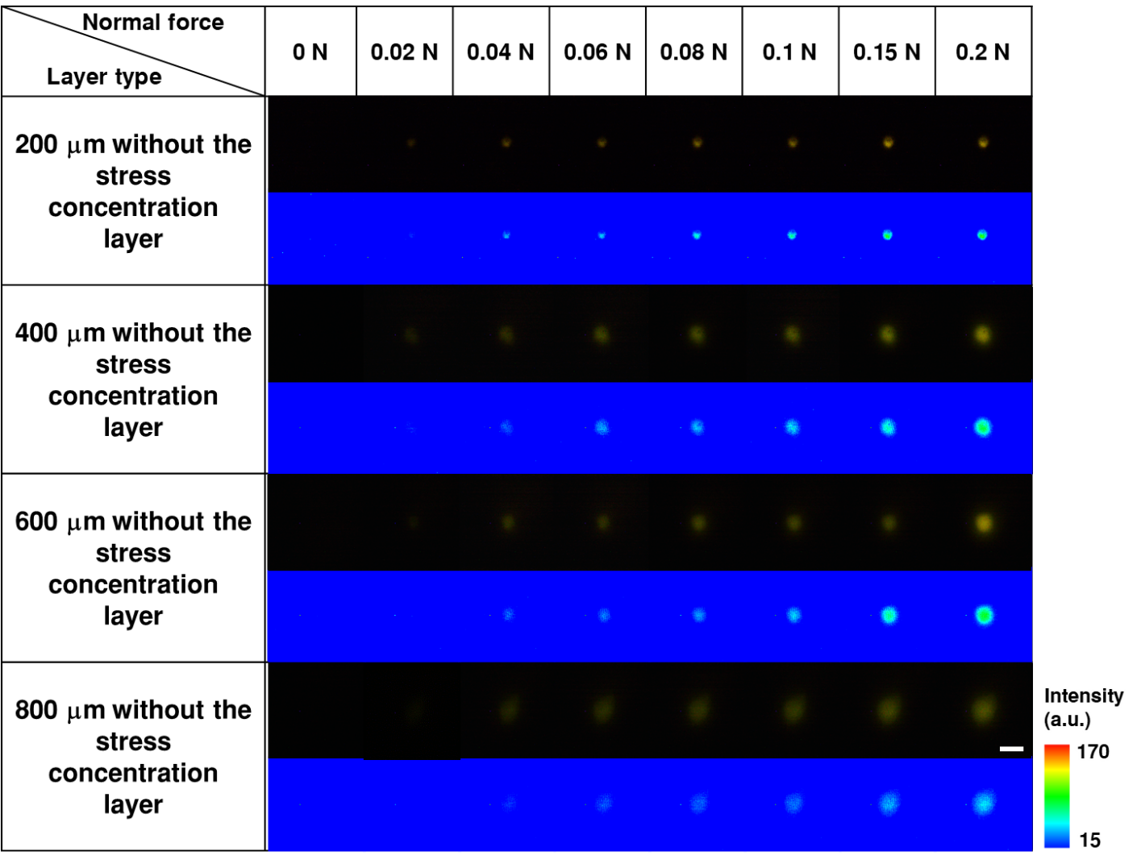
Supplementary Fig. 61 Symmetrical change in luminescence (top) and pressure distribution profile (bottom) according to the thickness of the optical tactile sensor without the locally stress concentration layer when normal force is increased from 0 to 0.2 N. (Scale bar, 2 mm)
Supplementary Fig. 62 a, b, (a)The axisymmetric UCN luminescence image (left) and its pressure distribution profile (right) under the normal force using a spherical indenter on the tactile sensor pad. (Scale bar, 2 mm) (b) Change of upconversion luminescence spectra with increasing normal force from 0 to 0.2 N.
Supplementary Fig. 63 a, b, Changes in (a) luminescence shape and (b) intensity according to the thickness of sensor pad without the stress concentration layer when pressing the sensor pad with triangular-shaped stamp. (Scale bar, 2 mm)
Supplementary Fig. 64 Optical (top) and luminescence (bottom) images of fingerprints when pressing the sensor pad with an index finger of three persons. (Scale bar, 2 mm)
Supplementary Fig. 65 Luminescence images when sensor pad is pressed with line-shaped stamp of 0.1–1.0 mm. (Scale bar, 1 mm)
Supplementary Fig. 66 a, b, Luminescence images when pressing the sensor pad with screws of various specifications (a) and recognition of thread information using MATLAB code (b). (Scale bar, 2 mm)
Supplementary Fig. 67 Schematic of a machine learning-based workflow for real-time braille-to-speech translation system.
Supplementary Fig. 68 Simplified machine learning process of braille to speech; extraction of six points, and judgment of on/off and recognition of alphabets.
Supplementary Fig. 69 a, Results of dimensionality reduction of features extracted from the RGB profile by principal component analysis. b, Normal force and threshold profiles of handwriting videos written by three individuals. c, Normal force and diameter of normal area profiles of handwriting videos written by three individuals.
Supplementary Fig. 70 a, Scatter plot of maximum intensity of normal region versus normal force (dots) and predicted plot by SVR (red line). b, Scatter plot of diameter of normal area versus normal force (dots) and predicted plot by SVR (red line).
Supplementary Fig. 71 a-c, Handwritten alphabet ‘e’ images of person 1 (a), person 2 (b), and person 3 (c). (Scale bar, 2 mm)
Supplementary Fig. 72 a, b, (a) Bar plot and (b) violin plot showing skewness distribution of pen tilts calculated on the pen moving videos with carisou velocities and normal foces. c, Pen tilt angle range of person 1, 2, and 3.
Supplementary Fig. 73 LDA clustering for handwriting comparison to distinguish letter images written by three individuals clustered by shear force related features, velocity related features, and both shear force and velocity related features.
Supplementary Fig. 74 Mean of intra cluster distance (gray) and mean of inter cluster distance (orange) clustered by shear force related features, velocity related features, and both shear force and velocity related features.
Supplementary Fig. 75 Comparison of LDA clustering performance in terms of Calinski–Harabasz index and Silhouette coefficient for clusters of shear force related features, velocity related features, and both shear force and velocity related features.
Supplementary Table 1. Features extracted from the red and green channels in RGB histograms for normal force prediction.
Purpose |  | Feature type | No. | Feature description
Predict Normal Force |  | Green intensity related features | F1 | The height of initial point with zero intensity
Predict Normal Force |  | Green intensity related features | F2 | The height of maximum peak
Predict Normal Force |  | Green intensity related features | F3 | The height of minimum peak
Predict Normal Force |  | Green intensity related features | F4 | The ratio of F2 to F1
Predict Normal Force |  | Green intensity related features | F5 | The ratio of F1 to F3
Predict Normal Force |  | Green intensity related features | F6 | The ratio of F2 to F3
Predict Normal Force |  | Green intensity related features | F7 | The slope of maximum peak to minimum peak
Predict Normal Force |  | Green intensity related features | F8 | The area between maximum peak to minimum peak
Predict Normal Force |  | Red intensity related features | F9 | The height of maximum peak
Predict Normal Force |  | Red intensity related features | F10 | The height of minimum peak
Predict Normal Force |  | Red intensity related features | F11 | The ratio of F9 to the height of initial point with zero intensity
Predict Normal Force |  | Red intensity related features | F12 | The ratio of F9 to the height of initial point with zero intensity
Predict Normal Force |  | Red intensity related features | F13 | The ratio of to the height of initial point with zero intensity to F10
Predict Normal Force |  | Red intensity related features | F14 | The slope of maximum peak to minimum peak
Predict Normal Force |  | Red intensity related features | F15 | The area between initial point to minimum point
Predict Normal Force |  | Red intensity related features | F16 | The area between initial point to minimum point
Predict Normal Force |  | Red intensity related features | F17 | The skewness of minimum area
Predict Normal Force |  | Red intensity related features | F18 | The kurtosis of minimum area

Supplementary Table 2. SVR model and parameters to predict the normal force.
Purpose | Model | Model parameter | r² | RMSE | MAPE
Predict normal force for indenter | SVR | C=10, cache_size=200, Coef0=0.0, degree=3, epsilon=0.1, gamma=’auto’, kernel=’rbf'’, max_iter=-1, shrinking=Ture, tol=0.001, verbose=False | 0.965 | 0.061 | 4.885
Predict normal force for pen | SVR | C=10, cache_size=200, Coef0=0.0, degree=3, epsilon=0.1, gamma=’auto’, kernel=’rbf'’, max_iter=-1, shrinking=Ture, tol=0.001, verbose=False | 0.943 | 0.105 | 6.724

Supplementary Table 3. SVR model and parameters to predict the shear force.
Purpose | Model | Model parameter | r² | RMSE | MAPE
Predict shear force for indenter | SVR | C=1000, cache_size=200, Coef0=0.0, degree=3, epsilon=0.05, gamma=0.25, kernel='rbf', max_iter=-1, shrinking=True, tol=0.001, verbose=False | 0.947 | 0.071 | 5.433
Predict shear force for pen | SVR | C=1000, cache_size=200, Coef0=0.0, degree=3, epsilon=0.05, gamma=0.25, kernel='rbf', max_iter=-1, shrinking=True, tol=0.001, verbose=False | 0.826 | 0.054 | 4.219

Supplementary Table 4. Performance of recent optical tactile sensor systems.
No. | Sensing method | Materials | Response time (ms) | Colors | Resolution | Detection limit  (Sensing range) | Quantification of shear force | Ref
1 | Triboelectrification induced electroluminescence | ZnS:Cu | < 250 | Green | 1.0 mm | 10 kPa  (10-80 kPa) | X | (3)
2 | Electroluminescence | Quantum dots | 1 | Multi colors | 1000 dpi | < 10 kPa  (0.1-160 kPa) | X | (4)
3 | Triboelectrification induced electroluminescence | ZnS:Cu, Al | < 100 | Green | Unknown | 20 kPa  (20-160 kPa) | X | (5)
4 | Mechanoluminescence | UCNs | Unknown | Multi colors | 0.7 mm | 5 N  (5-50 N) | X | (6)
5 | Mechanoluminescence | SrZn₂S₂O & SrZnSO | < 200 | Multi colors | Unknown | 100 N  (200-2200 N) | X | (7)
6 | Electroluminescence | ZnS:Cu | Unknown | Green | 0.5 mm | < 20 kPa  (20-80 kPa) | X | (8)
7 | Triboelectrification induced electroluminescence | ZnS:Cu | Unknown | Green | 0.08 mm | 4 kPa  (4-400 kPa) | X | (9)
8 | Mechanoluminescence | (Sr, Ba)Si₂O₂N₂:Eu²⁺, Dy³⁺ | Unknown | Multi colors | Unknown | 0.2 N  (Unknown) | X | (10)
9 | Mechanoluminescence | Y₃Al₅O₁₂:Ce³⁺ & Ba_{0.5}Sr_{0.5}Si₂O₂N₂:Eu³⁺ | Unknown | Yellow & Green | 2 mm | 0.2 N  (0.2-1.2 N) | X | (11)
10 | Mechanoluminescence | ZnS:Mn | 9.6 | Yellow | 0.1 mm (254 dpi) | 0.8 N  (0.8-10 N) | X | (12)
 | Optical sensing | UCNs | 9.12 | Multi colors | 0.1 mm | 0.02 N  (0.02-5 N) | O | This Work

Supplementary Table 5. Agglomerative Clustering model and parameters for clustering the intensity profile.
Purpose | Model | Model parameter
Cluster intensity profile | AgglomerativeClustering | Affinity=’euclidean’, compute_full_tree=’auto’, connectivity=None, linkage=’ward’, memory=None, n_cluster=5, pooling_func=’deprecated’

Supplementary Table 6. Normal force related features.
Purpose | Feature type | No. | Feature Description
Predict diameter of normal force area | Intensity profile related features | F1 | The radius containing the maximum value of the clustered intensity profile
Predict Maximum intensity of the normal force | Intensity profile related features | F1 | Maximum value of intensity profile

Supplementary Table 7. Two SVR models and parameters to extract normal force features.
Purpose | Model | Model parameter | r² | RMSE | MAPE
Predict max intensity of normal force area | SVR | C=1, cache_size=200, Coef0=0.0, degree=3, epsilon=0.1, gamma=’auto’, kernel=’poly’, max_iter=-1, shrinking=Ture, tol=0.001, verbose=False | 0.954 | 2.563 | 1.905
Predict diameter of normal force | SVR | C=10, cache_size=200, Coef0=0.0, degree=3, epsilon=0.1, gamma=’auto’, kernel=’poly’, max_iter=-1, shrinking=Ture, tol=0.001, verbose=False | -0.000916 | 25.324 | 20.963

Supplementary Table 8. Features fed into LDA.
Purpose | Feature type | No. | Feature description
Handwriting Analysis | Normal force related features | F1 | Mean, kurtosis, skewness, variance, standard deviation of maximum intensity in normal force
Handwriting Analysis | Normal force related features | F2 | Mean, kurtosis, skewness, variance, standard deviation of diameter in normal force
Handwriting Analysis | Shear force related features | F3 | Mean, kurtosis, skewness, variance, standard deviation of length of major axis in shear area
Handwriting Analysis | Shear force related features | F4 | Mean, kurtosis, skewness, variance, standard deviation of length of minor axis in shear area
Handwriting Analysis | Shear force related features | F5 | Mean, kurtosis, skewness, variance, standard deviation of the ratio of the major to the minor axis in shear area
Handwriting Analysis | Shear force related features | F6 | Mean, kurtosis, skewness, variance, standard deviation of the angle of major axis in shear area
Handwriting Analysis |  | F7 | Mean, kurtosis, skewness, variance, standard deviation of shear force
Handwriting Analysis | Velocity related features | F8 | Mean, kurtosis, skewness, variance, standard deviation of multi frame-based velocity
Handwriting Analysis | Velocity related features | F9 | Mean, kurtosis, skewness, variance, standard deviation of multi frame-based acceleration

Supplementary Table 9. Silhouette coefficient and Calinski-Harabasz index of force related features combination.
Combination | Silhouette coefficient | Calinski-Harabasz index
Normal force | 0.574174 | 65.192887
Shear force | 0.72751 | 311.606161
Velocity | 0.594683 | 142.291614
Normal force & Velocity | 0.780552 | 249.04227
Shear force & Velocity | 0.863768 | 682.738884
Normal force & Shear force & Velocity | 0.858308 | 452.007904
Normal force & Shear force | 0.866549 | 576.247464

Supplementary Movie 1 Axisymmetric circular luminescence change when applied the normal force.
Supplementary Movie 2 Non-axisymmetric oval luminescence change when applied the shear force.
Supplementary Movie 3 Machine learning assisted quantitative analysis of the normal force.
The top-left movie shows the normal force detection and its measurement value obtained from the force gauge. The red contour is based on the predicted threshold of the normal force, and the estimated normal force value is also shown frame-by-frame. The file automatically converts to a movie file with a stress distribution form and estimates the normal force value from the machine learning system (top-right side). The bottom movie shows a plot of both the measured and estimated normal force value changes at each time.
Supplementary Movie 4 Decoupling of the applied dynamic force to the normal and shear force by spherical indenter using machine learning algorithm.
The movie on the left shows the normal and shear force detection frame by frame from machine learning. The red contour is based on the predicted threshold of the normal force, and the yellow contour indicates the half value of the normal threshold for showing the shear force direction. The file automatically converts to a movie file with a stress distribution form and estimates the normal and shear force values and the direction of the force from the machine learning system.
Supplementary Movie 5 Classification of multiple types of screws.
Supplementary Movie 6 Machine learning assisted braille-to-speech system.
Supplementary Movie 7 Decoupling of the applied dynamic force to the normal and shear force by pen using machine learning algorithm.
The movie on the left shows the normal and shear force detection frame by frame from machine learning. The red contour is based on the predicted threshold of the normal force, and the yellow contour indicates the half value of the normal threshold for showing the shear force direction. The file automatically converts to a movie file with a stress distribution form and estimates the normal and shear force values and the direction of the force from the machine learning system.
References
1. Lee, J. et al. Universal process-inert encoding architecture for polymer microparticles. Nat. Mater. 13, 524-529 (2014).
2. Israelachvili, J. et al. Recent advances in the surface forces apparatus (SFA) technique. Rep. Prog. Phys 73, 036601 (2010).
3. Wei, X. Y. et al. Dynamic triboelectrification‐induced electroluminescence and its use in visualized sensing. Adv. Mater. 28, 6656-6664 (2016).
4. Lee, B. et al. Ultraflexible and transparent electroluminescent skin for real-time and super-resolution imaging of pressure distribution. Nat. Commun. 11, 1-11 (2020).
5. Zhao, X. et al. Self-powered user-interactive electronic skin for programmable touch operation platform. Sci. Adv. 6, eaba4294 (2020).
6. Du, Y. et al. Mechanically excited multicolor luminescence in lanthanide ions. Adv. Mater. 31, 1807062 (2019).
7. Chen, C. et al. Creating visible-to-near-infrared mechanoluminescence in mixed-anion compounds SrZn₂S₂O and SrZnSO. Nano Energy 68, 104329 (2020).
8. Wang, Y. et al. Enhanced high-resolution triboelectrification-induced electroluminescence for self-powered visualized interactive sensing. ACS Appl. Mater. Interfaces 11, 13796-13802 (2019).
9. Wei, X. Y. et al. High‐intensity triboelectrification‐induced electroluminescence by microsized contacts for self‐powered display and illumination. Adv. Mater. Interfaces 5, 1701063 (2018).
10. Zhuang, Y. et al. Force-induced charge carrier storage: a new route for stress recording. Light Sci. Appl. 9, 1-9 (2020).
11. Ma, Z. et al. Mechanics-induced triple-mode anticounterfeiting and moving tactile sensing by simultaneously utilizing instantaneous and persistent mechanoluminescence. Mater. Horiz. 6, 2003-2008 (2019).
12. Wang, X. et al. Dynamic pressure mapping of personalized handwriting by a flexible sensor matrix based on the mechanoluminescence process. Adv. Mater. 27, 2324-2331 (2015).

