Supplementary Figures and Tables

Supplementary Figures

Figure S1. The scatter plot depicts the Temperature-specific catch ratio of Chum. The vertical axis represents the daily catch ratio compared to the total catch for the year, while the right vertical axis represents UOT one day prior to the daily catch data. Magenta solid line represents the estimated polynomial regression line. Blue solid line represents the mean of catch ratio by UOT.

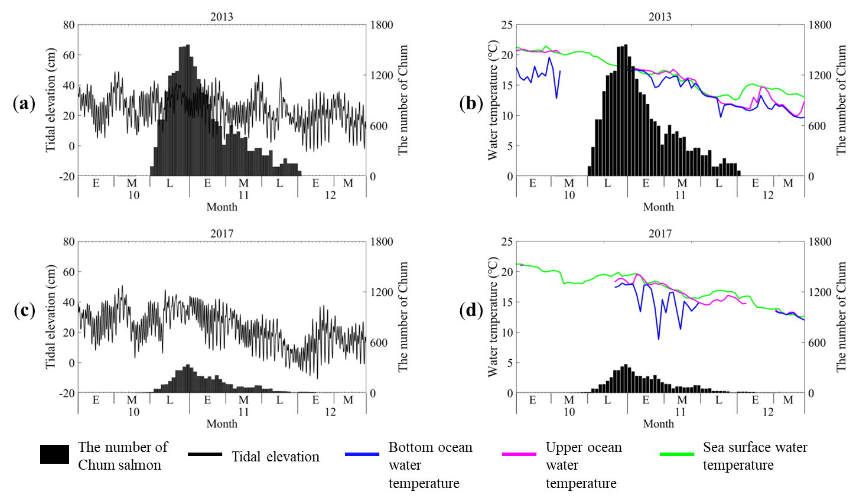
Figure S2. Daily variation in the number of Chum salmon (bars), tidal elevation (black solid line), sea surface (green solid line, SST), upper (magenta solid line, UOT) and bottom (blue solid line, BOT) water temperature in the representative years for Type 1 Chum migration (2013, 2017). E, M, and L on the x-axis indicate the early, middle, and late stages of each month, respectively. (a): Daily variation in the number of Chum salmon with tidal elevation in 2013. (b): Daily variation in the number of Chum salmon with SST, UOT and BOT in 2013. (c): Daily variation in the number of Chum salmon with tidal elevation in 2017. (d): Daily variation in the number of Chum salmon with SST, UOT and BOT in 2017.

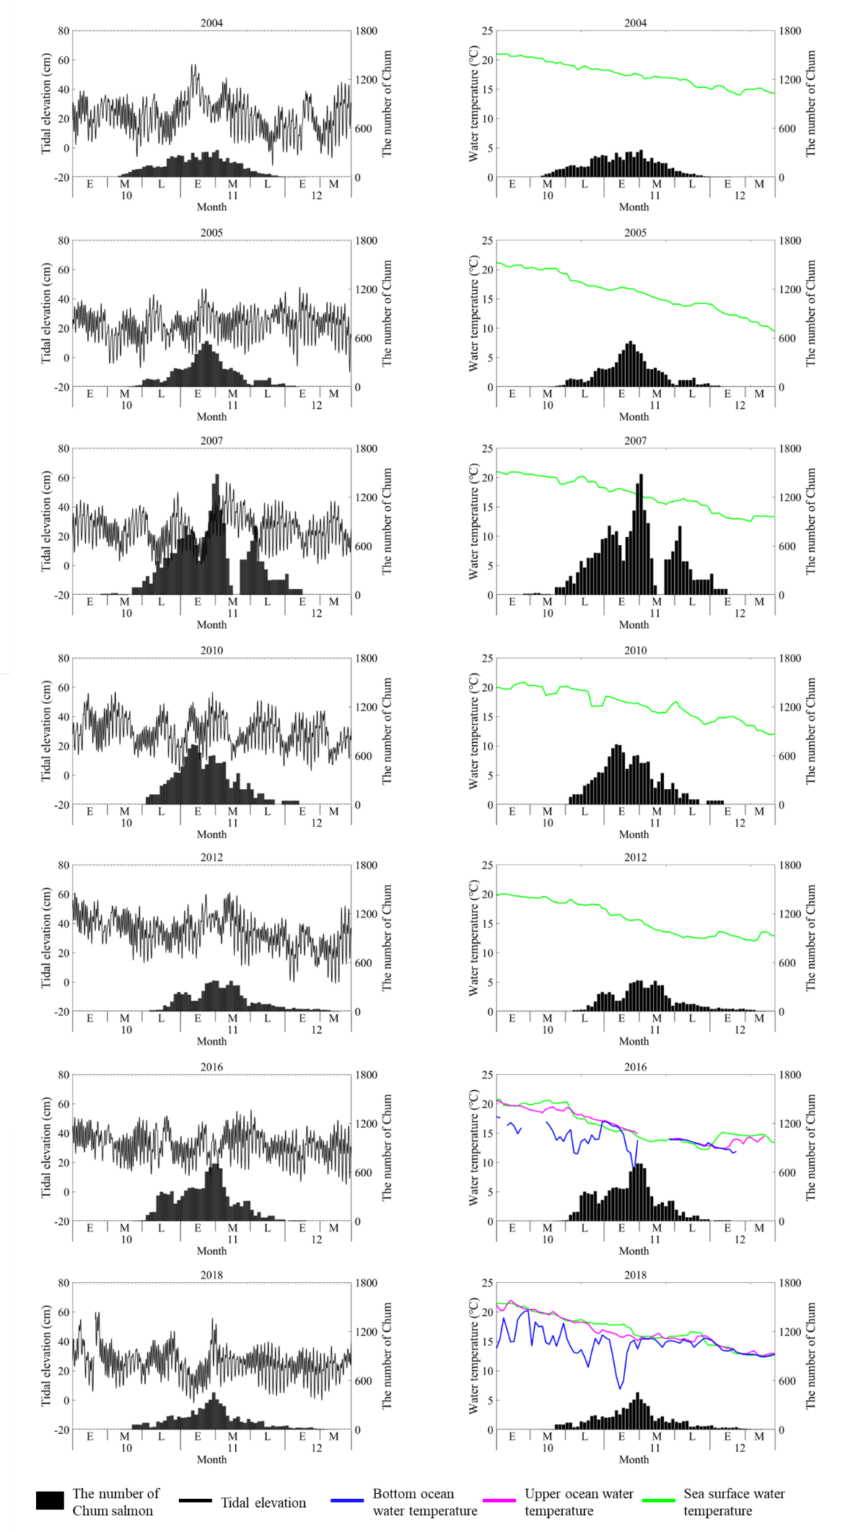
Figure S3. Daily variation in the number of Chum salmon (bars), tidal elevation (black solid line), sea surface (green solid line, SST), upper (magenta solid line, UOT) and bottom (blue solid line, BOT) water temperature in the representative years for Type 2 Chum migration (2004, 2005, 2007, 2010, 2012, 2016, 2018). E, M, and L on the x-axis indicate the early, middle, and late stages of each month, respectively.

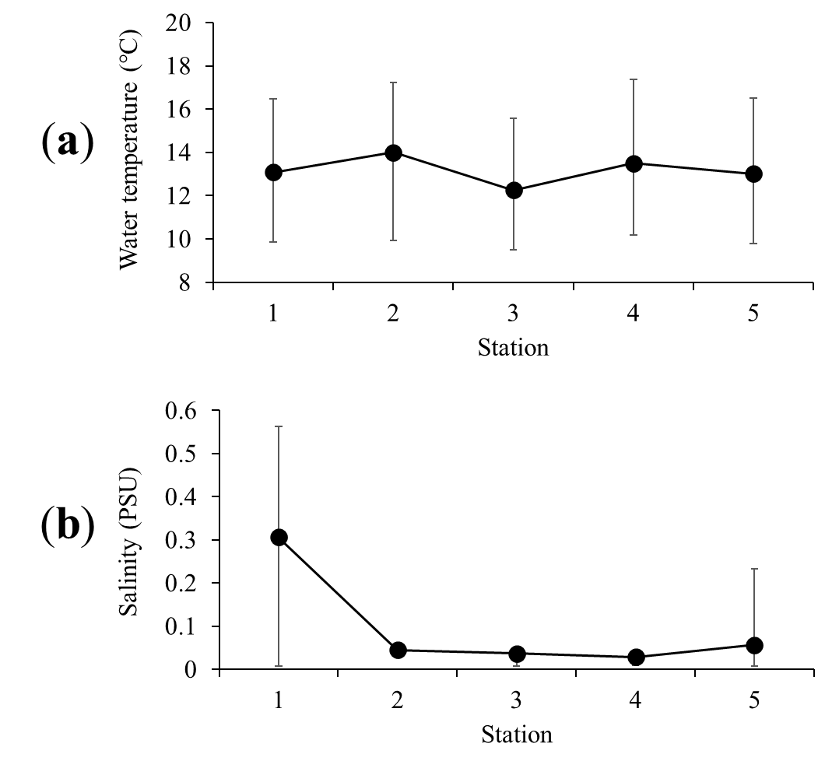
Figure S4. Water temperature (a), salinity (b) recorded at each station along the Namdae River from October 19 to November 25, 2019 (n =6). The values of black solid circle are the mean of each parameter at each station. The error bars represent the maximum and minimum values at each station.

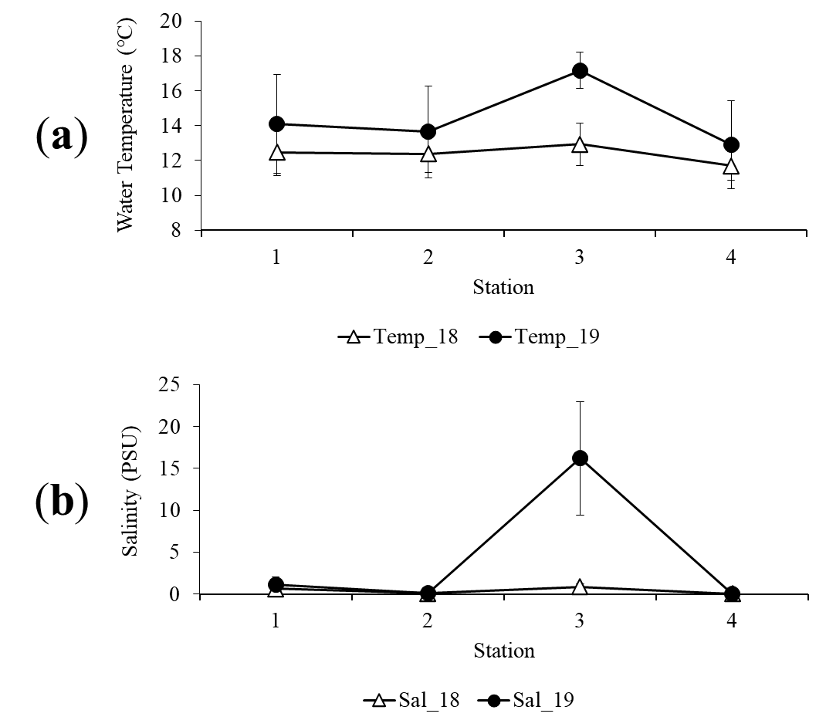
Figure S5. Water temperature (a), salinity (b) measured at four stations on the Yeongok River. The values of black solid circle and open triangle are the mean of each parameter at each station. The solid line joining the open triangles represents the observation period of October 24 to November 9, 2018. The black solid line adjoining the solid circles represents the observation period from October 12 to November 23, 2019.

Figure S6. Schematic diagram indicating salmon migration in Cases A, B, and C (a-c) in the Yeongok River in 2018. Line 1, 2, and 3 served as reference points for monitoring salmon location. The black circles indicate the salmon location estimated from the radio tags. The open circles indicate the locations where the salmon remained for an extended period. The dashed arrow indicates the estimated migration route. YR1–9 indicate the tagged fish that were tracked. EJS, East/Japan Sea.

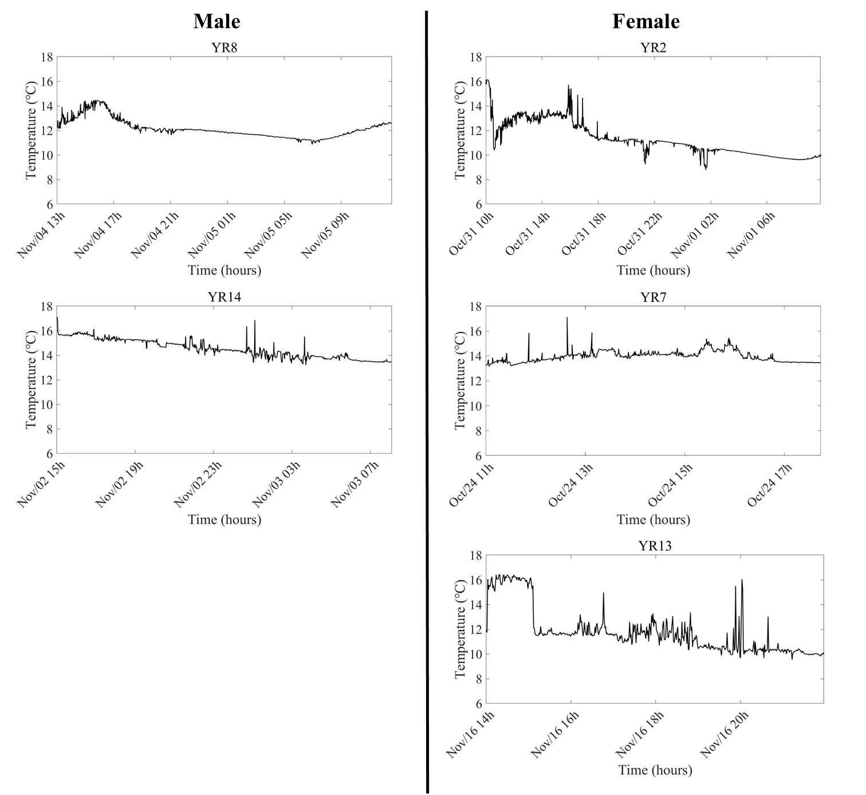
Figure S7. Time-series change in temperature (black line) measured by data loggers attached to the salmon YR2, YR7, YR8, YR13, YR14. It released at different times, unlike YR3-6 in Fig. 8.

Figure S8. Schematic diagram indicating salmon migration in Cases D–F. (a) Case D, 2018; (b) Case D, 2019; (c) Case E; (d) Case F. Lines 1, 2, and 3 served as reference points for monitoring salmon location. YR10-17 indicate the tagged fish that were tracked. The black circles indicate the salmon location estimated from the radio tags. The open circles indicate the locations where the salmon remained for an extended period. The dashed arrow indicates the estimated migration route. EJS, East/Japan Sea.

Figure S9. Changes in the Yeongok River’s topography from 2018 and 2019. Black circles with numbers indicate the conductivity-temperature-depth observation stations. The same stations were used in 2018 and 2019. C and R indicate the catch and release points, respectively, in 2018 (a) and 2019 (b).

Supplementary Tables
Type | Peak migration date* | Year
Type 1 | October 30 | 2009
Type 1 | October 30 | 2013
Type 1 | October 29 | 2015
Type 1 | October 31 | 2017
Type 2 | November 2 | 2004
Type 2 | November 5 | 2005
Type 2 | November 6 | 2007
Type 2 | November 5 | 2008
Type 2 | November 4 | 2010
Type 2 | November 3 | 2011
Type 2 | November 7 | 2012
Type 2 | November 2 | 2014
Type 2 | November 5 | 2016
Type 2 | November 7 | 2018
Type 3 | November 13 | 2006
*The date at which > 50 % of the total number of migratory salmon recorded had entered the river from the coast.
Table S1. Chum salmon migration types based on the date when more than 50 % of the recorded migrating salmon entered the Namdae River from the coast.

