Figure S1
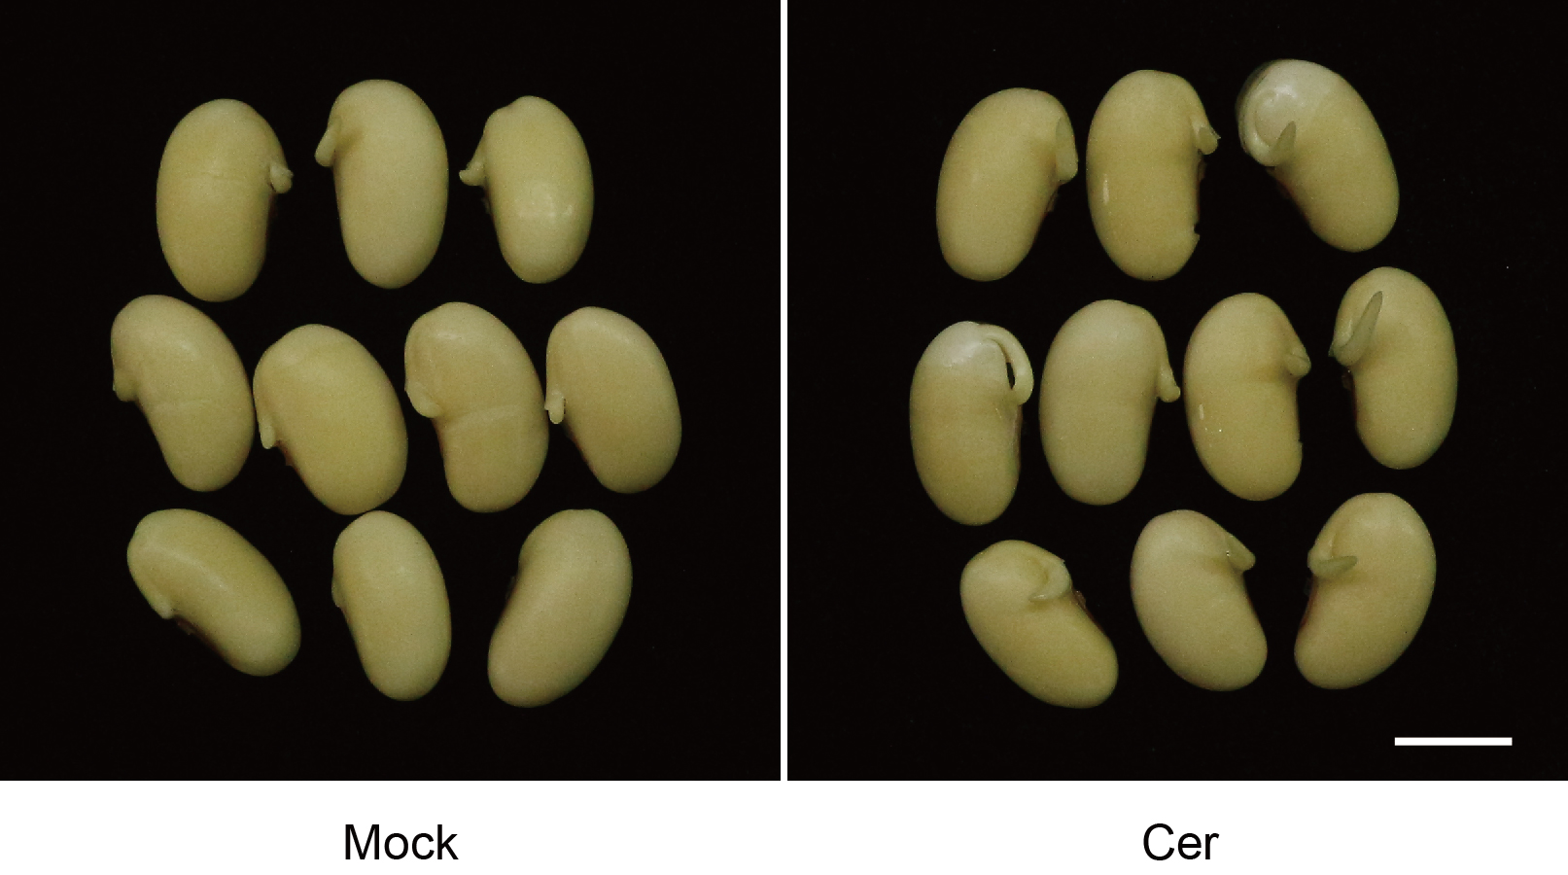
Figure S1. Germination performance of soybean seeds.
Germination performance of soybean seeds after 36h imbibition with or without C24 phytoceramide t18:0/24:0 (Cer) treatment. Bar, 1 cm.

Figure S2
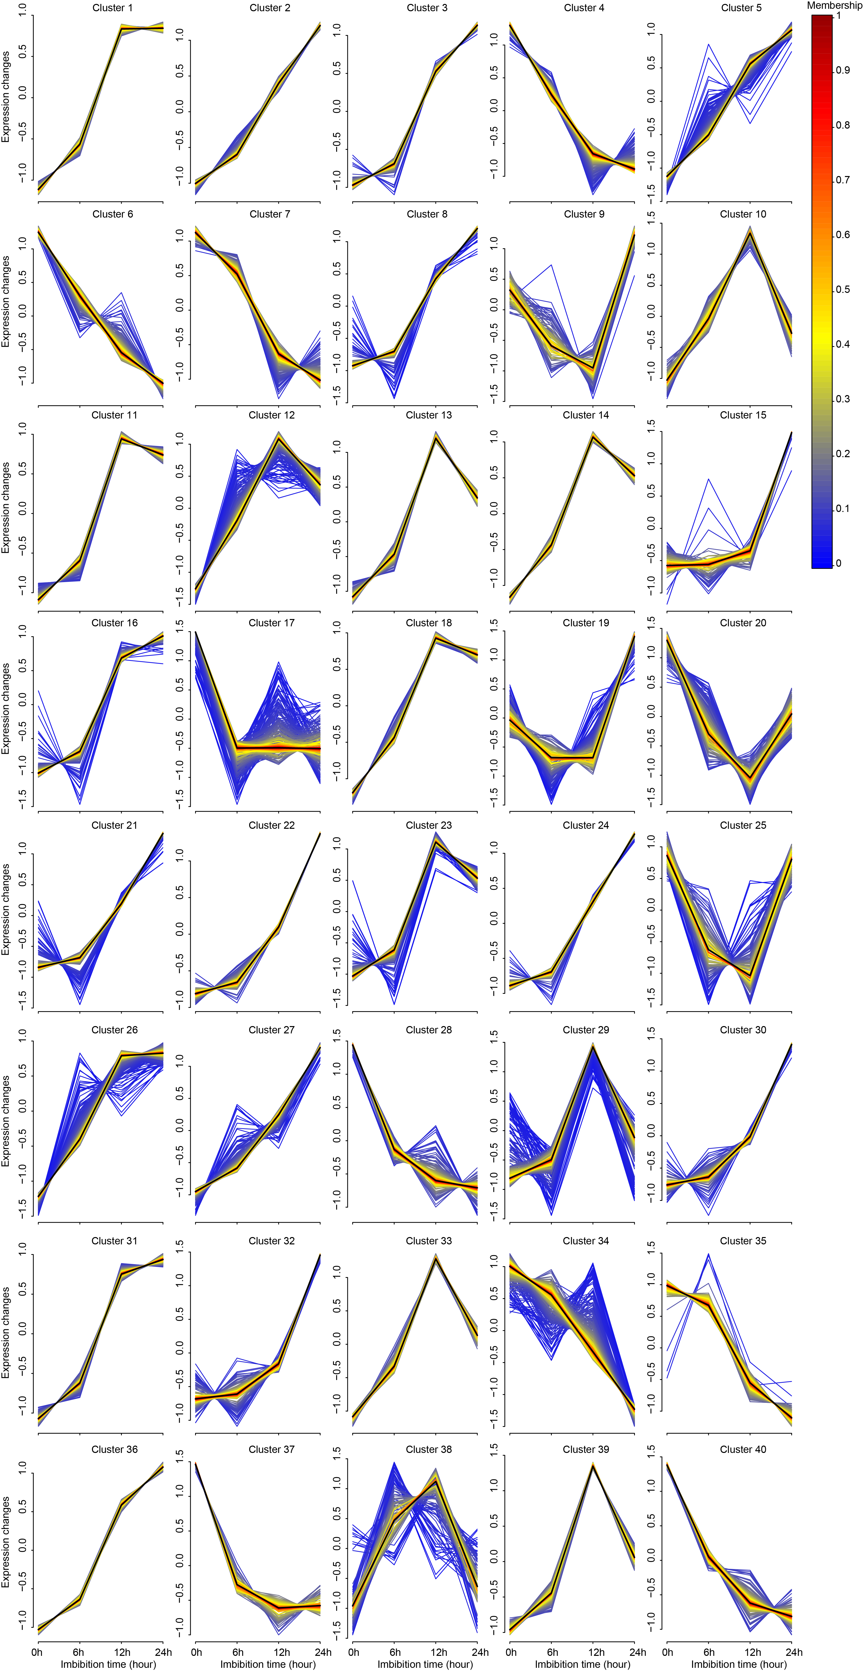
Figure S2. Temporal expression profiles of DEGs.
Time-course expression of DEGs analyzed by Mfuzz software. Different clusters represent different expression patterns. The ordinate represents changes in gene expression and the abscissa represents time series. The scale on the right represents the degree of participation of genes in different clusters, and the higher the value, the higher the importance.
Figure S3
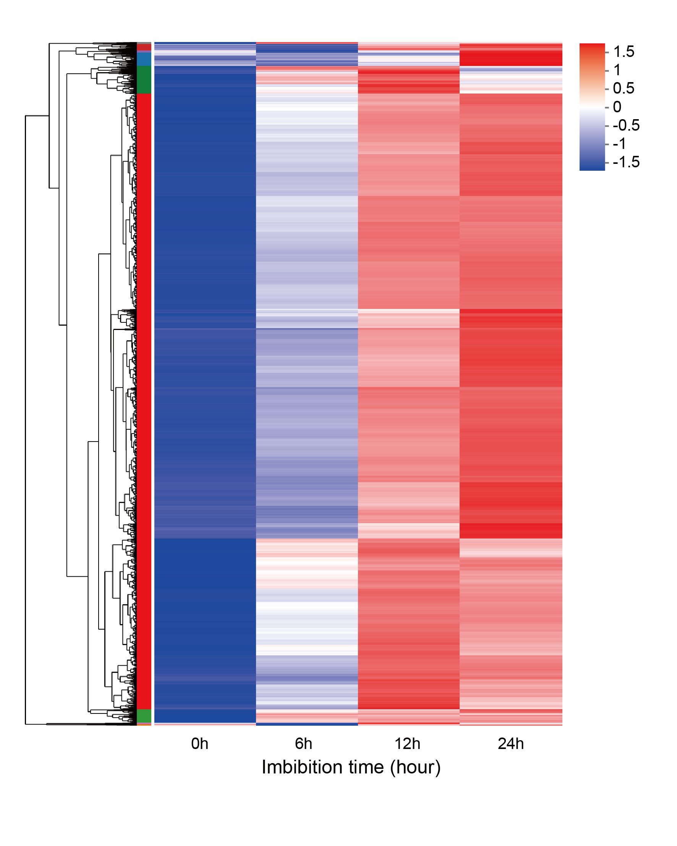
Figure S3. Cluster analysis of turquoise module genes.
Heat-map hierarchical clustering the 4555 DEGs identified in the turquoise module. Each column in the chart represents a sample, each row represents a gene, and the color in the chart represents the expression value of the gene after standardized treatment in each sample. Red represents the higher expression level of the gene in the sample, and blue represents the lower expression level. For the specific change trend of the expression level, please see the digital annotation under the color bar on the upper left. On the left are the tree diagram of gene cluster and the module diagram of sub-cluster.

Figure S4
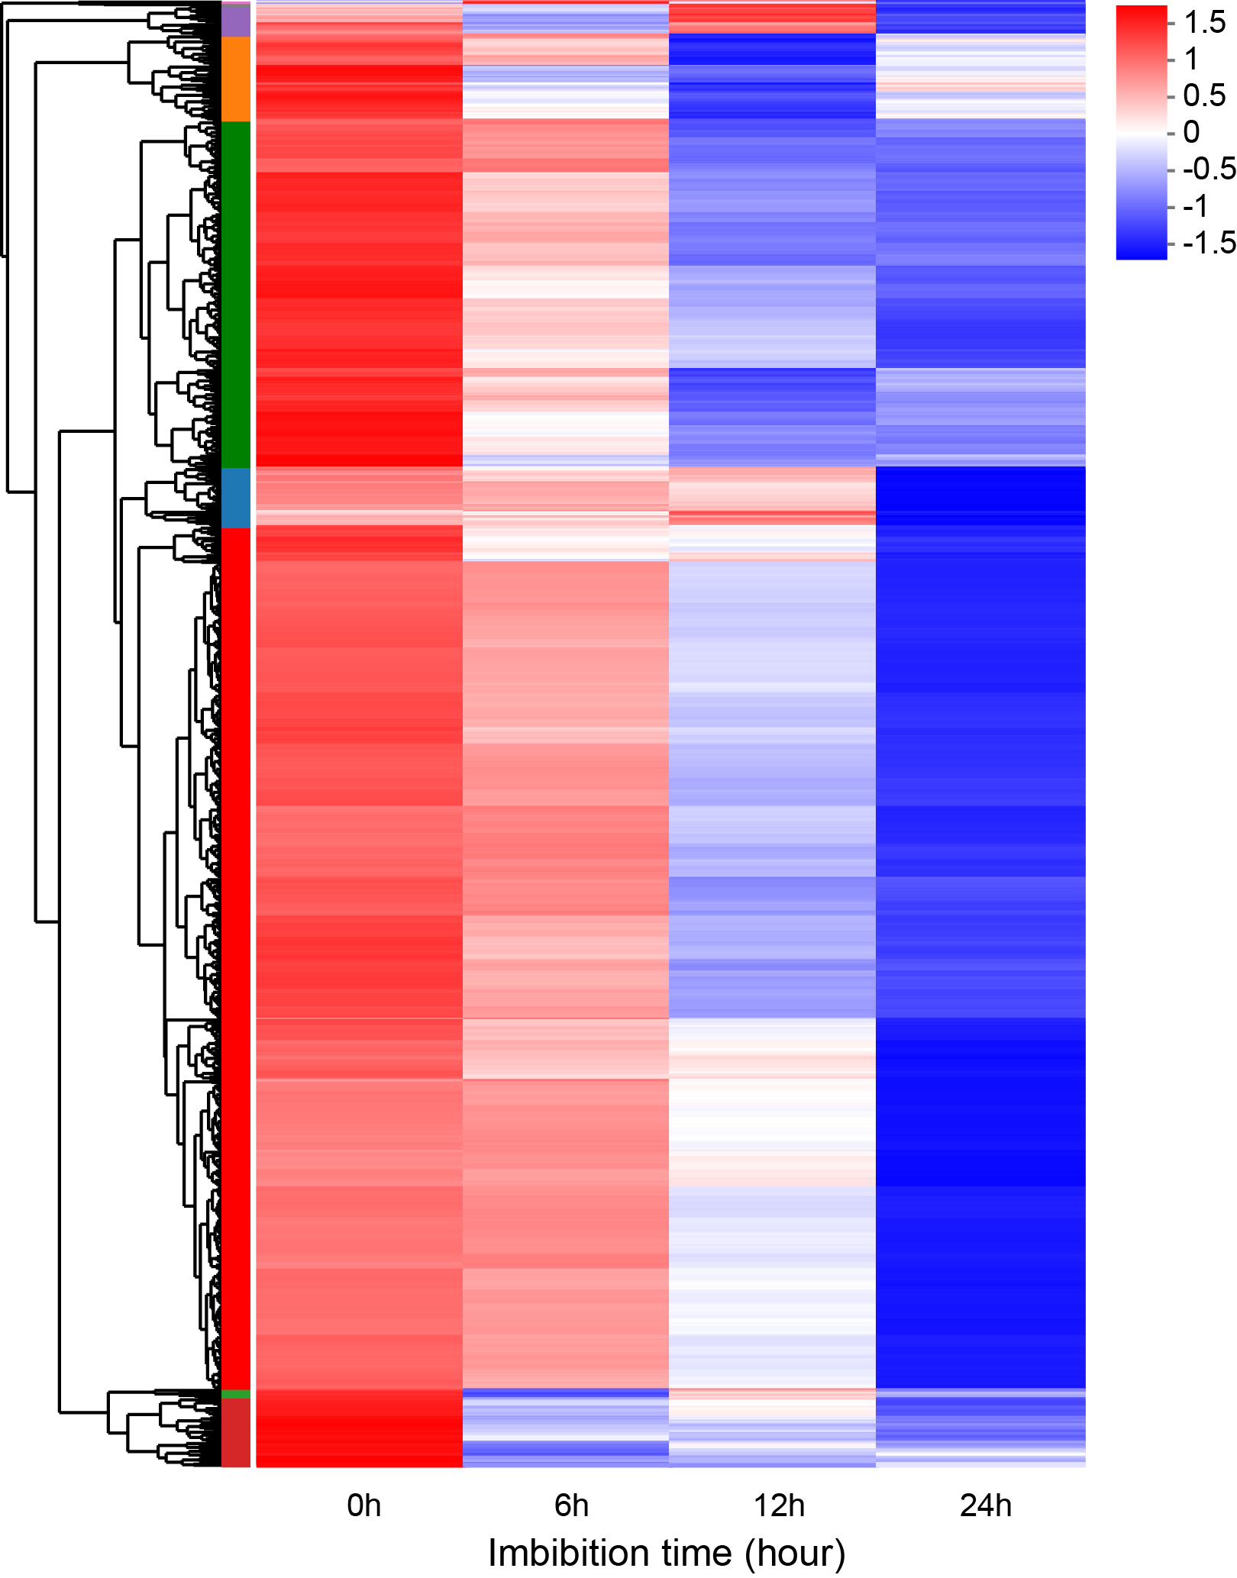
Figure S4. Cluster analysis of blue module genes.
Heat-map hierarchical clustering the 1174 DEGs identified in the blue module. Each column in the chart represents a sample, each row represents a gene, and the color in the chart represents the expression value of the gene after standardized treatment in each sample. Red represents the higher expression level of the gene in the sample, and blue represents the lower expression level. For the specific change trend of the expression level, please see the digital annotation under the color bar on the upper left. On the left are the tree diagram of gene cluster and the module diagram of sub-cluster.

Figure S5
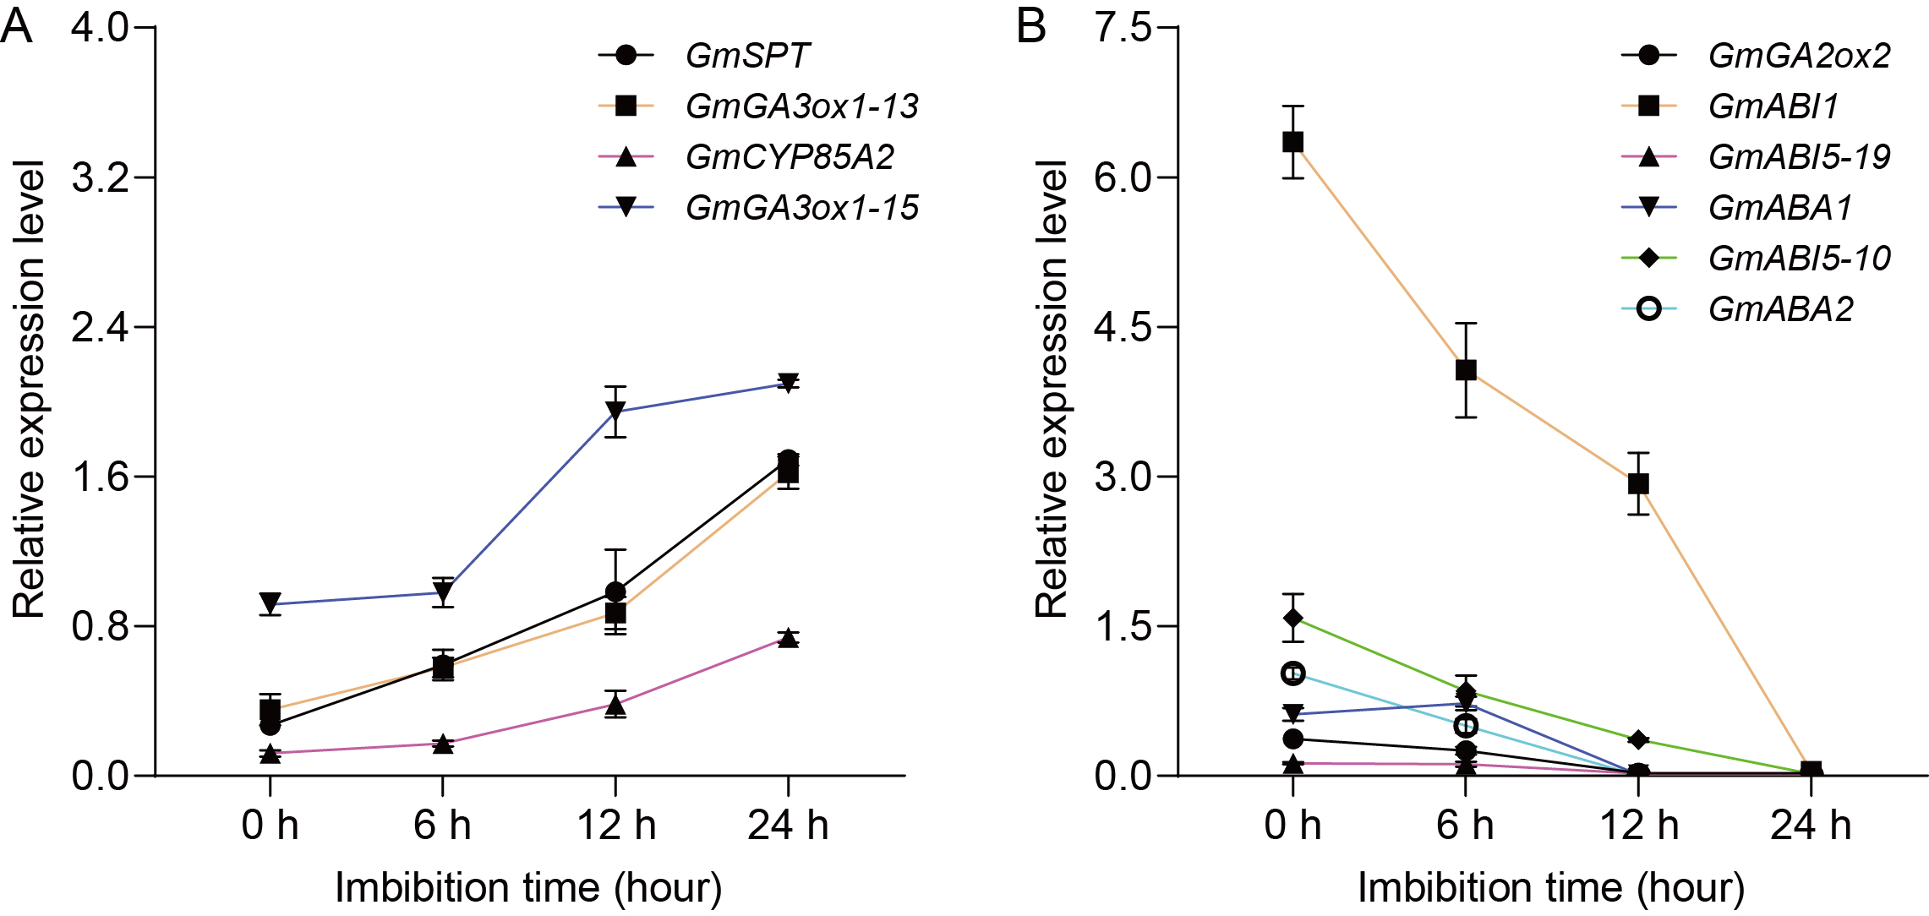
Figure S5. KEGG enrichment analysis of turquoise module genes.
A. The expression of turquoise module genes during seed germination detcted by Quantitative real-time PCR. B. The expression of blue module genes during seed germination detcted by Quantitative real-time PCR. GmGA3ox1-13 indicates the GmGA3ox1 gene is on chromosome 13, and so on. GmTUB4 was used as an internal control.

Figure S6
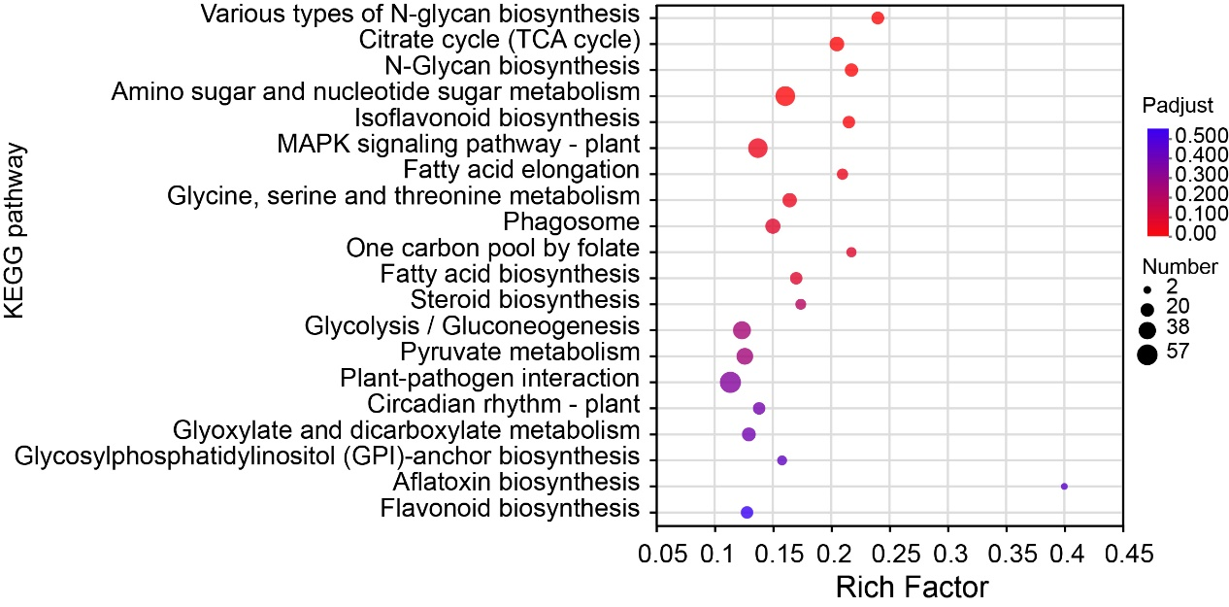
Figure S6. KEGG enrichment analysis of turquoise module genes.
The scatter plot shows detailed descriptions of the pathway within the top 20 KEGG enrichment analysis of the turquoise module genes. KEGG, Kyoto Encyclopedia of Genes and Genomes. The vertical axis represents the KEGG pathway, and the horizontal axis represents the ratio of the Rich factor (Sample number of genes enriched in the KEGG pathway) to the annotated gene number. The larger the Rich factor, the greater the degree of enrichment, the size of the dots indicates the number of genes in this KEGG pathway, and the color of the dots corresponds to different Padjust ranges.

Figure S6
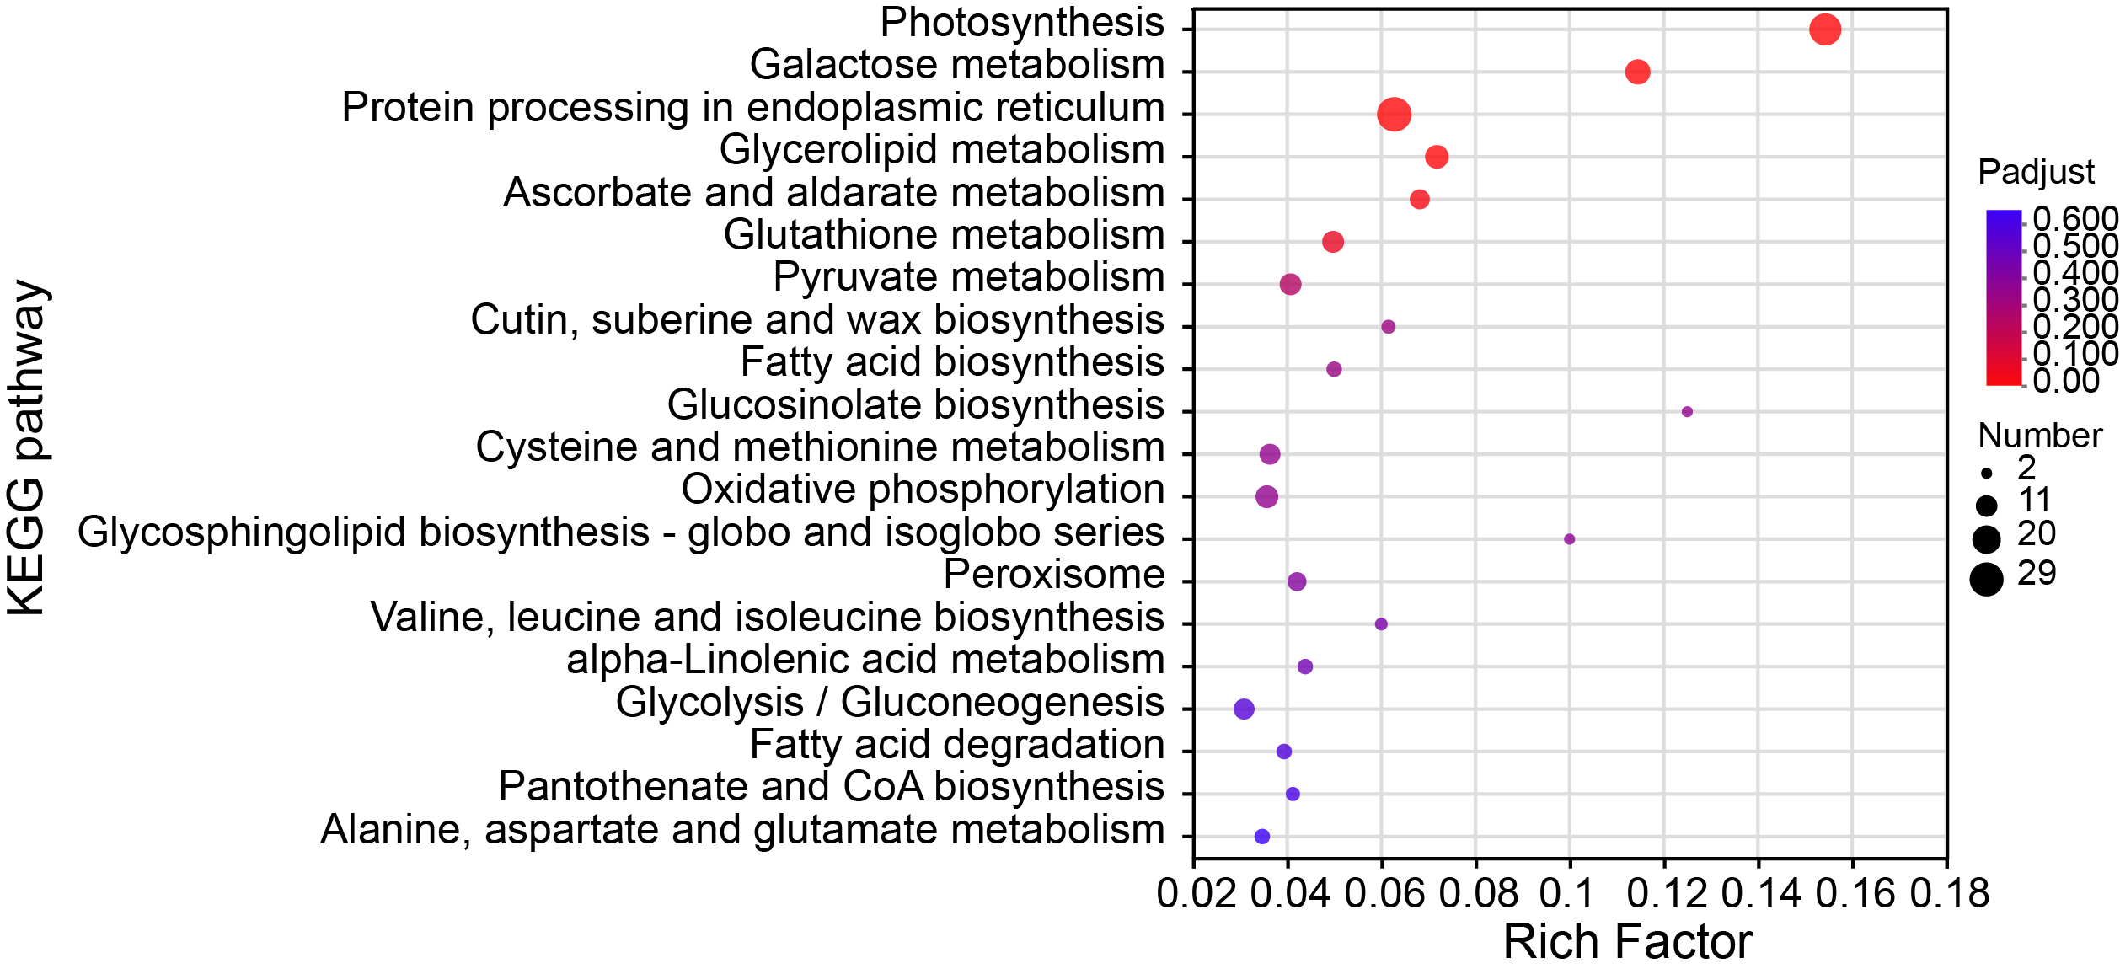
Figure S6. KEGG enrichment analysis of blue module genes.
The scatter plot shows detailed descriptions of the pathway within the top 20 KEGG enrichment analysis of the blue module genes. KEGG, Kyoto Encyclopedia of Genes and Genomes. The vertical axis represents the KEGG pathway, and the horizontal axis represents the ratio of the Rich factor (Sample number of genes enriched in the KEGG pathway) to the annotated gene number. The larger the Rich factor, the greater the degree of enrichment, the size of the dots indicates the number of genes in this KEGG pathway, and the color of the dots corresponds to different Padjust ranges.

Figure S8
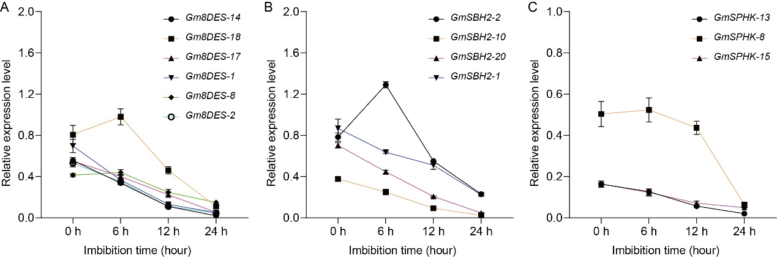
Figure S8. The expression levels of sphingolipid biosynthetic genes.
A. The expression of Gm8DES genes during seed germination detcted by Quantitative real-time PCR. B. The expression of GmSBH2 genes during seed germination detcted by Quantitative real-time PCR. C. The expression of GmSPHK genes during seed germination detcted by Quantitative real-time PCR. Gm8DES-14 indicates the Gm8DES gene is on chromosome 14. GmTUB4 was used as an internal control.

Table S1 Evaluation of sequencing quality
Sample | Raw reads | Raw bases | Clean reads | Clean bases | Error rate (%) | Q20 (%) | Q30 (%) | GC content (%)
0h_1 | 41857012 | 6320408812 | 41159018 | 6127429138 | 0.0241 | 98 | 96.12 | 45.75
0h_2 | 48803298 | 7369297998 | 47951942 | 7101954923 | 0.0238 | 98.12 | 96.41 | 45.64
0h_3 | 47604648 | 7188301848 | 46713434 | 6909135314 | 0.0243 | 97.83 | 95.97 | 45.63
6h_1 | 50359382 | 7604266682 | 49848172 | 7362632473 | 0.0237 | 98.15 | 96.47 | 45.52
6h_2 | 46272970 | 6987218470 | 45361238 | 6704234759 | 0.0257 | 97.27 | 94.86 | 45.65
6h_3 | 49776314 | 7516223414 | 49179808 | 7207418250 | 0.0237 | 98.17 | 96.53 | 45.67
12h_1 | 58844286 | 8885487186 | 57982690 | 8538337891 | 0.024 | 98 | 96.19 | 45.12
12h_2 | 54631576 | 8249367976 | 53712882 | 7965812117 | 0.0243 | 97.89 | 95.94 | 45.13
12h_3 | 58305202 | 8804085502 | 57644694 | 8535928001 | 0.0239 | 98.07 | 96.29 | 45.1
24h_1 | 50130262 | 7569669562 | 49452548 | 7106970413 | 0.0247 | 97.67 | 95.72 | 44.76
24h_2 | 45895082 | 6930157382 | 45292080 | 6556476864 | 0.0248 | 97.61 | 95.65 | 44.93
24h_3 | 51563012 | 7786014812 | 50853620 | 7320683759 | 0.0245 | 97.76 | 95.89 | 44.6

Table S2 Mapping efficiency statistics
Sample | Total reads | Total mapped | Multiple mapped | Uniquely mapped
0h_1 | 41159018 | 38902386(94.52%) | 1415411(3.44%) | 37486975(91.08%)
0h_2 | 47951942 | 45397837(94.67%) | 1590099(3.32%) | 43807738(91.36%)
0h_3 | 46713434 | 44202572(94.62%) | 1622946(3.47%) | 42579626(91.15%)
6h_1 | 49848172 | 46750476(93.79%) | 2195513(4.4%) | 44554963(89.38%)
6h_2 | 45361238 | 42355972(93.37%) | 2012143(4.44%) | 40343829(88.94%)
6h_3 | 49179808 | 46153048(93.85%) | 2230135(4.53%) | 43922913(89.31%)
12h_1 | 57982690 | 54817993(94.54%) | 1882318(3.25%) | 52935675(91.3%)
12h_2 | 53712882 | 50954231(94.86%) | 1703172(3.17%) | 49251059(91.69%)
12h_3 | 57644694 | 54681186(94.86%) | 1867935(3.24%) | 52813251(91.62%)
24h_1 | 49452548 | 46105630(93.23%) | 1306336(2.64%) | 44799294(90.59%)
24h_2 | 45292080 | 43049293(95.05%) | 1174239(2.59%) | 41875054(92.46%)
24h_3 | 50853620 | 48389486(95.15%) | 1374077(2.7%) | 47015409(92.45%)

Table S3 Listed of known genes involved in seed dormancy and germination in turquoise and blue module
gene id | name | module | germination | Cer d18:0/16:0 | Cer d18:0/22:0 | PhytoCer d18:0/24:0
Glyma.11G054600 | GmSPT | turquoise | 0.928 | 0.979 | 0.937 | 0.951
Glyma.13G361700 | GmGA3OX1 | turquoise | 0.907 | 0.944 | 0.951 | 0.93
Glyma.19G033900 | GmCYP85A2 | turquoise | 0.899 | 0.93 | 0.902 | 0.916
Glyma.15G012100 | GmGA3OX1 | turquoise | 0.899 | 0.916 | 0.93 | 0.909
Glyma.15G093900 | GmGA2OX2 | blue | -0.914 | -0.972 | -0.874 | -0.979
Glyma.11G018000 | GmABI1 | blue | -0.907 | -0.951 | -0.839 | -0.986
Glyma.19G194500 | GmABI5 | blue | -0.907 | -0.951 | -0.944 | -0.944
Glyma.11G055700 | GmABA1 | blue | -0.907 | -0.951 | -0.839 | -0.986
Glyma.10G071700 | GmABI5 | blue | -0.907 | -0.797 | -0.839 | -0.832
Glyma.11G180800 | GmABA2 | blue | -0.894 | -0.879 | -0.767 | -0.936

Table S4 List of differentially expressed genes (DEGs) involved in sphingolipid biosynthesis
Gene_id | Gene_name | Gene_description | 6h | 12h | 24h
Glyma.14G095400 | Gm8DES | Fatty acid/sphingolipid desaturase | no|down | yes|down | yes|down
Glyma.18G120400 | Gm8DES | Fatty acid/sphingolipid desaturase | yes|down | yes|down | yes|down
Glyma.17G228400 | Gm8DES | Fatty acid/sphingolipid desaturase | yes|down | yes|down | yes|down
Glyma.01G046000 | Gm8DES | Fatty acid/sphingolipid desaturase | yes|down | yes|down | yes|down
Glyma.08G299900 | Gm8DES | Fatty acid/sphingolipid desaturase | yes|down | yes|down | no|down
Glyma.02G106300 | Gm8DES | Fatty acid/sphingolipid desaturase | yes|down | yes|down | yes|down
Glyma.18G284300 | ATDPL1,DPL1 | dihydrosphingosine phosphate lyase | no|up | yes|up | no|up
Glyma.02G097200 | ATDPL1,DPL1 | dihydrosphingosine phosphate lyase | no|down | no|down | yes|down
Glyma.02G106700 | GmSBH2 | sphingoid base hydroxylase 2 | no|down | yes|down | no|up
Glyma.10G219700 | GmSBH2 | sphingoid base hydroxylase 2 | no|down | yes|down | yes|down
Glyma.20G172000 | GmSBH2 | sphingoid base hydroxylase 2 | yes|down | yes|down | yes|down
Glyma.01G046500 | GmSBH2 | sphingoid base hydroxylase 2 | no|down | yes|down | no|up
Glyma.08G039500 | Serine incorporator | Serinc-domain containing serine and sphingolipid biosynthesis protein | yes|down | yes|down | yes|down
Glyma.15G103300 | Serine incorporator | Serinc-domain containing serine and sphingolipid biosynthesis protein | no|up | yes|up | yes|up
Glyma.08G353600 | Serine incorporator | Serinc-domain containing serine and sphingolipid biosynthesis protein | no|up | no|up | yes|up
Glyma.05G232100 | Serine incorporator | Serinc-domain containing serine and sphingolipid biosynthesis protein | no|down | yes|down | yes|down
Glyma.09G188500 | Serine incorporator | Serinc-domain containing serine and sphingolipid biosynthesis protein | no|up | no|up | yes|down
Glyma.13G209400 | Serine incorporator | Serinc-domain containing serine and sphingolipid biosynthesis protein | yes|up | yes|up | yes|up
Glyma.20G167800 | Sphingomyelin synthase | Sphingomyelin synthetase family protein | no|down | yes|down | yes|down
Glyma.13G246000 | GmSPHK1 | sphingosine kinase 1 | no|down | yes|down | yes|down
Glyma.08G058400 | GmSPHK1 | sphingosine kinase 1 | no|up | no|up | yes|up
Glyma.15G067800 | GmSPHK1 | sphingosine kinase 1 | no|up | no|down | yes|down
no, not significantly changed; yes, significantly changed; up, up-regulated; down, down-regulated.

Table S5 List of primers used in this study
 | Forward (5'-3') | Reverse (5'-3')
qGmActin11 | CGGTGGTTCTATCTTGGCATC | GTCTTTCGCTTCAATAACCCTA
qGm8DES-14 | CACGGTGCCATTTGAGGAAG | TGGAACCATCTCTTGCCTGC
qGm8DES-18 | CTAGGCTCCCAAGGGCAC | CTGAGATTCCTGGCCTGGAG
qGm8DES-17 | CTGTTTCCAAGGCTGCCAC | CCGGATTGGAACCGTCTCTG
qGm8DES-1 | TCCAAGGCTACCTCGGTGC | CCTAGCTTGTAGGGCAGCAG
qGm8DES-8 | CCAAGGCTTCCAAGGGCAC | CCTGAAGAGCAGCAGTCCTG
qGm8DES-2 | TCCAAGGCTACCTCGGTGC | TAGCCTGTAGGGCAGCAGTC
qGmSBH2-2 | ACCACGATGTACACCACCAG | CCTCCAACGTGTAAGGCATG
qGmSBH2-10 | CAACTGCAAGGGCTGAAGTAC | TGCCTCGAACCCCCCTTC
qGmSBH2-20 | CATCATCAACTGCAAGGGCTG | TCCTTTGCTAGCCTTGCCTC
qGmSBH2-1 | CATCACCAGCTCTATGGCAAC | TCCTCCAACGTGTATGGCATG
qGmSPHK1-13 | GATTCAGTTGGGGATCCTTGTG | GGTAGCCACATCAAGTGGTCG
qGmSPHK1-8 | GGAACCTGGTCCACGCTTG | GCCATCAAAGCCTTCTGCTC
qGmSPHK1-15 | TGGTCCACGCACCAAGGAC | AGGCCATCAAAGTCTTCTGCTC
qGmTUB4 | GGCGTCCACATTCATTGGA | CCGGTGTACCAATGCAAGAA
qGmSPT | TGACACGCAAGCATGTGAAC | ATTGCATGCACGAACCTAGC
qGmGA3OX1-13 | CGGATCCAGCAAAGGCTTTC | AGCCGAACGGTTGAGAGTG
qGmCYP85A2 | GCACCCGACAGTGTCCAG | GTGCAGTCCATTAGGTGCCTC
qGmGA3OX1-15 | AGTGGGCCCAAATAAGCCTC | AGGTGCACAAAGCCGAACAG
qGmGA2OX2 | TGGAGGACCACCCTTGTGTG | GACGCGTACGCAGCCTTC
qGmABI1 | AGGTTGTACGAGGTTGCCTC | CTTTGCTTCCACGAGCCATAG
qGmABI5-19 | CGAGCTCGAGAGGGGAAGA | CTGCTACCATTACCGTGCAG
qGmABA1 | AGTCTACATGGCACCTGGATC | ACCACATCAGATGGACGGAC
qGmABI5-10 | ACGGCCAACTTAAACTAGCTC | TTGGCCTTCTGGGCGTTG
qGmABA2 | CTGCGGTGGAGCTTGGAC | GGCCACATCGTTTGGCAC

