Supporting Information
Cobalt on Tungsten Titanium Carbide MXene: A Electrocatalyst for Industrial-Scale High Current Density Alkaline Hydrogen Evolution Reaction
Xiaopeng Liu^{a,‡}, Fan Yang^{a,‡}, Deep M. Patel^{a,‡}, Mohammad Albloushiª, Shan Jiang^{b}, Christian J. Breckner^{b}, Connor W. Schroederª, Ruoyu Cui^{c,d}, Tao Ma^{e}, Dapeng Jing^{f}, Wenyu Huang^{c,d}, Jeffrey T. Miller^{b,*}, Wenzhen Li^{a,*}, Luke T. Roling^{a,*}, Yue Wu^{a,*}
Correspondence to: yuewu@iastate.edu; roling@iastate.edu; wzli@iastate.edu; and jeffrey-t-miller@purdue.edu

Supplementary Fig. 1. Theoretical XRD of (a) W₂TiAlC₂ and (b) W₂TiC₂ simulated by VESTA; Comparison of experimental and calculated XRD from 2θ = 5° to 70° of (c) W₂TiAlC₂ and (d) W₂TiC₂; (e) Lattice structure model of W₂TiAlC₂ and W₂TiC₂ for the simulation, color code: Al (pink), W (cyan), Ti (dark blue), and C (dark brown).

Supplementary Fig. 2. SEM images of (a) Co/W₂TiC₂-600 and (b) Co/W₂TiC₂-700; TEM images of (c) Co/W₂TiC₂-600 and (d) Co/W₂TiC₂-700.

Supplementary Fig. 3. TEM image of Co/W₂TiC₂-500 showing lattice fringes of cobalt on the MXene surface.

Supplementary Fig. 4. XPS survey spectra of W₂TiC₂ and Co/W₂TiC₂ annealed at 500, 600, and 700℃.
Supplementary Fig. 5. Co K-edge XANES from 7.700 to 7.750 keV of (a) Co F oil, CoO, and Co500; k²-Weighted and the magnitude (solid) and imaginary (dash) part of the Fourier transform of the Co K edge EXAFS of (b) Co foil, (c) CoO reference, and (d) Co/W₂TiC₂-500.

Supplementary Fig. 6. Linear sweep voltammetry (LSV) curves of the synthesized Co/W₂TiC₂-700 catalyst in (a) 1 M KOH, 1 M PBS, 0.5 M H₂SO₄ and (b) 0.1-1 M PBS. PBS stands for phosphate buffered saline.

Supplementary Fig. 7. LSV curves and Tafel slopes of Co/W₂TiC₂ catalysts, Co/WC and W₂TiC₂ in 0.5 M H₂SO₄.

Supplementary Fig. 8. (a) LSV curves of Co/W₂TiC₂-700 in 0.5 M H₂SO₄ at initial test and after leaving in electrolyte without applying current for 30 min; (b) TEM images of Co/W₂TiC₂-700 and (c) aggregation of Co after reacting in acidic electrolyte.

Supplementary Fig. 9. SEM images of Co/W₂TiC₂-700 after reacting in (a) 1 M KOH and (b) 0.5 M H₂SO₄.

Supplementary Fig. 10. LSV curves of H23 carbon paper, carbon paper with the Vulcan layer, and commercial 20% Pt/C compared with the Co/W₂TiC₂ catalysts in N₂ saturated 1 M KOH;

Supplementary Fig. 11. High current density LSV curves of Co/W₂TiC₂-700 catalyst compared with commercial 40% Pt/C in N₂ saturated 1 M KOH;

Supplementary Fig. 12. Cyclic voltammetry (CV) curves of W₂TiC₂ and Co/WC at different scan rates in a non-Faradaic region and electrochemical double-layer capacitance calculated from charging current density differences against scan rates plots.

Supplementary Fig. 13. CV curves of (a) Co/W₂TiC₂-700, (b) Co/W₂TiC₂-600, and (c) Co/W₂TiC₂-500 and (d) electrochemical double-layer capacitance of the catalysts.

Supplementary Note 1: Estimation of number of active sites from ECSA and comparison with loading mass derived quantities
The electrochemical active surface area (ECSA) can be obtained from electrochemical double-layer capacitance (C_{dl}), by dividing C_{dl} by the specific capacitance for a flat standard with 1 cm² of real surface area (C_{s}). The metal plane value of smooth metal plane is generally found to be in the range of 20-60 µF cm⁻² ¹, we conservatively using 60 µF cm⁻² to estimate the number of active sites. The geometric area of the sprayed electrodes are 1 × 1 cm², thus ECSA of the catalysts can be calculated as:
A_{ECSA(Co/W2TiC2-700)} = (55.47 mF/cm²) × 1 cm² / (60 μF/cm²) = 924.5 cm²
A_{ECSA(Co/W2TiC2-600)} = (38.61 mF/cm²) × 1 cm² / (60 μF/cm²) = 643.5 cm²
A_{ECSA(Co/W2TiC2-500)} = (11.76 mF/cm²) × 1 cm² / (60 μF/cm²) = 196.0 cm²
Co NP number in Co/W₂TiC₂-700 was further calculated by converting the electrochemical surface area to the number of binding sites. On this catalyst, the hydrogen is considered binding to the W atoms close to the Co-W interfaces (most stable H-binding sites marked on the DFT Co nanoparticle/W₂TiC₂ model, Figure 5a) in the ECSA tests at non-Faradaic region, while under reaction condition, hydrogen is proposed forming at the Co-W interface sites due to the most stable W sites poisoned by strong binding of H. The specific surface area per W atom on the (111) plane of W₂TiC₂ can be calculated as: S_{a(111)} = √3/4 × a² = 3.39 × 10⁻¹⁶ cm² ². Thus, the number of W surface sites can be obtained as N_{W} = ECSA / S_{a(111)}. Considering the amount of such W sites adjacent to each Co particle, and the number of Co-W interface sites on each Co NP, the number of active sites can be obtained as:
N_{Co-W(ECSA)} = (924.5 cm² / 3.39 × 10⁻¹⁶ cm²) / 6 × 3 = 1.36 × 10¹⁸
The quantity of active sites was checked through calculations based on the actual loading mass of Co. Given that EXAFS analysis revealed in Co/W₂TiC₂-700 Co existing entirely in the form of nanoparticles, determination of NP amount can be to dividing the total count by the number of Co atoms within a single particle of around 0.9 nm size:
N_{Co NPs(loading mass)} = (0.49 mg/cm²) × 1 cm² / (28.01 g/mol) × N_{A} / 22 = 4.79 × 10¹⁷
N_{Co-W(loading mass)} = N_{Co NPs} × 3 = 1.44 × 10¹⁸
In which the NA is Avogadro constant and N_{Co-W(loading mass)} stands for the active sites number directly derived from Co loading amount. The values obtained from two methods were similar (1.36 × 10¹⁸ and 1.44 × 10¹⁸), this numerical approximations derived from both methods further substantiate the specific structure of Co on W₂TiC₂.

Supplementary Fig. 14. High current LSV curves of Co/W₂TiC₂-700 and commercial Pt/C paired with Ni foam in a 2 × 2 cm² flow cell electrolyzer in 1 M KOH;

Supplementary Fig. 15. Chronopotentiometry curve of Co/W₂TiC₂-700 in 1 M KOH at a constant current density of 1000 mA/cm² for 20 h.

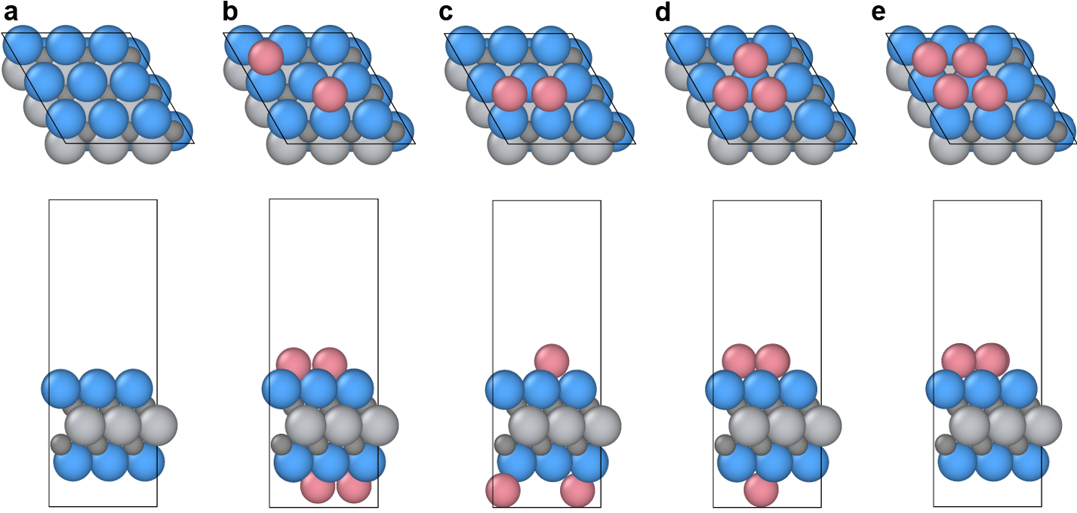
Supplementary Fig. 16. Top views and side views of the optimized structure of: (a) clean W₂TiC₂; (b) Isolated Co@W₂TiC₂; (c) Co dimer@W₂TiC₂; (d) Co trimer@W₂TiC₂; (e) Co tetramer@W₂TiC₂. Color code: Co (pink), W (blue), C (dark grey), Ti (light grey).

Supplementary Note 2: Effect of Co-Co coordination environment and H* surface coverage on the H* binding strength
To investigate the effect of Co-Co coordination environment on the H* binding strength, DFT calculations were performed for H* coverage varying from 0.11 ML to 0.44 ML on different W₂TiC₂ surfaces (see methods section in the main text for details). We note that when geometric optimization calculations were performed with an initial guess of single H* placed symmetrically or asymmetrically on top or at the hollow sites involving Co atoms on all the considered Co/W₂TiC₂ surfaces (i.e., isolated, dimer, trimer, and tetramer of Co), H* always shifted to a different binding site (fcc site for isolated Co/W₂TiC₂ and Co dimer/W₂TiC₂; W top site for Co trimer/W₂TiC₂ and Co tetramer/W₂TiC₂). Combining these observations with the most stable binding sites of H* on respective materials (Supplementary Figure 18), we note that H* does not prefer to bind with a single Co atom or ensemble of Co atoms, and therefore the expected active site for the HER chemistry at the isolated, dimer, trimer, and tetramer of Co on W₂TiC₂ might be the Co-W interface (same as Co NP) .
Supplementary Figure 17b summarizes trends in the adsorption free energies of H* ($G_{nH*}$) for the most stable binding geometries across all the considered Co/W₂TiC₂ surfaces and at H* coverages ranging from 0.11 ML to 0.44 ML. The snapshots of the most stable binding geometries of H* are provided in Figure S18. The qualitative trend in the adsorption free energies across different surfaces remains same at all the considered H* coverages – H* binds weakest on isolated Co/W₂TiC₂ and strongest on the clean W₂TiC₂, with an exception at 0.22 ML H* coverage where stronger H* binding was observed on Co tetramer/W₂TiC₂ compared to that on clean W₂TiC₂ with differential adsorption free energies of 0.39 eV. Such coverage sensitive trend in the $G_{nH*}$ across different materials indicates that the trend in the HER activity across different W₂TiC₂-based materials might be sensitive to the concentration of protons in the solution. This is evident from the significantly different experimental LSV profiles in the presence of 1 M KOH (Figure 4a) and 0.5 M H₂SO₄ (Figure 4b). Further, comparing the overall trend in the $G_{H*}$ across different Co/W₂TiC₂ surfaces, H* binding becomes stronger as the Co starts aggregating, i.e., H* binds stronger on Co tetramer/W₂TiC₂ ($G_{H*}$: -0.49 eV) compared to that on isolated Co/W₂TiC₂ ($G_{H*}$: -0.38 eV). This trend in H* binding is explained by a strong correlation between $G_{H*}$ and the d-band center of the W closest to H* (Figure 5b). This correlation suggests that the addition of Co on W₂TiC₂ surface alters the electronic structure of the interfacial W atoms, which ultimately impacts the binding strength of H* at the Co-W interface.

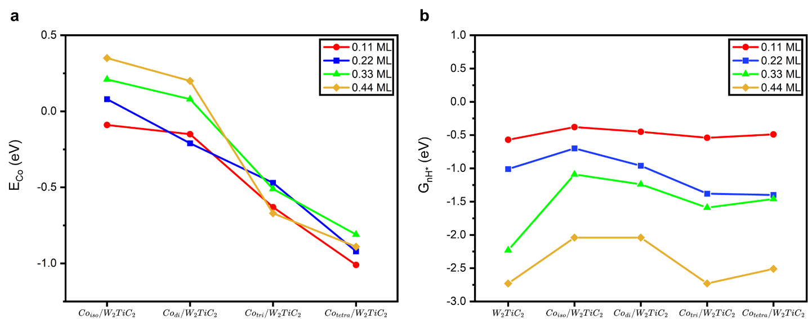Supplementary Fig. 17. (a) Formation energy of Co cluster ($E_{Co}$, eV) for different configurations of Co on W₂TiC₂ at respective H* coverages (ML), (b) Cumulative adsorption free energy of nH* ($G_{nH*}$, eV) on different W₂TiC₂ surfaces at respective H* coverages (ML). All the data points for a given surface coverage of H* are joined by a solid line for ease of visualization of the overall trend in both the figures. The snapshots of the most stable optimized geometries of respective systems are shown in Figure S18.

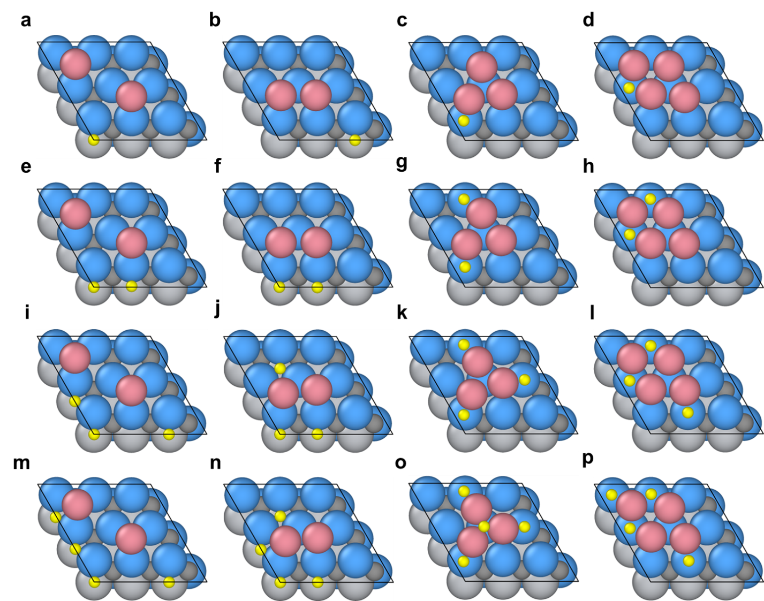
Supplementary Fig. 18. Top views of the most stable binding geometries of H* on isolated Co, Co dimer, Co trimer, and Co tetramer at H* coverage of (a)-(d) 0.11 ML, (e)-(h) 0.22 ML, (i)-(l) 0.33 ML, and (m)-(p) 0.44 ML. Atom color code: H (yellow), Co (pink), W (blue), C (dark grey), Ti (light grey).

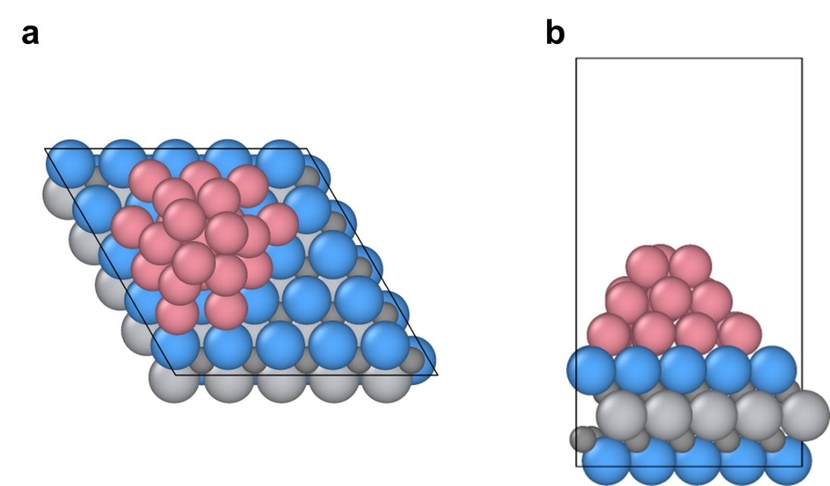
Supplementary Fig. 19. (a), (b) Top view and side view of Co nanoparticle/W₂TiC₂ system used for theoretical calculations. Atom color code: H (yellow), Co (pink), W (blue), C (dark grey), Ti (light grey).

Supplementary Fig. 20. High current LSV curves of Co/W₂TiC₂-700 and commercial Pt/C paired with IrO₂ in the flow cell electrolyzer in 1 M KOH at 60℃.
Supplementary Fig. 21. Flow cell electrolyzer tests at high temperature. (a) Chronopotentiometry profiles of Co/W₂TiC₂-700 (paired with IrO₂) at 50-400 mA/cm² in 1 M KOH at 60℃ compared with Pt/C; (c) Comparison of hydrogen production and hydrogen Faradic efficiency on Co/W₂TiC₂-700 and Pt/C at 50-400 mA/cm² at 60℃.

Supplementary Note 3: Energy efficiency analysis of flow cell tests
To further assess the performance of the flow cell electrolyzer using Co/W₂TiC₂ as the catalyst, the energy efficiency was calculated for the IrO₂||Co/W₂TiC₂-700 at 60℃. The equation for cell energy efficiency is:
η_{e} (Energy Efficiency) = η_{v} (Voltage Efficiency) × η_{F} (Faradaic Efficiency)
While energy efficiency is equal to equilibrium cell potential divided by the cell voltage. For water electrolyzer, the equilibrium cell potential is 1.229 V at room temperature (20℃) and 1.218 V at 60℃. At 400 mA/cm², the averaged H₂ faradaic efficiency in 3 h on Co/W₂TiC₂-700 is 94.88%, and cell voltage is 2.85 V, thus the energy efficiency can be calculated as:
η_{e} _{(400mA/cm}²₎ = (1.218V / 2.85 V) × 94.88% = 40.55%
Conventional alkaline water electrolyzers (AWE) are capable of achieving energy efficiencies ranging of 52%-69% when operating at current densities of 200-400 mA/cm² ³. The primary difference is posited to be the internal resistance attributed to the cation exchange membrane (CEM) that conducts K⁺ ions as compared to the liquid potassium hydroxide (KOH) utilized in AWEs. Therefore, the internal resistance led voltage drop was subtracted from the total cell voltage and iR-free voltage was calculated. Using EIS measured internal resistance values of 0.977 Ω, 1.02 Ω, and 0.967 Ω, the iR-free cell voltage at 200, 300, and 400 mA/cm² are 1.85 V, 2.05 V, and 2.46 V, respectively. The corresponding energy efficiencies are:
η_{e} _{(400mA/cm}²₎ = (1.218V / 2.46 V) × 94.88% = 46.98%
η_{e} _{(300mA/cm}²₎ = (1.218V / 2.07 V) × 94.61% = 56.21%
η_{e} _{(200mA/cm}²₎ = (1.218V / 1.85 V) × 99.23% = 65.33%
While the iR-free η_{e} for IrO₂||Pt at the same conditions are 44.63%, 52.08% and 58.31%. Also, the efficiency values of IrO₂||Co/W₂TiC₂-700 after excluding the impact of internal resistance are comparable with state-of-the-art water electrolyzers, indicating the high efficiency of this catalyst in the flow cell system.

Supplementary Table 1. Calculated lattice parameters and atomic coordinates for W₂TiAlC₂ and W₂TiC₂ by fitting the experimental XRD
W₂TiAlC₂
Lattice parameters
 | a (Å) |  | b (Å) |  | c (Å) |  | α (°) |  | β (°) |  | γ (°)
 | 2.98338 |  | 2.98338 |  | 18.73010 |  | 90 |  | 90 |  | 120
Atomic coordinates
 | W(1) | W(2) | W(3) | W(4) | Ti(1) | Ti(2) | Al(1) | Al(2) | C(1) | C(2) | C(3) | C(4)
x | 0.6667 | 0.3333 | 0.3333 | 0.6667 | 0.0000 | 0.0000 | 0.0000 | 0.0000 | 0.3333 | 0.6667 | 0.6667 | 0.3333
y | 0.3333 | 0.6667 | 0.6667 | 0.3333 | 0.0000 | 0.0000 | 0.0000 | 0.0000 | 0.6667 | 0.3333 | 0.3333 | 0.6667
z | 0.3648 | 0.6352 | 0.8648 | 0.1352 | 0.5000 | 0.0000 | 0.2500 | 0.7500 | 0.4776 | 0.5224 | 0.9776 | 0.0224
W₂TiC₂
Lattice parameters
 | a (Å) |  | b (Å) |  | c (Å) |  | α (°) |  | β (°) |  | γ (°)
 | 2.98660 |  | 2.98660 |  | 30.08700 |  | 90 |  | 90 |  | 120
Atomic coordinates
 | W(1) | W(2) | W(3) | W(4) | Ti(1) | Ti(2) | C(1) | C(2) | C(3) | C(4)
x | 0.6667 | 0.3333 | 0.3333 | 0.6667 | 0.0000 | 0.0000 | 0.3333 | 0.6667 | 0.6667 | 0.3333
y | 0.3333 | 0.6667 | 0.6667 | 0.3333 | 0.0000 | 0.0000 | 0.6667 | 0.3333 | 0.3333 | 0.6667
z | 0.4063 | 0.5937 | 0.9063 | 0.0937 | 0.5000 | 0.0000 | 0.4776 | 0.5224 | 0.9776 | 0.0224

Supplementary Table 2. Quantitative information of the XANES data and EXAFS fits
Samples | Pre-edge Energy, keV | XANES  Energy, keV | Scatter | CN | R, Å | δ²  (x10³) | E₀, eV
Co Foil  (Co⁰ ref) | - | 7.709 | Co-Co | 12 | 2.49
CoO  (Co²⁺ ref) | 7.7084 | 7.7166 | Co-O | 6 | 2.13
Co/W₂TiC₂-500 | - | 7.7087 | Co-Co | 2.8 | 2.48 | 8.0 | -4.4
Co/W₂TiC₂-500 | - | 7.7087 | Co-O | 2.1 | 1.97 | 6.0 | -2.8
Co/W₂TiC₂-600 | - | 7.7087 | Co-Co | 3.3 | 2.49 | 8.0 | -4.8
Co/W₂TiC₂-600 | - | 7.7087 | Co-O | 1.1 | 1.96 | 6.0 | 1.1
Co/W₂TiC₂-700 | - | 7.7087 | Co-Co | 3.8 | 2.47 | 10.0 | -5.0
Co/W₂TiC₂-700 | - |  | Co-O | - | - | - | -

Supplementary Table 3. Summary of distribution of Co on the different catalysts
Catalyst | Single sites | NPs | NPs true CN | NPs size
Co/W₂TiC₂-700 | - | 100% | 3.8 | 0.9 nm
Co/W₂TiC₂-600 | ~25% | ~75% | 4.4 | 1.0 nm
Co/W₂TiC₂-500 | ~50% | ~50% | 5.6 | 1.5 nm

Supplementary Table 4. ICP-OES elemental analysis of the Co/W₂TiC₂ samples
Catalysts | Co Weight% | Averaged Co Weight%
Co/W₂TiC₂-700 | 4.27% | 4.3%
Co/W₂TiC₂-700 | 4.36% | 4.3%
Co/W₂TiC₂-700 | 4.28% | 4.3%
Co/W₂TiC₂-600 | 4.04% | 4.0%
Co/W₂TiC₂-600 | 3.89% | 4.0%
Co/W₂TiC₂-600 | 3.95% | 4.0%
Co/W₂TiC₂-500 | 4.10% | 4.1%
Co/W₂TiC₂-500 | 4.15% | 4.1%
Co/W₂TiC₂-500 | 4.01% | 4.1%

Supplementary Table 5. The Co and total loading mass of different catalysts on the electrodes
Catalysts | Loading of catalyst | Loading of Co
Co/W₂TiC₂-700 | 12.3 mg/cm² | 0.49 mg/cm²
Co/W₂TiC₂-600 | 12.9 mg/cm² | 0.52 mg/cm²
Co/W₂TiC₂-500 | 12.8 mg/cm² | 0.51 mg/cm²
Co/WC | 14.7 mg/cm² | 0.59 mg/cm²
W₂TiC₂ | 12.5 mg/cm² | -

Supplementary Table 6. Summary of HER activity catalyzed by different Co/MXene catalysts
Catalyst | Overpotential  @ 10 mA/cm² | Tafel slope
Co/W₂TiC₂-700 | 62.58 mV | 44.34 mV/dec
Co/W₂TiC₂-600 | 88.78 mV | 50.78 mV/dec
Co/W₂TiC₂-500 | 99.34 mV | 71.00 mV/dec
Co/WC | 211.93 mV | 166.30 mV/dec
W₂TiC₂ | 291.11 mV | 268.04 mV/dec

Supplementary Table 7. Summary of HER activity catalyzed by Co/MXene catalysts and Pt
Samples | Overpotential  @ 10 mA/cm² | Overpotential  @ 100 mA/cm²
Co/W₂TiC₂-700 | 62.58 mV | 191.18 mV
Co/W₂TiC₂-600 | 88.78 mV | 231.90 mV
Co/W₂TiC₂-500 | 99.34 mV | 349.60 mV
Co/WC | 211.93 mV | 387.03 mV
W₂TiC₂ | 291.11 mV | 476.21 mV
Commercial 40% Pt/C | 51.74 mV | 238.02 mV

Supplementary Table 8. Summary of high current density HER activity catalyzed by Co/W₂TiC₂-700 and Pt
Overpotential | Commercial 40% Pt/C | Co/W₂TiC₂-700
η @ 10 mA/cm² | 51.74 mV | 62.58 mV
η @ 100 mA/cm² | 238.02 mV | 191.18 mV
η @ 200 mA/cm² | 312.41 mV | 245.79 mV
η @ 300 mA/cm² | 362.49 mV | 286.33 mV
η @ 400 mA/cm² | 398.65 mV | 309.47 mV
η @ 500 mA/cm² | 423.90 mV | 330.43 mV
η @ 1000 mA/cm² | 499.19 mV | 407.72 mV

Supplementary Table 9. Comparison of alkaline HER performance reported for cobalt and transition metal carbide based non-noble metal catalysts
Catalysts | η @ 10  mA/cm2  (mV) | Tafel slope  (mV/dec) | η @ 100 mA/cm2  (mV) | η @ 500 mA/cm2  (mV) | η @ 1000 mA/cm2  (mV) | Stability | Reference
Co/W2TiC2Tx-700 | 62.58 | 44.34 | 191.18 | 330.43 | 407.72 | 500h @10 mA/cm2  100h @1000 mA/cm2 | This work
NiFe-LDH/Ti3C2Tx/NF | 132 | 70 | - | 205 | - | 280h @10 mA/cm²  200h @1000 mA/cm2 | [4]
MoS2@Mo2CTx | 176 | 207 | - | - | - | 8h @0.400 V | [5]
Ni0.9Co0.1@Nb-doped Ti3C2Tx | 43.4 | 116 | - | - | - | 50h @10 mA/cm² | [6]
Nb4C3T | 398 | 122 | - | - | - | 50h @0.398 V (~10 mA/cm²) | [7]
WP–W2C | 43 | 42.11 | 139 | - | 560 | 40h @350 mA/cm2  60h @570 mA/cm2  60h @1000 mA/cm2 | [8]
Mo₂C@C | 47 | 71 | - | - | - | - | [9]
MoS2–Mo2C | 56 | 64.2 | 171 | - | 446 | - | [10]
HC-MoS2/Mo2C | - | - | - |  | 441 | 24h @500 mA/cm² | [11]
MoS2–Mo2C | - | 43 | - | 191 | 220 | 24h @200 mA/cm² | [12]
Mo2C/MoC/carbon nanotube | 82 | 42 | - | 201 | 233 | 336h @1000 mA/cm² | [13]
MoC–Mo2C-790 | 98.2 | 59 | - | 292 | - | 100h @100 mA/cm2  50h @300 mA/cm2  50h @500 mA/cm2  2400h @1000 mA/cm2 | [14]
Co₂P/N@Ti₃C₂T_{x}@NF | 15 | 30 | - | - | - | 4h @10-80 mA/cm2 | [15]
CoP/Ti₃C₂T_{x} | 113 | 57 | - | - | - | 24h @50 mA/cm² | [16]
Co₇Se₈/Ti₃C₂T_{x} | 270 | 128.5 | - | - | - | 24h @50 mA/cm² | [16]
Co-CeO2 | - | - | 132 | 215 | - | 14h @150 mV (~40 mA/cm²)  14h @200 mV (~70 mA/cm²) | [17]
Co3Mo/Cu | 12 | 40 | 96 @ 400 mA/cm2 |  |  | 1000h @60 mA/cm2  500h @210 mA/cm2 | [18]
Co-Mo5N6 | 19 | 29 | - | - | 280 | 10h @5000 mA/cm² | [19]
CoP/MoP@NC/CC | 94 | 40 | - | - | 475 | - | [20]
CoP | - | 78 | 141 | 243 | 290 | 300h @1000 mA/cm2 | [21]
N−Co₂P/CC | 34 | 51 | - | - | - | - | [22]
Co-B-P/NF | 42 | 42.1 | - | - | 165 | 20h @1000 mA/cm2 | [23]
A-NiCo LDH | 36 | 57 | 151 | 286 | 381 | 72h @1000 mA/cm²  72h @1000 mA/cm² | [24]
NiCo/NiCo-OH | 19 | 42 | 104 | 184 | - | 24h @500 mA/cm² | [25]

Supplementary References
1. McCrory, C. C. L., Jung, S., Peters, J. C., Jaramillo, T. F., Benchmarking heterogeneous electrocatalysts for the oxygen evolution reaction. J. Am. Chem. Soc. 135, 16977-16987 (2013).
2. Bergeret, G., Gallezot, P., Handbook of Heretogeneous Catalysis. vol. 2, pp. 738-765 (Wiley-VCH, 2008).
3. Carmo, M., Fritz, D. L., Mergel, J., Stolten, D., A comprehensive review on PEM water electrolysis. Int. J. Hydrogen Energy 38, 4901-4934 (2013).
4. Yu, M. et al., A hierarchically porous and hydrophilic 3D nickel–iron/MXene electrode for accelerating oxygen and hydrogen evolution at high current densities. Nano Energy 63, 103880 (2019).
5. Ren, J. et al., 2D organ-like molybdenum carbide (MXene) coupled with MoS₂ nanoflowers enhances the catalytic activity in the hydrogen evolution reaction. CrystEngComm 22, 1395-1403 (2020).
6. Du, C.-F. et al., Synergy of Nb doping and surface alloy enhanced on water–alkali electrocatalytic hydrogen generation performance in Ti-based MXene. Adv. Sci. 6, 1900116 (2019).
7. Tan, Y. et al., Nb₄C₃T_{x} (MXene) as a new stable catalyst for the hydrogen evolution reaction. Int. J. Hydrogen Energy 46, 1955-1966 (2021).
8. Huang, J., Jian, C., Cai, Q., Hong, W., Liu, W., A large scale self-supported WP–W₂C nanoporous network for efficient hydrogen evolution reaction in alkaline media. J. Mater. Chem. A 10, 10990-10997 (2022).
9. Chen, Y.-Y. et al., Pomegranate-like N,P-doped Mo₂C@C nanospheres as highly active electrocatalysts for alkaline hydrogen evolution. ACS Nano 10, 8851-8860 (2016).
10. Jian, C., Cai, Q., Liu, W. J. C. C., A three-dimensional macroporous framework molybdenum disulfide–carbide heterojunction for highly efficient electrocatalytic hydrogen evolution at high current densities. Chem. Commun. 57, 11819-11822 (2021).
11. Zhang, C. et al., High-throughput production of cheap mineral-based two-dimensional electrocatalysts for high-current-density hydrogen evolution. Nat. Commun. 11, 3724 (2020).
12. Luo, Y. et al., Morphology and surface chemistry engineering toward pH-universal catalysts for hydrogen evolution at high current density. Nat. Commun. 10, 269 (2019).
13. Li, C. et al., Ultrafast self-heating synthesis of robust heterogeneous nanocarbides for high current density hydrogen evolution reaction. Nat. Commun. 13, 3338 (2022).
14. Liu, W. et al., A durable and pH-universal self-standing MoC–Mo₂C heterojunction electrode for efficient hydrogen evolution reaction. Nat. Commun. 12, 6776 (2021).
15. Lv, Z. et al., Co‐constructing interfaces of multiheterostructure on MXene (Ti₃C₂T_{x})‐modified 3D self‐supporting electrode for ultraefficient electrocatalytic HER in alkaline media. Adv. Funct. Mater. 31, 2102576 (2021).
16. Selvam, N. C. S. et al., MXene supported Co_{x}A_{y}(A=OH, P, Se) electrocatalysts for overall water splitting: unveiling the role of anions in intrinsic activity and stability. J. Mater. Chem. A 7, 27383-27393 (2019).
17. Jiang, S. et al., Promoting formation of oxygen vacancies in two-dimensional cobalt-doped ceria nanosheets for efficient hydrogen evolution. J. Am. Chem. Soc. 142, 6461-6466 (2020).
18. Shi, H. et al., Spontaneously separated intermetallic Co₃Mo from nanoporous copper as versatile electrocatalysts for highly efficient water splitting. Nat. Commun. 11, 2940 (2020).
19. Lin, F. et al., Electrocatalytic hydrogen evolution of ultrathin Co‐Mo₅N₆ heterojunction with interfacial electron redistribution. Adv. Energy Mater. 10, 2002176 (2020).
20. Tang, Y.-J. et al., Solid-phase hot-pressing of POMs-ZIFs precursor and derived phosphide for overall water splitting. Appl. Catal., B 245, 528-535 (2019).
21. Li, Y. et al., Bifunctional porous cobalt phosphide foam for high-current-density alkaline water electrolysis with 4000-h long stability. ACS Sustainable Chem. Eng. 8, 10193-10200 (2020).
22. Men, Y. et al., Tailoring the electronic structure of Co₂P by N doping for boosting hydrogen evolution reaction at all pH values. ACS Catal. 9, 3744-3752 (2019).
23. Sun, H. et al., Superhydrophilic amorphous Co–B–P nanosheet electrocatalysts with Pt-like activity and durability for the hydrogen evolution reaction. J. Mater. Chem. A 6, 22062-22069 (2018).
24. Yang, H., Chen, Z., Guo, P., Fei, B., Wu, R., B-doping-induced amorphization of LDH for large-current-density hydrogen evolution reaction. Appl. Catal., B 261, 118240 (2020).
25. Zhu, W. et al., NiCo/NiCo–OH and NiFe/NiFe–OH core shell nanostructures for water splitting electrocatalysis at large currents. Appl. Catal., B 278, 119326 (2020).

