Supplementary Materials

Supplemental Figure 1S. Individual Responses to Feasibility and Acceptability Questionnaire- Integrated Exercise Group
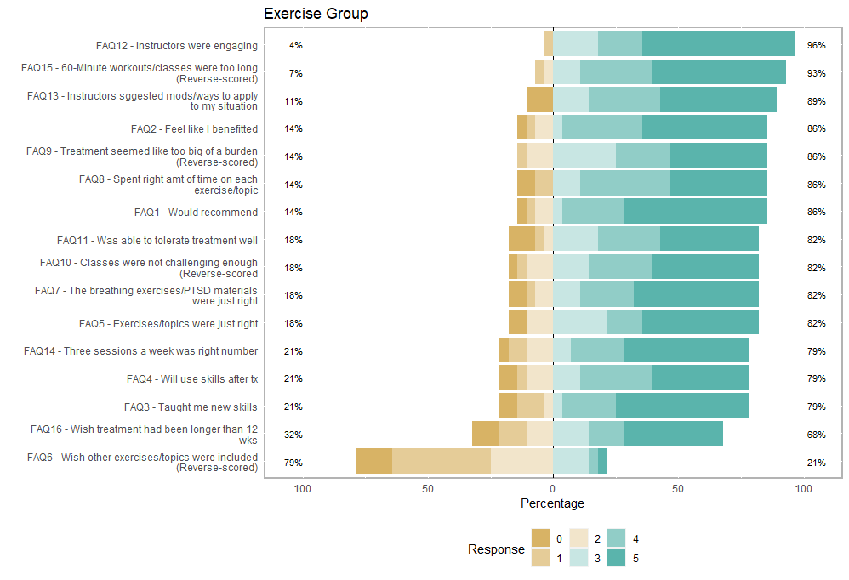
Participants responded to each statement on a 6-point Likert type scale, with 0-2 scores indicating disagreement (tan colors) and 3-5 (green colors) indicating agreement.
Supplemental Figure 2S. Individual Responses to Feasibility and Acceptability Questionnaire- Recovery Group
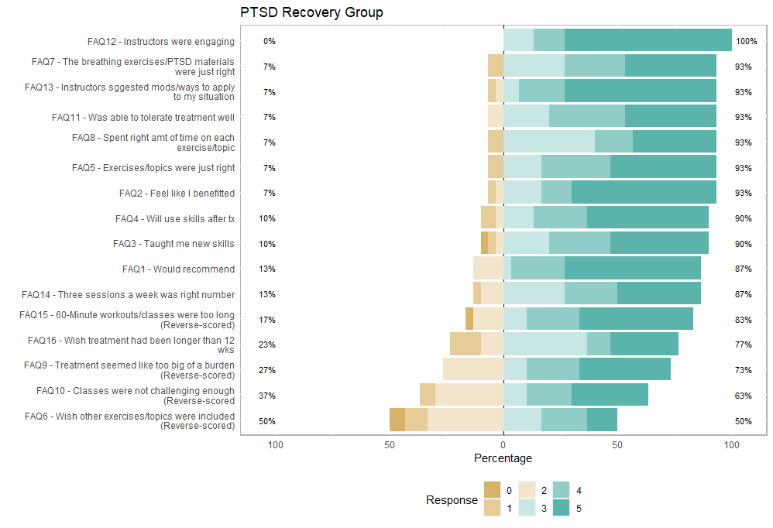
Participants responded to each statement on a 6-point Likert type scale, with 0-2 scores indicating disagreement (tan colors) and 3-5 (green colors) indicating agreement.

Supplemental Figure 3S: WHOQOL Psychological Domain

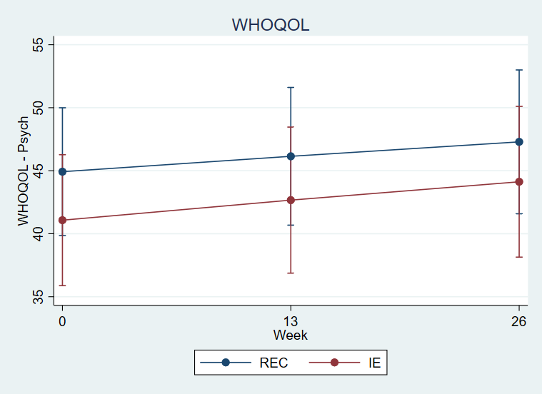

Supplemental Figure 4S. Change in WHOQOL Psych in IE and REC conditions by setting and number of sessions attended
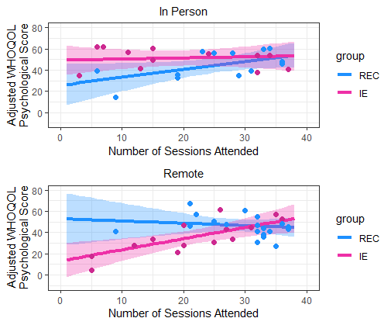
Supplemental Table 1S Demographic and Clinical Characteristics of In-Person and Remote Samples
 | In-Person | Remote | p-value
 | N=37 | N=47
Age | 56.3 (11.1) | 48.1 (11.1) | <0.01
Sex |  |  | 0.03
Male | 30 (81%) | 28 (60%)
Female | 7 (19%) | 19 (40%)
Race |  |  | 0.04
American Indian/Alaska Native | 1 (3%) | 3 (6%)
Asian | 6 (16%) | 1 (2%)
Black or African American | 8 (22%) | 13 (28%)
White | 16 (43%) | 28 (60%)
Other | 6 (16%) | 2 (4%)
Ethnicity |  |  | 0.64
Hispanic or Latino | 5 (14%) | 9 (19%)
Non-Hispanic or Latino | 26 (70%) | 33 (70%)
Unknown | 6 (16%) | 5 (11%)
Education |  |  | 0.11
High School Graduate / GED | 0 (0%) | 4 (9%)
Some College | 14 (39%) | 15 (33%)
Associate Degree | 7 (19%) | 2 (4%)
Bachelors Degree | 6 (17%) | 8 (17%)
Some Graduate School | 3 (8%) | 2 (4%)
Masters Degree | 5 (14%) | 14 (30%)
Doctoral Degree | 1 (3%) | 1 (2%)
VA Service-Connected Disability |  |  | 0.13
No | 6 (16%) | 14 (30%)
Yes | 31 (84%) | 32 (70%)
ASI Alcohol
Smoking history |  |  | 0.97
Current Smoker | 6 (16%) | 8 (18%)
Former Smoker | 10 (27%) | 12 (27%)
Never Smoked | 21 (57%) | 24 (55%)
CAPS_Total_baseline | 31.2 (8.1) | 31.6 (8.4) | 0.81
PCL5 Total | 42.4 (16.1) | 41.4 (12.5) | 0.75
WHOQOL Physical Health | 53.2 (16.1) | 50.2 (14.0) | 0.37
WHOQOL Psychological | 44.8 (17.6) | 41.2 (15.9) | 0.33
WHOQOL Social Relationships | 45.0 (25.0) | 44.2 (23.1) | 0.87
WHOQOL Environment | 57.4 (18.3) | 57.8 (14.2) | 0.92
WHOQOL Overall Heatlth (Q. 2) | 41.9 (27.0) | 41.3 (24.8) | 0.92
FFMQ Observing | 27.4 (5.9) | 22.7 (9.8) | 0.01
FFMQ Describing | 25.9 (6.8) | 20.8 (8.9) | <0.01
FFMQ Acting with Awareness | 25.7 (5.9) | 21.5 (9.2) | 0.02
FFMQ Nonjudging of Inner Experience | 25.3 (7.0) | 22.4 (10.7) | 0.15
FFMQ Nonreactivity to Inner Experience | 20.9 (4.1) | 17.6 (7.2) | 0.02
GLTEQ Activity Score | 38.7 (37.5) | 25.2 (21.2) | 0.04
Physical Activity Self-Efficacy | 2.8 (1.0) | 2.7 (0.8) | 0.70
DERS Total Score | 87.9 (19.7) | 87.7 (22.6) | 0.96
Emotion Regulation - Cognitive Reappraisal | 4.8 (1.2) | 4.7 (1.1) | 0.70
Emotion Regulation - Expressive Suppression | 4.6 (1.3) | 3.9 (1.3) | 0.02
MAIA Noticing | 3.2 (1.2) | 3.2 (0.9) | 0.99
MAIA Not-Distracting | 1.8 (0.8) | 1.9 (0.8) | 0.61
MAIA Not-Worrying | 2.8 (0.9) | 2.7 (0.7) | 0.35
MAIA Attention Regulation | 2.9 (1.1) | 2.8 (0.8) | 0.64
MAIA Emotional Awareness | 3.3 (1.2) | 3.3 (0.8) | 0.94
MAIA Self-Regulation | 2.9 (1.2) | 2.8 (0.9) | 0.53
MAIA Body Listening | 2.5 (1.3) | 2.3 (1.0) | 0.54
MAIA Trusting | 3.1 (1.1) | 2.9 (1.1) | 0.40
Positive States of Mind | 10.6 (3.5) | 9.5 (4.5) | 0.24
SCL90 Global Severity Index | 1.2 (0.7) | 1.2 (0.5) | 0.77
PSQI | 10.8 (3.9) | 12.3 (3.6) | 0.08
PSQI PTSD Addendum Global Score | 7.8 (4.5) | 8.3 (3.7) | 0.56
Insomnia Severity Index | 15.2 (6.8) | 16.1 (5.4) | 0.48
PROMIS Pain Intensity T-Score | 56.3 (9.5) | 56.5 (10.0) | 0.93
PROMIS_8A Pain Interference T-Score | 55.6 (8.1) | 55.0 (8.7) | 0.76
PASS Total Score | 28.4 (23.3) | 27.1 (18.2) | 0.77
Physical Activity Self-Efficacy | 2.8 (1.0) | 2.7 (0.8) | 0.70
Data are presented as mean (SD) for continuous measures, and n (%) for categorical measures.

