Supplementary figures and data
Fig. S1
Network legend
 | TFRs | TFs | Protein  kinases | Other type  of genes | Reported  in GWAS studies
Expressed in this  study |  |  | 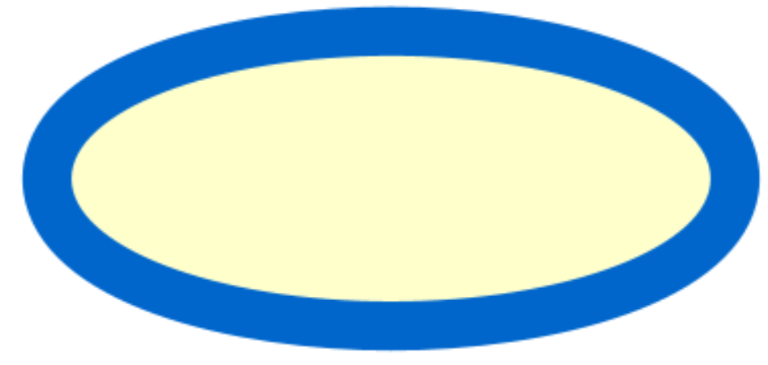 | 
Expressed in this  study or in other previous studies |  |  | 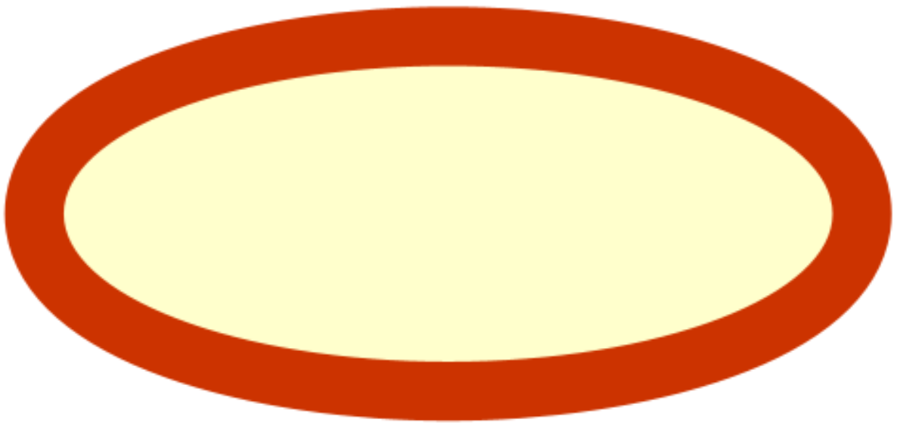 |  | 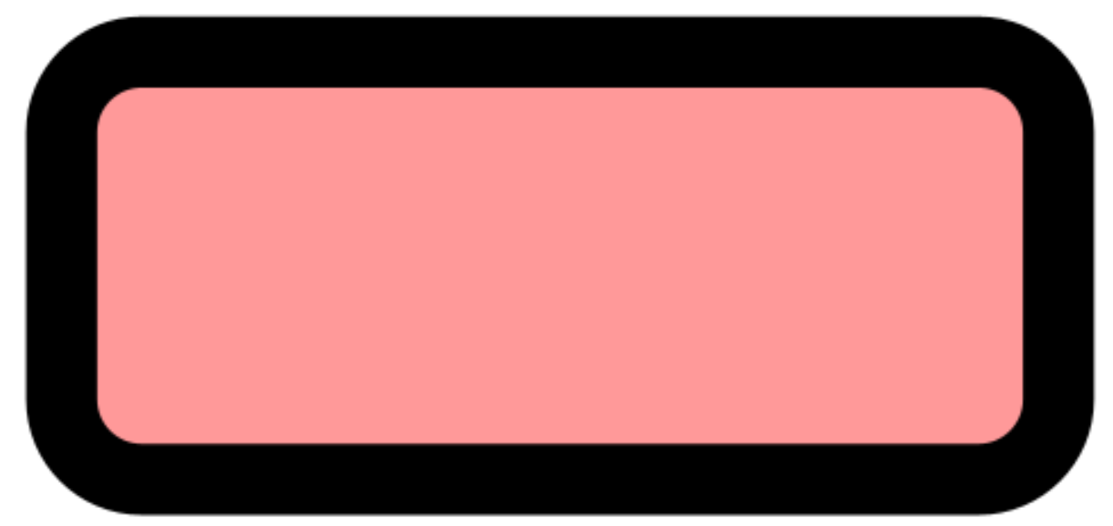
Validated / known ZDR genes |  | 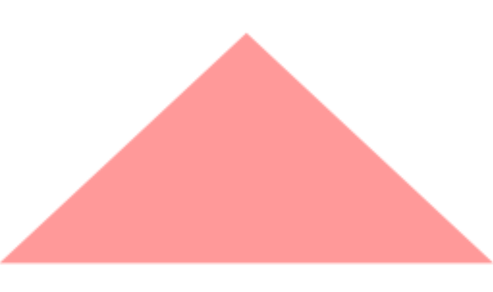

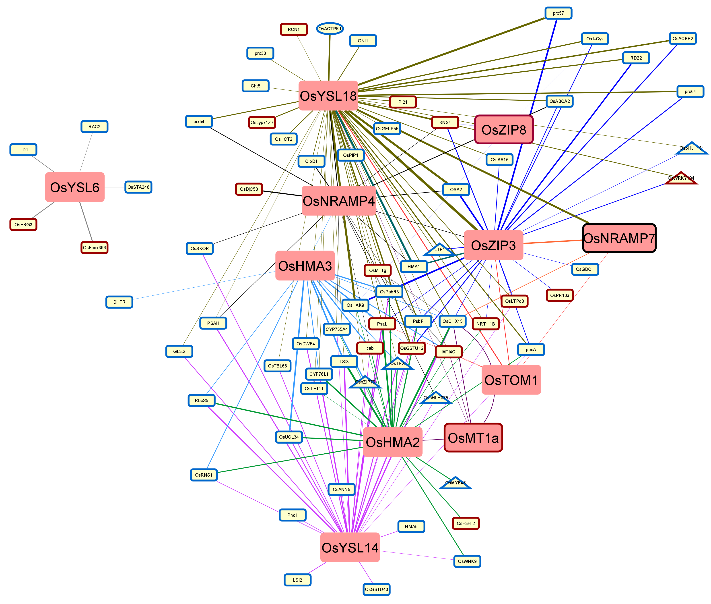
(a)

(b)
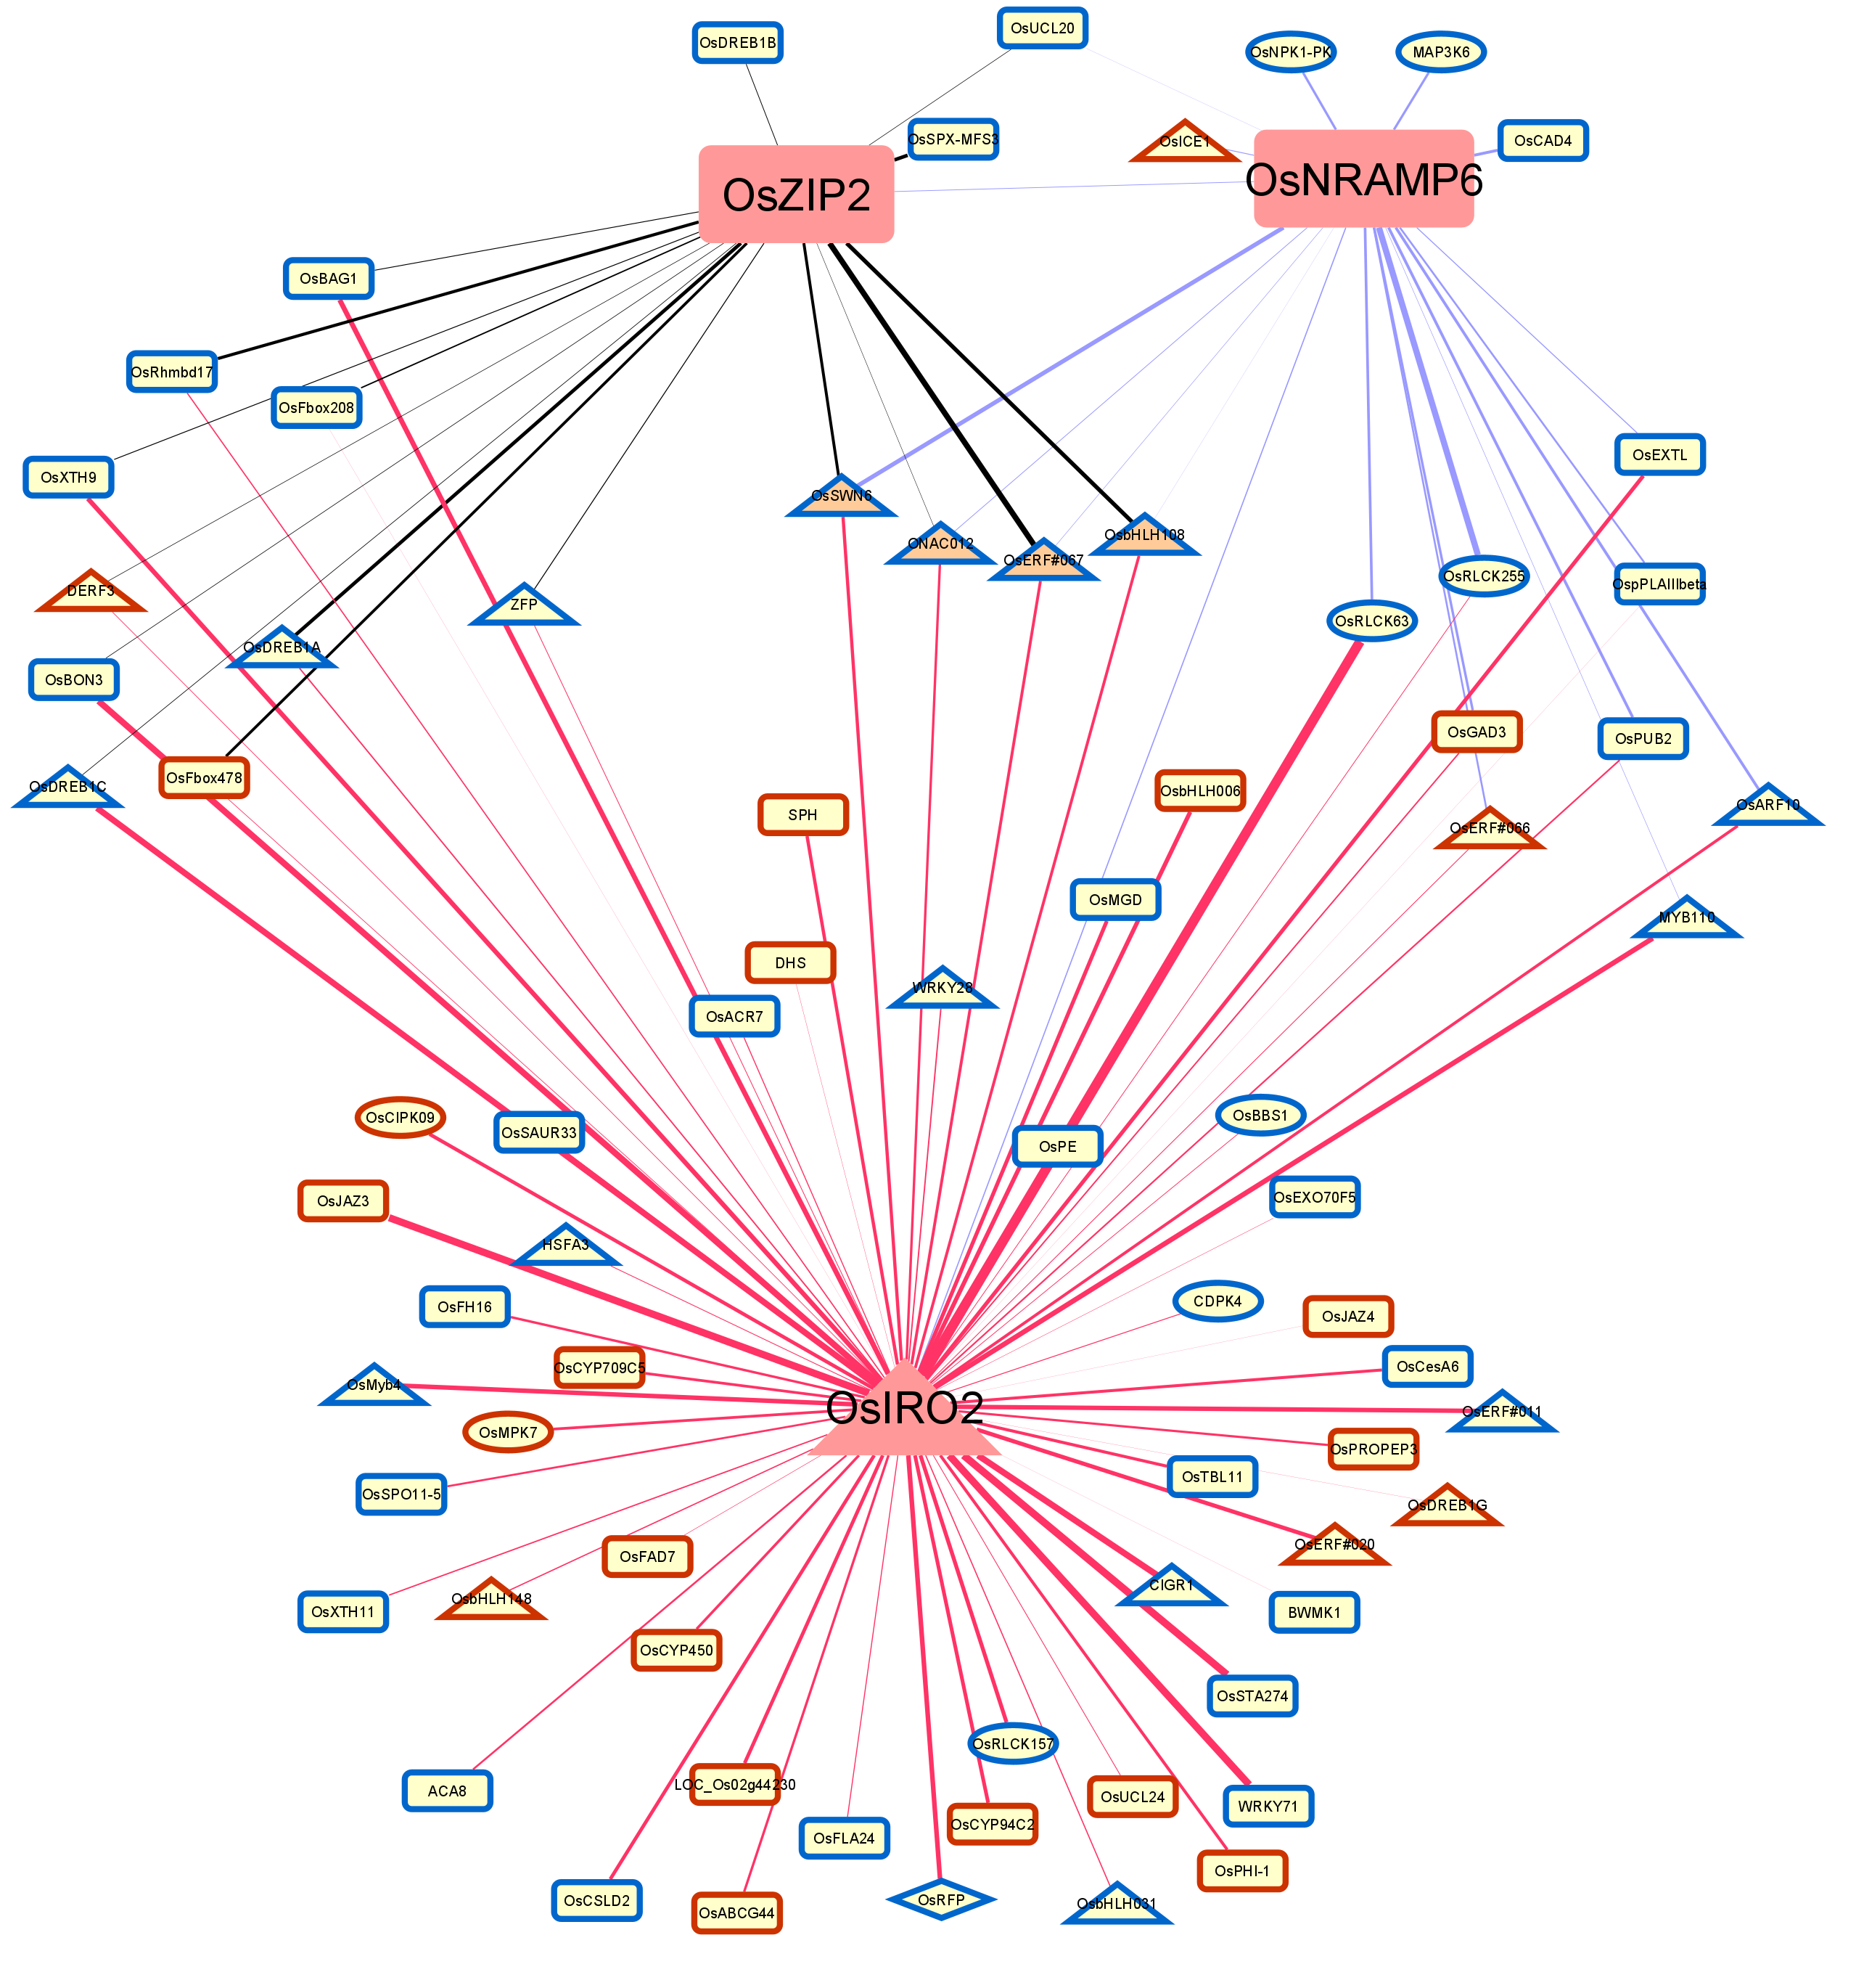

(c)
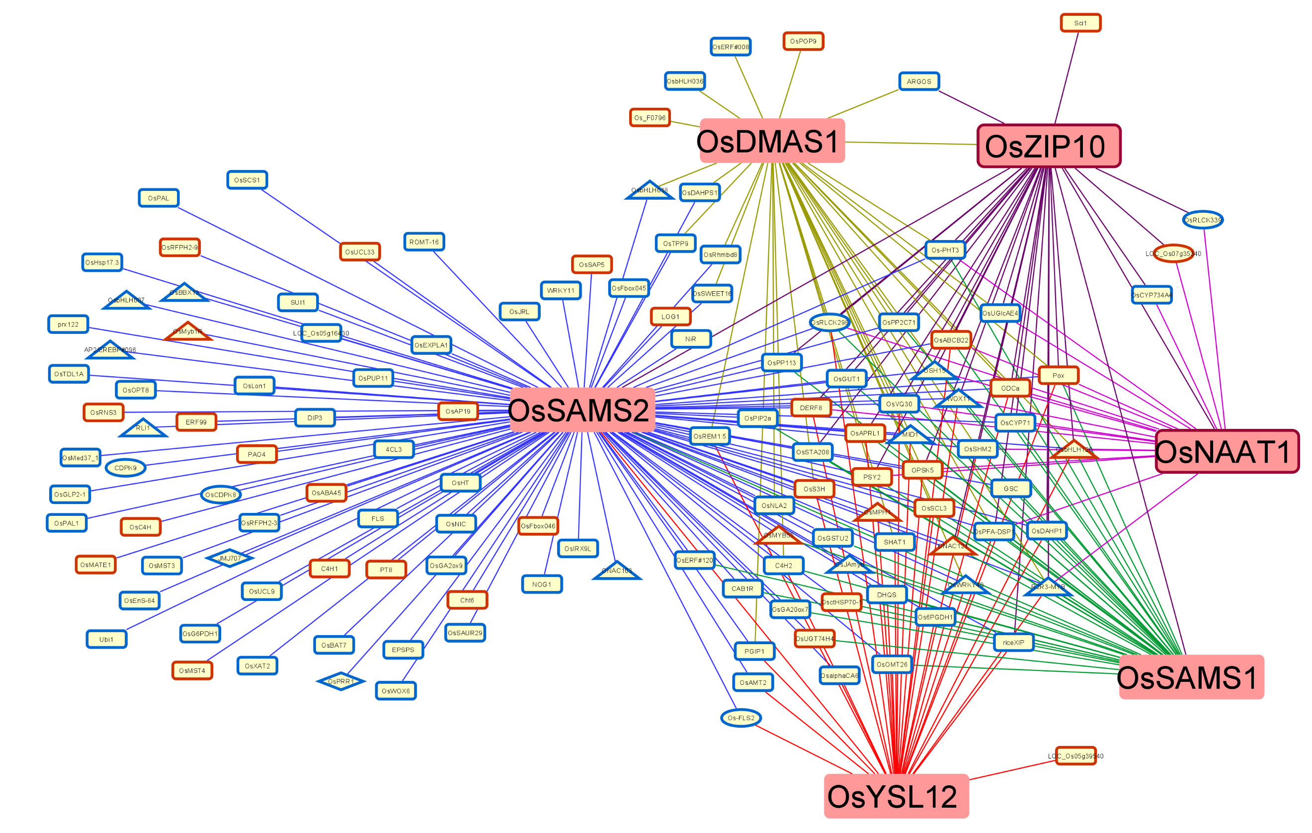

Figure S1 Visualization of gene-gene interactions networks in ZDR modules. a TTA-M module. b TRA-M module. c CA-M module. Edges represent interactions. Edges from the interactions between the well-known Zn deficiency genes ( bigger nodes and font size) and other genes are represented with different colored lines (edges). The thicker the edges, the stronger the degree of connections between the linked nodes is. A more detailed network legend is provided at the top of the panel.

Fig. S2
(a)
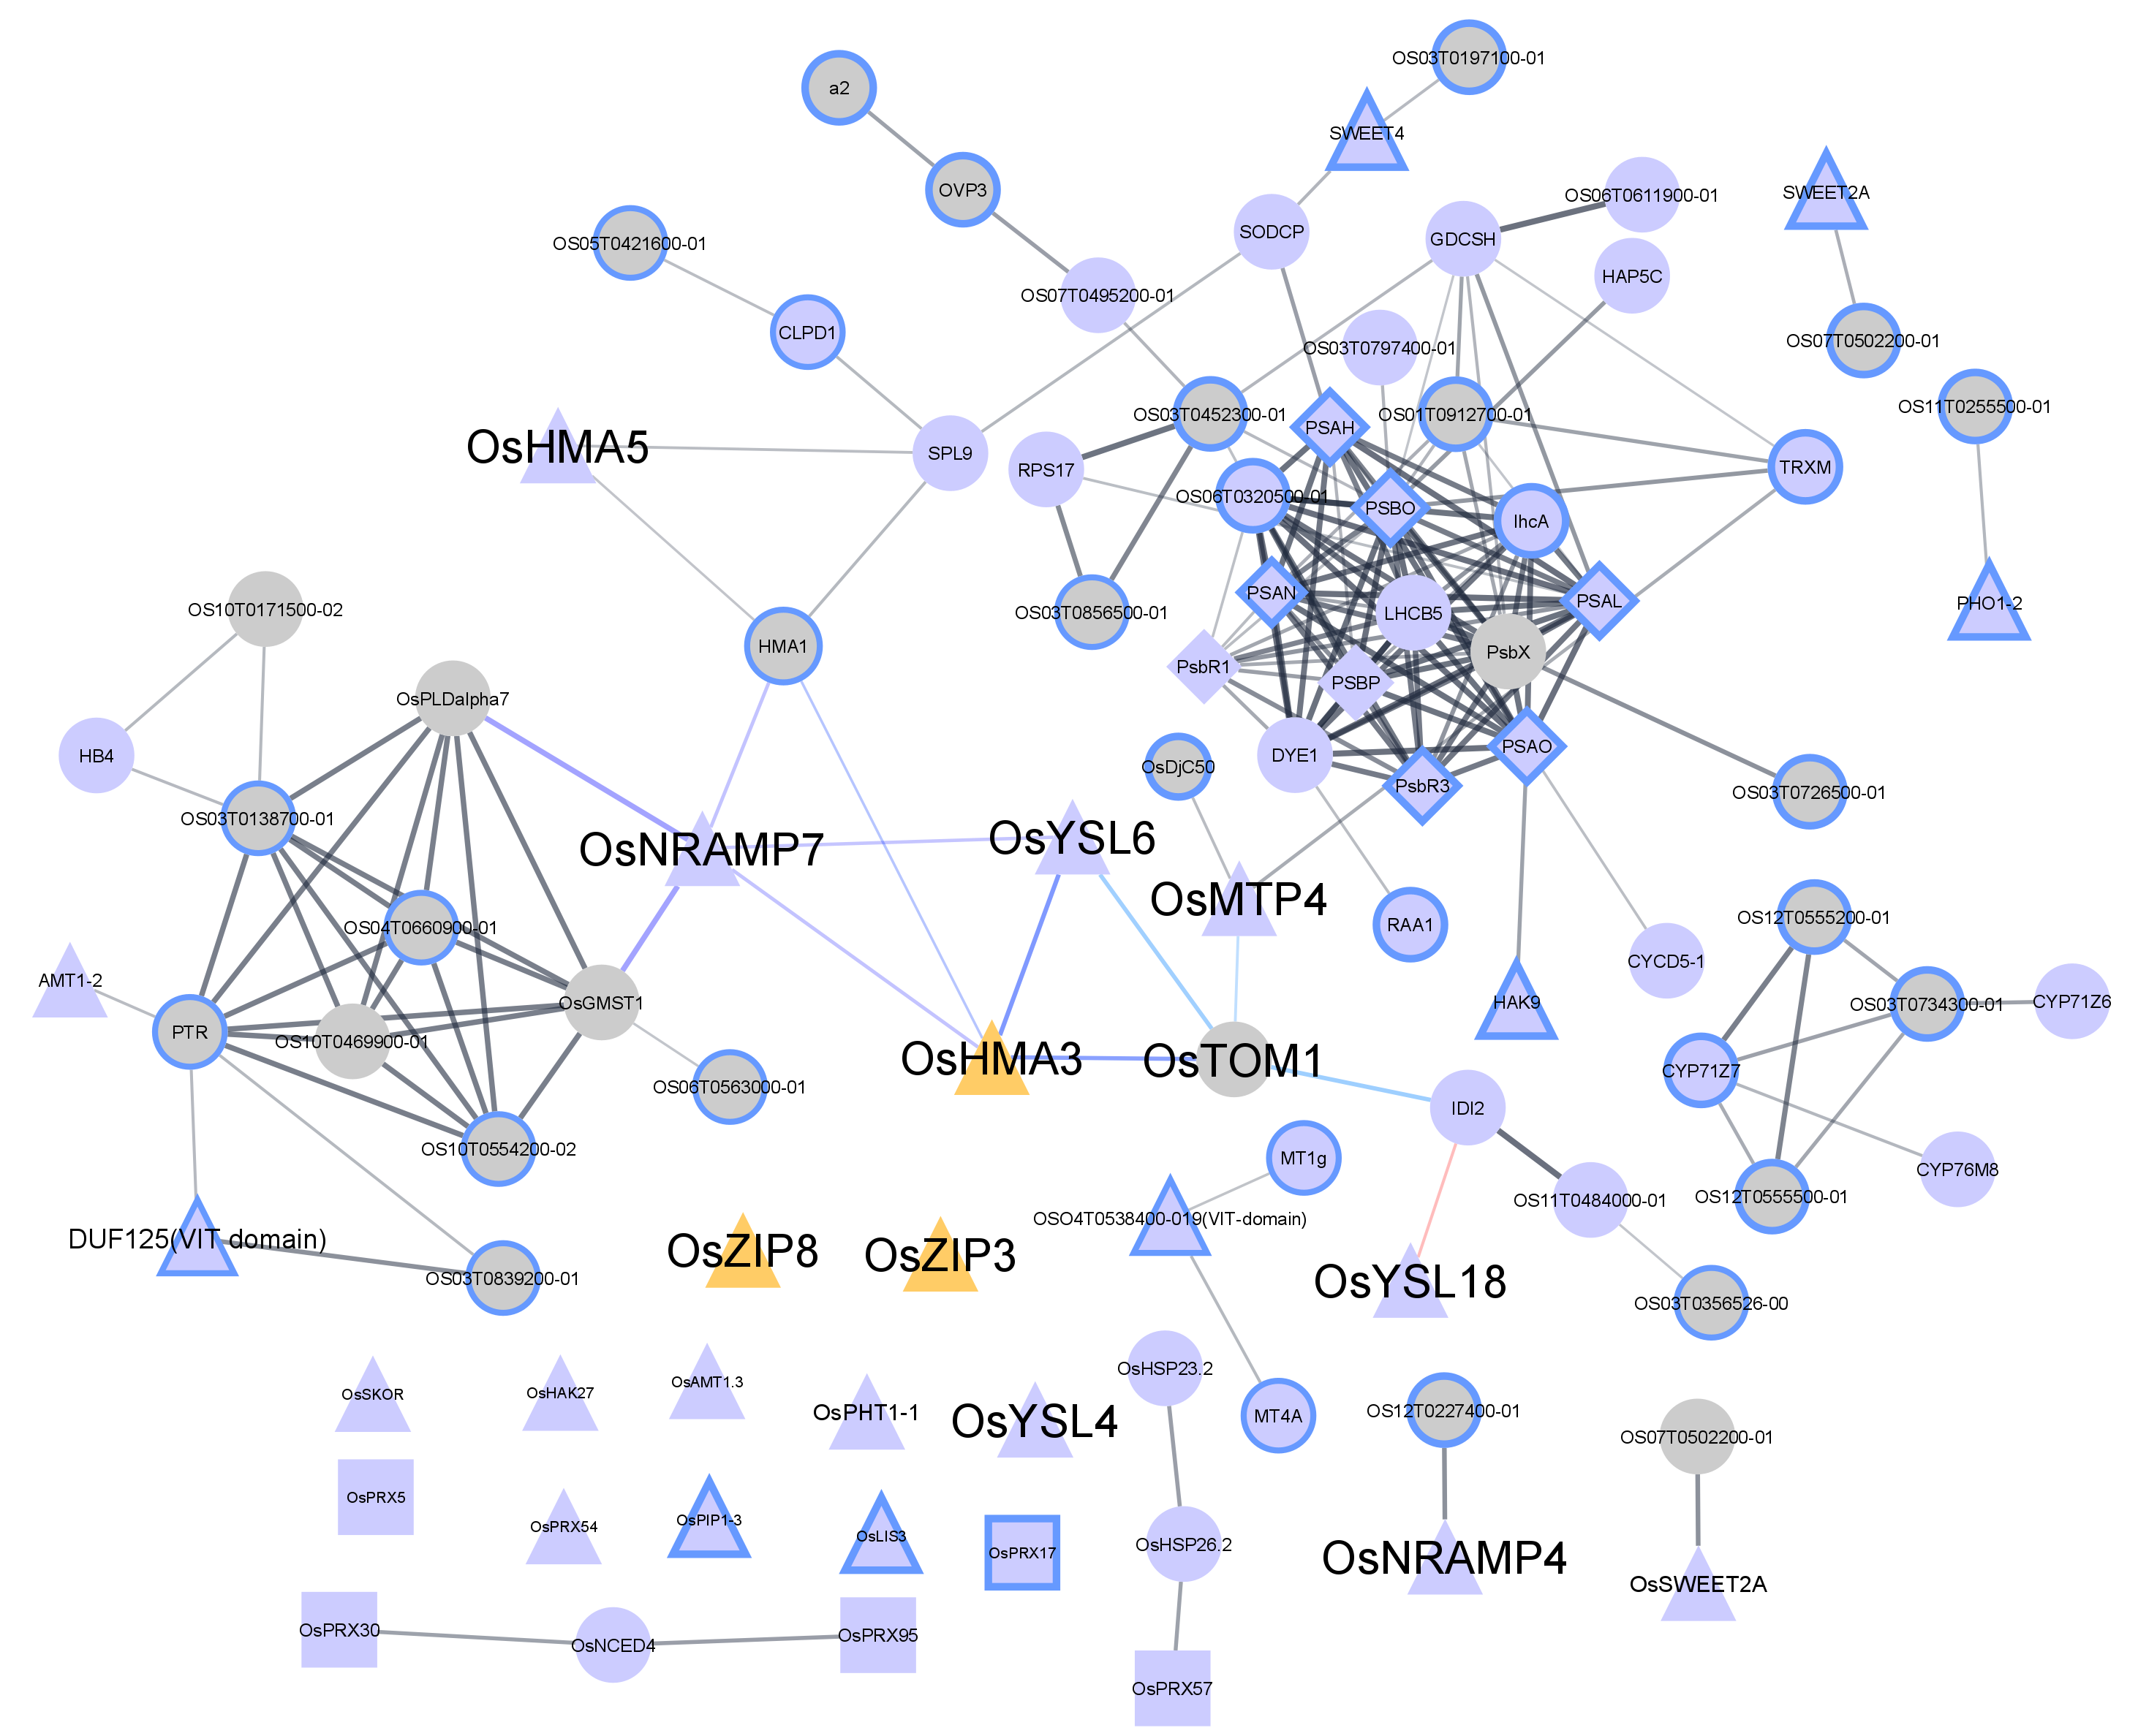

Protein functional annotations | Term ID | FDR | Node label
 |  |  | Proteins were expressed in our study | Proteins were not expressed in our study
Transmembrane transport activity | GO.00022857 | 1.30E-10
Photosynthesis | map00195 | 8.90E-05
Phenylpropanoid biosynthesis | map00940 | 8.90E-05 | 
All the other genes with significantly enriched functional sets | NA | NA
Genes without significantly enriched functional sets | NA | NA |  | 

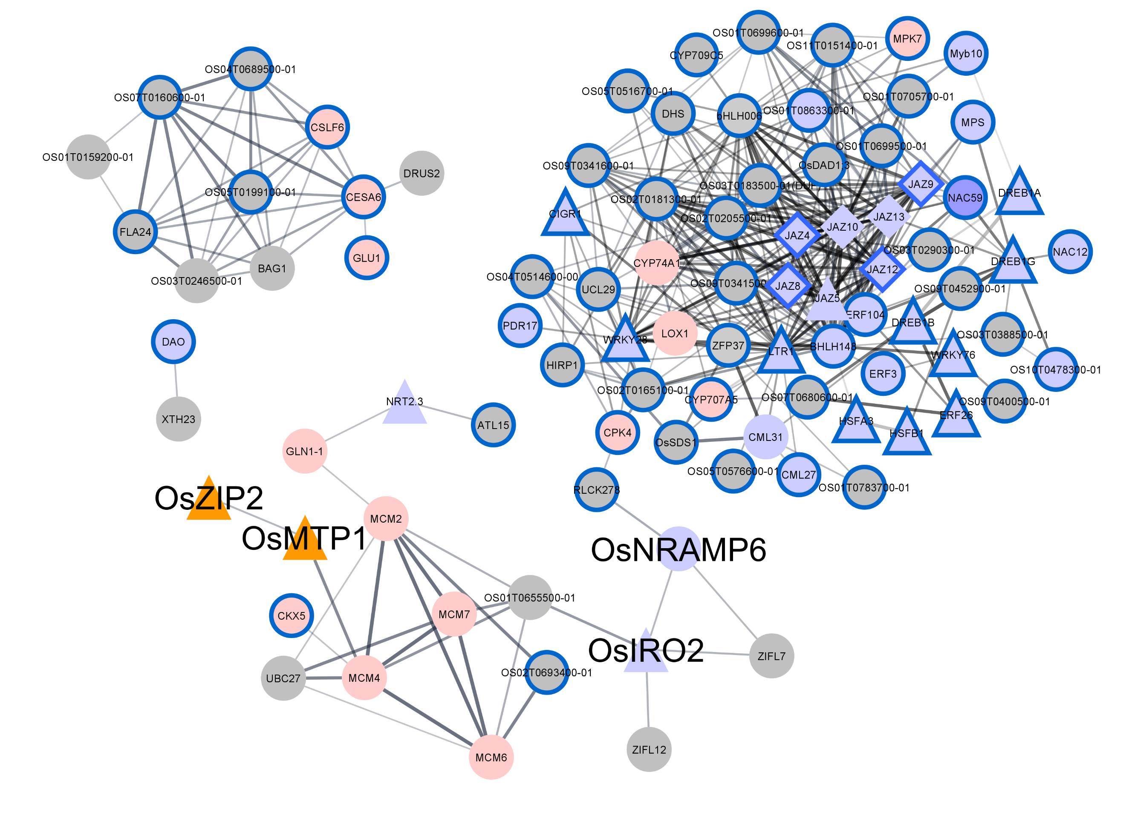
(b)

Protein functional  annotations | Term ID | FDR | Node label
 |  |  | Proteins were expressed in our study | Proteins were not expressed in our study
Transcription regulator activity | GO.0140110 | 2.50E-09
JA mediated signaling pathway | GO.2000022 | 9.20E-08
Organic substance metabolic process | GO.00710704 | 1.40E-08
Zinc ion transmembrane transporter activity | GO.0005385 | 0.046
All the other genes with  significantly enriched functional sets | NA | NA
Genes without significantly  enriched functional sets | NA | NA

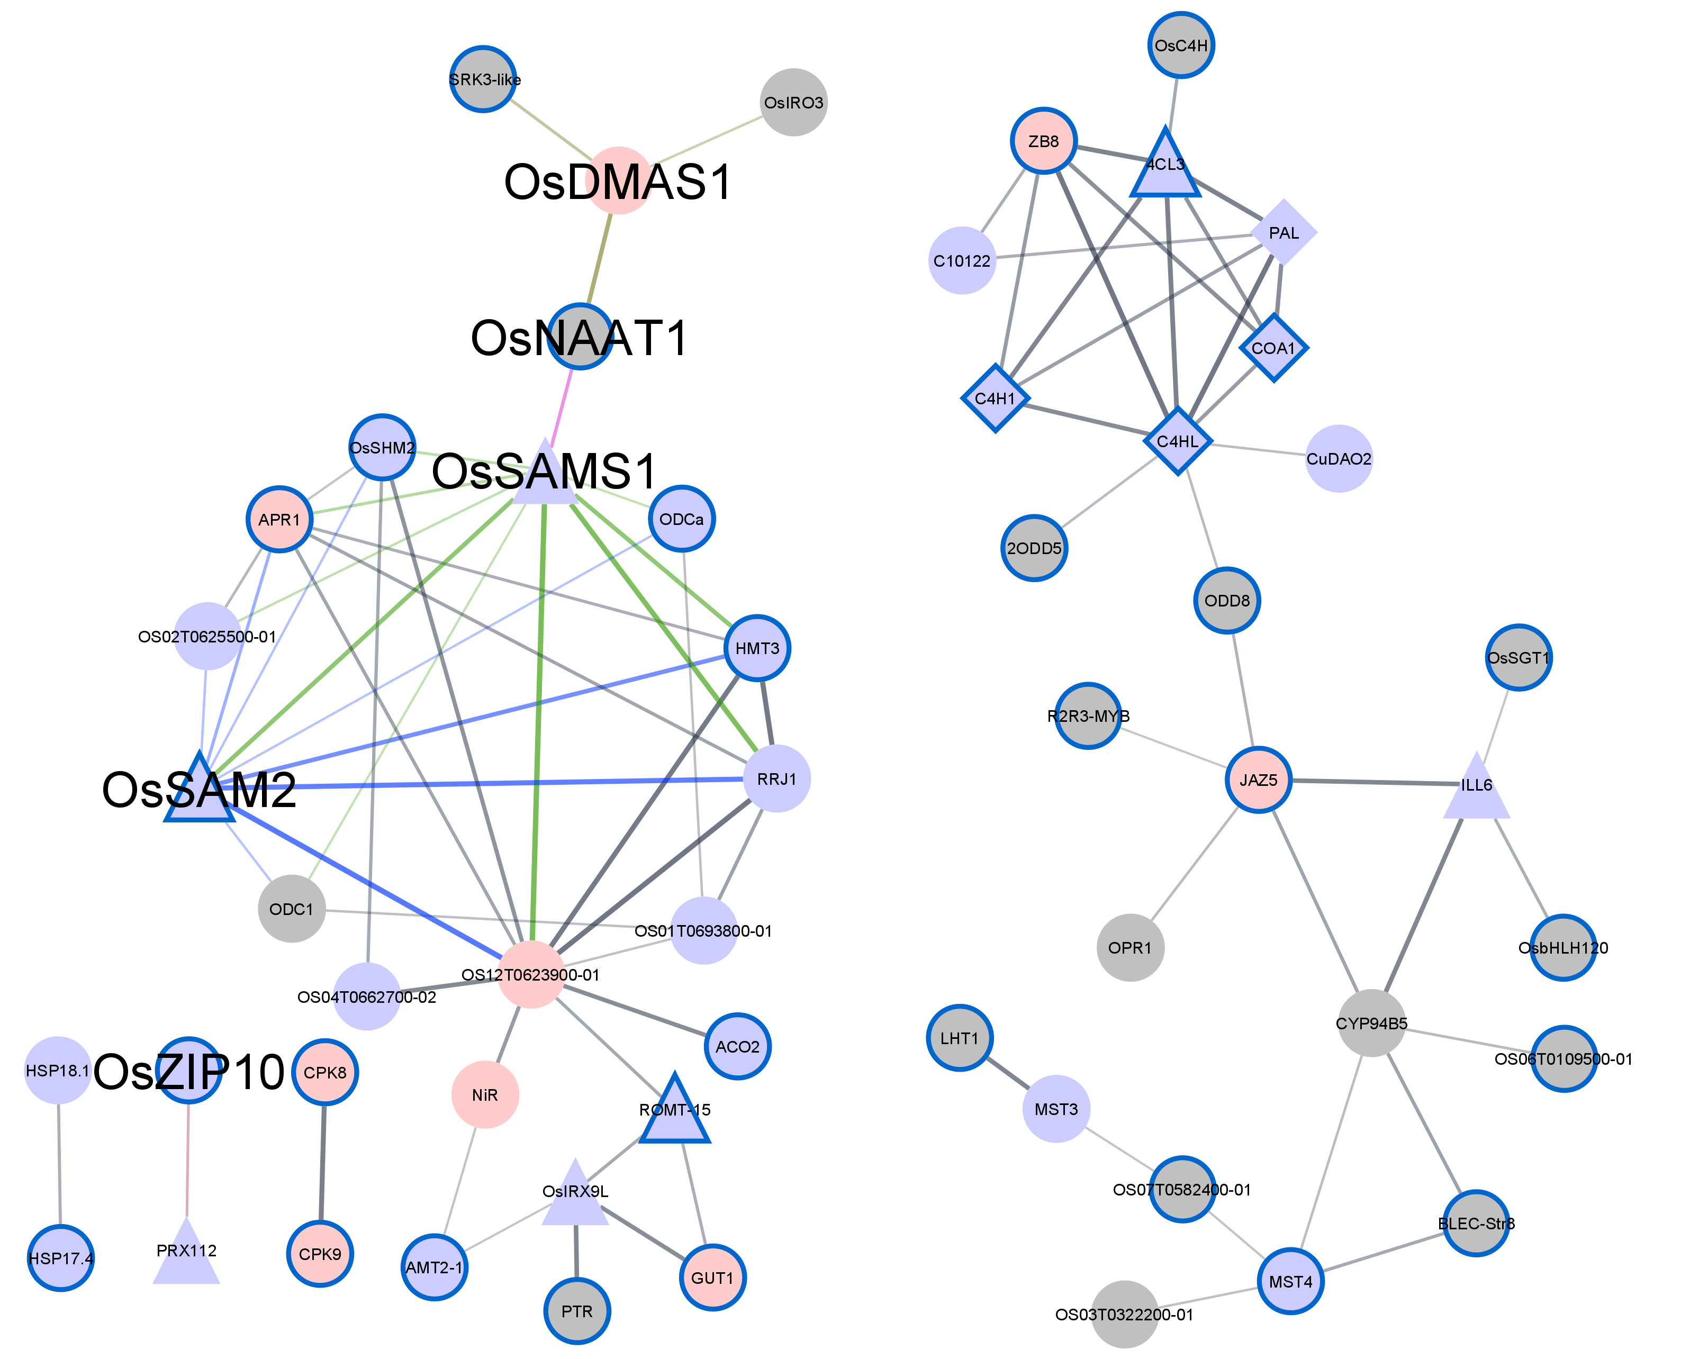
(c)

Protein functional annotations | Term ID | FDR | Node label
 |  |  | Proteins were expressed in our study | Proteins not were expressed in our study
Catalytic activity | GO.0003824 | 4.40E-06
Phenylpropanoid biosynthesis | map00940 | 1.30E-05
Nitrogen compound metabolic process | GO.0006807 | 1.70E-03 |  | 
All the other genes with significantly enriched functional sets | NA | NA
Genes without significantly enriched functional sets | NA | NA | 

Figure S2 PPIN and functional annotations of interacting proteins in ZDR modules. a TTA-M module. b TRA-M module. c CA-M module. Edges represent interactions. Edges from the interactions between the well-known Zn deficiency proteins (bigger font size) and other proteins are represented with different colored lines (edges). The thickness of edge positively correlates with higher connectivity level between the linked nodes. Protein functions were predicted by string tool version:11.0 https://string-db.org. Significant functional annotations (Fisher’s test, p < 0.05, FDR < 0.05) for interacting proteins are presented in tables underneath each PPIN.

Fig. S3
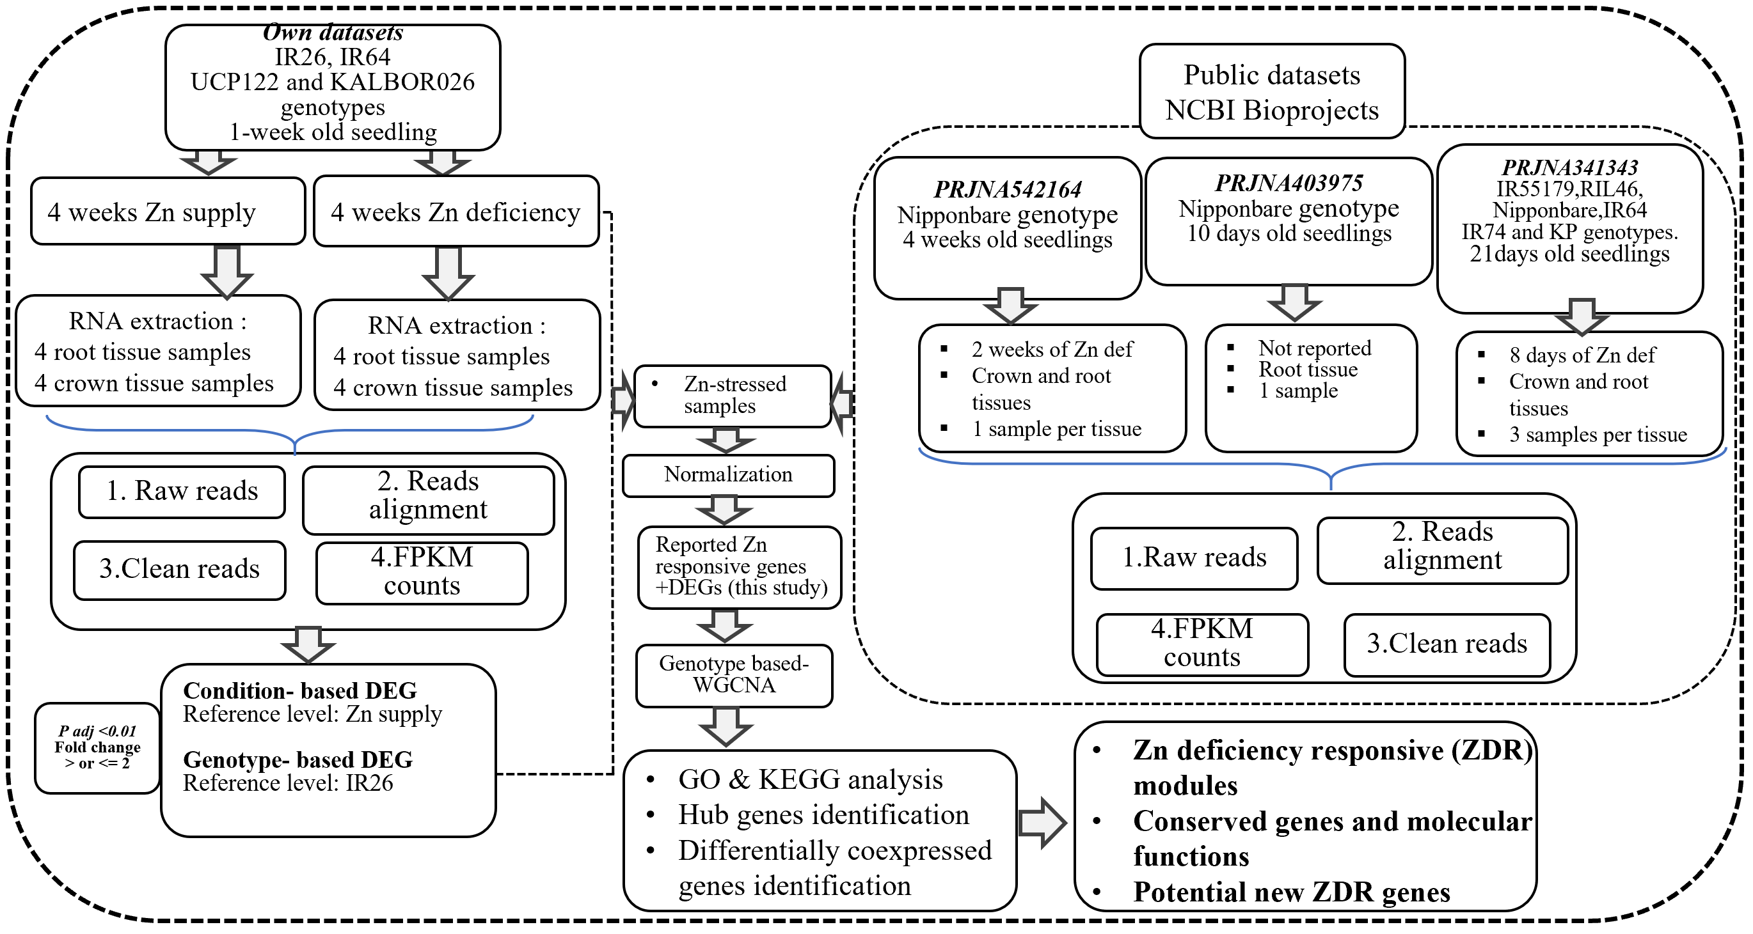

Figure S3. A comprehensive pipeline used in this study.

Fig. S4
(a)
(b)

Groups

PC1: 51 % of variance

Figure S4 Samples’ cluster analysis and principal component analysis before. a before controlling batches effects from previous projects (PRJNA341343, PRJNA542164 and PRJNA403975 deposited at NCBI repository). b After correcting for batches effects. The other controlled variations were those coming from different tissues used (crown or root), plant growth stage and the duration Zn deficiency exposure. Controlling these variations slightly improved data homogeneity for downstream analysis. Height represents the average Euclidean distance between samples computed with hclust() function. The root sample of IR26 genotype was an outlier at cutHeight = 0.5. We kept this sample, assuming that this observation was not due to technical errors, since the sample was from this project. A heat map of ZUE categories across all genotypes is illustrated underneath the sample dendrogram. Genotypes from the same category of ZUE are represented by red-colored bars. ZUE levels of AUS genotypes are still unknown. Therefore, no specific categories were attributed to AUS genotypes.

Fig. S5
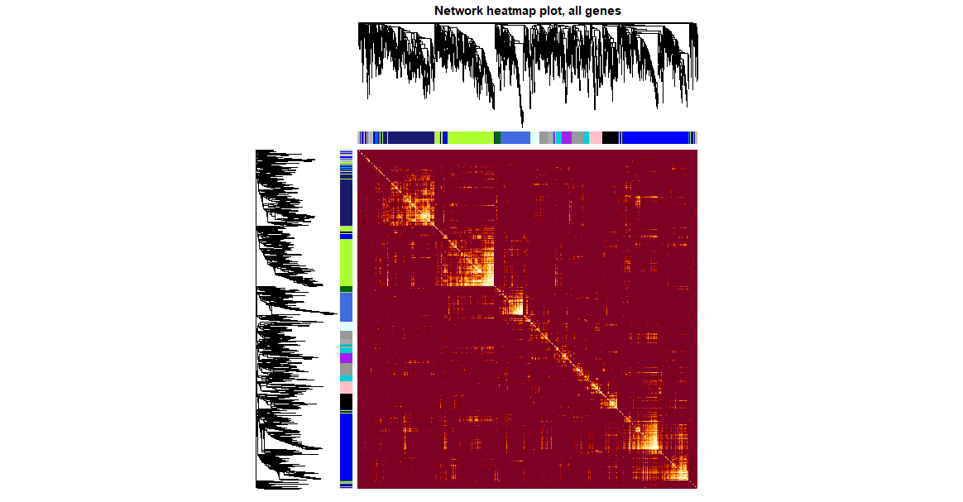
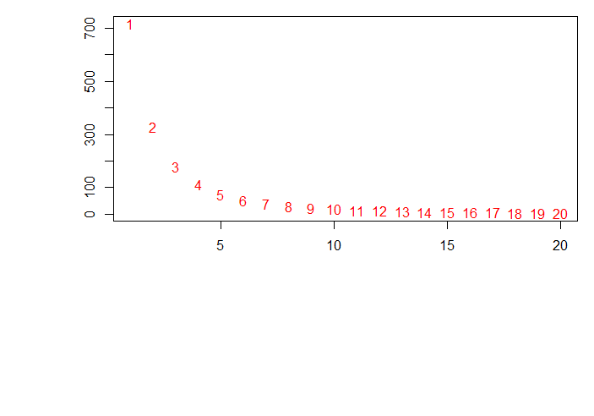
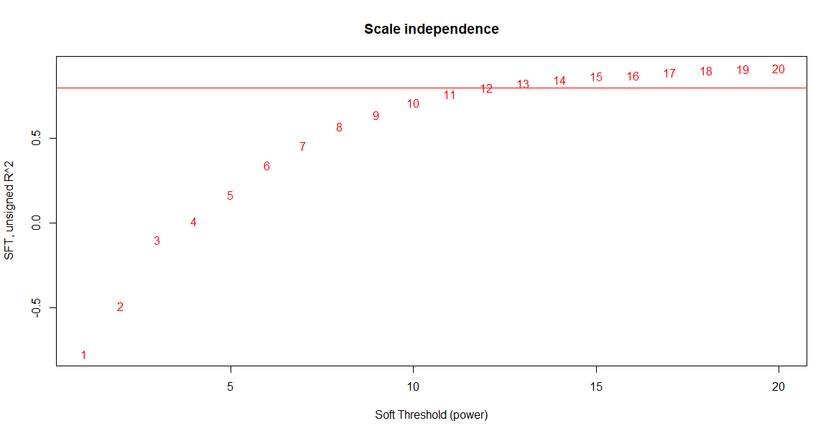
(a)
Soft threshold (power)
Soft threshold (power)
Mean connectivity
Soft threshold, R²

dissTOM

dissTOM

(b)

Figure S5 Selections of parameters for network construction. a Scale independence and mean connectivity. A soft thresholding power of 13 was selected as it was well above an R² of 0.85 independence, while the mean connectivity was still above 0. b Illustration of hierarchical cluster dendrogram of nodes/genes. dissTOM or (1-TOM) represents coexpression distance.

