Supplemental Digital Appendix 1. Note Count by International Classification of Diseases, 10th edition, Clinical Modification

Diagnostic Area | ICD-10-CM Chapter | Chapter Number | ICD Code Range | Notes
Infectious | Certain infectious and parasitic diseases | 1 | A00-B99 | 4308
Hematologic/  Oncologic | Neoplasms | 2 | C00-D49 | 1917
Hematologic/  Oncologic | Diseases of the blood and the blood-forming organs and certain disorders involving the immune system | 3 | D50-D89 | 1165
Endocrine | Endocrine, nutritional and metabolic disorders | 4 | E00-E89 | 2208
Psychiatric | Mental, behavioral and neurodevelopmental disorders | 5 | F01-F99 | 1440
Neurologic | Diseases of the nervous system | 6 | G00-G99 | 937
Cardiac | Diseases of the circulatory / cardiovascular system | 9 | I00-I99 | 7787
Pulmonary | Diseases of the respiratory system | 10 | J00-J99 | 3626
Gastrointestinal | Diseases of the digestive system | 11 | K00-K95 | 3559
Dermatologic | Diseases of the skin and subcutaneous tissue | 12 | L00-L99 | 1164
Musculoskeletal | Diseases of the musculoskeletal system and the connective tissue | 13 | M00-M99 | 1267
Genitourinary | Diseases of the genitourinary system | 14 | N00-N99 | 2592
Other | Diseases of the eye and adnexa | 7 | H00-H59 | 25
Other | Diseases of the ear and mastoid process | 8 | H60-H95 | 37
Other | Pregnancy, childbirth and the puerperium | 15 | O00-O9A | 50
Other | Certain conditions originating in the perinatal period | 16 | P00-P96 | 0
Other | Congenital malformations, deformations and chromosomal abnormalities | 17 | Q00-Q99 | 15
Other | Symptoms, signs and abnormal clinical and laboratory findings, not elsewhere classified | 18 | R00-R99 | 2093
Other | Injury, poisoning and certain other consequences of external causes | 19 | S00-T88 | 1117
Other | External causes of morbidity | 20 | V00-Y99 | 157
Other | Factors influencing health status and contact with health services | 21 | Z00-Z99 | 192
Other | Codes for Special Purposes | 22 | U00-U99 | 0
Unknown | N/A | N/A | Unavailable | 2094

Supplemental Digital Appendix 2. Resident Count by Site and by Academic Year

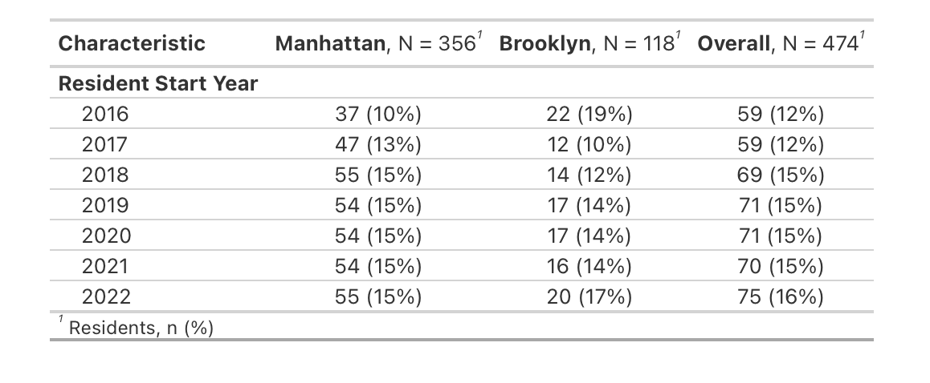

Supplement Digital Appendix 3: Descriptive Statistics of Note Quality by Resident Post-Graduate Year (PGY), Clinical Learning Environment Characteristics, and Patient Characteristics

