Table 1. Descriptive Statistics of Note Quality by Site, Resident Characteristics, Clinical Learning Environment Characteristics, and Patient Characteristics
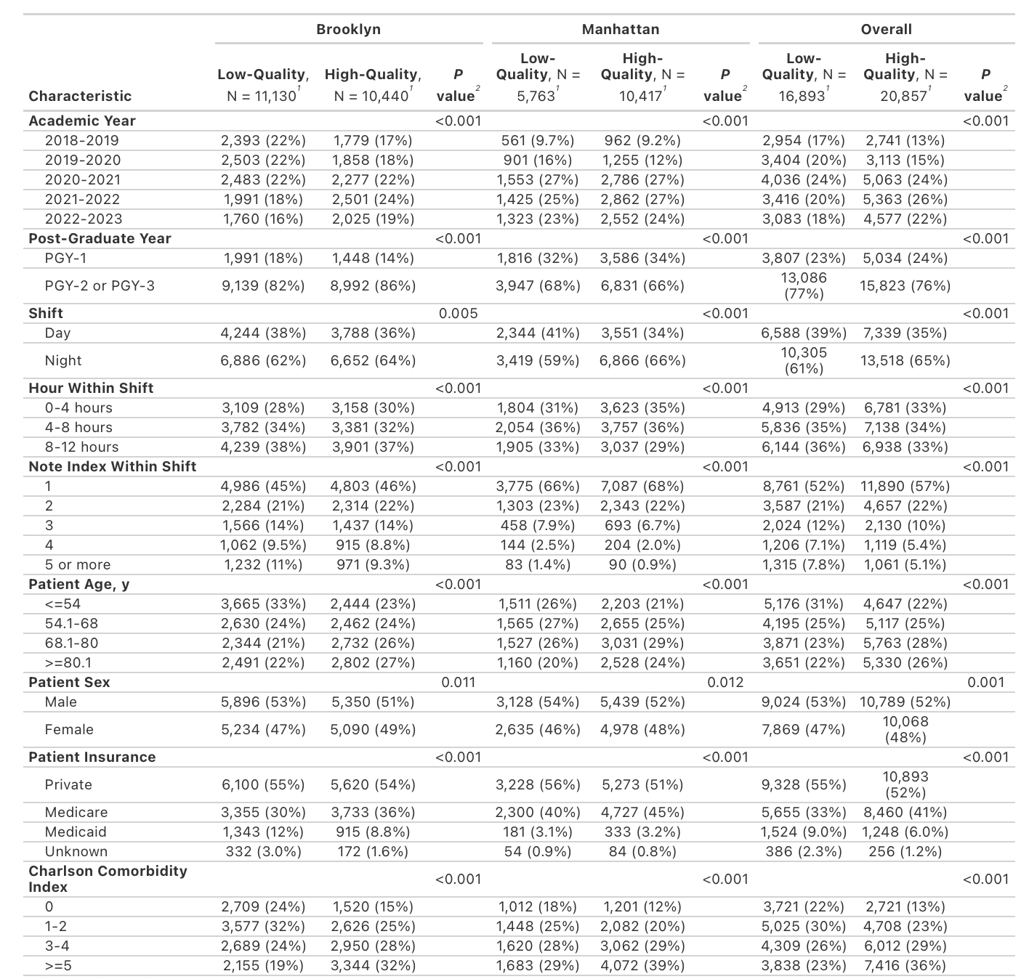
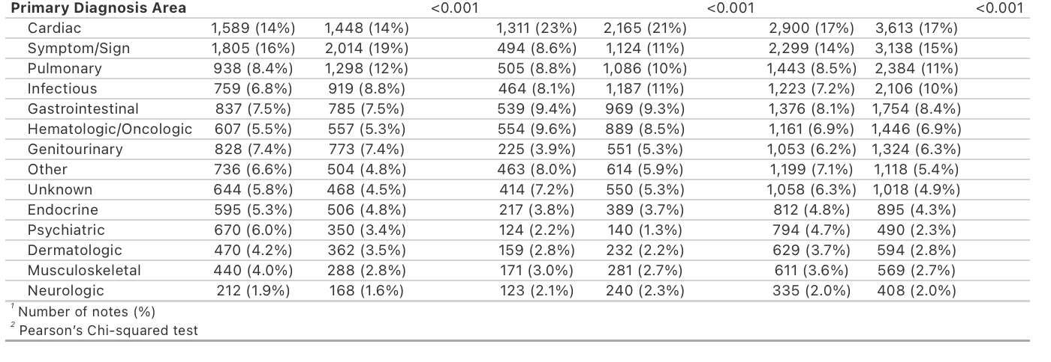

Resident Characteristics, Clinical Learning Environment Characteristics, and Patient Characteristics
