Article title: Synergistic antidepressant-like effects of biotics and n-3 polyunsaturated fatty acids on dopaminergic pathway through the brain-gut axis in rats exposed to chronic mild stress
Journal name: Probiotics and Antimicrobial Proteins
Author name: Hyunji Cho, Yongsoon Park
Email address of corresponding author: yongsoon@hanyang.ac.kr

Supplementary Table 1. Compositions of experimental diets
 | n-6 PUFA diet | n-3 PUFA diet
Energy (kcal/kg diet) | 4000 | 4000
Protein | 812 | 812
Carbohydrate | 2556 | 2556
Fat | 632 | 632
Ingredient | (g/kg diet)
Casein | 200 | 200
L-Cysteine | 3 | 3
Sucrose | 100 | 100
Cornstarch | 397 | 397
Maltodextrin | 132 | 132
Cellulose | 50 | 50
Mineral Mix | 35 | 35
Vitamin Mix | 10 | 10
Choline | 2.5 | 2.5
T-Butyl hydroquinone | 0.014 | 0.014
Fat composition
Grape seed oil | 70 | 62.67
Fish oil (re-esterified triglyceride) | - | 7.33
FA composition | (% Total FAs)
18:3n3 | 0.34 | 0.76
20:5n3 | 0.08 | 4.29
22:5n3 | 0.01 | 0.53
22:6n3 | 0.01 | 2.93
SFA | 11.50 | 10.55
MUFA | 23.41 | 21.43
n-3 PUFA | 0.44 | 9.17
n-6 PUFA | 64.55 | 58.22
FA, fatty acid; SFA, saturated fatty acid; MUFA, monounsaturated fatty acid; PUFA, polyunsaturated fatty acid; Vitamin mix contains 9.74 g of sucrose.

 | NS | CMS |  |  |  |  |  | P-value
 | NS | N6 | Pro | Post | N3 | N3Pro | N3Post | CMS | Diet | Biotics | Diet×  Biotics
Dietary intake  (g/day) | 19.75  ± 1.40 | 20.60  ± 0.51 | 19.46  ± 0.79 | 20.27  ± 1.05 | 20.05  ± 1.14 | 19.94  ± 0.47 | 21.00  ± 0.63 | 0.210 | 0.421 | 0.054 | 0.134
Initial BW (g) | 152.98  ± 19.51 | 147.51  ± 15.03 | 153.44  ± 6.56 | 149.55  ± 11.55 | 148.60  ± 13.24 | 145.36  ± 7.58 | 149.51  ± 18.24 | 0.591 | 0.452 | 0.142 | 0.551
Final BW (g) | 508.15  ± 29.70* | 448.06  ± 24.17 | 467.72  ± 35.44 | 459.31  ± 25.75 | 472.87  ± 56.61 | 462.29  ± 38.82 | 474.50  ± 40.82 | 0.003 | 0.376 | 0.915 | 0.621
Hippocampus (g) | 0.12  ± 0.02 | 0.13  ± 0.01 | 0.13  ± 0.02 | 0.11  ± 0.02 | 0.12  ± 0.02 | 0.14  ± 0.02 | 0.12  ± 0.02 | 0.085 | 0.053 | 0.062 | 0.718
Colon (g) | 0.46  ± 0.17 | 0.37  ± 0.06 | 0.32  ± 0.05 | 0.37  ± 0.07 | 0.38  ± 0.09 | 0.41  ± 0.12 | 0.42  ± 0.04 | 0.242 | 0.057 | 0.561 | 0.470
Supplemental Table 2. Dietary intakes, body and organ weight
Values are means and standard deviation (n = 6/group); CMS, chronic mild stress; BW, body weight; NS, n-6 PUFA diet without CMS; N6, n-6 PUFA diet with CMS; Pro, n-6 PUFA diet and probiotics with CMS; Post, n-6 PUFA diet and postbiotics with CMS; N3, n-3 PUFA diet with CMS; N3Pro, n-3 PUFA diet and probiotics with CMS; N3Post, n-3 PUFA diet and postbiotics with CMS.
*P < 0.05 compared with N6
Supplemental Table 3. Long chain fatty acid compositions of brain phospholipids
Fatty acids (%) | NS | CMS |  |  |  |  |  | P-value
Fatty acids (%) | NS | N6 | Pro | Post | N3 | N3Pro | N3Post | CMS | Diet | Biotics | Diet ×  Biotics
14:0 | 0.19  ± 0.05 | 0.19  ± 0.04 | 0.19  ± 0.04 | 0.19  ± 0.04 | 0.19  ± 0.03 | 0.19  ± 0.03 | 0.19  ± 0.03 | 0.679 | 0.633 | 0.067 | 0.078
16:0 | 25.54  ± 0.61 | 25.37  ± 0.65 | 25.48  ± 0.76 | 25.67  ± 0.67 | 24.04  ± 0.66 | 25.77  ± 0.77 | 25.12  ± 0.60 | 0.636 | 0.506 | 0.644 | 0.940
18:0 | 23.26  ± 1.66 | 23.06  ± 1.39 | 23.08  ± 1.36 | 23.10  ± 1.35 | 22.98  ± 1.36 | 23.04  ± 1.34 | 23.96  ± 1.36 | 0.858 | 0.522 | 0.966 | 0.946
SFA | 49.83  ± 0.96 | 49.05  ± 0.70 | 49.22  ± 1.17 | 48.88  ± 0.61 | 49.38  ± 0.91 | 49.56  ± 1.29 | 48.91  ± 0.61 | 0.480 | 0.447 | 0.430 | 0.897
16:1n7 | 0.37  ± 0.08 | 0.38  ± 0.06 | 0.37  ± 0.05 | 0.37  ± 0.06 | 0.38  ± 0.05 | 0.37  ± 0.05 | 0.37  ± 0.06 | 0.127 | 0.219 | 0.116 | 0.532
18:1n9 | 20.74  ± 0.37 | 20.86  ± 0.30 | 20.72  ± 0.30 | 20.79  ± 0.00 | 20.89  ± 0.30 | 20.91  ± 0.34 | 20.90  ± 0.36 | 0.177 | 0.266 | 0.864 | 0.786
20:1n9 | 0.30  ± 0.05 | 0.30  ± 0.05 | 0.30  ± 0.05 | 0.30  ± 0.05 | 0.30  ± 0.04 | 0.30  ± 0.06 | 0.30  ± 0.07 | 0.070 | 0.096 | 0.641 | 0.264
MUFA | 21.01  ± 0.39 | 21.01  ± 0.38 | 20.87  ± 0.38 | 21.04  ± 0.02 | 20.89  ± 0.37 | 20.91  ± 0.40 | 20.91  ± 0.43 | 0.200 | 0.555 | 0.842 | 0.811
18:2n6 | 0.69  ± 0.02 | 0.68  ± 0.01 | 0.67  ± 0.01 | 0.68  ± 0.01 | 0.64  ± 0.01† | 0.64  ± 0.01† | 0.64  ± 0.01† | 0.098 | <0.001 | 0.824 | 0.723
20:2n6 | 0.16  ± 0.03 | 0.16  ± 0.01 | 0.16  ± 0.01 | 0.16  ± 0.00 | 0.16  ± 0.01† | 0.16  ± 0.02† | 0.16  ± 0.00† | 0.616 | <0.001 | 0.053 | 0.052
20:3n6 | 0.31  ± 0.07 | 0.31  ± 0.04 | 0.32  ± 0.05 | 0.32  ± 0.01 | 0.30  ± 0.04† | 0.30  ± 0.01† | 0.30  ± 0.00† | 0.366 | <0.001 | 0.154 | 0.193
20:4n6 | 10.40  ± 0.24 | 10.37  ± 0.15 | 10.49  ± 0.19 | 10.58  ± 0.06 | 10.00  ± 0.16† | 9.85  ± 0.32† | 10.06  ± 0.00† | 0.542 | <0.001 | 0.095 | 0.192
22:4n6 | 2.30  ± 0.04 | 2.28  ± 0.03 | 2.31  ± 0.04 | 2.33  ± 0.01 | 2.20  ± 0.03† | 2.18  ± 0.07† | 2.22  ± 0.00† | 0.693 | <0.001 | 0.135 | 0.309
22:5n6 | 1.91  ± 0.02 | 1.91  ± 0.01 | 1.91  ± 0.02 | 1.91  ± 0.00 | 0.20  ± 0.01† | 0.20  ± 0.03† | 0.20  ± 0.00† | 0.232 | <0.001 | 0.052 | 0.365
n-6 PUFA | 16.14  ± 0.32 | 16.08  ± 0.21 | 16.11  ± 0.30 | 16.21  ± 0.11 | 13.34  ± 0.25† | 13.13  ± 0.50† | 13.43  ± 0.01† | 0.673 | <0.001 | 0.180 | 0.283
20:5n3 | 0.35  ± 0.07 | 0.35  ± 0.01 | 0.35  ± 0.00 | 0.35  ± 0.01 | 0.37  ± 0.00† | 0.37  ± 0.00† | 0.37  ± 0.00† | 0.618 | <0.001 | 0.866 | 0.613
22:5n3 | 0.12  ± 0.01 | 0.12  ± 0.00 | 0.12  ± 0.04 | 0.12  ± 0.02 | 0.43  ± 0.06† | 0.42  ± 0.07† | 0.43  ± 0.03† | 0.840 | <0.001 | 0.131 | 0.740
22:6n3 | 11.47  ± 0.23 | 11.57  ± 0.01 | 11.33  ± 0.37 | 11.50  ± 0.19 | 11.92  ± 0.17† | 12.06  ± 0.22† | 12.20  ± 0.07† | 0.259 | <0.001 | 0.205 | 0.057
n-3 PUFA | 12.08  ± 0.24 | 12.19  ± 0.02 | 12.22  ± 0.38 | 12.40  ± 0.20 | 12.87  ± 0.19† | 13.00  ± 0.24† | 13.15  ± 0.07† | 0.270 | <0.001 | 0.209 | 0.077
Values are means and standard deviation (n = 6/group); CMS, chronic mild stress; SFA, saturated fatty acid; MUFA, monounsaturated fatty acid; PUFA, polyunsaturated fatty acid; NS, n-6 PUFA diet without CMS; N6, n-6 PUFA diet with CMS; Pro, n-6 PUFA diet and probiotics with CMS; Post, n-6 PUFA diet and postbiotics with CMS; N3, n-3 PUFA diet with CMS; N3Pro, n-3 PUFA diet and probiotics with CMS; N3Post, n-3 PUFA diet and postbiotics with CMS.
† P < 0.05 compared with n-6 PUFA diet groups in the same probiotics group with CMS.
Supplemental Table 4. Long chain fatty acid compositions of gut phospholipids
Fatty acids (%) | NS | CMS |  |  |  |  |  | P-value
Fatty acids (%) | NS | N6 | Pro | Post | N3 | N3Pro | N3Post | CMS | Diet | Biotics | Diet ×  Biotics
14:0 | 0.81  ± 0.07 | 0.78  ± 0.03 | 0.79  ± 0.03 | 0.79  ± 0.03 | 0.79  ± 0.03 | 0.80  ± 0.02 | 0.80  ± 0.02 | 0.381 | 0.346 | 0.748 | 0.884
16:0 | 19.69  ± 0.38 | 20.45  ± 1.13 | 20.92  ± 0.35 | 20.23  ± 0.64 | 21.13  ± 0.70 | 20.61  ± 1.05 | 20.79  ± 0.70 | 0.147 | 0.252 | 0.644 | 0.269
18:0 | 18.75  ± 0.45 | 18.83  ± 0.46 | 18.57  ± 0.30 | 18.61  ± 0.36 | 18.68  ± 0.34 | 18.68  ± 0.45 | 18.69  ± 0.36 | 0.774 | 0.920 | 0.683 | 0.655
SFA | 39.25  ± 0.47 | 40.06  ± 0.94 | 41.68  ± 0.54 | 41.10  ± 0.87 | 41.05  ± 0.47 | 41.53  ± 1.05 | 41.73  ± 0.60 | 0.088 | 0.053 | 0.236 | 0.087
16:1n7 | 1.67  ± 0.05 | 1.66  ± 0.04 | 1.67  ± 0.04 | 1.67  ± 0.04 | 1.66  ± 0.04 | 1.67  ± 0.04 | 1.66  ± 0.03 | 0.754 | 0.848 | 0.853 | 0.911
18:1n9 | 17.32  ± 0.58 | 17.10  ± 0.37 | 17.00  ± 0.36 | 17.19  ± 0.49 | 16.98  ± 0.47 | 17.30  ± 0.46 | 17.48  ± 0.34 | 0.459 | 0.275 | 0.234 | 0.389
20:1n9 | 0.90  ± 0.01 | 0.89  ± 0.03 | 0.90  ± 0.03 | 0.90  ± 0.03 | 0.91  ± 0.01 | 0.90  ± 0.04 | 0.89  ± 0.03 | 0.488 | 0.886 | 0.875 | 0.729
MUFA | 19.89  ± 0.55 | 19.66  ± 0.38 | 19.77  ± 0.38 | 19.84  ± 0.43 | 19.75  ± 0.43 | 20.05  ± 0.46 | 20.25  ± 0.30 | 0.412 | 0.064 | 0.123 | 0.628
18:2n6 | 4.85  ± 0.01 | 4.85  ± 0.02 | 4.85  ± 0.04 | 4.84  ± 0.04 | 2.68  ± 0.01† | 2.69  ± 0.03† | 2.68  ± 0.04† | 0.824 | <0.001 | 0.870 | 0.957
20:2n6 | 0.41  ± 0.03 | 0.40  ± 0.01 | 0.41  ± 0.01 | 0.41  ± 0.01 | 0.29  ± 0.01† | 0.30  ± 0.02† | 0.29  ± 0.03† | 0.559 | <0.001 | 0.576 | 0.597
20:3n6 | 4.90  ± 0.09 | 4.88  ± 0.44 | 4.53  ± 0.23 | 4.71  ± 0.20 | 3.57  ± 0.29† | 3.63  ± 0.38† | 3.37  ± 0.23† | 0.912 | <0.001 | 0.333 | 0.163
20:4n6 | 18.08  ± 0.39 | 17.83  ± 0.59 | 18.05  ± 0.32 | 18.29  ± 0.17 | 12.19  ± 0.22† | 12.20  ± 0.42† | 12.06  ± 0.27† | 0.401 | <0.001 | 0.502 | 0.143
22:4n6 | 1.45  ± 0.09 | 1.47  ± 0.23 | 1.47  ± 0.03 | 1.43  ± 0.04 | 0.28  ± 0.04† | 0.25  ± 0.00† | 0.27  ± 0.08† | 0.869 | <0.001 | 0.814 | 0.771
22:5n6 | 1.31  ± 0.04 | 1.30  ± 0.02 | 1.31  ± 0.01 | 1.31  ± 0.01 | 0.13  ± 0.00† | 0.12  ± 0.00† | 0.13  ± 0.00† | 0.787 | <0.001 | 0.465 | 0.309
n-6 PUFA | 30.99  ± 0.46 | 30.72  ± 0.76 | 30.66  ± 0.56 | 31.05  ± 0.24 | 19.16  ± 0.21† | 19.20  ± 0.68† | 18.81  ± 0.35† | 0.477 | <0.001 | 0.999 | 0.143
20:5n3 | 0.53  ± 0.05 | 0.55  ± 0.06 | 0.52  ± 0.03 | 0.54  ± 0.01 | 0.65  ± 0.01† | 0.65  ± 0.01† | 0.65  ± 0.01† | 0.527 | <0.001 | 0.577 | 0.356
22:5n3 | 0.30  ± 0.01 | 0.31  ± 0.01 | 0.31  ± 0.01 | 0.30  ± 0.01 | 0.39  ± 0.01† | 0.39  ± 0.03† | 0.39  ± 0.01† | 0.675 | <0.001 | 0.826 | 0.890
22:6n3 | 6.84  ± 0.87 | 6.71  ± 0.57 | 6.75  ± 0.27 | 6.83  ± 0.47 | 17.71  ± 0.40† | 17.82  ± 0.21† | 17.82  ± 0.54† | 0.762 | <0.001 | 0.795 | 0.960
n-3 PUFA | 7.72  ± 0.83 | 7.61  ± 0.57 | 7.62  ± 0.27 | 7.72  ± 0.45 | 18.77  ± 0.40† | 18.93  ± 0.21† | 18.93  ± 0.55† | 0.802 | <0.001 | 0.749 | 0.908
Values are means and standard deviation (n = 6/group); CMS, chronic mild stress; SFA, saturated fatty acid; MUFA, monounsaturated fatty acid; PUFA, polyunsaturated fatty acid; NS, n-6 PUFA diet without CMS; N6, n-6 PUFA diet with CMS; Pro, n-6 PUFA diet and probiotics with CMS; Post, n-6 PUFA diet and postbiotics with CMS; N3, n-3 PUFA diet with CMS; N3Pro, n-3 PUFA diet and probiotics with CMS; N3Post, n-3 PUFA diet and postbiotics with CMS.
† P < 0.05 compared with n-6 PUFA diet groups in the same probiotics group with CMS.

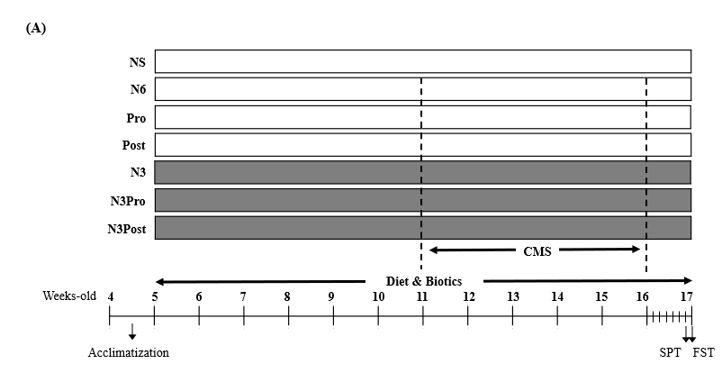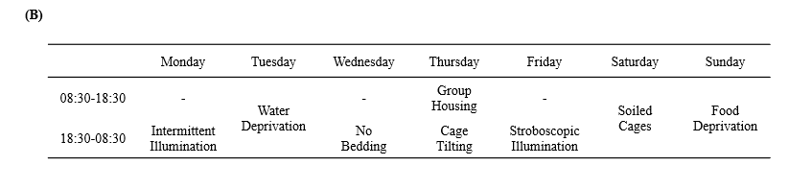
Supplemental Fig. 1. The experimental design (A) and chronic mild stress procedure (B). CMS, chronic mild stress; SPT, sucrose preference test; FST, forced swimming test; NS, n-6 PUFA diet without CMS; N6, n-6 PUFA diet with CMS; Pro, n-6 PUFA diet and probiotics with CMS; Post, n-6 PUFA diet and postbiotics with CMS; N3, n-3 PUFA diet with CMS; N3Pro, n-3 PUFA diet and probiotics with CMS; N3Post, n-3 PUFA diet and postbiotics with CMS.

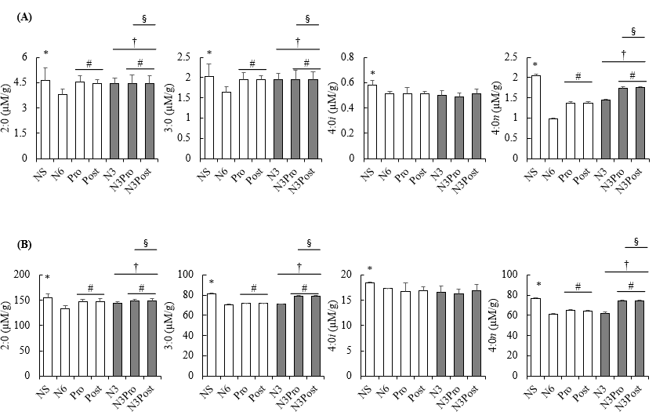
Supplementary Fig. 2. Levels of short chain fatty acids in brain (A) and gut (B). Values are mean with standard deviation (n = 6/group); Independent t-test was used to determine chronic mild stress (CMS) effect; Effects of diet and biotics, and their synergistic effect were determined by two-way ANOVA followed by Duncan’s post hoc test; ∗P < 0.05 compared to n-6 PUFA diet with chronic mild stress (N6); #P < 0.05 compared to non-probiotics in the same diet with CMS; †P < 0.05 compared to n-6 PUFA diet with CMS; §P < 0.05 synergistic effects of biotics and n-3 PUFA; NS, n-6 PUFA diet without CMS; N6, n-6 PUFA diet with CMS; Pro, n-6 PUFA diet and probiotics with CMS; Post, n-6 PUFA diet and postbiotics with CMS; N3, n-3 PUFA diet with CMS; N3Pro, n-3 PUFA diet and probiotics with CMS; N3Post, n-3 PUFA diet and postbiotics with CMS.

