Real-world impact of physical activity reward-driven digital App use on cardiometabolic and cardiovascular disease incidence

Adi Berliner Senderey^{1,2,3}, Tom Mushkat^{1,4}, Ofer Hadass^{5,6}, Daphna Carmeli⁵, Samah Hayek^{1,7}, Marie-Laura Charpingnon⁸, Eyal Jacobson⁵, Ran D. Balicer^{1,3,9}
Affiliation
¹ Clalit Research Institute, Innovation Division, Clalit Health Services, Ramat Gan, Israel
² Department of Biomedical Informatics, Harvard Medical School, Boston, MA
³ The Ivan and Francesca Berkowitz Family Living Laboratory Collaboration at Harvard
Medical School and Clalit Research Institute, Boston, MA, USA.
⁴ Department of Psychology, Faculty of Social Science, The Hebrew University of
Jerusalem, Jerusalem, Israel
⁵ Clalit Supplementary Health Services, Clalit Health Services, Bnei Brak, Israel
⁶ Department of General History, Faculty of History, University of Haifa, Haifa, Israel
⁷ Department of Epidemiology and Preventive Medicine, School of Public Health, Faculty of
Medicine, Tel Aviv University, Tel Aviv, Israel
⁸ Institute for Data, Systems, and Society, Massachusetts Institute of Technology,
Cambridge
⁹ School of Public Health, Faculty of Health Sciences, Ben Gurion University of the Negev,
Be’er Sheva

Corresponding author:
Adi Berliner Senderey, PhD
Clalit Research Institute
Toval 40, Ramat Gan, Israel
T: +972-54-5313549

Contents
Supplemental Figure 1: Study design and data collection 3
Supplemental table 1: Variable Definitions 4
Supplemental Figure 2: Covariate Balance (love) plot 8
Supplemental Table 2: Top-10 incentives purcheses by levels of physical activity: 8
Supplemental Figure 3: The Cumulative incidence curves by type of chronic condition (with a different matching approach - Propensity Score Matching (PSM)) 10

Supplemental Figure 1: Study design and data collection

Cohort entry date is for registered users of the mobile app between January 2021 and June 2023, with follow-up until September 2023. The index data was set based on matching.

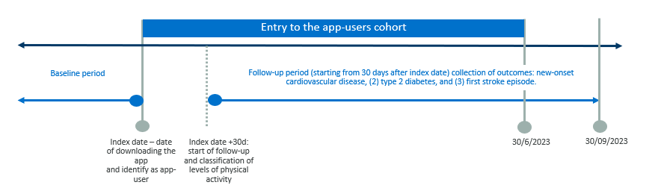

Supplemental table 1: Variable Definitions

Variable | Values | Definitions¹ | Timing
Outcomes
Cardiovascular disease | 0/1 | Procedure codes:  G0085,G00T8,G0072,G0172,G0173,BC226  ICD-9 codes:  443.9,410,410.*,411,411.[18],411.8[19],  413.[01],434.9[01],434,434.0[01],  434.0,434.[19],  434.1[01],433.11,433.[123]0,433.1,  433.81,433.[02],433.31,  433,433.[389],433.9[01],433.[02]1,  433.[08]0,436,432,432.[019],431,  430,36.0*,36.1*  Internal CHS Registry code: 96.1 | Ever
Cerebral vascular accident | 0/1 | ICD-9 codes:  434.9[01],434,434.0[01],434.0,  434.[19],434.1[01],  433.11,433.[123]0,433.1,433.81,  433.[02],433.31,  433,433.[389],433.9[01],433.[02]1,  433.[08]0,436,432,432.[019],431,430 | Ever
Type 2 Diabetes Mellitus | 0/1 | HbA1C > 6.5 mg/dL  ATC5 codes: A10[AB]  ICD-9 codes: 250*, 357.2, 362.0*  And not:  ICD-9 codes: 250._1, 250._3 | Ever
Covariates
Age | Integer | Age in complete months devided by 12.0 | Current
Gender | Male/Female | As defined in CHS’ files | Current
Sector | Jewish/ Ultra-orthodox/ Non-Jewish | As defined in CHS’ files | Current
BMI | Integer | Body Mass Index in decimal points | Current
BMI levels | Underweight Normal  Overweight  Obesity  Morbid Obesity | BMI < 18.5  18.5-24.5  24.5-29.5  29.5-35  +35
HbA1C blood count | Integer | Lab code: 25203  Values in mg/dL | Last 6 months
HbA1C levels | 1/2/3/4/5 | HbA1C mg/dL -6,6-7,7-8,  8-10,+10, No measure | Last 6 months
Glucose blood count | Integer | Lab code: 20100  Values in mg/dL | Last 3 years
HDL blood count | Integer | Lab code: 21400  Values in mg/dL | Last 3 years
LDL blood count | Integer | Lab code: 21500  Values in mg/dL | Last 3 years
Triglycerides blood count | Integer | Lab code: 21300  Values in mg/dL | Last 3 years
Smoking category | Non-smoker/Former smoker/Current smoker | Internal CHS Registry | Last recorded value
Socio-economic status | Low/ Moderate/ High | Internal CHS Registry | Last recorded value
Diabetes complications | 0/1 | ICD-9 codes: 362.0*, 250.4, 250.4[02],  583.81, 250.6, 250.6[02], 357.2, 585*  Internal CHS Registry codes: 96.1, 173, 174  ICPC code: u88011  Albumin / Creatinine < 60  GFR level > 30
Hypertension | 0/1 | Have at least two diagnostic code  ICD-9 codes: 40[12345]*,I1[01235]*  ICPC code: K86  Internal CHS Registry codes: 120.[129] | Ever
Chronic renal disease | 0/1 | Have at least two diagnostic code  ICD-9 codes: 491.2*,492,492.[08],496*  ICPC code: R95 | Ever
Asthma | 0/1 | Have at least two diagnostic code  ICD-9 codes: 493*  Internal CHS Registry code: 144 | Ever
Bronchiectasis | 0/1 | Have at least two diagnostic code  ICD-9 codes: 494.[01]  Internal CHS Registry code: 148 | Ever
Pulmonary fibrosis | 0/1 | Have at least two diagnostic code  ICD-9 codes: 516.3[01],516.[89],515.0,501.0 | Ever
Chronic kidney disease | 0/1 | Have at least two diagnostic code  ICD-9 codes: 858*  Internal CHS Registry codes: 17[34] | Ever
Hyperlipidemia | 0/1 | Have at least two diagnostic code  ICD-9 codes: 272,272.[^678]*,E78.[^78]*  ICPC code: T93  Internal CHS Registry codes: 56* | Ever
Count of pre-existing conditions | 0/1-2/3-4/+5 | Summation of 1 point for each of the following:  • Cancer  • CKD  • Heart Disease  • Sickle Cell Disease  • Asthma  • Cerebrovascular Disease  • Hypertension  • Neurological Disease  • Liver Disease  • Thalassemia  • COPD or other respiratory disease  • Type 1 or 2 Diabetes Mellitus  • Solid organ transplant recipient or immunodeficiency  • Obesity or severe obesity | Current
No. of Flu vaccine in 5yr | Integer | Number of influenza vaccines the patients received in the last 5 years prior the index date | Last 5 years
No. GP visits in 5yr | Integer | Number of general physician visits the patients conducted in the last 5 years prior the index date | Last 5 years
District of living | List of places | Geo-statistical area in which the patient resides per CHS’ files | Last recorded value
Type of living | Jewish cities/ Towns/ Small towns/ Village | Internal Clalit Registry | Last recorded value

Note: Additional confirmation of the diagnostic codes was done by checking the matching of the free text within the diagnosis description field. Abbreviations: CHS: Clalit Health Services; ICD, International Classification of Disease. ATC, Anatomic therapeutic chemical

Supplemental Figure 2: Covariate Balance (love) plot
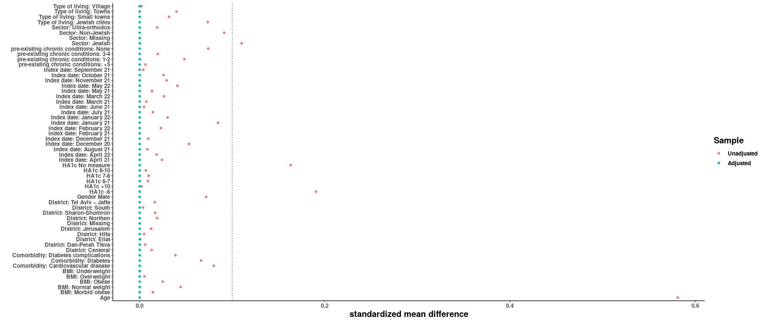
A covariate balance (Love) plot for the matched and unmatched, showing the difference in means for different set of covariates (confounders). It was assessed by absolute mean difference. A strict balance cut-off was set at 0.1.

Supplemental Table 2: Top-10 incentives purchases by levels of physical activity:

 | Mild | Moderate | High
Alternative medicine voucher | 9516 (5%) | 5695 (4.2%) | 4827 (3.5%)
Lenovo headphones | 7453 (3.9%) | 5020 (3.7%) | 5477 (4%)
massage tool | 7088 (3.7%) | 5181 (3.8%) | 5666 (4.1%)
Running cellphone bag | 7784 (4.1%) | 4385 (3.2%) | 4648 (3.4%)
Smart weight | 11219 (5.9%) | 19336 (14.3%) | 10964 (8%)
Sport bag | 12302 (6.4%) | 7558 (5.6%) | 7651 (5.6%)
Sport equipment voucher | 67606 (35.3%) | 45547 (33.6%) | 54054 (39.3%)
Xiaomi headphones | 25108 (13.1%) | 16498 (12.2%) | 17797 (12.9%)
Xiaomi smart band | 37290 (19.5%) | 22687 (16.8%) | 23061 (16.8%)
Yoga mattress | 6063 (3.2%) | 3512 (2.6%) | 3319 (2.4%)

Supplemental Figure 3: The Cumulative incidence curves by type of chronic condition
(with a different matching approach - Propensity Score Matching (PSM))

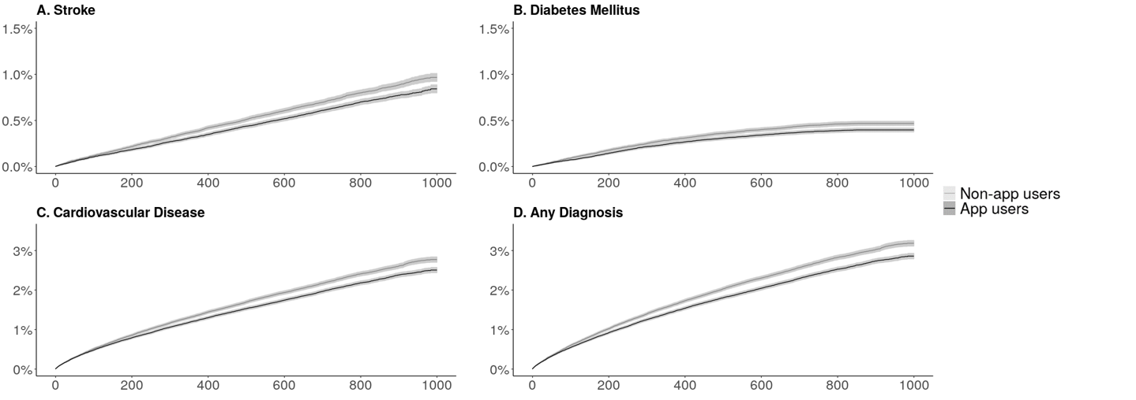

Note: Cumulative incidence for the four study outcomes among app users vs their matched, non-app user counterparts (a: stroke, b: type 2 diabetes, c: CVD, d: composite outcome). The x-axis defines the number of days since the index date. Shaded areas represent 95% confidence intervals.

