The genome of a giant clam zooxanthella (Cladocopium infistulum) offers few clues to adaptation as an extracellular symbiont with high thermotolerance

Raúl A. González-Pech^{1,2*}, Jihanne Shepherd^{3,4}, Zachary L. Fuller³, Todd C. LaJeunesse², and John Everett Parkinson^{1*}

¹Department of Integrative Biology, University of South Florida, Tampa, Florida 33620, USA
²Department of Biology, Pennsylvania State University, University Park, Pennsylvania 16802, USA
³Department of Biological Sciences, Columbia University, New York, New York 10027, USA
⁴Miller School of Medicine, University of Miami, Miami, Florida 33136, USA

*Authors for Correspondence: Raúl A. González-Pech, Department of Biology, The Pennsylvania State University, University Park, USA, +1 (813) 370-6598, rag5851@psu.edu; John E. Parkinson, Department of Integrative Biology, University of South Florida, Tampa, USA, +1 (845) 258-0803‬, jparkinson@usf.edu‬‬‬‬‬

Supplementary Figures

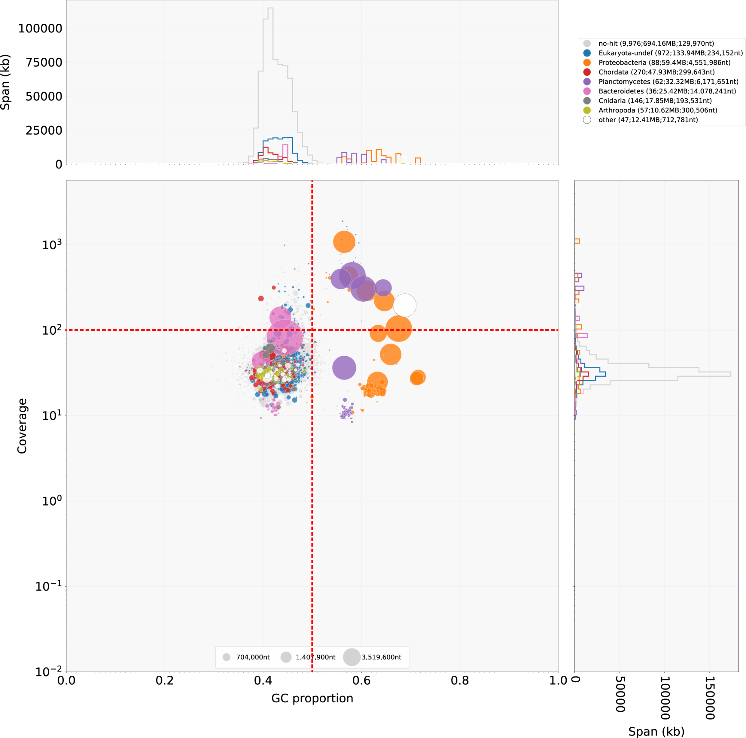
Supplementary Figure 1. Blob plot showing nucleotide composition (i.e. G+C content) in the x-axis and read coverage in the y-axis. The size of each datapoint corresponds with the length of the sequence as indicated in the bottom legend. The legend at the top-right corner denotes the taxonomic identification based on the color of the data points. The legend also includes the number and added length of the sequences, as well as the size of the longest sequence, within each taxonomic group in that order and in parentheses. The values used as cutoffs for removal are represented as red dashed lines.

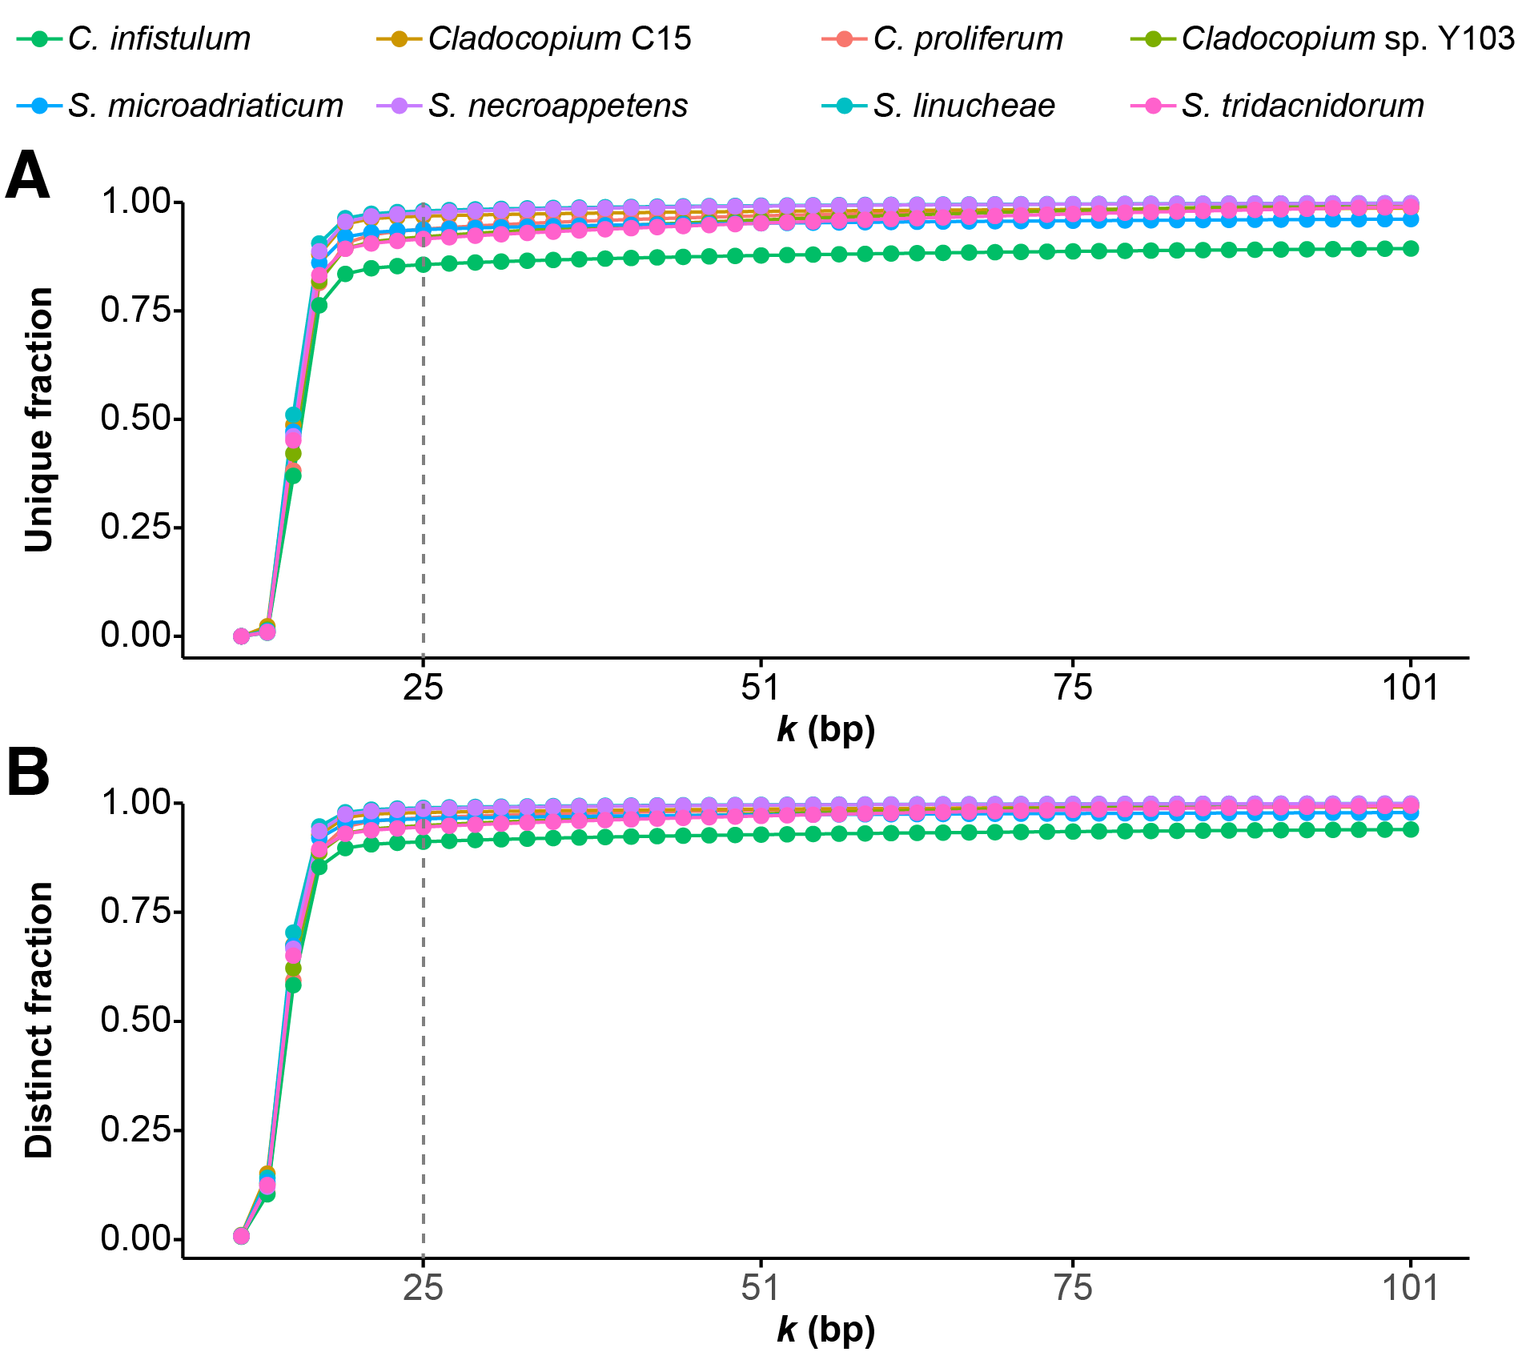
Supplementary Figure 2. Fractions of (A) unique and (B) distinct k-mers counted in each of the eight genome assemblies across a range of k sizes; k = 25 was selected as the appropriate size for the phylogenomic analysis as indicated with a gray dashed line.

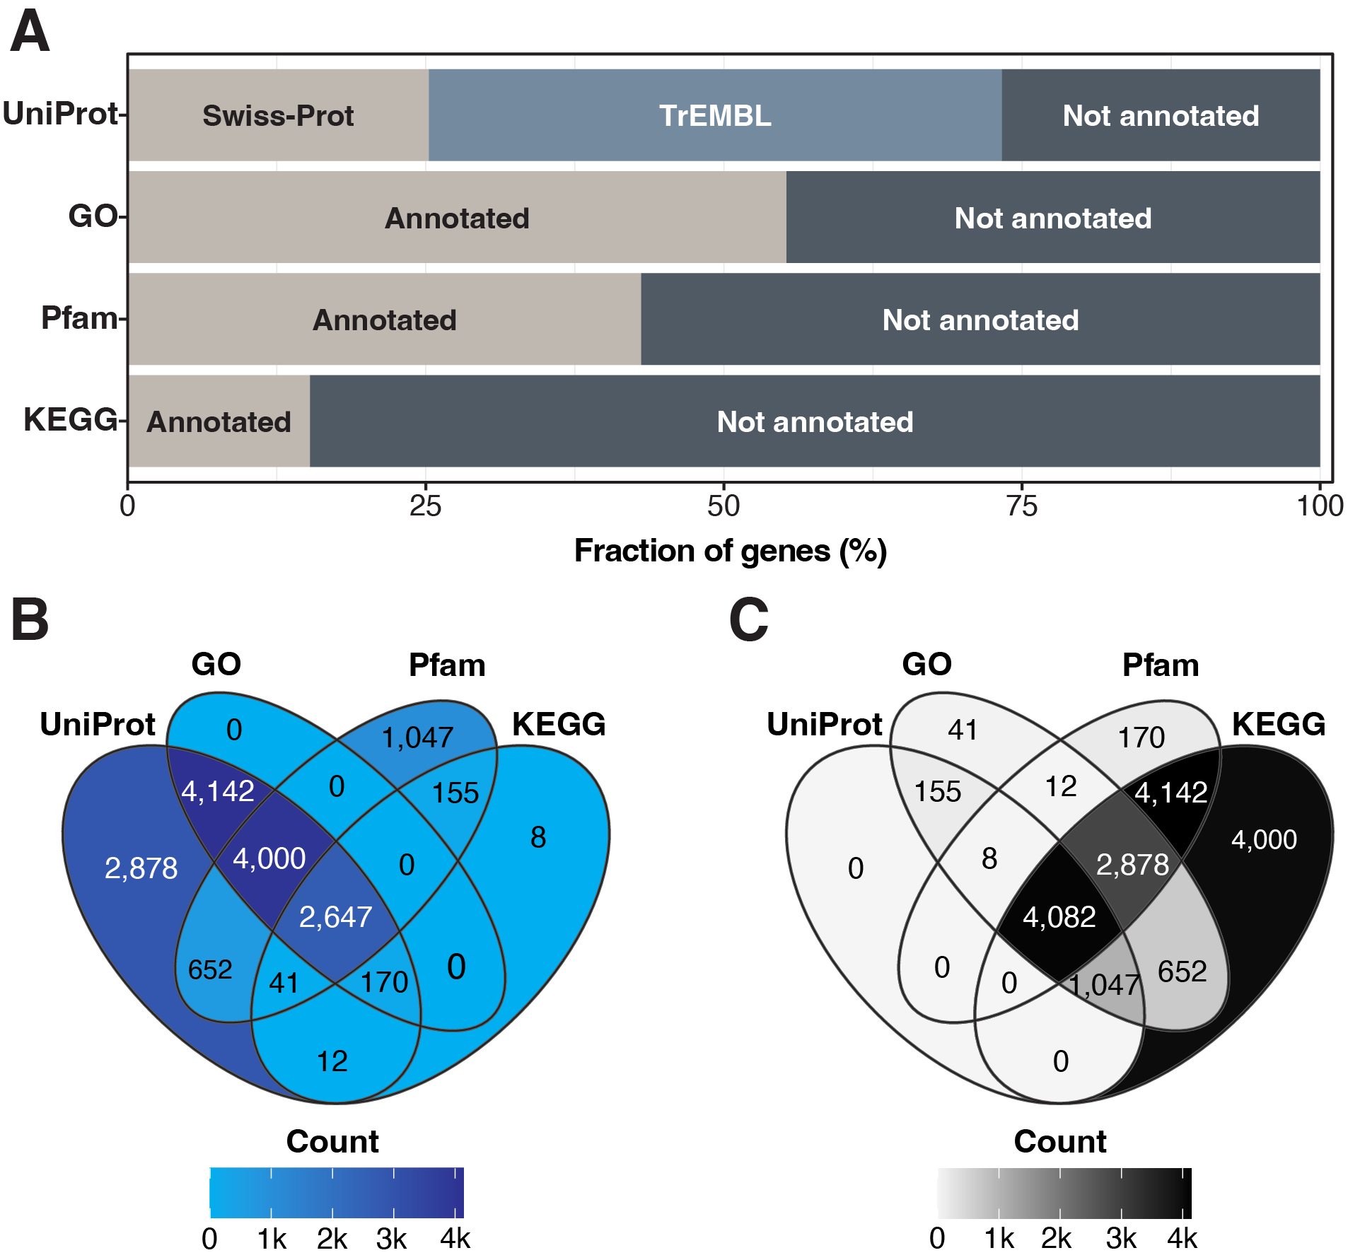
Supplementary Figure 3. (A) Fraction of genes annotated with different types of functions. (B) Venn diagram showing the overlaps between distinct types of function annotation. (C) Venn diagram showing the number of genes that were not annotated with each type of function as well as the overlaps.

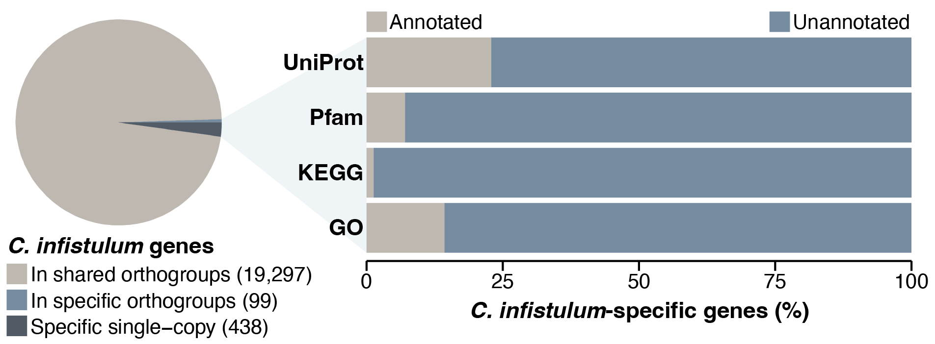
Supplementary Figure 4. Genes specific to C. infistulum. The pie chart on the left shows the fraction of genes exclusive to C. infistulum that are either single-copy or part of orthogroups, relative to the genes in orthogroups with members from other Symbiodiniaceae. The bar chart on the right shows fractions of these genes with distinct types of functional annotation.

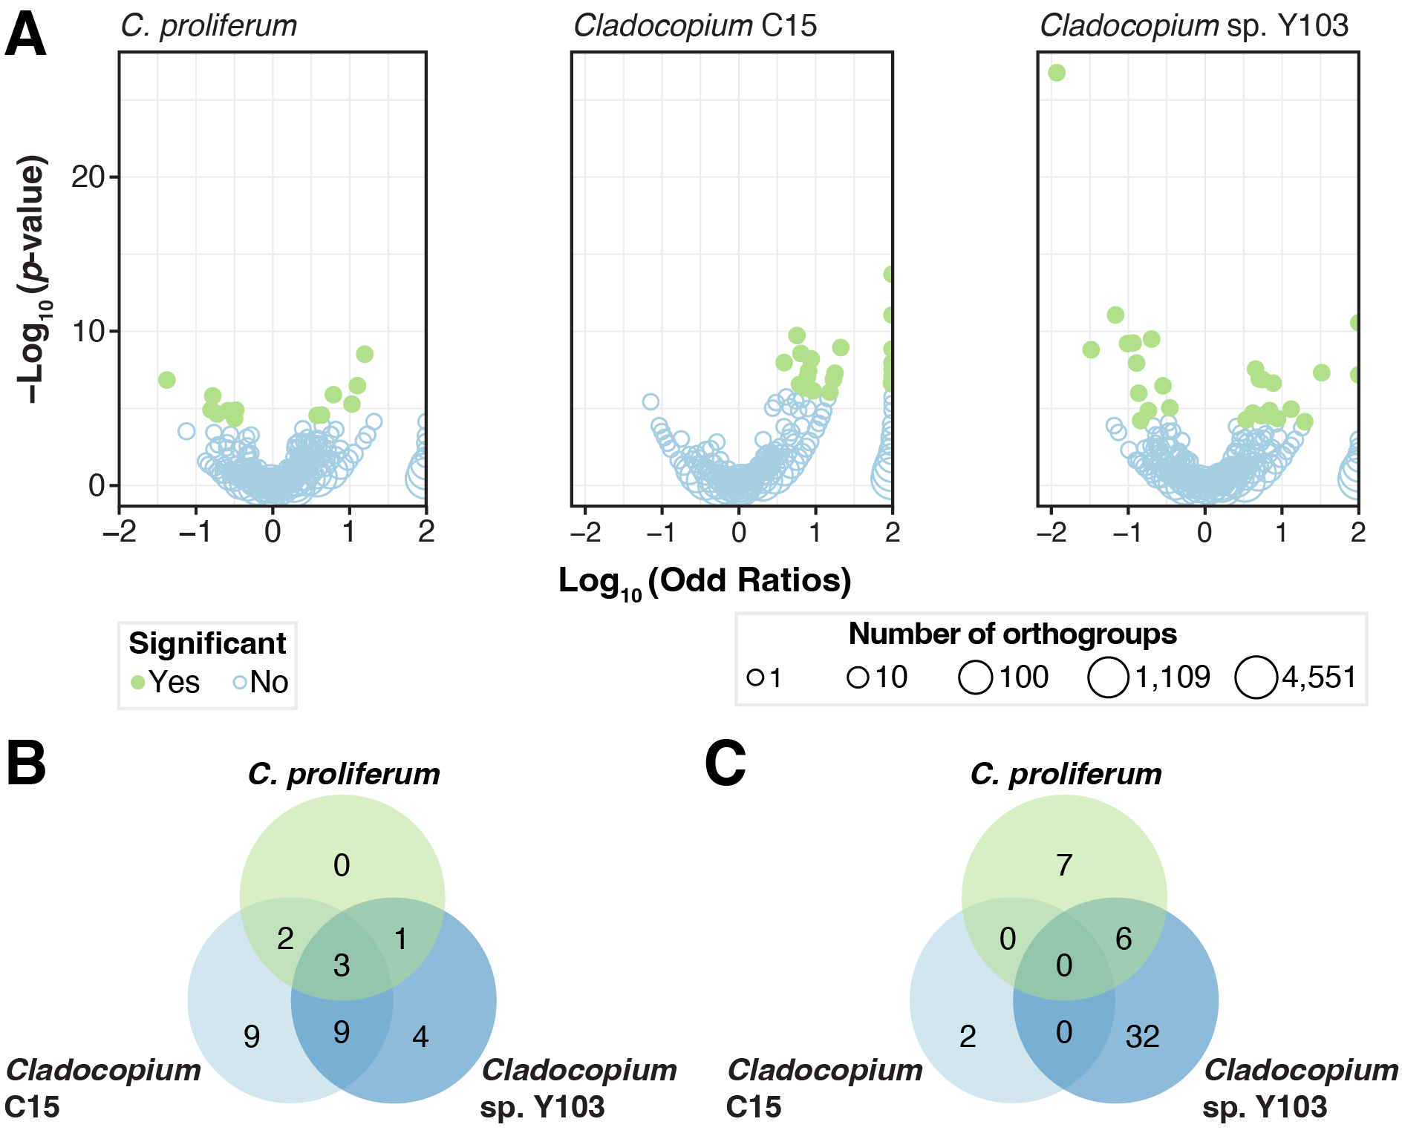
Supplementary Figure 5. Expanded and reduced orthogroups in C. infistulum. (A) Volcano showing significance (p-value) as a function of difference in orthogroup sizes (odd ratios or OR) between C. infistulum and each of the other Cladocopium with genomes available. Circle color indicates whether those orthogroups were considered significant (p_{adj} ≤ 0.05) and circle size represents the number of orthogroups with the same OR and p-value (see bottom legend). Orthogroups with log₁₀(OR) > 0 and < 0 are larger and smaller in C. infistulum, respectively. At the bottom, Venn diagrams show overlaps across all three comparisons for orthogroups (B) greater and (C) smaller in C. infistulum.

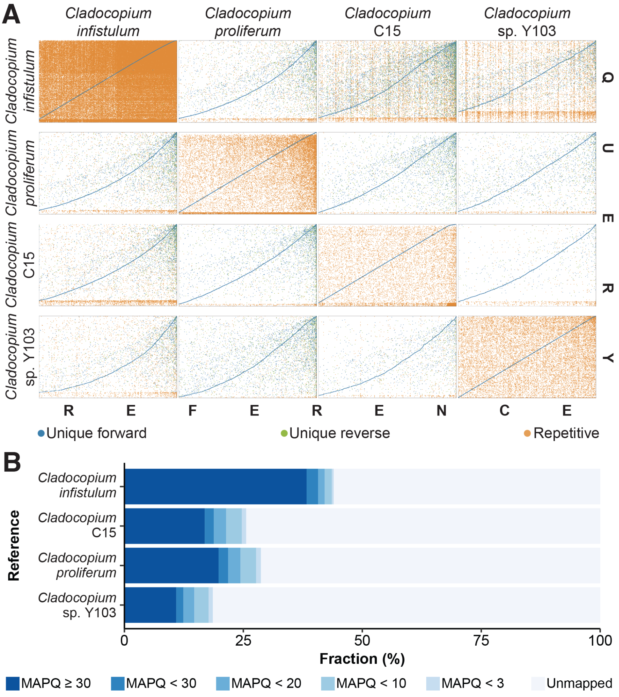
Supplementary Figure 6. Genome-sequence similarity among Cladocopium. (A) WGA dot plots between pairs of Cladocopium genomes; each dot represents an alignment of at least 1 kbp. (B) Alignment rate of C. infistulum quality-controlled sequence reads against the genome sequences of all other Cladocopium broken down by mapping quality (MAPQ).

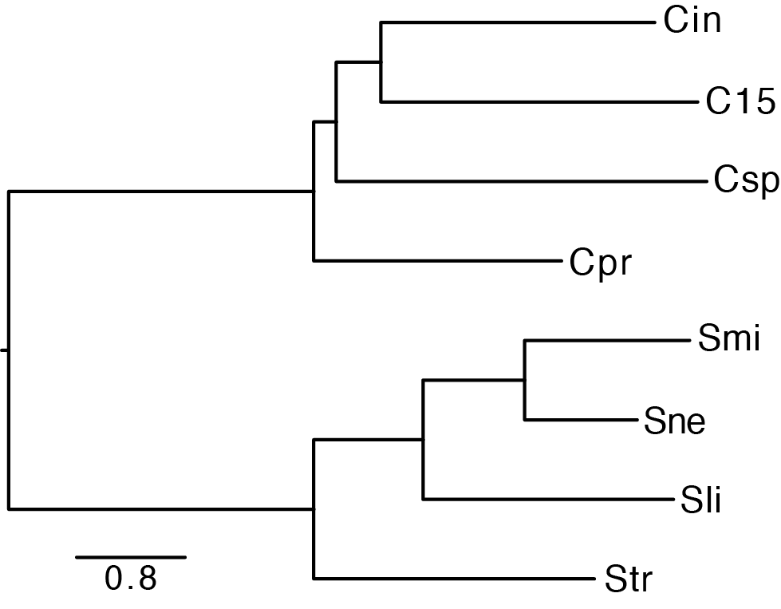
Supplementary Figure 7. Average NJ tree built based on 25-mers shared by and unique to Cladocopium and Symbiodinium genomes. All nodes are supported by 100 % of the jackknife pseudoreplicates (Supplementary Figure 7); scale shows D₂^{S} distance. ‘Cin’: C. infistulum, ‘C15’: Cladocopium C15, ‘Csp’: Cladocopium sp. Y103, ‘Cpr’: C. proliferum, ‘Smic’: S. microadriaticum, ‘Snec’: S. necrroappetens, ‘Slin’: S. linucheae, ‘Str’: S. tridacnidorum.


Supplementary Figure 8. Tree for each jackknife pseudoreplicate of the 25-mer phylogenomic analysis. ‘Cpro’: C. proliferum, ‘Csp’: Cladocopium sp. Y103, ‘Cinf’: C. infistulum, ‘C15’: Cladocopium C15, ‘Stri’: S. tridacnidorum, ‘Slin’: S. linucheae, ‘Smic’: S. microadriaticum, ‘Snec’: S. necrroappetens.

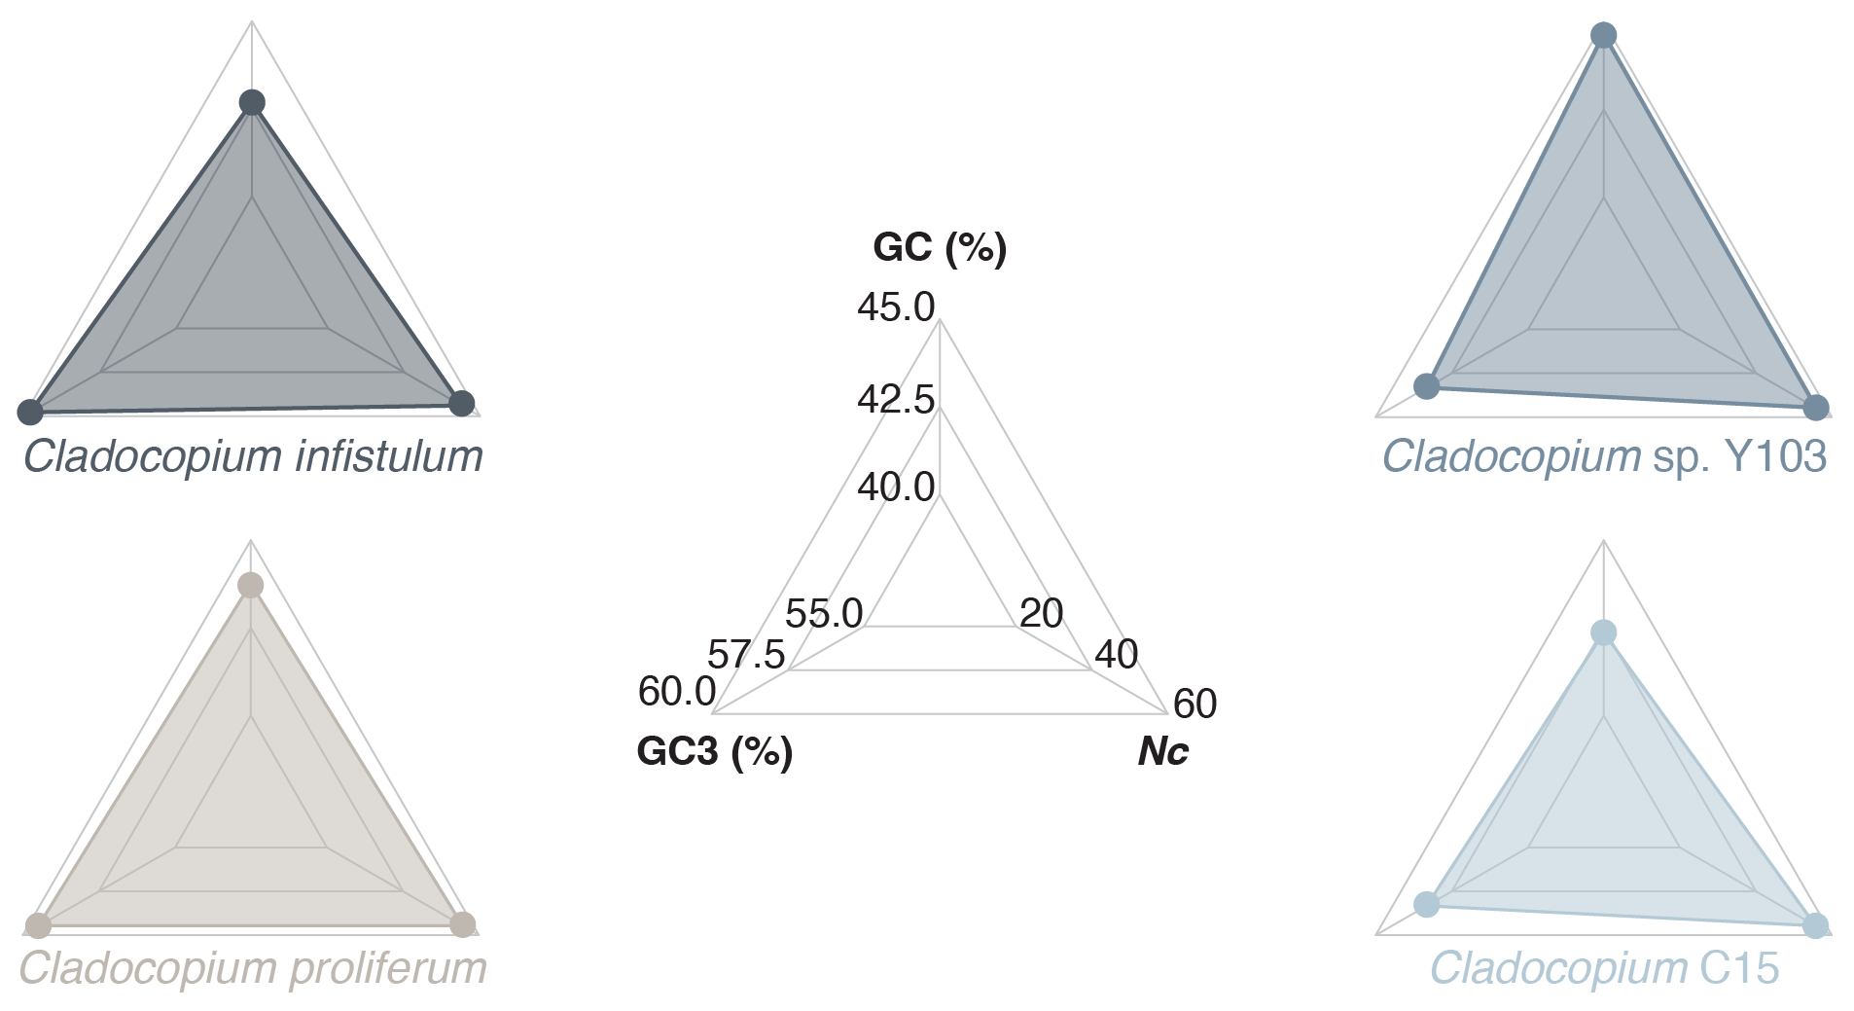
Supplementary Figure 9. Three-dimensional radar plots showing genomic GC content (GC), GC content in third codon position of coding sequences (GC3) and effective number of codons used (Nc) per genome; the center plot shows the scales for the three axes.

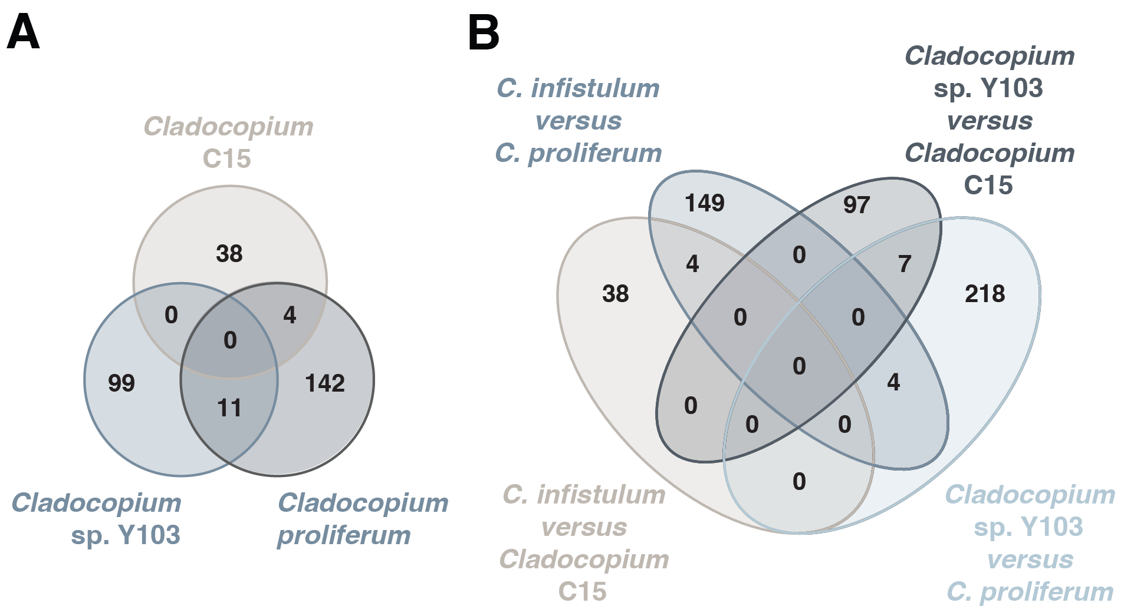
Supplementary Figure 10. Venn diagrams showing genes under positive selection in (A) C. infistulum when compared against each of the other Clacodopium separately and in (B) the two extracellular symbionts (i.e., C. infistulum and Cladocopium sp. Y103) pairwise against the intracellular symbionts (i.e., C. proliferum and Cladocopium C15).

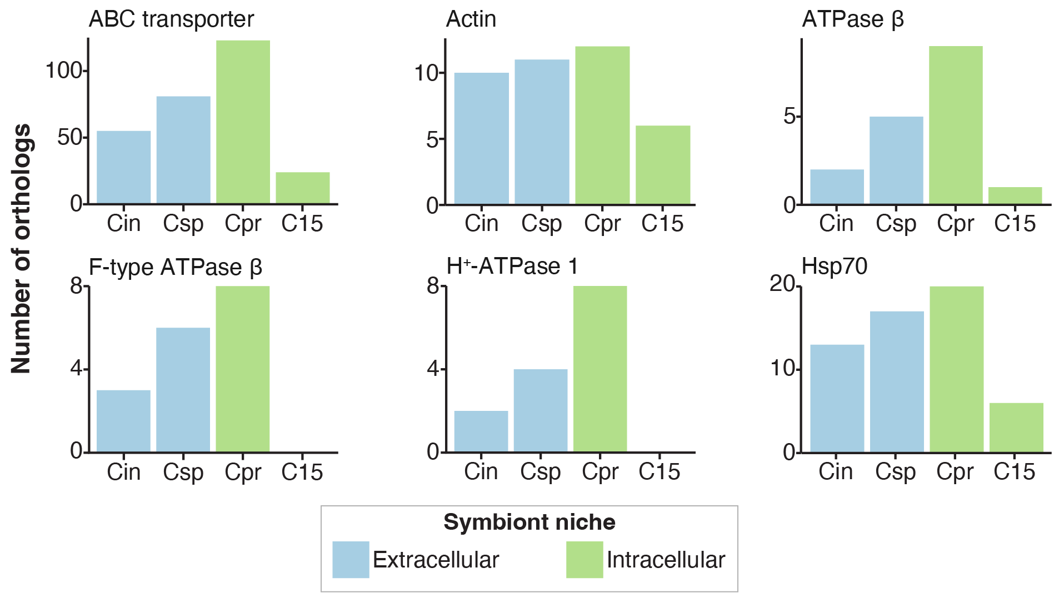
Supplementary Figure 11. Orthologs of genes implicated in interactions with the host membranes ((Peng et al., 2010), Supplementary Table 7). A brief gene description is provided on top of each bar plot; ‘Hsp70’: Hsp70, ‘ATPase 𝛽’: ATP synthase beta subunit; ‘Actin’: Actin-1; ‘H+-ATPase 1’: H+-transporting ATPase, subunit 1; ‘F-type ATPase 𝛽’: F0F1-type ATP synthase, 𝛽 subunit; ‘ABC transporter’: ABC transporter. ‘Cin’: C. infistulum, ‘Csp’: Cladocopium sp. Y103, ‘Cpr’: C. proliferum, ‘C15’: Cladocopium C15.

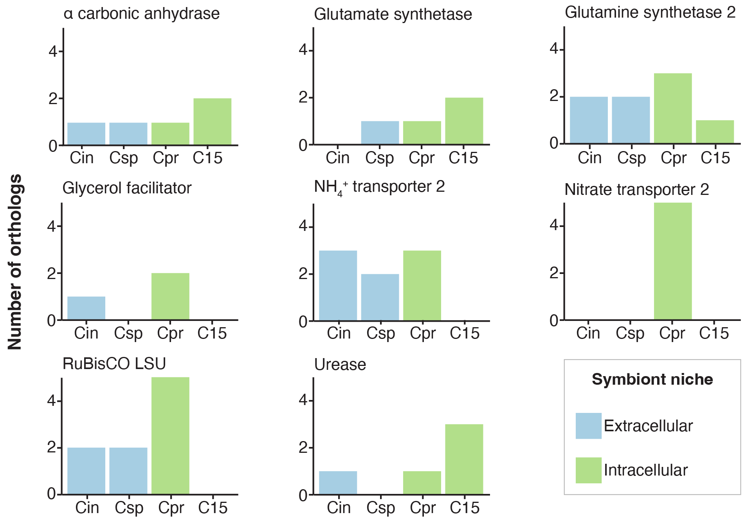
Supplementary Figure 12. Orthologs of genes implicated in light response in Cladocopium genomes (Supplementary Table 9). ‘Cin’: C. infistulum, ‘Csp’: Cladocopium sp. Y103, ‘Cpr’: C. proliferum, ‘C15’: Cladocopium C15.

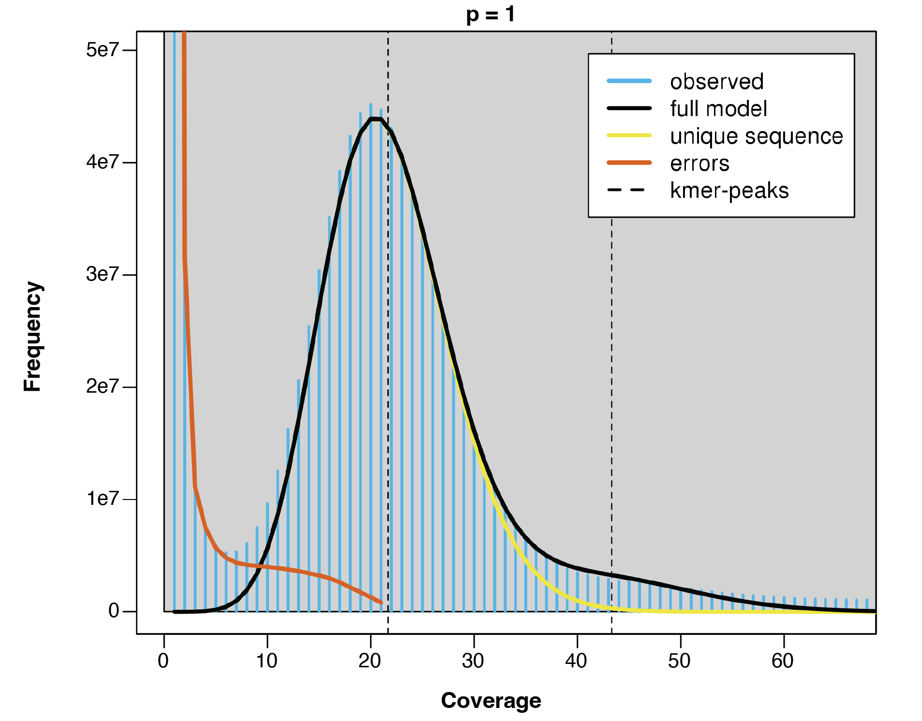
Supplementary Figure 13. GenomeScope2 25-mer frequency distribution with ploidy set to 1.

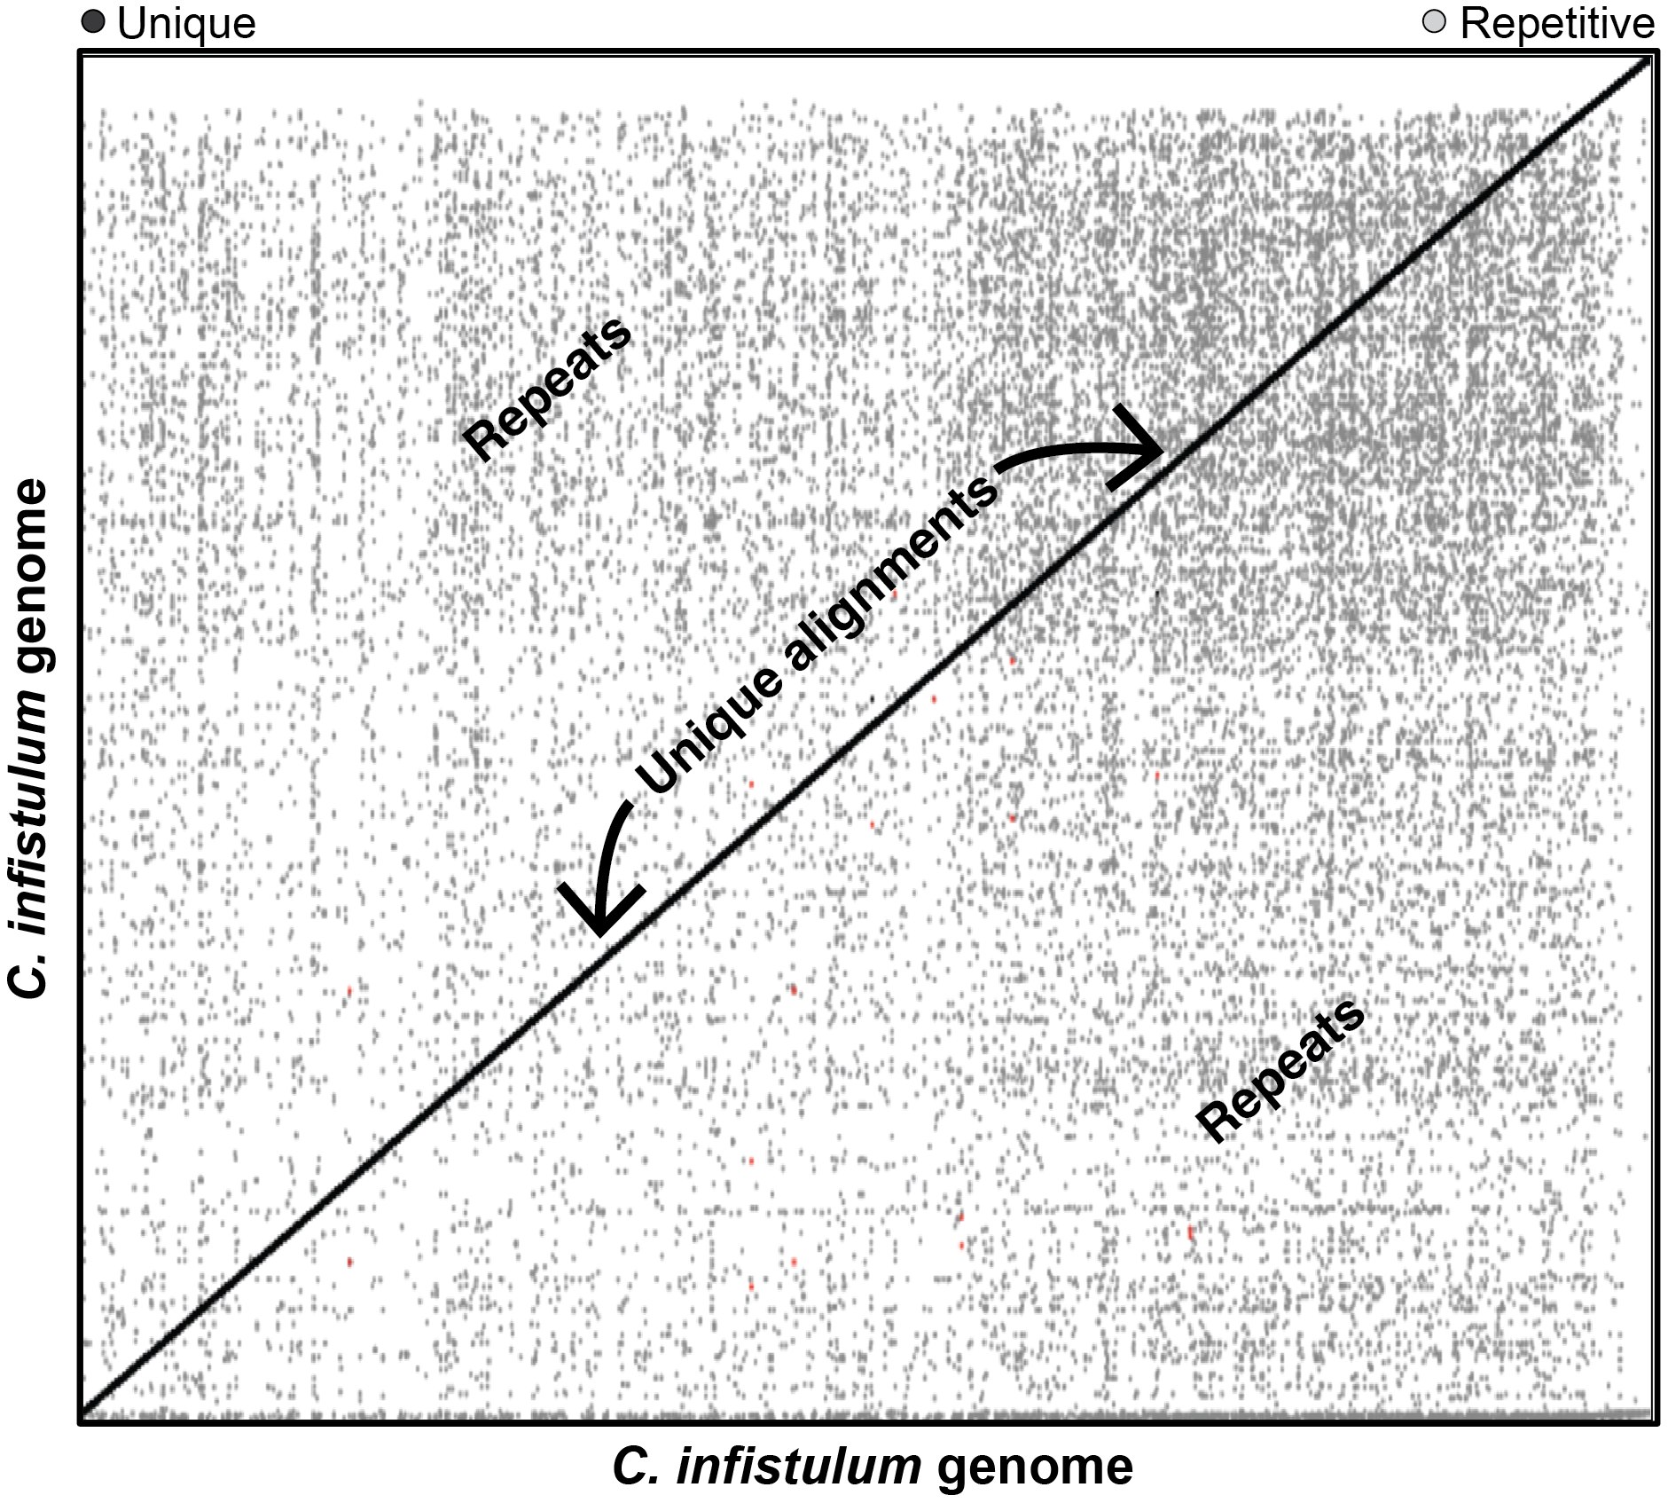
Supplementary Figure 14. Dot plot of the alignment of the C. infistulum genome against itself (only alignments ≥10 kbp and of sequence identity ≥80% are shown) with scaffolds/contigs ordered by decreasing size from left to right (x-axis) and bottom to top (y-axis). The plot shows large numbers of duplicated regions (light-grey dots) along with a preponderance of unique, single-copy, alignments (black dots creating a diagonal line).

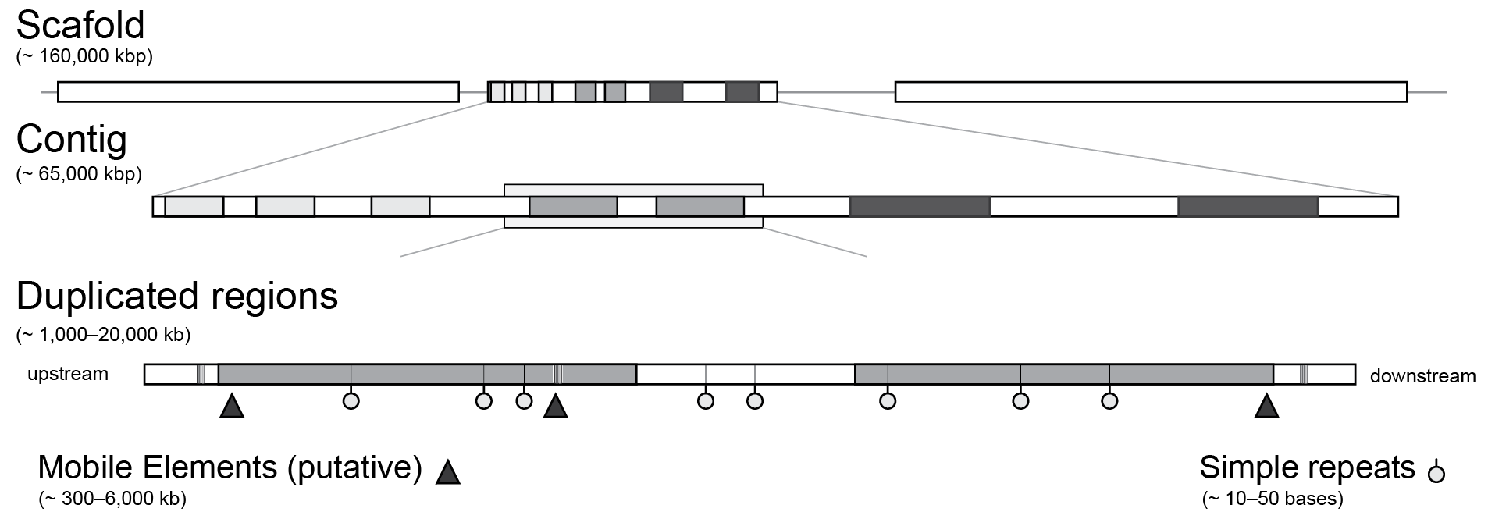
Supplementary Figure 15. Graphic representation of the genome assembly, including scaffolds, contigs, and duplicated regions with them. The various distributions of both simple repeats and putative mobile elements containing repeat motifs occurring within duplicated regions.

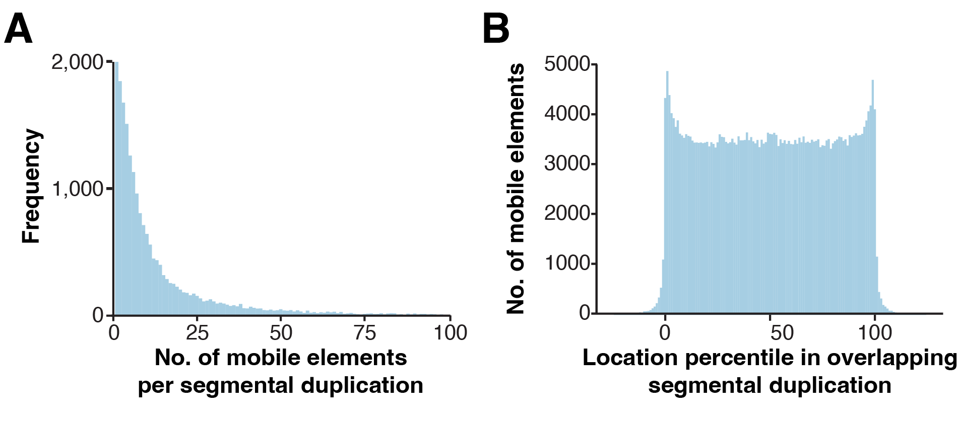
Supplementary Figure 16. Duplicated regions in the C. infistulum genome overlap with mobile elements. (A) Histogram showing the frequency of occurrence of putative mobile elements for each duplicated region found in the genome (x-axis). (B) Distribution frequencies of mobile elements along a duplicated region. The length of each region was normalized by transforming to a percentile (x-axis) and the distribution of mobile elements graphed along this scale.

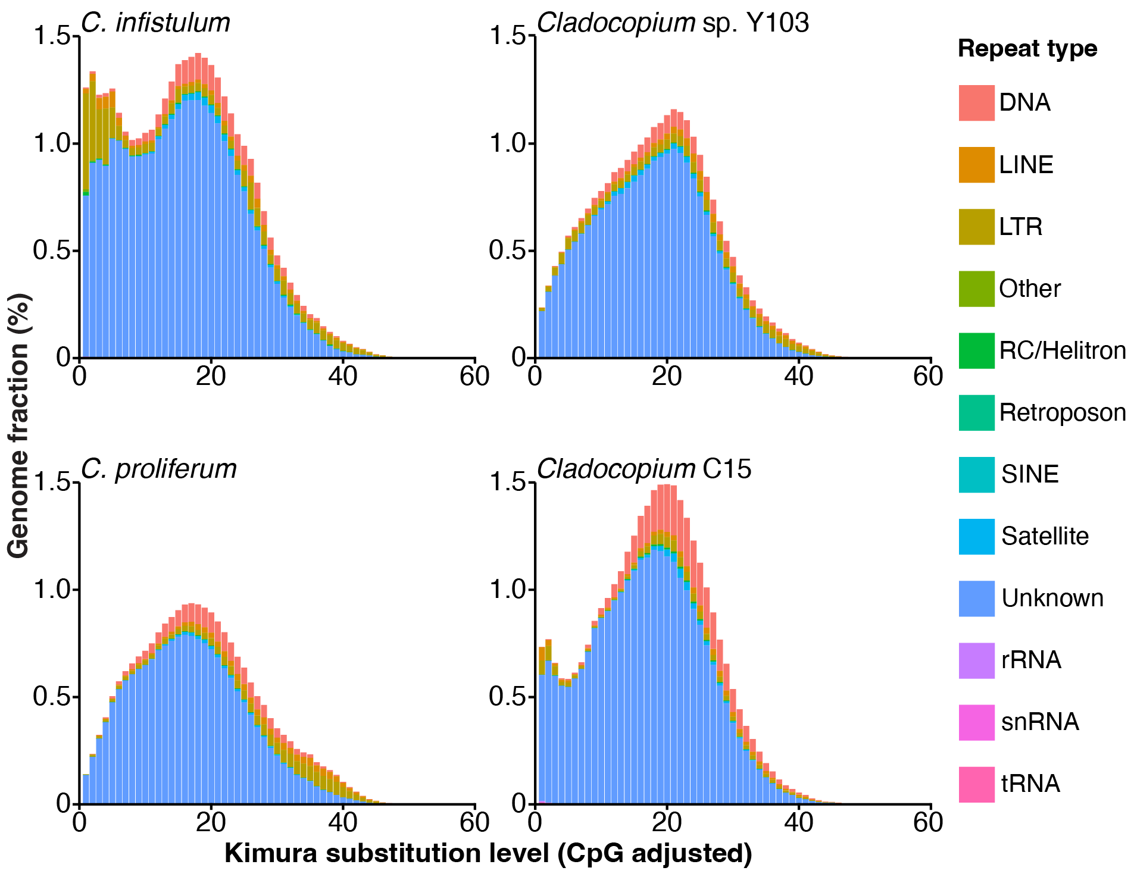
Supplementary Figure 17. Interspersed repeat landscapes of Cladocopium genomes.

