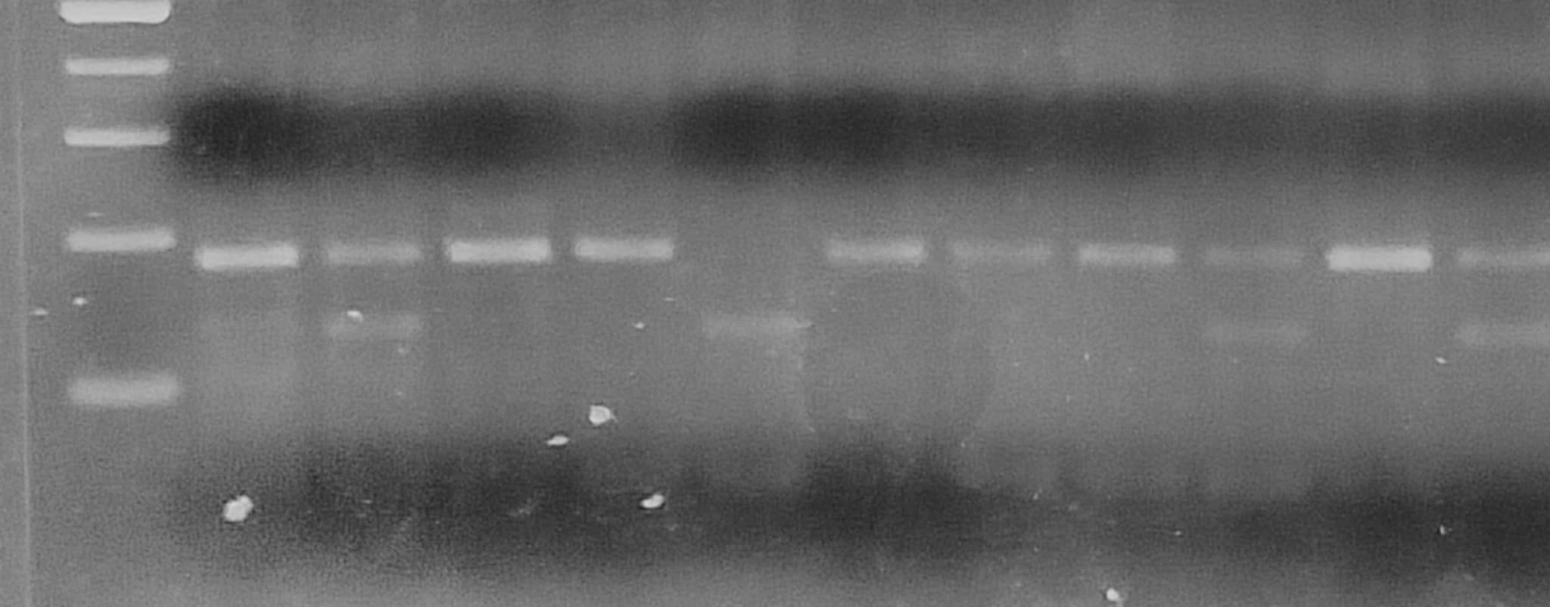
Figure 1: The electrophoretic profile of the enzymatic digestion by the enzyme HaeIII of the rs6280 variant
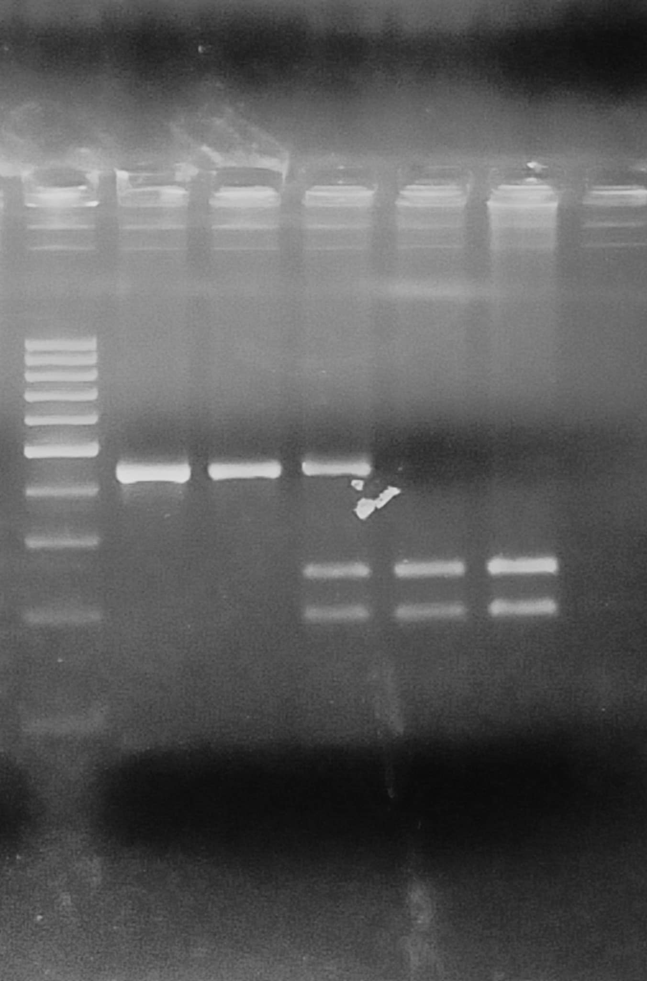
Figure 2: The electrophoretic profile of the enzymatic digestion by the enzyme BspEI of the rs6313 variant.

