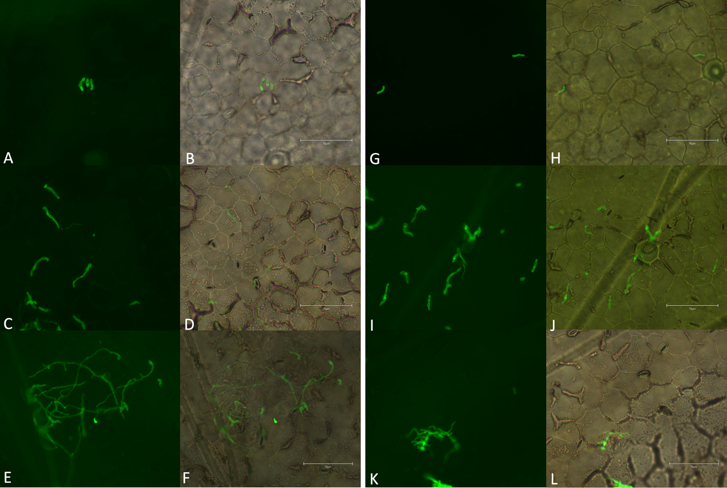
Figure S1. A. medicaginicola hyphal growth on inoculated leaf surface of M. truncatula. Images were taken under GFP fluorescence (482/524 nm) and overlaid on an RGB image of (A-B) A17 at 24 hpi, (C-D) A17 at 48 hpi, (E-F) A17 at 72 hpi, (G-H) HM078 at 24 hpi, (I-J) HM078 at 48 hpi, and (K-L) HM078 at 72 hpi.

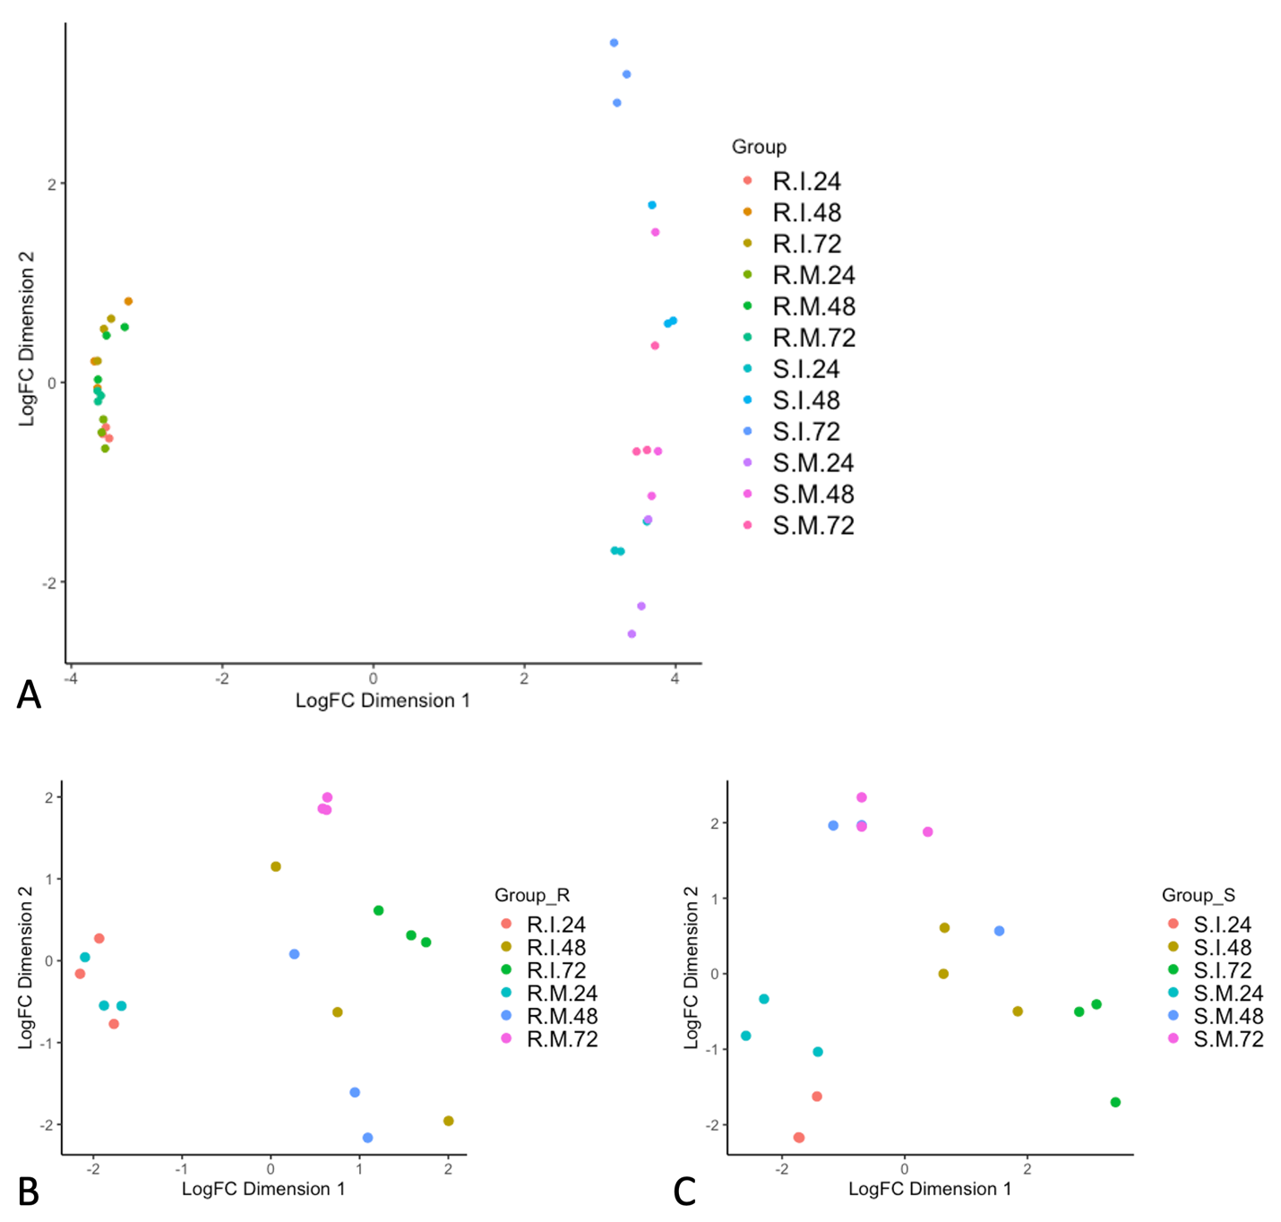
Figure S2. PCA plots of the biological coefficient of variation. PCA plots of RNA-seq samples for (A) resistant (HM078) and susceptible (A17) genotypes together, (B) the resistant genotype, and (C) the susceptible genotype. Sample naming conventions are R: resistant, S: susceptible, I: inoculated, M: mock-inoculated, followed by 24, 48, or 72 to indicate the time point.

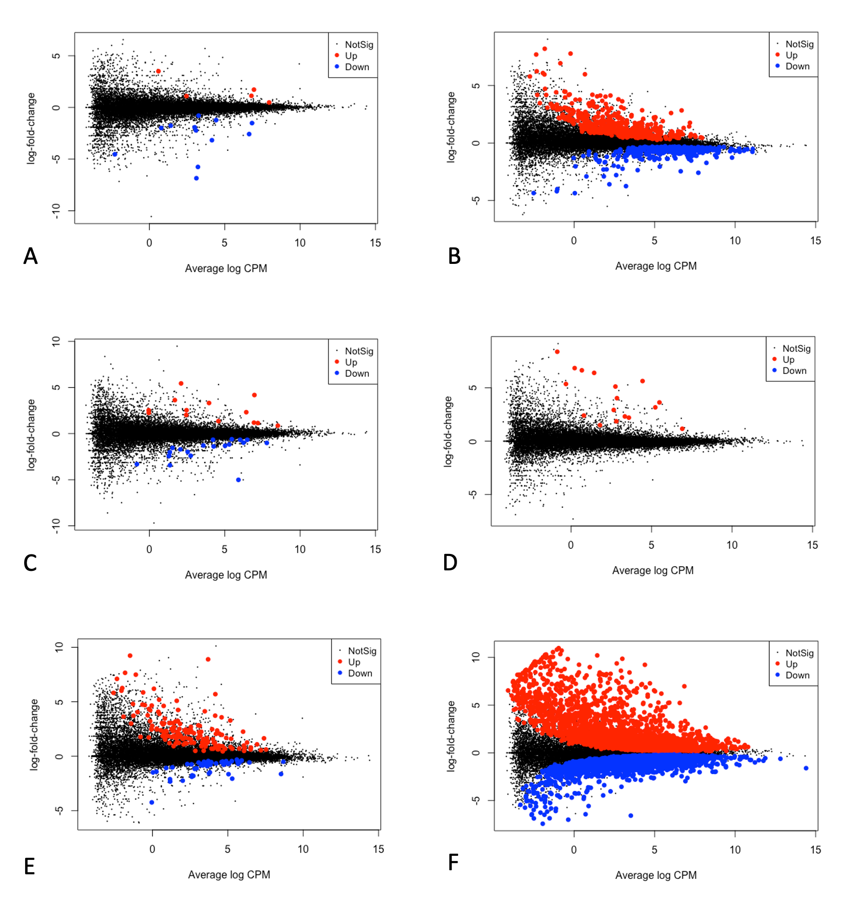
Figure S3. DEGs of HM078 and A17 at 24, 48, and 72 hours post inoculation (hpi). Statistical comparisons were inoculated versus mock inoculated within each accession at each time point. Volcano diagrams of (A) DEGs of HM078 at 24 hpi, (B) DEGs of A17 at 24 hpi, (C) DEGs of HM078 at 48 hpi, (D) DEGs of A17 at 48 hpi, (E) DEGs of HM078 at 72 hpi, and (F) DEGs of A17 at 72 hpi.
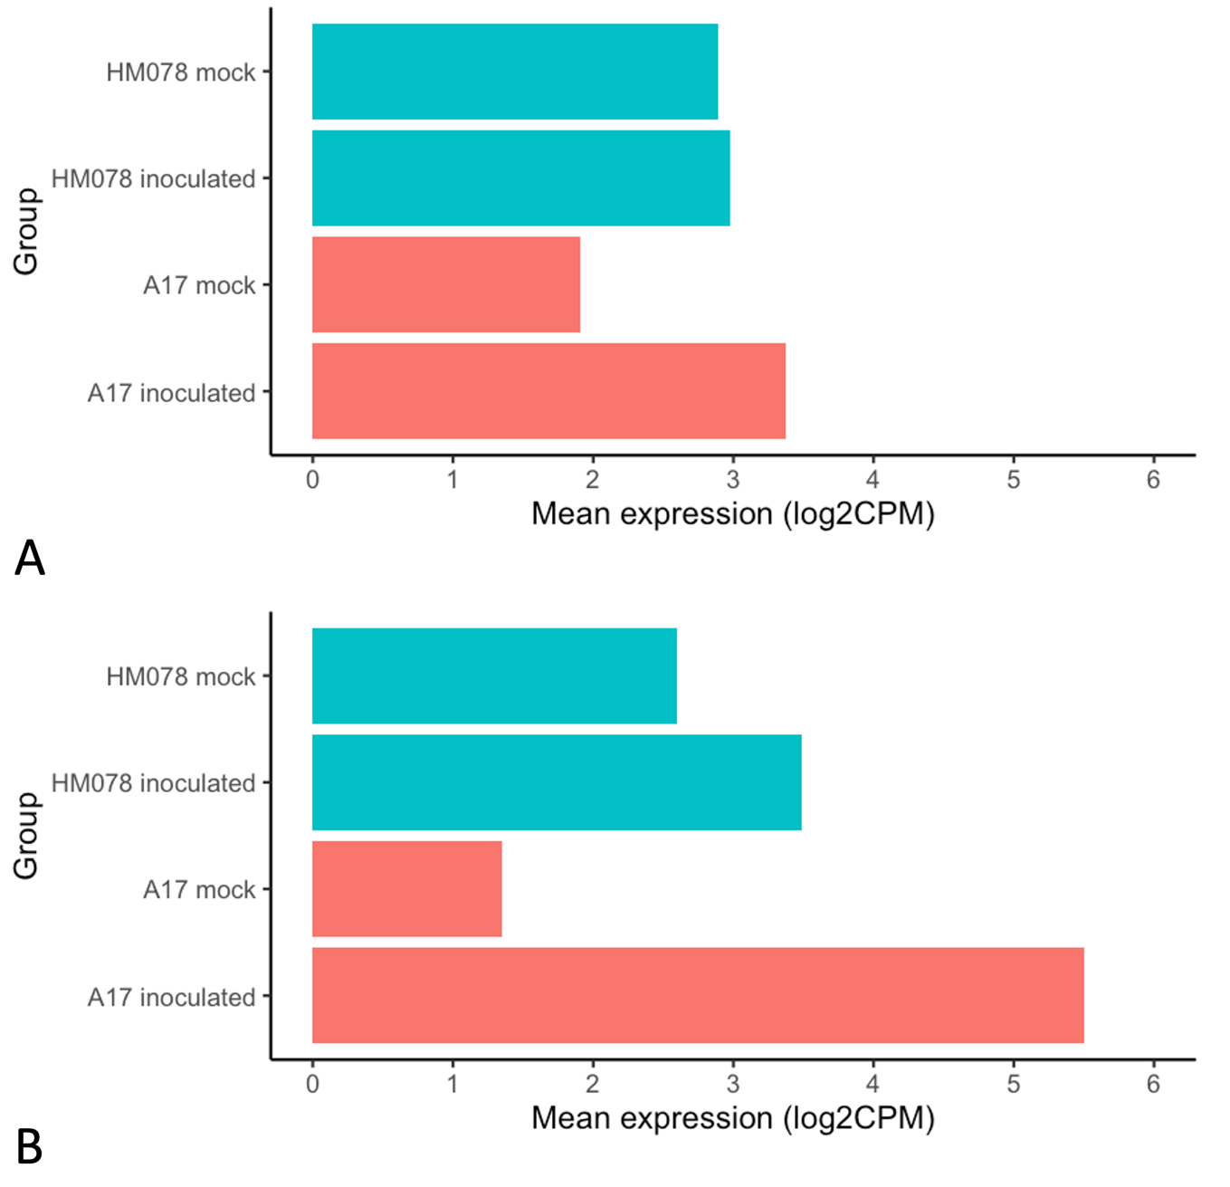

Figure S4. Mean expression of SA biosynthesis and signaling genes. (A) Isoflavone reductase (MtrunA17_Chr5g0404511) and (B) phenylalanine ammonia lyase (MtrunA17_Chr1g0181091) are upregulated in the susceptible genotype, but have higher constitutive expression in the resistant genotype.

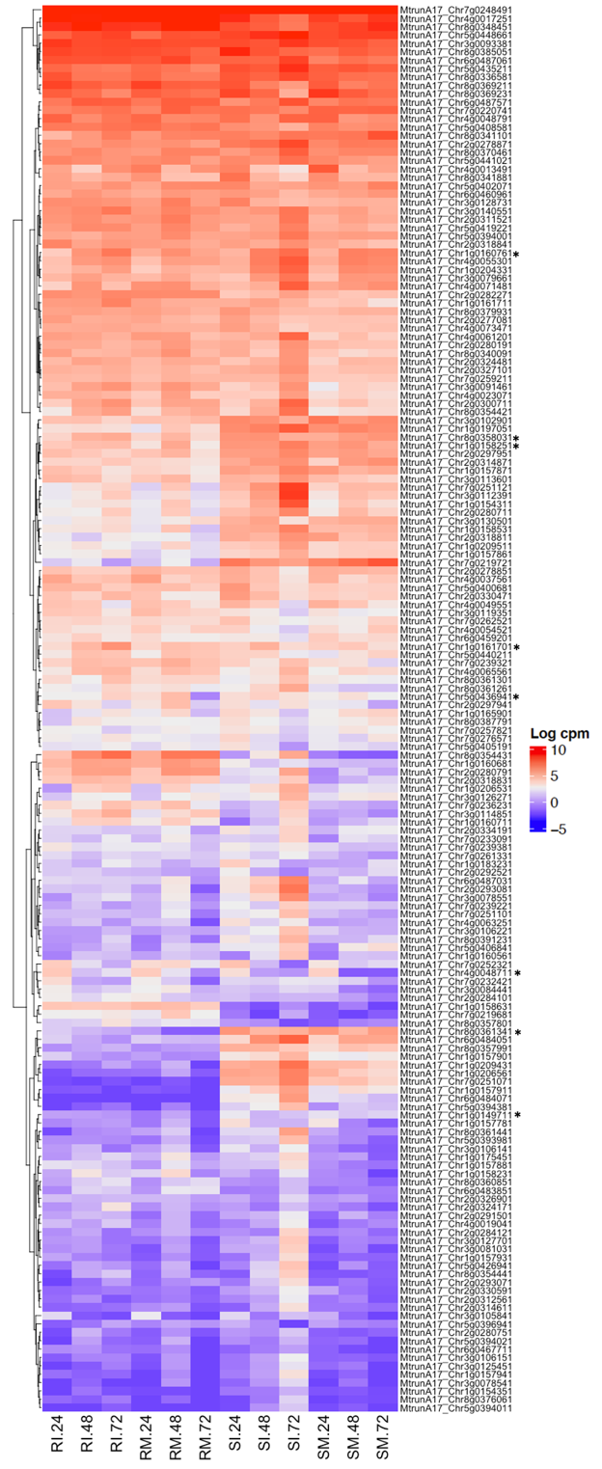
Figure S5. RLK expression profiles among DEGs for HM078 and A17. Differentially expressed genes in resistant genotype HM078 are marked with an asterisk. Sample ID abbreviations are SM: susceptible mock-inoculated, SI: susceptible inoculated, RM: resistant mock-inoculated, RI: resistant inoculated, followed by hours post inoculation (24, 48, or 72 hpi) and biological replicate (1, 2, or 3).
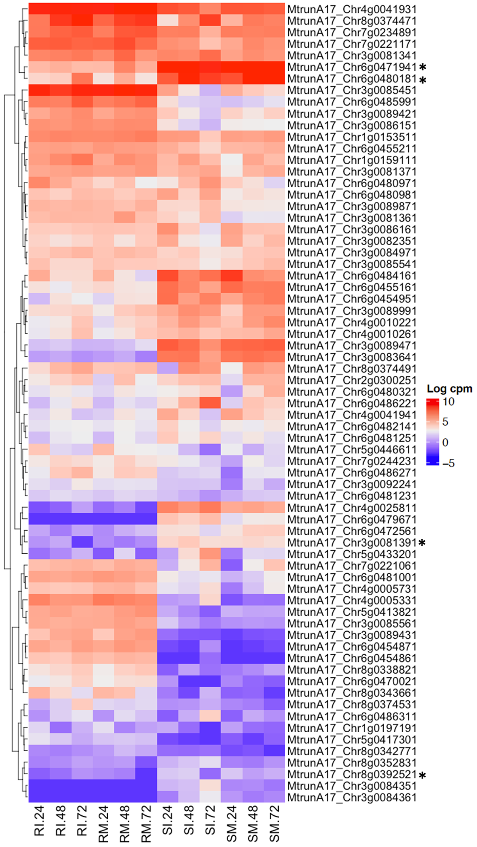
Figure S6. Plant disease resistance gene expression profiles for DEGs of HM078 and A17. DEGs in the resistant genotype HM078 are marked with an asterisk. Sample ID abbreviations are SM: susceptible mock-inoculated, SI: susceptible inoculated, RM: resistant mock-inoculated, RI: resistant inoculated, followed by hours post inoculation (24, 48, or 72 hpi).

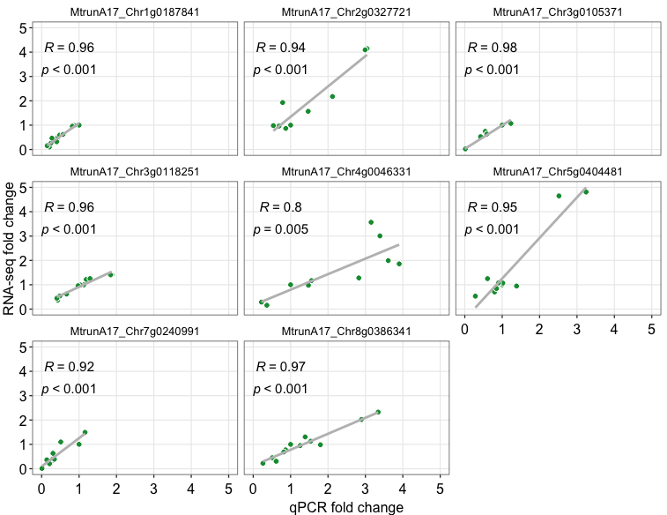
Figure S7. Pearson’s correlation of fold change values was performed to compare RNA-seq and qPCR expression data. Genes included were Nepenthesin (MtrunA17_Chr1g0187841), MtKCS12 (MtrunA17_Chr2g0327721), MtPP2C (MtrunA17_Chr3g0105371), MtEDS1L-like (MtrunA17_Chr3g0118251), MtCYP93C19 (MtrunA17_Chr4g0046331), MtIFR (MtrunA17_Chr5g0404481), MtLAC7 (MtrunA17_Chr7g0240991), and MtP21-like (MtrunA17_Chr8g0386341).

