Electronic Supplementary Information
An iridium(III) complex based luminogenic probe for high-throughput screening of H₂S donors in living cells
Ke-Jia Wu¹, Wen Sun², Jian-Min Sun¹, Chang Lu¹, Yan Li^{2*}, Ning Sun^{1*}, Chung‐Hang Leung^{3*}, Chun Wu^{4*}
¹ Wuxi School of Medicine, Jiangnan University, Wuxi 214122, China
² Key Laboratory of Animal Biological Products & Genetic Engineering, Ministry of Agriculture and Rural, Sinopharm Animal Health Corporation Ltd., Wuhan 430023, China
³ State Key Laboratory of Quality Research in Chinese Medicine, Institute of Chinese Medical Sciences, University of Macau, Macao, China
⁴ College of Science, Sichuan Agricultural University, Xin Kang Road, Yucheng District, Ya’an 625014, China
Email: keliyanust@163.com (Yan Li); sunning@jiangnan.edu.cn (Ning Sun); duncanleung@um.edu.mo (Chung‐Hang Leung); ccwuchem@hotmail.com (Chun Wu)

Part A. Chemicals and materials
Iridium chloride hydrate (IrCl₃·xH₂O) was purchased from Aladdin (China). Unless specified, all the reagents were purchased from Shanghai Macklin Biochemical Co., Ltd. (Shanghai, China) and used as received without further purification, and all aqueous solutions were prepared with Milli-Q water (18.2 MΩ cm⁻¹) unless specified.

Part B. Synthesis
Mass spectrometry was performed on Aglient 7250 GC/Q-TOF (USA). Deuterated solvents for NMR purposes were obtained from Armar and used as received. ¹H and ¹³C NMR were recorded on a Bruker Avance 400 spectrometer operating at 400 MHz (¹H) and 100 MHz (¹³C). ¹H and ¹³C chemical shifts were referenced internally to solvent shift (DMSO-d₆: ¹H, 2.50, ¹³C, 39.52; acetone-d₆: ¹H, 2.05, ¹³C, 29.8). Chemical shifts are quoted in ppm, the downfield direction being defined as positive. Uncertainties in chemical shifts are typically ±0.01 ppm for ¹H and ±0.05 for ¹³C. Coupling constants are typically ±0.1 Hz for ¹H-¹H and ±0.5 Hz for ¹H-¹³C couplings. The following abbreviations are used for convenience in reporting the multiplicity of NMR resonances: s, singlet; d, doublet; t, triplet; q, quartet; m, multiplet; br, broad. All NMR data were acquired and processed using standard Bruker software (Topspin).

Synthesis of complexes Ir-mito1
Ir-mito1: Complex Ir-mito1 was synthesized according to reported literature with some modifications (Nat Chem 2019, 11, 1041-1048; Chem Sci 2020, 11, 11404-11412). Specifically, 2.1 equivalents of 4-chloro-2-phenylquinoline and 1 equivalent of IrCl₃·xH₂O were mixed and further heated overnight at 120 °C in 2-methoxyethanol/H₂O (v/v, 3/1). Afterwards, the mixture was filtered and washed with excess deionized water and then diethyl ether for three times respectively to generate the dichloro-bridged dimer [Ir(ppy)₂Cl]₂. [Ir(ppy)₂Cl]₂ and 2.1 equivalents of 10-phenanthroline-5,6-dione were mixed together in DCM/MeOH (v/v, 1:1) for overnight reaction. After the completion of reaction, excess NH₄PF₆ was added to the reaction mixture for reaction of another 20 minutes. The reaction mixture was washed with Milli-Q water and subsequently evaporated to obtain the crude products of Ir-mito1. The crude was purified using DCM/MeOH as eluent. Yield: 54%. ¹H NMR (400 MHz, Acetone-d₆) δ 8.74 (s, 2H), 8.67 (d, J = 4.9 Hz, 2H), 8.63 (d, J = 7.8 Hz, 2H), 8.37 (d, J = 7.5 Hz, 2H), 8.16 (dd, J = 8.3, 1.0 Hz, 2H), 8.02 (dd, J = 7.9, 5.5 Hz, 2H), 7.56 (t, J = 7.3 Hz, 2H), 7.44 (d, J = 8.8 Hz, 2H), 7.29 – 7.17 (m, 4H), 6.94 – 6.86 (m, 2H), 6.69 (d, J = 7.4 Hz, 2H). ¹³C NMR (101 MHz, Acetone-d₆) δ 174.50, 170.18, 154.55, 152.25, 149.70, 147.99, 146.35, 145.21, 137.87, 134.77, 132.36, 131.21, 129.91, 128.05, 125.58, 125.44, 125.35, 123.53, 118.51. HRMS: Calcd. for C₄₂H₂₄Cl₂IrN₄O₂ [M-PF6]⁺: 879.0906 Found: 879.0887.

Part C: Luminescence experiments

Photophysical measurement
Emission spectra and lifetime measurements for complex Ir-mito1 were performed on a PTI TimeMaster C720 Spectrometer (Nitrogen laser: pulse output 335 nm) fitted with a 395 nm filter. Error limits were estimated: λ (±1 nm); τ (±10 %); φ (±10 %). UV/Vis absorption spectra were recorded on an Agilent Cary 8454 UV-Vis Spectrophotometer. The luminescence lifetime of the complex was measured by time-correlated single-photon counting (TCSPC), following excitation at 340 nm with a NanoLED light source. Luminescence quantum yields were determined using the method of Demas and Crosby with [Ru(bpy)₃][PF₆]₂ in degassed acetonitrile (ACN) as a standard reference solution (Φ_{r} = 0.062) and were calculated according to the following reported equation (1):
Φ_{s} = Φ_{r}(B_{r}/B_{s})(n_{s}/n_{r})²(D_{s}/D_{r}) (1)
Where the subscripts s and r refer to the sample and reference standard solution respectively, n is the refractive index of the solvents, D is the integrated intensity, and Φ is the luminescence quantum yield. The quantity B was calculated by B = 1–10^{–AL}, where A is the absorbance at excitation wavelength and L is the optical path length.

Time-resolved emission spectroscopy (TRES) measurement
Time-gated emission spectra were determined with a time-correlated single-photon counting (TCSPC) technique on the Horiba fluorescence spectrometer (FL3C-21). Under excitation at 340 nm (NanoLED), the emission signals over the indicated range were recorded with intervals of 10 nm. Thioflavin S (THS) (0.5 μM) were used as ﬂuorescent interferences. After they were added into the solution of complex Ir-mito1 (5 μM) in PBS buﬀer (1×, pH 7.4), the time-resolved emission spectra of the mixture were acquired with a delay time of 3.2 μs.

Part D: Biological assays

Cell culture
Cells were cultivated in DMEM medium with 1% penicillin (100 units/mL)/streptomycin (100 μg/mL) and 10% fetal bovine serum (FBS). Cells were maintained at a density of 6 × 10⁵ cell/mL in 5% CO₂ at 37 °C.

MTT assay
LO2 cells were seeded at 5000 cells per well in a 96-well plate and incubated overnight at 37 °C. The cells were treated with Ir-mito1 at a final concentration as indicated for 12 h. Then 3-(4,5-dimethylthiazol-2-yl)-2,5-diphenyltetrazolium bromide (MTT) reagent was added to each well at a final concentration of 0.5 mg/mL for a further 4 h. After that, the medium was replaced with 100 μL DMSO. The viability of the cells was measured by recording the absorbance of each well at 490 nm after shaking the plate for 10 min at room temperature in the dark.

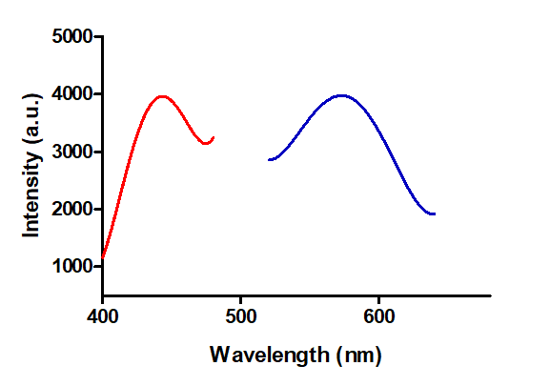
Part E: Supporting information

Figure S1 Excitation and emission spectra of Ir-mito1 (10 μM) in PBS.
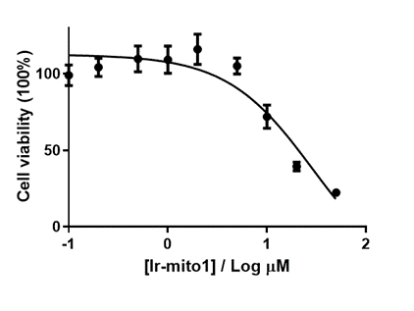

Figure S2 Cell viability of THLE-2 cells after treatment with Ir-mito1 for 12 h..
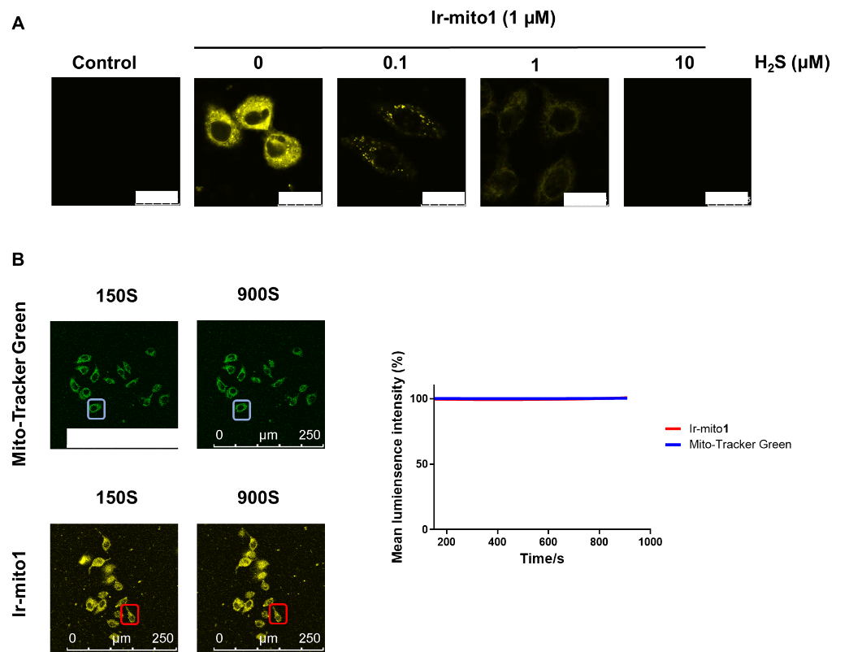
Figure S3 Ir-mito1 is a promising H₂S probe with good biocompatibility. (A) Confocal imaging of cells incubated with Ir-mito1 (0-10 μM, λ_{ex}/λ_{emi} = 405/500−600 nm) for 1 h. Scale bar =25 μm. (B) Comparison of Mito-Tracker green and Ir-mito1 for resistance to photobleaching. Confocal luminescence images of Ir-mito1 (λ_{ex}/λ_{emi} = 405/500−600 nm) or Mito-Tracker green (λ_{ex}/λ_{emi} = 488/500−600 nm) in LO2 cells under continuous irradiation with different laser scan times (0−900 s). Scale bar = 250 μm. The relative mean luminescence intensity of Ir-mito1 and Mito-Tracker green detected.

Figure S4 (A) The luminescence change of cells with Ir-mito1 in TRES mode after treated with different concentration of H₂S for 1 h. (B) The fluorescence change of cells with WSP-1 in steady-state emission mode after treated with different concentration of H₂S for 1 h.

Figure S5 The fluorescence change of cells with WSP-1 after treated with different H₂S donors for 1 h.

