Supplemental Table 1. Imaging acquisitions and parameters
Modality | Site | Voxel size  (mm) | TR (msec) | TE (msec) | Flip angle (⁰) | Slice thickness (mm) | Machine
3D T1 | A | 1.00 x 1.00 | 2300 | 2.98 | 9 | 1.0 | Siemens Verio
3D T1 | B | 1.00 x 1.00 | 2300 | 2.26 | 8 | 1.0 | Siemens Skyra
FLAIR | A | 0.43 x 0.43 | 8000 | 94  96 | 150 | 3.0  2.0 | Siemens Verio
FLAIR | B | 0.94 x 0.94 | 9110 | 96 | 150 | 2.0 | Siemens Skyra
3D GRE | A | 0.72 x 0.72 | 28 | 20, 15 | 15 | 1.5 | Siemens Verio
3D GRE | B | 0.72 x 0.72 | 28 | 20, 15 | 15 | 1.5 | Siemens Skyra
Abbreviations: TR = time of repetition, TE = time of echo, FALIR = Fluid attenuated inversion recovery, GRE = gradient echo.

Supplemental Table 2. Cohort characteristics for each follow up
 | Follow I |  |  | Follow II
 | Followed  (n = 293) | Not followed  (n = 477) | P value | Followed  (n = 219) | Not followed  (n = 74) | P value
Demographics
Age, y | 61.4 ± 3.41 | 62.4 ± 5.64 | 0.001 | 60.8 ± 3.20 | 63.0 ± 3.52 | <0.001
Male | 115 (39.2) | 212 (44.4) | 0.180 | 84 (38.4) | 31 (41.9) | 0.689
Education, y | 5.23 ± 3.80 | 5.43 ± 3.80 | 0.481 | 5.42 ± 3.70 | 4.66 ± 4.04 | 0.157
Cognition
Baseline MMSE, score | 26.0 (23.0, 28.0) | 26.0 (22.0, 28.0) | 0.381 | 26.0 (23.0, 28.0) | 25.5 (20.2, 28.0) | 0.128
Baseline MoCA, score | 18.0 (13.0, 22.0) | 18.0 (13.0, 22.0) | 0.932 | 19.0 (13.0, 23.0) | 15.0 (11.0, 20.0) | 0.007
Follow-up MMSE, score | 25.0 (22.0, 28.0) | - | - | 25.0 (22.0, 27.0) | - | -
Follow-up MoCA, score | 18.0 (14.0, 22.0) | - | - | 17.0 (13.0, 21.0) | - | -
Follow-up time, year | 1.67 ± 0.40 | - | - | 1.06 ± 0.01 | - | -
Neuroimaging
Cortical QSM | 0.84 ± 0.73 | 0.69 ± 0.80 | 0.006 | 0.85 ± 0.67 | 0.80 ± 0.88 | 0.672
AG-specific signature QSM | 2.07 ± 0.87 | 1.99 ± 0.97 | 0.237 | 2.07 ± 0.81 | 2.05 ± 1.02 | 0.865
AG signature QSM | 1.12 ± 0.80 | 0.98 ± 0.93 | 0.024 | 1.14 ± 0.75 | 1.08 ± 0.95 | 0.606
AD signature QSM | 1.57 ± 1.54 | 1.07 ± 1.91 | <0.001 | 1.63 ± 1.54 | 1.39 ± 1.56 | 0.248
Global atrophy | 0.69 ± 0.03 | 0.70 ± 0.04 | 0.211 | 0.70 ± 0.03 | 0.69 ± 0.03 | 0.024
Grey matter atrophy | 0.38 ± 0.02 | 0.38 ± 0.03 | 0.625 | 0.38 ± 0.02 | 0.37 ± 0.02 | 0.020
Data are mean ± SD, n (%), or median (interquartile range).
Demographic information and clinical characteristics were compared using χ2, Student t-test and Mann-Whitney U-test.
Abbreviations: AG = Aging; AD = Alzheimer’s disease; MMSE = Mini-Mental State Examination; MoCA = Montreal Cognitive Assessment; QSM = quantitative susceptibility mapping.

Supplemental Table 3. Association between localized QSM and classic MRI markers of cortical atrophy
 | Thickness |  | Grey matter volume† |  | Local gyrification index* |  | Surface area
 | $β$ (SE) | P | $β$ (SE) | P | $β$ (SE) | P | $β$ (SE) | P
Cortical QSM
Model 1 | -0.311 (0.037) | <0.001 | -0.180 (0.038) | <0.001 | -0.133 (0.035) | 0.001 | 0.068 (0.043) | 0.228
Model 2 | -0.302 (0.037) | <0.001 | -0.179 (0.038) | <0.001 | -0.133 (0.036) | 0.001 | 0.076 (0.044) | 0.164
Model 3 | -0.302 (0.037) | <0.001 | -0.179 (0.039) | <0.001 | -0.140 (0.036) | <0.001 | 0.075 (0.044) | 0.176
AG-specific signature QSM
Model 1 | -0.293 (0.037) | <0.001 | -0.112 (0.038) | 0.005 | -0.091 (0.036) | 0.016 | 0.048 (0.043) | 0.355
Model 2 | -0.286 (0.037) | <0.001 | -0.104 (0.039) | 0.009 | -0.088 (0.037) | 0.022 | 0.063 (0.044) | 0.205
Model 3 | -0.286 (0.037) | <0.001 | -0.103 (0.039) | 0.010 | -0.091 (0.037) | 0.019 | 0.064 (0.044) | 0.195
AG signature QSM
Model 1 | -0.383 (0.036) | <0.001 | -0.135 (0.038) | 0.001 | -0.114 (0.036) | 0.003 | 0.101 (0.043) | 0.082
Model 2 | -0.371 (0.036) | <0.001 | -0.131 (0.038) | 0.001 | -0.113 (0.036) | 0.004 | 0.108 (0.044) | 0.059
Model 3 | -0.372 (0.036) | <0.001 | -0.130 (0.038) | 0.001 | -0.119 (0.037) | 0.002 | 0.108 (0.044) | 0.057
AD signature QSM
Model 1 | -0.100 (0.037) | 0.007 | -0.042 (0.038) | 0.266 | -0.035 (0.035) | 0.324 | -0.019 (0.041) | 0.647
Model 2 | -0.088 (0.038) | 0.019 | -0.034 (0.038) | 0.372 | -0.026 (0.036) | 0.468 | -0.001 (0.042) | 0.986
Model 3 | -0.088 (0.038) | 0.019 | -0.038 (0.038) | 0.319 | -0.033 (0.036) | 0.351 | -0.006 (0.042) | 0.877
Comparison of QSM with cerebral structures via multiple regression.
Model 1 was adjusted for sex, age, years of education, site.
Model 2 was additionally adjusted smoking, drinking, hypertension, diabetes, and hyperlipidemia.
Model 3 was additionally adjusted cognitive dysfunction.
† Grey matter volume was normalized by eTIV.
* Data was missing in 5 of 770, 0.6%.
Abbreviations: AG = Aging; AD = Alzheimer's disease; QSM = quantitative susceptibility mapping.
Benjamini-Hochberg FDR corrected P < .05 are shown bold.
Supplemental Table 4. Association between localized QSM and longitudinal domain-specific cognitive scores
 | Episodic Memory |  | Attention |  | Executive function |  | Visuospatial function |  | Language
 | $β$ (SE) | P | $β$ (SE) | P | $β$ (SE) | P | $β$ (SE) | P | $β$ (SE) | P
Cortical QSM
Model 1 | -0.102 (0.167) | 0.698 | -0.391 (0.166) | 0.030 | -0.187 (0.167) | 0.350 | -0.464 (0.165) | 0.007 | -0.277 (0.167) | 0.130
Model 2 | -0.122 (0.169) | 0.598 | -0.376 (0.168) | 0.037 | -0.182 (0.168) | 0.373 | -0.466 (0.167) | 0.007 | -0.288 (0.168) | 0.116
Model 3 | -0.123 (0.169) | 0.604 | -0.380 (0.168) | 0.039 | -0.185 (0.169) | 0.362 | -0.464 (0.167) | 0.008 | -0.285 (0.168) | 0.122
AG-specific signature QSM
Model 1 | -0.216 (0.166) | 0.387 | -0.359 (0.165) | 0.030 | -0.320 (0.165) | 0.107 | -0.331 (0.165) | 0.045 | -0.409 (0.165) | 0.054
Model 2 | -0.220 (0.167) | 0.374 | -0.355 (0.166) | 0.037 | -0.313 (0.166) | 0.120 | -0.336 (0.166) | 0.043 | -0.421 (0.166) | 0.046
Model 3 | -0.220 (0.167) | 0.377 | -0.356 (0.167) | 0.039 | -0.315 (0.166) | 0.118 | -0.335 (0.166) | 0.045 | -0.418 (0.166) | 0.048
AG signature QSM
Model 1 | -0.222 (0.167) | 0.387 | -0.402 (0.166) | 0.030 | -0.151 (0.167) | 0.366 | -0.477 (0.165) | 0.007 | -0.321 (0.167) | 0.110
Model 2 | -0.228 (0.168) | 0.374 | -0.396 (0.168) | 0.037 | -0.147 (0.168) | 0.382 | -0.484 (0.167) | 0.007 | -0.341 (0.168) | 0.086
Model 3 | -0.227 (0.169) | 0.377 | -0.401 (0.168) | 0.039 | -0.151 (0.169) | 0.372 | -0.481 (0.167) | 0.008 | -0.338 (0.168) | 0.090
AD signature QSM
Model 1 | -0.064 (0.165) | 0.698 | -0.366 (0.165) | 0.030 | -0.411 (0.164) | 0.050 | -0.479 (0.163) | 0.007 | 0.177 (0.165) | 0.284
Model 2 | -0.089 (0.168) | 0.598 | -0.351 (0.167) | 0.037 | -0.412 (0.167) | 0.055 | -0.487 (0.166) | 0.007 | 0.173 (0.168) | 0.302
Model 3 | -0.087 (0.168) | 0.604 | -0.347 (0.167) | 0.039 | -0.411 (0.167) | 0.057 | -0.491 (0.166) | 0.008 | 0.171 (0.168) | 0.308
Standardized Beta coefficient values represent a one unit change in global cognition z-score per 1 years with a one PPB change in QSM.
Model 1 was adjusted for sex, age, years of education and eTIV.
Model 2 was additionally adjusted smoking, drinking, hypertension, diabetes, and hyperlipidemia.
Model 3 was additionally adjusted cortical thickness of each ROI.
Abbreviations: AG = Aging; AD = Alzheimer's disease; QSM = quantitative susceptibility mapping.
Benjamini-Hochberg FDR corrected P < .05 are shown bold.

Supplemental Table 5. Clusters showing significant differences in cortical absolute susceptibility among the Dementia, MCI and NC groups
Cluster number | Brain region | Cluster size (voxels) | P_{FWE} value | Peak MNI coordinates (mm)
 |  |  |  | X | Y | Z
Dementia > CN
1 | Left frontal pole/middle frontal gyrus/superior frontal gyrus | 2786 | 0.018 | -24 | 35 | 28
2 | Left paracingulate gyrus/superior frontal gyrus/frontal pole | 1469 | 0.040 | -4 | 51 | 17
3 | Left paracingulate gyrus/medial frontal cortex/cingulate gyrus | 940 | 0.041 | -1 | 42 | -4
4 | Left caudate/accumbens/putamen/subcallosal cortex | 837 | 0.036 | -8 | 14 | -7
5 | Left frontal pole | 68 | 0.049 | -8 | 62 | 9
Dementia > MCI
1 | Left middle frontal gyrus/superior frontal gyrus/frontal pole | 352 | 0.031 | -24 | 35 | 27
Clusters larger than 30 voxels are listed.
Abbreviations: FWE = family-wise error; MNI = Montreal Neurological Institute.

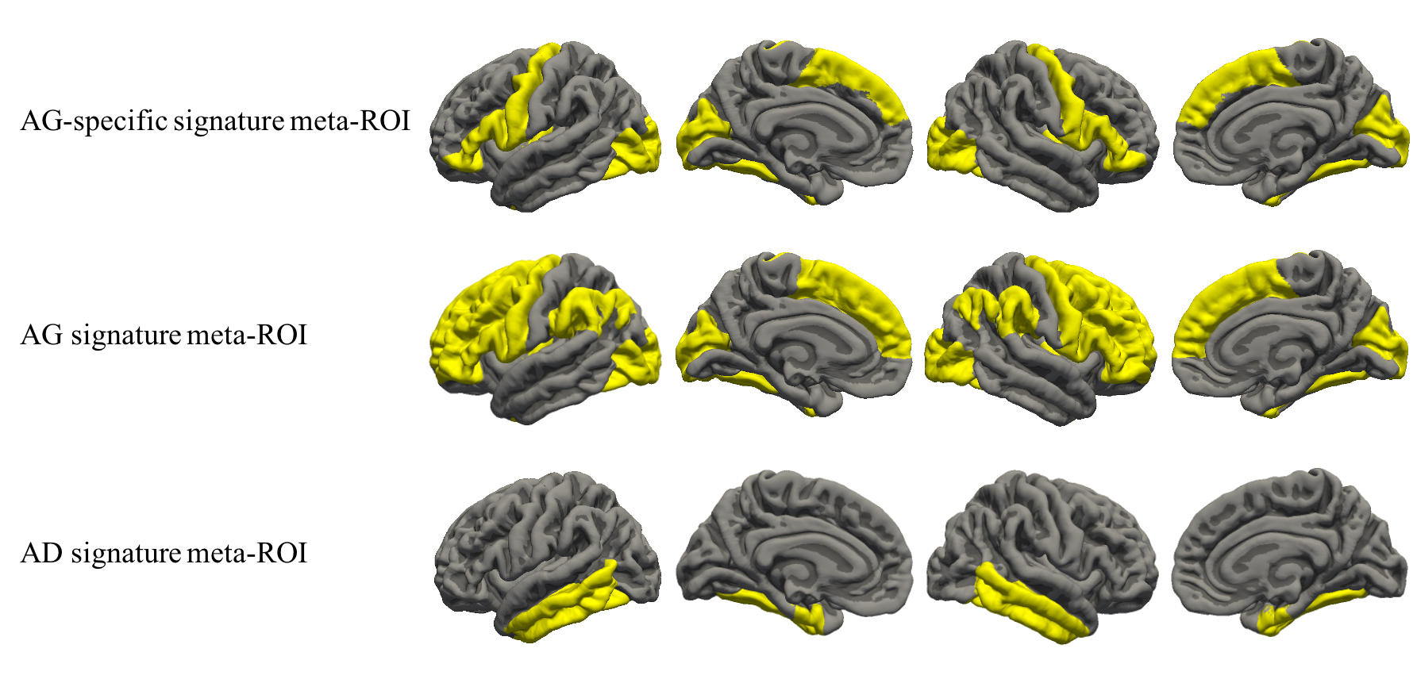
Supplemental Figure 1. Signature cortical regions
AG-specific signature meta-ROI (top row), surface area weighted mean of inferior and dorsomedial frontal, precentral, fusiform, lateral occipital, cuneus, pericalcarine, and caudal insula cortex regions; AG signature meta-ROI (middle row), surface area weighted mean of inferior, middle and superior frontal, precentral, fusiform, angular, supramarginal, lateral occipital, cuneus, pericalcarine, and caudal insula cortex regions; AD signature meta-ROI (bottom row), surface area weighted mean of entorhinal, fusiform, inferior, and middle temporal cortex regions. AG = Aging; AD = Alzheimer's disease.

Supplemental Figure 2. Relationship between (a) Cortical, (b) AG-specific signature, (c) AG signature, (d) AD signature QSM and age
The reported β values are standardized coefficients and P values are Benjamini-Hochberg FDR corrected. The model is adjusted for sex, age, years of education, smoking, drinking, hypertension, diabetes, and hyperlipidemia, cognitive status, grey matter atrophy and global atrophy.
Abbreviations: AG = Aging; AD = Alzheimer's disease; QSM = quantitative susceptibility mapping.

