Supplementary Materials
- Supplementary Figures 1-3
- Supplementary Tables 1-2
- Supplementary Materials and Methods

Supplementary Figures
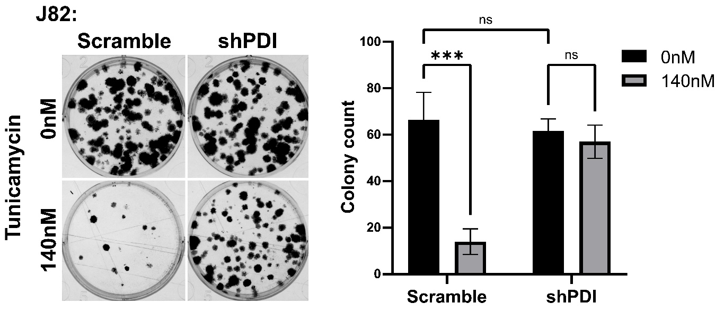
Supplementary Figure 1. Reduced PDI expression promotes J82 bladder cancer cell survival under elevated ER stress. J82 cell survival following shPDI or scramble control shRNA transfection and tunicamycin treatment (0 or 140 nM) was analyzed in a clonogenic assay.
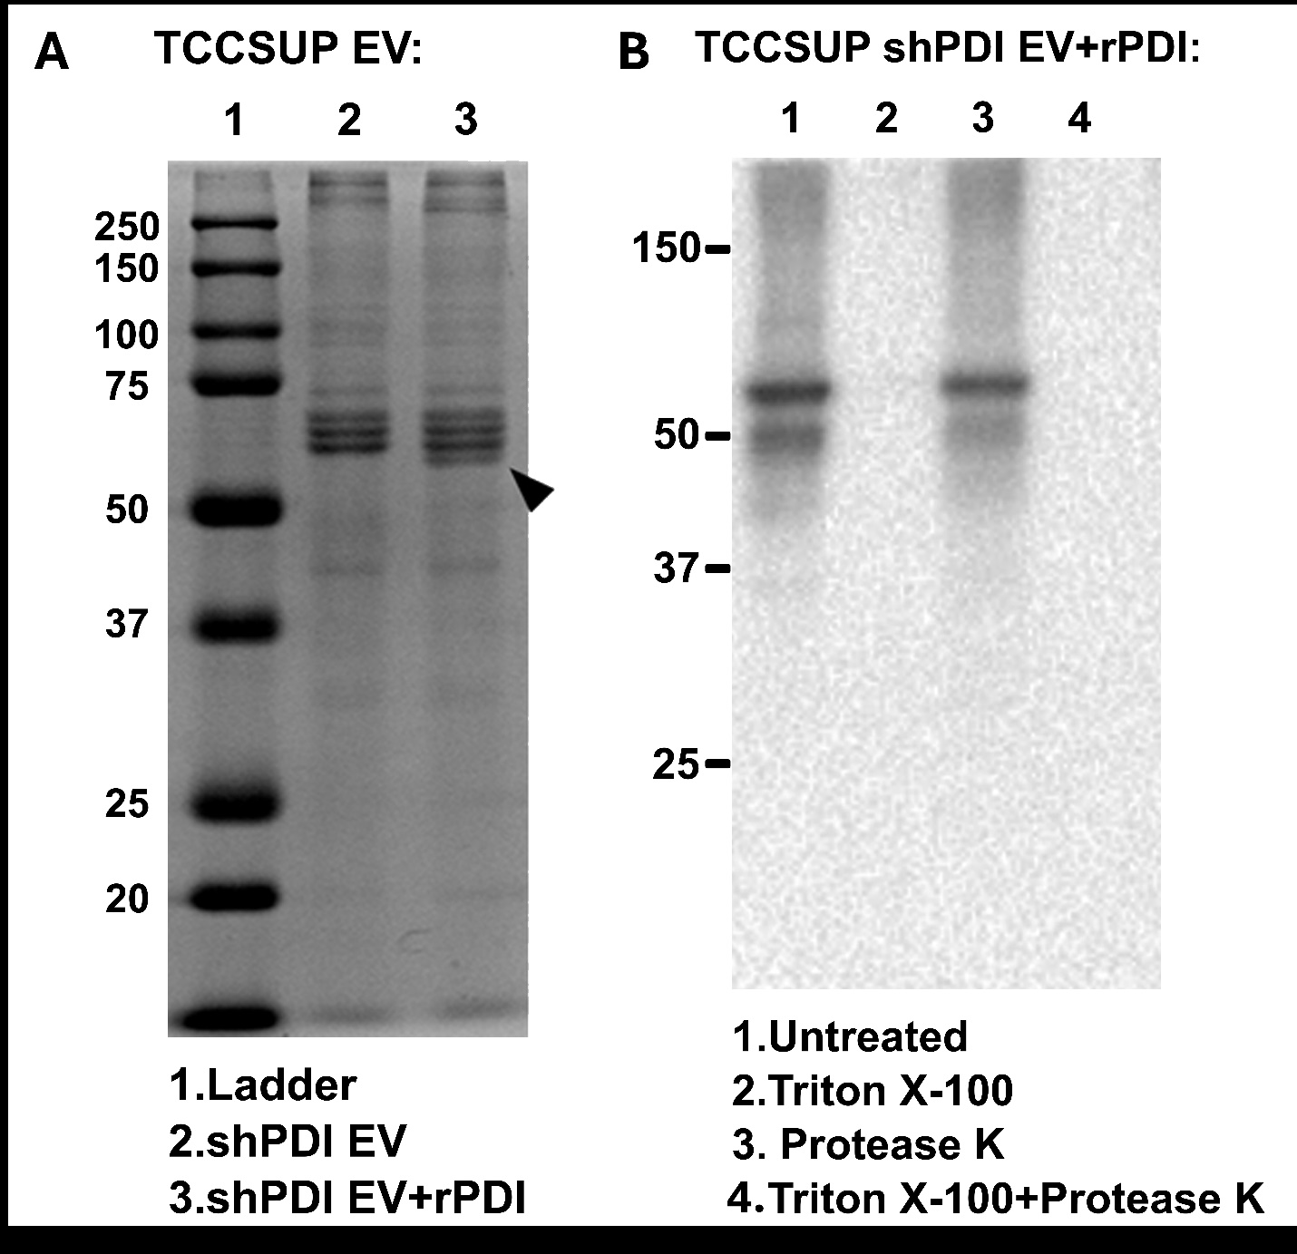

Supplementary Figure 2. Confirmation of extrusion-mediated recombinant PDI (rPDI) loading into EVs. A. Coomassie blue staining was used to analyze protein content in shPDI EVs with or without rPDI extrusion. The rPDI band is indicated with an arrowhead. B. The indicated EVs were treated with Triton X-100 and/or Proteinase K and analyzed for protein content.
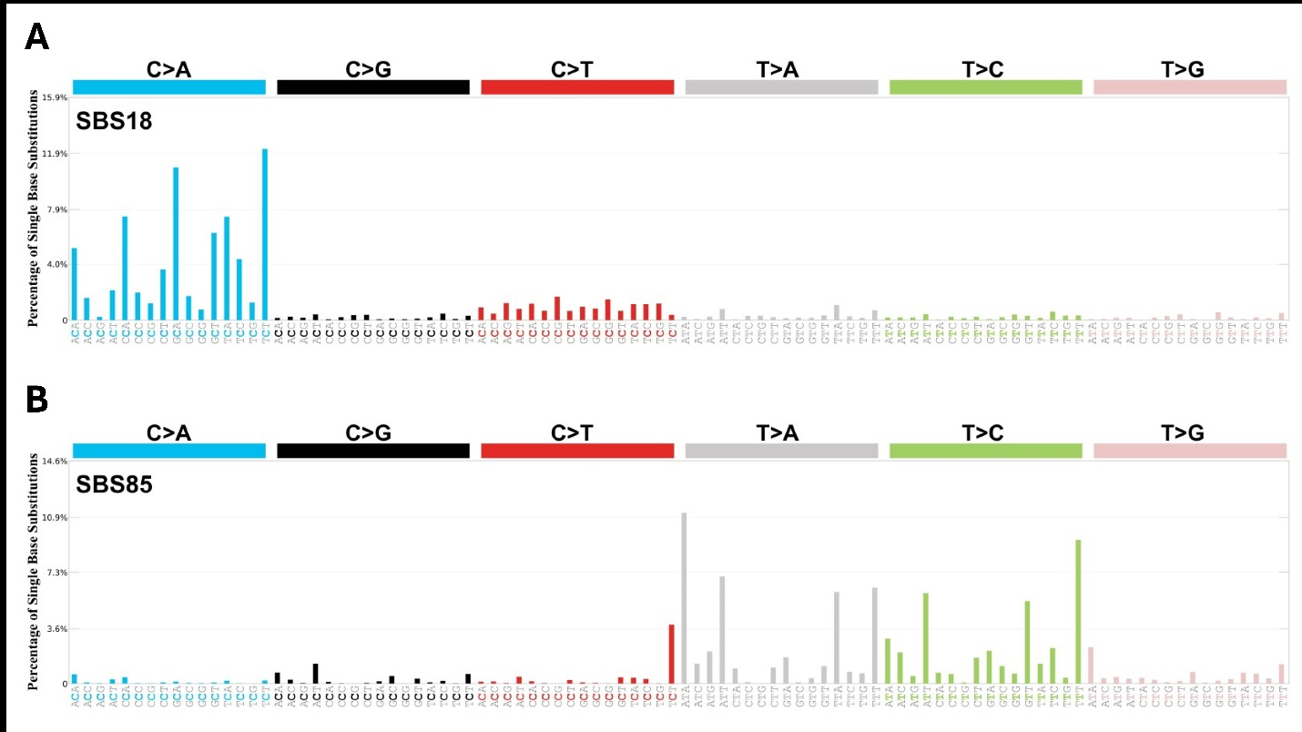
Supplementary Figure 3. COSMIC signatures identified when comparing transformed and parental SV-HUC cells. A. The SBS18 signature. B. The SBS85 signature.

Supplementary Table 1. Unique variants identified in the parental and transformed SV-HUC cells. See the provided Excel file.

Supplementary Table 2. Demographic and baseline characteristics for patients included in the tissue microarray.
 |  | No. (%) of Participants
Characteristics |  | Non-Recurrent LG NMIBC Group (n=55) | Recurrent LG NMIBC Group (n=67)
Age, median (IQR), y |  | 70 (64-78) | 67 (60-75)
Male sex |  | 35 (63) | 46 (67)
Race
Caucasian |  | 54 (98) | 65 (97)
African American |  | 0 | 2 (3)
Smoking history
Current |  | 10 (18) | 18 (27)
Prior |  | 29 (53) | 32 (48)
Never |  | 16 (29) | 15 (22)
Unknown |  | 0 | 2 (3)
Intravesical therapy
All types |  | 12 (22) | 54 (81)
Bacille Calmette-Guerin |  | 2 (4) | 38 (57)
Mitomycin C |  | 8 (15) | 29 (43)
Gemcitabine |  | 3 (5) | 27 (40)
None |  | 43 (78) | 13 (19)
Abbreviations: LG: low-grade; NMIBC: non-muscle invasive bladder cancer

Supplementary Materials and Methods
RNA interference
Three shRNAs specific for P4HB (Horizon Discovery, Cambridge, UK) were tested, and the shRNA exhibiting optimal knockdown efficiency was selected for subsequent use. TCCSUP and J82 cells were transduced with shRNA pGIPZ lentiviral particles targeting P4HB or with scrambled control particles (Thermo Fisher Scientific) as directed. Following selection in 2-4 μg/mL puromycin, the expression levels of P4HB were confirmed by qPCR and Western blotting.
Clonogenic assay
Cells were seeded in 6-well plates (600 cells/well) and allowed to adhere overnight, Cells were then treated with DMSO or 140 nM tunicamycin. After 48 hours, medium was replaced every 3 days until visible colonies formed. Colonies were then fixed and stained with 1.5% (v/v) glutaraldehyde (catalog no. G4004, Sigma-Aldrich), 0.5% (w/v) crystal violet (catalog no. C581, Thermo Fisher Scientific) in PBS, washed with tap water, and counted using ImageJ.
Immunofluorescence staining
Initially, 0.6-1.5 × 10⁵ cells were seeded in 4-well chamber slides and were treated for 24 hours with 40 µg/ml of EVs or 140 nM tunicamycin as indicated. Cells were washed with PBS and fixed in 1% ultrapure formaldehyde (catalog no. 04018, Polysciences, Warrington, PA, USA) in PBS for 20 minutes at room temperature. Following PBS washes, cells were treated with methanol for 10 min at -20°C, air dried, and permeabilized with acetone (catalog no. A18-1, Thermo Fisher Scientific) for 1 minute at room temperature. Cells were then blocked with 5% swine normal serum for 1 hour at room temperature before overnight primary antibody incubation at 4°C. The following primary antibodies were used: anti-γH2AX (1:400; catalog no. 05-636, Millipore), anti-PDI (1:100; catalog no. 3501, Cell Signaling), anti-TSG101 (1:100; catalog no. sc-7964, Santa Cruz Biotechnology, Dallas, TX, USA). The following secondary antibodies were used: Alexa Flour 488 F(ab’)₂ fragment IgG (catalog no. A11017, Invitrogen), Alexa Flour 546 F(ab’)₂ fragment IgG (catalog no. A11010, Invitrogen). DAPI was used to indicate nuclei.
ROS analyses
Total ROS levels were analyzed using the CellROX Deep Red Reagent (catalog no. C10422, Invitrogen). 6×10⁵ cells were seeded in 6 well plates and treated for 24 hours with 40 µg/ml EVs or 140 nM tunicamycin as indicated. Cells were detached with trypsin, neutralized, washed, and stained with 10 µM ROS staining solution for 30 minutes at 37°C. CellROX fluorescence intensity was detected using flow cytometry and analyzed using FlowJo software. The GSH/GSSG ratio was analyzed using a GSH/GSSG-Glo assay (catalog no. V6611, Promega, Madison, WI, USA). 1 × 10⁴ cells per well were seeded in 96-well plates and treated for 24 hours with DMSO or 140 nM tunicamycin. Cells were then washed with HBSS and analyzed according to the manufacturer’s instructions. Luminescence was measured using a plate reader (Synergy H1 hybrid reader, Biotek, Winsooki, VT, USA), and the GSH/GSSG ratio was calculated. H₂O₂ levels were analyzed using the Amplex Red hydrogen peroxide/peroxidase assay kit (catalog no. A22188, Invitrogen). 24-hour conditioned medium was collected from DMSO- or tunicamycin-treated cells, spun at 400 × g for 5 minutes to remove cell debris, and analyzed according to the manufacturer’s instructions. Excitation and emission wavelengths were set at 571 nm and 585 nm respectively, and emission was measured using a plate reader (Synergy H1 hybrid reader, Biotek).
Western blots
Whole-cell lysates and EV samples were separated by 10% SDS-PAGE. The following antibodies were used: monoclonal anti-PDI (1:1000; catalog no. 3501, Cell Signaling); polyclonal anti-CD9 (1:1000; System Biosciences, EXOAB-CD9A-1); monoclonal anti-BiP (1:1000; catalog no. 3177, Cell Signaling); monoclonal anti-GAPDH (1:10,000; Santa Cruz Biotechnology, sc-32233). Densitometry measurements were performed using ImageJ. Values were normalized to GAPDH and compared to the parental TCCSUP cells.
Propidium iodide staining
To prepare confluent cultures, 1.5 × 10⁶ parental cells were seeded in 6 well plates and treated with DMSO or tunicamycin for 48 hours. Cells were then harvested with trypsin and counted. Next, 2 × 10⁶ cells were fixed with ice-cold 70% ethanol at -20°C overnight and then treated with 0.2 mg/ml RNase in 0.1% Triton X-100 at 37°C for 30 min. The cells were stained with 20 µg/ml of propidium iodide (P3596, Life Technologies) in 0.1% Triton X-100. Propidium iodide fluorescence intensity was quantified using flow cytometry and analyzed using FlowJo.
Reduced thiol quantification assay
Protein G Sepharose beads (catalog no. ab193259, Abcam) were cross-linked with anti-PDI antibody (1:100; catalog no. 3501, Cell Signaling) overnight at 4°C according to the manufacturer’s instructions. Next, 85 µg of EVs or whole cell lysate were modified with equal volumes of hydrogen peroxide (final concentration: 5 mM; catalog no. 323381, Sigma-Aldrich), dithiothreitol (DTT; final concentration: 10 mM; catalog no. BP172-5, Thermo Fisher Scientific), or PBS for 1 hour at room temperature. PDI was then immunoprecipitated from all groups by incubating with antibody crosslinked beads overnight at 4°C. Beads were washed with PBS and analyzed using a thiol and sulfide quantification kit (catalog no. T6060, Invitrogen) following the manufacturer’s instructions. Each procedure was performed in the liquid nitrogen evaporation phase, and samples were filled with nitrogen during incubation to avoid oxidation from air. Reduced thiol quantification reactions were analyzed using a plate reader (Synergy H1 hybrid reader, Biotek). The absorbance of H₂O₂ or DTT-modified samples was set as 0% or 100% reduced, respectively, and the absorbance of the PBS-treated group was used for comparison to determine the reduced PDI percentage.
qPCR
Total RNA was collected from cells using TRIzol (catalog no. 1596018, Life Technologies) and quantified using spectrophotometry (NanoDrop, Thermo Fisher Scientific). First-strand cDNA was synthesized using 1 µg of total RNA in a 20 µl reaction using the iScript cDNA synthesis kit according to the instructions (Bio-Rad, Hercules, CA, USA). cDNA levels were measured in triplicate using iQ SYBR Green (Bio-Rad), and relative target gene expression was normalized to that of HPRT. Primer sequences are available upon request.
Nanoparticle tracking analysis
Particle size distributions in EV isolates were measured using a NanoSight NS300 instrument (Malvern Panalytical, Malvern, UK). Each sample was diluted 1:10 in DPBS with negligible background signal and recorded into five video files of 40 seconds each.SV-HUC transformation and soft agar colony formation assay
SV-HUC cells were seeded in 48-well plates (2 × 10⁴ cells/well) and maintained in F-12K medium (catalog no. 21127, Life Technologies) supplemented with 10% EV-depleted FBS. The cells were treated twice per week with PBS vehicle or with 20 µg/ml of EVs derived from TCCSUP parental or shPDI cell lines. The cells were passaged approximately weekly as needed and re-plated at the starting density. The cells were harvested at 13 weeks and maintained in normal culture for at least 5 weeks before further analysis. For soft agar colony formation assays, 0.8% Noble agar (catalog no. A5431, Sigma-Aldrich) in serum-free F-12K medium was added to 6-well plates (2 mL/well) and allowed to solidify. Cancer EV-treated and control cells were then suspended at a density of 1 × 10⁵ cells/ml in medium containing 0.4% Noble agar and then placed on top of the 0.8% agarose underlayer. Medium was refreshed twice per week for 6 weeks. The colonies were then photographed and counted using ImageJ image analysis software.

