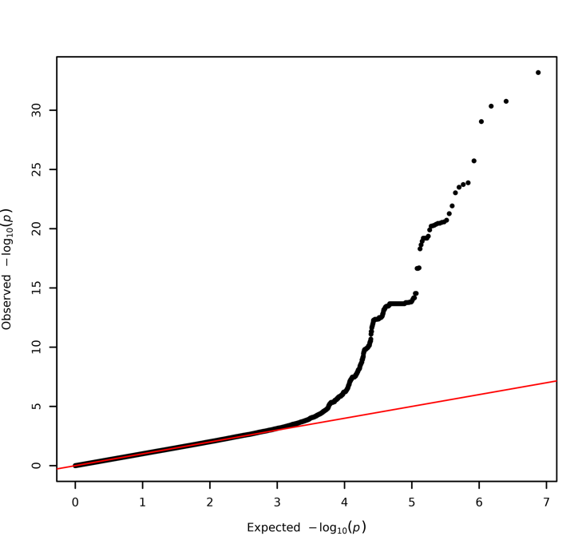
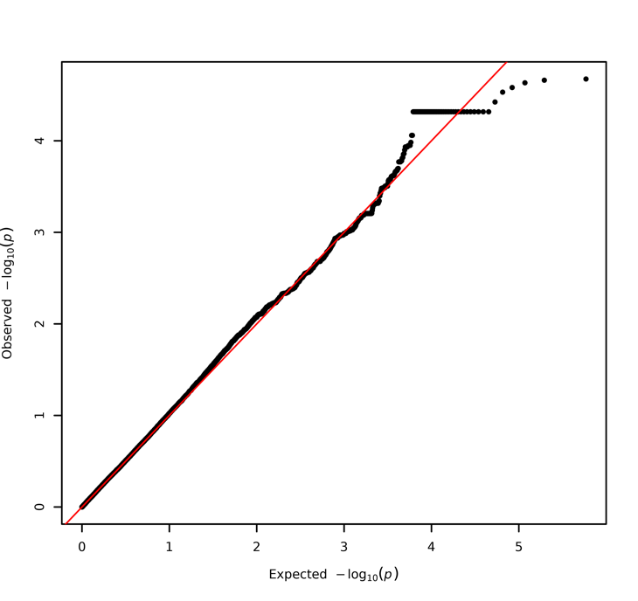
Supplementary Figures
a
b

Supplementary Figure 1. QQ plots of linear regression p-values for a) the Columbia cohort with adjustments for age, sex, disease status, Ashkenazi Jewish status, LRRK2 p.G2019S, ASM activity, GAA activity, GLA activity, GALC activity, and the top 10 PCs, b) the PPMI cohort with adjustments for age, sex, disease status, LRRK2 G2019S genotype, ASM activity, GAA activity, GLA activity, GALC activity, white blood cell count, and the top 10 PCs

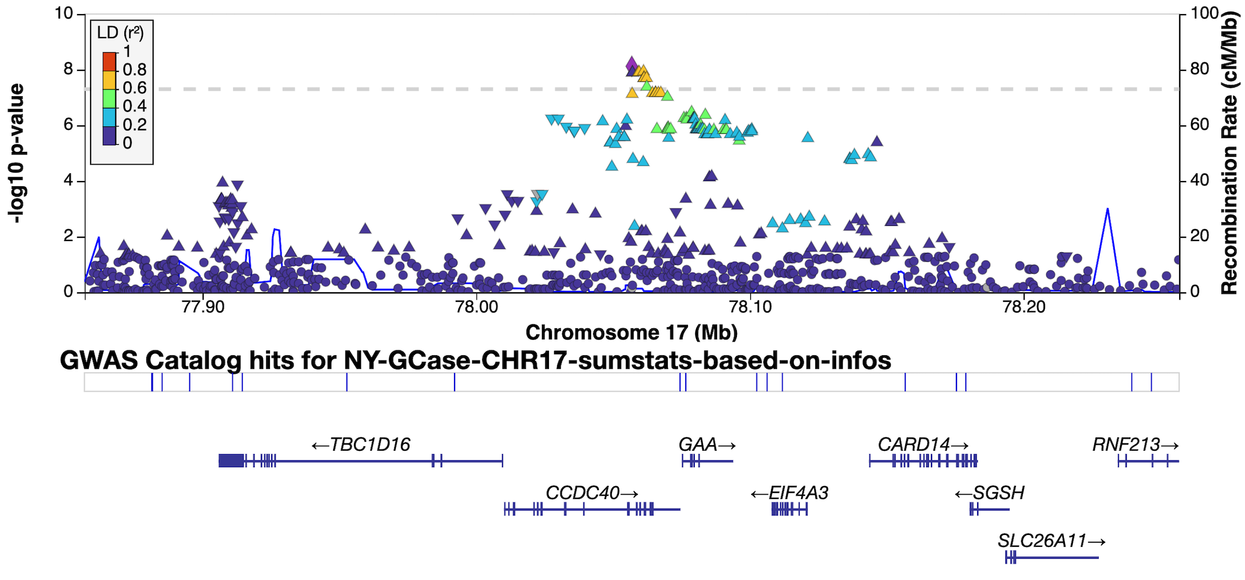
Supplementary Figure 2. LocusZoom Manhattan plot of the GAA locus from the analysis of the Columbia cohort. Color is described in the legend and based on linkage disequilibrium (R²).

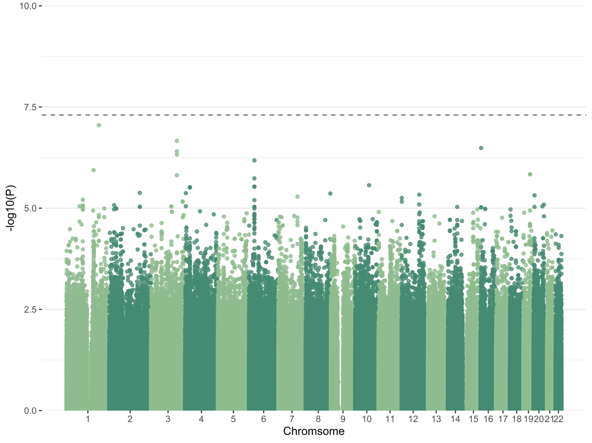

Supplementary Figure 3. Meta-analysis of Columbia and PPMI cohorts using age, sex, disease status, GBA1 p.N370S, p.E326K, and p.T369M genotype status, and 10 PCs.

