Table 5: Examples of displacement field represented as a deformed mesh, the corresponding loading level and the strain map
Parallel specimen (S26)  Third loading | Perpendicular specimen (S20)  Third loading | Perpendicular specimen (S24)  Third loading
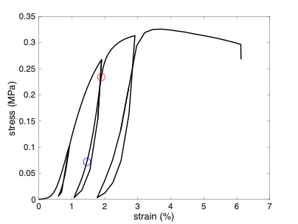  a) | 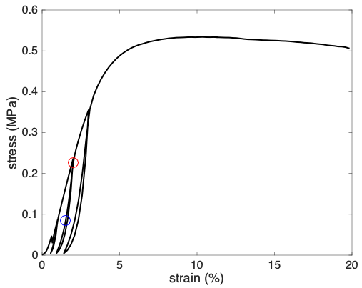  b) | 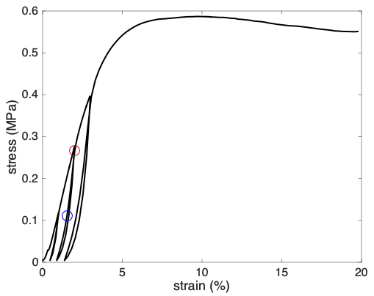  c)
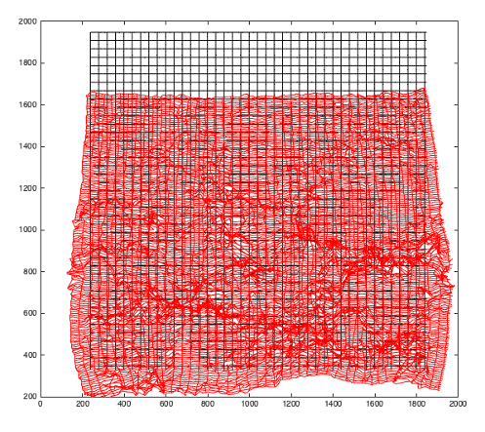  - barrel distortion | 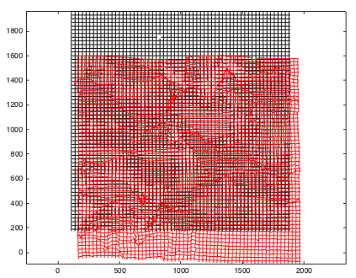  - lateral movement | 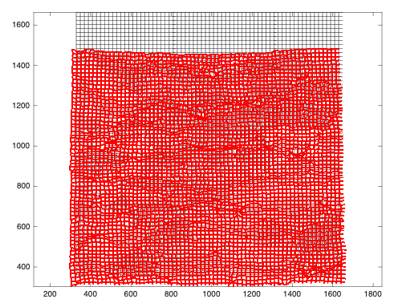  - non-uniform loading
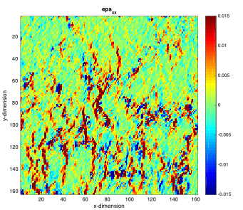  - Localization of high strain zones at the boundaries between aggregates | 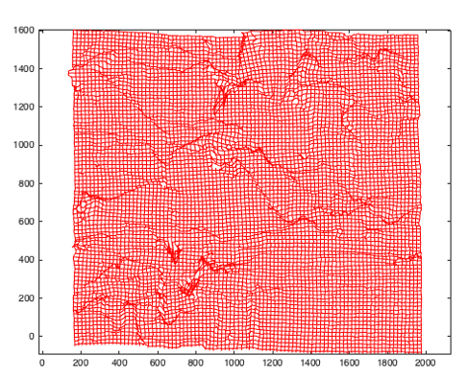  - Localization of the strain mechanisms at the aggregate scale | 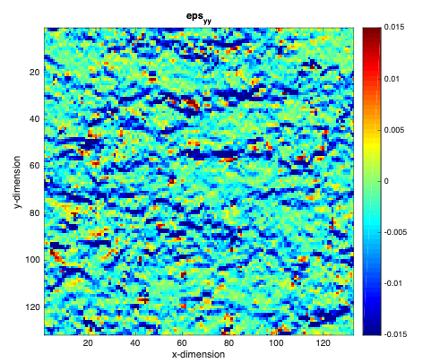  - Localization of high strain zones at the boundaries between aggregates
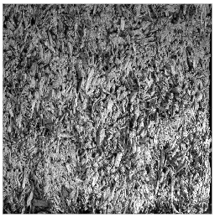  - Global view of a parallel specimen under compression | 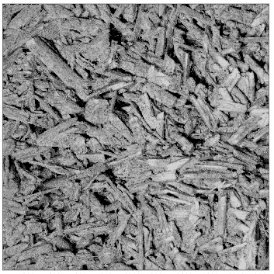  - Central zone of a perpendicular specimen under compression | 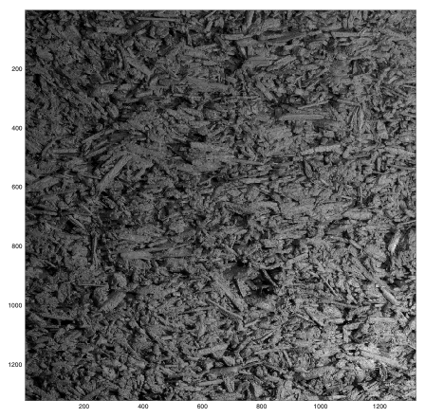  - Global view of a perpendicular specimen under compression

