Mathematical Modelling on Extraction Types and Characterizations of Olea europaea Leaves; Their Antioxidant Performance in Bio-actives and Phenolic Profile by LC-MS/MS

Eyyup KARAOGUL¹, Email: e.karaogul@harran.edu.tr
Gjulten NEDJIP², Email: gnedjip@harran.edu.tr
ª Harran University, Engineering Faculty, Food Engineering, Şanlıurfa, Türkiye; https://orcid.org/0000-0001-8162-6838
^{b}Harran University, Faculty of Science and Letters, Department of Chemistry, Şanlıurfa, Türkiye. https://orcid.org/0000-0001-8288-8653
Correspondence: Eyyup KARAOĞUL, Harran University, Engineering Faculty, Food Engineering, Şanlıurfa, Türkiye. Email: e.karaogul@harran.edu.tr

FIGURE S1 Experimental design in microwave-assisted extraction method (MAE).

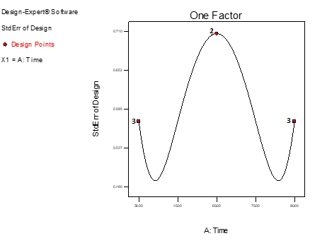
FIGURE S2. Experimental design in conventional extraction method (CE).

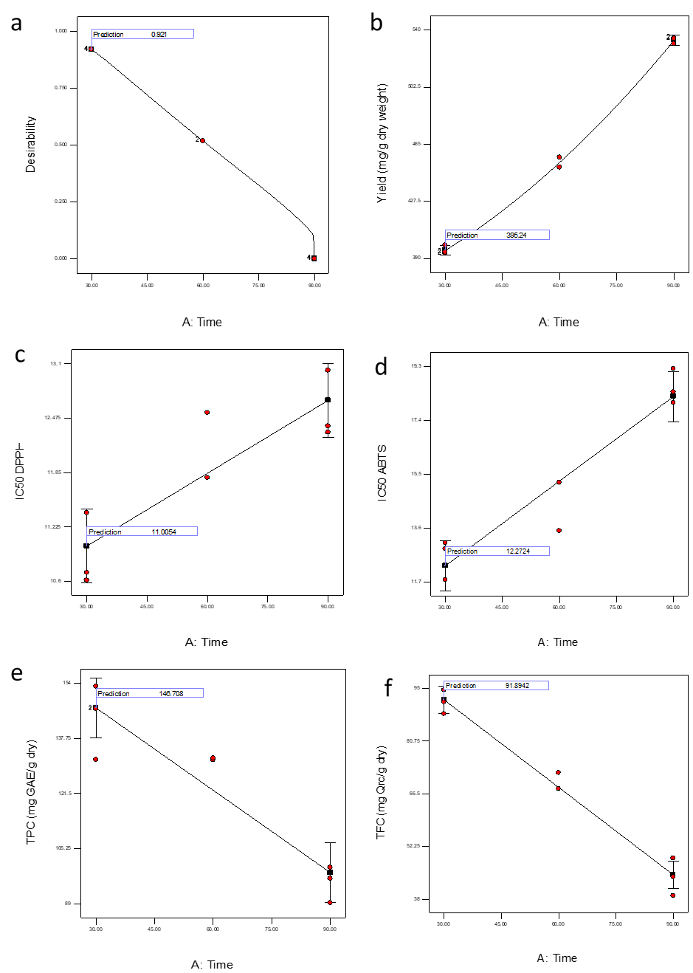
FIGURE S3. Response surface plots of desirability (a), yield (mg/g dry weight) (b), IC₅₀-DPPH (c), IC₅₀-ABTS (d), TPC (mg GAE/g dry) (e), TFC (mg Qrc/g dry) (f), values us functions of extraction time (min) in the CE.

TABLE S1. Experimental design and responses for microwave-assisted extraction (MAE).

 | Independent parameters |  |  |  | Dependent Parameters
 |  |  |  |  | RSA-ABTS (%) |  | RFRC-ABTS (mg Trolox/L) |  | AA-CUPRAC (mg Trolox/L) | IC₅₀-ABTS
Extract Conc. |  |  |  |  | 7.5 ppm | 5.0 ppm | 7.5 ppm | 5.0 ppm | 2.5 ppm | 2.5-7.5 ppm
Run |  | Watt | T(min)
1 | 250 |  |  | 60 | 24.72 | 17.97 | 333.67 | 361.79 | 19.67 | 15.42
2 | 350 |  |  | 90 | 28.73 | 20.79 | 317.00 | 350.07 | 21.11 | 15.70
3 | 250 |  |  | 30 | 27.86 | 19.92 | 320.63 | 353.68 | 19.70 | 14.21
4 | 300 |  |  | 90 | 29.50 | 20.54 | 313.81 | 351.09 | 19.47 | 13.31
5 | 350 |  |  | 30 | 33.59 | 21.80 | 296.79 | 345.84 | 20.36 | 13.39
6 | 300 |  |  | 30 | 29.42 | 20.16 | 314.11 | 352.67 | 20.56 | 12.52
7 | 350 |  |  | 60 | 30.41 | 20.83 | 310.02 | 349.90 | 20.38 | 14.50
8 | 300 |  |  | 60 | 30.12 | 19.12 | 311.20 | 357.02 | 19.31 | 13.12
9 | 250 |  |  | 90 | 26.97 | 20.64 | 324.32 | 350.67 | 20.12 | 15.30
10 | 250 |  |  | 60 | 27.29 | 18.24 | 322.99 | 360.67 | 19.29 | 14.59
11 | 250 |  |  | 60 | 25.67 | 17.70 | 329.74 | 362.92 | 19.50 | 14.40
12 | 350 |  |  | 90 | 27.14 | 20.52 | 323.62 | 351.17 | 21.11 | 15.23
13 | 350 |  |  | 90 | 27.94 | 20.65 | 320.31 | 350.62 | 21.11 | 15.17
14 | 250 |  |  | 30 | 27.05 | 19.04 | 323.99 | 357.32 | 19.92 | 13.10
15 | 250 |  |  | 30 | 28.67 | 18.17 | 317.27 | 360.96 | 19.28 | 13.20
16 | 300 |  |  | 90 | 29.65 | 19.77 | 313.17 | 354.31 | 19.05 | 12.65
17 | 300 |  |  | 90 | 30.11 | 19.00 | 311.24 | 357.52 | 18.98 | 12.65
18 | 350 |  |  | 30 | 33.59 | 22.24 | 296.79 | 344.00 | 20.48 | 12.65
19 | 350 |  |  | 30 | 33.73 | 24.31 | 296.17 | 335.42 | 20.30 | 12.57
20 | 300 |  |  | 30 | 30.51 | 20.03 | 309.57 | 353.23 | 19.53 | 12.04
21 | 300 |  |  | 30 | 30.24 | 19.89 | 310.71 | 353.80 | 20.13 | 12.01
22 | 350 |  |  | 60 | 31.80 | 19.58 | 304.24 | 355.10 | 19.83 | 13.05
23 | 350 |  |  | 60 | 31.10 | 19.99 | 307.13 | 353.36 | 19.94 | 13.10
24 | 300 |  |  | 60 | 29.79 | 19.64 | 312.57 | 354.82 | 19.52 | 12.35
25 | 300 |  |  | 60 | 30.45 | 19.25 | 309.83 | 356.47 | 19.83 | 12.28
26 | 250 |  |  | 90 | 27.25 | 18.44 | 323.17 | 359.83 | 19.94 | 13.93
27 | 250 |  |  | 90 | 27.61 | 17.71 | 321.65 | 362.89 | 20.15 | 13.86
RSA=radical scavenging activity; AA=antioxidant activity; RFRC=remaining free radical concentration; IC₅₀=half maximal inhibitory concentration.

TABLE S2. Experimental design and responses for conventional extraction (CE).

Independet Parameters |  | Dependent Parameters
 |  | RSA-DPPH (%) |  | RFRC-DPPH  (mg Trolox/L) |  | RSA-ABTS (%) |  | RFRC-ABTS  (mg Trolox/L) | IC₅₀-DPPH | IC₅₀-ABTS | TPC  (mg GAE/g dry) | TFC  (mg Qrc/g dry)
Extract Conc. (ppm) |  | 7.5 | 5.0 | 7.5 | 5.0 | 7.5 | 2.5 | 2.5 | 2.5-7.5 |  | 100 | 100
Run | T(min)
1 | 90 | 32.83 | 23.35 | 405.88 | 463.69 | 20.43 | 6.65 | 408.91 | 13.02 | 18.39 | 96.38 | 43.99
2 | 60 | 33.68 | 24.76 | 400.70 | 455.06 | 25.96 | 8.94 | 399.37 | 12.54 | 15.20 | 131.85 | 67.83
3 | 30 | 35.94 | 25.19 | 386.89 | 452.47 | 31.19 | 12.72 | 383.63 | 11.39 | 13.08 | 131.40 | 94.52
4 | 90 | 31.98 | 22.92 | 411.05 | 466.28 | 20.23 | 7.03 | 407.31 | 12.31 | 19.21 | 99.64 | 49.07
5 | 60 | 33.11 | 23.49 | 404,15 | 462.83 | 26.88 | 9.18 | 405.70 | 11.79 | 13.50 | 131.34 | 72.19
6 | 30 | 35.38 | 26.18 | 390.35 | 446.43 | 3031 | 11.23 | 389.86 | 10.70 | 12.87 | 153.05 | 88.08
7 | 30 | 36.37 | 25.90 | 384.31 | 448.16 | 31.19 | 11.48 | 388.82 | 10.61 | 11.77 | 146.47 | 91.30
RSA=radical scavenging activity; AA=antioxidant activity; RFRC=remaining free radical concentration; IC₅₀=half maximal inhibitory concentration.TPC=total phenolic compound; TFC=total flavanoid compound; GAE=Gallic acid; Qrc=Quarcetin.

TABLE S3. IC₅₀-DPPH and IC₅₀-ABTS of olive leaf extract.

 | Watt | Time (min) | IC₅₀-DPPH | F(X) | R² | IC₅₀-ABTS | F(X) | R²
MAE | 250 | 30 | 14.30 | y = 3.4434x + 0.6446 | 0.9954 | 13.50 | y = 3.6696x + 0.4561 | 0.9995
MAE | 250 | 60 | 14.13 | y =3.4669x + 0.8962 | 0.9999 | 14.80 | y = 3.2876x + 1.3361 | 0.9996
MAE | 250 | 90 | 10.11 | y =4.8584x + 0.8648 | 0.9996 | 14.36 | y = 3.3149x + 2.3955 | 0.9998
MAE | 300 | 30 | 14.28 | y =3.3019x + 2.8459 | 0.9972 | 12.19 | y = 4.0686x – 0.4087 | 0.9999
MAE | 300 | 60 | 12.30 | y = 3.9622x + 1.2736 | 0.9999 | 12.58 | y = 3.9682x + 0.0732 | 0.9975
MAE | 300 | 90 | 13.41 | y = 3.6792x + 0.6446 | 0.9999 | 12.87 | y = 3.8815x + 0.0343 | 0.9999
MAE | 350 | 30 | 12.06 | y = 3.8773x + 3.2547 | 0.9979 | 12.87 | y = 3.2211x + 8.5439 | 0.9613
MAE | 350 | 60 | 12.11 | y = 3.9151x + 2.5786 | 0.9999 | 13.55 | y = 3.2768x + 5.6002 | 0.9631
MAE | 350 | 90 | 12.74 | y = 3.5943x + 4.1981 | 0.9999 | 15.37 | y = 2.8156x + 6.7374 | 0.9996
CE |  | 30 | 10.90 | y = 4.132x + 4.9685 | 0.9999 | 12.57 | y = 3.8171x + 2.0097 | 0.9978
CE | - | 60 | 12.09 | y = 3.632x + 6.1006 | 0.9999 | 14.07 | y = 3.4939x + 0.8498 | 0.991
CE |  | 90 | 12.57 | y = 3.5283x + 5.6446 | 0.9999 | 18.53 | y = 2.6722x + 0.4711 | 0.9991
Mc | - | - | 11.23 | y = 4.1603x + 3.2704 | 0.9999 | 8.57 | y = 5.5131x + 2.735 | 0.9983
IC₅₀=half maximal inhibitory concentration; MAE=microwave-assisted extraction; CE=conventional extraction; Mc=maceration.

