Surface dispersal, emission source and human health risk assessment of heavy metal(loid)s in an active gas field, Southern Iran

Nafise Khodabakhshloo*, Bhabananda Biswas^{2, 3}, Farid Moore¹, Jianhua Du^{3, 4}, Ayanka Wijayawardena^{3,4}, Morteza Arabzadeh⁵,

- Department of Earth Sciences, College of Science, Shiraz University, 71454 Shiraz, Iran
- Future Industries Institute, STEM unit of University of South Australia, Mawson Lakes SA 5095, Australia.
- Cooperative Research Centre for Contamination Assessment and Remediation of the Environment (CRC CARE), ATC building, The University of Newcastle, Callaghan, NSW 2308, Australia
- Global Centre for Environmental Remediation (GCER), The University of Newcastle, Australia
- Department of health, safety and environment, Fajr e jam gas refinery, Bushehr, Iran

Supplementary information
Supplementary Table 1. Applied indices of heavy metal pollution in the current study
Pollution index | Formula | Classification | Description of variables
Geoaccumulation (I_{geo}) | I_{geo}= log₂ $\frac{Ci}{1.5Bi}$ | non-pollution (Igeo < 0), no pollution (0<Igeo < 1), moderate pollution (1<Igeo <2), moderate to severe pollution (2<Igeo < 3), severe pollution (3<Igeo < 4) severe to extreme pollution (4<Igeo < 5), and extreme pollution (Igeo > 5) | C_{i} :measured concentration of (Mohammadi et al.) of i (mg/kg)  Bi: geochemical background concentration of (Mohammadi et al.) of i (mg/kg)  Constant (1.5): used to normlize possible lithogenic variations in background matrix  (G. MÜLLER, 1969; Zhuo et al., 2020)
Contamination factor (C_{f}) | C_{fi}= $\frac{C_{i}}{C_{n}}$ | (C_{f} <8) low contamination; (8 ≤ C_{f} <16) moderate contamination; (16 ≤ C_{f}≥32) considerable contamination; (32 ≥ C_{f}) very high contamination | $C_{i}$ the concentration of the corresponding element in sample of interest  $C_{n}$is the concentration of heavy metal i in reference soil (Hakanson, 1980; Hu and Cheng, 2016; Keshav Krishna and Rama Mohan, 2016)
Pollution Load Index  (PLI) | PLI=$\sqrt[n]{CF1×CF2×….×CFn}$ | (PLI = 0), unpolluted (0 < PLI ≤ 1), unpolluted to moderately polluted (1 < PLI ≤ 2), moderately polluted (2 <PLI ≤ 3), moderately to highly polluted (3 < PLI ≤ 4), highly polluted (4 < PLI ≤ 5), or very highly polluted (PLI > 5). | PLI: overall pollution status for a sample  $C_{f}:$Contamination factor  (Kowalska et al., 2018; Kumar et al., 2019b)
Ecological risk factor | ${Er}^{i}= {Tr}^{i}$×$C_{f}$ | Eri < 40, low risk; 40 ≤ Eri < 80, moderate risk; 80 ≤ Eri < 160, considerable risk; 160 ≤ Eri < 320, high risk; Eri ≥ 320, very high risk | ${Er}^{i}$: potential ecological risk factor of single metal  ${Tr}^{i}$ is the biological toxic factor of metals i; ${Tr}^{i}$ is the toxic response factor (Cd: 30, As: 10, Pb: 5, Cu: 5, Zn:1, Cr:2).  $C_{f}:$ Contamination factor  (Adimalla and Wang, 2018; Hakanson, 1980)
Potential ecological risks (PERI) | RI= $\sum_{i=1}^{n}{{Er}^{i}}$ | PERI < 150 Low risk, 150 < PERI < 300 Moderate risk, 300 < PERI < 600, Considerable risk, PERI > 600 High risk | PERI is the ${Er}^{i}$ of eight metals (Kowalska et al., 2018)

Supplementary Table 2. Definition and parameters for health risk assessment of heavy metal in studied soils with RFD and SF
Factor | Definition | unit | Value |  | Reference
Factor | Definition | unit | Adult | Child | Reference
Factor | Definition | unit | (>21 y) | (5-11 y) | Reference
AT | Average time: | d |  |  | U.S. EPA, 2011
AT | for carcinogens | d | 365×70 | 365×70 | U.S. EPA, 2011
 | for non-carcinogens |  | 365×ED | 365×ED
AF | Soil-adherence factor | mg (cm²·d)⁻¹ | 0.07 | 0.2 | U.S. EPA, 2004
BW | Average body weight | kg | 80 | 15 | U.S. EPA, 2011
CF | Conversion factor | kg·mg⁻¹ | 10⁻⁶ | 10⁻⁶ | U.S. EPA, 2004
ABS_{d} | Dermal absorption factor |  | 0.001 | 0.001 | U.S. EPA, 2011
FE | Dermal exposure ratio |  | 0.61 | 0.61 | U.S. EPA, 2004
EF | Exposure frequency | d·y⁻¹ | 350 | 350 | U.S. EPA, 2004
ED | Exposure duration | y | 26 | 6 | U.S. EPA, 2011
SA | Exposed skin surface area | cm² | 6032 | 2373 | U.S. EPA, 2011
PEF | particulate emission factor | M³·kg | 1.36×10⁹ | 1.36×10⁹ | U.S. EPA, 2004
C_{s} | Studied soils concentration | mg·kg⁻¹ |  |  | This study
InhR | Inhalation rate | m³·d⁻¹ | 20 | 12 | U.S. EPA, 2011
IngR | Ingestion rate | mg·d-1 | 100 | 200 | U.S. EPA, 2011
Factor | Pb | Cd | As | Cr | Ni | Co | Cu | Zn
RfD ing. | 3.50E-03 | 1.00E-03 | 3.00E-04 | 3.00E-03 | 2.00E-02 | 2.00E-02 | 3.70E-02 | 3.00E-01
RfD inh. | 5.25E-03 | 1.70E-05 | 1.23E-04 | 2.86E-05 | 2.06E-02 | 5.71E-06 | 4.02E-02 | 3.00E-01
RfD derm | 5.25E-04 | 1.00E-05 | 1.23E-04 | 6.00E-05 | 5.40E-03 | 1.60E-02 | 1.20E-02 | 6.00E-02
CSF ing. | 1.50E+00 | 6.10E+00 | 1.50E+00 | 5.00E-01 | 9.10E-01
CSF inh. | 1.50E+01 | 6.30E+00 | 1.51E+01 | 4.20E+01 | 8.40E-01 | 9.80E+00
CSF derm | 1.50E+00 | 6.10E+00 | 3.66E+00

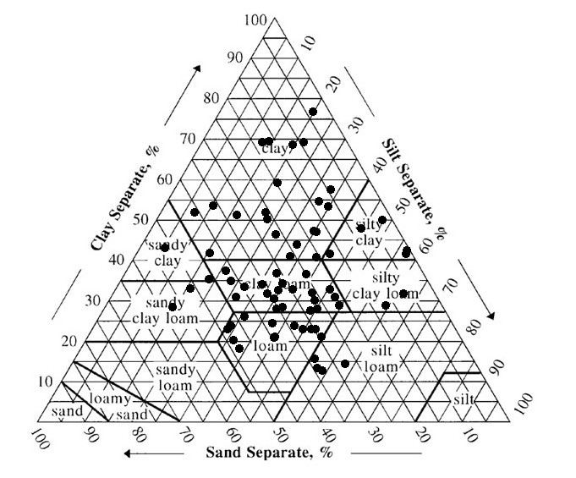
Supplementary Fig 1. Soil texture of studied area (classified according USDA)

* Corresponding author E-mail addresses: Nafise_kh@shirazu.ac.ir

