Supplementary information
for
Mangrove tree aerial root extract mediated green synthesis of Ag/Fe₃O₄/GO nanocomposite and its application as a catalyst for one pot synthesis of 7-phenyl-6H,7H-benzo[4,5]imidazo[2,1-b]chromeno[4,3-d][1,3]thiazin-6-one derivatives

Devendiran Parthiban¹, Muniyan Ramasamy Kuppusamy¹, Chinnaswamy Vanitha¹, Ayyanan Gomathi¹, Dhanasekaran Suraksha¹*
¹Research Department of Chemistry, Rajeshwari Vedachalam Government Arts College, Chengalpattu, Tamilnadu,India-603001.
* Corresponding author mail id: surakshadhanasekaran211@gmail.com

GRAPHICAL ABSTRACT

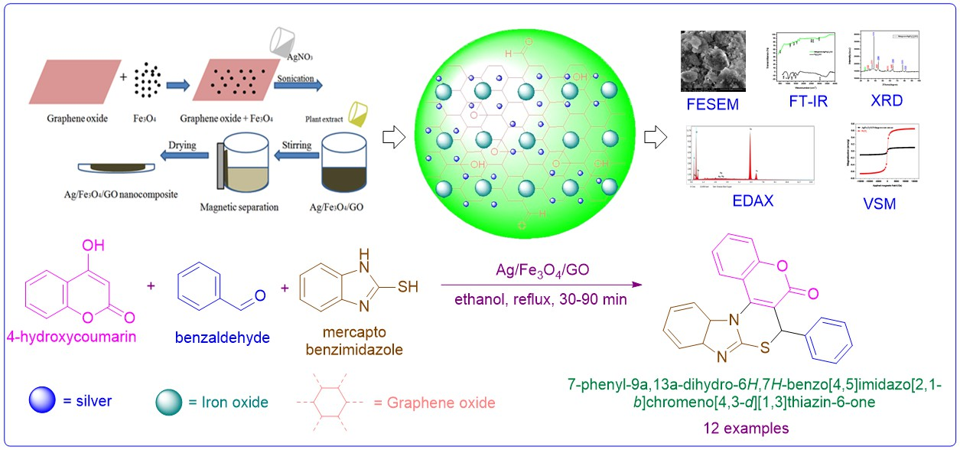

Synthesis of Graphene Oxide and Fe₃O₄/GO

Graphite powder was used to prepare Graphene oxide (GO) using improved version of Hummer's method.⁵⁴ iron oxide/ graphene oxide (Fe₃O₄/GO) nanocomposite was prepared by the co-precipitation of Fe²⁺ and Fe³⁺ in the presence of graphene oxide by dissolving 0.31 g of FeCl₂.4H₂O and 0.75 g of FeCl₃·6H₂O (molar ratio of 1:2) in 30 mL of distilled water under sonication for 10 min, then adding 0.2758 g graphene oxide pre-dissolved in 30 ml of distilled water, carefully stirred for about 25 min at room temperature, then, adding 3 mL of aqueous ammonia to increase pH to alkaline (10–11) condition. The formation of Fe₃O4 was confirmed by observing the colour change from light brown to black. The resultant suspension was heated to 80ºC for about 15 min, then kept at room temperature for 1 h. The synthesized Fe₃O₄/GO nanoparticles were removed from reaction vessel with help of external bar magnet. The Fe₃O₄/GO nanoparticles were washed with water and ethanol in order to remove unreacted reactants. Finally, the precipitate was dried at 80ºC in oven for 4 h.

Preparation of Mangrove tree aerial root extract

The mangrove tree aerial root extract was prepared using fresh part of aerial root tip, washed with water, chopped into fine pieces. About 5 g of chopped aerial roots was grained using mortar and pestle. chopped aerial roots was mixed with 100 mL of distilled water. The mixture was stirred for 2 h at 80ºC and cooled down to room temperature. The extract was centrifuged with help of Remi R-80C+ centrifuging machine at 4000 rpm for 20 minutes and finally the clear extract was stored in glass container at 5 ºC. (Fig 4)
- 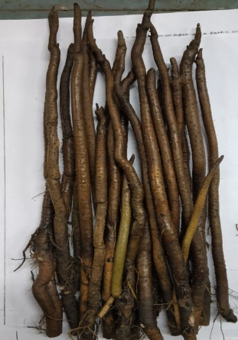 b) 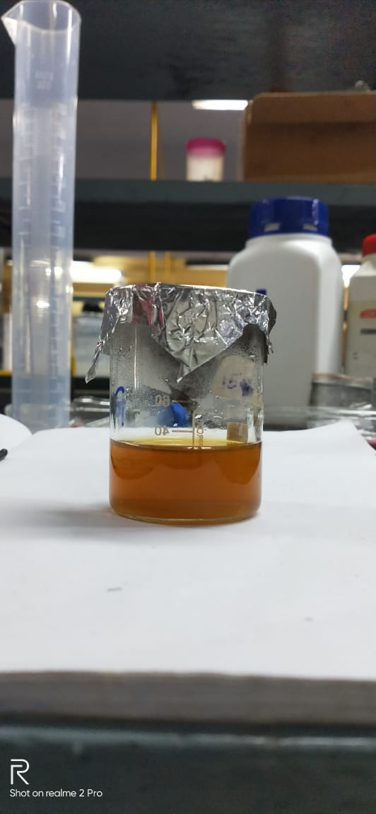
Figure 4: a) Mangrove aerial root tip b) Mangrove root extract

Synthesis of Ag/Fe₃O₄/GO nanocomposite using Mangrove aerial root extract

0.5 g of Fe₃O₄/GO nanocomposite was dispersed in 50 mL of water and was sonicated for 15 minutes. 20 mL of 0.1 M aqueous solution of AgNO₃ was added drop wise into the suspension of Fe₃O₄/GO nanocomposite and sonication was continued for 1 h. 40 mL of Mangrove aerial root extract was then added drop wise into the above mixture and pH was reached 9.0 by adding aqueous solution of NaOH under the continuous stirring and heated at 80 ºC for 3 h. After the completion of reaction, the obtained Ag/Fe₃O₄/GO nanocomposite was separated by applying external magnetic field, washed with distilled water for several times, dried in oven at 80 ºC for 12 h.(Fig 5)
a) 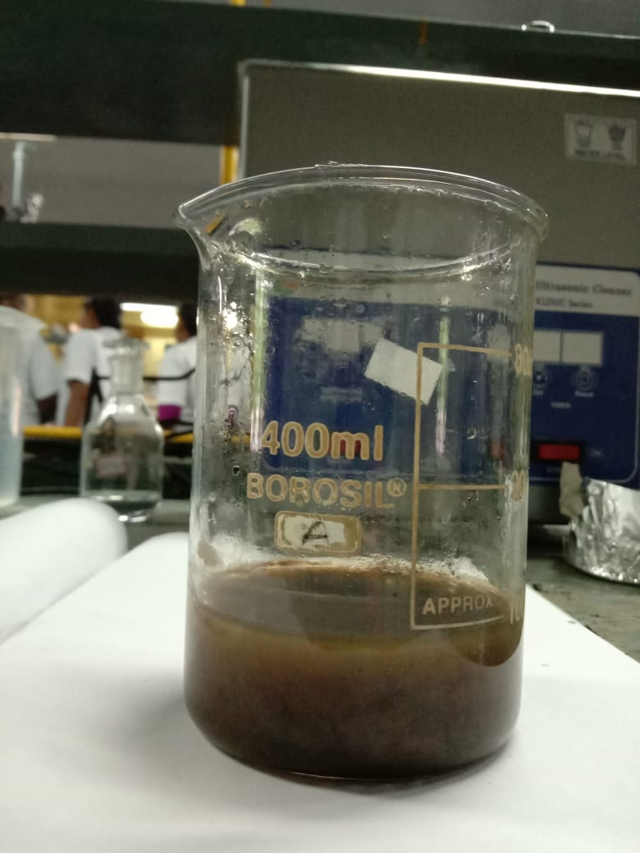 b) 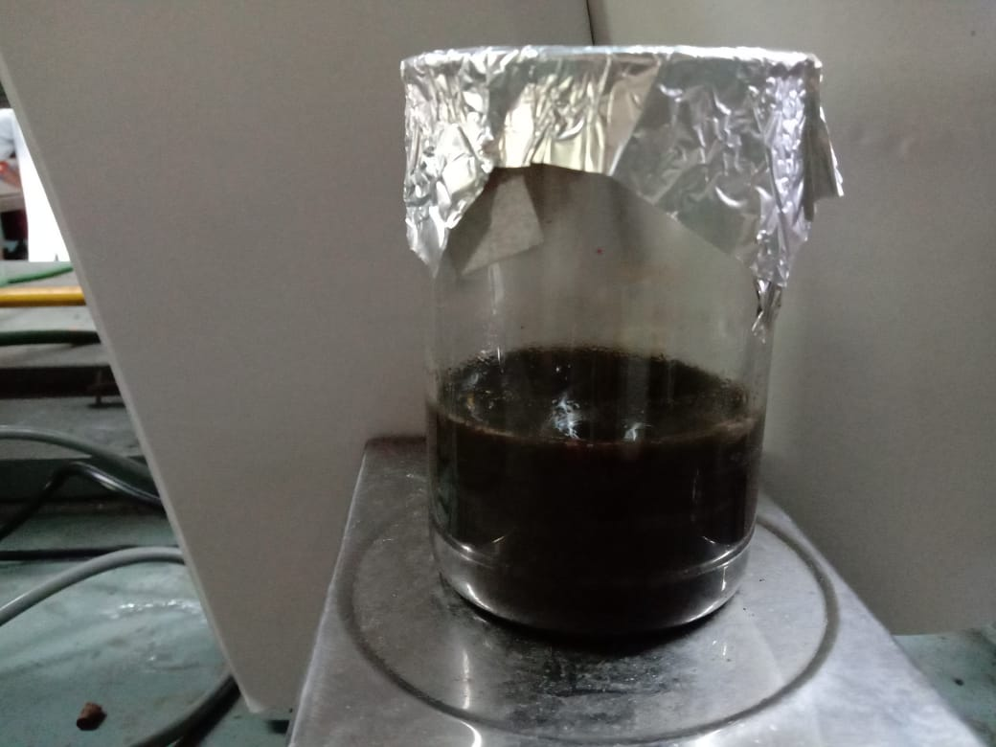
Synthesis of Ag/Fe₃O₄/GO a) Before addition of Mangrove extract b) After addition of Mangrove extract.
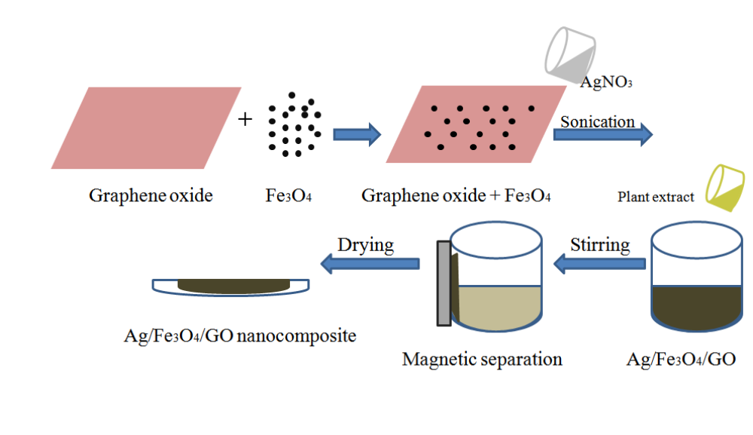
Scheme of synthesis of Ag/Fe₃O₄/GO nanocomposite using banyan and mangrove root extracts.

General procedure for synthesis of 7-phenyl-6H,7H-benzo[4,5]imidazo[2,1-b]chromeno[4,3-d][1,3]thiazin-6-one derivatives

The mixture of hydroxycoumarin (10 mmol), mercaptobenzimidazole (10 mmol) and different aldehyde (10 mmol), Ag/Fe₃O₄/rGO (45 mg) and 10 ml of EtOH was taken in 100 ml round bottom flask, refluxed on water bath for appropriate time and the progress of the reaction was monitored by TLC. After completion of the reaction as indicated by TLC, the reaction mixture was cooled to room temperature. The solid formed upon cooling was filtered, dried and purified by recrystallizing in hot ethanol. The synthesised compounds were characterised partially by proton NMR.

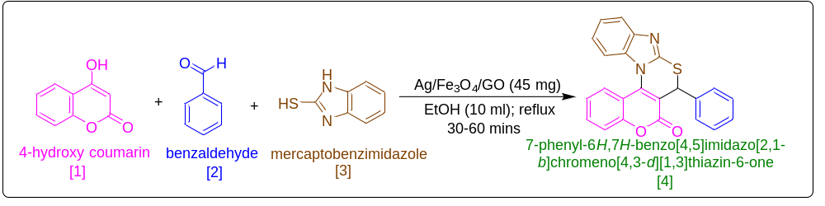
Scheme 1 Synthesis of 7-phenyl-6H,7H-benzo[4,5]imidazo[2,1-b]chromeno[4,3-d][1,3]thiazin-6-one derivatives

FT-IR spectra of Mangrove aerial root extract mediated Ag/Fe₃O₄/rGO nanocomposite

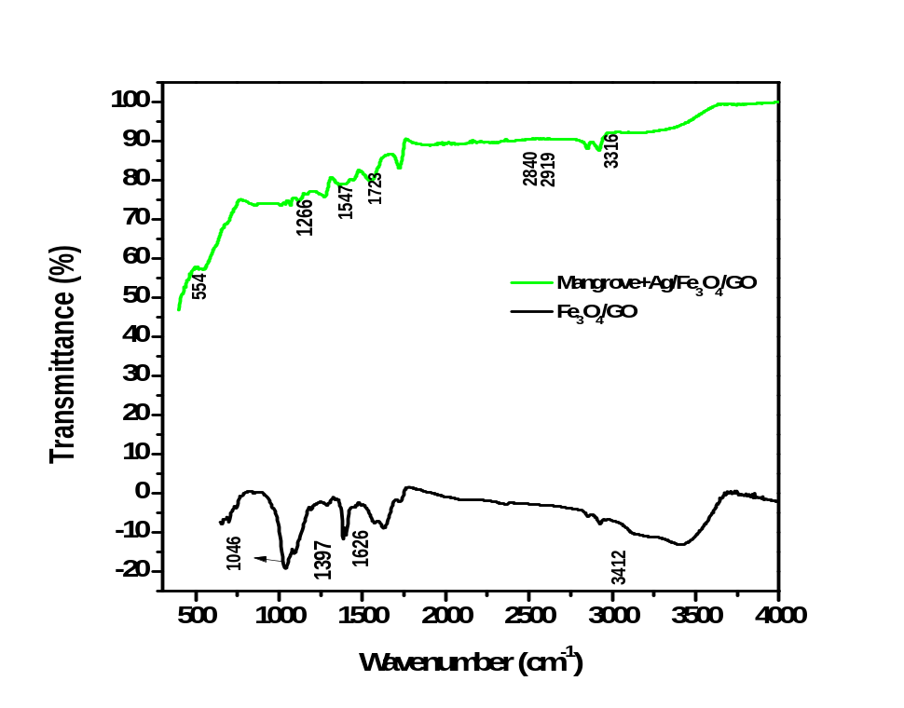

XRD pattern of mangrove tree aerial root extract mediated Ag/Fe₃O₄/rGO nanocomposite

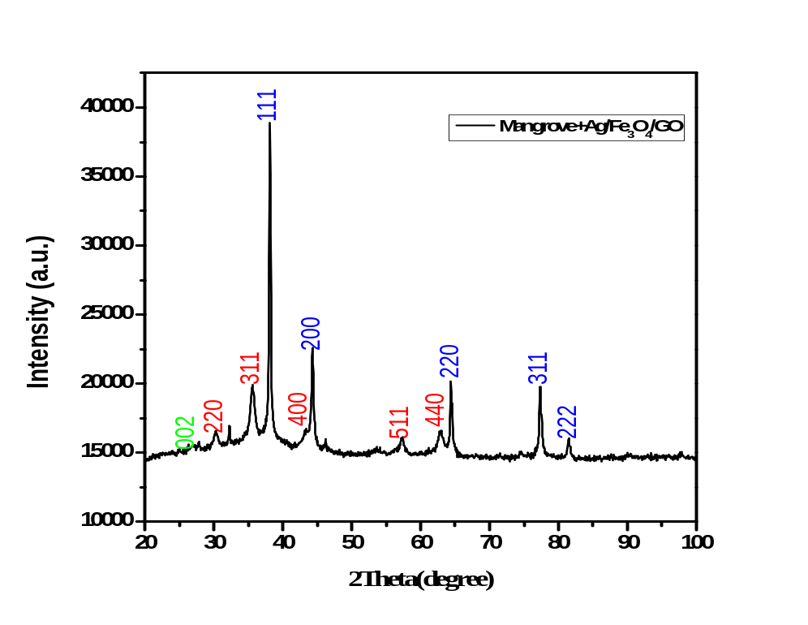

SEM image of mangrove tree aerial root mediated Ag/Fe₃O₄/rGO nanocomposite

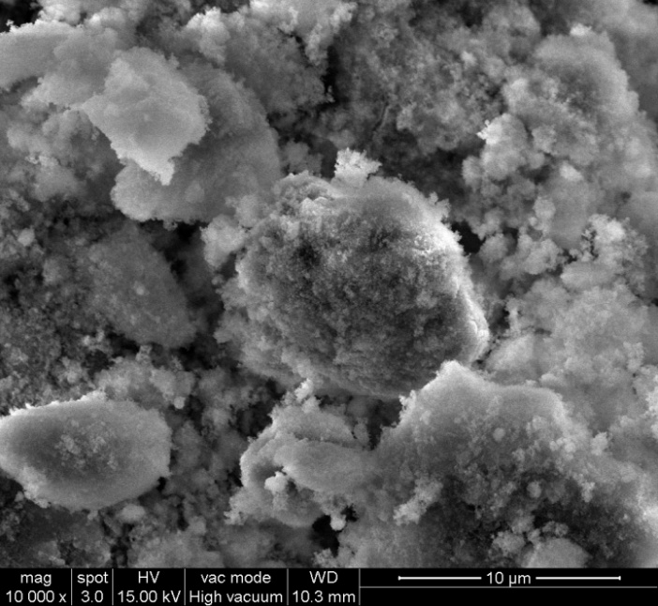
- Magnification of 10 µm

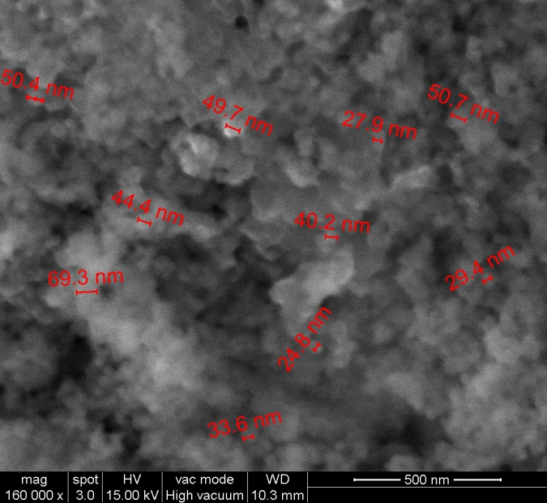
- Magnification of 500 nm

EDAX spectrum of mangrove tree aerial root mediated Ag/Fe₃O₄/rGO nanocomposite

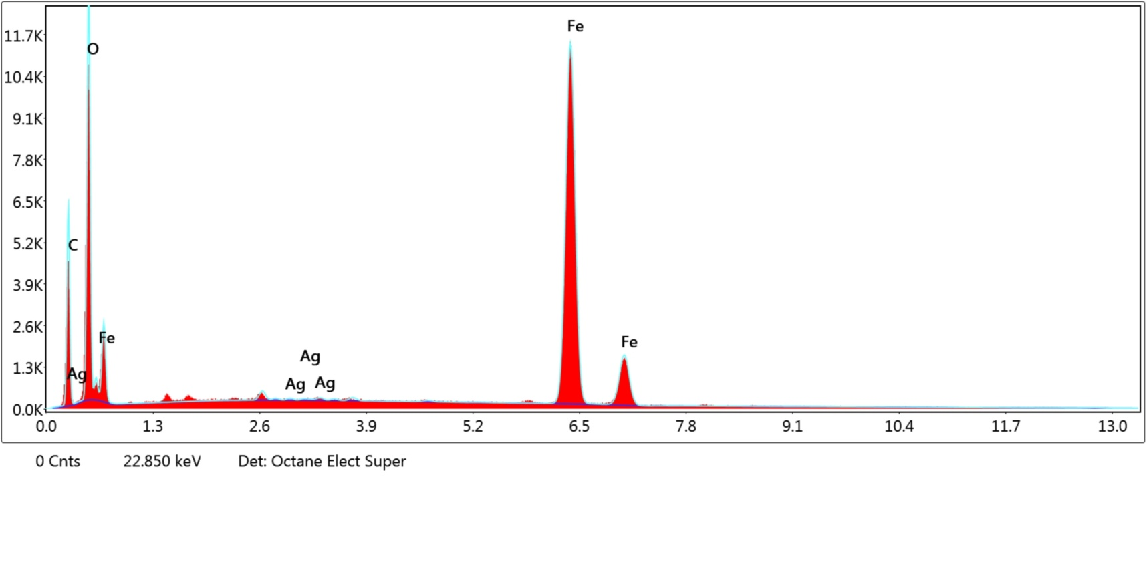

VSM spectra of mangrove aerial root extract mediated Ag/Fe₃O₄/rGO nanocomposite

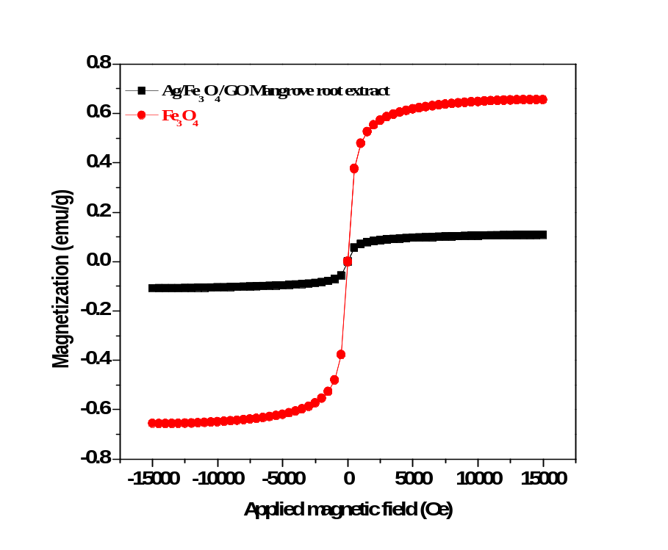

Spectral data for selected few compounds

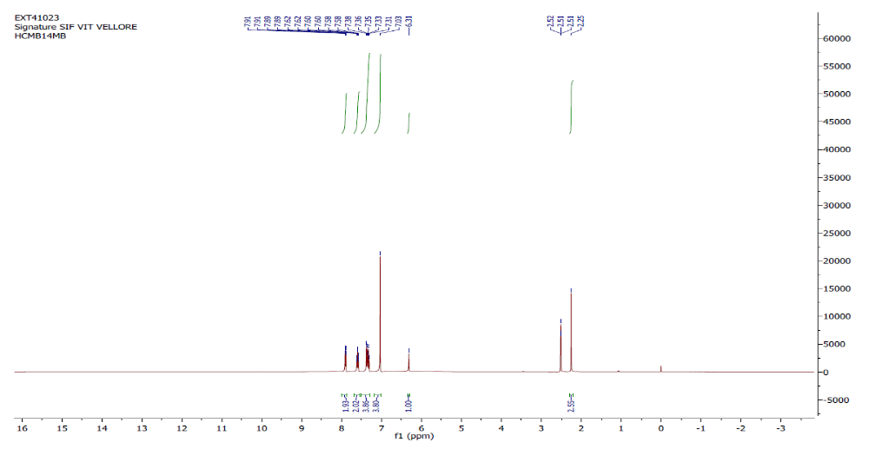
Proton NMR spectrum of 7-(p-tolyl)-6H,7H-benzo[4,5]imidazo[2,1-b]chromeno[4,3-d][1,3]thiazin-6-one (4e)

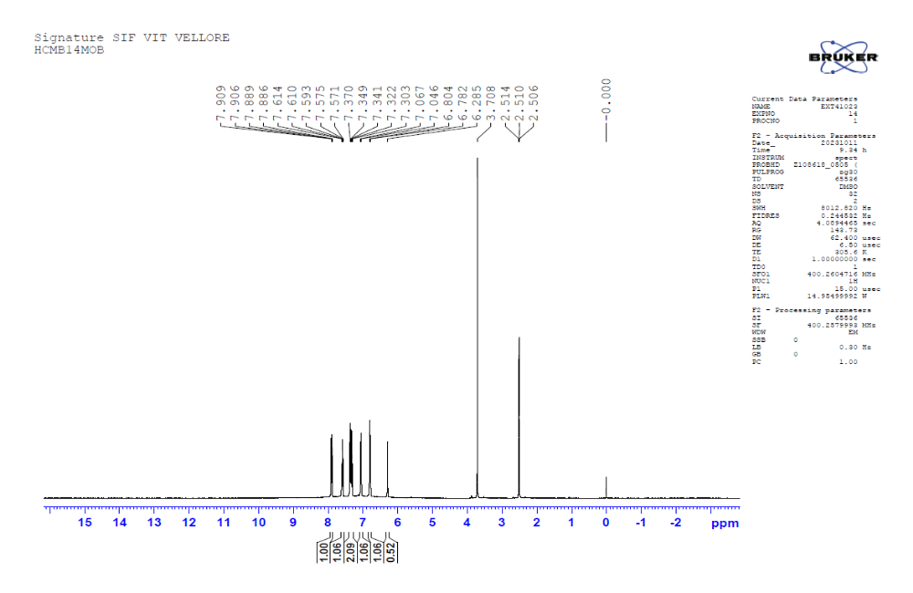
Integration multiplied by 2
Proton NMR spectrum of 7-(4-methoxyphenyl)-6H,7H-benzo[4,5]imidazo[2,1-b]chromeno[4,3-d][1,3]thiazin-6-one (4f)

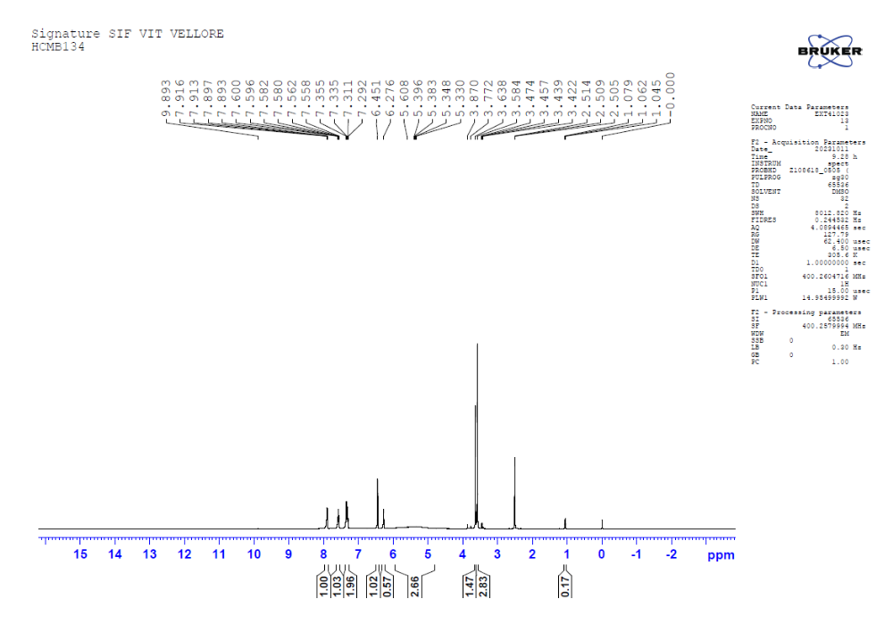
Integration multiplied by 2
Proton NMR spectrum of 7-(3,4,5-trimethoxyphenyl)-6H,7H-benzo[4,5]imidazo[2,1-b]chromeno[4,3-d][1,3]thiazin-6-one (4g)

