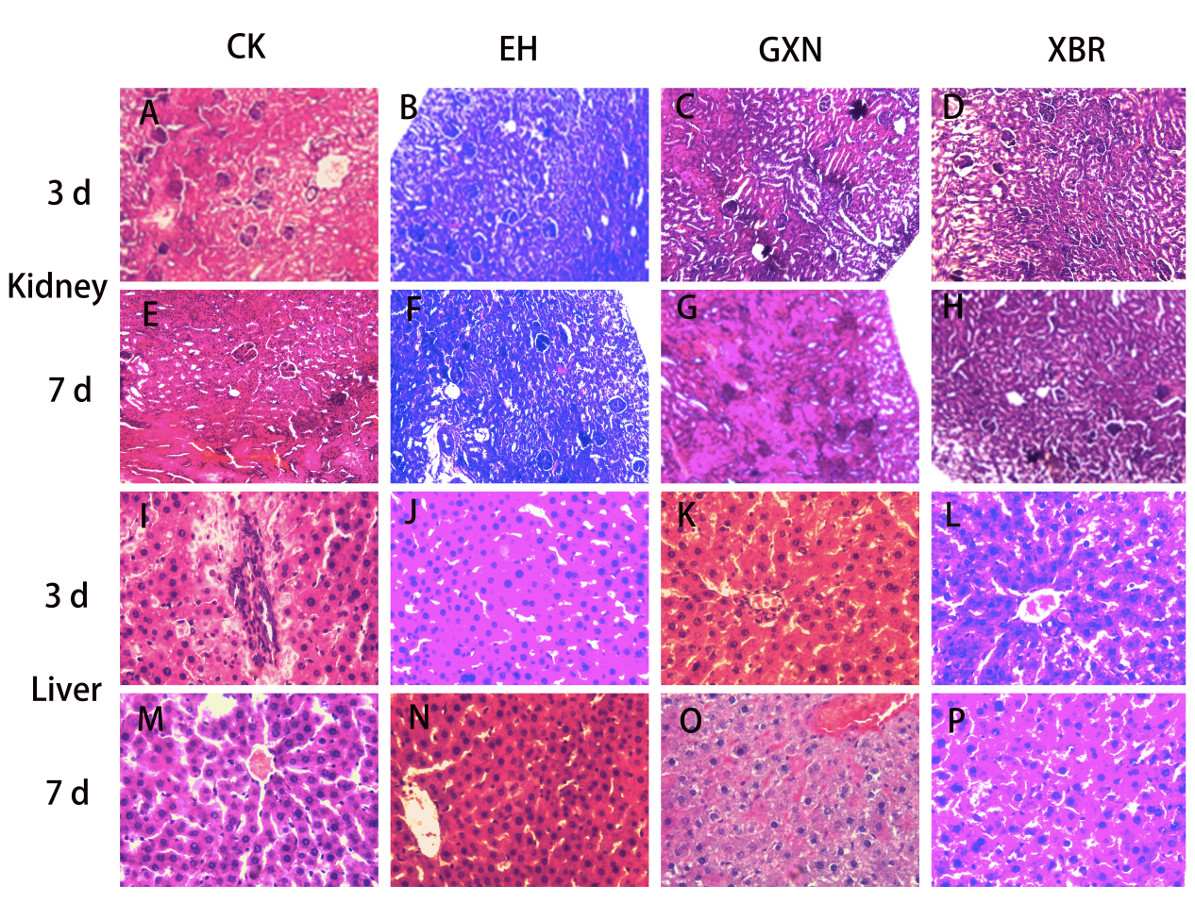
Fig. S2. Kidney and liver histologic sections of endometrial hyperplasia rats. (A, B, C, D) Three-day intragastrically treated rat kidney. (Paraffin section, H&E. 10 X) (E, F, G, H) Images of rat kidney after 7 d of gavage. (Paraffin section, H&E. 10 X). (I, J, K, L) Three-day intragastrically treated rat liver. (Paraffin section, H&E. 40 X). (M, N, O, P) Images of rat liver after 7 d of gavage (Paraffin section, H&E. 40 X).

