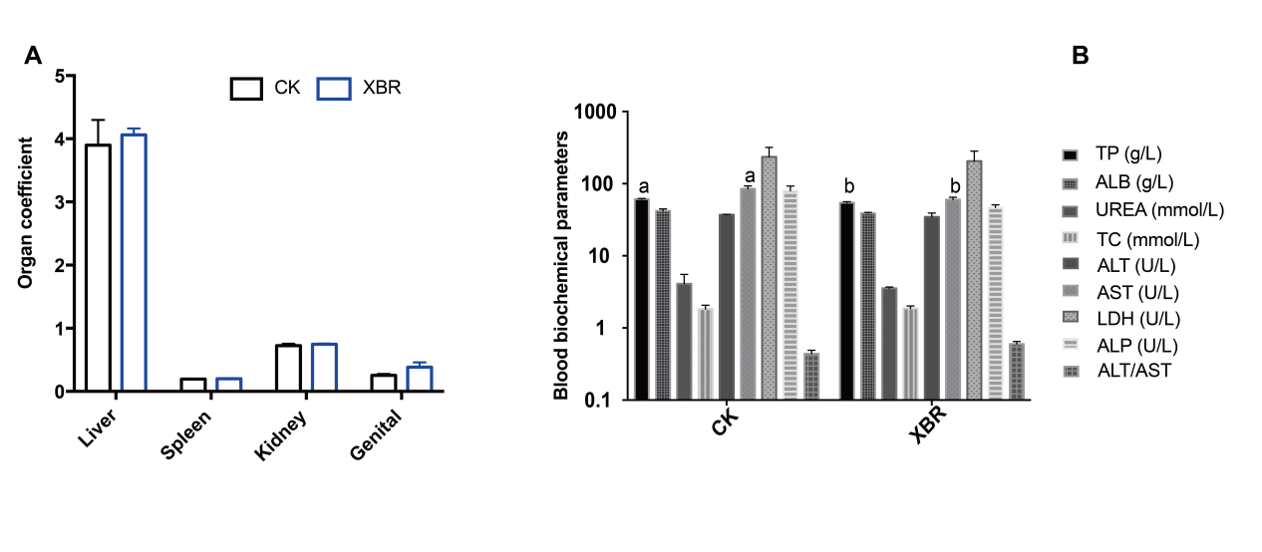
Figure S1. Five-dose of XBR exhibits no adverse impact on the SD rats. (A) Effects of XBR medication on organ coefficients. (B) The alterations of blood biochemical parameters under the gavage of XBR drug. Values are means ± SEM. ^{ab} Different superscripts or * asterisk indicate the significant difference (p < 0.05, t-Student test, n=4).

