Supplementary materials
Cu-Co bimetallic organic framework heterostructure as effective adsorbents for removal of tetracycline and doxycycline antibiotics
Jiayuan Yueª, # Shushu Ding^{a, b},# Yujian Yinª, Xiaodan Zhangª, Liyun Wangª, Yipeng Guª, Jiejia Li^{c}, Yuhan Zhangª, Yurou Shiª, Yuetan Dongª, Qing Zhu^{a, b*}, Huixiao Duo^{a, b*}
ªSchool of Pharmacy, Nantong University, Nantong 226001, Jiangsu, China
^{b}Provincial Key Laboratory of Inflammation and Molecular Drug Target, Nantong 226001, Jiangsu, China
^{c}Affiliated Hospital 2 of Nantong University, Nantong 226001, Jiangsu, China
E-mail: zhuqing@ntu.edu.cn (Qing Zhu); duohuixiao@ntu.edu.cn (Huixiao Duo)

#These two authors contributed equally to this work.
*Corresponding authors
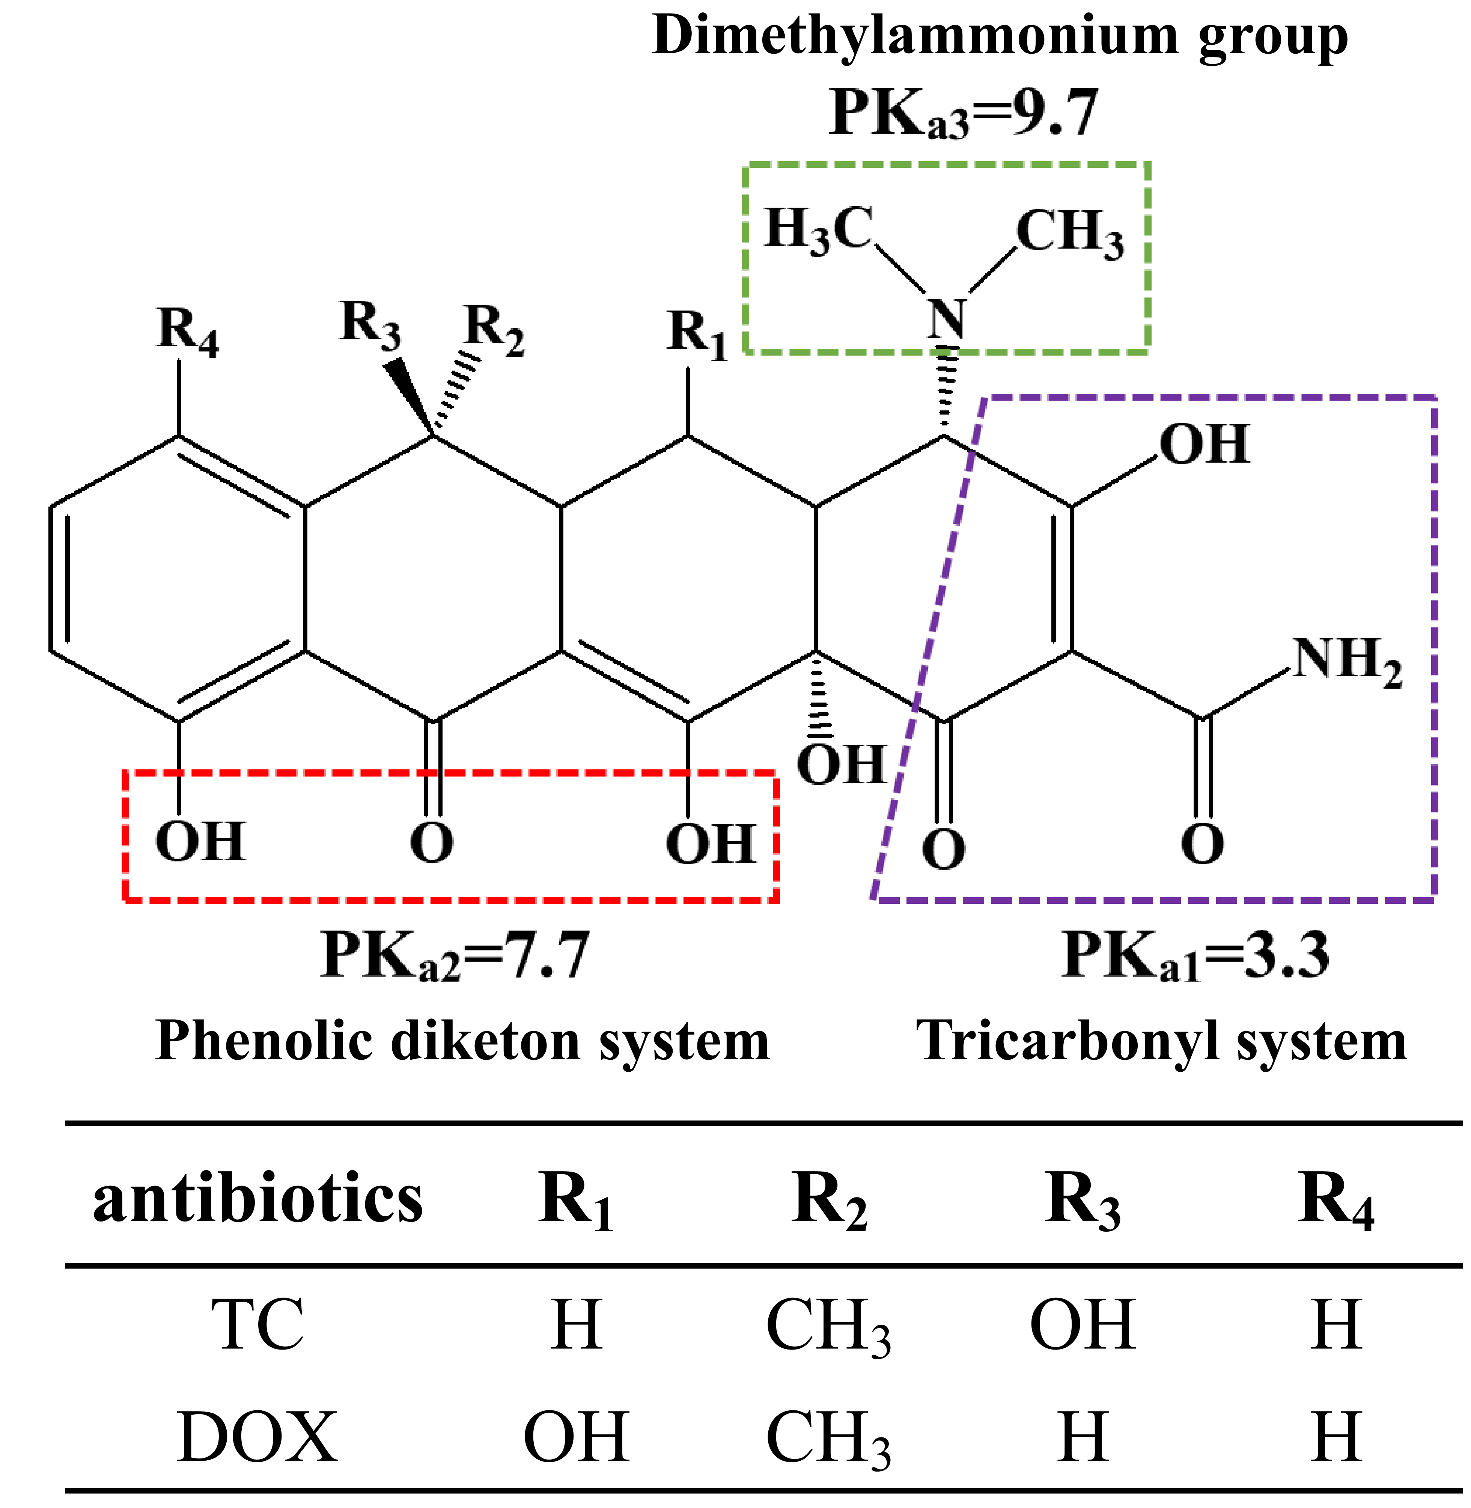
Fig. S1. Structure of tetracycline (TC) and doxycycline (DOX) molecule.
Fig. S2. SEM images of Co-MOF.
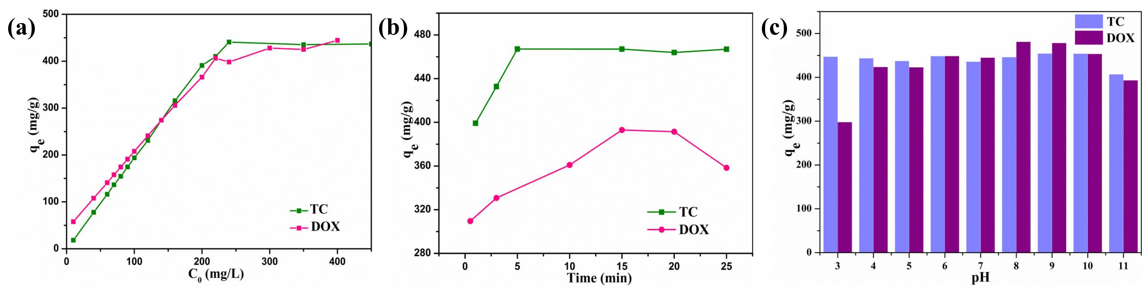
Fig. S3. Effects of adsorption conditions on the adsorption capacity of TCs: (a) initial concentration; (b) adsorption time; (c) pH.
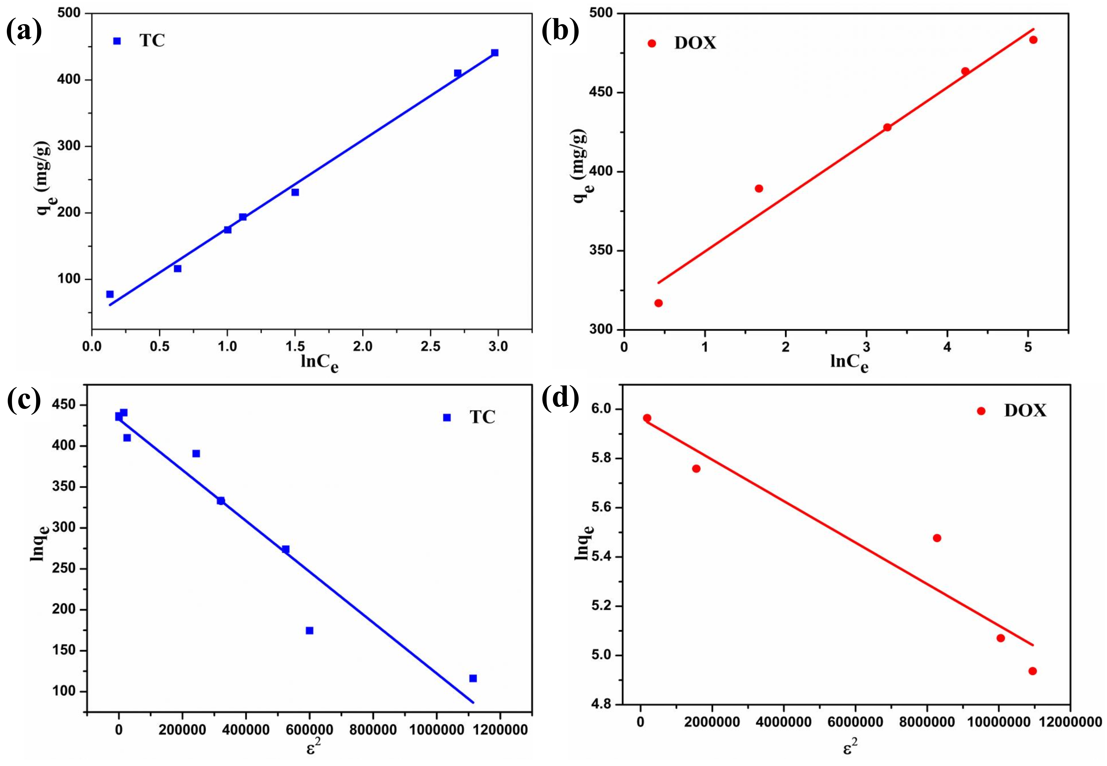
Fig. S4. Isotherms fitting curves for (a, b) Temkin; (c, d) Dubinbin-Radushkevich.
Fig. S5. Intra-particle diffusion kinetic models fitting curves of TCs adsorption by Cu-MOF@Co-MOF.
Fig. S6. Adsorption thermodynamics of Cu-MOF@Co-MOF.

