Supplementary figures and figure legends
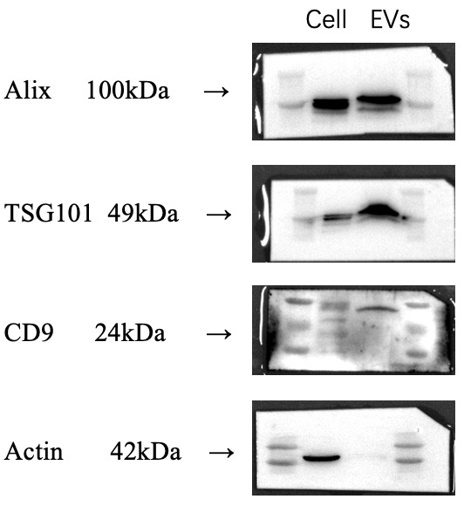

Supplementary Figure 1. Full length gels of three independent western blots for Fig. 1C. MSC-EVs were collected for western blot. Lane 1: MSCs; Lane 2:MSC-EVs;

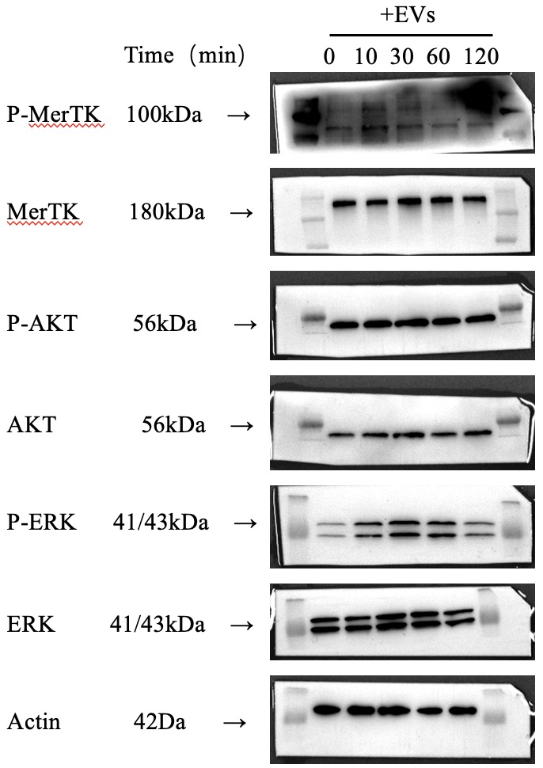

Supplementary Figure 2. Full length gels of three independent western blots for Fig. 5B. BMDMs pretreated with MSC-EVs for 0, 10, 30, 60, and 120 minutes. The cells were collected for western blot. Lane 1: 0 min; Lane 2: 10 min; Lane 3: 30 min; Lane 4: 60 min; Lane 5: 120 min.

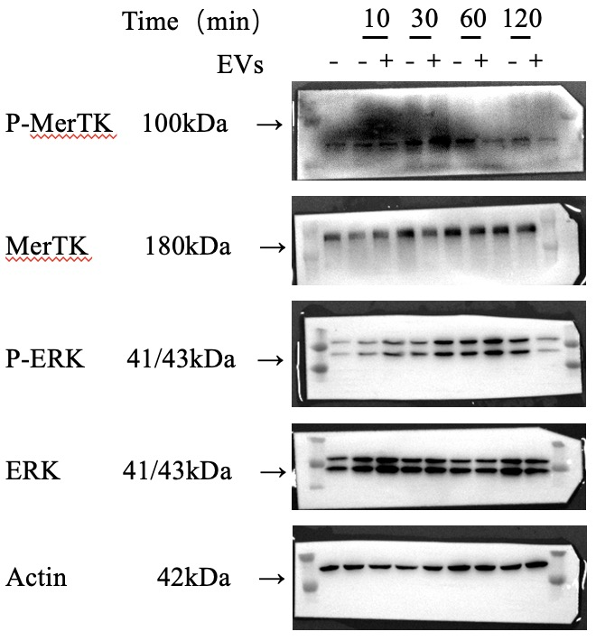

Supplementary Figure 3. Full length gels of three independent western blots for Fig. 5E. BMDMs pretreated or not with MSC-EVs for 120 minutes, then co-cultured with ACs for 0, 10, 30, 60, and 120 minutes and the cells were collected for western blot. Lanes as shown in the picture.

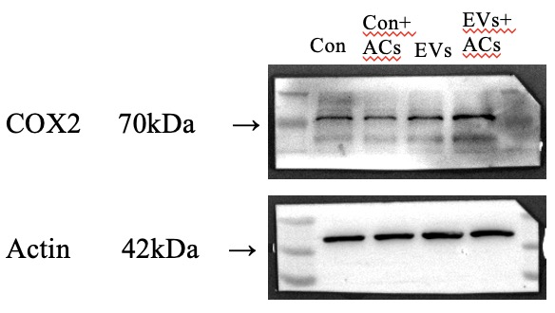

Supplementary Figure 4. Full length gels of three independent western blots for Fig. 5F. Lane 1: con; Lane 2: con+ ACs; Lane 3: EVs; Lane 4: EVs+ ACs.

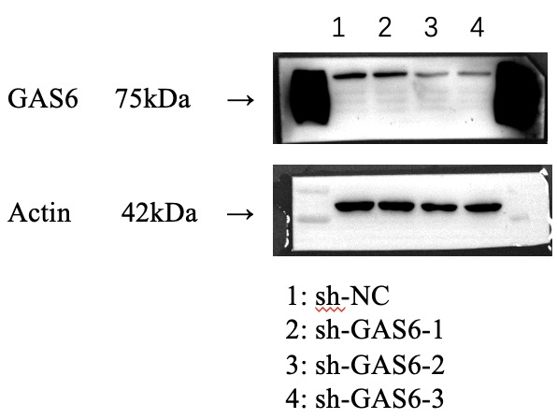

Supplementary Figure 5. Full length gels of three independent western blots for Fig. 6A. MSCs transfected by GAS6-specific lentivirus and the cells were collected for western blot. Lane 1: sh-NC group; Lane 2: sh-GAS6-1 group; Lane 3: sh-GAS6-2 group; Lane 4: sh-GAS6-3 group.

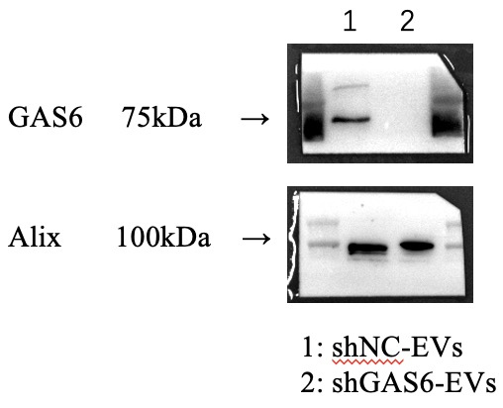

Supplementary Figure 6. Full length gels of three independent western blots for Fig. 6B. MSCs transfected by GAS6-specific lentivirus and the MSC-EVs were collected for western blot. Lane 1: shNC-EVs group; Lane 2: shGAS6-EVs group.

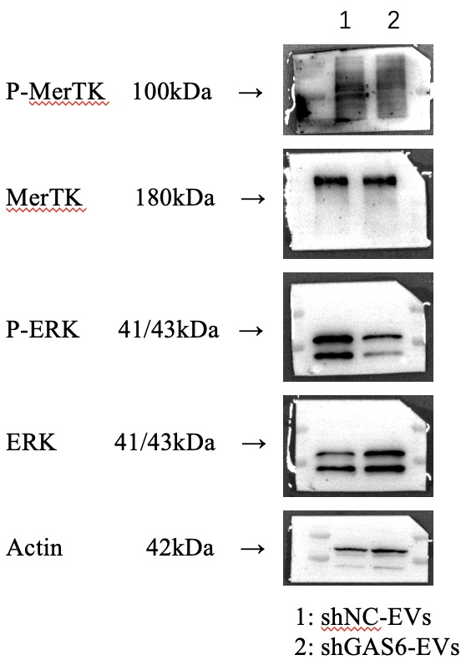

Supplementary Figure 7. Full length gels of three independent western blots for Fig. 6D. BMDMs pretreated with shNC-EVs or shGAS6-EVs for 120 minutes. The cells were collected for western blot. Lane 1: shNC-EVs; Lane 2: shGAS6-EVs.

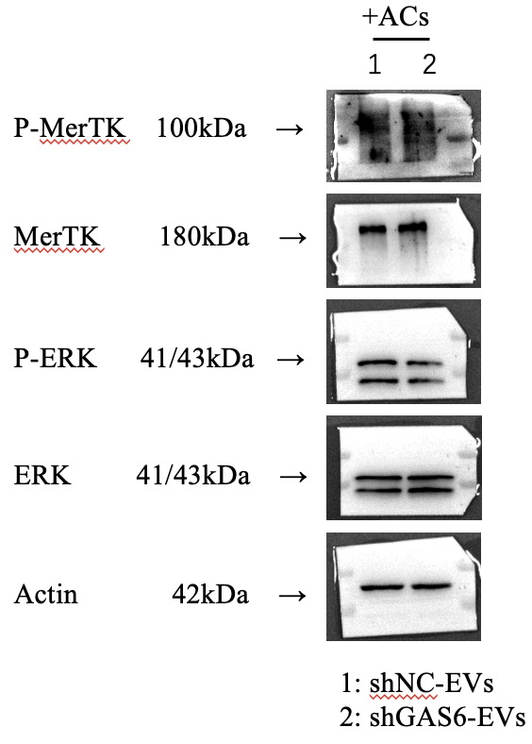

Supplementary Figure 8. Full length gels of three independent western blots for Fig. 6E. BMDMs pretreated with shNC-EVs or shGAS6-EVs, then co-cultured with ACs for 30 minutes and the cells were collected for western blot. Lanes as shown in the picture.

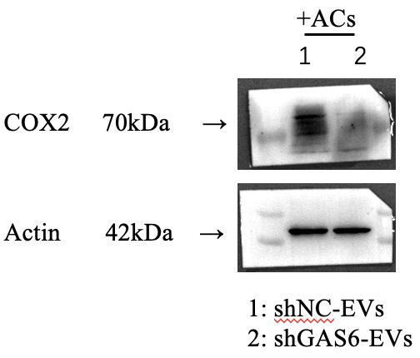

Supplementary Figure 9. Full length gels of three independent western blots for Fig. 6F. BMDMs pretreated with shNC-EVs or shGAS6-EVs, then co-cultured with ACs for 45 minutes, cells were collected 6 hours after removed the ACs.
Lane 1: shNC-EVs+ACs; Lane 2: shGAS6-EVs+ ACs.

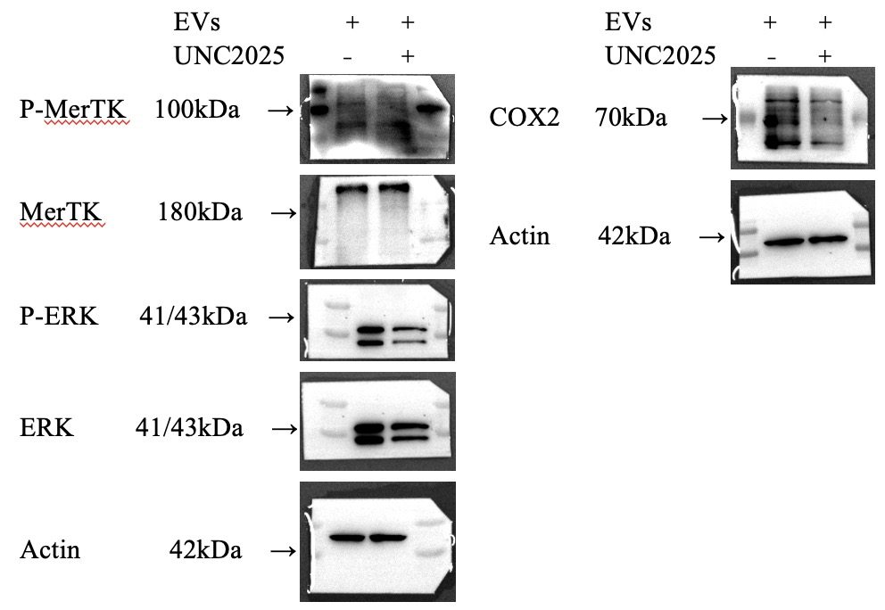

Supplementary Figure 10. Full length gels of three independent western blots for Fig. 7B. BMDMs pretreated with or without UNC2025 in the presence of MSC-EVs. Lanes as shown in the picture.

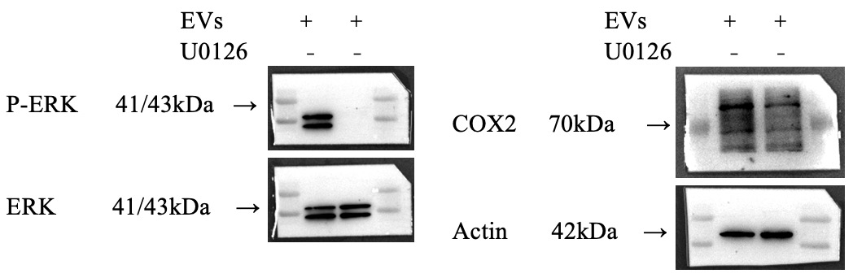

Supplementary Figure 11. Full length gels of three independent western blots for Fig. 7E. BMDMs treated with or without the ERK inhibitor U0126 in the presence of MSC-EVs. Lanes as shown in the picture.

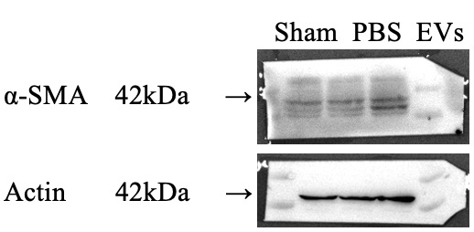

Supplementary Figure 12. Full length gels of three independent western blots for Fig. 8E. HIRI mice treated with PBS or MSC-EVs, and liver tissues were collected for western blot. Lane 1: sham group (a midline laparotomy incision without blocking blood); Lane 2: PBS group (PBS injected by tail vein); Lane 3: MSC-EVs group (MSC-EVs injected by tail vein).

Abbreviations
Table 1. Abbreviations
Abbreviations
AC  ALT  AST  α-SMA  BMDMs  BMMSCs  BP  CC  C-caspase 3  COX2  COL1A1  CXCL1  ELISA  ERK  GAS6  GO  H&E  HIRI  HNF4α  IL-1β  IL-17  KEGG  LC-MS/MS  MCP-1  M-CSF  MerTK  MF  MSC-EVs  NTA  PBS  TNF-α  TEM  TGF-β | apoptotic cell  alanine aminotransferase  aspartate aminotransferase  Alpha-smooth muscle actin  bone marrow-derived macrophages  bone marrow-derived mesenchymal stromal cells  biological processes  cellular compartments  Cleaved-caspase 3  cyclooxygenase 2  collagen type I alpha 1 chain  C-X-C motif chemokine ligand 1  Enzyme linked immunosorbent assay  extracellular regulated protein kinases  growth arrest-specific 6  Gene ontology  hematoxylin-eosin staining  Hepatic ischaemia-reperfusion injury  Hepatocyte Nuclear Factor 4 Alpha  Interleukin-1beta  Interleukin-17  kyoto encyclopedia of genes and genomes  Liquid Chromatograph Mass Spectrometer  monocyte chemoattractant protein-1  macrophage colony-stimulating factor  myeloid-epithelial-reproductive tyrosine kinase  molecular functions  extracellular vesicles derived from mesenchymal stem cells  nanoparticle tracking analysis  phosphate buffer saline  tumor necrosis factor-alpha  transmission electron microscope  Transforming growth factor-beta
TUNEL  PGE2 | terminal deoxynucleotidyl transferase dUTP-biotin nick end labelling  Prostaglandin E2

Table 2. Gene-specific primers used in the RT-qPCR
Gene | Accession number | Primer sequences
m-GAPDH | NM_001289726.1 | Forward: GCCACCCAGAAGACTGTGGAT
 |  | Reverse: GGAAGGCCATGCCAGTGA
m-TNF-α | NM_013693.3 | Forward: ACAAGGCTGCCCCGACTAC
 |  | Reverse: TGGGCTCATACCAGGGTTTG
m-IL-1β | NM_008361.4 | Forward: CTTTCCCGTGGACCTTCCA
 |  | Reverse: CTCGGAGCCTGTAGTGCAGTT
m-IL-17 | NM_010552.3 | Forward: GACTCTCCACCGCAATGAAGAC
 |  | Reverse: CTCTTCAGGACCAGGATCTCTTG
m-CXCL1 | NM_008176.3 | Forward: CGCTTCTCTGTGCAGCGCTGCTGCT
 |  | Reverse: AAGCCTCGCGACCATTCTTGAGTC
m-MCP-1 | NM_011333.3 | Forward: CAGCAAGATGATCCCAATGAGTAG
 |  | Reverse: TTTTTAATGTATGTCTGGACCCATTC
m-TGF-β | NM_011577.2 | Forward: CAACAATTCCTGGCGTTACCTT
 |  | Reverse: CAAGAGCAGTGAGCGCTGAA
m-COL1A1 | NM_007742.4 | Forward: TGACTGGAAGAGCGGAGAGTACT
 |  | Reverse: TTCGGGCTGATGTACCAGTTC
m-α-SMA | NM_007392.3 | Forward: TGCCGAGCGTGAGATTGTC
 |  | Reverse: CGTTCGTTTCCAATGGTGATC
m-Ptgs2 | NM_011198.5 | Forward: CAACTCCATCCTCCTGGAACA
 |  | Reverse: TATTTCATCTCTCTGCTCTGGTCAA

