Supplementary materials
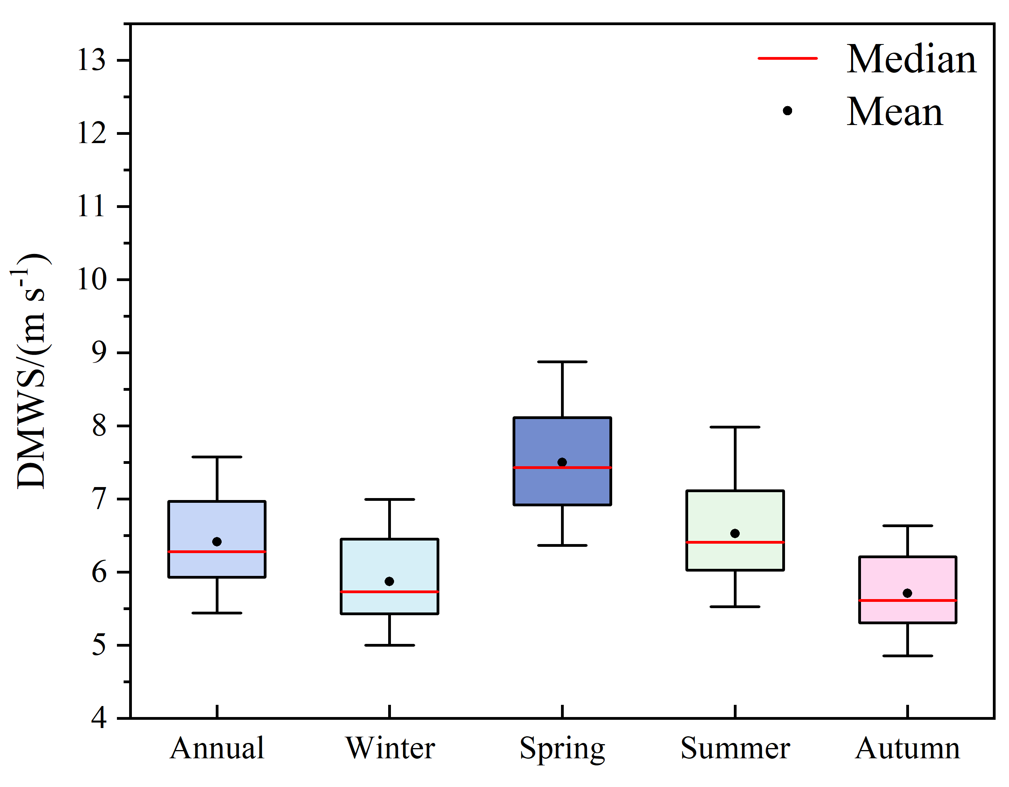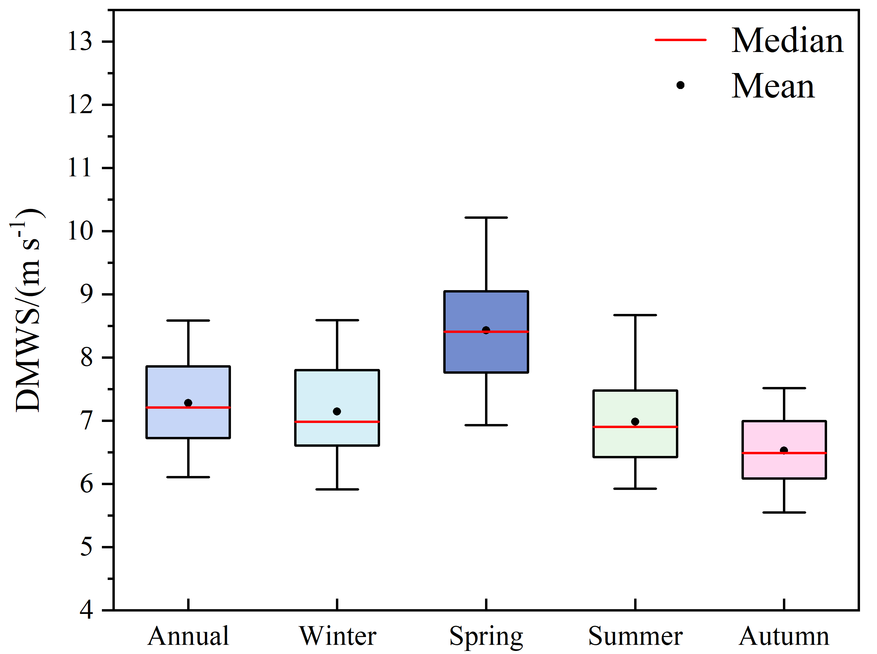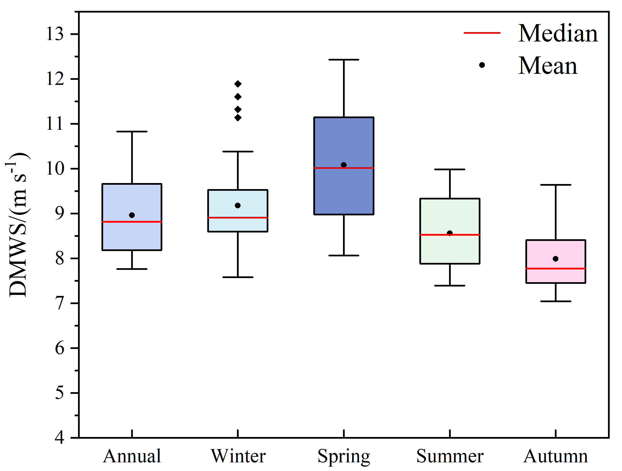
Fig. S1 Annual and seasonal box-whisker plot of DMWS (m s⁻¹) in the LES, MES and HES for 1973-2020. The mean dot (black dot), the median (red line), the maximum and minimum (whiskers), the 25th and 75th percentile range (boxes) and the abnormal value (black diamond) are represented, respectively.
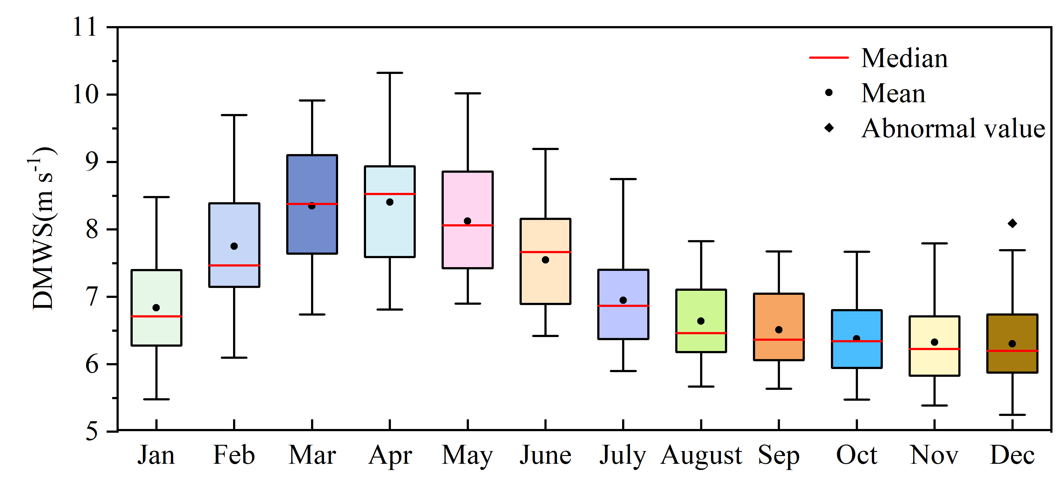
Fig. S2 Monthly Box-whisker Plot of DMWS(m s-1) for 104 homogenized stations in the TP for 1973-2020. The mean dot (black dot), the median (red line), the maximum and minimum (whiskers), the 25th and 75th percentile range (boxes) and the abnormal value (black diamond) are represented, respectively.
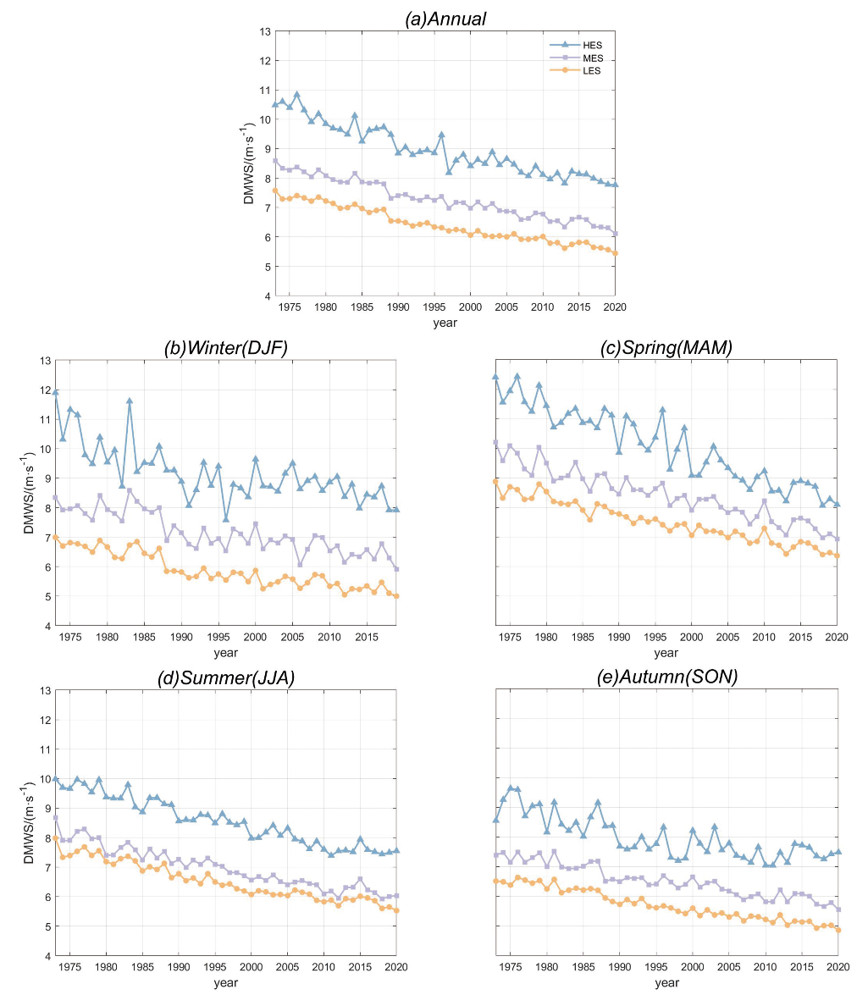
Fig. S3 Annual and seasonal near-surface DMWS at different elevations (HES, MES and LES) of the TP for 1973-2020.
Fig. S4 As for the Fig. S3, but at monthly basis.
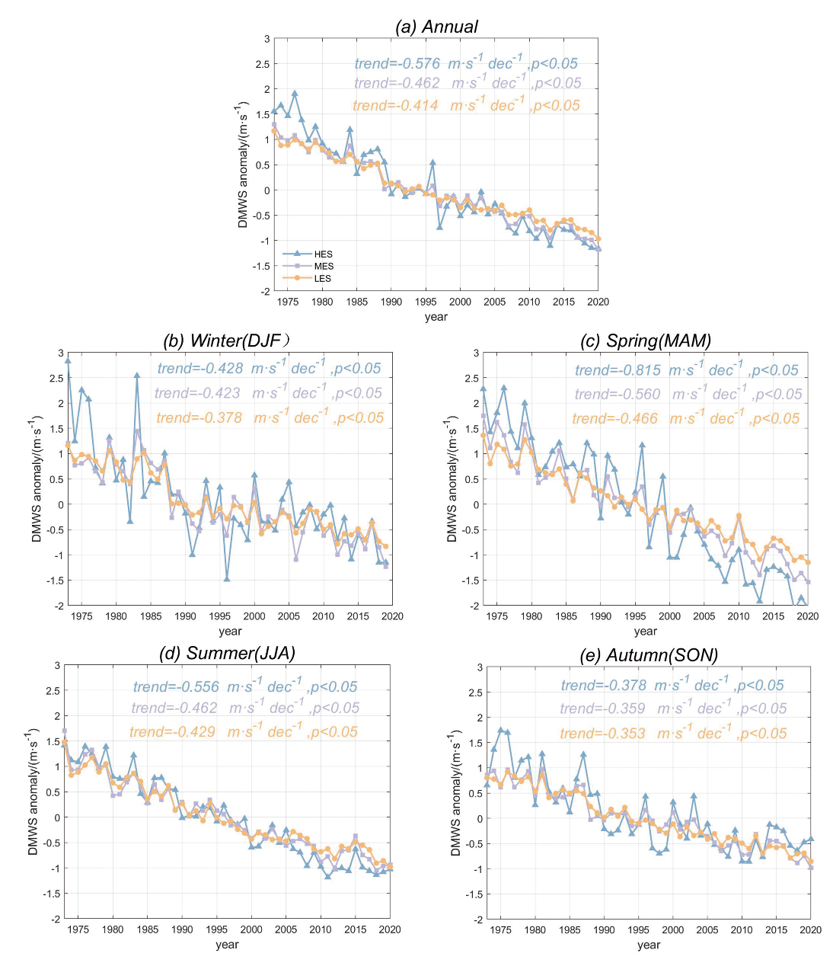
Fig. S5 Annual and seasonal trend of DMWS at the three elevation ranges over the TP for 1973–2020. The trend (in m s⁻¹dec⁻¹) and statistical significance (p-level) of the long-term trends are also displayed for each plot.

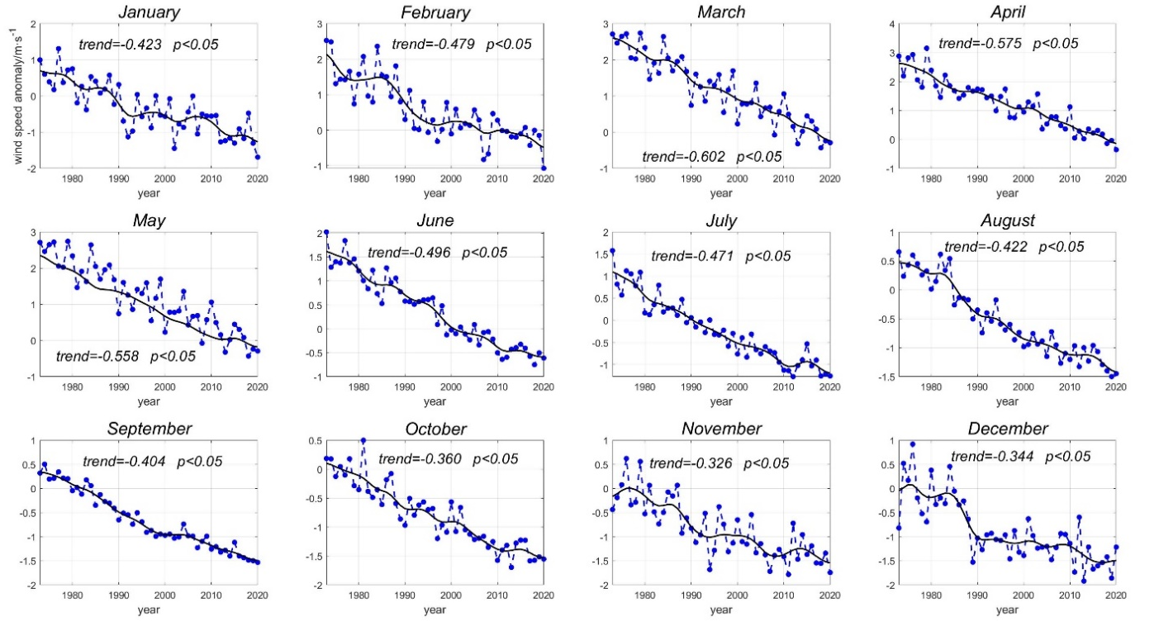
Fig. S6 Monthly DMWS magnitude over the Tibetan Plateau for 1973–2020. Wind speed anomalies of all stations (in m s⁻¹) were calculated as the deviation from the 1981–2010 mean. The black solid lines indicate the 11-year Gaussian low-pass filter. The magnitude (in m s⁻¹dec⁻¹) and statistical significance (p-level) of the long-term trends are also displayed for each plot.
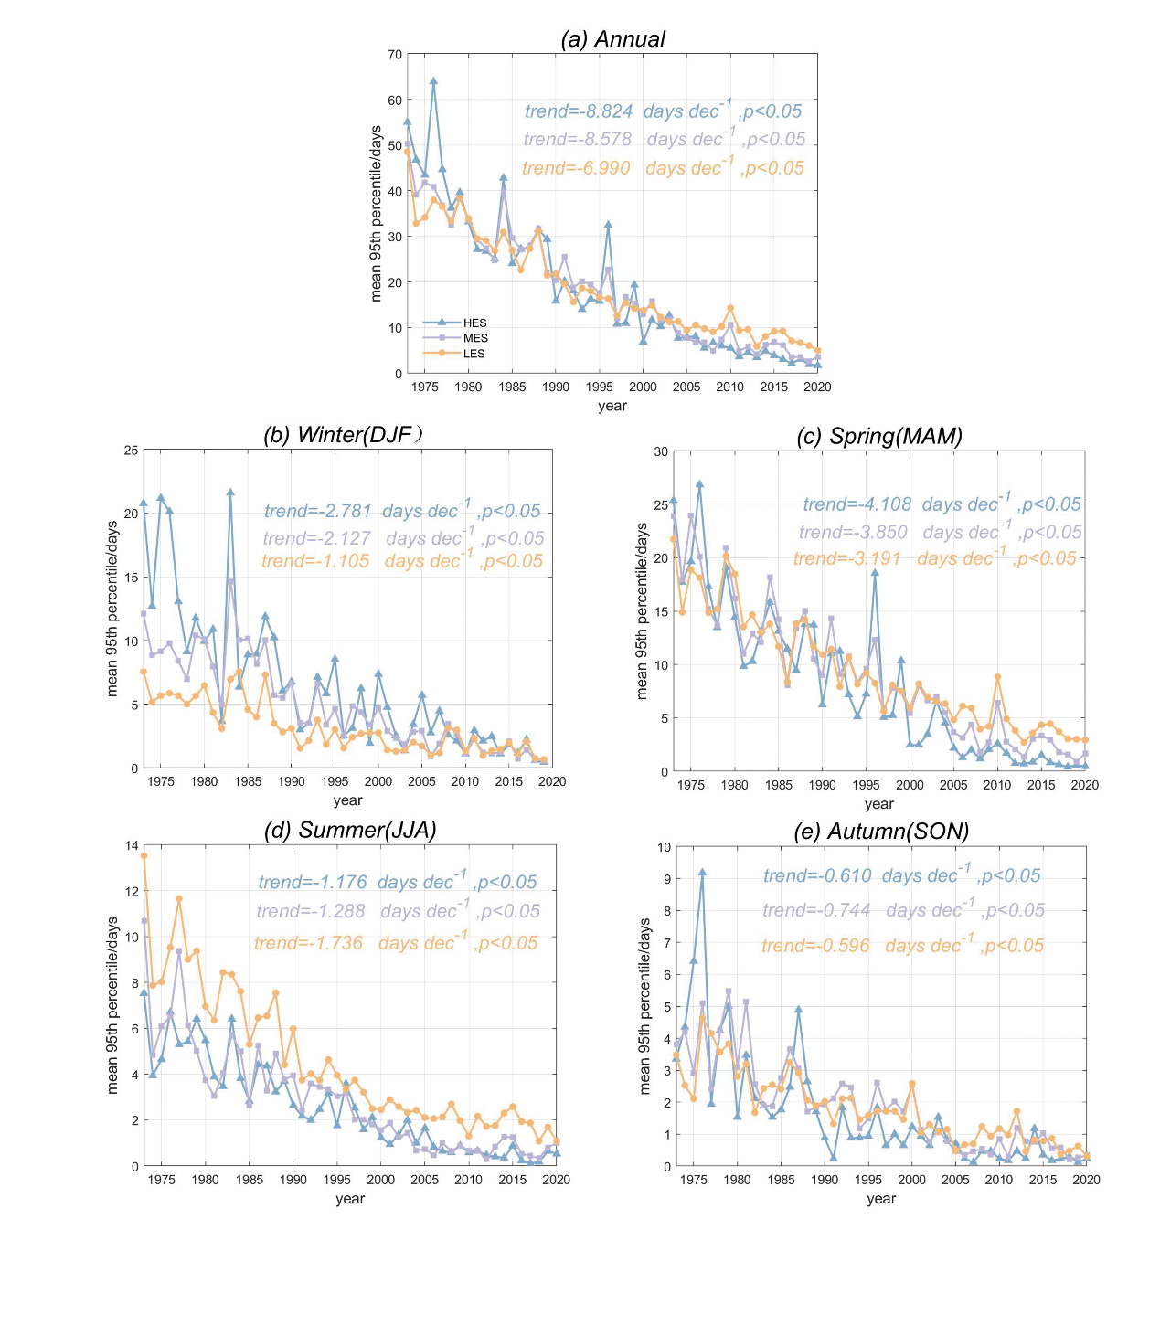
Fig. S7 As for Fig. S6, but for DMWS95 (in days dec⁻¹) in three elevations for 1973–2020.
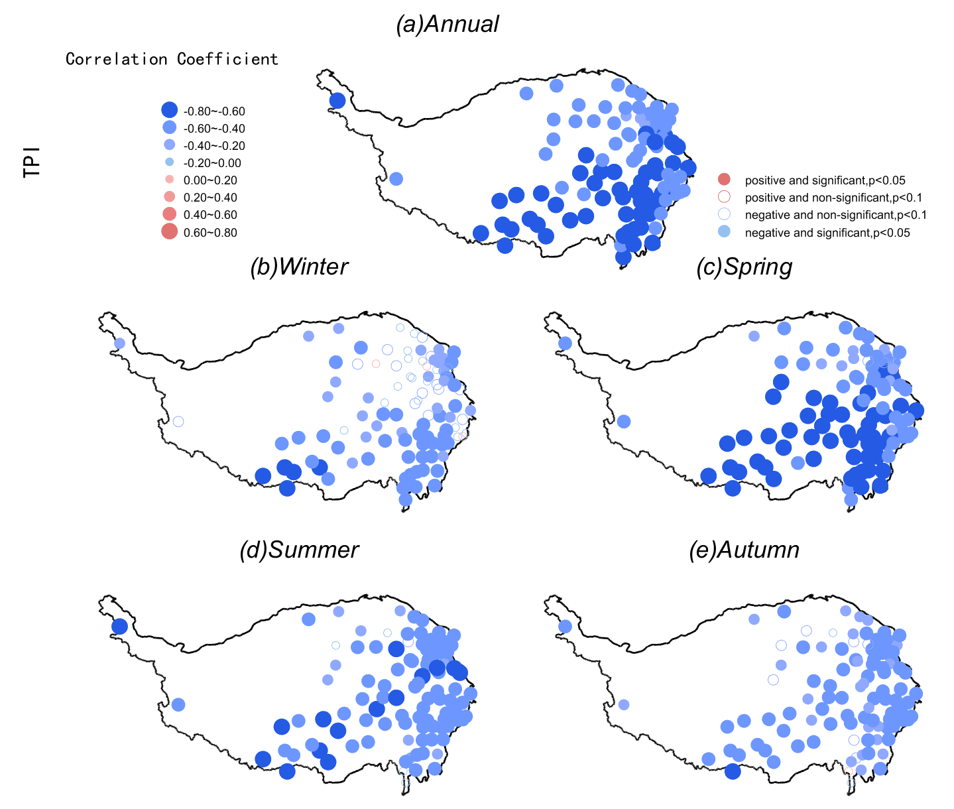
Fig. S8 Spatial distribution of the sign, magnitude, and significance of annual and seasonal correlation coefficients of DMWS anomalies and TPI in TP for 1973–2020.
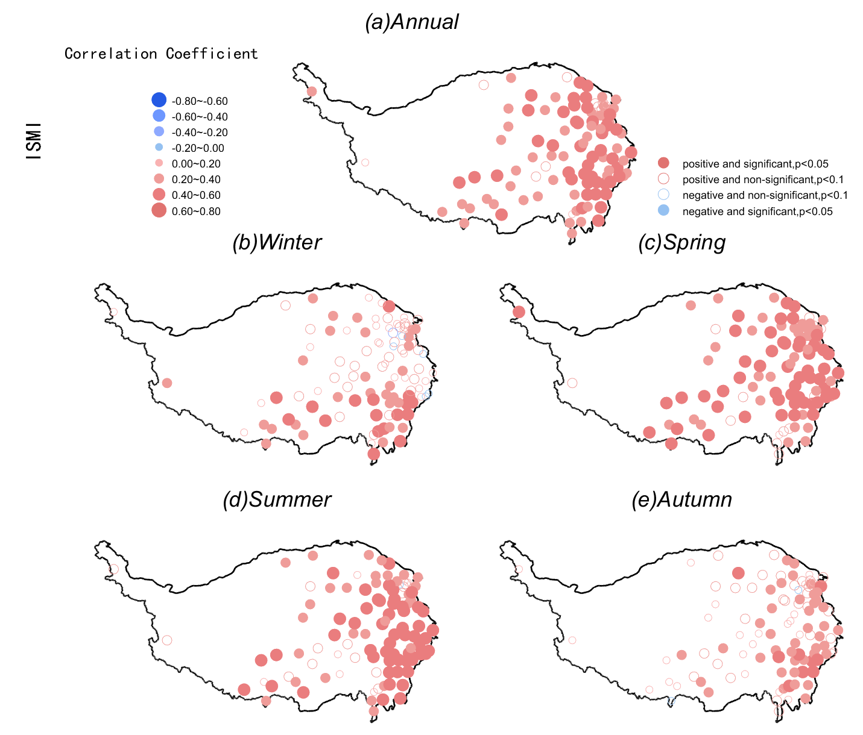
Fig. S9 As for the Fig. S8, but for the ISMI.
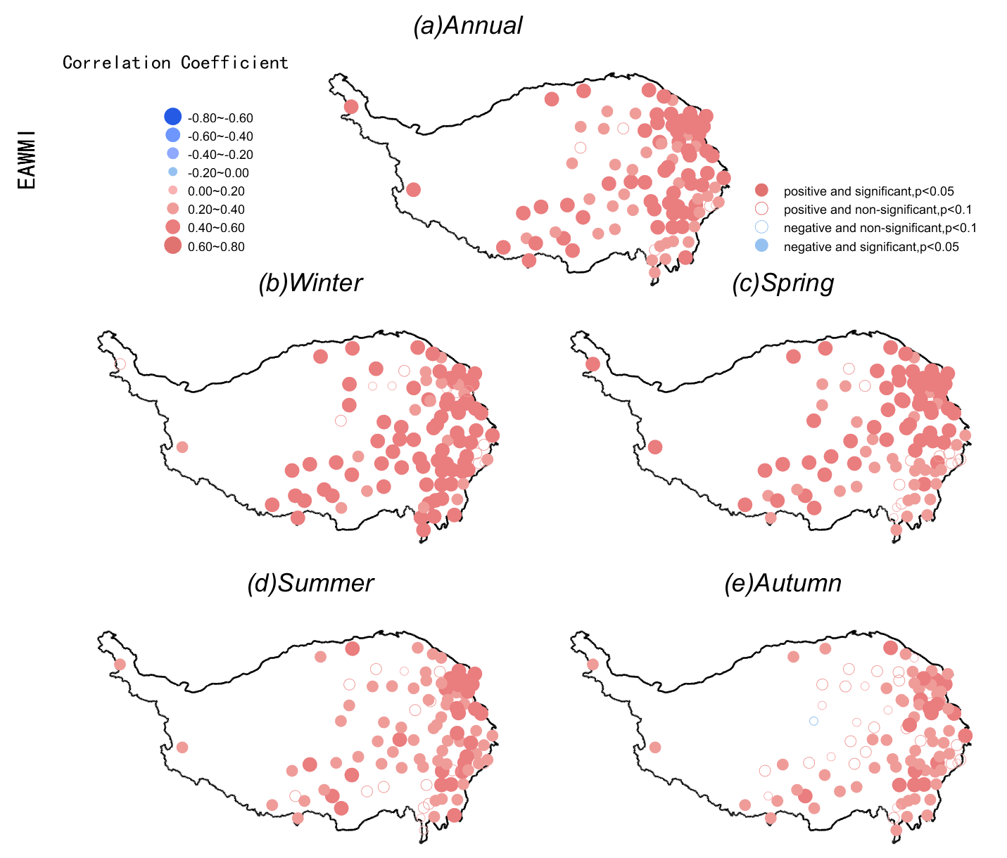
Fig. S10 As for the Fig. S8, but for the EAWMI.
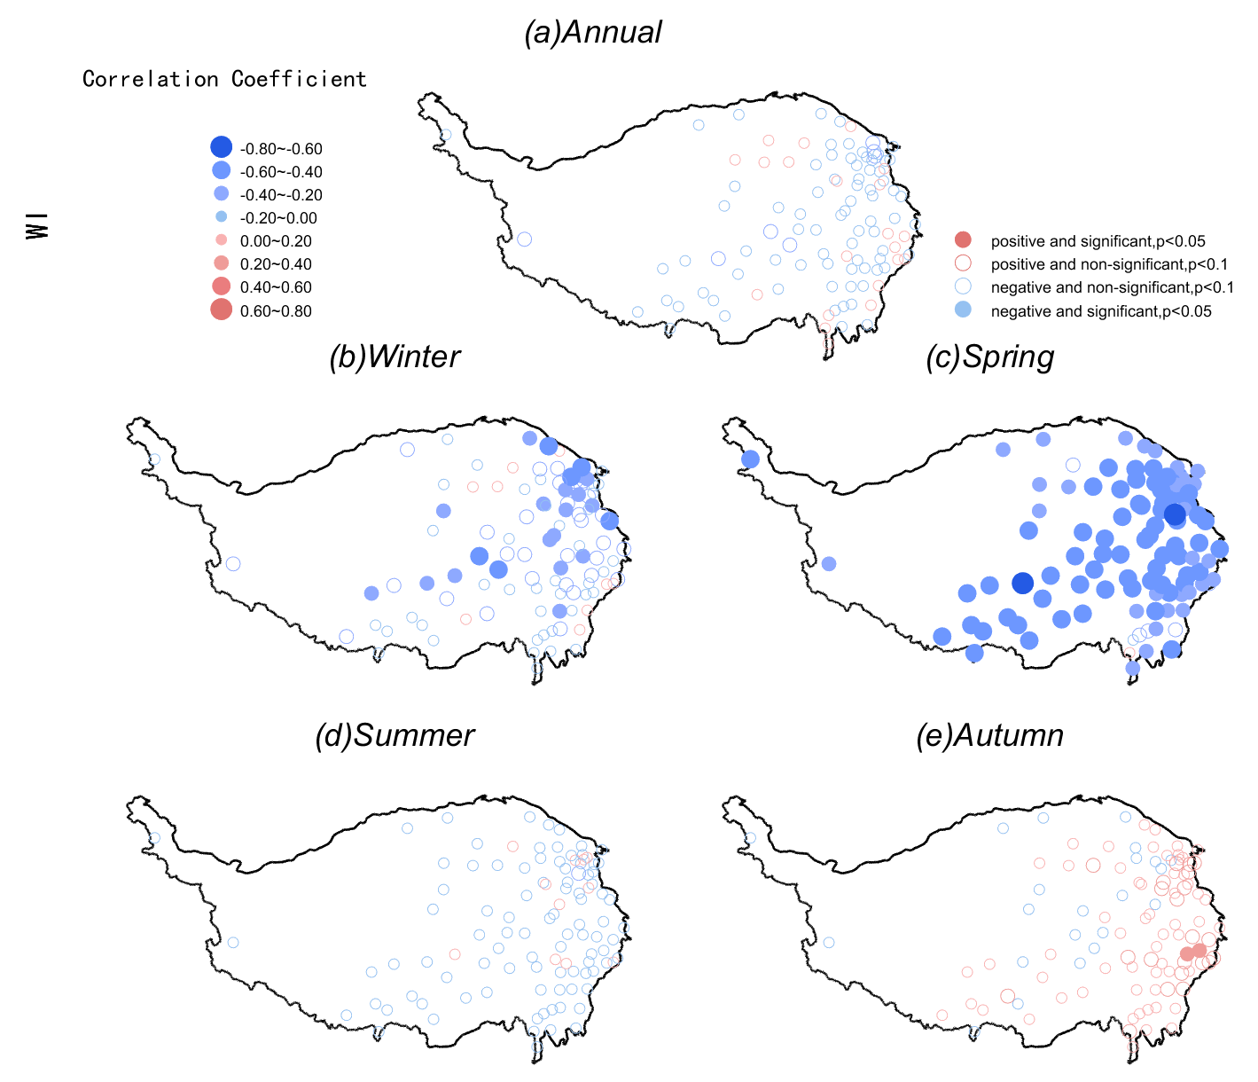
Fig. S11 As for the Fig. S8, but for the WI.
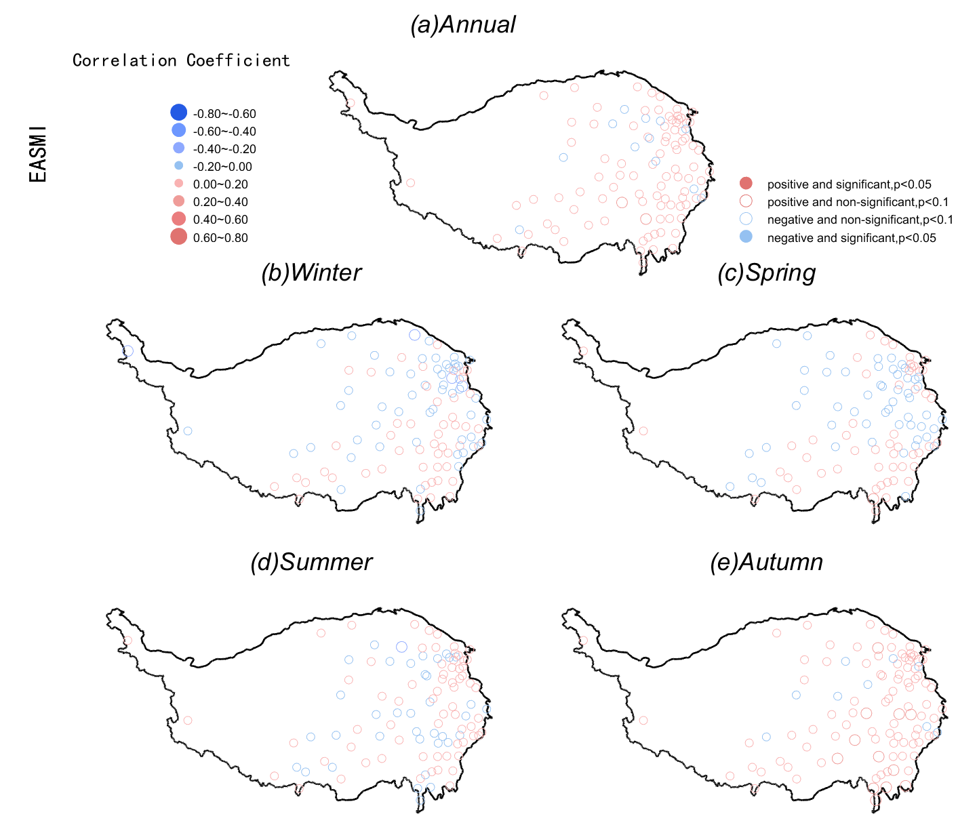
Fig. S12 As for the Fig. S8, but for the EASMI.
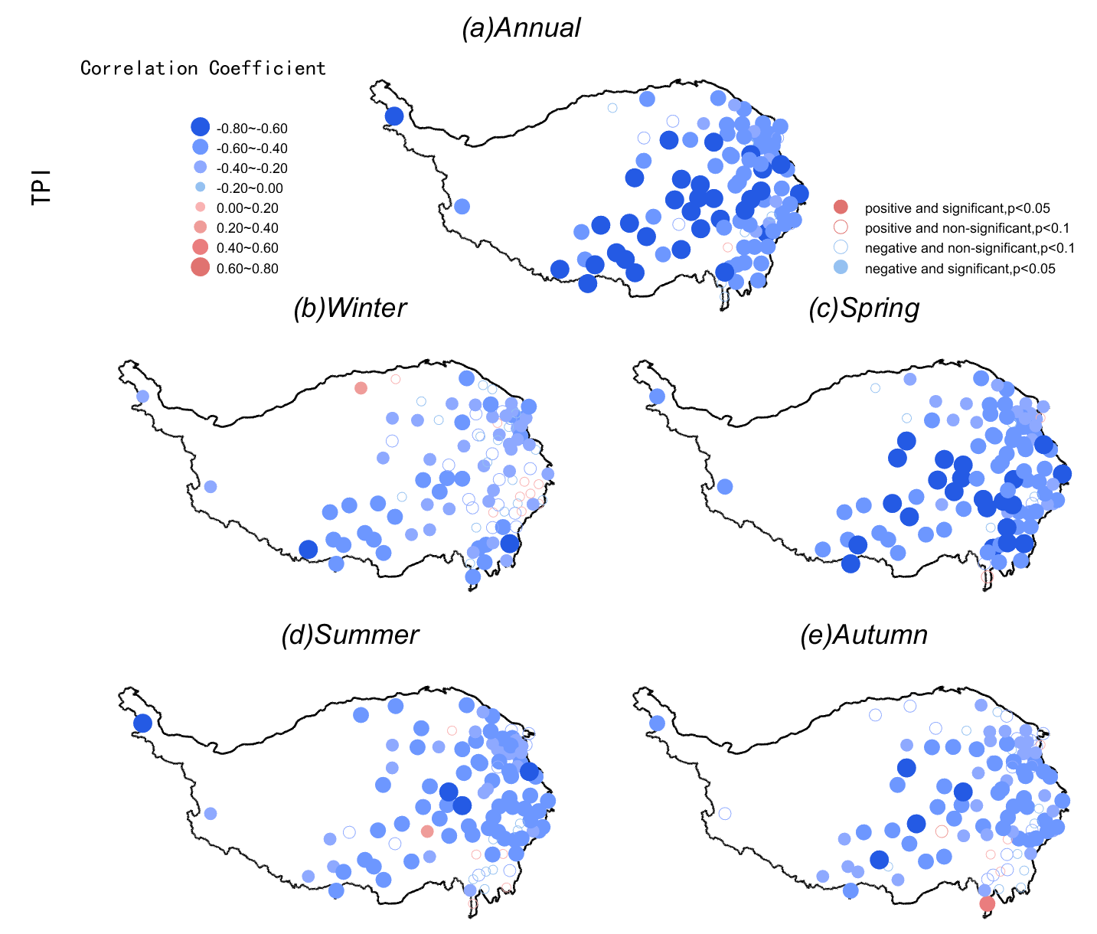
Fig. S13 As for the Fig. S8, but for DMWS95 and TPI.
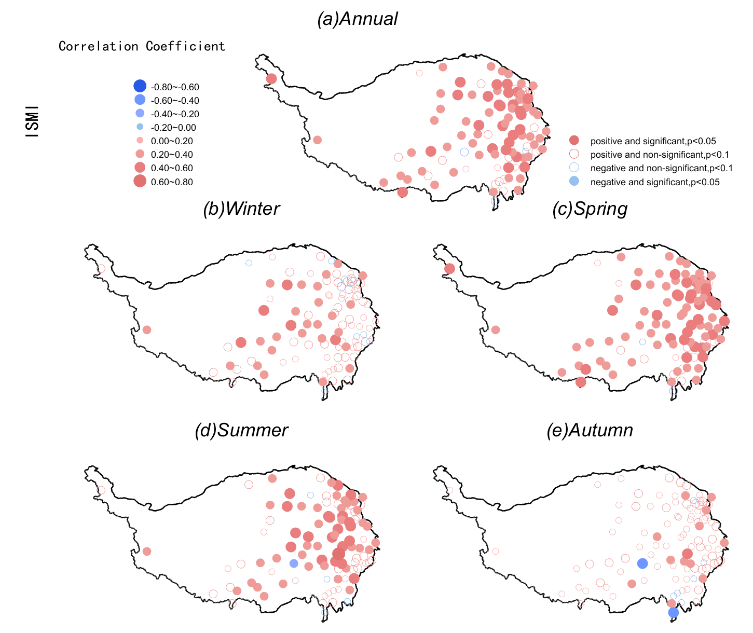
Fig.S 14 As for the Fig. S8, but for DMWS95 and ISMI.

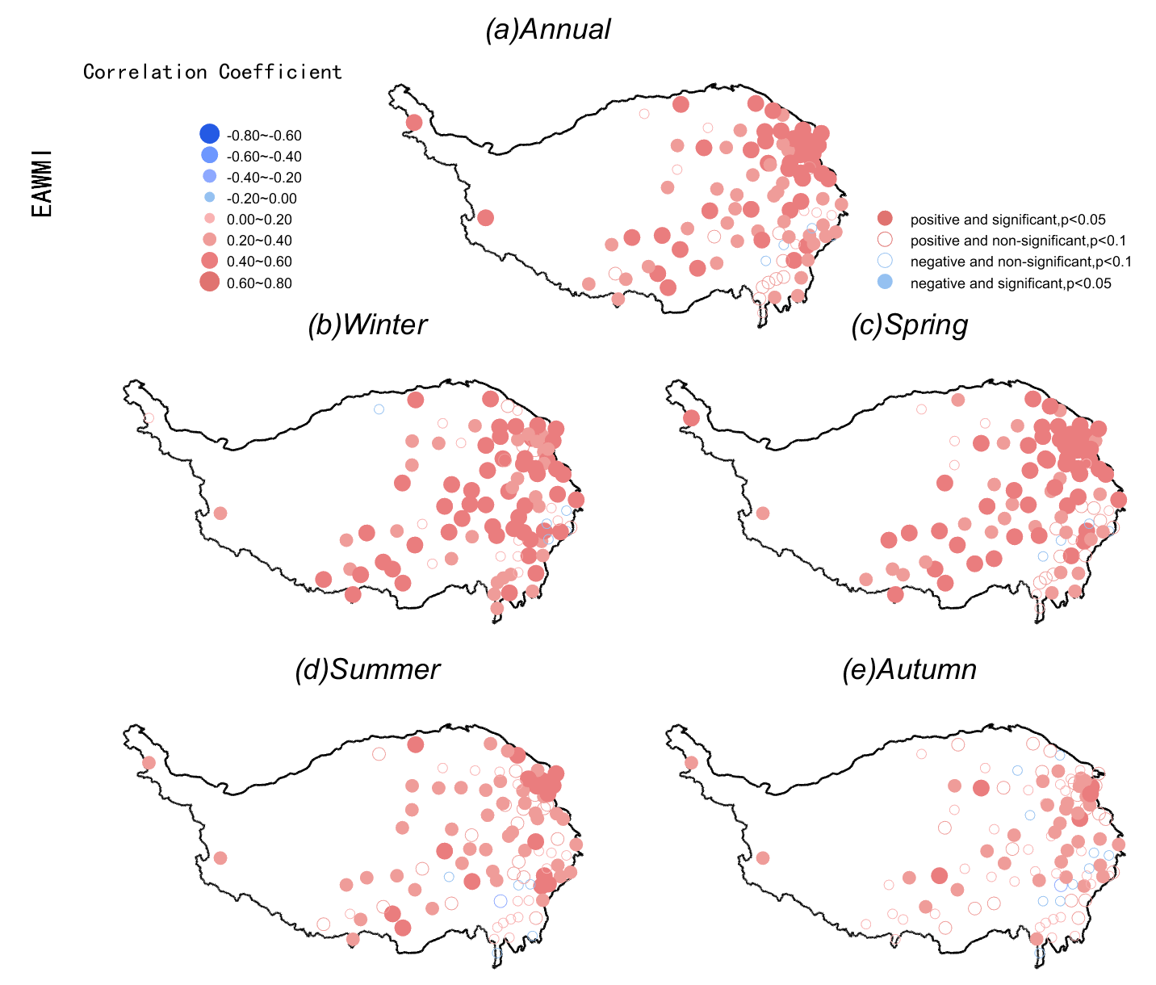
Fig. S15 As for the Fig. S8, but for DMWS95 and EAWMI.

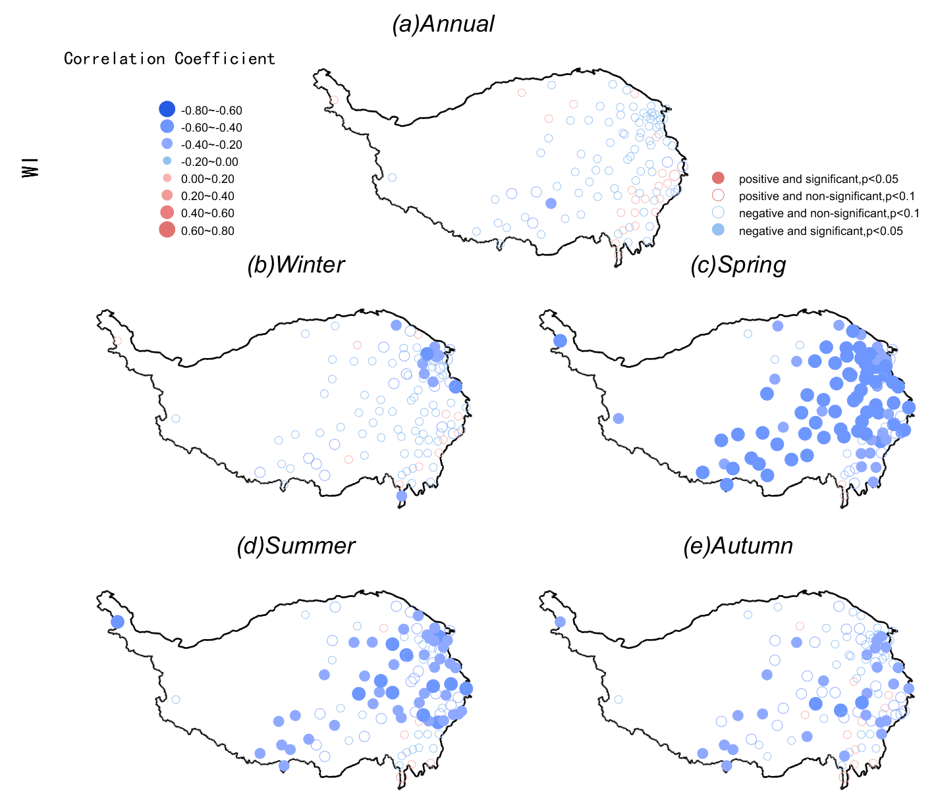
Fig. S16 As for the Fig. S8, but for DMWS95 and WI.
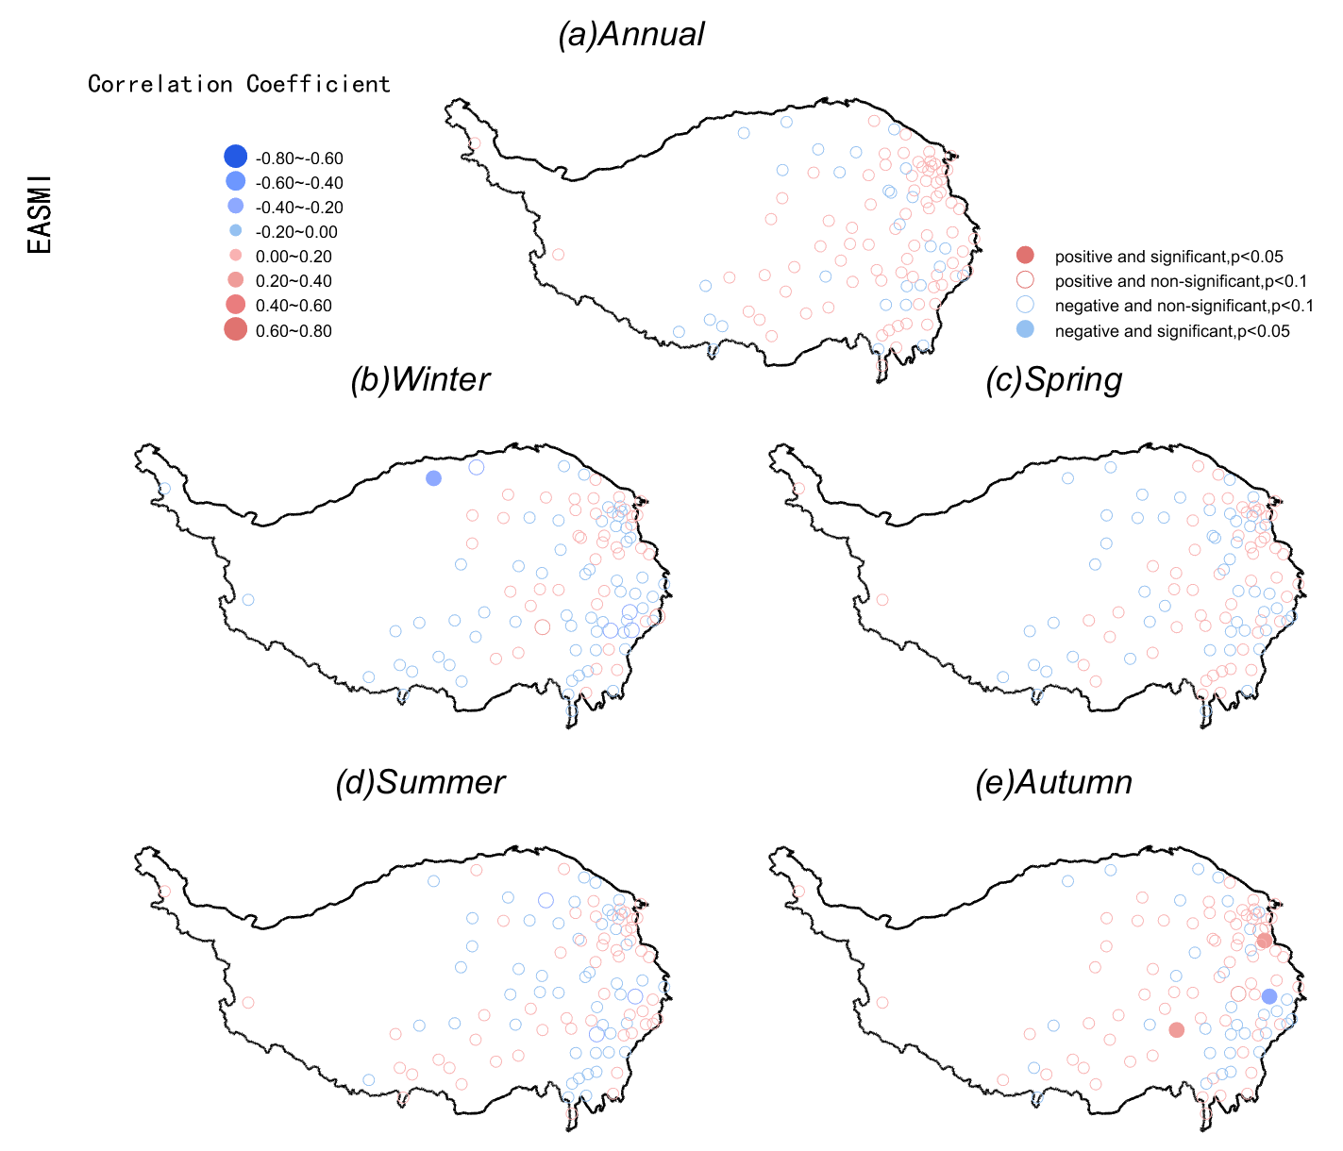
Fig. S17 As for the Fig. S8, but for DMWS95 and EASMI.
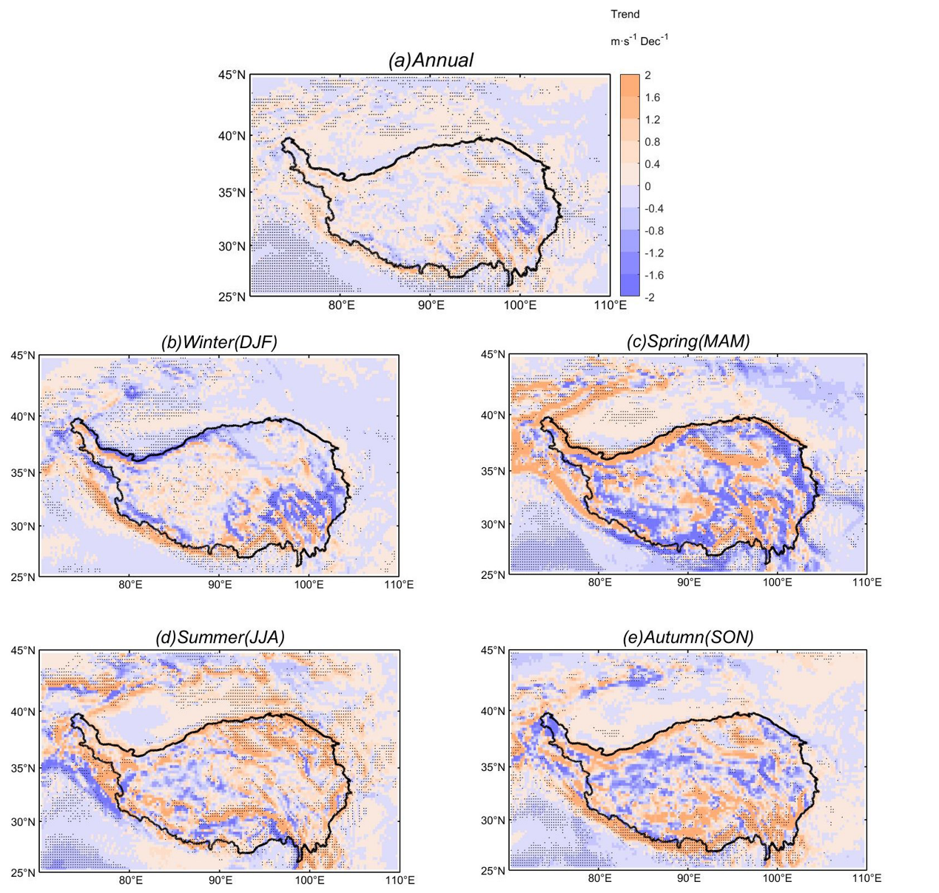
Figure. S18 Spatial distribution of annual and seasonal geostrophic wind speed trends (in m s⁻¹ dec⁻¹) at 850 hPa across the TP and surroundings for 1973–2020. A small black ‘‘·’’ represents a grid cell with a significant trend at p < 0.05.

