Novel multifibrillar carbon and oxidation-stable carbon/ceramic hybrid fibers consisting of thousands of individual nanofibers with high tensile strength
Jakob Denk,^{a,} Xiaojian Liao,^{b,*} Wolfgang Knolle,^{d} Axel Kahnt,^{d} Andreas Greiner,^{b} Stefan Schafföner,ª Seema Agarwal,^{b,c,*} and Günter Motz^{a,∗}
a Chair of Ceramic Materials Engineering, University of Bayreuth, Bayreuth 95440, Germany.
b Macromolecular Chemistry 2 and Bavarian Polymer Institute, University of Bayreuth, Bayreuth 95440, Germany
c Bavarian Center for Battery Technology (BayBatt), University of Bayreuth, Bayreuth 95440, Germany
d Leibniz Institute of Surface Engineering (IOM), Permoserstr. 15, 04318 Leipzig, Germany

Fig. S1 Chemical structure of Polyacrylonitrile PAN and the oligosilazane Durazane 1800
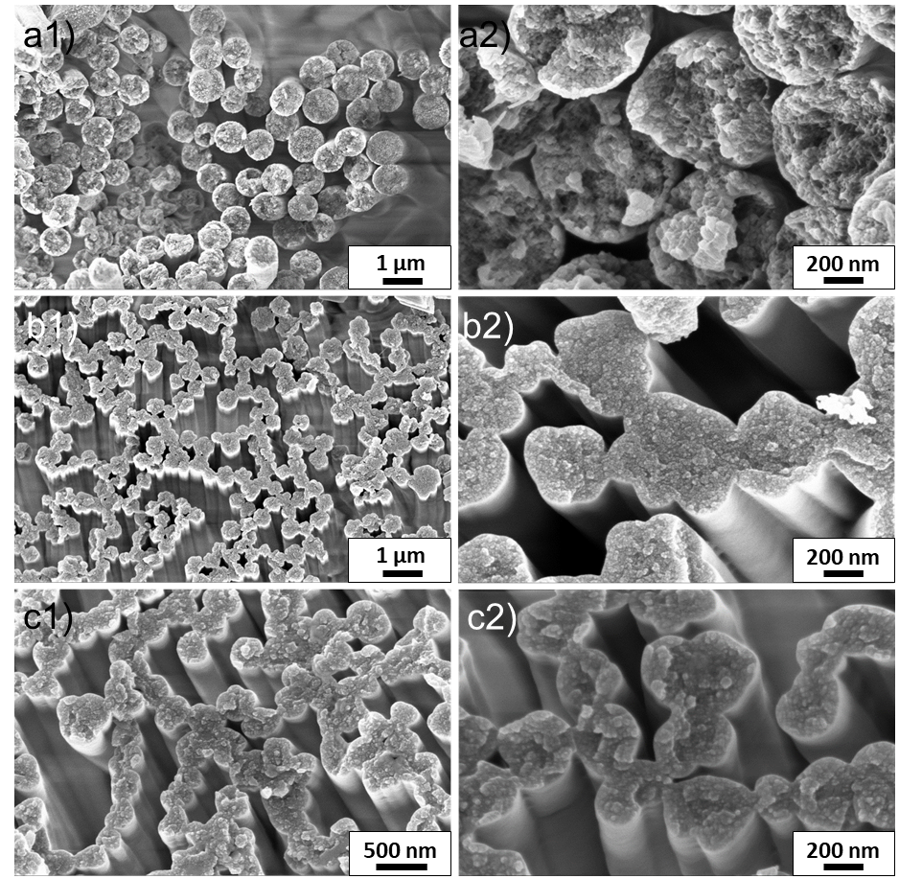
Fig. S2 SEM images of PAN multifibrillar fibers after a) soxhlet extraction in acetone, b) soxhlet extraction and oxidative stabilization at 250 °C and c) immersing in silicon oil and oxidative stabilization at 250 °C
Table S1 Peak location, onset and released energy of the crosslinking reaction of PAN with different catalysts.
Catalyst | Peak  [°C] | Energy  [J g⁻¹] | Peak Onset  [°C]
- | 310 | -1390 | 266
SnCl₂ | 285 | -635 | 167
ZnAc₂ | 292 | -756 | 205
SnF₂ | 312 | -720 | 266
Co(acac)₃ | 302 | -896 | 255
CoCl₂ | 293 | -716 | 246
CuAc₂ | 298 | -660 | 232

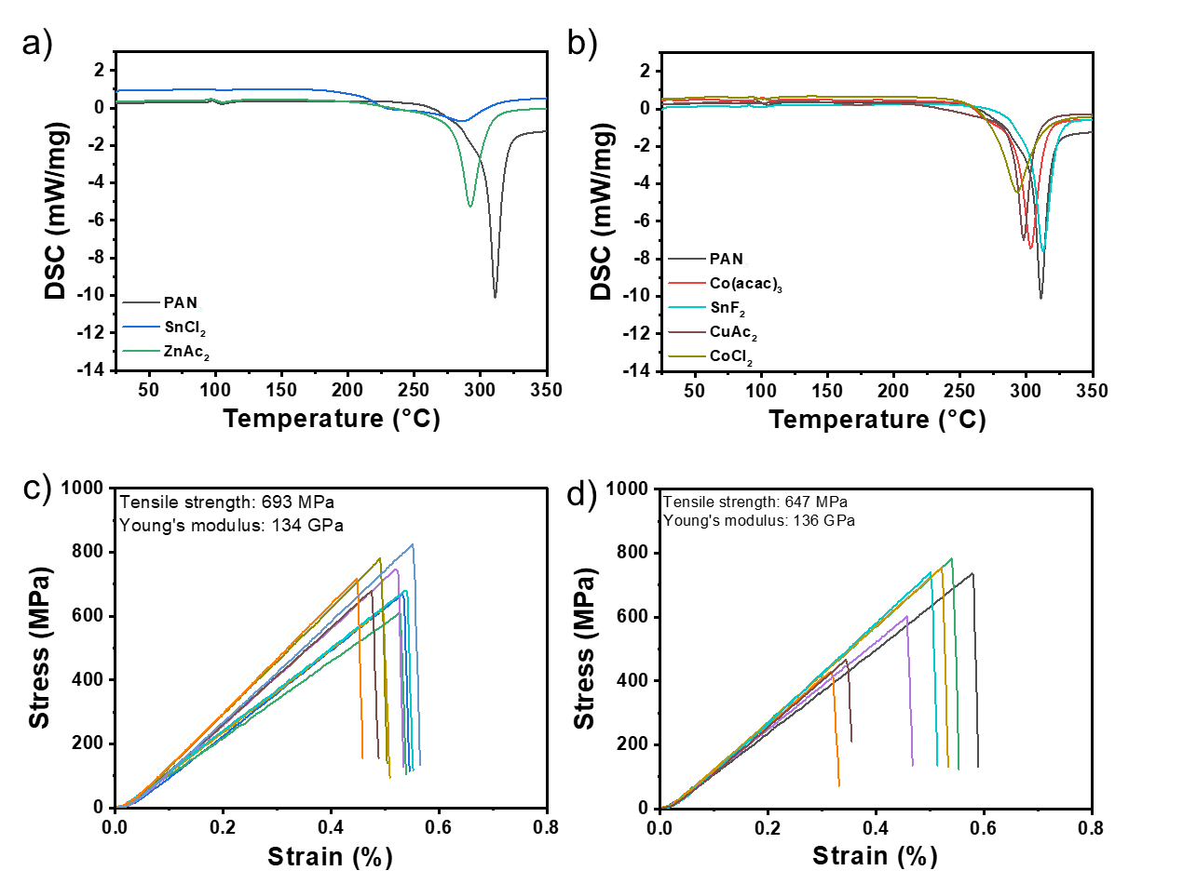
Fig. S3 DSC measurements of the stabilization process of PAN with the catalysts a) SnCl₂, ZnAc₂ and b) Co(acac)₃, SnF₂, CuAc₂ and CoCl₂. Single fiber tensile strength of multifibrillar carbon fibers with catalysts c) SnCl₂ and d) ZnAc₂
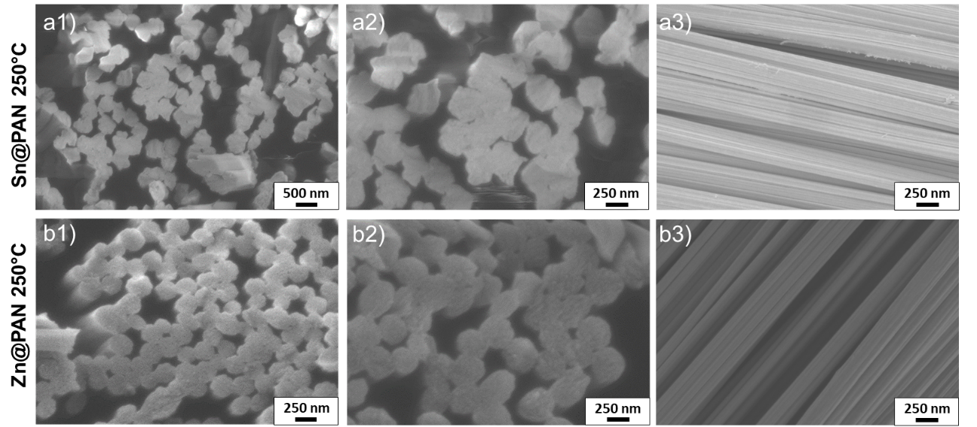
Fig. S4 SEM images of PAN multifibrillar fibers with 3 wt.% of the catalysts a) SnCl₂ and b) ZnAc₂ and oxidative stabilization at 250°C
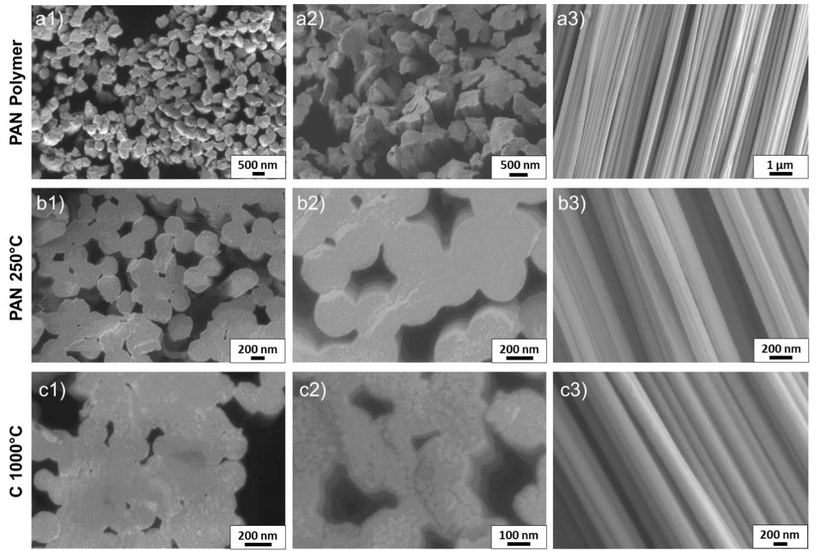
Fig. S5 SEM images of carbon multifibrillar fibers after an electronbeam treatment of 1000 kGy in a) polymer condition, b) after stabilization at 250 °C and c) pyrolysis at 1000°C.
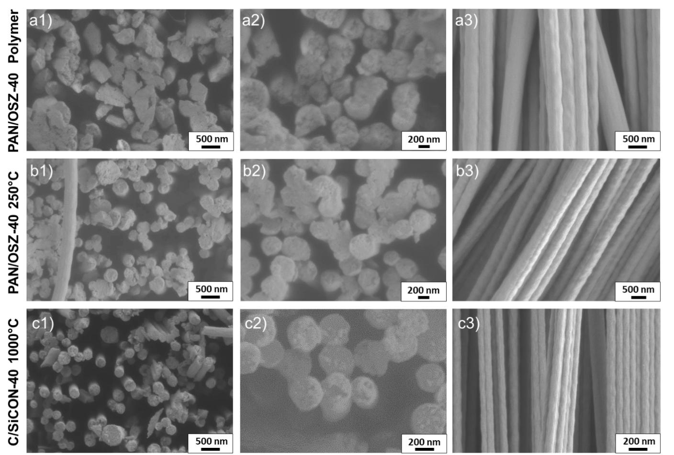
Fig. S6 SEM images of C/SiCON-40 multifibrillar fibers after an electronbeam treatment of 1000 kGy in a) polymer condition, b) after stabilization at 250 °C and c) pyrolysis at 1000°C.
Table S2: Compositions of electrospinning solutions of PAN and PAN/OSZ-40 fibers. 3 wt.% DCP was added with respect to OSZ.
Content  [wt.%] | PAN  [g] | OSZ  [g] | DMF  [g] | Acetone  [g] | SR
0 | 1 | - | 4.70 | 0.96 | 9
40 | 1 | 0.67 | 6.03 | 0.67 | 6

Table S3: Linear densities of the various electrospun mulitfibrillar fibers.
sample | Linear density  [tex]
carbon fiber SR9 | 0.33
C/SiCON-40 SR6 | 1.04

Table S4: Measured densities of the various electrospun fibers.
sample | Density  [g cm⁻³]
carbon fiber | 1.80 (± 0.045)
C/SiCON-40 | 2.00 (± 0.075)

* Corresponding author. E-mail address: Guenter.Motz@uni-bayreuth.de (Günter Motz); Seema.Agarwal@uni-bayreuth.de (Seema Agarwal); xj_liao24@tju.edu.cn (Xiaojian Liao)

