Endobronchial valve (EBV) insertion for severe emphysema does not improve skeletal muscle mass or function - Supplemental

J. Rubenstein¹, I. Benlala^{2,3}, A. C. Toublanc¹, M. Guecamburu¹, A. Maurac¹, C. Bon¹, C. Vergnenegre¹, L. Grassion¹, G. Moucheboeuf⁴, P. Dehail⁴, P. Henrot^{1, 2, *} and M. Zysman^{1,2, *}

- Service des Maladies Respiratoires et des épreuves fonctionnelles respiratoires CHU Bordeaux, 33604 Pessac, France
- Univ-Bordeaux, Centre de Recherche cardio-thoracique de Bordeaux, U1045, CIC 1401. F-33604 Pessac, France.
- Service d’Imagerie Médicale Radiologie diagnostique et thérapeutique CHU Bordeaux, 33604 Pessac, France
- Service de Médecine Physique et de Réadaptation CHU Bordeaux, 33076 Bordeaux, France

* contributed equally

*Address correspondence: Service des Maladies Respiratoires, CHU Bordeaux, 33604 Pessac, France, maeva.zysman@chu-bordeaux.fr

Supplementary Figure 1. Flow-chart of the study.
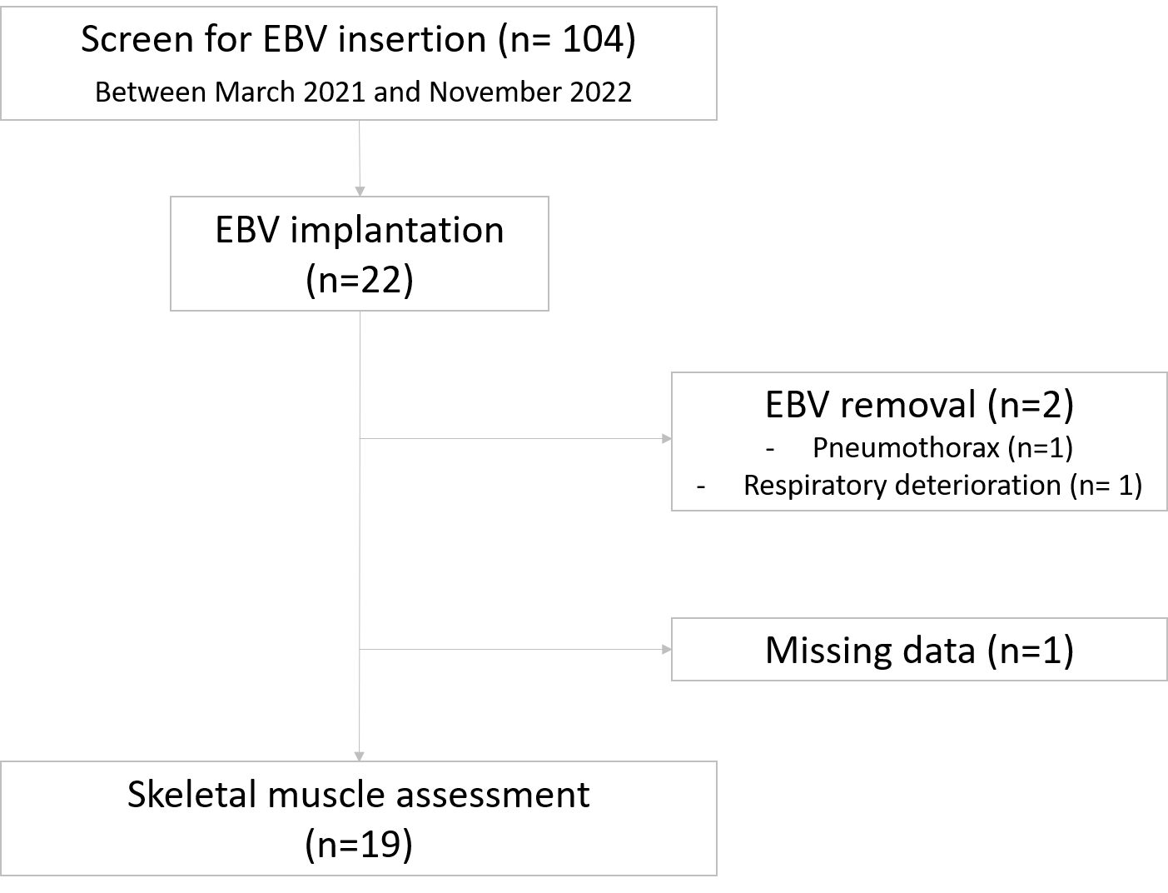

Supplementary Figure 2: Evolution of lung and muscles parameters at 6 months after EBV insertion, described as percentage of improvement from baseline (6MWT: 6-minute-walking test; FEV1: forced expiratory volume in 1s; mMRC: modified Medical Research Council Dyspnea Scale, RV: residual volume; ASMI: appendicular skeletal muscle mass index; TLC: total lung capacity)

Supplementary figure 3: Evolution of thoracic muscles density at 3 and 6 months after EBV insertion. HU: Hounsfield units. No significant difference was observed at 3 or 6 months in comparison to baseline.

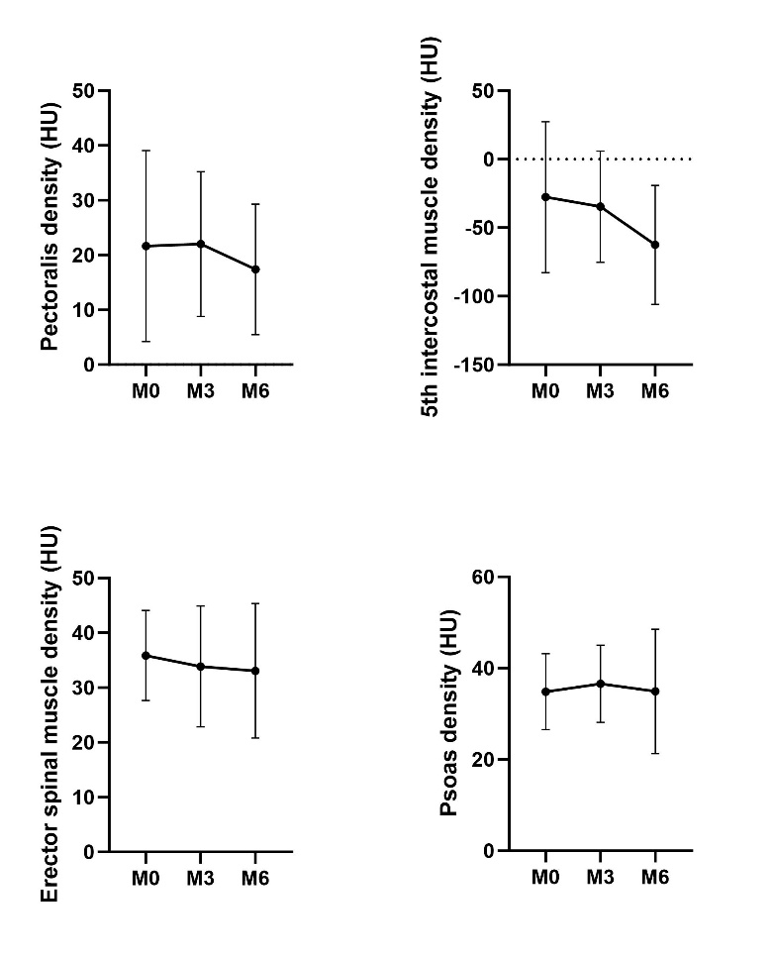
Table S1: Patients’ characteristics at baseline according to the sarcopenic status.
Sarcopenia was diagnosed on the basis of low muscle mass (cf Methods). BMI: body mass index, LTOT: Long term oxygen therapy, mMRC: modified Medical Research Council Dyspnea Scale, CAT: COPD assessment test, 6MWD: 6-minute-walk distance; FEV1: forced expiratory volume in 1s; FVC: forced vital capacity; RV: residual volume; TLC: total lung capacity, DLCO: carbon monoxide diffusing capacity; ASMI: appendicular skeletal muscle mass index.

Values are mean ±SD, a: 2 missing data, b: 1 missing data, c: 5 missing data.

 |  | Non-sarcopenic patients (n=14) | Sarcopenic patients (n=5) | p-value
Demographic data | Age, years | 64.7 ± 8.3 | 68.6 ± 6.1 | 0.34
Demographic data | Sex, n (%)  Female | 9 (50) | 4 (80) | 0.23
Demographic data | BMI, kg/ m2 | 25.9 ± 6.0 | 21.5 ± 3.5 | 0.15
Demographic data | Smoking : active, n(%) | 0 (0) | 0 (0) | >0.99
Demographic data | Former smoking, n (%) | 12 (86) | 5 (100) | >0.99
Demographic data | Smoking history, pack-years | 32 ± 19 | 34 ± 17.8 | 0.84
Non-drug therapies | Patients on LTOT, n (%) | 7 (50) | 3 (60) | >0.99
Non-drug therapies | Patients on NIV, n (%) | 1 (7) | 1 (20) | 0,47
Non-drug therapies | Rehabilitation within 6 months before the procedure, n (%) | 9 (64) | 5 (100) | 0.26
Symptoms & COPD severity | Severe exacerbation the year before EBV, n (%) | 2 (14) | 1 (20) | >0.99
Symptoms & COPD severity | BODE index | 4.7 ± 1.6 | 4.8 ± 1.6 | 0.92
Symptoms & COPD severity | mMRC, points | 2.8 ± 0.4 | 2.2 ± 1.1 | 0.10
Symptoms & COPD severity | CAT, points | 16.6 ± 5.9ª | 22.6 ± 4.5 | 0.06
Pulmonary function tests | FEV₁, L | 0.86 ± 0.3 | 0.66 ± 0.3 | 0.16
Pulmonary function tests | FEV₁, %pred | 35.1 ± 8.3 | 30.2 ± 7.2 | 0.26
Pulmonary function tests | FEV₁ / FVC | 39.3 ± 12.9 | 33.7 ± 3.7 | 0.36
Pulmonary function tests | RV, %pred | 233.2 ± 47.1^{b} | 225.8 ± 43.7 | 0.76
Pulmonary function tests | TLC, %pred | 134.9 ± 23.2 | 129.4 ± 21.3 | 0.65
Pulmonary function tests | DLCOc, %pred | 27.9 ± 17.7ª | 28 ± 13.7^{b} | 0.99
Arterial blood gas | PaO₂, mmHg | 70.8 ± 10.4 | 60.7 ± 7.0 | 0.06
Arterial blood gas | PaCO₂, mmHg | 40.3 ± 4.1 | 43.6 ± 3.7 | 0.13
Cardiac assessment | LVEF, % | 64 ± 6.6^{b} | 67 ± 7.4 | 0.53
Exercice capacity | 6MWD, m | 377.4 ± 84.9 | 292.4 ± 75.7 | 0.06
Exercice capacity | 6MWD, %pred | 74.1 ± 17.7 | 54.4 ± 17.1 | 0.04
Exercice capacity | Average walking speed*, m/s | 1.05 ± 0.24 | 0.81 ± 0.21 | 0.06
Body composition | ASMI, kg/m2 | 7.52 ± 1.8ª | 5.54 ± 1.2 | 0.04
Body composition | Fat mass, % | 32.4 ± 7.7^{b} | 31.1 ± 3.7 | 0.72
Body composition | Phase angle, ° | 5.0 ± 0.7ª | 5.5 ± 1.5 | 0.33
Skeletal muscle force | Handgrip test, kg | 34.1 ± 7.4^{c} | 19.8 ± 6.4^{b} | 0.01

