SUPPLEMENTS

Longitudinal Assessment of Coronary Plaque Regression Related to Sodium-Glucose Cotransporter-2 Inhibitor Using Coronary Computed Tomography Angiography

Running title: SGLT2i and coronary plaque regression

Tianhao Zhang¹, Xuelian Gao², Tianlong Chen³, Hongkai Zhang², Xiaoming Zhang¹, Yu Xin¹, Dongmei Shi¹, Yu Du^{1*}, Lei Xu^{2*}, Yujie Zhou^{1*}

Supplemental Table S1. Baseline characteristics of the overall study plaques
 |  |  |  | Unmatched |  |  |  |  |  |  | Matched
 | SGLT2i |  |  | Non-SGLT2i |  |  |  | p value |  | SGLT2i | Non-SGLT2i | p value
 | (n=244) |  |  | (n=191) |  |  |  |  |  | (n=118) | (n=118)
Clinical characteristics
Age, years | 60.2±10.1 |  |  | 61.3±8.4 |  |  |  | 0.225 |  | 60.4±10.1 | 60.1±8.4 | 0.839
Male, n (%) | 173 (70.9) |  |  | 124 (64.9) |  |  |  | 0.184 |  | 86 (72.9) | 90 (76.3) | 0.550
BMI, kg/m² | 25.9 (24.0, 28.2) |  |  | 26.3 (24.2, 28.7) |  |  |  | 0.373 |  | 26.0 (24.0, 28.1) | 26.4 (24.3, 29.1) | 0.137
SBP, mmHg | 131.2 (118.0, 139.8) |  |  | 132.0(124.0, 141.0) |  |  |  | 0.031 |  | 132.0 (120.0, 140.0) | 130.0(120.0, 138.5) | 0.476
DBP, mmHg | 78.0 (69.0, 85.0) |  |  | 76.0 (66.0, 83.0) |  |  |  | 0.014 |  | 77.0 (69.0, 81.3) | 77.0 (67.0, 85.0) | 0.919
Risk factors, n (%)
Hypertension | 178 (73.0) |  |  | 147 (77.0) |  |  |  | 0.339 |  | 91 (77.1) | 84 (71.2) | 0.298
Dyslipidemia | 218 (89.3) |  |  | 163 (85.3) |  |  |  | 0.209 |  | 103 (87.3) | 102 (86.4) | 0.847
Current Smoking | 85 (34.8) |  |  | 51 (26.7) |  |  |  | 0.069 |  | 32 (27.1) | 35 (29.7) | 0.665
Medical histories, n (%)
Myocardial infarction | 20 (8.2) |  |  | 19 (9.9) |  |  |  | 0.526 |  | 13 (11.0) | 16 (13.6) | 0.552
Myocardial revascularization | 50 (20.5) |  |  | 31 (16.2) |  |  |  | 0.257 |  | 27 (22.9) | 26 (22.0) | 0.876
Stroke | 32 (13.1) |  |  | 39 (20.4) |  |  |  | 0.041 |  | 11 (9.3) | 17 (14.4) | 0.227
Lab tests
FBG, mmol/L | 7.6 (6.4, 9.6) |  |  | 6.9 (5.6, 8.6) |  |  |  | <0.001 |  | 7.5 (6.3, 8.7) | 7.6 (5.7, 9.2) | 0.831
Creatinine, mmol/L | 72.5 (63.9, 87.0) |  |  | 72.7 (63.5, 86.4) |  |  |  | 0.759 |  | 75.5 (64.7, 87.0) | 72.9 (63.5, 84.5) | 0.528
eGFR, mL/min/1.73 m² | 91.6 (81.5, 101.5) |  |  | 90.5 (76.2, 100.1) |  |  |  | 0.182 |  | 91.8 (78.5, 99.9) | 94.8 (79.0, 101.1) | 0.376
TG, mmol/L | 1.51 (1.17, 2.09) |  |  | 1.55 (1.07, 2.10) |  |  |  | 0.436 |  | 1.45 (1.17, 1.96) | 1.40 (1.06, 1.98) | 0.408
TC, mmol/L | 3.95 (3.43, 4.65) |  |  | 4.11 (3.39, 4.93) |  |  |  | 0.319 |  | 4.18 (3.44, 4.81) | 4.11 (3.38, 5.01) | 0.868
HDL-C, mmol/L | 1.01 (0.87, 1.19) |  |  | 1.01 (0.87, 1.25) |  |  |  | 0.418 |  | 1.06 (0.89, 1.19) | 1.02 (0.87, 1.26) | 0.856
LDL-C, mmol/L | 2.10 (1.65, 2.75) |  |  | 2.27 (1.72, 2.81) |  |  |  | 0.235 |  | 2.27 (1.90, 2.84) | 2.24 (1.73, 2.90) | 0.889
hs-CRP, mg/L | 1.09 (0.58, 3.07) |  |  | 1.23 (0.68, 2.34) |  |  |  | 0.349 |  | 1.02 (0.49, 3.10) | 1.42 (0.68, 2.40) | 0.122
Time interval between CCTAs, month | 14.2 (12.9, 17.8) |  |  | 17.6 (13.3, 23.7) |  |  |  | <0.001 |  | 14.2 (12.7, 21.5) | 15.0 (12.7, 23.2) | 0.605
Tube voltage of CT acquisition, n  (%) |  |  |  |  |  |  |  | 0.993 |  |  |  | 0.575
100 kV | 170 (69.7) |  |  | 133 (69.6) |  |  |  |  |  | 83 (70.3) | 79 (66.9)
120 kV | 74 (30.3) |  |  | 58 (30.4) |  |  |  |  |  | 35 (29.7) | 39 (33.1)
Study plaque*
Number, per patient | 1.82 (244/134) |  |  | 1.87 (191/102) |  |  |  | - |  | 1.64(118/72) | 1.69(118/70) | -
Location, n (%) |  |  |  |  |  |  |  | 0.533 |  |  |  | 0.988
LAD | 76 (31.1) |  |  | 56 (29.3) |  |  |  | - |  | 37 (31.4) | 36 (30.5) | -
LCX | 91 (37.3) |  |  | 65 (34.0) |  |  |  | - |  | 44 (37.3) | 45 (38.1) | -
RCA | 77 (31.6) |  |  | 70 (36.6) |  |  |  | - |  | 37 (31.4) | 37 (31.4) | -
Diameter stenosis ≥ 50%, n (%) | 85 (34.8) |  |  | 53 (27.7) |  |  |  | 0.115 |  | 43 (36.4) | 39 (33.1) | 0.584
FFR-CT ≤ 0.8, n (%) | 60(24.6) |  |  | 49(25.7) |  |  |  | 0.799 |  | 28(23.7) | 35(29.7) | 0.303
Medications, n (%)
Metformin | 93 (38.1) |  |  | 90 (47.1) |  |  |  | 0.059 |  | 47 (39.8) | 53 (44.9) | 0.429
Incretins | 63 (25.8) |  |  | 31 (16.2) |  |  |  | 0.016 |  | 29 (24.6) | 25 (21.2) | 0.535
Insulin | 49 (20.1) |  |  | 41 (21.5) |  |  |  | 0.724 |  | 27 (22.9) | 28 (23.7) | 0.878
Statins | 244 (100) |  |  | 191 (100) |  |  |  | 1.000 |  | 118 (100) | 118 (100) | 1.000
Ezetimibe | 69 (28.3) |  |  | 43 (22.5) |  |  |  | 0.172 |  | 34 (28.8) | 36 (30.5) | 0.776
BMI, body mass index; CCTA, coronary computed tomographic angiography; DBP, diastolic blood pressure; eGFR, estimated glomerular filtration rate; FPG, fasting plasma glucose; HDL-C, High density lipoprotein cholesterol; hs-CRP, hypersensitive C-reactive protein; LM, Left main artery: LAD, left anterior descending artery; LCX, left circumflex coronary artery; LDL-C, Low density lipoprotein cholesterol; RCA, right coronary artery; SGLT2i, Sodium-dependent glucose transporters 2 inhibitor; SBP, systolic blood pressure; TG, Triglyceride; TC, Total cholesterol

Supplemental Table S2. Annual changes of compositional PV and PAV on a per-plaque level
 | Unmatched |  |  |  | Matched
 | SGLT2i | Non-SGLT2i | p value |  | SGLT2i | Non-SGLT2i | p value
 | (n=244) | (n=191) | p value |  | (n=118) | (n=118) | p value
Annual PV change, mm³/year
Overall | -13.13 (-61.35, 27.42) | 2.28 (-25.98, 51.75) | <0.001 |  | -9.80 (-45.01, 20.62) | 3.28 (-28.45, 60.17) | 0.007
Calcified | 1.38 (-0.43, 9.42) | 2.47 (0.00, 13.75) | 0.055 |  | 1.68 (-0.08, 10.01) | 4.83 (0.00, 16.26) | 0.024
Non-Calcified | -19.05 (-66.39, 21.76) | -1.13 (-31.01, 40.29) | <0.001 |  | -14.79 (-50.20, 18.28) | -0.94 (-32.27, 42.52) | 0.021
Low-attenuated | -3.62 (-16.62, 6.40) | -1.77 (-11.41, 7.83) | 0.188 |  | -1.57 (-13.41, 7.98) | -1.98 (-13.25, 7.53) | 0.994
Annual PAV change, %/year
Overall | -2.38 (-9.18, 6.26) | 1.26 (-4.77, 7.49) | 0.002 |  | -2.71 (-9.65, 3.76) | 2.56 (-4.34, 11.32) | 0.001
Calcified | 0.19 (-0.11, 1.81) | 0.65 (0.00, 2.45) | 0.050 |  | 0.32 (-0.12, 1.63) | 0.89 (0.00, 3.33) | 0.018
Non-Calcified | -3.47 (-9.90, 4.49) | 0.02 (-5.59, 6.10) | 0.002 |  | -4.13 (-10.59, 2.96) | 0.59 (-5.69, 6.99) | 0.002
Low-attenuated | -0.48 (-2.70, 1.54) | -0.26 (-1.87, 1.36) | 0.204 |  | -0.76 (-2.71, 1.96) | -0.13 (-2.59, 1.42) | 0.476
Annualized change of PV or PAV indicated change of PV or PAV from baseline divided by the CCTA time intervals (years)
Abbreviations: PV, plaque volume; PAV, percent atheroma volume; Other abbreviations shown in Table S1.

Supplemental Figure S1. Annual changes of compositional PV and PAV
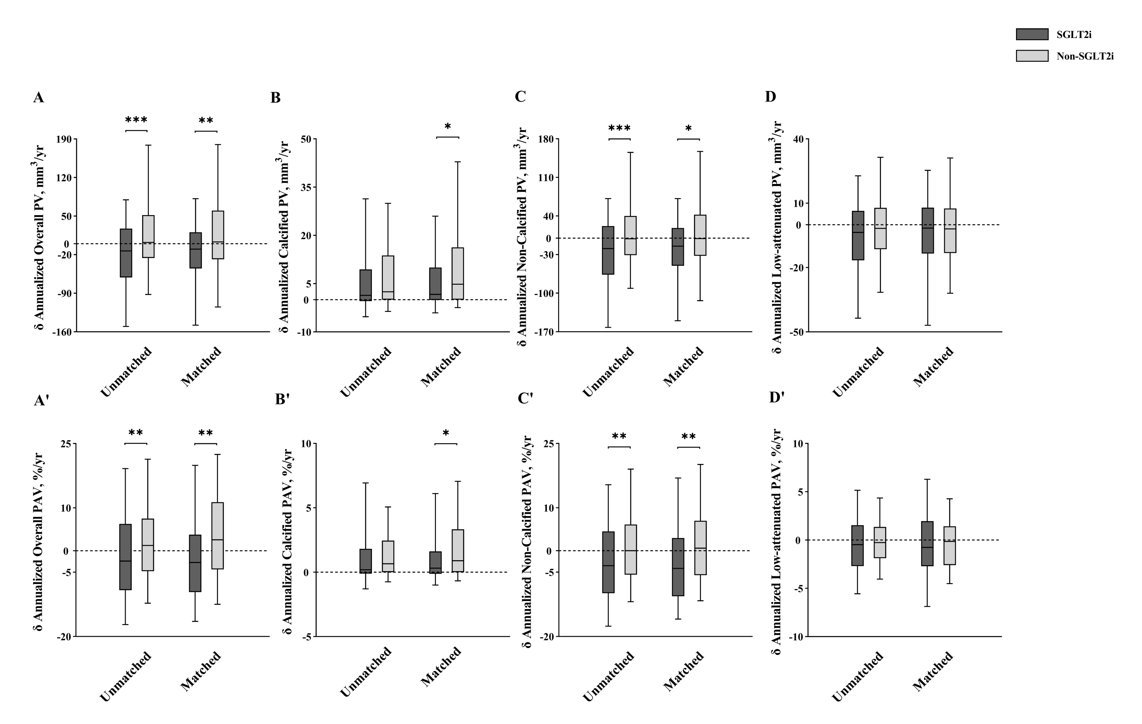
*p < 0.05, **p < 0.01, ***p < 0.001. Abbreviations: PV, plaque volume; PAV, percent atheroma volume; SGLT2i, Sodium-dependent glucose transporters 2 inhibitor
Supplemental Figure S2. Subgroup analysis for the effect of SGLT2i on the progression of overall PV and PAV
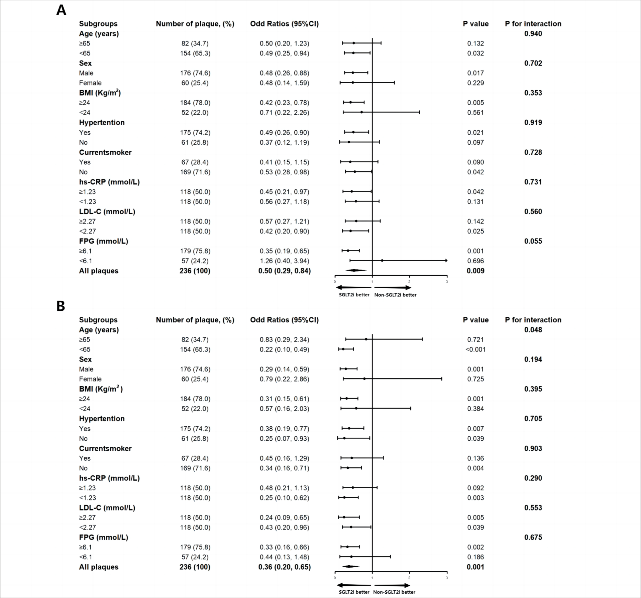
Subgroup analysis of the propensity score matching cohort for the effect of SGLT2i on the progression of overall plaque volume (A) and percent atheroma volume (B). The black vertical solid line represents the OR value of 1. The subgroup analysis was adjusted for baseline overall plaque volume or percent atheroma volume.
Abbreviations shown in Figure 1.

