content
eFigure 1 Scatter plot for modifiable lifestyle factors on overall BC.
eFigure 2 Scatter plot for modifiable lifestyle factors on ER+ BC.
eFigure 3 Scatter plot for modifiable lifestyle factors on ER- CB.
eFigure 4 Scatter plot for modifiable lifestyle factors on benign neoplasm of breast.
eFigure 5 Scatter plot for modifiable lifestyle factors on Inflammatory disorders of breast.
eFigure 6 Leave one out analysis for modifiable lifestyle factors on overall BC.
eFigure 7 Leave one out analysis for modifiable lifestyle factors on ER+ BC.
eFigure 8 Leave one out analysis for modifiable lifestyle factors on ER- BC.
eFigure 9 Leave one out analysis for modifiable lifestyle factors on benign neoplasm of breast.
eFigure 10 Leave one out analysis for modifiable lifestyle factors on inflammatory disorders of breast.
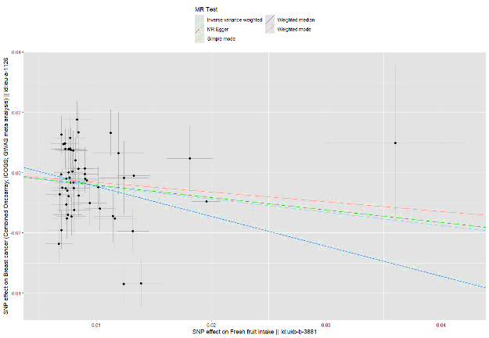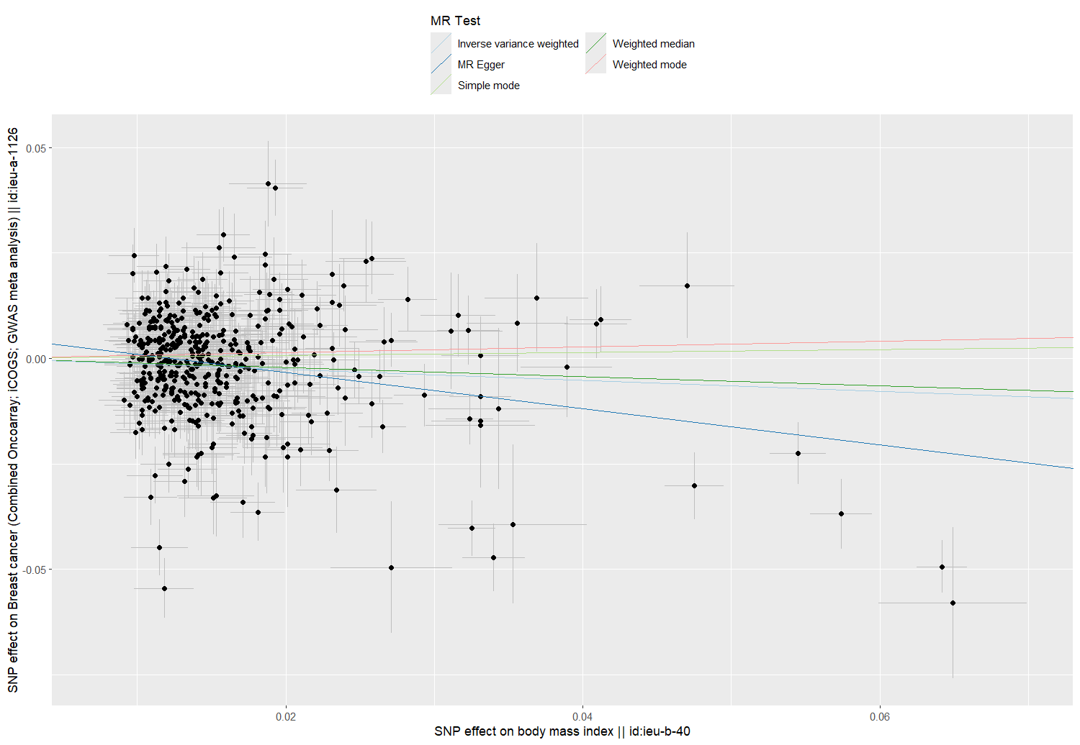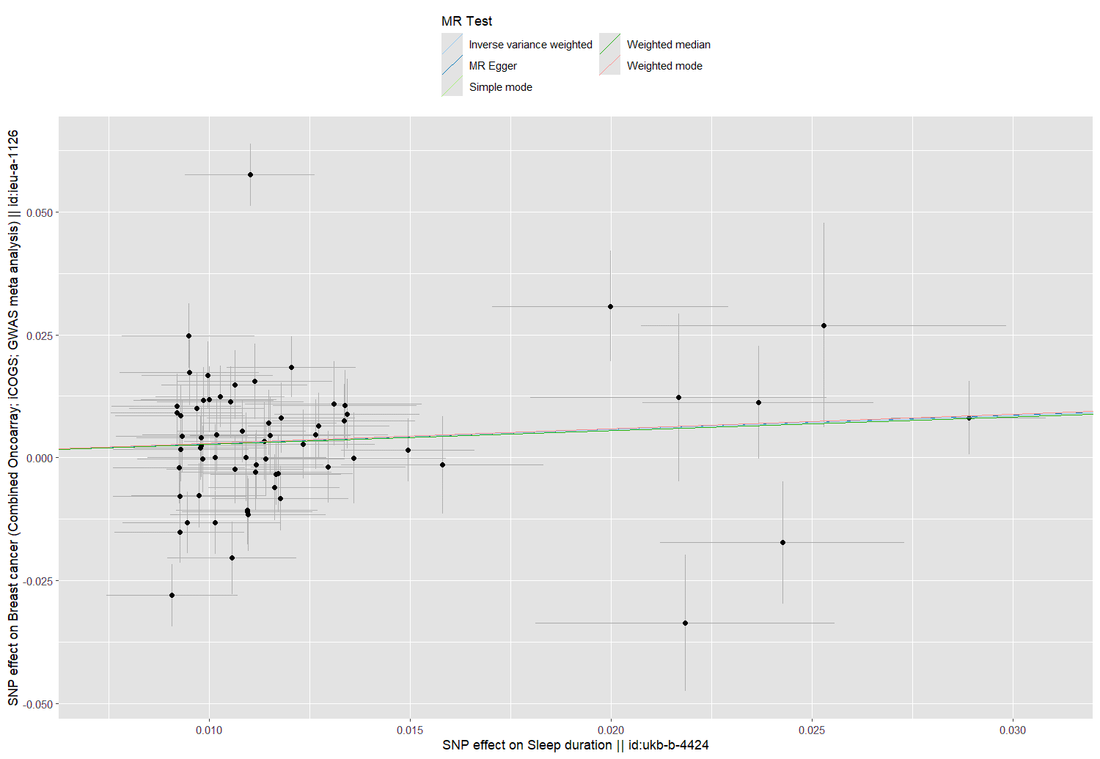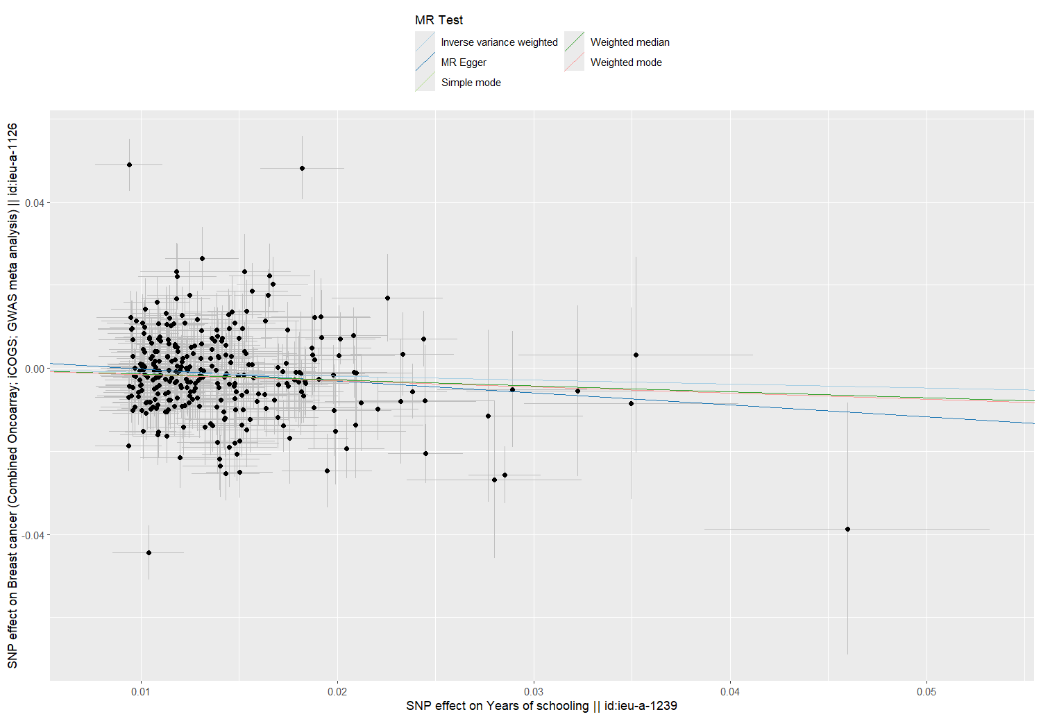
eFigure 1 Scatter plot for modifiable lifestyle factors on overall breast cancer. a. Scatter plot of sleep duration and overall BC risk. b. Scatter plot of years of schooling and overall BC risk. c. Scatter plot of fresh fruit intake and overall BC risk. d. Scatter plot of body mass index and overall BC risk.
a
b
c
d
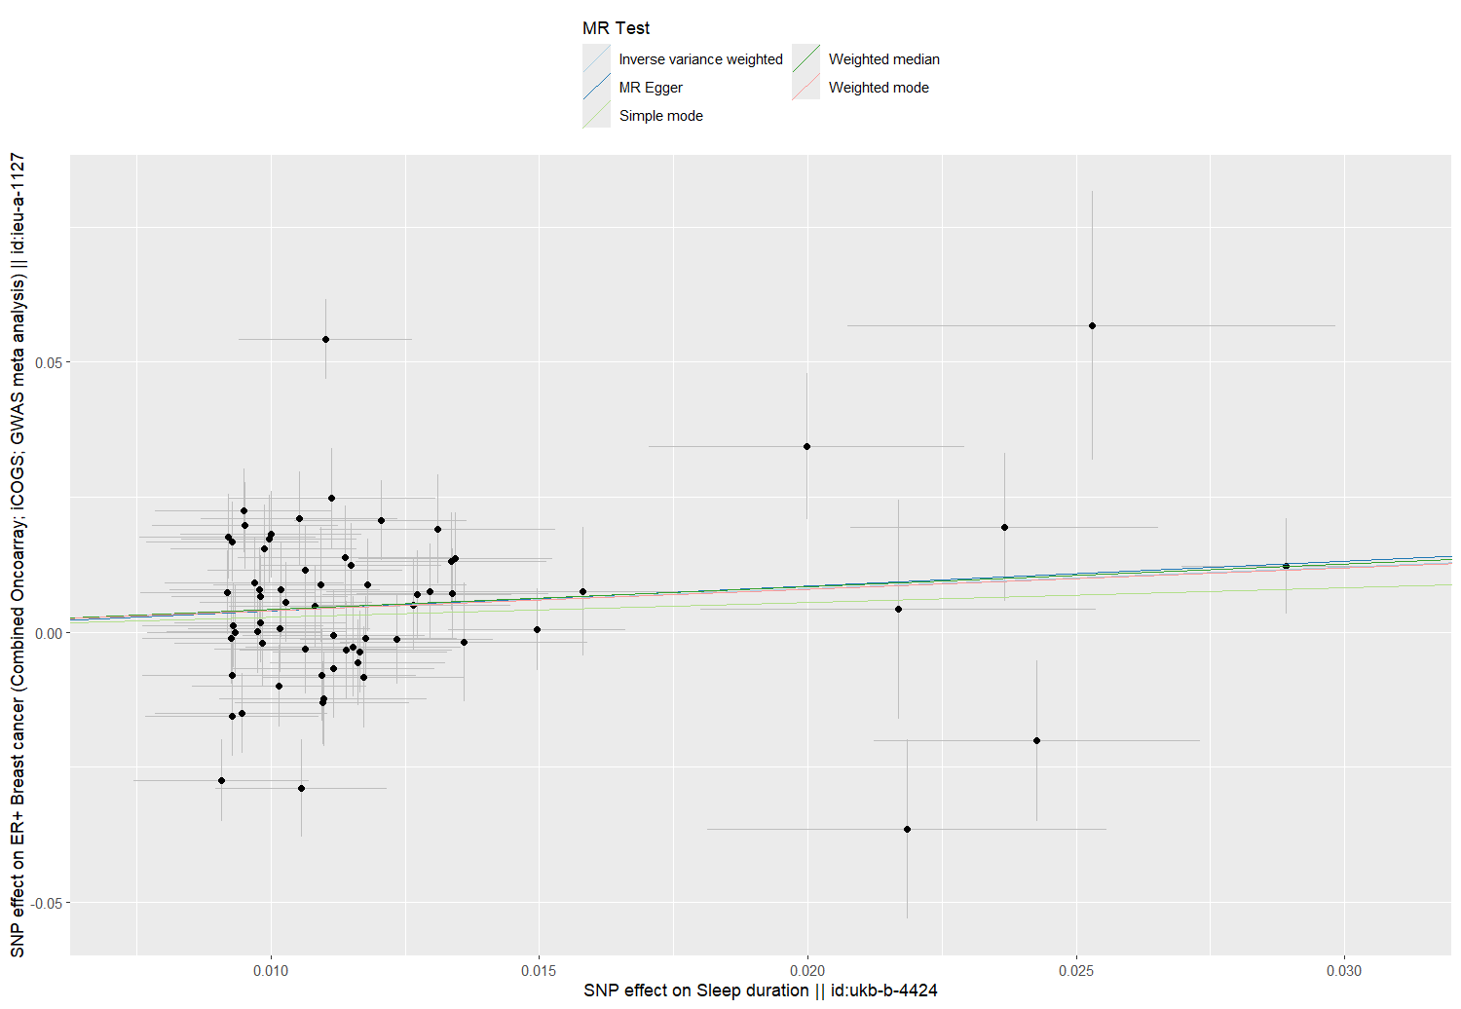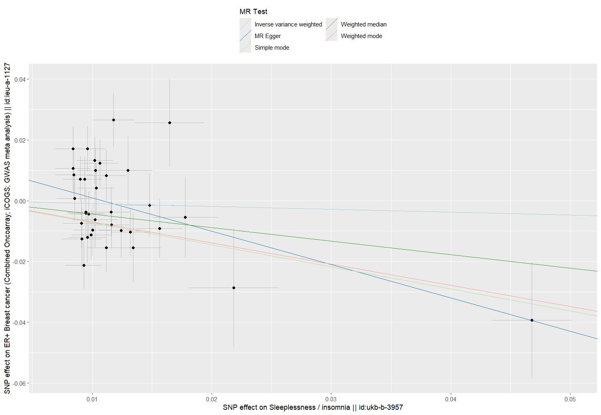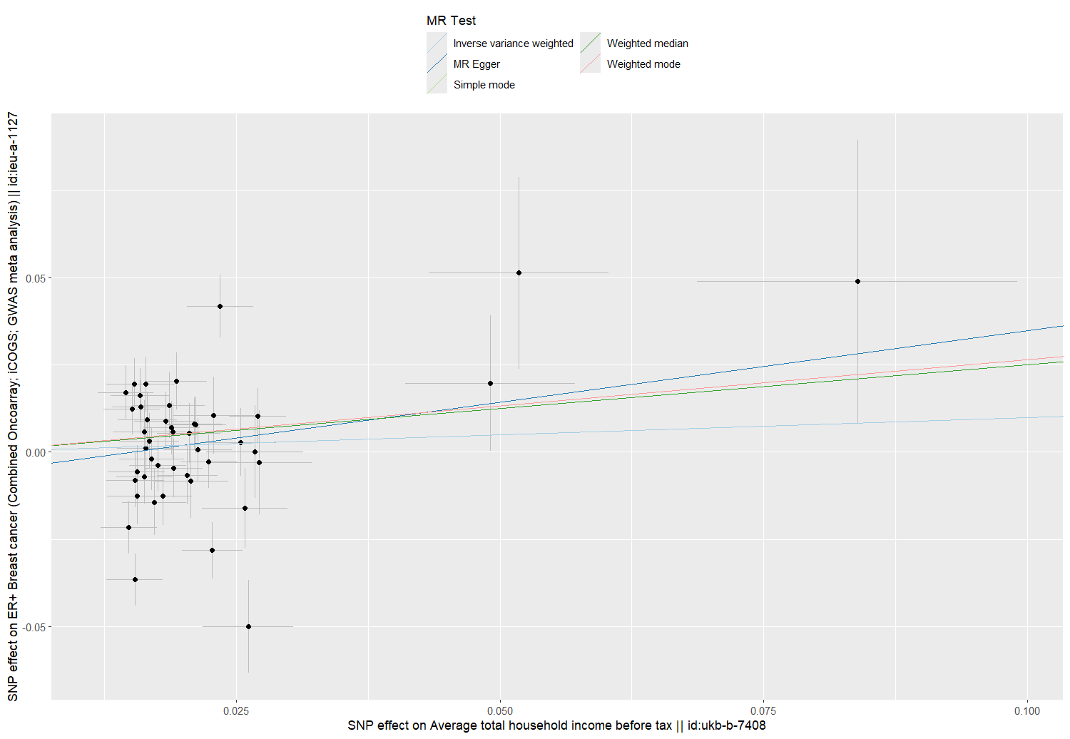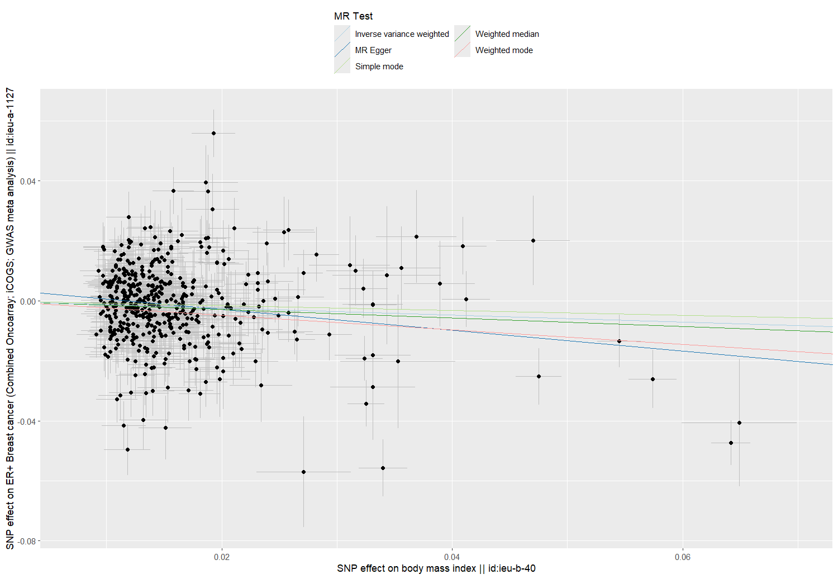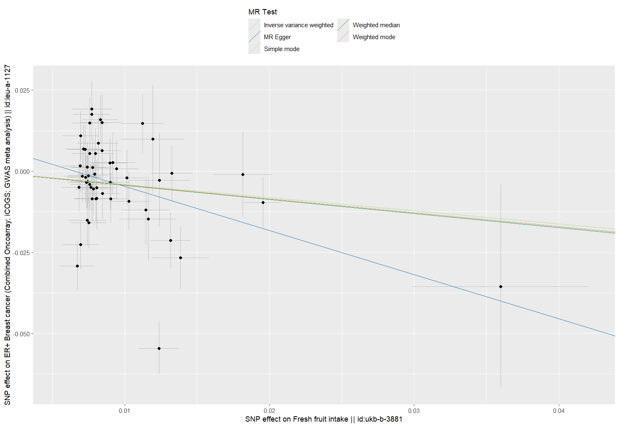
eFigure 2 Scatter plot for modifiable lifestyle factors on ER+ breast cancer. a. Scatter plot of sleep duration and ER+ BC risk. b. Scatter plot of sleeplessness/insomnia and ER+ BC risk. c. Scatter plot of household income and ER+ BC risk. d. Scatter plot of fresh fruit intake and ER+ BC risk. e. Scatter plot of body mass index and ER+ BC risk.
a
b
e
c
d
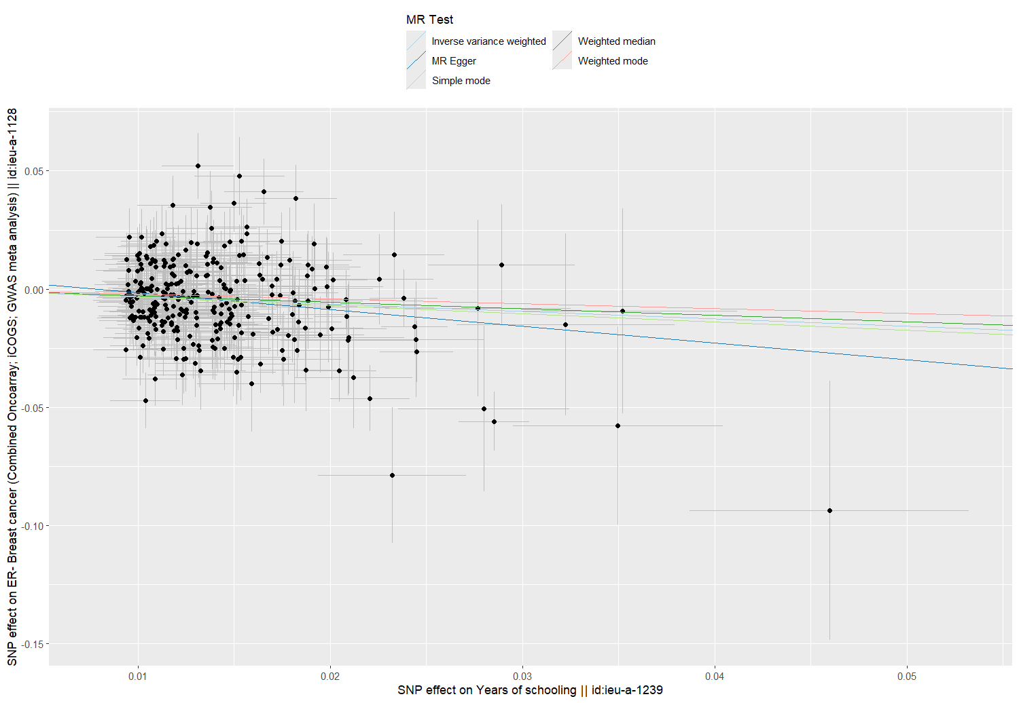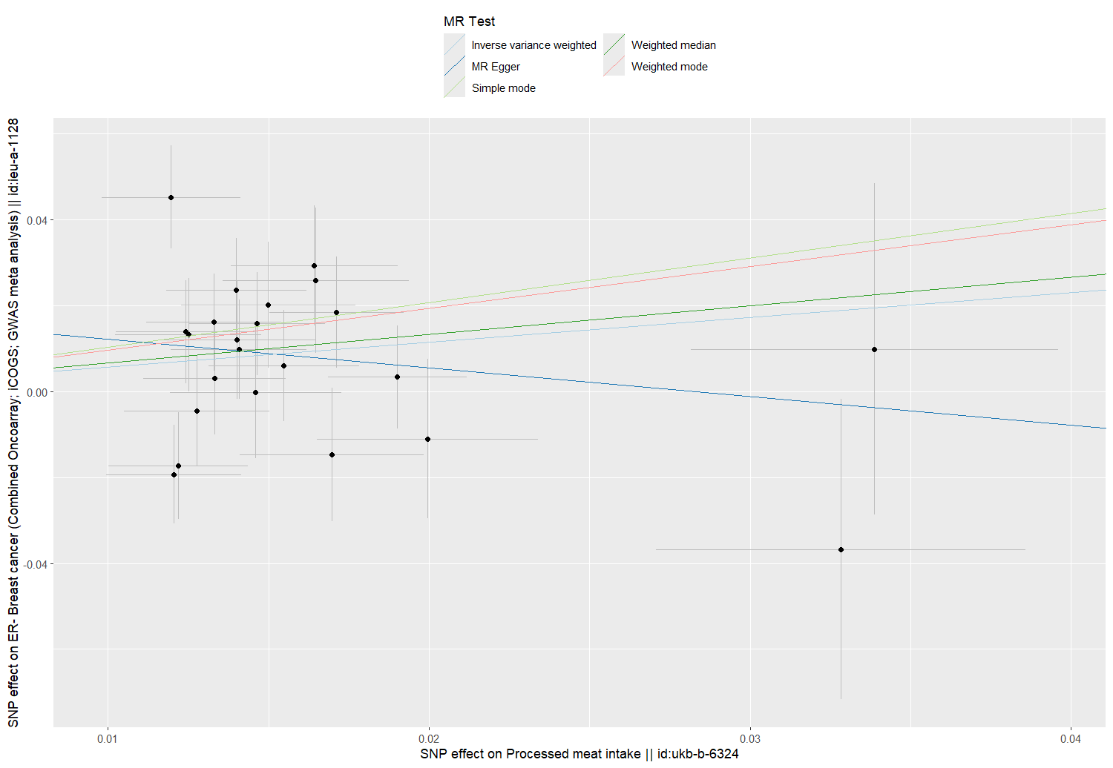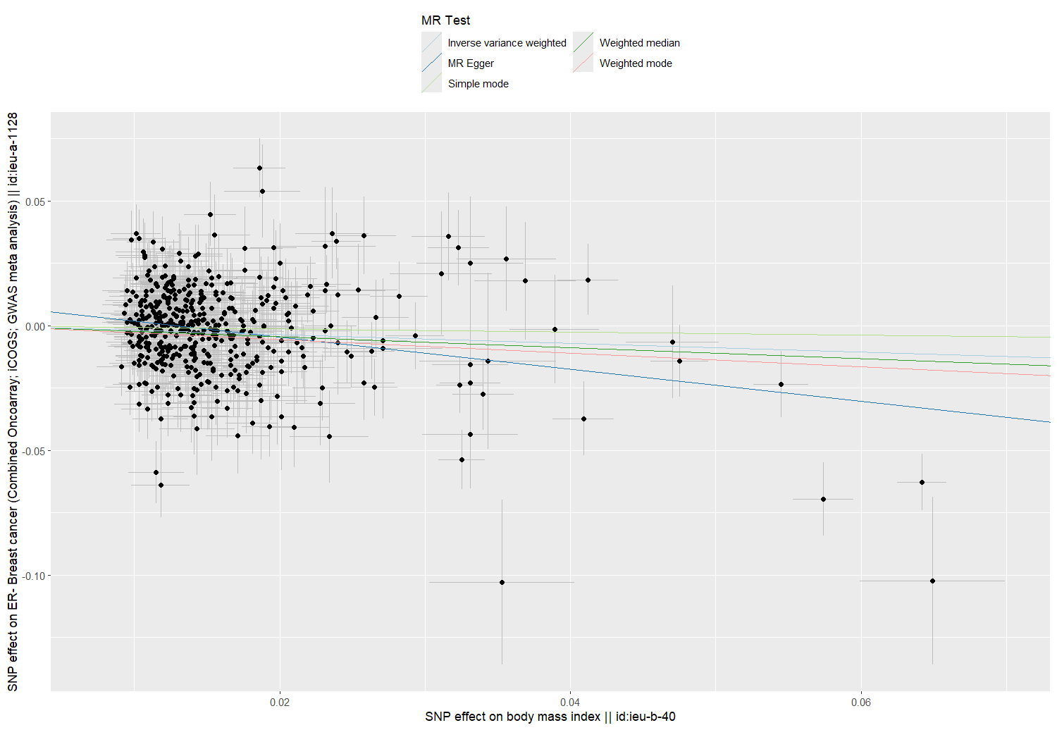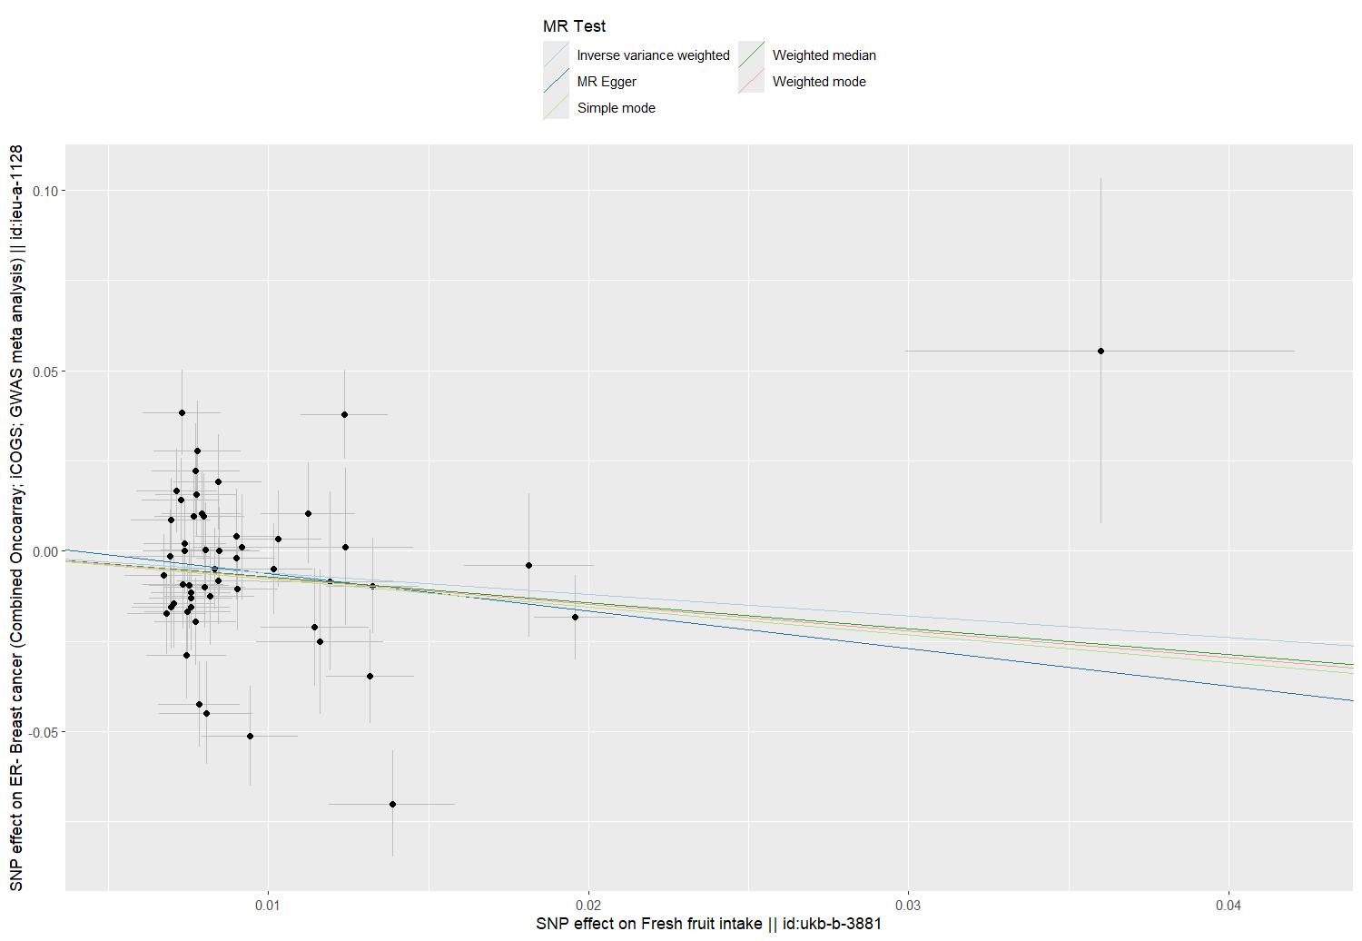
eFigure 3 Scatter plot for modifiable lifestyle factors on ER- breast cancer. a. Scatter plot of years of schooling and ER- BC risk. b. Scatter plot of processed meat intake and ER- BC risk. c. Scatter plot of fresh fruit intake and ER- BC risk. d. Scatter plot of body mass index and ER- BC risk.
a
b
d
c
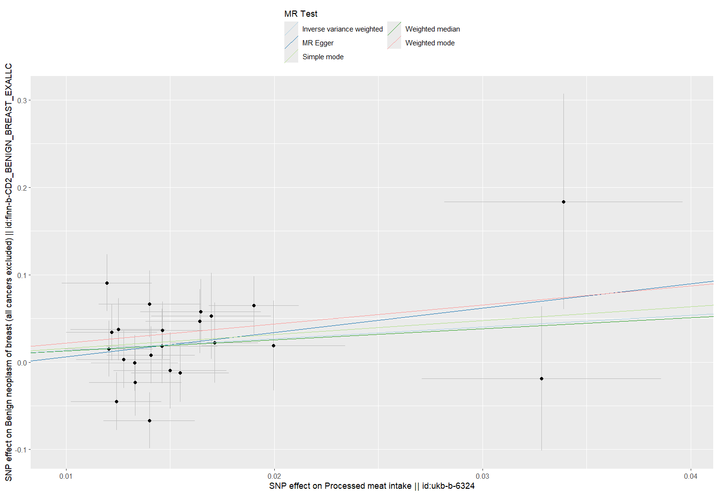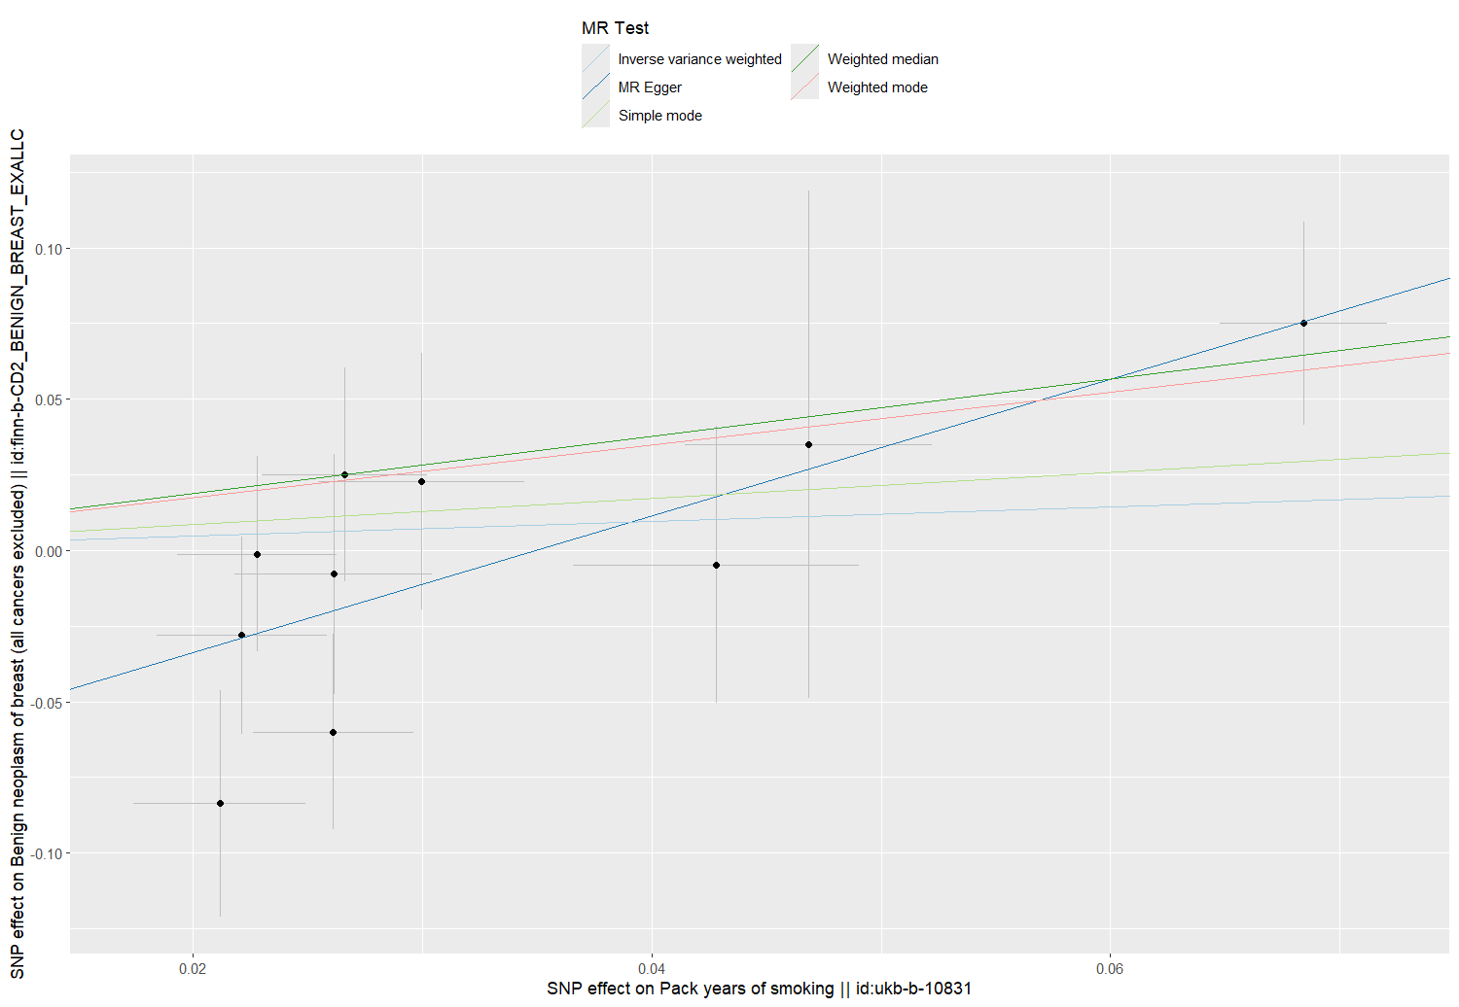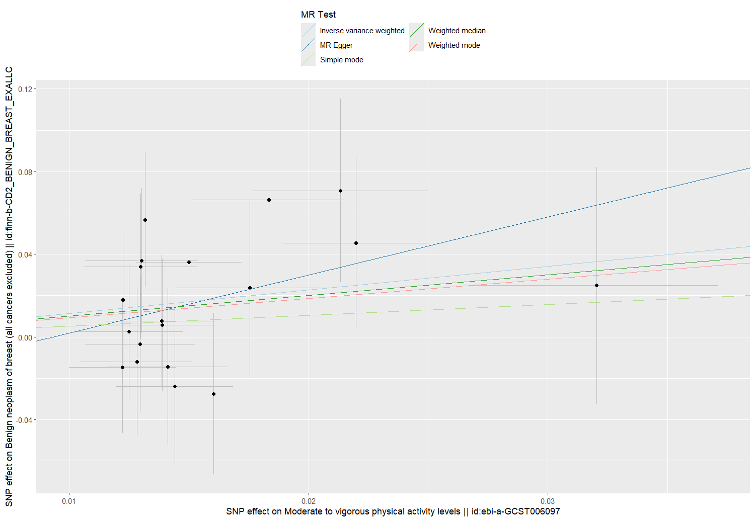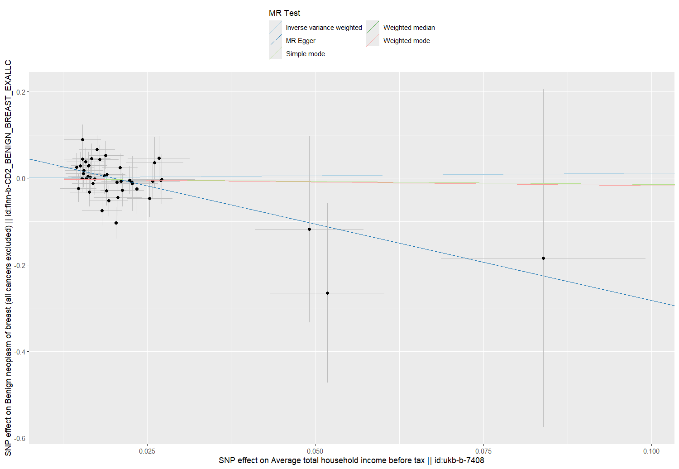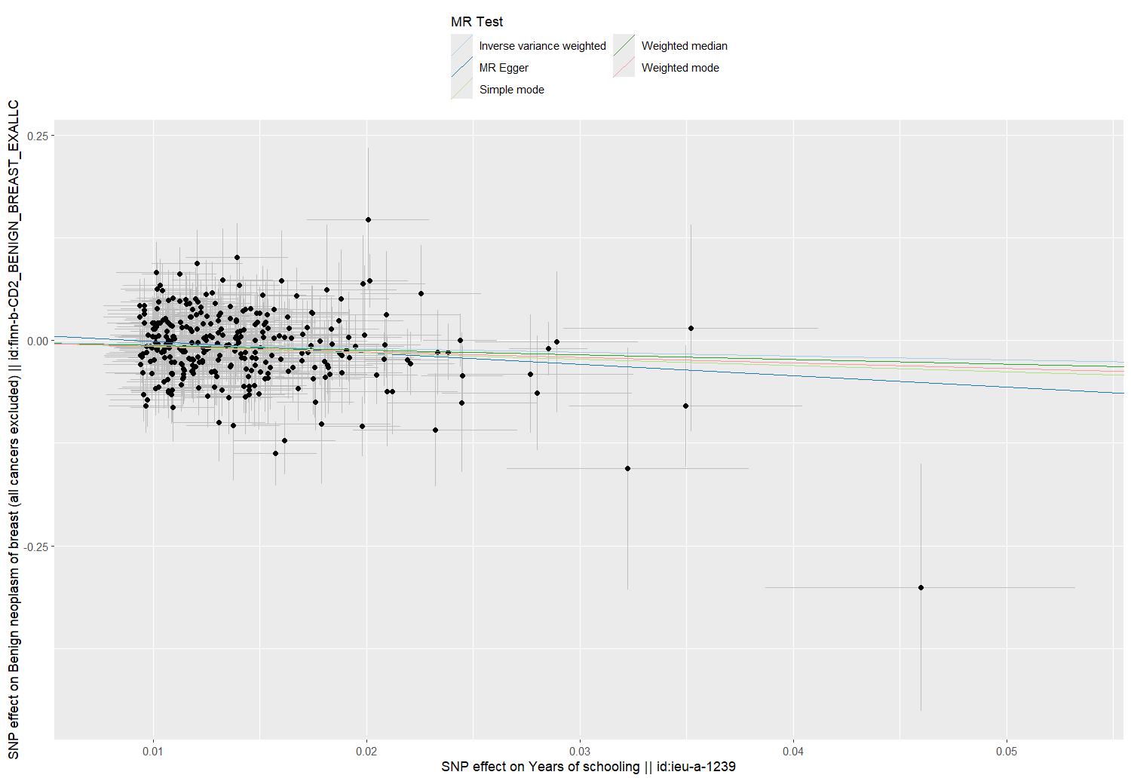
eFigure 4 Scatter plot for modifiable lifestyle factors on benign neoplasm of breast. a. Scatter plot of pack years of smoking and benign neoplasm of breast risk. b. Scatter plot of physical activity and benign neoplasm of breast risk. c. Scatter plot of years of schooling and benign neoplasm of breast risk. d. Scatter plot of household income and benign neoplasm of breast risk. e. Scatter plot of processed meat intake and benign neoplasm of breast risk.
a
b
c
d
e
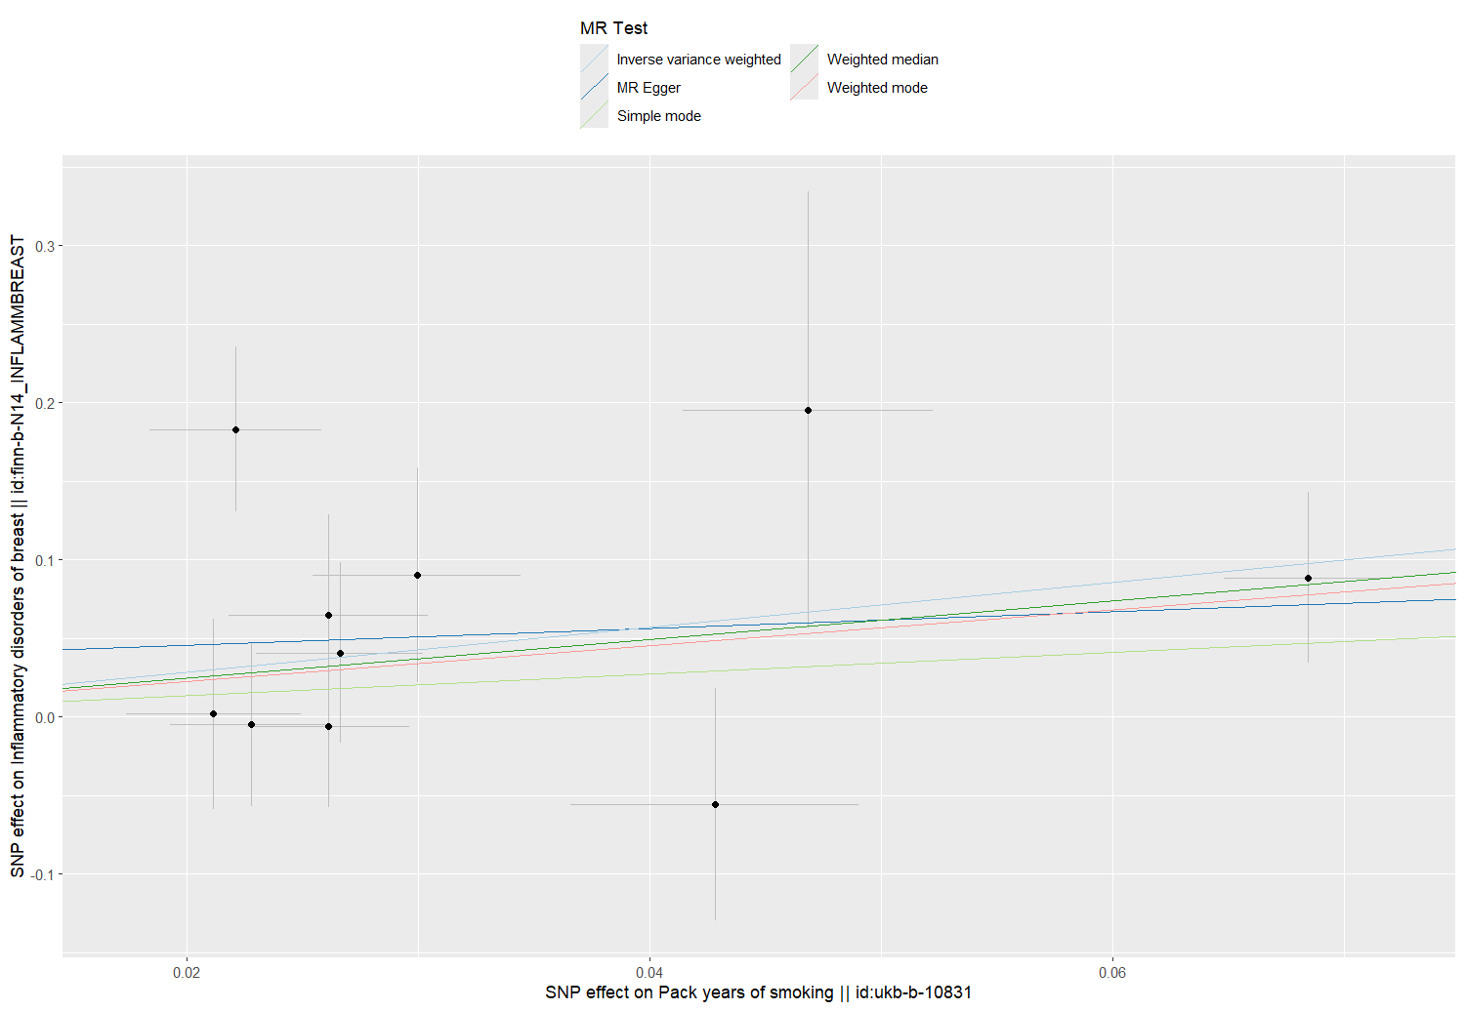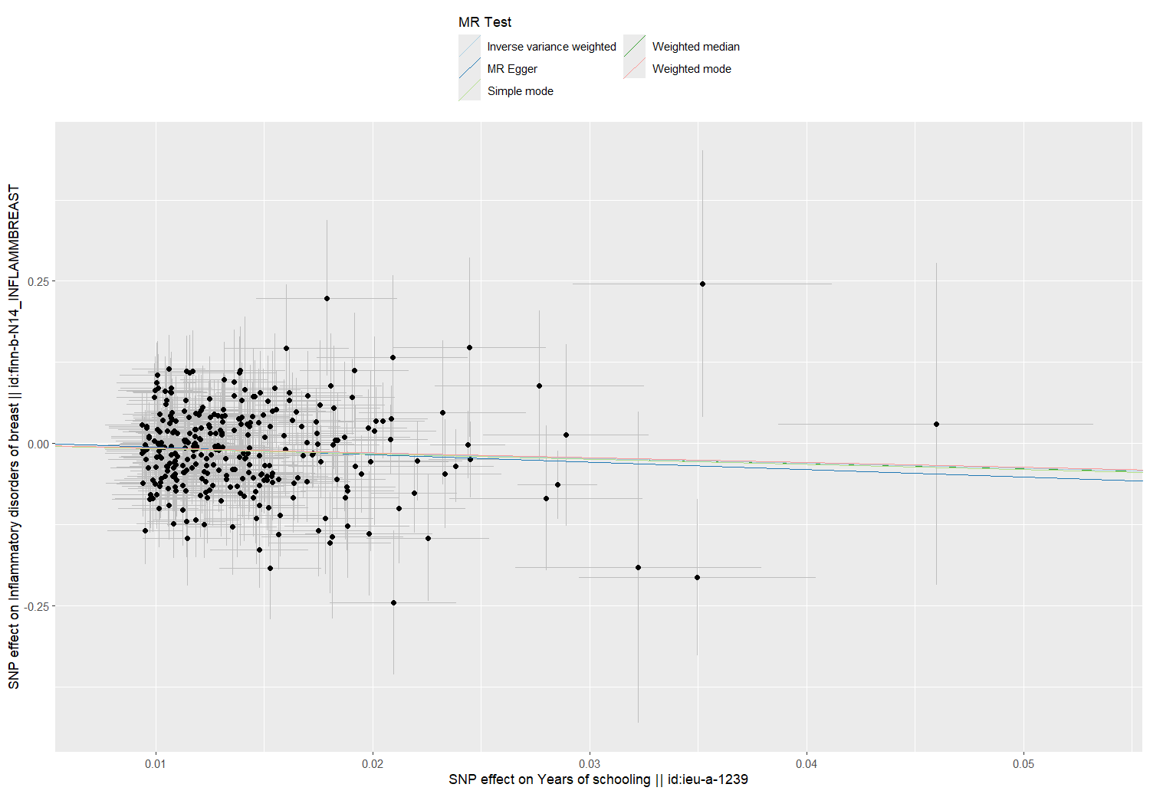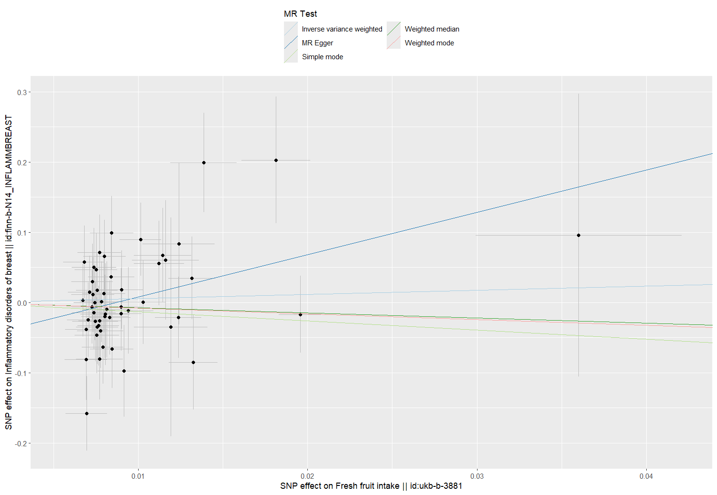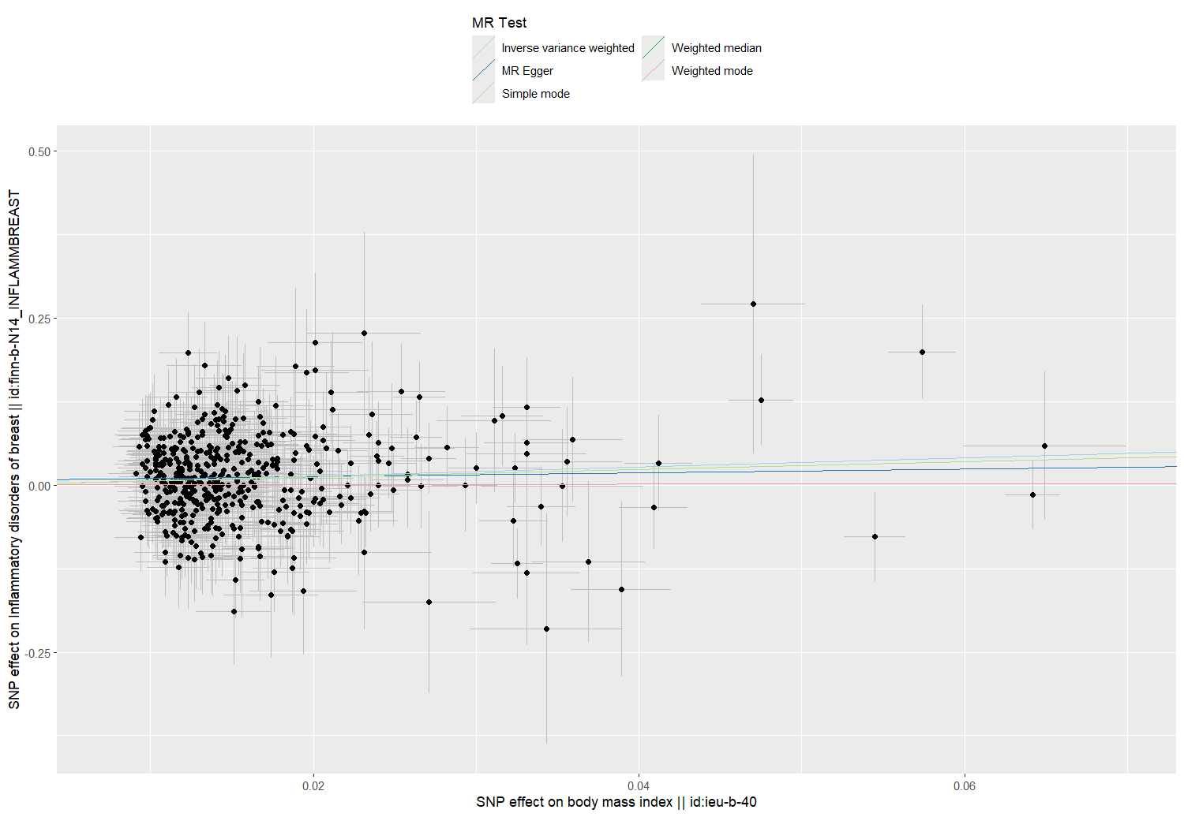
eFigure 5 Scatter plot for modifiable lifestyle factors on Inflammatory disorders of breast. a. Scatter plot of pack years of smoking and inflammatory disorders of breast risk. b. Scatter plot of years of schooling and inflammatory disorders of breast risk. c. Scatter plot of fresh fruit intake and inflammatory disorders of breast risk. d. Scatter plot of body mass index and inflammatory disorders of breast risk.
d
a
b
c

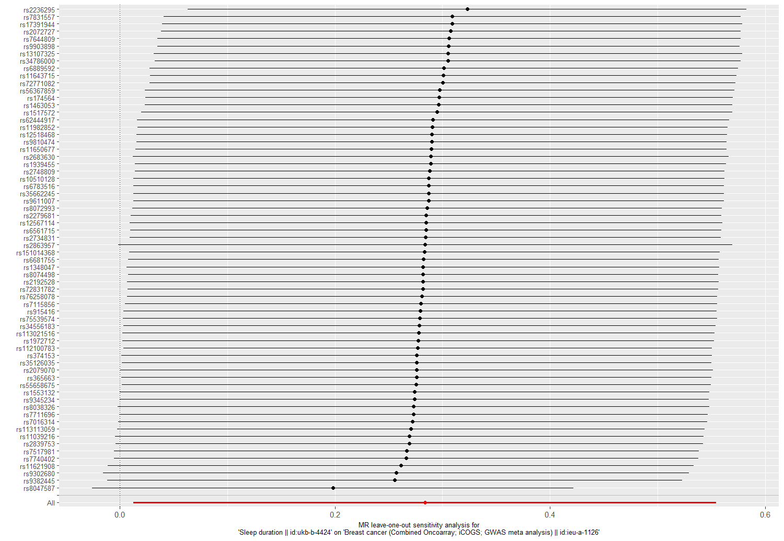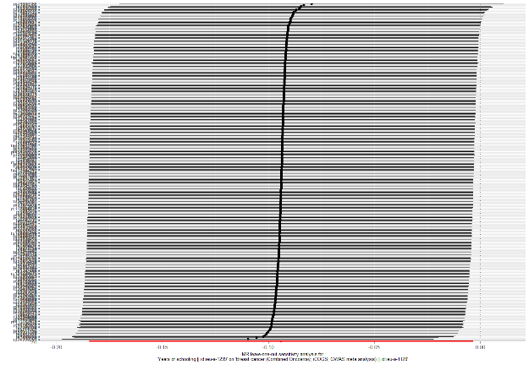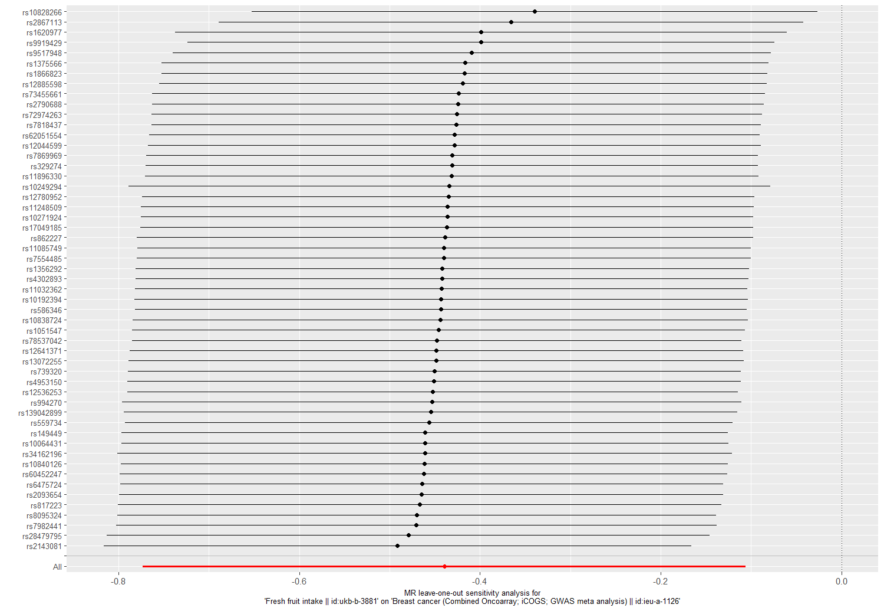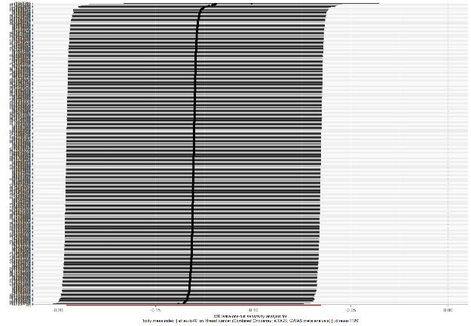
c
eFigure 6 Leave one out analysis for modifiable lifestyle factors on overall breast cancer. a. Leave-one-out analysis of sleep duration and overall BC risk. b. Leave-one-out analysis of years of schooling and overall BC risk. c. Leave-one-out analysis of fresh fruit intake and overall BC risk. d. Leave-one-out analysis of body mass index and overall BC risk.
a
b
d
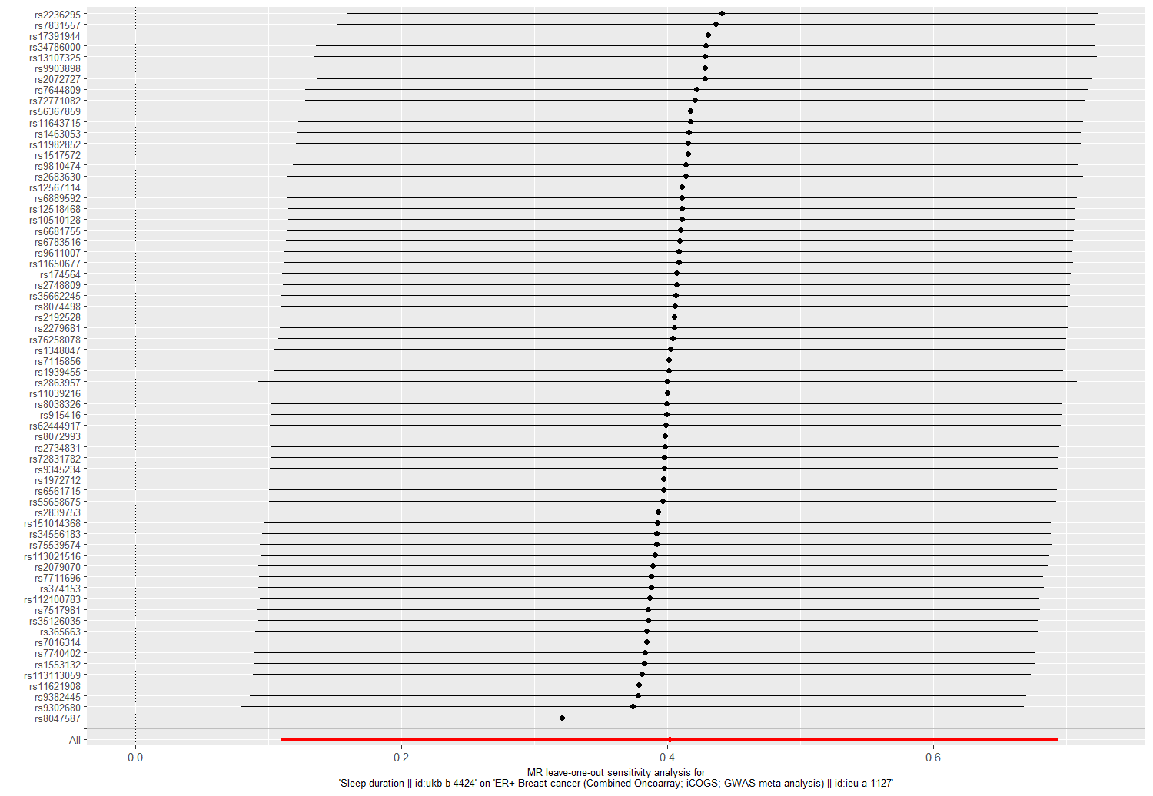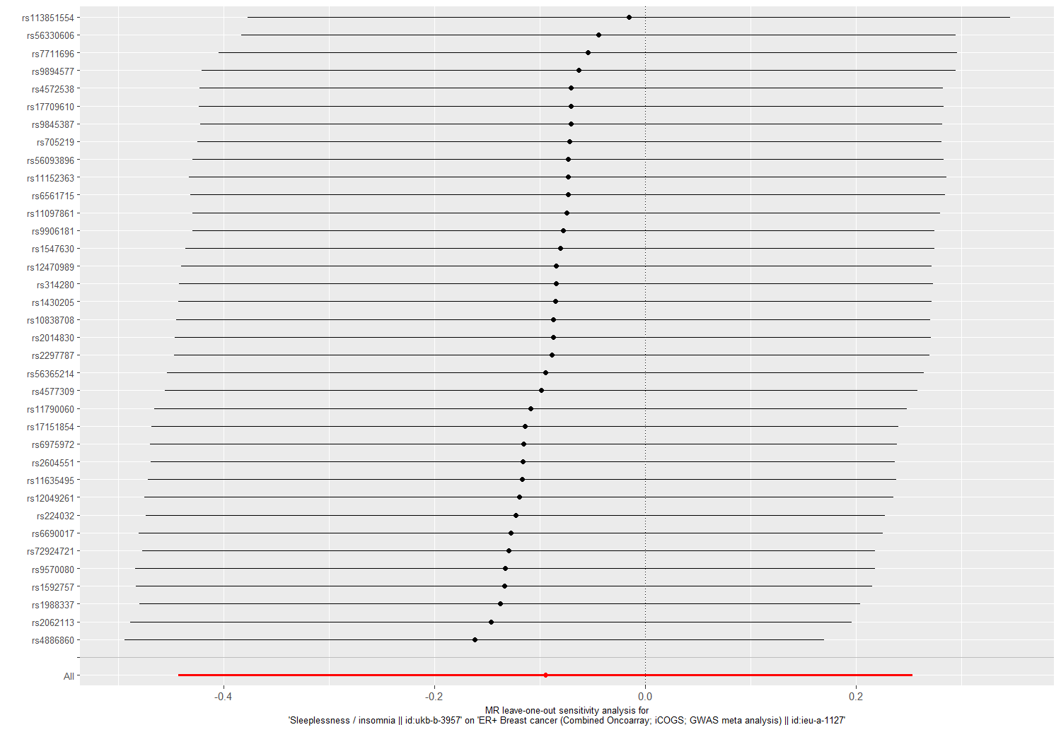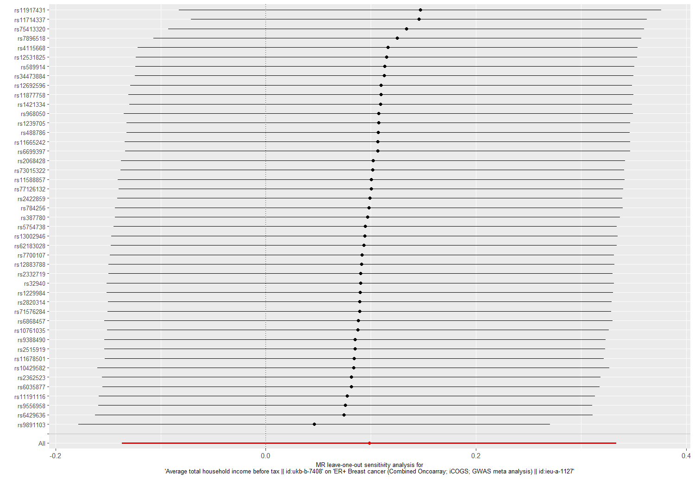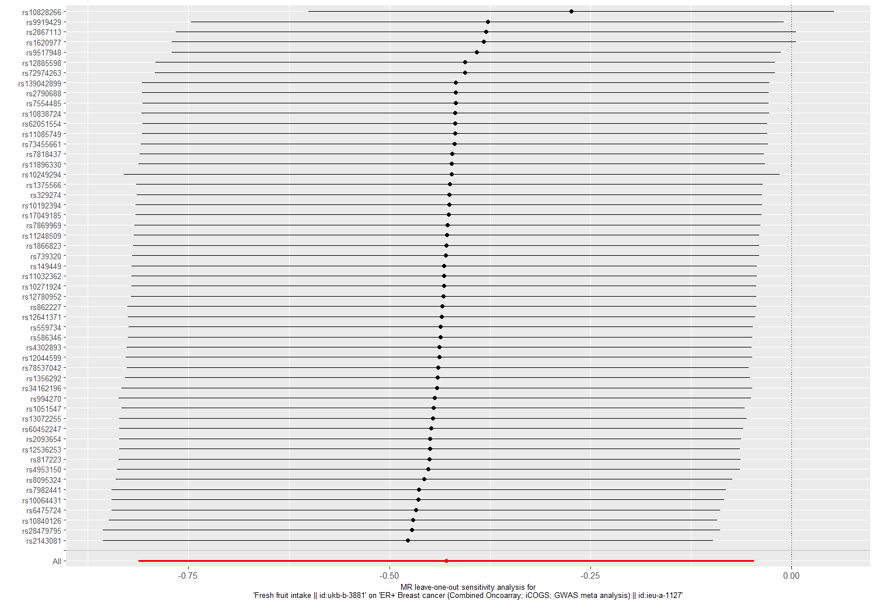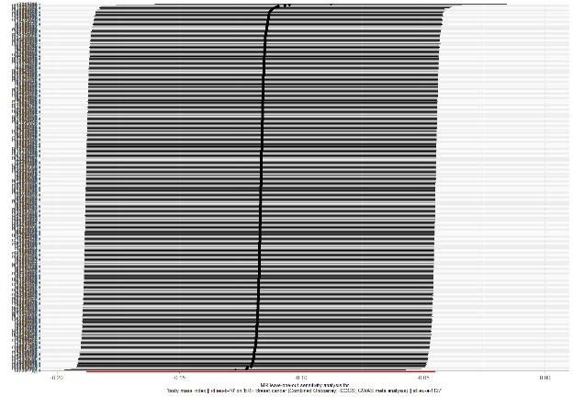
eFigure 7 Leave one out analysis for modifiable lifestyle factors on ER+ BC. a. Leave-one-out analysis of sleep duration and ER+ BC risk. b. Leave-one-out analysis of sleeplessness/insomnia and ER+ BC risk. c. Leave-one-out analysis of household income and ER+ BC risk. d. Leave-one-out analysis of fresh fruit intake and ER+ BC risk. e. Leave-one-out analysis of body mass index and ER+ BC risk.

a
b
c
e
d
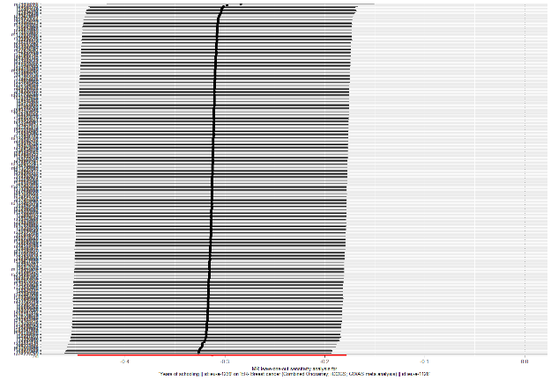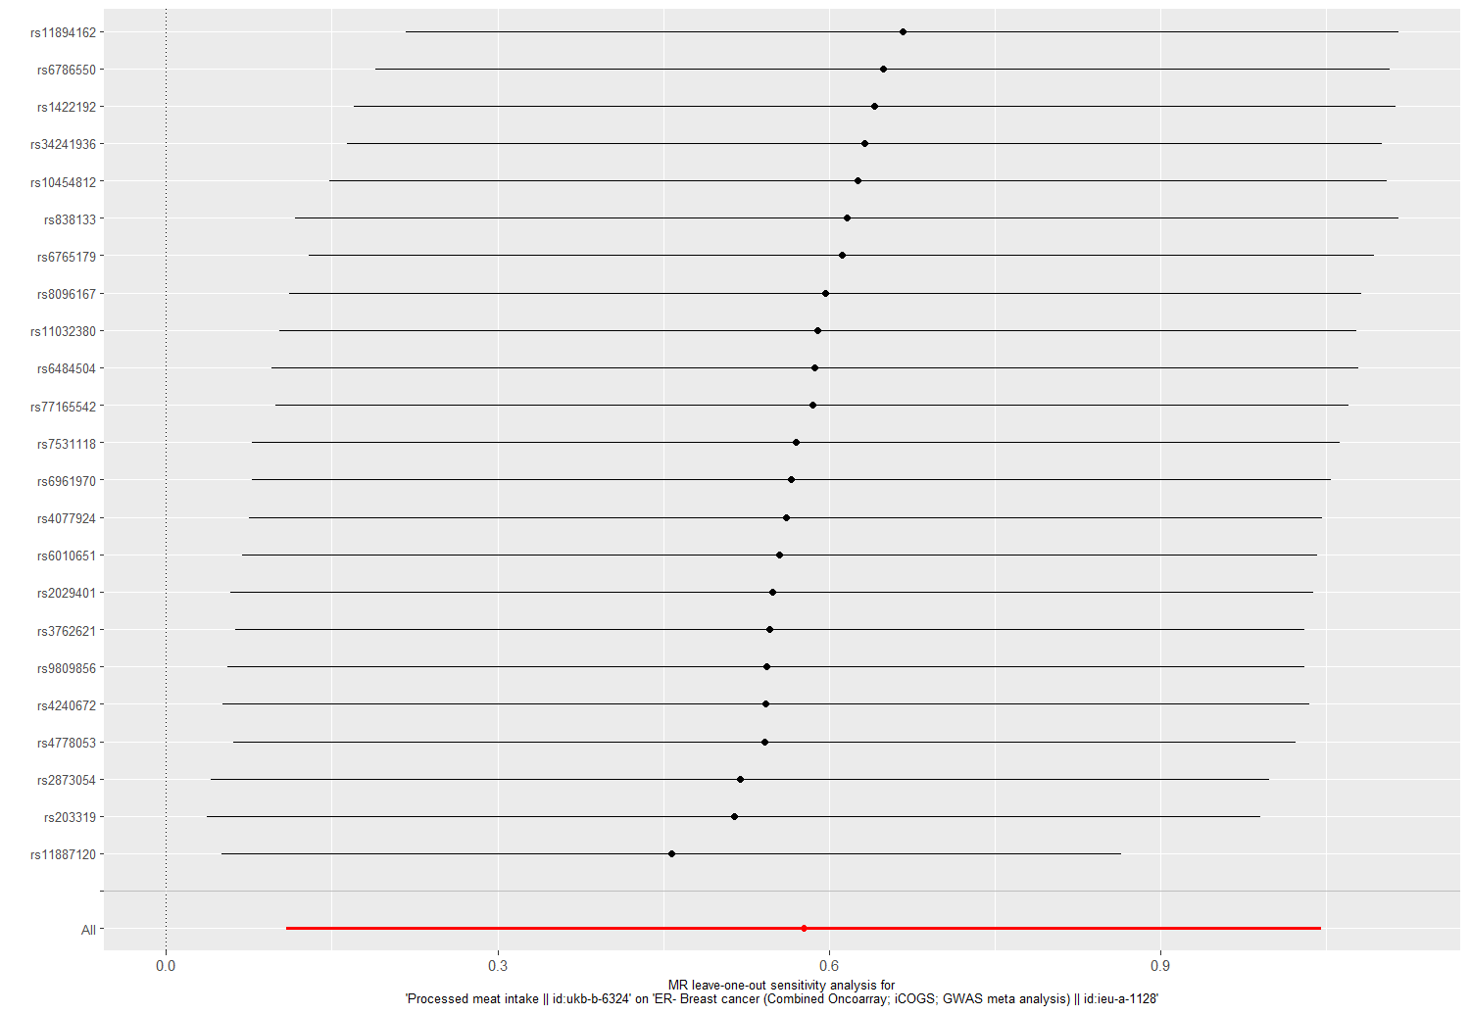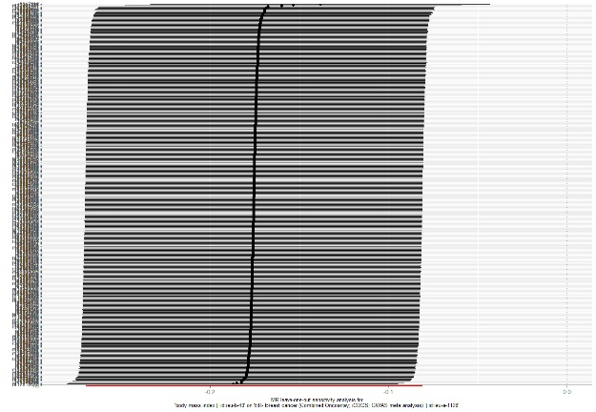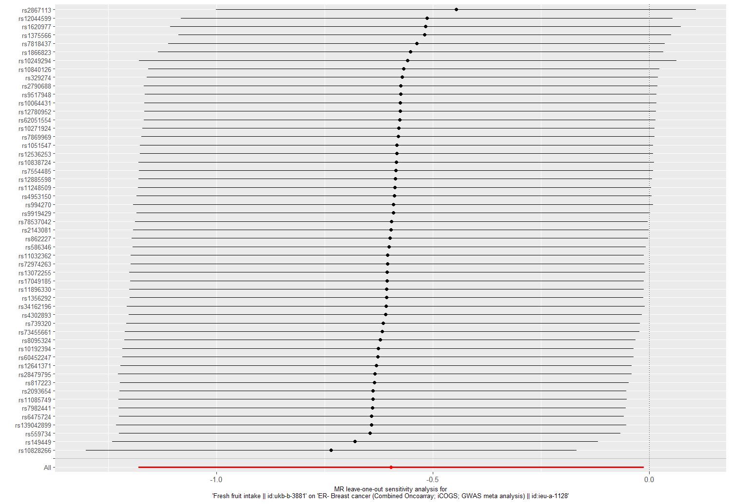
eFigure 8 Leave one out analysis for modifiable lifestyle factors on ER- BC. a. Leave-one-out analysis of years of schooling and ER- BC risk. b. Leave-one-out analysis of processed meat intake and ER- BC risk. c. Leave-one-out analysis of fresh fruit intake and ER- BC risk. d. Leave-one-out analysis of body mass index and ER- BC risk.

d
c
a
b
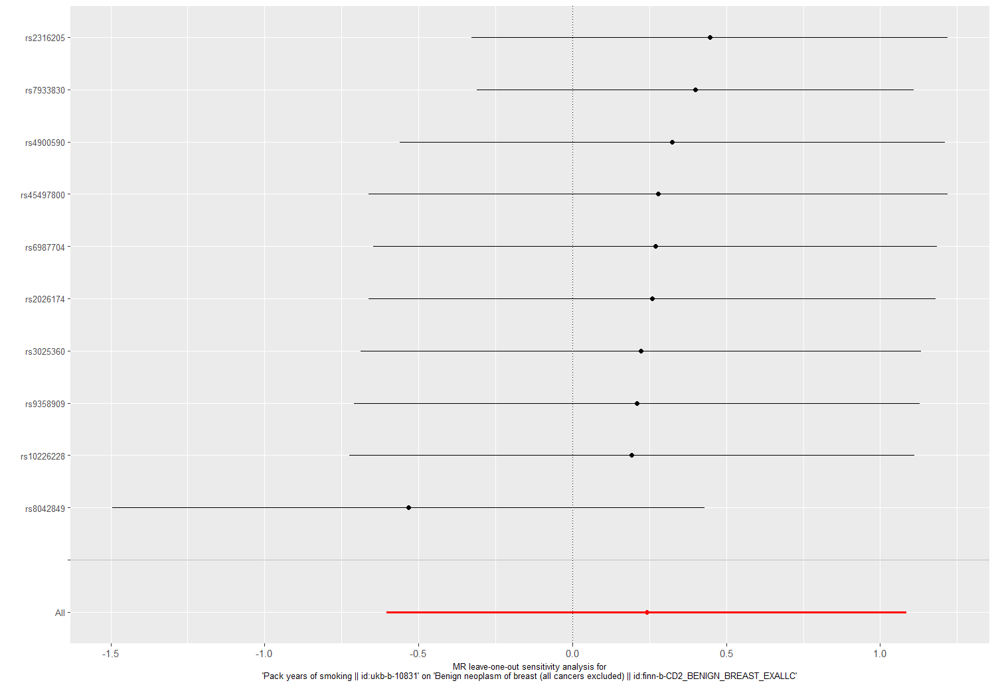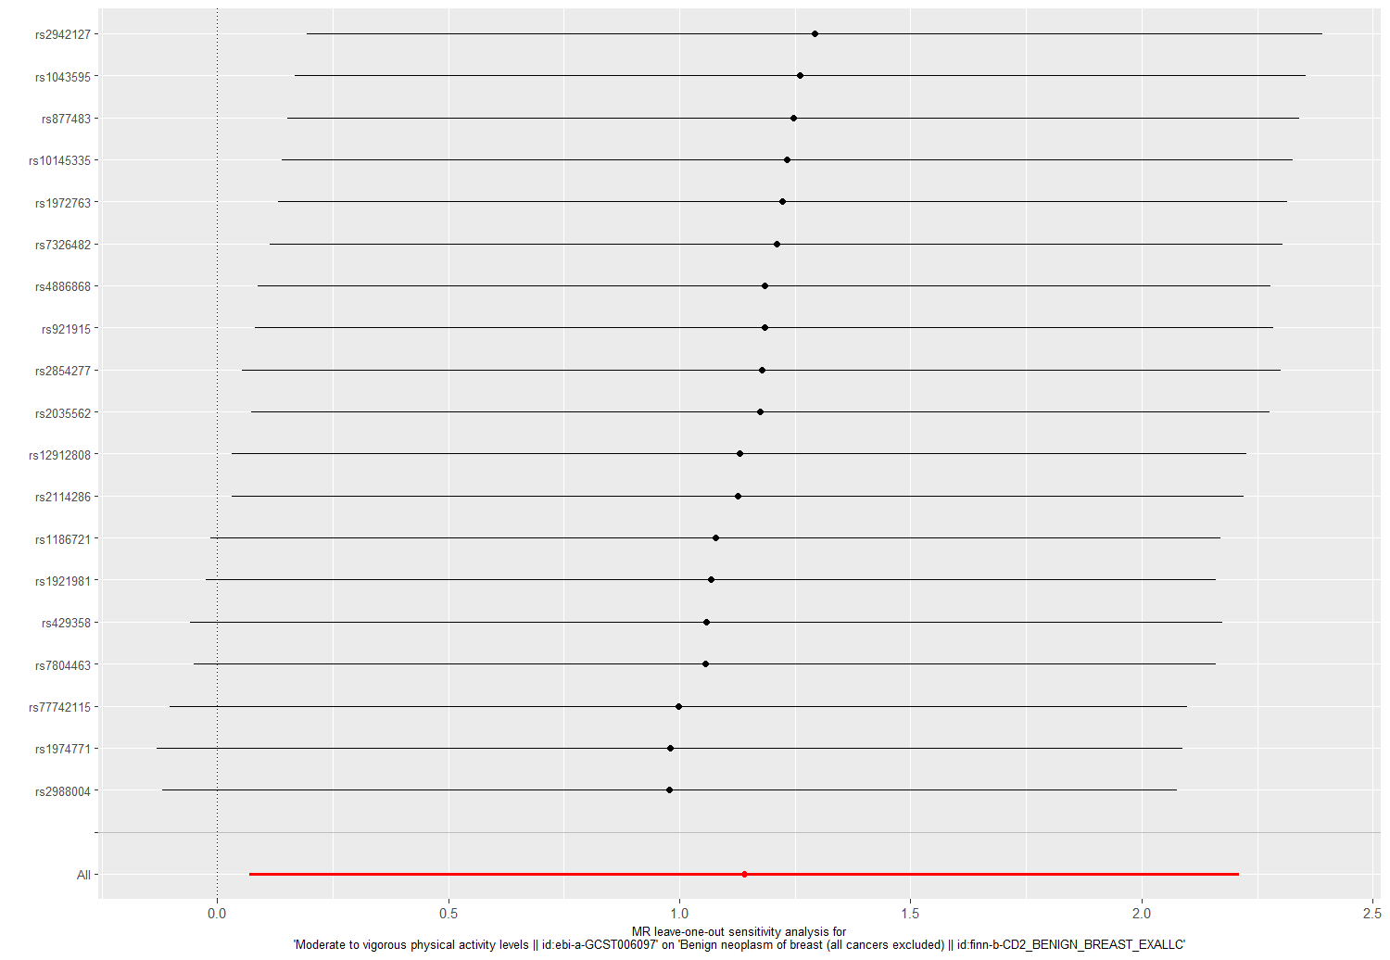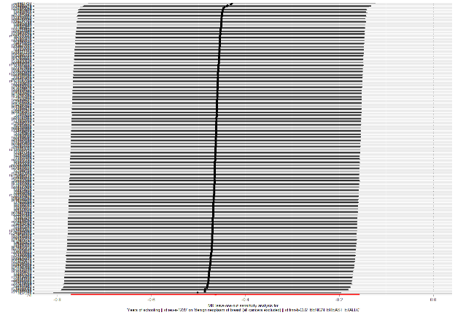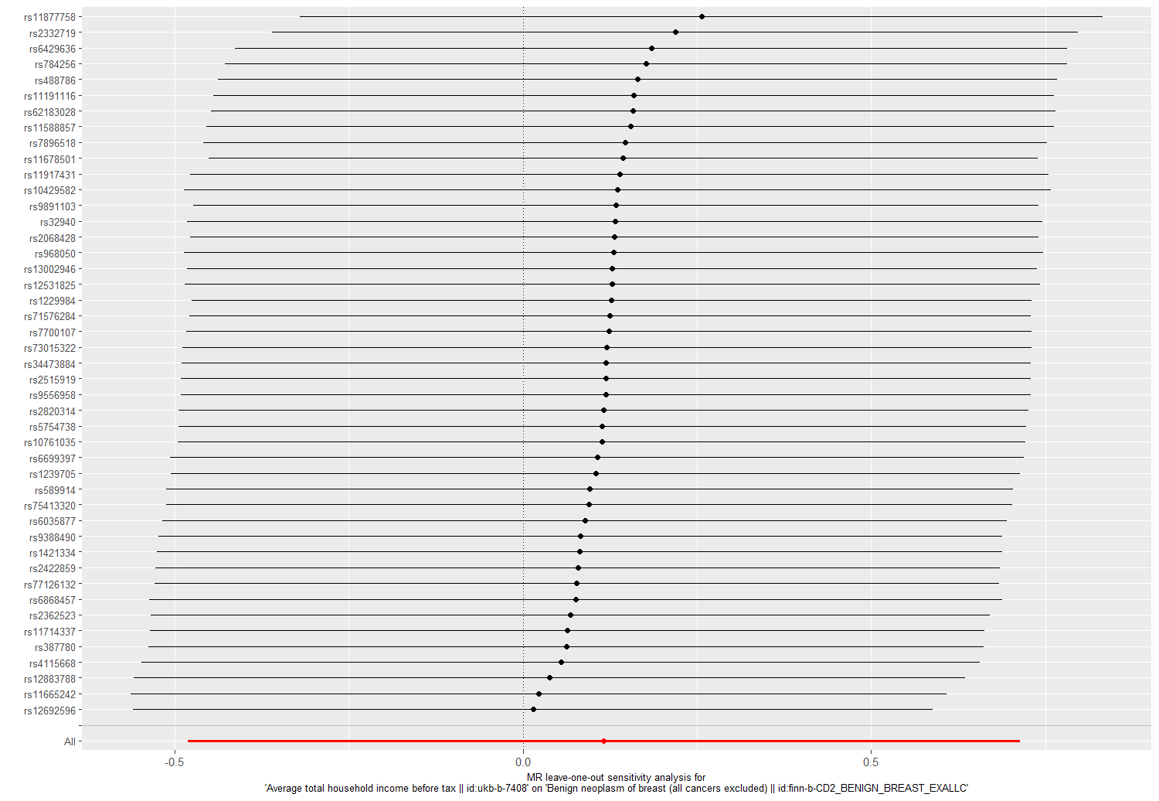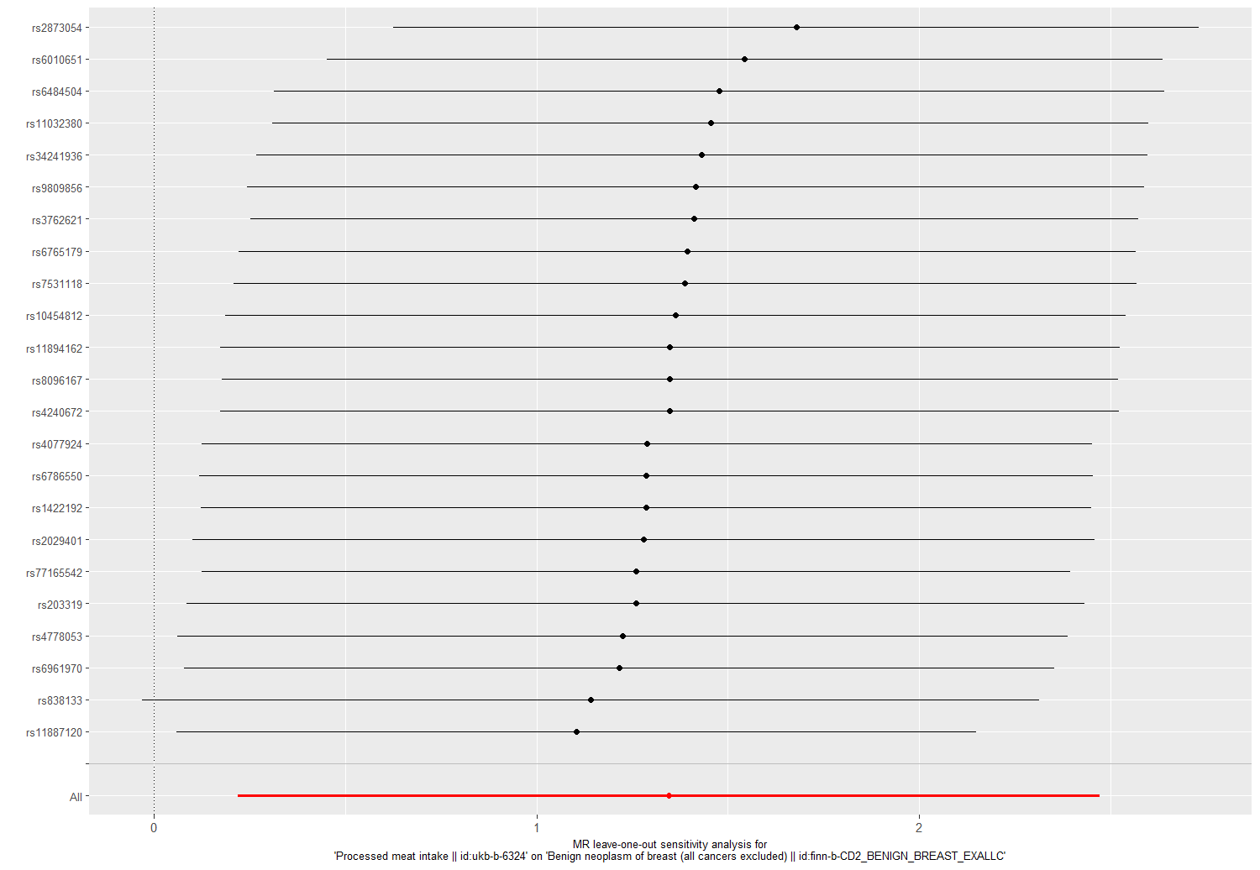
a
b
eFigure 9 Leave one out analysis for modifiable lifestyle factors on benign neoplasm of breast. a. Leave-one-out analysis of pack years of smoking and benign neoplasm of breast risk. b. Leave-one-out analysis of physical activity and benign neoplasm of breast risk. c. Leave-one-out analysis of years of schooling and benign neoplasm of breast risk. d. Leave-one-out analysis of household income and benign neoplasm of breast risk. e. Leave-one-out analysis of processed meat intake and benign neoplasm of breast risk.
c
d
e
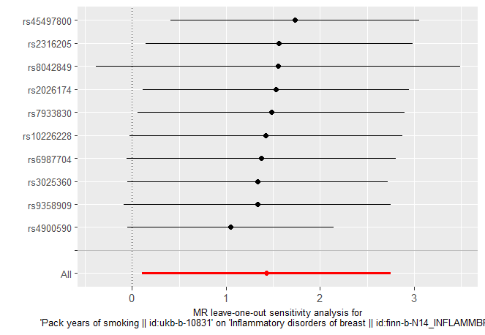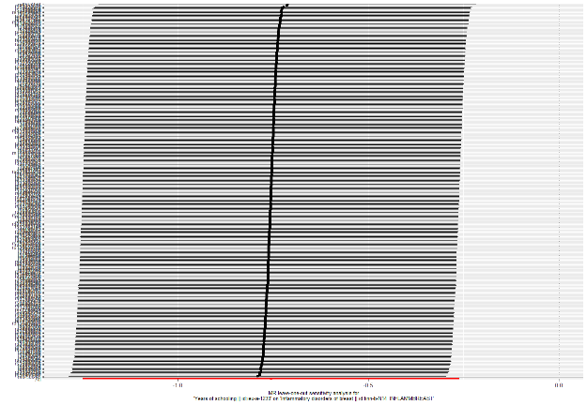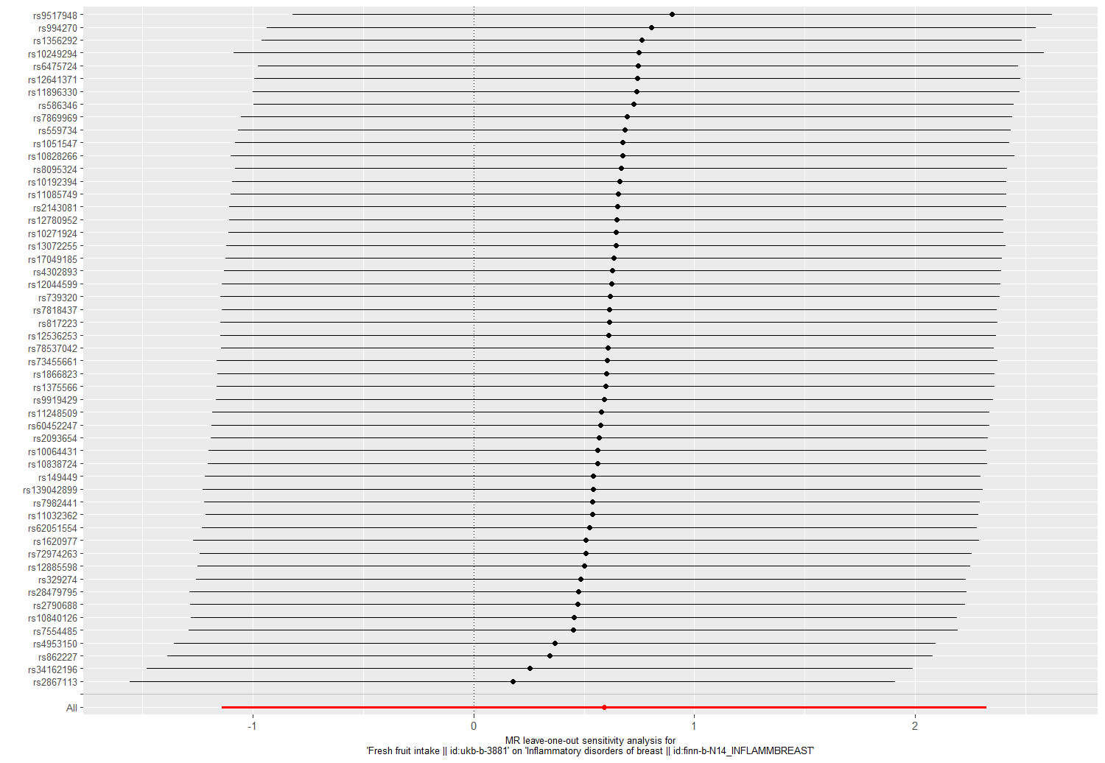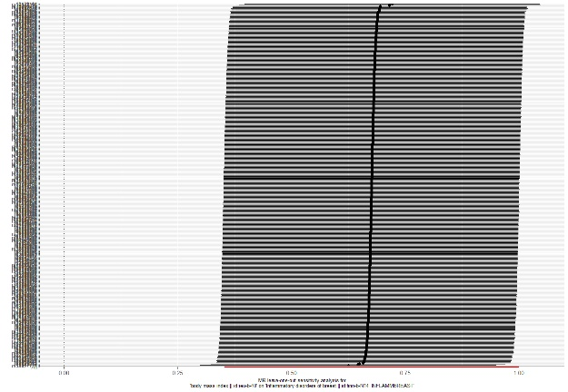
eFigure 10 Leave one out analysis for modifiable lifestyle factors on inflammatory disorders of breast. a. Leave-one-out analysis of pack years of smoking and inflammatory disorders of breast risk. b. Leave-one-out analysis of years of schooling and inflammatory disorders of breast risk. c. Leave-one-out analysis of fresh fruit intake and inflammatory disorders of breast risk. d. Leave-one-out analysis of body mass index and inflammatory disorders of breast risk.

a
b
c
d

