Electronic Supporting Information (ESI)

for

DNP-supported solid-state NMR studies of ¹³C,¹⁵N,²⁹Si-enriched biosilica of Cyclotella cryptica and Thalassiosira pseudonana

Helena Leona Ehren,^{1#} Felicitas Kolbe,² Alessandra Lucini Paioni,¹ Eike Brunner,² Marc Baldus^{1*}

¹ NMR Spectroscopy, Bijvoet Center for Biomolecular Research, Utrecht University, 3584 CH Utrecht, The Netherlands
² Chair of Bioanalytical Chemistry, Faculty of Chemistry and Food Chemistry, TU Dresden, 01062 Dresden, Germany

# present address: Chemical Biology and Drug Discovery, Utrecht Institute for Pharmaceutical Sciences and Bijvoet Center for Biomolecular Research, Utrecht University, 3584 CG Utrecht, The Netherlands

1. Scanning Electron Microscopy (SEM) images

Figure S1. SEM images of the ¹³C,¹⁵N,²⁹Si-enriched C. cryptica biosilica prepared for the NMR experiments, originally. The fibers shown in this image are supposed to consist of β-chitin and have a diameter of ca. 50 nm.

2. Additional DNP solid-state NMR spectrum of T. pseudonana biosilica
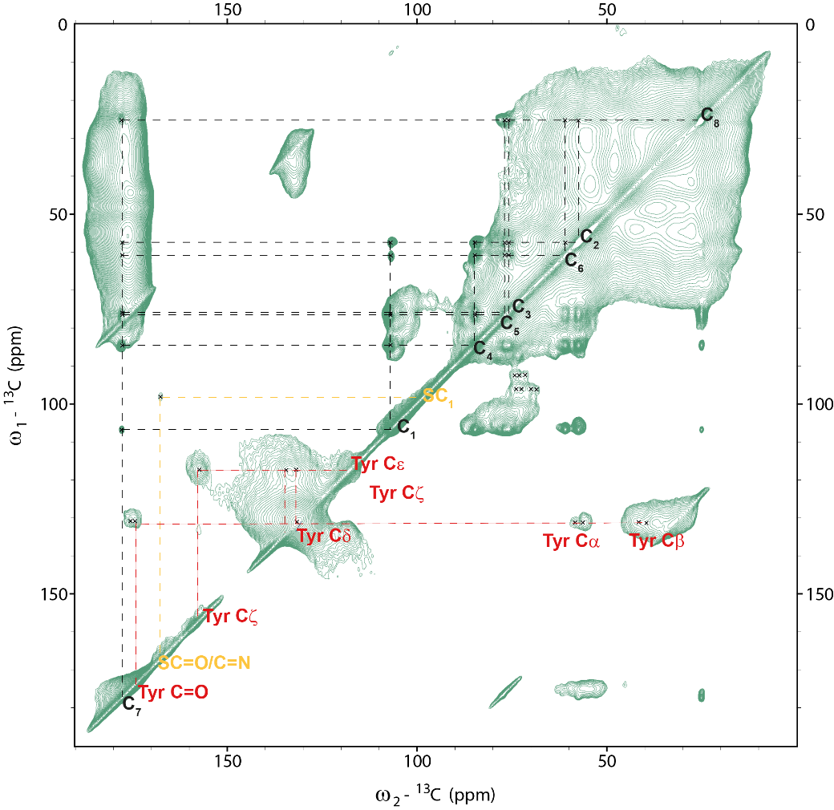

Figure S2. PDSD (Proton-Driven Spin-Diffusion) experiment of ¹³C,¹⁵N,²⁹Si-enriched T. pseudonana biosilica under DNP conditions. Additional carbohydrate peaks are visible between 90-100 ppm. A correlation from the sugar C1 region to a signal at 165 ppm indicates the presence of imine or guandinium containing sugars or cross linking between sugars and amino acids such as the guanidinum containing arginine or the carboxamide of citrulline. Also lower abundant, aromatic amino acids such as tyrosine become visible.

