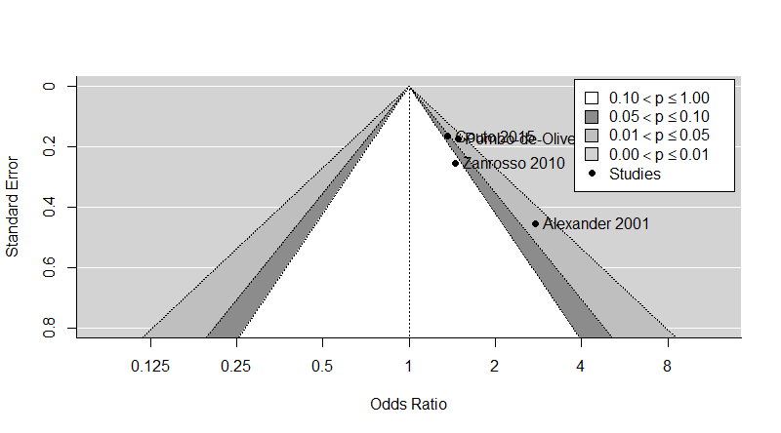Figure S2 - Funnel plot for the infant leukemia analysis

