ML-guided Design for New Electrolyte Additives for High-Performance 5 V LiNi_{0.5}Mn_{1.5}O₄ Cathodes
Bingning Wang,^{a,†} Hieu A. Doan^{b,†}, Seoungbum Son,ª Daniel P. Abraham,ª Stephen E. Trask,ª Andrew Jansen,ª Kang Xu,*^{,c} Chen Liao*^{, a}
ª Chemical Sciences and Engineering Division, Argonne National Laboratory, 9700 South Cass Avenue, Lemont, Illinois, 60439, United States
^{b} Materials Science Division, Argonne National Laboratory, 9700 South Cass Avenue, Lemont, Illinois, 60439, United States
^{c} SES AI Corps, 35 Cabot Road, Woburn, MA, 01801, United States
† These authors contributed equally: BW and HAD
* Corresponding authors: Kang Xu, kang.xu@ses.ai, Chen Liao, liaoc@anl.gov
Contents
1. Machine Learning methods 4
2. Design of the protocol 4
3. Laminate optimization 5
4. Electrochemical performance 7
4.1 Selection of Additives 7
4.2 3D plot 15
5. Capacity Loss Mechanisms demonstrated by various methods 16
5.1 Diagnostic Cycling of the Harvested Cells 16
5.2 ¹H Nuclear Magnetic Resonance 20
5.3 X-ray Photoelectron Spectroscopy (XPS) 20
5.4 Inductively Coupled Plasma Mass Spectrometry 22
5.5 Scanning Electron Microscopy and Energy-dispersive X-ray spectroscopy (EDX) analysis 23
5.6 Online Electrochemical Mass Spectrometry (OEMS) 26
6. References 27

Figure S1. Comparison between old and new LNMO laminates. The symbols in circles represent laminates w/o Armor- SAS polymer, while symbols in squares represent new laminates with SAS Armor Polymer. Electrolytes with additives show good performance for both the laminates with and without Armor Polymer 7
Figure S2. Capacity retention of LNMO//Gr using ) single additives b) dual additives, and c) ML predicted additives . 11
Figure S3. The HPPC (Hybrid Pulse Power Characterization) data of the additives is presented in Figure S3. Five formulas of additives demonstrate superior performance compared to the baseline electrolyte of 1.0 M LiPF₆ in EC/EMC (1/9, v/v): 1 wt% LiDFOB + 0.1M LDF, 1 wt% LiDFOB + 1 wt% MS, 1 wt% VC + 1 wt% MS, 1 wt% LiDFOB + 1 wt% TMSPi, and 0.25 wt% tVCBO + 1 wt% MS. Specifically, additives containing LiDFOB exhibit the best performance in terms of reducing the initial ific Impedance (ASI) and inhibiting its increase (∆ASI) during cycling. 12
Figure S4. The HPPC (Hybrid Pulse Power Characterization) data of the ML-predicted additives is presented here. Three formulas of additives demonstrate superior performance compared to the baseline electrolyte of 1.0 M LiPF6 in EC/EMC (1/9): 1 wt% LiDFOB + 1 wt% SA, 1 wt% LiBOB + 1 wt% MS, and 1 wt% LiBOB + 1 wt% SA. 13
Figure S5. Measured performance metrics of all the additives in this work. The red dots represent the 4 formulations that have the post-test analysis carried out in their cycled coin cells. 16
Figure S6. Schematic illustration to demonstrate the inaccessible site of Li (orange dots) that can be refilled at a slow rate. 18
Figure S7. Compared cycling performance of aged cathode at RPT 94th cycle (black) vs aged cathode reassembled with a fresh Li metal anode (blue). The cell was cycled with a) Baseline; b) 1wt% LiDFOB + 1wt% TMSPi; and c) 1wt% LiBOB + 1wt% SA; d) 1wt% LiBOB + 1wt% MS, and e) 1wt% LiDFOB + 1wt% TMSPi. 19
Figure S8. ¹H NMR spectra of the aged electrolytes in CDCl₃. 20
Figure S9. The C 1s, O 1s, F 1s and P 2p regions of XPS spectra of cycled cathodes: (a) C 1s region; (b) O 1s region; (c) F 1s region; (d) P 2p region. The legend shows the baseline electrolytes 1 (black), 1 wt% LiBOB + 1 wt% SA (purple), 1 wt% LiBOB + 1 wt% MS (green), 1 wt% LiDFOB + 1 wt% TMSPi (blue), 0.25 wt% tVCBO + 1 wt% MS (red). 21
Figure S10. ICP-MS spectra of electrolytes extracted from cycled cells. 22
Figure S11. SEM image (a) and the EDX mapping (b) of the cycled Gr anode using the baseline. 24
Figure S12. SEM image (a, b) and the EDX mapping (b, d) of the cycled Gr anode using the electrolyte with 0.25wt% tVCBO + 1wt% MS. cluster of Mn rich particles are presented in red cycles. 24
Figure S13. SEM image (a) and the EDX mapping (b) of the cycled Gr anode using the electrolyte with 1wt% LiDFOB + 1wt% TMSPi. Si and O rich particle depostions are presented in red cycles. 25
Figure S14. SEM image (a) and the EDX mapping (b) of the cycled Gr anode using the electrolyte with 1wt% LiBOB + 1wt% MS. 25
Figure S15. SEM image (a) and the EDX mapping (b) of the cycled Gr anode using the electrolyte with 1wt% LiBOB + 1wt% SA. 26
Figure S 16. OEMS measurement of H2 gas evolution during the first two galvanostatic cycles with LNMO//Gr cells. The cell was cycled between 2.5-5V for two cycles, and a 3h-constant voltage hold at 5 V was applied after each charge. 27

Scheme S1. Formation mechanism of a)in situ generated lithium malonato tetrafluorophosphates (MS); b) aged trimethylsilyl phosphite (TMSPi)……………………..9
Table S1. Summary of final area specific impedance (ASI), impedance rise (∆ASI), and final specific capacity (Q) for experimentally tested additives…………………………………….14
Table S2. The Li inventory content calculated from the first charge, first discharge and final charge capacity……………………………………………………………………………….17

1. Machine Learning methods
A Gaussian Process (GP) is a collection of random variables, any finite number of which have a joint Gaussian distribution.¹ A GP is completely specified by its mean function m(x) and covariance function (or kernel) k(x,x’), and can be written as:
$$f\left(x\right) \sim GP\left(m\left(x\right),k(x,x^{'})\right)$$
If x and x’ represent the feature vectors, then their covariance based on the Matérn kernel (ν=1.5) is expressed as follows:
$$k\left(x,x^{'}\right)=\left(1+\frac{\sqrt{3 } |x-x^{'}|}{σ_{l}}\right)*exp\left(-\frac{\sqrt{3}|x-x^{'}|}{σ_{l}}\right)+σ_{n}^{2}$$
Here, σ_{l} and σ_{n} are the length scale and the expected noise level in the data set, respectively. Each parameter was determined using the maximum likelihood estimate during model training, using Adam optimizer with a learning rate of 0.1 as implemented in the GPyTorch library ²

2. Design of the protocol
The protocol design of LiNi_{0.5}Mn_{1.5}O₄//Gr (LNMO//Gr) is critical for both the identification of decomposition products and the development of viable additives for improvements. A modification was made to the previous protocol³ to reduce the cycle length, which currently spans approximately 60 days. The revised protocol comprises the following steps:
a. Formation step of 5 cycles at C/10 cycles
b. Reference performance test (RPT) of C/25. Note that the revised protocol incorporates a slower rate compared to our previous results on the LiNi_{0.9}Mn_{0.05}Co_{0.05}O₂ study.⁴ This slower RPT is specifically designed to counteract the impedance effect observed at higher C rates, while simultaneously to ensure the generation of distinct and well-defined voltage plateaus.
c. Preparation cycle of 1/C and one Hybrid Pulse Power Characterization (HPPC) cycle.⁵ The HPPC cycle consists of 10-second pulses of 2C discharge and 1.5C charge. The currents in this context are expressed as C-rates, where 1C is approximately 2.4 mA. It is important to note that the theoretical capacity for LNMO is 147 mAh g⁻¹, assuming a loading of 21 mg per disc(1.54 cm²).
d. Aging cycles at a rate of C/3, the upper cutoff voltage is 4.7 V with 1 h hold (current drop to C/20) and a lower cutoff voltage of 3.8 V. Due to the relatively high upper cutoff voltage of 4.7 V, delamination is more prominently manifested in the large format (Φ=20 cm²) cells rather than the coin cells (Φ=1.54 cm²). To assess the performance of both the baseline and the additives, coin cells were also made using Armor-SAS polymer and carbon-coated Al current collectors, while keeping all other parameters unchanged. This choice of current collector aims to address the delamination issue while evaluating the performance of the cells..
e. Repeat steps b-d 4 times (a loop of 4).
f. The last RPT cycle of C/25 followed by one HPPC cycle.

3. Laminate optimization
Unlike the previous NMC (LiNi_{x}Mn_{y}Co_{z}O₂, x+y+z = 1) cathode materials, the LNMO cathodes exhibit delamination issues that are further exacerbated in larger formats.⁶ Luckily, where coin cell format with a 14 mm diameter cathode was utilized, the delamination had minimal impact on the cycling performance, allowing for good repeatability of results. One strategy to mitigate the delamination is to use specialty current collector, for example, a polymer-coated aluminum current collector provided by ARMOR-SAS.⁷ However, a noticeable discrepancy was observed in the baseline electrolyte system for LNMO laminates using ARMOR-SAS. As depicted in Fig. S1, the coated laminates (represented by black squares) exhibited a comparatively inferior cycling performance in contrast to the non-coated laminates (represented by black circles). This indicates that the ARMOR-SAS polymer coating may have had adversely affected the cycling behavior of the LNMO laminates. Further investigation is required to understand the underlying factors contributing to this discrepancy and identify potential solutions and will be reported in the future.
However, when additives (0.25 wt% tVCBO + 0.1M LDF, 0.25 wt% tVCBO + 1 wt% MS, or 1 wt% LiDFOB + 1 wt% TMSPi) were introduced to the system, a similar performance was observed between the coated and non-coated systems. This suggests that the presence of the non-coated laminate does not impede the efficacy of additives. In fact, all non-coated laminates perform better in presence of the additives than their coated laminate counterparts. The results indicate that the potential delamination at the high working voltage, does not emerge as a primary issue that interferes with the evaluation of additive efficiency. (Fig. S1)
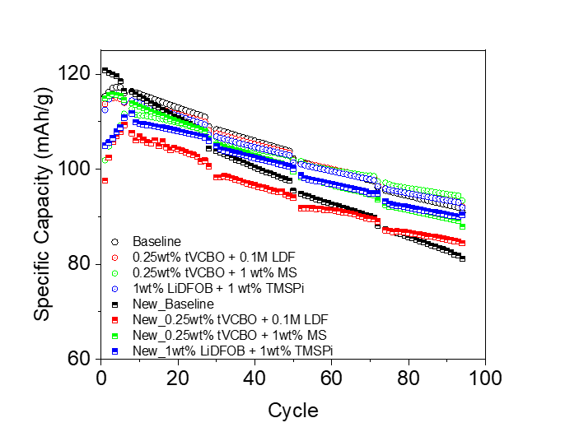
Figure S1. Comparison between old and new LNMO laminates. The symbols in circles represent laminates w/o Armor- SAS polymer, while symbols in squares represent new laminates with SAS Armor Polymer. Electrolytes with additives show good performance for both the laminates with and without Armor Polymer

4. Electrochemical performance

4.1 Selection of Additives
A series of additives, commonly employed to enhance the performance of either cathodes or anodes, have been utilized in the study. These additives are known to have beneficial effects such as reducing impedance, preventing lithium inventory loss, and mitigating electrolyte hydrolysis. They have been traditionally reported to contribute to the improvement of cathode and anode performance by addressing these specific issues. As depicted in Fig. 2 in the main text, both the single and dual additives (combination of two additives) are employed in the cathode and anode systems. For the cathode additives, we have included the following: lithium difluorophosphate (LDF), ⁸ in situ generated lithium malonato tetrafluorophosphates (MS),⁹ and aged trimethylsilyl phosphite (TMSPi).¹⁰ The aged TMSPi refers to a static aging process of approximately 1 week to allow the spontaneous reaction between the LiPF₆ and TMSPi to reach optimal concentration of (OSi(CH₃)₃)₂PF and (OSi(CH₃)₃)PF₂ to serve as a cathode additive.^{10, 11}The in situ lithium malonato tetrafluorophosphates (MS) was prepared through the spontaneous reaction between a bifunctional malonato trimethylsilyl ester with PF₆⁻. Scheme S1 (a) shows that the precursor replaces fluoride in the hexafluorophosphate, forming a bidentate monoanion tetrafluorophosphate P(ms)F₄⁻. As shown in Scheme S1 (b), in 1 week of aging of TMSPi, there is a spontaneous reaction between TMSPi and PF₅ and the optimal product of (OSi(CH₃)₃)₂PF and (OSi(CH₃)₃)PF₂ are obtained. Note that too long of aging (> 3 weeks) would lead to harmful PF₃ products. In terms of the anode additives, our selection comprises lithium difluorooxalato borate (LiDFOB),¹² vinylene carbonate (VC),¹³ and phenylboronic acid 1,3-propanediol ester (PBE),¹⁴ and trivinylcyclotriboroxane pyridine complex (tVCBO).¹⁵ The selection represents different elements consisting of C, H, Li, P, F, O, Si. Several functional groups are also represented in these additives, including aromatic of C₆H₅-, and C₅H₅ groups, P=O, P-F, -O-C(=O)-CH₂-C(=O)-O-, -SiMe₃, -C(=O)-O-, B-F, B-O, B-CHCH₂, -C=C-, etc. By adopting an experimentalàtheoreticalàexperimental approach, even with a limited dataset, we can draw meaningful conclusions and make informed improvements to the additives used for LNMO cathodes. This approach allows us to leverage the available experimental data as a starting point and then employ theoretical insights to guide further experimentation.

a.
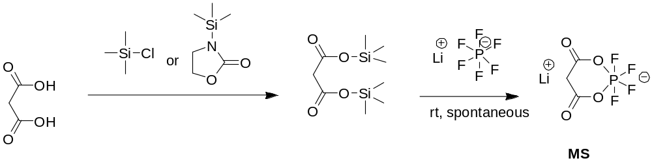
b.
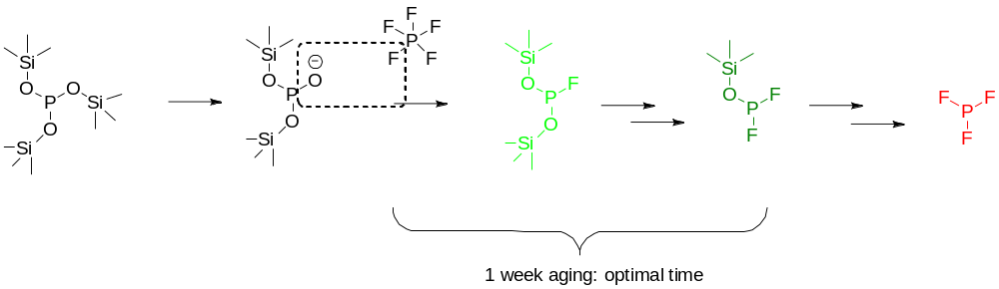
Scheme S1. Formation mechanism of a)in situ generated lithium malonato tetrafluorophosphates (MS); b) aged trimethylsilyl phosphite (TMSPi).
The structures of the additives are shown in Fig. 2 in the main text, and their acronyms and full names are listed below:
LiDFOB, lithium difluorobisoxalatoborate; VC, vinylene carbonate; PBE, Phenylboronic acid 1,3-propanediol ester; tVCBO, trivinylcyclotriboroxane; VTA, 1-vinyl-1,2,4-triazole; Vim, 1-Vinylimidazole; LiBOB, Lithium bis(oxalato)borate; Li₂C₂O₄, Lithium oxalate; ADM, 6-Methyl-2-vinyl-1,3,6,2-dioxazaborocane-4,8-dione; LDF, lithium difluorooxyphosphate; TMSPi, tris(trimethylsilyl) phosphite; MS, in situ lithium malonatotetrafluorophosphate; DDD, dimethyl-2,5-dioxahexanedioate; LiBFEP, lithium bis(2,2,2-trifuoroethyl) phosphate; BA, Butyric anhydride; PTSI, p-toluenesulfonyl; MPS, Methyl phenyl sulfone; LiOtC₄F₉, lithium nonafluoro-tert-butoxide; DEPP, diethyl phenylphosphonite; DPDMS, dimethoxydiphenylsilane; SA, succinic anhydride; TPP, triphenyl phosphate; TMSPa, tris(trimethylsilyl) phosphate; PES, prop-1-ene-1,3-sultone.
The overall electrochemical performance of the additives is presented in Fig. S2. The baseline electrolyte comprises 1.0 M of LiPF₆ in EC/EMC (1/9, v/v) with a lower EC content compared to previous generations of baselines, which were utilized for other transition metal oxide cathodes (TMOs). The reduced EC content is to improve its stability at high voltages, as EC has a ring structure with a lower anodic stability than other carbonates.¹⁶ According to Manthiram et al, ¹⁷ a formulation with a lower EC content is preferred for high voltage cathodes to minimize side reactions at high states of charge (SOC).
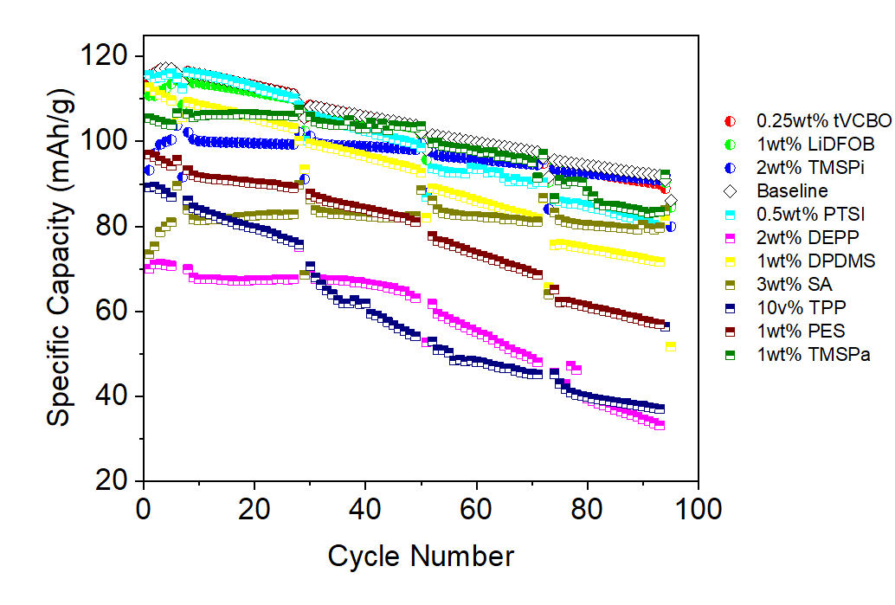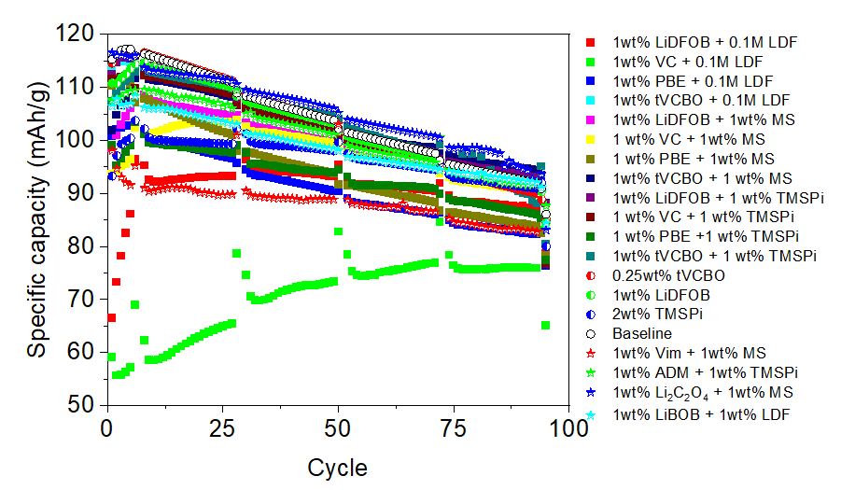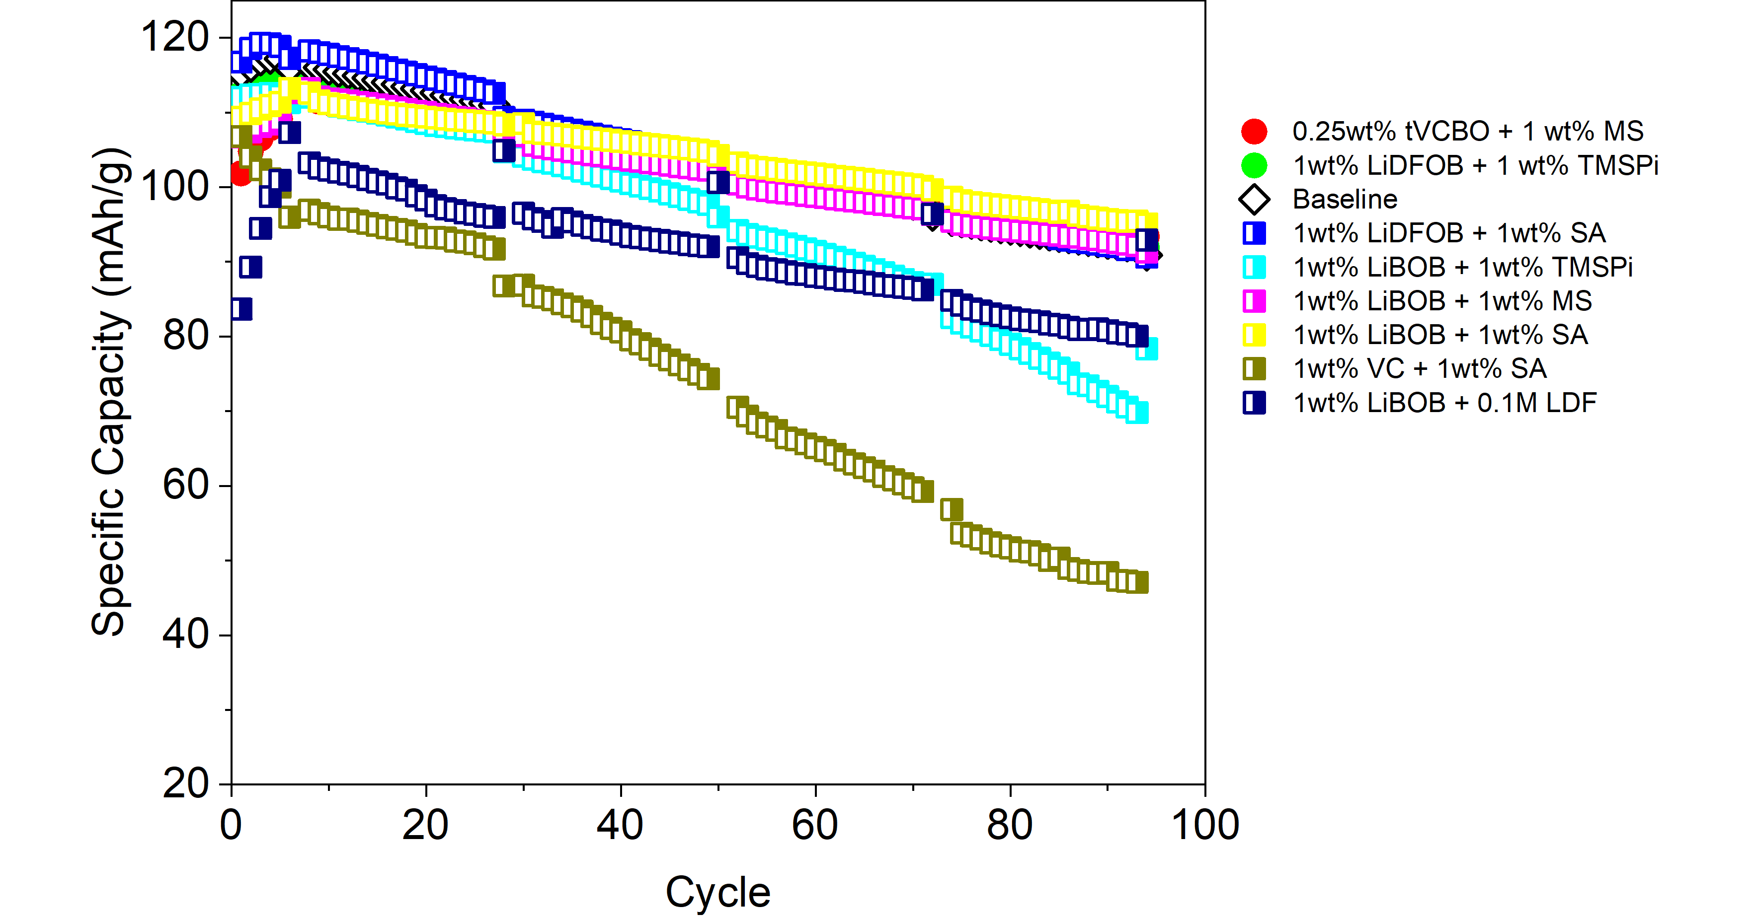
c
b
a
Figure S2. Capacity retention of LNMO//Gr using ) single additives b) dual additives, and c) ML predicted additives .
The HPPC data of the additives is presented in Figs. S3 and S4. Specifically, additives containing LiDFOB exhibit the best performance in terms of reducing the initial Area Specific Impedance (ASI) and inhibiting its increase during cycling.
In a parallel study, it was observed that the main impedance in the LNMO||Gr (graphite) system originates from the cathode side, and the composition of the laminate significantly impacts the impedance. For instance, the addition of 0.05 wt% Single-Wall Carbon Nanotube (SWCNT)in the slurry composition for the cathode laminate results in a reduction of the initial impedance from 55 Ω·cm² to 25.58 Ω·cm² (unpublished data).

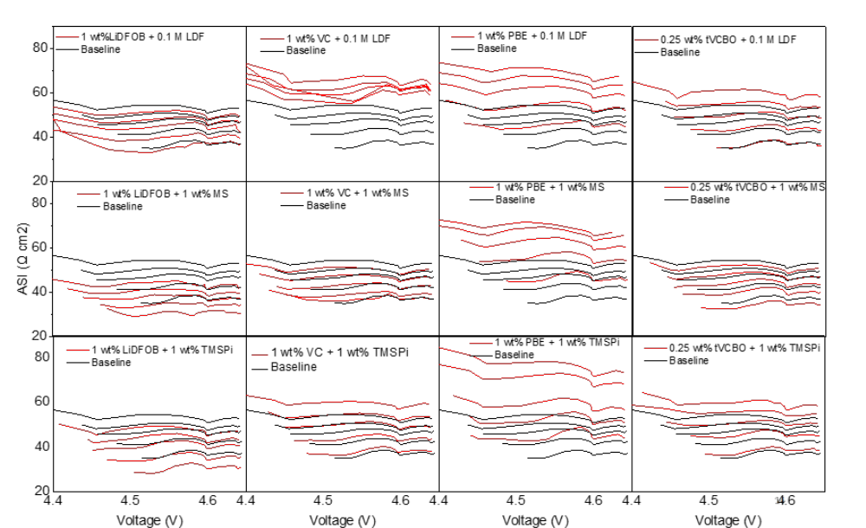
Figure S3. The HPPC (Hybrid Pulse Power Characterization) data of the additives is presented in Figure S3. Five formulas of additives demonstrate superior performance compared to the baseline electrolyte of 1.0 M LiPF₆ in EC/EMC (1/9, v/v): 1 wt% LiDFOB + 0.1M LDF, 1 wt% LiDFOB + 1 wt% MS, 1 wt% VC + 1 wt% MS, 1 wt% LiDFOB + 1 wt% TMSPi, and 0.25 wt% tVCBO + 1 wt% MS. Specifically, additives containing LiDFOB exhibit the best performance in terms of reducing the initial ific Impedance (ASI) and inhibiting its increase (∆ASI) during cycling.

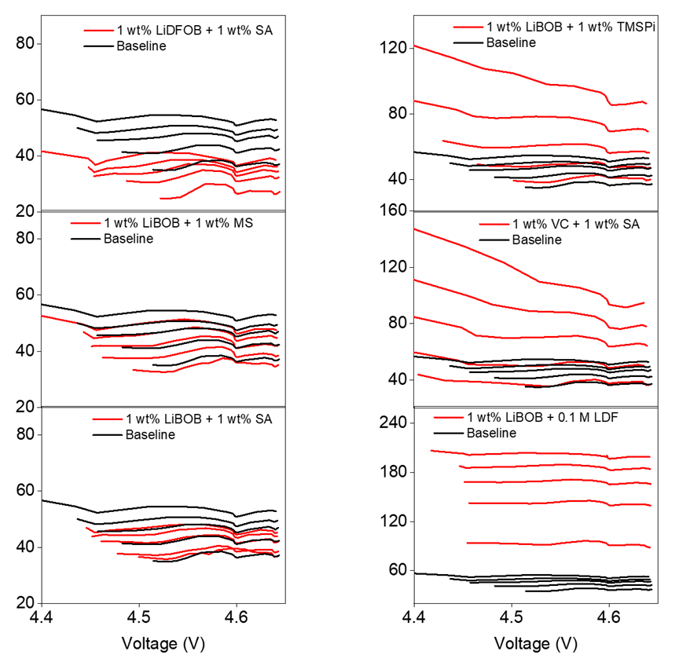
Figure S4. The HPPC (Hybrid Pulse Power Characterization) data of the ML-predicted additives is presented here. Three formulas of additives demonstrate superior performance compared to the baseline electrolyte of 1.0 M LiPF6 in EC/EMC (1/9): 1 wt% LiDFOB + 1 wt% SA, 1 wt% LiBOB + 1 wt% MS, and 1 wt% LiBOB + 1 wt% SA.
The final ASI, the impedance rise (∆ASI), as well as the final specific capacity (Q) in the experimentally validated results are shown in Table S1.

Table S1. Summary of final area specific impedance (ASI), impedance rise (∆ASI), and final specific capacity (Q) for experimentally tested additives.
Electrolyte Composition | ASI (Ω•cm²) | ΔASI (Ω•cm²) | Q (mAh/g)
0.25wt% tVCBO | 50.15 | 18 |  | 89.966
1wt% LiDFOB | 45.78 | 17 |  | 91.235
2wt% TMSPi | 50.29 | 16 |  | 90.96
0.5wt% PTSI | 69.53 | 41 |  | 79.961
2wt% DEPP | 143.07 | 88 |  | 33.216
1wt% DPDMS | 72.92 | 39 |  | 71.673
3wt% SA | 81.72 | 24 |  | 79.728
10wt% TPP | 105.10 | 57 |  | 37.072
1wt% PES | 118.84 | 76 |  | 56.982
1wt% TMSPa | 50.99 | 17 |  | 83.502
1wt% LiDFOB + 0.1M LDF | 50.79 | 17 |  | 87.057
1wt% VC + 0.1M LDF | 65.58 | 7 |  | 75.883
1wt% PBE + 0.1M LDF | 71.36 | 28 |  | 82.240
0.25wt% tVCBO + 0.1M LDF | 61.18 | 26 |  | 93.334
1wt% LiDFOB + 1wt% MS | 44.21 | 15 |  | 90.903
1wt% VC + 1wt% MS | 51.01 | 15 |  | 90.196
1 wt% PBE +1 wt% MS | 71.76 | 27 |  | 83.830
0.25 wt% tVCBO + 1 wt% MS | 51.26 | 19 |  | 94.367
1wt% LiDFOB + 1wt% TMSPi | 49.01 | 21 |  | 92.980
1wt% VC + 1wt% TMSPi | 60.01 | 23 |  | 92.011
1 wt% PBE +1 wt% TMSPi | 77.95 | 35 |  | 86.013
0.25wt% tVCBO + 1 wt% TMSPi | 59.62 | 23 |  | 88.058
1wt% Li₂C₂O₄ + 1wt% MS | 60.09 | 19 |  | 91.579
1wt% LiBOB + 1wt% LDF | 54.77 | 16 |  | 92.042
1wt% ADM + 1wt% LiOtC₄F₉ | 118.40 | 80 |  | 42.188
1wt% LiBOB + 1wt% LiBFEP | 180.22 | 94 |  | 50.021
1wt% LiDFOB + 1wt% LiBFEP | 111.47 | 53 |  | 66.744
1wt% ADM + 1wt% TMSPi | 129.23 | 46 |  | 91.470
Baseline | 54.47 | 19 |  | 91.942
1wt% LiDFOB + 1wt% SA | 41.19 | 16 |  | 91.792
1wt% LiBOB + 1wt% TMSPi | 104.76 | 66 |  | 69.803
1wt% LiBOB + 1wt% MS | 50.13 | 17 |  | 92.171
1wt% LiBOB + 1wt% SA | 46.79 | 10 |  | 95.486
1wt% VC + 1wt% SA | 123.53 | 86 |  | 47.072
1wt% LiBOB + 1wt% LDF | 203.43 | 110 |  | 80.061

4.2 3D plot

The effectiveness of the additives is further assessed through a 3D plot,¹⁵ as shown in Fig. S5. Only 4 additives outperform the baseline electrolyte. These four superior formulations are identified as 1 wt% LiDFOB + 1 wt% TMSPi, 0.25 wt% tVCBO + 1 wt% MS, 1 wt% LiBOB + 1 wt% MS, and 1 wt% LiBOB + 1 wt% SA. Note that the latter two formulations are predicted through ML before validation in experiments. These cells were submitted to further post-test analysis to understand the fading mechanism.
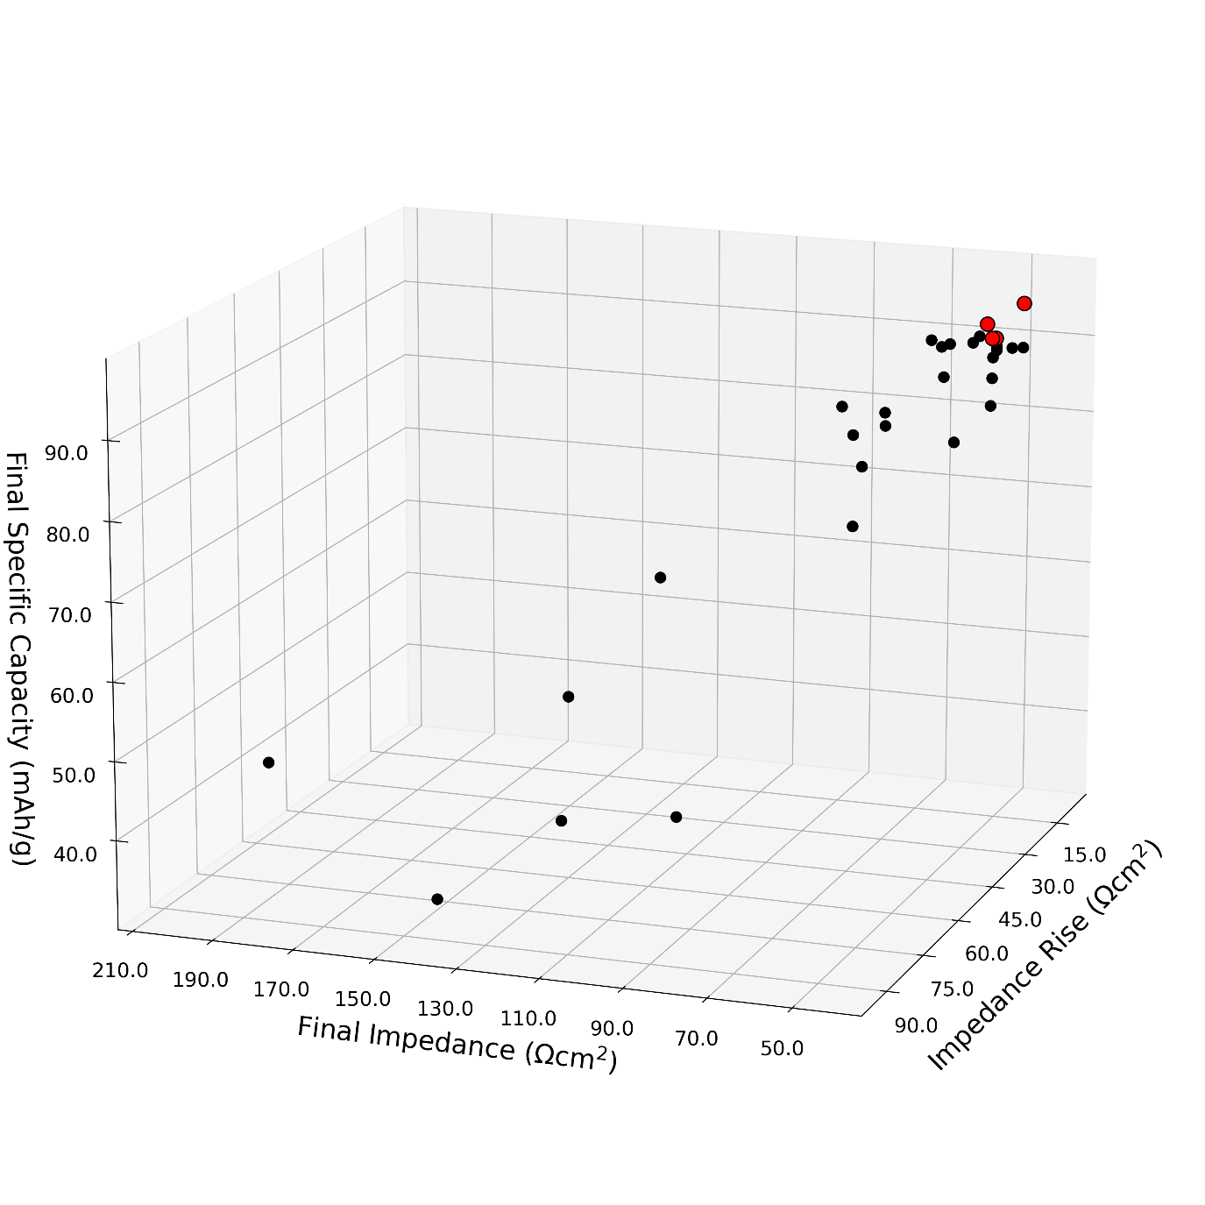
Figure S5. Measured performance metrics of all the additives in this work. The red dots represent the 4 formulations that have the post-test analysis carried out in their cycled coin cells.

5. Capacity Loss Mechanisms demonstrated by various methods

5.1 Diagnostic Cycling of the Harvested Cells
The initial results of the kinetically accessible Li inventory obtained by electrochemical cycling are shown in Table S2. From Table S2, the baseline solution shows significant loss of inventory in cathodes. The consumption of Li inventory during the solid electrolyte interface (SEI) formation is the most in 1wt% LiDFOB +1wt% TMSPi, and much less in the electrolyte containing 0.25wt% tVCBO + 1wt% MS and 1wt% LiDFOB +1wt% TMSPi. The table further confirms that the difference observed in the 3D plot is mainly due to the loss of inventory in cathode that is exacerbated by transition metal (TM) dissoltuion.

Table S2. The Li inventory content calculated from the first charge, first discharge and final charge capacity.
Electrolytes | Kinetically inaccessible Li inventory (mAh g⁻¹)ª | First Charge capacity  (mAh g⁻¹) | First Discharge capacity  (mAh g⁻¹) | Irreversible capacity for 1st cycle (SEI)  (mAh g⁻¹)^{b} | Final discharge capacity  (mAh g⁻¹) | Loss of inventory in cathode  (mAh g⁻¹)^{c}
Baseline | 13.2 | 133.8 | 122.0 | 11.7 | 74.8 | 47.3
0.25wt% tVCBO + 1wt% MS | 2.5 | 144.5 | 133.1 | 11.3 | 90.7 | 42.4
1wt% LiDFOB +1wt% TMSPi | 0.8 | 146.2 | 132.5 | 13.6 | 91.3 | 41.2
1wt% LiBOB + 1wt% MS | 0.9 | 146.1 | 136.0 | 10.1 | 97.8 | 38.2
1wt% LiBOB + 1wt% SA | 2.1 | 144.9 | 135.1 | 9.7 | 97.6 | 37.6
- The kinetically inaccessible Li inventory was calculated by subtracting first charge from the theoretical capacity of 147 mAh g⁻¹;
- Irreversible capacity for 1st cycle was calculated by subtracting first discharge capacity from first charge capacity.
- Loss of inventory was calculated by subtracting final discharge capacity from first charge capacity.

A specific protocol was implemented to investigate the amount of lithium inventory trapped in the cathode. In this protocol, the cell was disassembled when it reached the discharged state, with all cyclable lithium inventory remaining in the cathode. Subsequently, both the anode and cathode were paired with fresh lithium metal and fresh lithium electrolyte (1.0 M LiPF₆ in EC/EMC, 1/9 v/v). Note that neither of the discs were washed during the disassembly process to preserve the primary morphologies and compositions of the potential SEI and Cathode Electrolyte Interphase (CEI), as well as the grain boundaries. This preservation helps in analyzing the properties and behavior of these interfaces.
The protocol for the cathode involved an initial discharge step at a rate of C/100 (hundredth of the capacity of the cell) followed by one charge and one discharge cycle at the same rate.
By following this protocol, we were able to study the amount of lithium inventory that remained trapped in the cathode and investigate the behavior of these cathode under controlled conditions. Note also only the cells with the best performers are subjected to this procedure, namely, 0.25wt% tVCBO + 1wt% MS, 1wt% LiDFOB +1wt% TMSPi, 1wt% LiBOB + 1wt% MS, and 1wt% LiBOB + 1wt% SA.

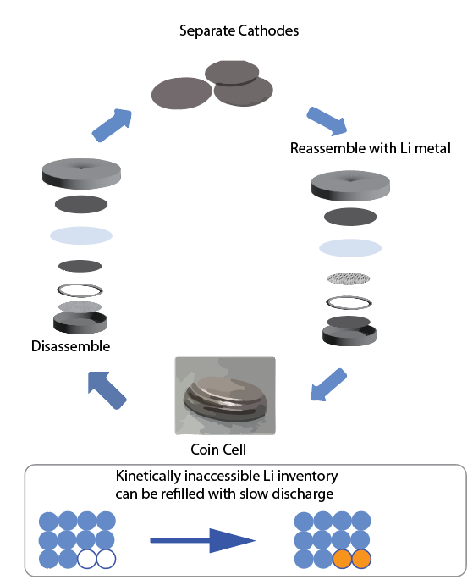
Figure S6. Schematic illustration to demonstrate the inaccessible site of Li (orange dots) that can be refilled at a slow rate.

As depicted in Fig. S7, the performance of three reassembled cells using the baseline, 1 wt% LiDFOB + 1 wt% TMSPi, and 1 wt% LiBOB + 1 wt% SA is shown. These results demonstrate that the aged cathode that is coupled with fresh Li (blue) exhibited high specific capacities, surpassing the specific capacities of the last slow C/25 RPT cycles. This observation indicates that the degradation mechanism is primarily attributed to lithium inventory loss rather than the loss of cathode active materials.
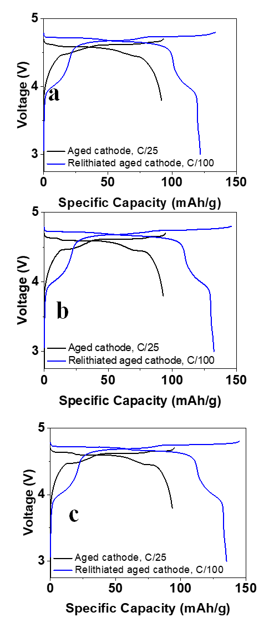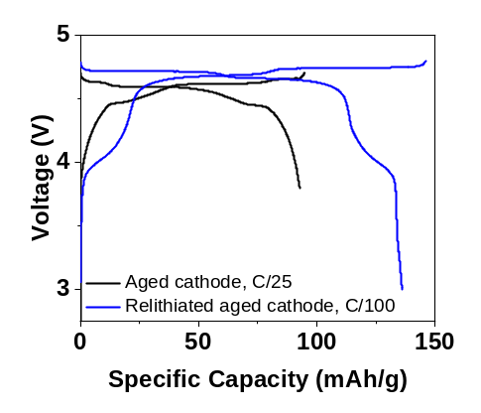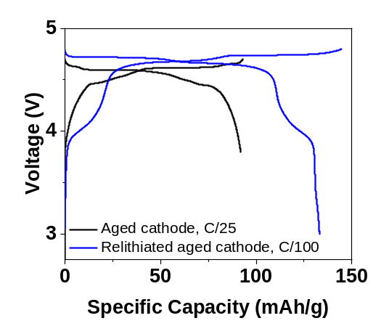
d
e

Figure S7. Compared cycling performance of aged cathode at RPT 94th cycle (black) vs aged cathode reassembled with a fresh Li metal anode (blue). The cell was cycled with a) Baseline; b) 1wt% LiDFOB + 1wt% TMSPi; and c) 1wt% LiBOB + 1wt% SA; d) 1wt% LiBOB + 1wt% MS, and e) 1wt% LiDFOB + 1wt% TMSPi.

5.2 ¹H Nuclear Magnetic Resonance
¹H spectroscopy serves as a valuable method for detecting side products such as transesterification or hydrolysis that are generated in the electrolyte during cycling. Transesterification involves the interchange of carbonate esters, wherein the side products of diethyl carbonate (DEC) and dimethyl carbonate (DMC) indicate the self-exchange between two EMC molecules. These techniques provide important insights into the presence and nature of side reactions occurring during the cycling process. Clearly, the presence of additives inhibited the formation of transesterification products (Fig. S8).

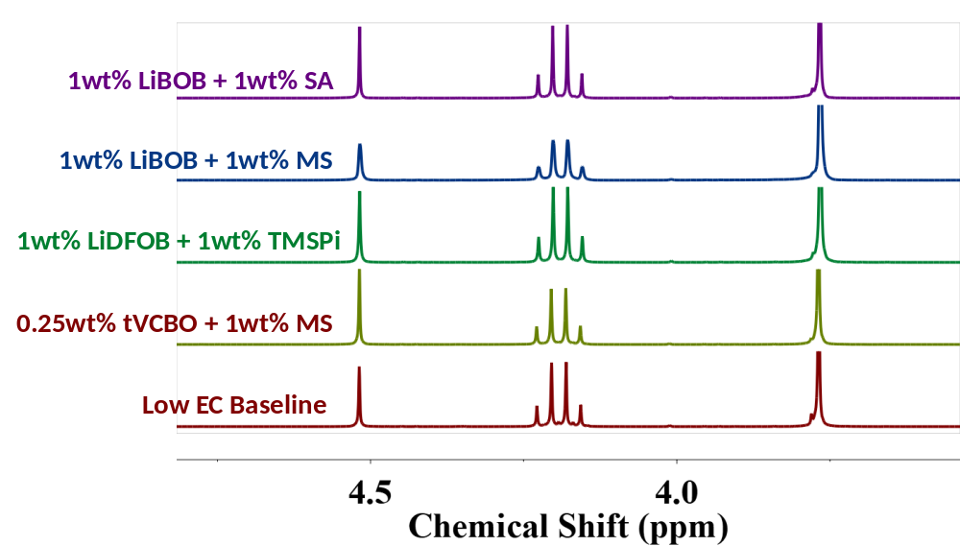
Figure S8. ¹H NMR spectra of the aged electrolytes in CDCl₃.

5.3 X-ray Photoelectron Spectroscopy (XPS)
XPS analysis provides valuable information on the chemical composition and bonding at the outermost layer of the cathode laminate, including the formation of the SEI and CEI. Our previous XPS study revealed a correlation between the content of oxyfluorophosphate (LiPO_{x}F_{y}) on the cathode surface and the beneficial effect on impedance reduction.⁸ Here, the CEI contents of aged cathodes were examined by XPS from the best performing additives (0.25 wt% tVCBO + 1 wt% MS and 1 wt% LiDFOB + 1 wt% TMSPi, 1wt% LiBOB + 1wt% MS, and 1wt% LiBOB + 1wt% SA) and compared to that of the baseline. The XPS spectra (Fig. S9) demonstrate that the presence of two additive formulas (1 wt% LiDFOB + 1 wt% TMSPi and 0.25 wt% tVCBO + 1 wt% MS) promotes the formation of oxyfluorophosphate (indicated by a peak at 135 eV in the P2p region) and LiF (indicated by a peak at 685 eV in the F1s region), leading to improved CEI quality and a significant reduction in impedance.
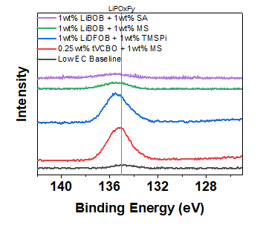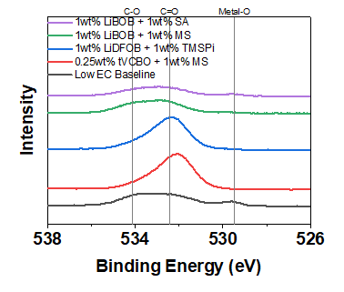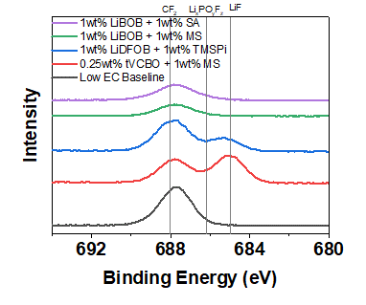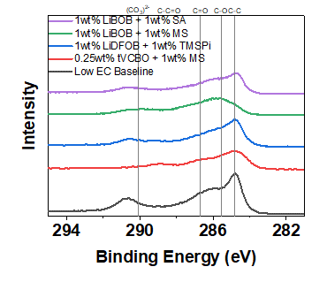
a
b
c
d
Figure S9. The C 1s, O 1s, F 1s and P 2p regions of XPS spectra of cycled cathodes: (a) C 1s region; (b) O 1s region; (c) F 1s region; (d) P 2p region. The legend shows the baseline electrolytes 1 (black), 1 wt% LiBOB + 1 wt% SA (purple), 1 wt% LiBOB + 1 wt% MS (green), 1 wt% LiDFOB + 1 wt% TMSPi (blue), 0.25 wt% tVCBO + 1 wt% MS (red).

5.4 Inductively Coupled Plasma Mass Spectrometry (ICP-MS)
A direct comparison TM dissolution from the cathode and its subsequent migration to the anode side can be observed through the ICP-MS data obtained from the anodes in the aged cell. Fig. S10 demonstrates that the implementation of all these additives results in enhanced protection of cathode surfaces, as evidenced by the reduced quantities of Mn and Ni detected in the anodes.
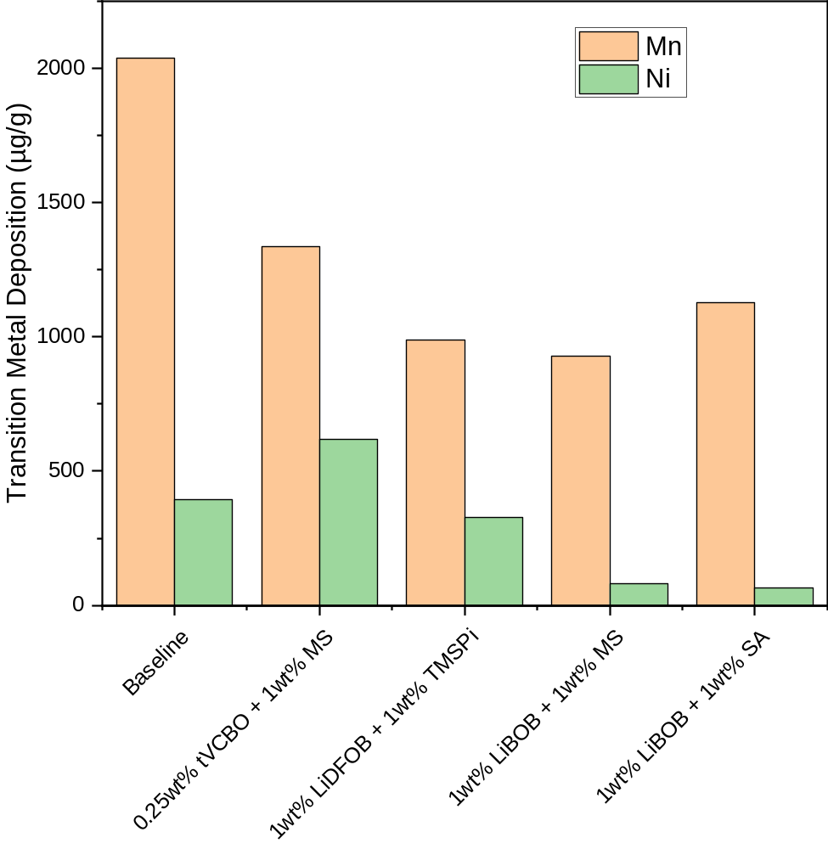
Figure S10. ICP-MS spectra of electrolytes extracted from cycled cells.

5.5 Scanning Electron Microscopy (SEM) and Energy-dispersive X-ray spectroscopy (EDX) analysis
An additional characterization technique involves performing SEM and EDX mapping analysis on the cycled anodes. As shown in Figs. S11-15, the SEM images also indicate a more uniformly formed SEI when additives are present, resulting in reduced loss of lithium inventory.¹⁸ The concept of the high surface areal lithium (HSAL) refers to the formation of lithium dendrites during the cycling, a phenomenon observed in the TMO||Gr full cells. By using SEM to study the morphology of the cycled graphite anodes, a correlation is established between the superior performance of certain additives and the inhibition of HSAL, leading to formation of a more uniform lithiated graphites. Although the LNMO||Gr cells did not exhibit the typical rollover behavior, significant incoherence and variations were observed among triplicate cells. As shown in Fig. S11-15, the aged graphite anodes display areas with different shades of SEI, indicating the composition differences after cycling.
As shown in Fig. S11, the SEI formed on graphite in the cells using baseline is not uniform, with regions rich in O, F, and Mn while poor in C exist. While in the presence of the best-performing additives (four formulas of 0.25wt% tVCBO + 1wt% MS, 1wt% LiDFOB + 1wt% TMSPi, 1wt% LiBOB + 1wt% MS, and 1wt% LiBOB + 1wt% SA), the graphite anode exhibits uniform and compact SEI (Fig. S12-15). Furthermore, the cycled anode with 0.25wt% tVCBO + 1wt% MS (Fig. S12) shows accumulated island-like TM in the SEM images, agreeing with the previous report on the ability of additives to aggregate the TM dissolution and mitigate their overall effect on reducing lithium inventory loss. Particularly in the TMSPi case, visible Si deposits on the graphite suggest that the aggregates originate from the decomposition from the 1wt% LiDFOB + 1wt% TMSPi additive (Fig. S13).

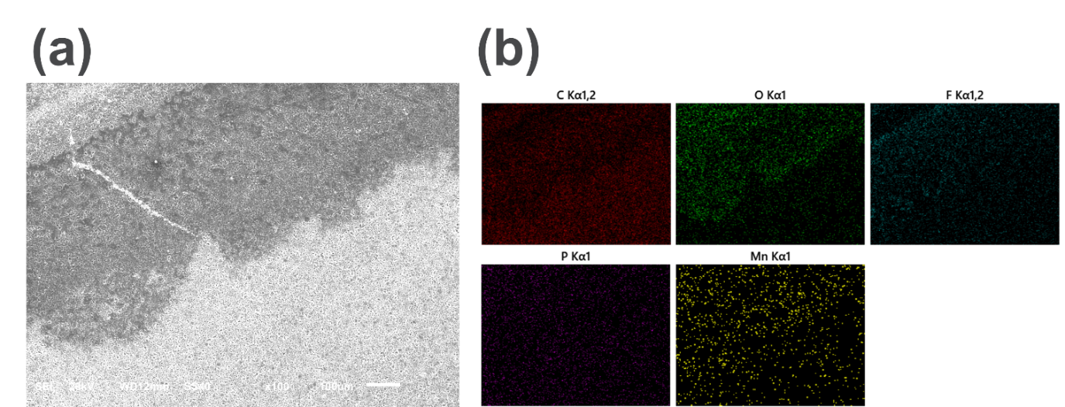
Figure S11. SEM image (a) and the EDX mapping (b) of the cycled Gr anode using the baseline.
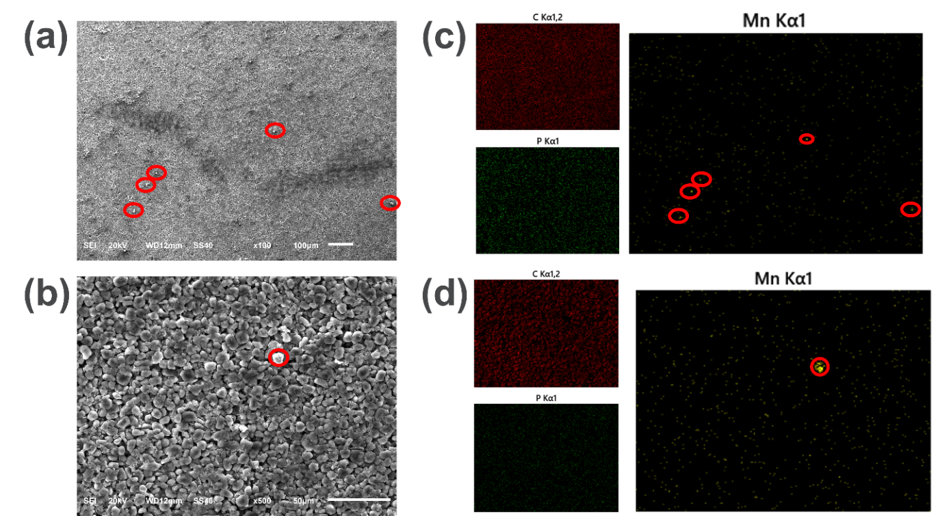
Figure S12. SEM image (a, b) and the EDX mapping (b, d) of the cycled Gr anode using the electrolyte with 0.25wt% tVCBO + 1wt% MS. cluster of Mn rich particles are presented in red cycles.

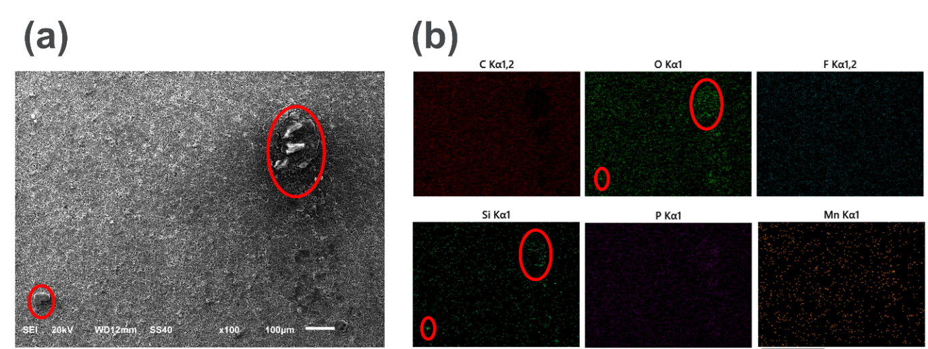
Figure S13. SEM image (a) and the EDX mapping (b) of the cycled Gr anode using the electrolyte with 1wt% LiDFOB + 1wt% TMSPi. Si and O rich particle depostions are presented in red cycles.

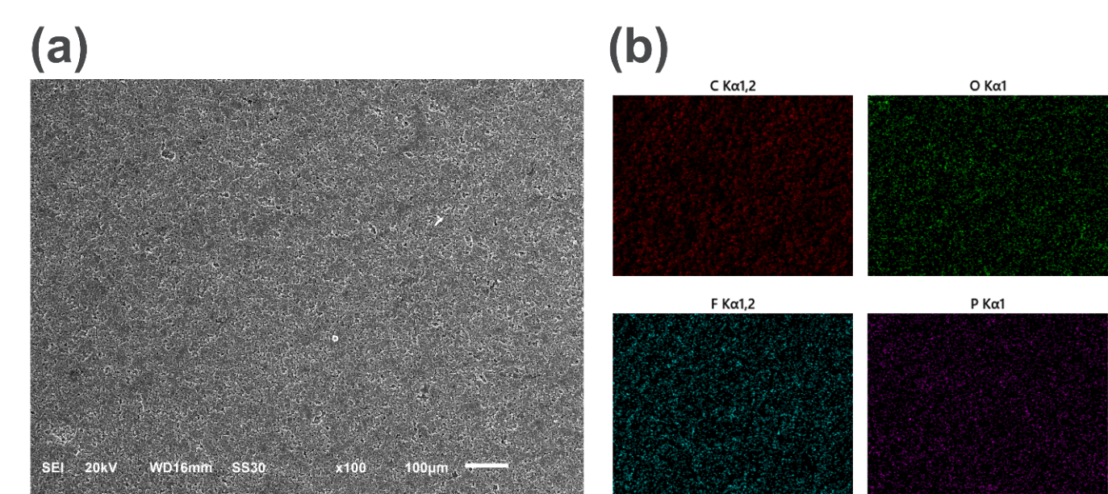
Figure S14. SEM image (a) and the EDX mapping (b) of the cycled Gr anode using the electrolyte with 1wt% LiBOB + 1wt% MS.

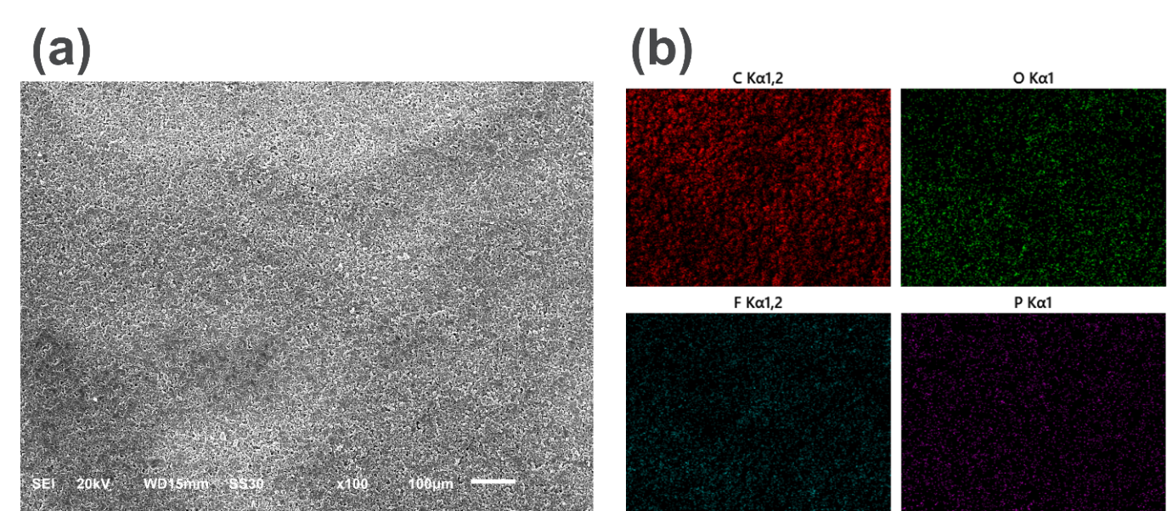
Figure S15. SEM image (a) and the EDX mapping (b) of the cycled Gr anode using the electrolyte with 1wt% LiBOB + 1wt% SA.

5.6 Online Electrochemical Mass Spectrometry (OEMS)
To understand the fading mechanism, diagnostic experiments were carried out on OEMS to monitor H₂ evolution through different stages of cycling. Through an in-house set up of OEMS, the effective formation of H₂ gas evolution is clearly observed at the high state of charge (SOC), particularly during the high voltage hold period. This observation aligns with the previous report indicating a close relationship between H₂ content generation and graphite lithiation and LNMO delithiation. Our OEMS system utilized a modified version of capillary based online electrochemical mass spectrometer that does not disturb the pressure inside the gas line. Therefore, the pressure change of the OEMS directly reflects the amount of the gas generated, and the system allows complete evacuation and flushing of the system with He, as well as the real-time calibration for gas quantification. By comparing the H₂ evolution of the full cells during the first two galvanostatic cycles using additives (0.25 wt% tVCBO + 1 wt% MS, 1 wt% LiBOB + 1 wt% MS, 1 wt% LiBOB + 1 wt% SA) and the baseline, it is demonstrated that interfacial reactions on the anode and cathodes closely relate to H₂ evolution (Fig. S16). In the first cycle, the first significant H₂ evolution occurs during the high voltage potentiostatic hold at ~ 23 hours (marked as ), which is attributed to the H₂O reduction during the high voltage hold. More interestingly is the second H2 evolution, which is found at the end of the discharge step (marked as ). This step, as suggested by Janek et al.,¹⁹ is attributed to the breakdown of the SEI, leading to the subsequent reduction of solvent during the SEI rebuilding process in the 0.25 wt% tVCBO + 1 wt% MS additive case, however, the H₂ evolution is much suppressed, indicating a much robust SEI with the presence of such additives.

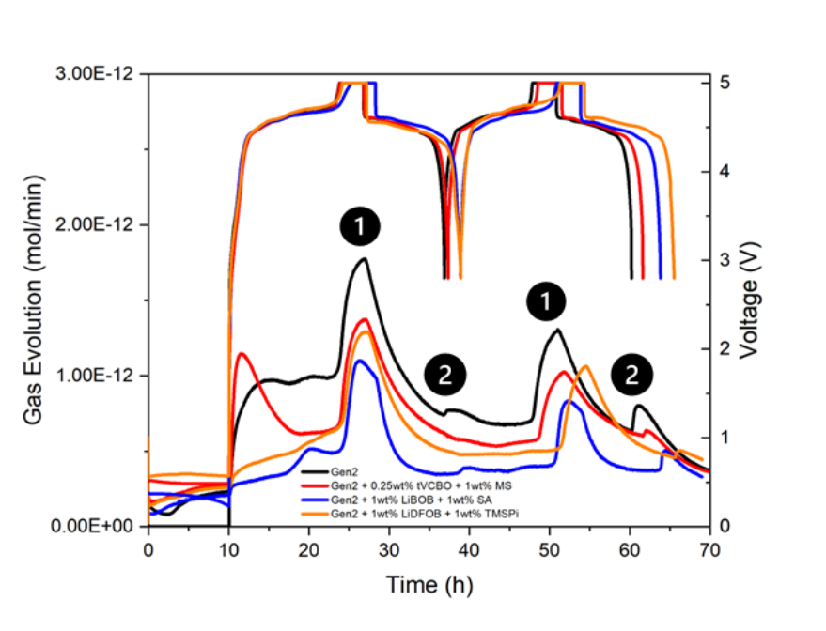
Figure S 16. OEMS measurement of H2 gas evolution during the first two galvanostatic cycles with LNMO//Gr cells. The cell was cycled between 2.5-5V for two cycles, and a 3h-constant voltage hold at 5 V was applied after each charge.

6. References
1. Rasmussen CE, Williams CKI. Gaussian Processes for Machine Learning. The MIT Press (2005).

2. Gardner JR, Pleiss G, Bindel D, Weinberger KQ, Wilson AG. GPyTorch: blackbox matrix-matrix Gaussian process inference with GPU acceleration. In: Proceedings of the 32nd International Conference on Neural Information Processing Systems). Curran Associates Inc. (2018).

3. Long BR, et al. Enabling High-Energy, High-Voltage Lithium-Ion Cells: Standardization of Coin-Cell Assembly, Electrochemical Testing, and Evaluation of Full Cells. J Electrochem Soc 163, A2999 (2016).

4. Wang B, et al. Electrolyte Study for High-Nickel LiNi0.9Mn0.05Co0.05O2 Cathodes. J Electrochem Soc 170, 020505 (2023).

5. Bloom I, et al. An accelerated calendar and cycle life study of Li-ion cells. J Power Sources 101, 238-247 (2001).

6. Wang B, et al. Understanding and Mitigating the Dissolution and Delamination Issues Encountered with High-Voltage LiNi0.5Mn1.5O4 (2023).

7. Bizot C, Blin M-A, Guichard P, Soudan P, Gaubicher J, Poizot P. Aluminum current collector for high voltage Li-ion battery. Part II: Benefit of the En’ Safe® primed current collector technology. Electrochem Commun 126, 107008 (2021).

8. Yang J, et al. Dual-Salt Electrolytes to Effectively Reduce Impedance Rise of High-Nickel Lithium-Ion Batteries. ACS Appl Mater Interfaces 13, 40502-40512 (2021).

9. Yang J, et al. Structural underpinnings of cathode protection by in situ generated lithium oxyfluorophosphates. J Power Sources 438, 227039 (2019).

10. Peebles C, et al. Chemical “Pickling” of Phosphite Additives Mitigates Impedance Rise in Li Ion Batteries. J Phys Chem C 122, 9811-9824 (2018).

11. Garcia CPIASCLDAHIJ. Additives for high voltage lithium ion batteries (2023).

12. Shui Zhang S. An unique lithium salt for the improved electrolyte of Li-ion battery. Electrochem Commun 8, 1423-1428 (2006).

13. Wang Y, Nakamura S, Tasaki K, Balbuena PB. Theoretical Studies To Understand Surface Chemistry on Carbon Anodes for Lithium-Ion Batteries: How Does Vinylene Carbonate Play Its Role as an Electrolyte Additive? J Am Chem Soc 124, 4408-4421 (2002).

14. Zhu Y, Li Y, Bettge M, Abraham DP. Positive Electrode Passivation by LiDFOB Electrolyte Additive in High-Capacity Lithium-Ion Cells. J Electrochem Soc 159, A2109-A2117 (2012).

15. Tornheim A, et al. Evaluating electrolyte additives for lithium-ion cells: A new Figure of Merit approach. J Power Sources 365, 201-209 (2017).

16. Xu K. Nonaqueous Liquid Electrolytes for Lithium-Based Rechargeable Batteries. Chem Rev 104, 4303-4418 (2004).

17. Li W, Song B, Manthiram A. High-voltage positive electrode materials for lithium-ion batteries. Chem Soc Rev 46, 3006-3059 (2017).

18. Klein S, et al. Suppressing Electrode Crosstalk and Prolonging Cycle Life in High-Voltage Li Ion Batteries: Pivotal Role of Fluorophosphates in Electrolytes. ChemElectroChem 9, e202200469 (2022).

19. Michalak B, Berkes BB, Sommer H, Brezesinski T, Janek J. Electrochemical Cross-Talk Leading to Gas Evolution and Capacity Fade in LiNi0.5Mn1.5O4/Graphite Full-Cells. J Phys Chem C 121, 211-216 (2017).

