Table 1 intergroup significant differences
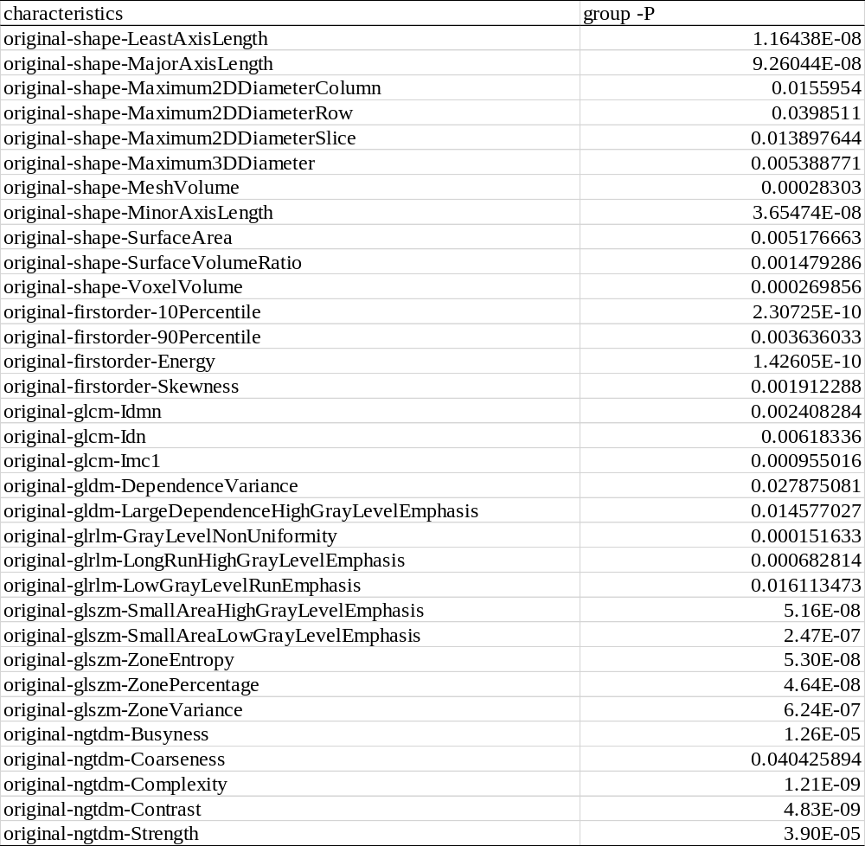

Table 2 significant differences between the plain lung window group and the enhanced lung window group
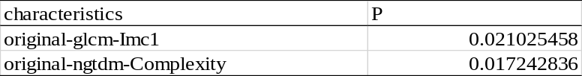

Table 3 significant differences between the enhanced lung window and the plain scanning mediastinal window
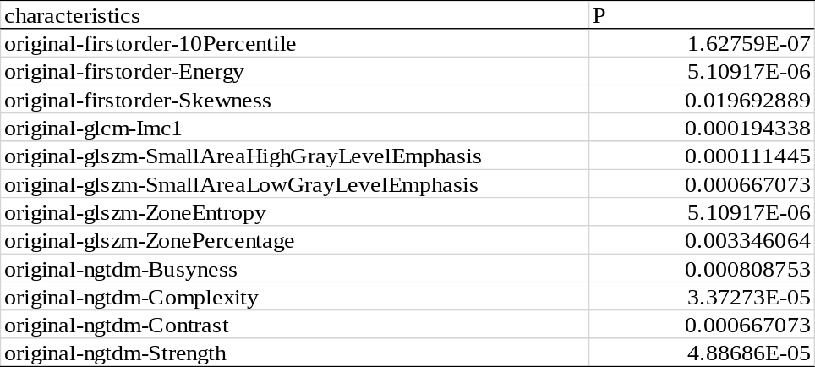

Table4 significant difference between plain scanning and enhancement of the mediastinal window

Table5 significant differences between the plain scan lung window and the enhanced mediastinal window groups
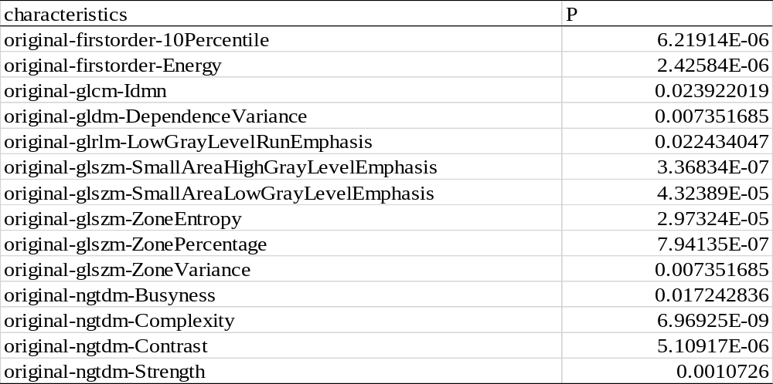

Table6 significant differences between the lung window and mediastinal window in plain scan
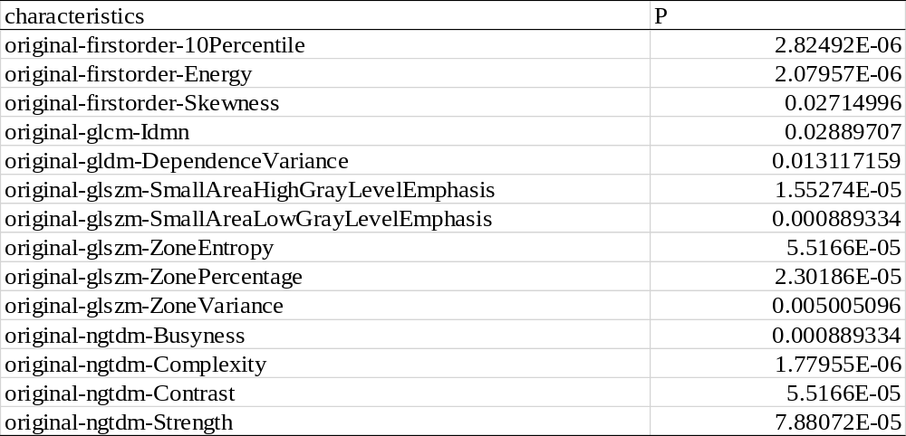

Table7 significant differences between the enhanced lung window and the mediastinal window
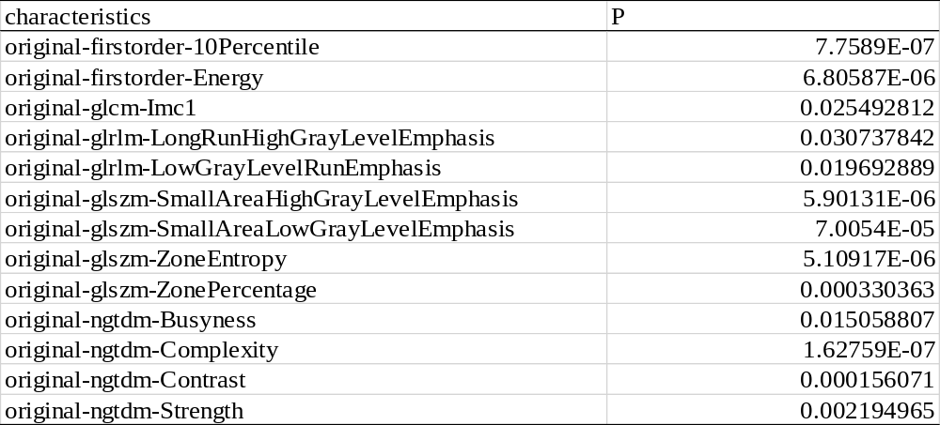

Table8 significant differences between squamous cell carcinoma and adenocarcinoma
