Supplementary Table 1: Protein description, accession number, average abundance in high-inflammation cows (n = 8), average abundance in low-inflammation cows (n = 7), fold-changes, and Log(P value) of the 155 platelet-proteins that were differentially expressed in cows with high- and low inflammation. Proteins are listed according to the fold change difference in abundance in high-inflammation cows compared to low-inflammation cows.

Protein Description | Accession Number | Average Abundance (High-Inflammation) | Average Abundance (Low-Inflammation) | Fold Change | Log  (P-value)
Haptoglobin | Q2TBU0 | 26.24 | 22.46 | 3.8 | 2.9
Alpha-actinin-1 | Q3B7N2 | 22.60 | 19.43 | 3.2 | 2.1
Alpha-1,4 glucan phosphorylase | B0JYK6 | 23.20 | 20.47 | 2.7 | 1.6
Filamin C | A0A3Q1LV98 | 22.35 | 19.81 | 2.5 | 1.9
Protein kinase C | A0A3Q1MGP0 | 20.86 | 18.31 | 2.5 | 2.0
Non-specific protein-tyrosine kinase | F6PN06 | 22.17 | 19.64 | 2.5 | 2.8
Prealbumin-like fold domain-containing protein | F1MF76 | 25.46 | 23.08 | 2.4 | 2.2
NADH-ubiquinone oxidoreductase 75 kDa subunit, mitochondrial | P15690 | 21.62 | 19.24 | 2.4 | 2.2
Unc-13 homolog D | E1BFF0 | 21.84 | 19.51 | 2.3 | 3.4
Placenta associated 8 B | A0A3Q1M2C0 | 22.32 | 20.04 | 2.3 | 1.9
MOB kinase activator 1A | A0A3Q1M4W1 | 21.32 | 19.08 | 2.2 | 2.2
Phosphatidylinositol-4-phosphate 3-kinase catalytic subunit type 2 alpha | E1BE68 | 20.41 | 18.20 | 2.2 | 2.5
Hexose-6-phosphate dehydrogenase/glucose 1-dehydrogenase | F1MM13 | 19.79 | 17.66 | 2.1 | 3.6
Deoxyribonuclease | A6QNN7 | 23.84 | 21.74 | 2.1 | 2.0
Actin beta like 2 | A0A3Q1NKP5 | 21.61 | 19.58 | 2.0 | 1.5
Beta-centractin | A4IFE3 | 21.10 | 19.10 | 2.0 | 1.6
MAP7 domain containing 1 | A0A3Q1LNR7 | 20.42 | 18.54 | 1.9 | 1.3
Cytoplasmic linker associated protein 2 | E1BQ15 | 20.30 | 18.43 | 1.9 | 1.5
Glutathione peroxidase 3 | P37141 | 20.02 | 18.17 | 1.9 | 2.0
Serpin H1 | Q2KJH6 | 23.82 | 21.97 | 1.8 | 1.4
Ubiquitin-conjugating enzyme E2 K | P61085 | 21.34 | 19.65 | 1.7 | 2.0
Small ubiquitin-related modifier 3 | Q17QV3 | 20.89 | 19.20 | 1.7 | 1.4
VPS37B subunit of ESCRT-I | A0A3Q1NLW9 | 20.53 | 18.85 | 1.7 | 2.6
Discs large MAGUK scaffold protein 3 | A0A3Q1MBH0 | 21.05 | 19.39 | 1.7 | 2.2
Raftlin | A0A3Q1M6R4 | 20.21 | 18.55 | 1.7 | 1.9
Electron transfer flavoprotein subunit alpha | F1MWR3 | 20.54 | 18.88 | 1.7 | 2.1
Glucose-6-phosphate 1-dehydrogenase | A0A3Q1MM55 | 26.34 | 24.69 | 1.6 | 2.3
Beta-adrenergic receptor kinase 1 | P21146 | 20.37 | 18.74 | 1.6 | 2.7
Uridine diphosphate glucose pyrophosphatase NUDT14 | Q05B60 | 21.54 | 19.93 | 1.6 | 1.5
Calcium binding and coiled-coil domain 1 | A0A3Q1MRI3 | 20.39 | 18.77 | 1.6 | 2.1
Endopin 2 | G8JKW7 | 19.48 | 17.90 | 1.6 | 1.4
Synaptobrevin homolog YKT6 | Q3T000 | 22.33 | 20.76 | 1.6 | 1.3
Vacuolar protein sorting-associated protein 33B | Q2HJ18 | 22.21 | 20.66 | 1.5 | 2.1
Aminopeptidase B | A2T1U6 | 20.68 | 19.14 | 1.5 | 1.5
Trafficking protein particle complex subunit 8 | A0A3Q1N5L8 | 22.11 | 20.57 | 1.5 | 1.4
Aldehyde dehydrogenase family 16 member A1 | F1N441 | 20.83 | 19.30 | 1.5 | 2.5
Exportin 7 | G3N1J2 | 22.53 | 21.01 | 1.5 | 2.6
Hydroxysteroid (17-beta) dehydrogenase 11 | Q2KIS5 | 21.02 | 19.50 | 1.5 | 1.9
Adenylosuccinate synthetase isozyme 2 | A7MBG0 | 20.65 | 19.14 | 1.5 | 2.1
PKHD1 like 1 | A0A3Q1MGJ7 | 20.95 | 19.45 | 1.5 | 1.7
Adenine phosphoribosyltransferase | A0A452DIE3 | 22.37 | 20.89 | 1.5 | 1.8
Tyrosine-protein kinase | Q5E9H3 | 21.54 | 20.07 | 1.5 | 2.3
Glycerol-3-phosphate phosphatase | Q2T9S4 | 20.89 | 19.43 | 1.5 | 1.3
Wiskott-Aldrich syndrome protein family member | A0A3Q1N9V7 | 19.29 | 17.86 | 1.4 | 1.9
NID1 protein | A6QNS6 | 24.54 | 23.13 | 1.4 | 2.1
Afadin, adherens junction formation factor | A0A3Q1LN46 | 19.63 | 18.23 | 1.4 | 1.3
Solute carrier family 25 (Carnitine/acylcarnitine translocase), member 20 | Q3SZA4 | 21.39 | 20.01 | 1.4 | 1.4
Ral GTPase activating protein non-catalytic subunit beta | F1MCG4 | 19.49 | 18.14 | 1.3 | 1.4
Dolichyl-diphosphooligosaccharide--protein glycotransferase | A5D7G6 | 22.72 | 21.38 | 1.3 | 2.7
Importin 7 | E1BGE5 | 23.87 | 22.54 | 1.3 | 2.7
Proteasome assembly chaperone 2 | Q2NL24 | 18.77 | 17.46 | 1.3 | 1.9
Prostaglandin reductase 2 | Q32L99 | 19.10 | 17.80 | 1.3 | 1.3
RAB3 GTPase activating non-catalytic protein subunit 2 | G5E601 | 21.54 | 20.25 | 1.3 | 1.8
5'-3' exoribonuclease 1 | E1BMZ8 | 21.83 | 20.57 | 1.3 | 2.1
Non-specific serine/threonine protein kinase | G3X7B2 | 20.82 | 19.56 | 1.3 | 1.4
Dedicator of cytokinesis 2 | A0A3Q1LWX5 | 19.30 | 18.08 | 1.2 | 2.2
Nuclear transport factor 2 | Q32KP9 | 20.04 | 18.84 | 1.2 | 1.5
Divergent protein kinase domain 2A | E1BNC4 | 21.52 | 20.32 | 1.2 | 1.7
Tubulin-specific chaperone D | Q28205 | 23.80 | 22.61 | 1.2 | 2.3
Elastin microfibril interfacer 1 | E1BLS8 | 25.58 | 24.41 | 1.2 | 2.5
ER membrane protein complex subunit 1 | A0A3Q1M901 | 21.82 | 20.65 | 1.2 | 1.5
Propionyl-CoA carboxylase alpha chain, mitochondrial | A0A3Q1N969 | 22.47 | 21.31 | 1.2 | 1.9
Annexin | A0A3Q1MHG7 | 23.87 | 22.71 | 1.2 | 1.3
GDP-mannose pyrophosphorylase A | A0A3Q1LUY6 | 20.67 | 19.51 | 1.2 | 1.5
DNA damage-binding protein 1 | A0A452DJ09 | 22.32 | 21.17 | 1.1 | 1.4
Golgi transport 1B | A0A3Q1LJT9 | 19.83 | 18.68 | 1.1 | 2.6
Interferon regulatory factor 3 | A0A2H4GTF0 | 21.22 | 20.08 | 1.1 | 1.5
Peptidyl-prolyl cis-trans isomerase NIMA-interacting 1 | Q5BIN5 | 21.65 | 20.52 | 1.1 | 1.6
C-terminal binding protein 1 | A0A3Q1M504 | 21.30 | 20.17 | 1.1 | 1.7
Raftlin, lipid raft linker 1 | F1N1Q3 | 21.23 | 20.11 | 1.1 | 1.4
CTP synthase | A0JNE9 | 21.19 | 20.07 | 1.1 | 1.3
Proteasome 26S subunit, non-ATPase 10 | A0A3S5ZP61 | 20.07 | 18.97 | 1.1 | 1.3
Solute carrier family 35 member B4 | E1BEH8 | 21.18 | 20.09 | 1.1 | 1.3
Trafficking protein particle complex subunit 11 | A6QLC7 | 21.33 | 20.24 | 1.1 | 1.8
Lon protease homolog, mitochondrial | A0A140T842 | 22.03 | 20.94 | 1.1 | 1.5
Importin 5 | A0A3Q1LV36 | 25.13 | 24.06 | 1.1 | 2.0
ENAH actin regulator | F1N214 | 25.68 | 24.61 | 1.1 | 2.0
ATP synthase subunit f, mitochondrial | A0A3Q1ML66 | 21.92 | 20.87 | 1.1 | 1.3
60S acidic ribosomal protein P0 | F1MDN4 | 23.52 | 22.47 | 1.0 | 2.2
Small monomeric GTPase | A6QLB1 | 25.08 | 24.04 | 1.0 | 2.5
Mitochondrial calcium uptake 2 | A0A3Q1LR44 | 22.54 | 21.51 | 1.0 | 1.8
Calcyclin-binding protein | Q3T168 | 23.42 | 22.41 | 1.0 | 2.2
Proteasome subunit beta type-2 | Q5E9K0 | 21.71 | 20.70 | 1.0 | 1.4
Heat shock protein 75 kDa, mitochondrial | Q2TBI4 | 22.70 | 21.70 | 1.0 | 2.1
Transferrin receptor protein 1 | E1BIG6 | 17.78 | 22.91 | -5.1 | 7.7
Vesicle-associated membrane protein 8 | Q3T0Y8 | 19.79 | 23.28 | -3.5 | 2.5
Myristoylated alanine-rich C-kinase substrate | P12624 | 20.44 | 23.43 | -3.0 | 2.0
CXXC motif containing zinc binding protein | A0A3Q1LX93 | 18.17 | 21.03 | -2.9 | 3.7
Thioredoxin | O97680 | 18.43 | 20.97 | -2.5 | 2.2
AP-1 complex subunit sigma-2 | Q3ZBS3 | 19.04 | 21.56 | -2.5 | 1.3
Podocalyxin | F1MLI8 | 17.97 | 20.45 | -2.5 | 2.4
Tropomyosin alpha-3 chain | Q5KR47 | 21.30 | 23.70 | -2.4 | 2.3
Calpastatin | A0A3Q1MZC5 | 19.95 | 22.35 | -2.4 | 2.7
Ribosomal protein L18 | A0A3Q1MH44 | 18.87 | 21.15 | -2.3 | 1.9
Transthyretin | O46375 | 19.45 | 21.67 | -2.2 | 2.1
Transmembrane anterior posterior transformation 1 | F1MN55 | 18.65 | 20.86 | -2.2 | 1.7
TSC22 domain family member 4 | E1BFH5 | 17.85 | 20.05 | -2.2 | 2.5
Ig-like domain-containing protein | A0A3Q1LI44 | 17.91 | 20.07 | -2.2 | 1.6
Superoxide dismutase [Cu-Zn] | P00442 | 21.65 | 23.74 | -2.1 | 1.7
Large ribosomal subunit protein eL8 | Q2TBQ5 | 18.51 | 20.61 | -2.1 | 1.8
Conglutinin | P23805 | 21.20 | 23.28 | -2.1 | 1.4
Nucleoside diphosphate kinase | A0A8J8YPU5 | 21.11 | 23.17 | -2.1 | 1.5
LOC781700 protein | A5D7L4 | 18.80 | 20.85 | -2.0 | 4.6
DnaJ homolog subfamily A member 1 | Q5E954 | 18.15 | 20.20 | -2.0 | 2.1
Alpha-2-macroglobulin | A0A3Q1LLI6 | 18.43 | 20.44 | -2.0 | 1.3
Histone H2A | A0A3Q1MDK7 | 21.75 | 23.75 | -2.0 | 3.2
Tropomyosin 4 | F6QQ60 | 25.13 | 27.11 | -2.0 | 1.4
TSC complex subunit 1 | F1MM99 | 18.82 | 20.79 | -2.0 | 1.7
non-specific serine/threonine protein kinase | A0A3Q1MBK9 | 18.81 | 20.75 | -1.9 | 1.4
Calumenin | F1N3H1 | 18.01 | 19.93 | -1.9 | 2.2
Alpha-2-HS-glycoprotein | P12763 | 23.30 | 25.22 | -1.9 | 2.9
Costars family protein ABRACL | Q3ZBN0 | 17.95 | 19.79 | -1.8 | 2.0
Microtubule-associated protein | F1MAZ1 | 23.77 | 25.61 | -1.8 | 1.8
Globin A1 | D4QBB4 | 23.92 | 25.73 | -1.8 | 2.2
Ubiquitin-protein ligase E3A | A4IFN7 | 19.30 | 21.05 | -1.8 | 1.3
Tumor protein, translationally-controlled 1 | A0A452DID1 | 20.41 | 22.16 | -1.8 | 1.5
Formin-binding protein 1-like | F1MSM9 | 21.18 | 22.91 | -1.7 | 2.1
40S ribosomal protein S8 | A0A3Q1LPB5 | 18.98 | 20.69 | -1.7 | 3.1
Eukaryotic translation initiation factor 4B | F1MYS7 | 18.18 | 19.88 | -1.7 | 1.5
Small VCP/p97-interacting protein | A0A3Q1NDL5 | 18.31 | 19.97 | -1.7 | 1.5
Hemoglobin subunit alpha | P01966 | 24.51 | 26.13 | -1.6 | 2.1
Anamorsin | Q5EAC7 | 20.00 | 21.61 | -1.6 | 2.5
Eukaryotic translation initiation factor 5B | A0A3Q1MS04 | 18.93 | 20.52 | -1.6 | 2.6
TPD52 like 2 | A0A3Q1MQD7 | 19.02 | 20.60 | -1.6 | 2.6
Glutaredoxin-1 | P10575 | 20.41 | 21.99 | -1.6 | 3.2
NADH dehydrogenase [ubiquinone] 1 beta subcomplex subunit 5, mitochondrial | Q02380 | 20.13 | 21.66 | -1.5 | 1.4
Maestro heat like repeat family member 5 (gene/pseudogene) | G3MYB3 | 17.96 | 19.45 | -1.5 | 1.6
OCIA domain-containing protein 2 | Q3SYY7 | 21.18 | 22.66 | -1.5 | 1.5
Hematopoietic cell-specific Lyn substrate 1 | Q3SYW3 | 21.67 | 23.14 | -1.5 | 1.4
Glyceraldehyde-3-phosphate dehydrogenase, testis-specific | Q2KJE5 | 21.92 | 23.35 | -1.4 | 1.6
Vesicle-associated membrane protein-associated protein B | A2VDZ9 | 21.33 | 22.75 | -1.4 | 4.1
Beta-2-microglobulin | A0A3Q1MU93 | 23.48 | 24.87 | -1.4 | 2.4
H1.2 linker histone, cluster member | A0A452DIF5 | 17.96 | 19.34 | -1.4 | 1.7
Ig-like domain-containing protein | A0A3Q1LPG0 | 24.53 | 25.90 | -1.4 | 1.3
Ribosomal protein L5 | A0A3Q1MMW5 | 18.33 | 19.70 | -1.4 | 1.8
Synaptosomal-associated protein | Q2T9M8 | 19.12 | 20.47 | -1.3 | 1.6
C2CD2 like | A7Z071 | 20.40 | 21.74 | -1.3 | 1.4
Na(+)/H(+) exchange regulatory cofactor NHE-RF1 | Q3SZK8 | 25.30 | 26.61 | -1.3 | 2.7
Rho GTPase-activating protein 15 | A4IF90 | 21.07 | 22.37 | -1.3 | 2.5
Glycerol-3-phosphate dehydrogenase | A0A3Q1MTV4 | 27.67 | 28.97 | -1.3 | 3.0
ArfGAP with GTPase domain, ankyrin repeat and PH domain 2 | E1BIQ2 | 18.68 | 19.97 | -1.3 | 1.8
PRA1 family protein 2 | Q2KHX3 | 18.22 | 19.51 | -1.3 | 2.2
Mitochondrial Rho GTPase 2 | Q5E9M9 | 18.01 | 19.26 | -1.2 | 1.6
Galactokinase | A6H768 | 21.52 | 22.73 | -1.2 | 3.4
DENN domain containing 2B | F6QME3 | 18.19 | 19.36 | -1.2 | 1.7
Histone H4 | A0A3Q1MJQ1 | 22.34 | 23.51 | -1.2 | 1.9
Apolipoprotein A4 | F1N3Q7 | 24.00 | 25.16 | -1.2 | 1.3
Ribosome binding protein 1 | A0A3Q1LHT7 | 23.14 | 24.27 | -1.1 | 1.9
Eukaryotic translation initiation factor 5A-1 | Q6EWQ7 | 21.60 | 22.74 | -1.1 | 2.6
SLAIN motif family member 2 | F1MF02 | 22.55 | 23.68 | -1.1 | 3.0
Small ribosomal subunit protein uS7 | Q5E988 | 18.74 | 19.79 | -1.0 | 1.6
WD repeat domain 37 | E1B9V7 | 20.31 | 21.35 | -1.0 | 1.6
Nuclear export mediator factor | A0A3Q1LQA1 | 18.84 | 19.85 | -1.0 | 2.0
ArfGAP with FG repeats 1 | A0A3Q1NF13 | 18.31 | 19.32 | -1.0 | 1.6
BRO1 domain-containing protein BROX | F1MU85 | 20.62 | 21.62 | -1.0 | 1.7

Supplementary Table 2: Protein description, accession number, average abundance in high-inflammation cows (n = 8), average abundance in low-inflammation cows (n = 7), fold-changes, and Log(P value) of the 24 plasma-proteins that were differentially expressed in cows with high- and low inflammation. Proteins are listed according to the fold change difference in abundance in high-inflammation cows compared to low-inflammation cows.
Protein Description | Accession Number | Average Abundance (High Inflammation) | Average Abundance (Low-Inflammation) | Fold Change | Log  (P-value)
Endosome/lysosome-associated apoptosis and autophagy regulator family member 2 | A7E2Z9 | 23.31 | 17.96 | 5.3 | 3.5
Ig heavy chain variable region (Fragment) | A0A6B9SBD0 | 21.47 | 18.28 | 3.2 | 2.0
Keratin, type II cytoskeletal 7 | Q29S21 | 22.64 | 19.97 | 2.7 | 1.3
Ig lamda chain variable region (Fragment) | A0A6B9SBT1 | 20.50 | 17.83 | 2.7 | 2.1
Ig lamda chain variable region (Fragment) | A0A6B9SE32 | 18.58 | 21.84 | -3.3 | 2.2
MBL associated serine protease 2 | E1BJ49 | 19.22 | 21.93 | -2.7 | 2.1
Guanylate cyclase activator 2A | E1BIM0 | 18.19 | 20.78 | -2.6 | 3.2
MHC class I lymphocyte antigen mRNA, 3' end (Fragment) | Q30304 | 18.57 | 20.86 | -2.3 | 1.6
Filamin A | F1N169 | 17.84 | 20.11 | -2.3 | 2.5
Chitinase | F1MH27 | 21.56 | 23.81 | -2.3 | 1.7
Ig lamda chain variable region (Fragment) | A0A6B9SE69 | 17.17 | 19.14 | -2.0 | 1.4
Complement C8 alpha chain | F1MX87 | 20.79 | 22.69 | -1.9 | 2.3
Laminin subunit beta 1 | A0A3Q1MY30 | 19.50 | 21.36 | -1.9 | 2.2
Cathepsin S | P25326 | 20.75 | 22.59 | -1.8 | 1.4
SRCR domain-containing protein | A0A3Q1MHR7 | 20.78 | 22.50 | -1.7 | 1.5
Conglutinin | P23805 | 26.91 | 28.60 | -1.7 | 1.4
Adipocyte plasma membrane-associated protein | A0A452DHZ7 | 19.75 | 21.40 | -1.6 | 1.7
Corticosteroid-binding globulin | E1BF81 | 22.13 | 23.70 | -1.6 | 1.5
Serum amyloid A-4 protein | Q32L76 | 25.95 | 27.40 | -1.4 | 2.0
Serpin family G member 1 | E1BMJ0 | 21.13 | 22.56 | -1.4 | 1.4
Serpin family A member 7 | Q3SYR0 | 25.07 | 26.33 | -1.3 | 2.4
Tubulin beta chain | A0A3Q1M442 | 17.92 | 19.15 | -1.2 | 1.6
Fatty acid desaturase 6 | A2VE15 | 23.47 | 24.61 | -1.1 | 1.6
Apolipoprotein M | A0A3Q1MB70 | 21.83 | 22.89 | -1.1 | 2.0

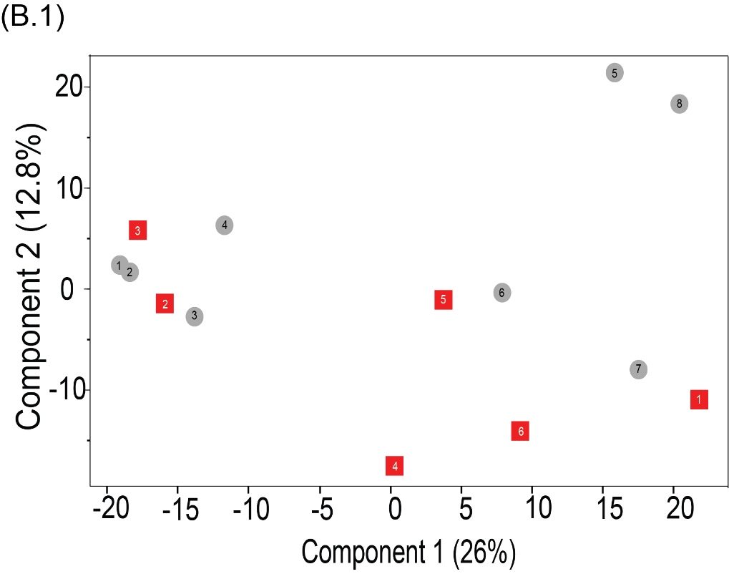

Supplementary Figure 1: PCA plot representing the differences in plasma protein expression between high- and low-inflammation cows.

