Supplementary Information

Mechanism of Micro and Nanoplastics Formation from Semicrystalline Polymers

Nicholas F. Mendez,¹ Vivek Sharma,² Michele Valsecchi,¹ Sabin Adhikari,¹ Vighnesh Pai,¹ Gorugantu Sribala,³ Linda Broadbelt,³ Linda Schadler,⁴ Alejandro J. Müller,^{5,6} Shelby Watson,⁷ Mark Dadmun,⁷ Guruswamy Kumaraswamy,^{2*} Sanat K. Kumar¹*

¹ Department of Chemical Engineering, Columbia University, New York, New York, 10027, USA.
² Department of Chemical Engineering, Indian Institute of Technology Bombay, Mumbai, 400076, India.
³ Department of Chemical Engineering, Northwestern University, Evanston, IL
⁴Department of Mechanical Engineering, University of Vermont, Burlington, VT
⁵ POLYMAT and Department of Advanced Polymers and Materials: Physics, Chemistry and Technology, Faculty of Chemistry, University of the Basque Country UPV/EHU, Paseo Manuel de Lardizabal 3, 20018 Donostia-San Sebastián, Spain
⁶ IKERBASQUE, Basque Foundation for Science, Plaza Euskadi 5, Bilbao 48009, Spain
⁷Department of Chemistry, University of Tennessee Knoxville, Knoxville TN

Keywords. Microplastics, Nanoplastics, Semicrystalline polymers, Environmental Degradation

Table of Contents

Note 1: Details of oxidative degradation 3
Figure S1: Free radical generation from oxidative degradation 4
Figure S2-4: Electron microscopy of MNPLs and droplets 4
Figure S5: X-ray scattering of native and degraded PET films 6
Figure S6: DSC of native and degraded PET films 6
Figure S7: ATR-FTIR of native and degraded PET films 8
Figure S8-11: Terephthalic acid characterization 9
Figure S12-14: ATR-FTIR spectra of MNPLs 12
Figure S15: TGA of all PET samples 15
Figure S16-17: DSC of additional PET MNPL samples 15
Figure S18-19: Addition PLOM Images from melting and recrystallization of MNPLs 17
Figure S20-21: X-ray scattering of additional MNPL samples, larger scattering mass 19
Figure S22-25: Autocorrelation function and interface distribution function analysis 20
Note 2: Details of SAXS analysis 21
Figure S26: WAXS analysis of PET 23
Figure S27: Summarized crystallinities of bulk PET from different methods 24
Note 3: Details of WAXS analysis 24
Figure S28-30: Size distributions of PET MNPLs 25
Figure S31-32: Characterization of Amorphous PET (prior to recrystallization) 27
Figure S33: Further details on SEM image analysis 29

Note 1: Details of oxidative degradation
K₂S₂O₈ decomposes upon heating in water following the reaction:
$K_{2}S_{2}O_{8}+2H_{2}O→K_{2}SO_{4}+ H_{2}SO_{4}+2{\left[OH\right]}^{∙-}$ [1]
Therefore, as K₂S₂O₈ decomposes, it forms free radicals and H₂SO₄, resulting in a pH decrease. Equation [1] shows that the number of free radicals generated is double the amount of acid formed. Therefore, the rate of free radical generation can be estimated by measuring the change in pH (Figure S1). We observe that the rate of K₂S₂O₈ decomposition (viz. free radical generation) is pH dependent and is highly accelerated when the pH decreases below 1 (viz. after about 3 hours for 4 g K₂S₂O₈ in 100 mL water at 70 °C, Figure S1). After about 6 hours, as pH decreases to ~ 0.7 and beyond, the rate of free radical generation decreases. We note that, at this point, only about 50% of the K₂S₂O₈ originally added is decomposed. Addition of base (KOH) to this reaction mixture neutralizes the acid and increases the pH, allowing decomposition of the K₂S₂O₈ to resume following a similar cycle.

Figure S1: Free radical generation from oxidative degradation
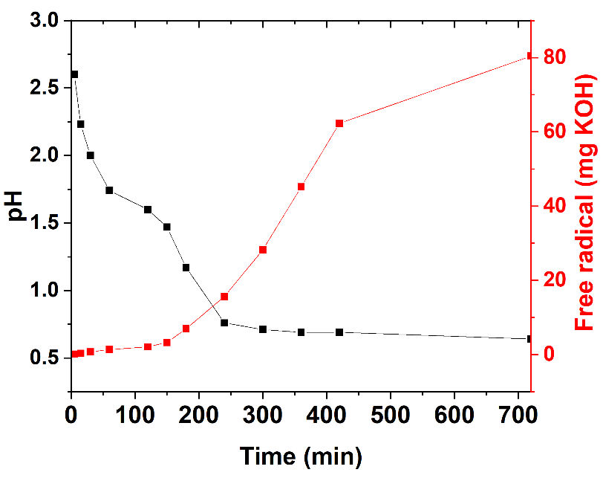
Figure S1: Variation of pH and concentration of free radicals (in units of mg KOH added to neutralize the acid formed, estimated in aliquots extracted from the reaction mixture) over time for decomposition of 4 g K₂S₂O₈ in 100 mL water at 70 °C.

Figure S2-4: Electron microscopy of MNPLs and droplets
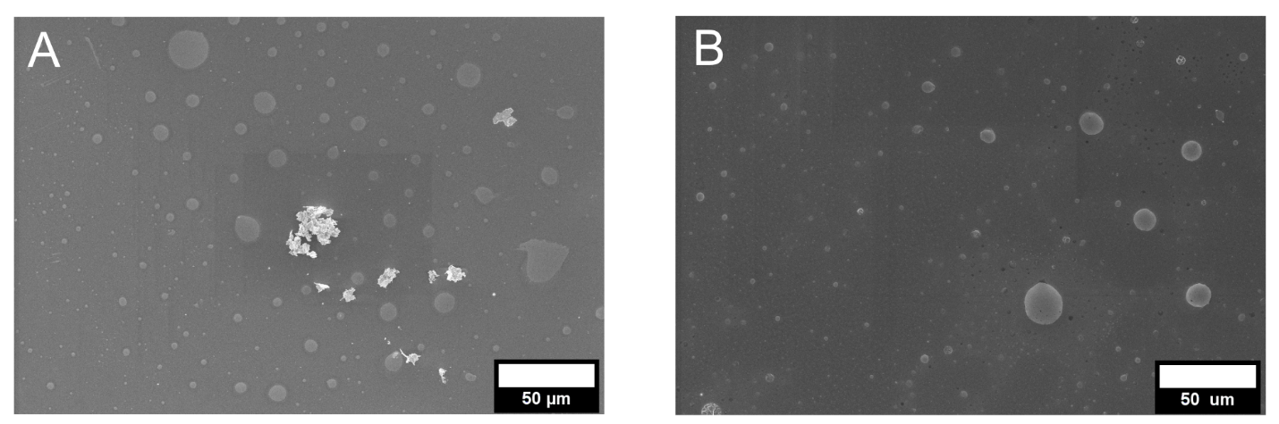
Figure S2: Low magnification SEM of MNPLs created from A) iPP and B) aPP solutions after 2 days of degradation. A similar droplet background can be observed for both polymers, but particles are only observed for iPP.

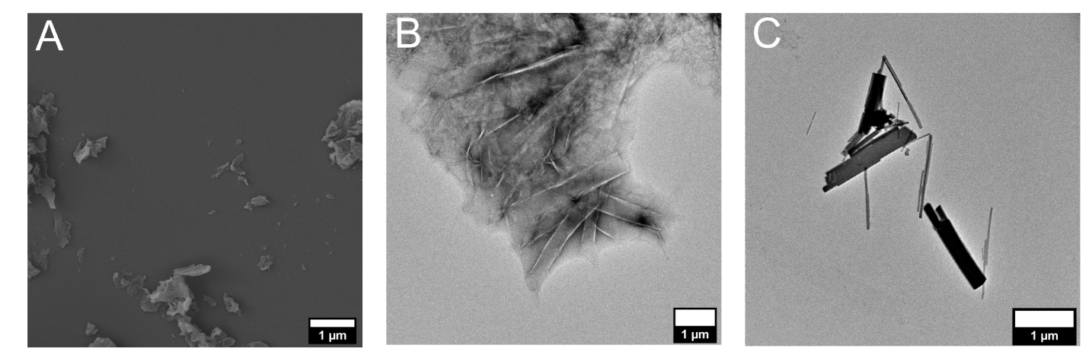
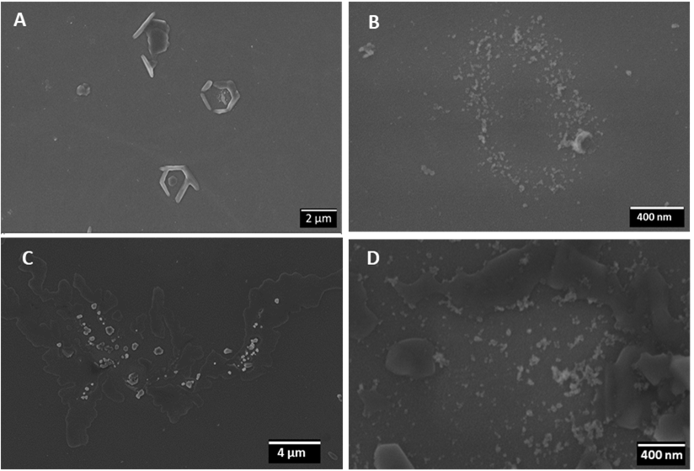
Figure S3: A) SEM and B, C) TEM imaging of PET MNPLs formed through neutral water hydrolysis at 110 °C after 7 days.
Figure S4: SEM micrographs of sPS (A, B) and iPP (C, D) at day 2 (A, C) and for continued degradation without the bulk films for 2 additional days (B, D).

Figure S5: X-ray scattering of native and degraded PET films
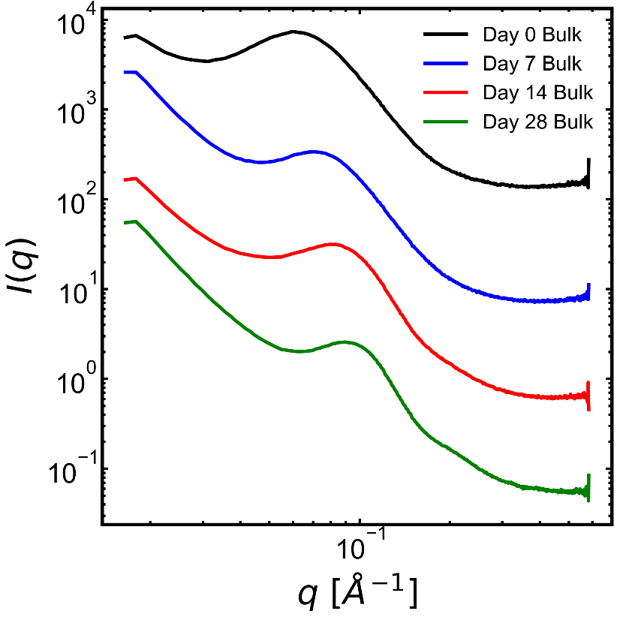
Figure S5: 1D SAXS intensity as a function of wavevector, $q$, for bulk PET samples degraded through neutral water hydrolysis at 110 °C. Curves are vertically shifted for clarity.

Figure S6: DSC of native and degraded PET films
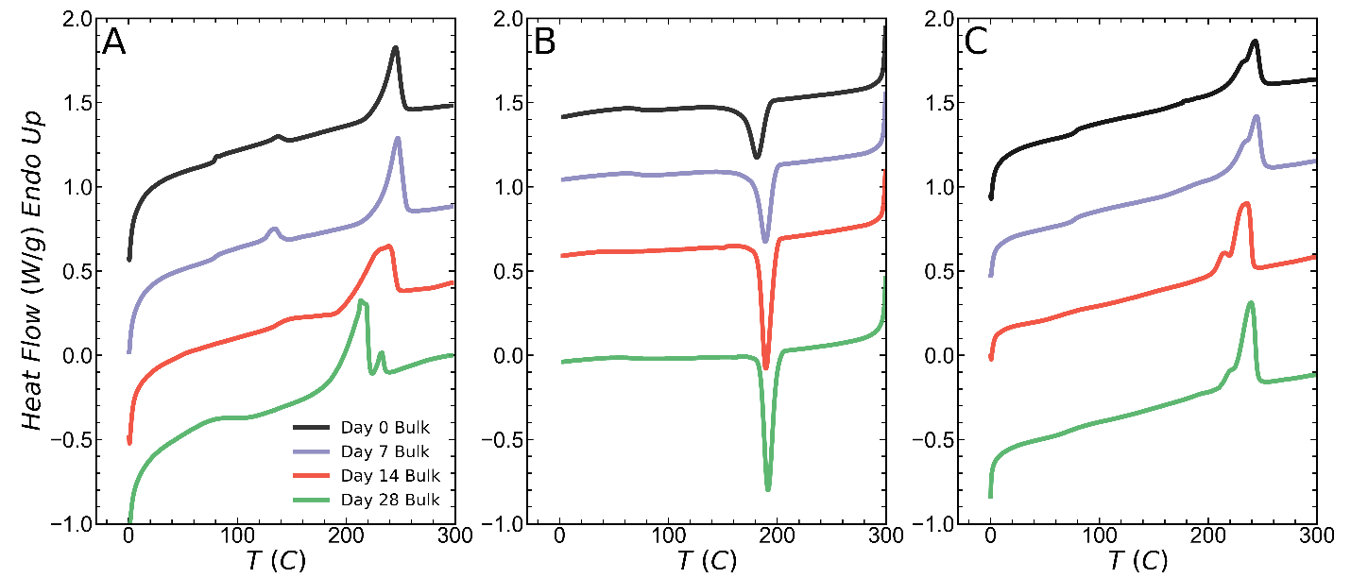
Figure S6: DSC curves for bulk PET samples degraded through neutral water hydrolysis at 110 °C. All experiments are conducted with temperature ramps of 10 °C/min. A) first heat up to 300 °C. B) first cool to 0 °C C) second heat to 300 °C.

The heating endotherms of PET show a main melting peak at around 240 °C while smaller peaks can be observed at much lower temperatures. Ronkay et al. discuss the multiple melting endotherms in PET in detail.¹ From Figure S6 we observe that during the first heating the bulk material melts at a slightly lower temperature relative to the second heating. This feature is also observed in other degraded semicrystalline polymers, a behavior that is commonly interpreted as a result of chemi-crystallization.^{2–4}

Figure S7: ATR-FTIR of native and degraded PET films
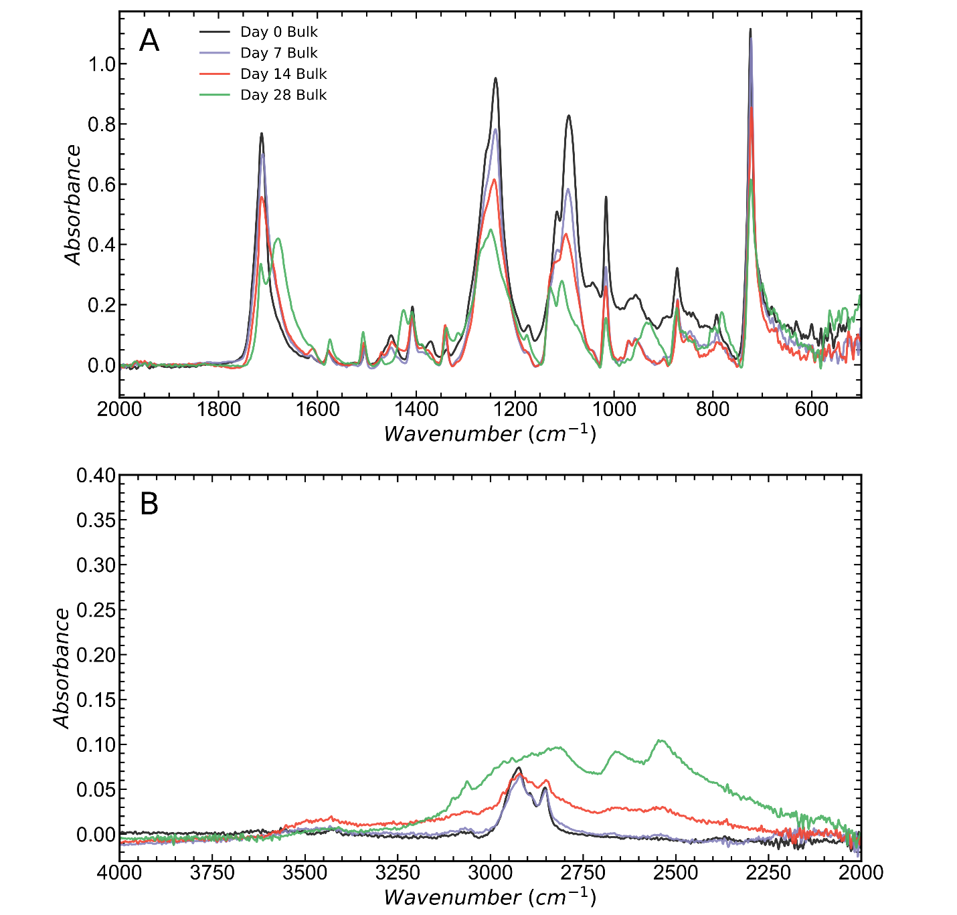
Figure S7: ATR-FTIR spectra for bulk PET samples degraded through neutral water hydrolysis at 110 °C. A) low wavenumbers B) high wavenumbers.

Figure S8-11: Terephthalic acid characterization
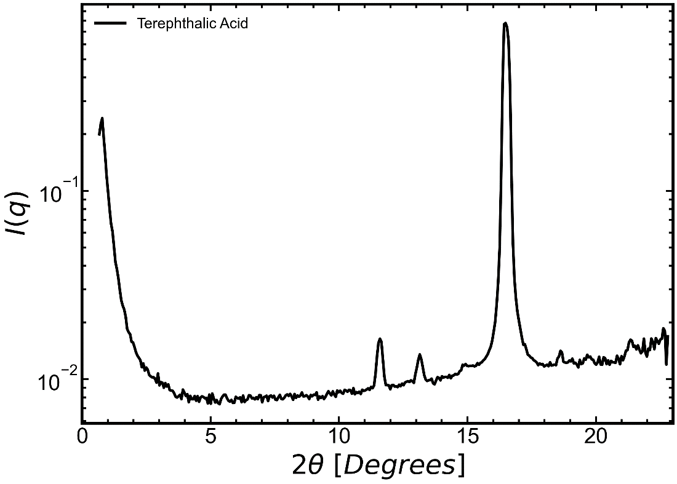
Figure S8: WAXS intensity as a function of scattering angle for pure terephthalic acid.
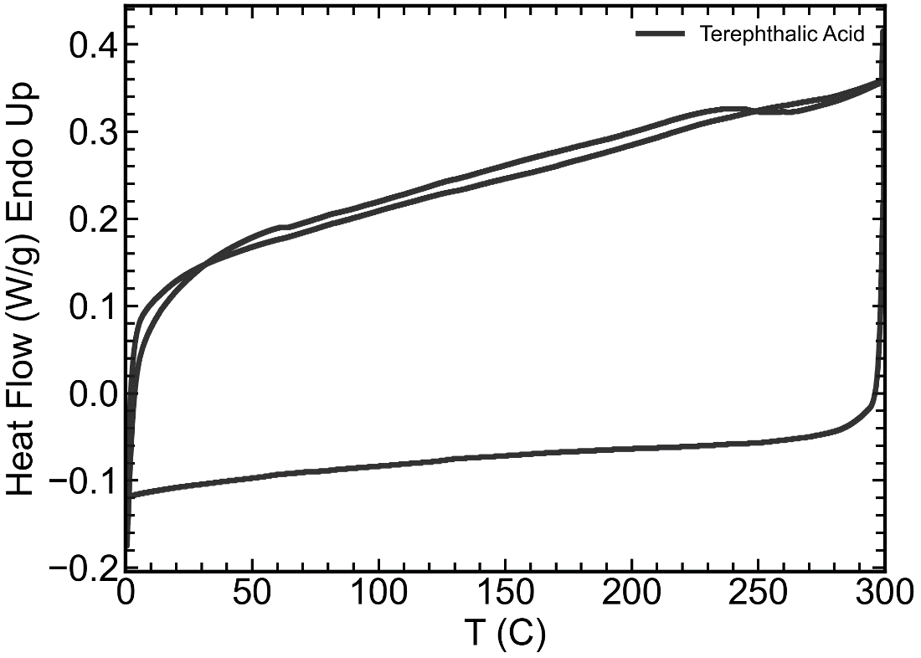
Figure S9: DSC heat-cool-heat scan of pure terephthalic acid conducted at 10 °C/min.
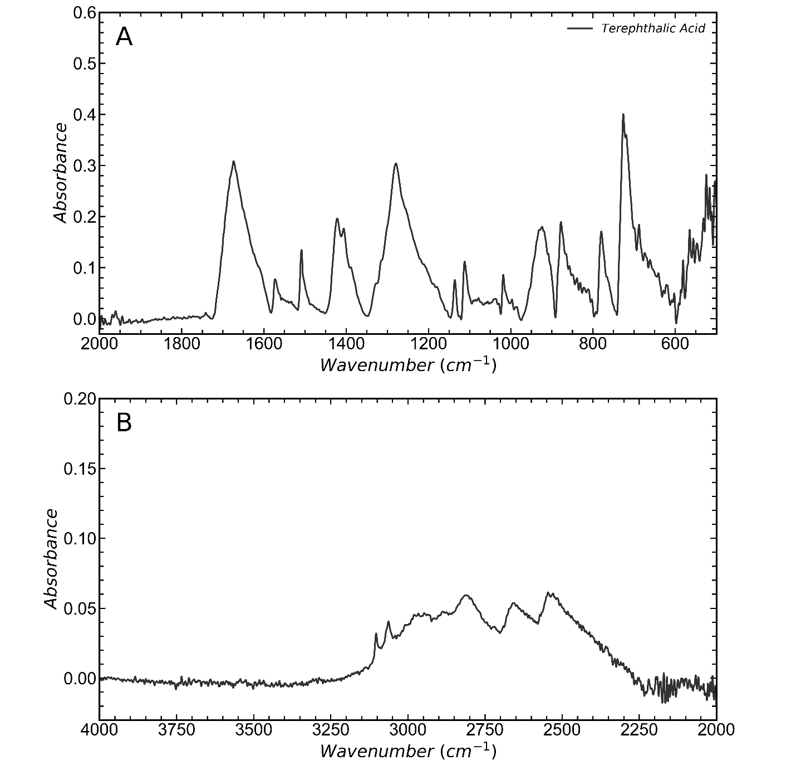
Figure S10: ATR-FTIR spectrum for pure terephthalic acid. A) low wavenumbers B) high wavenumbers.
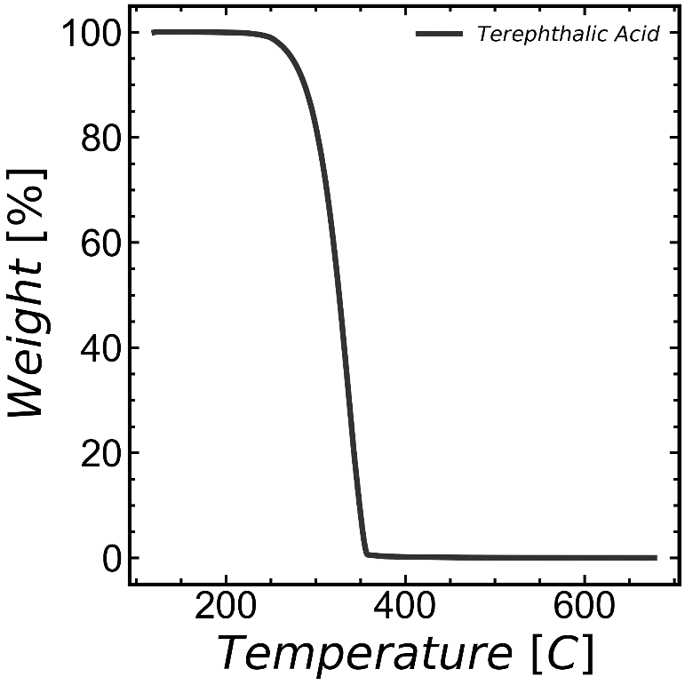
Figure S11: Thermal degradation of pure terephthalic acid under nitrogen atmosphere at a ramp rate of 30 °C/min.

Figure S12-14: ATR-FTIR spectra of MNPLs
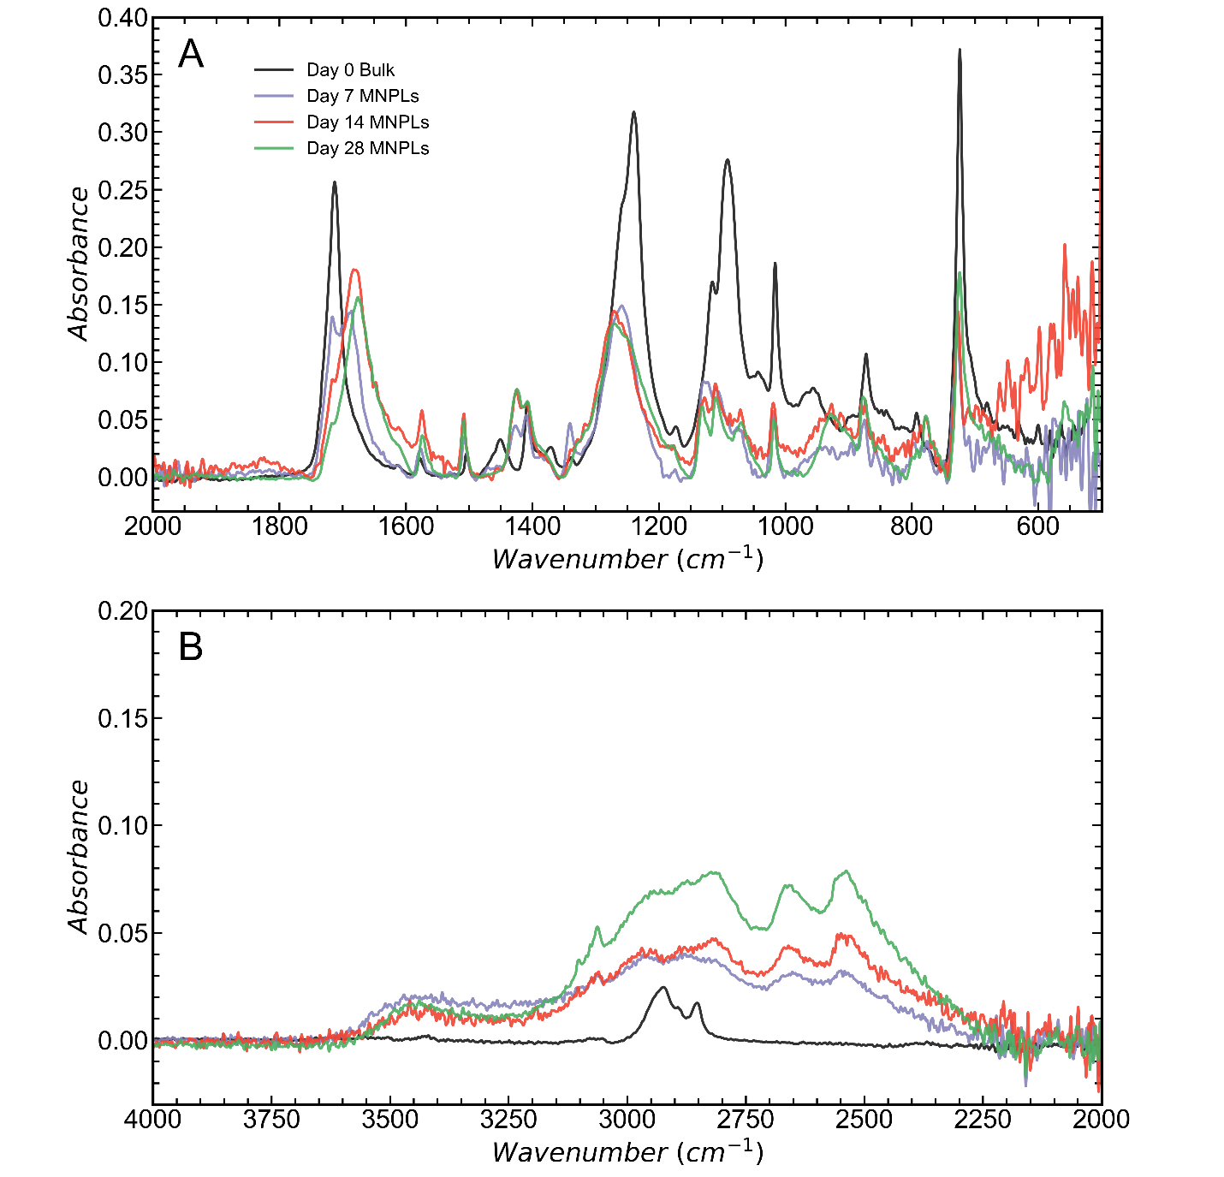
Figure S12: ATR-FTIR spectra for all PET MNPL samples from neutral water hydrolysis at 110 °C. The native film’s spectrum is provided as a reference. A) low wavenumbers B) high wavenumbers.
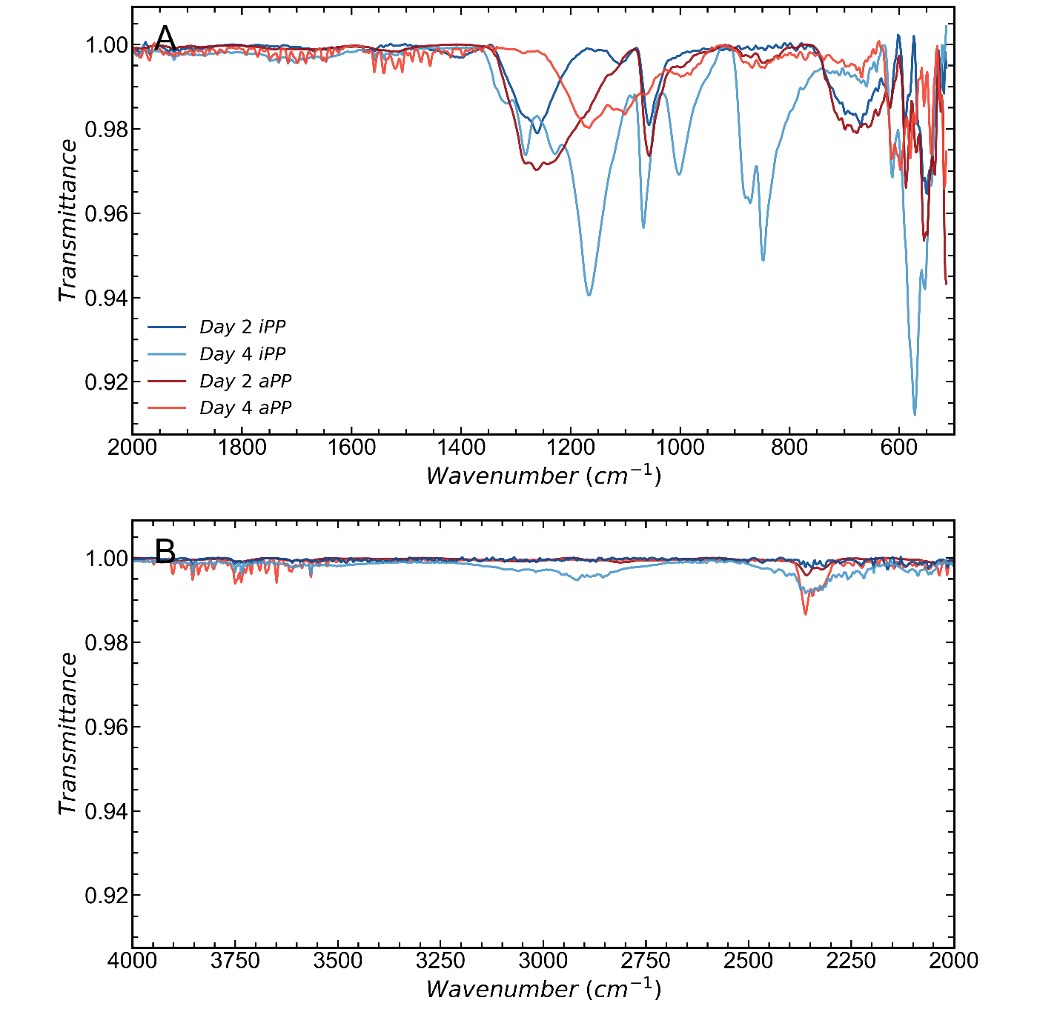
Figure S13: ATR-FTIR spectrum for iPP MNPLs from oxidative degradation and dried aPP solution. A) low wavenumbers B) high wavenumbers.
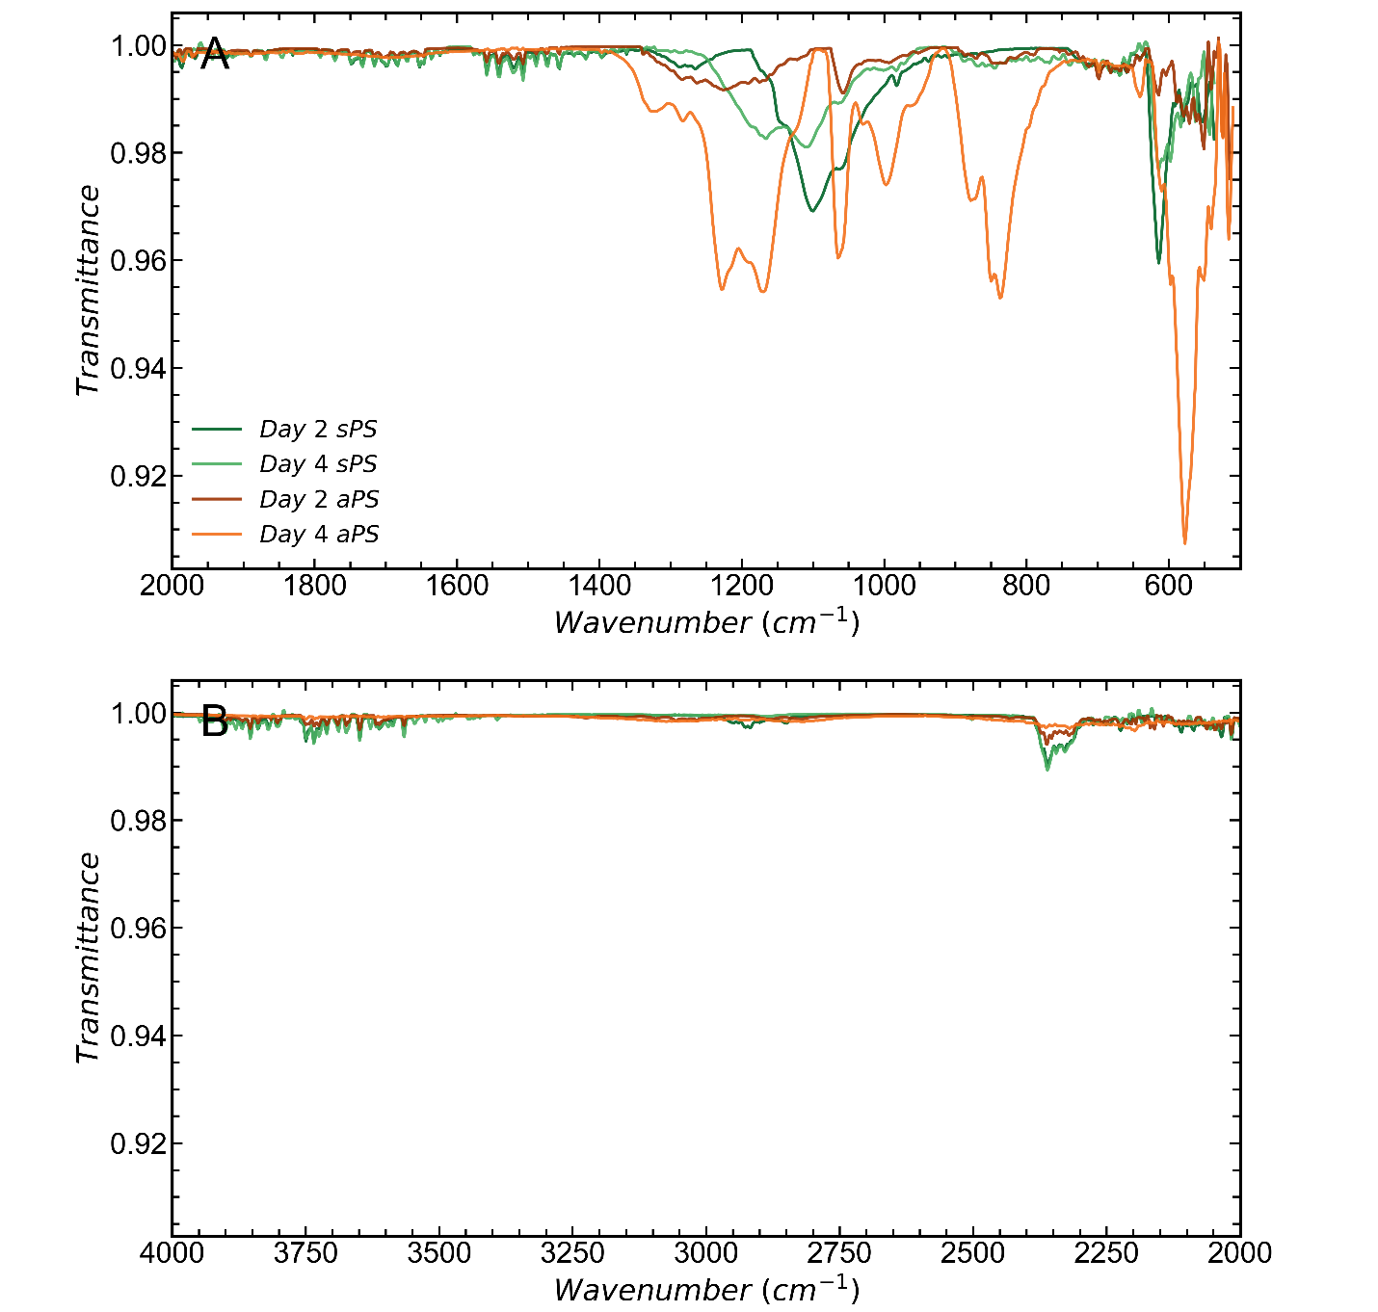
Figure S14: ATR-FTIR spectrum for sPS MNPLs from oxidative degradation and dried aPS solution. A) low wavenumbers B) high wavenumbers.

Figure S15: TGA of all PET samples
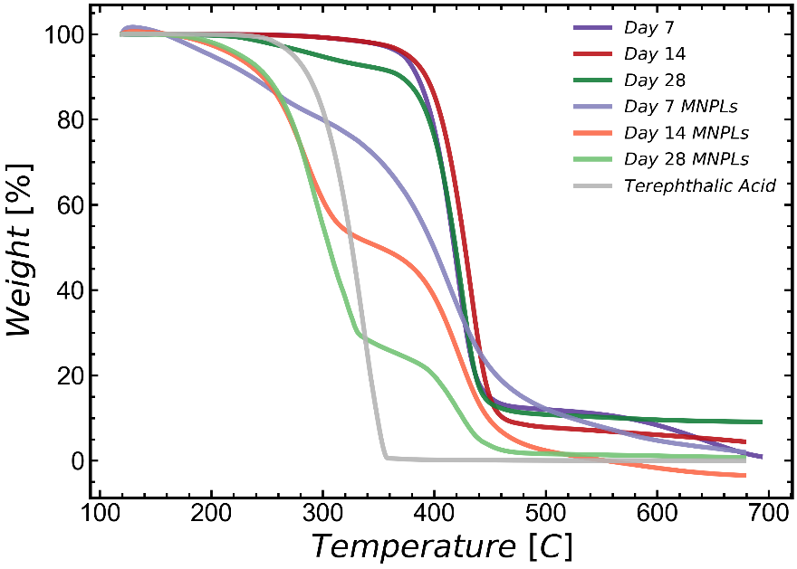
Figure S15: TGA of all PET samples degraded by neutral water hydrolysis at 110 °C. Measurements done under nitrogen atmosphere using a 30 °C/min ramp rate.

Figure S16-17: DSC of additional PET MNPL samples
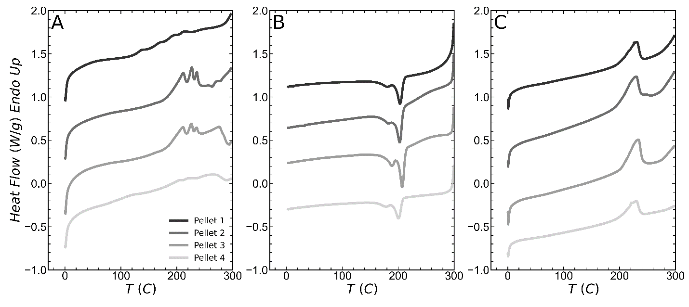
Figure S16: Additional DSC A) heat B) cool C) heat scans for PET MNPL pellets created after 14 days of degradation (pellets are created from pressing centrifuged and dried MNPL powder) at 110 °C. The DSC runs are conducted at 10 °C/min. Data from pellets 2 and 4 is also presented in the main text.
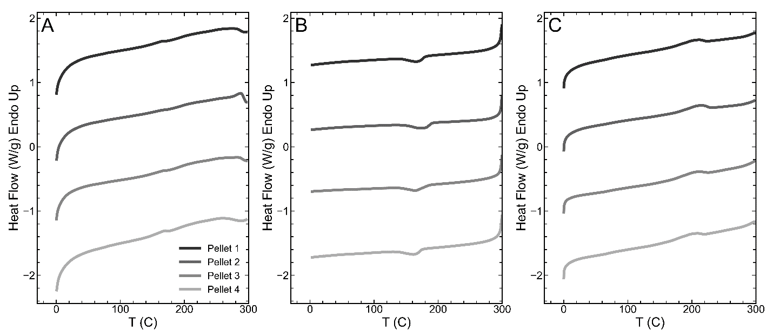
Figure S17: Additional DSC A) heat B) cool C) heat scans for PET MNPL pellets created after 28 days of degradation (pellets are created from pressing centrifuged and dried MNPL powder) at 110 °C. The DSC runs are conducted at 10 °C/min. Data from pellet 2 is presented in the main text.

Figure S18-19: Addition PLOM Images from melting and recrystallization of MNPLs
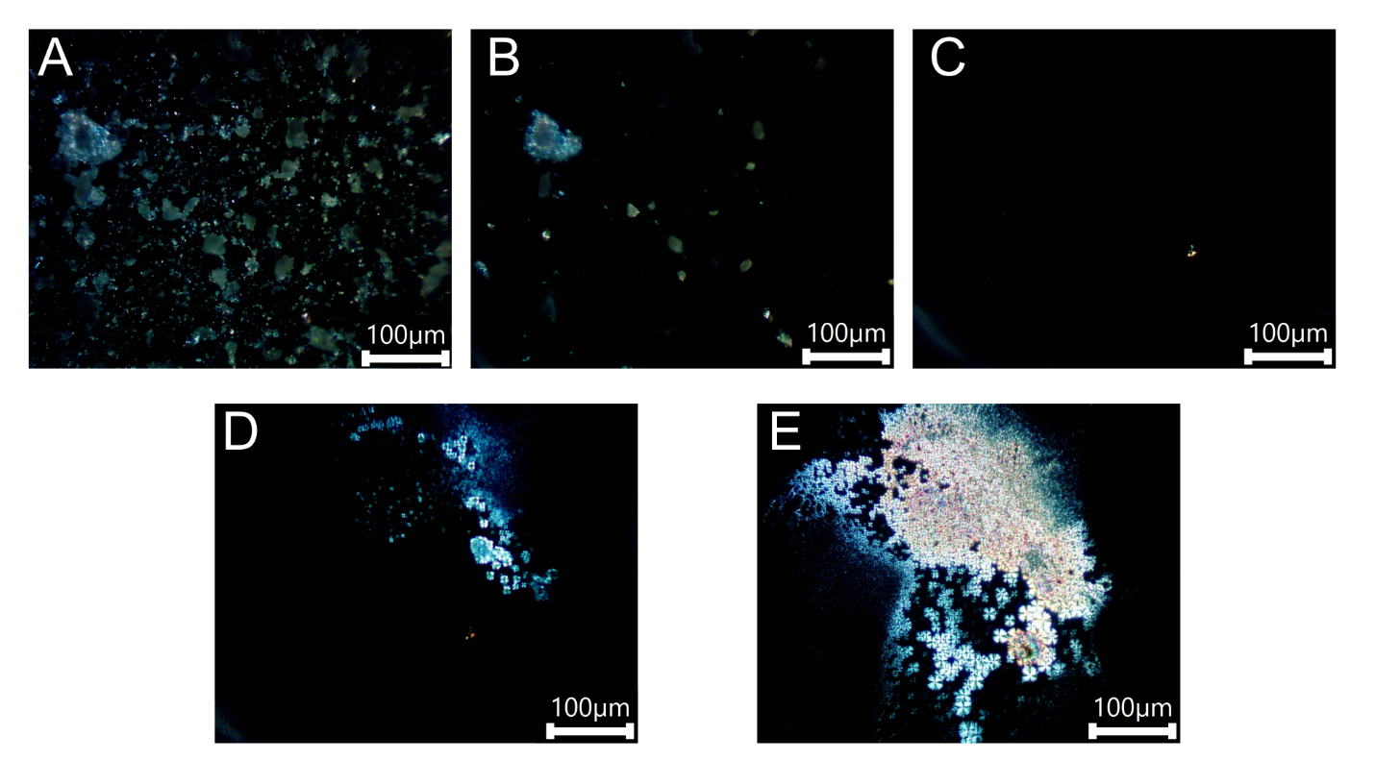
Figure S18: Additional PLOM images from a heat-cool protocol conduced on a Linkam stage using 90 ° cross polarizers at a ramp rate of 10 °C/min (same as DSC). Images correspond to different temperatures during the protocol A) 30 °C; B) 230 °C; C) 300 °C (all heat); D) 215 °C (cooling); E) 100 °C (cooling).

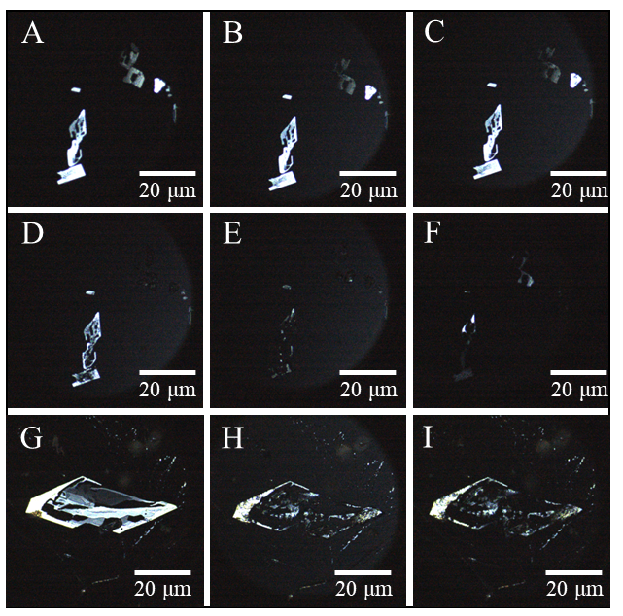
Figure S19: Polarized light optical microscopy images from heat-cool protocol conducted on a Linkam stage using 90°cross polarizers at a 10 °C /min ramp rate. Samples were prepared by drying solutions containing the MNPLs and dissolved salt (from the oxidation process) on a glass cover slip. The stage temperature was calibrated under experimental conditions using an external standard. Images A-F correspond to sPS and G-I correspond to iPP at different temperatures. sPS A) 70 °C; B) 210 °C; C) 212.8 °C; D) 220.4 °C; E) 222.8 °C; F) 120 °C (rapid cooling at 20ºC/min). iPP G) 32.5 °C; H) 156.9 °C (heating); I) 65 °C (cooling). Onset of melting for sPS appears to start at 210 °C and completes at 222 °C. The onset of melting for iPP appears to start at 153 °C and completes at 163 °C. For the iPP sample, drying was not sufficiently slow as to cleanly separate the MNPL from salt crystals. The bright areas to the left of the image correspond to potassium salt that was not spatially separated during sample preparation,

Figure S20-21: X-ray scattering of additional MNPL samples, larger scattering mass
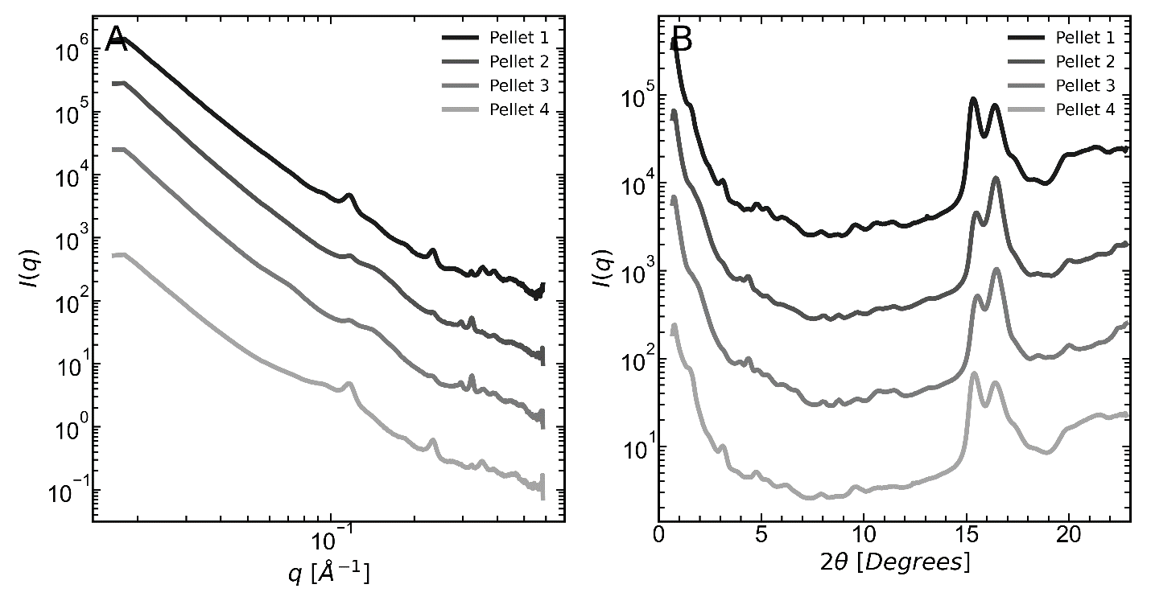
Figure S20: A) SAXS and B) WAXS intensities as a function of q of PET MNPL pellets created after 14 days of degradation at 110 °C measured on pellets (created from pressing centrifuged and dried MNPL powder). The spectra reported in the main text were obtained from smaller scattering volumes that are drop-cast on an SiN substrate.

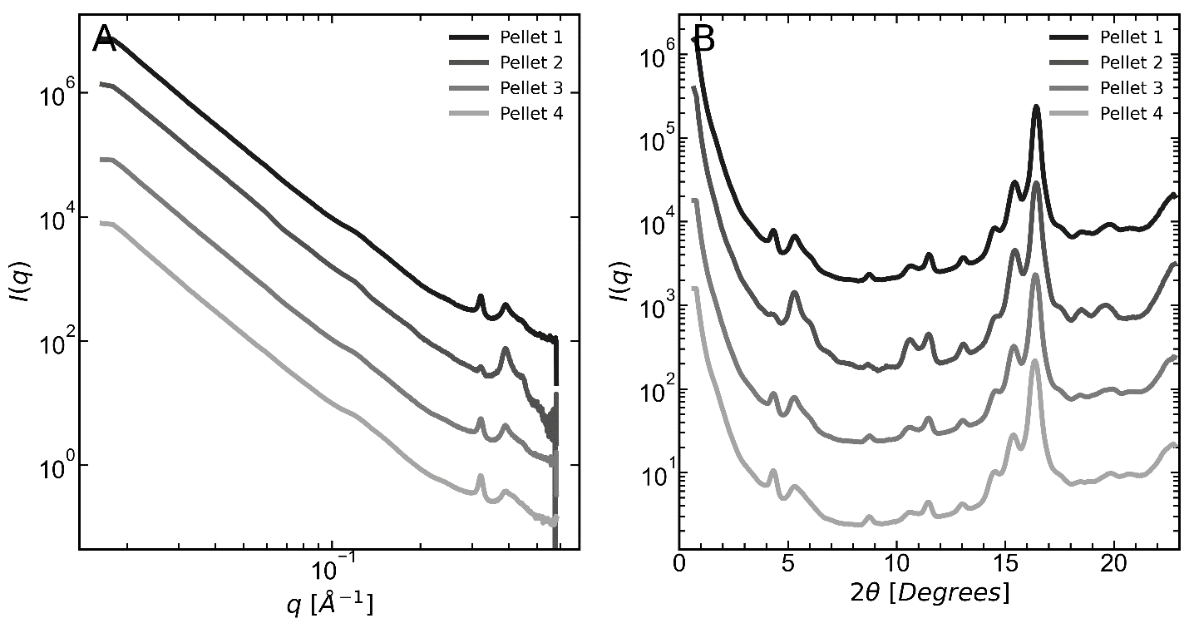
Figure S21: A) SAXS and B) WAXS intensities as a function of q of PET MNPL pellets created after 28 days of degradation at 110 °C measured on pellets (created from pressing centrifuged and dried MNPL powder). The spectra reported in the main text were obtained from smaller scattering volumes that are drop-cast on an SiN substrate.

Figure S22-25: Autocorrelation function and interface distribution function analysis
Figure S22: Representative 1D scattering data depicting the procedure for background subtraction. The slope of a plot of Iq⁴ v q⁴ represents the constant background that needs to be subtracted from all q values. A) spectrum before baseline removal B) spectrum after removal. Dashed black lines represent the area where the constant slope background was fit.

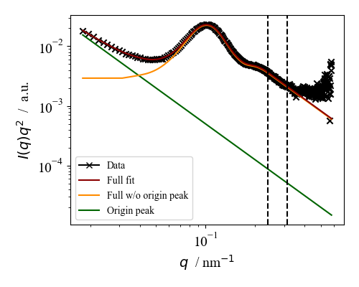
Figure S23: After background subtraction, the origin peak at low q is also removed as depicted in this figure. The black dashed lines represent the regime where the constant background was removed. The green solid line shows the origin peak fitting which is subtracted to give the yellow curve used for the autocorrelation analysis.

Note 2: Details of SAXS analysis
Here we outline the procedures used to analyze the scattering data presented in the main text. We also discuss additional results. The first step performed is removing the constant background from the data by requiring Porod scaling ($I ∝ K_{p}q^{-4}$) in the high q region, where $K_{p}$ is Porod’s constant. This process is shown in Figure S22. After this, an origin peak is removed from the low q region to ensure that the resulting 1D power spectral density (PSD) approaches a small constant as q $→$0 (the subsequent analysis is not affected by the choice of this constant). The origin peak takes the form of $I_{origin}\sim C_{origin}q^{-4}$. Figure S23 shows the origin peak removal. After performing these corrections to the data, we calculate the autocorrelation function $R_{LS}(ξ)$ through a Fourier transform of the scattering data, following the methods of Strobl and Schneider.⁵ The autocorrelation functions for a series of bulk samples and for MNPL samples are presented in Figure S24. The first maximum in $R_{LS}\left(ξ\right)$ provides an estimate of the long period. We go a step further to calculate the second derivative of the autocorrelation function ${R''}_{LS}(ξ)$ [also known as interface distribution function (IDF)] as the real part of the (one-dimensional) Fourier transform of $K_{p}-I\left(q\right)q^{4}$. We follow the work and interpretations of Albrecht and Strobl⁶ and present the IDFs for the same set of samples in Figure S25. The first maximum in the IDF provides an estimate of the shortest length scale (in our system this is the lamellar thickness), while the first minimum provides an estimate of the long period. The behavior in the IDF can be used to analyse the validity of the 1D autocorrelation model as the IDF should be 0 (a.u.) at $ξ=$0 Å. Our results show that the IDF at $ξ=$ 0 Å is 0 (a.u.) for the undegraded sample and increases with degradation time, potentially indicating an increase in the density of lateral lamellar surfaces^{6,7} (presumably generated by fragmentation of the lamellae). Here, we note that this procedure is notoriously sensitive to the extent of data smoothing and hence this conclusion should be treated with some caution.
Figure S24: Calculated autocorrelation functions for A) bulk samples and B) MNPL samples.

Figure S25: Calculated interface distribution functions for A) bulk samples and B) MNPL samples.

Figure S26: WAXS analysis of PET
Figure S26: Demonstrating WAXS peak deconvolution for A) a PET film and B) an MNPL sample.

Figure S27: Summarized crystallinities of bulk PET from different methods
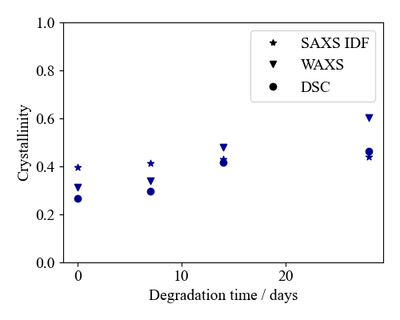
Figure S27: Crystallinities of PET films calculated from different methods and techniques.

Note 3: Details of WAXS analysis
Analysis of WAXS data is performed to estimate the crystallinity of the bulk samples and compare it to DSC and IDF (SAXS) estimates. This quantity can be estimated through a comparison of peak areas calculated through fitting pseudo-Voigt functions to the data. Figure S26 demonstrates the peak fitting process for two representative samples. Peak 1 represents the ($0\overline{1}1$) reflection in PET while peak 2 represents the ($010$) reflection of PET (and terephthalic acid in the case of MNPL samples). Peak 3 represents the amorphous halo and peak 4 is a fitting tool to account for the high q behaviour (information in this region is not interpreted as the full azimuthal intensity is not present at high q values due to the limited detector size). While performing this analysis on the MNPL samples it is observed that virtually no amorphous halo is present in the MNPLs samples, so crystallinities are hard to estimate due to the presence of other products that would influence the integration area. This finding also suggests that the only amorphous mass that persists in the MNPLs is the amorphous mass in the interlamellar region of MNPLs that maintain their stacking. Figure S27 summarizes the crystallinity information for bulk samples from WAXS, IDF of SAXS data (where volumetric crystallinity is converted to a mass crystallinity), and DSC. We find that WAXS and DSC suggest increases in crystallinity while the IDF analysis suggests a less significant increase.

Figure S28-30: Size distributions of PET MNPLs
The size distributions for PET MNPLs represent measurements from collections of images that have been measured by hand. In the case of neutral water hydrolysis terephthalic acid crystallizes in solution and cannot be effectively removed without potentially altering the formed MNPLs. The PET and TPA crystals could not be distinguished from each other using electron diffraction patterns. Therefore, we measure what was observed in samples that are primarily PET (7 and 14-day degraded samples) and report the resulting distributions acknowledging that some of the objects may be terephthalic acid (that forms on a similar size scale to the measured PET). Since the MNPLs formed by PET have a natural tendency to aggregate we focus our measurements on MNPLs which we can unequivocally identify as individual particles. This procedure introduces a bias in our measurements where larger MNPLs (> 1-10 μm depending on the scale of the image) are not considered as they could be large aggregates.
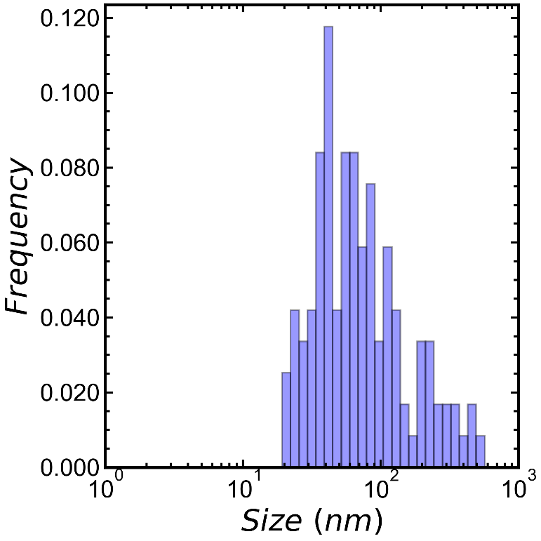
Figure S28: Size distribution measured from TEM images of a dilute sample of PET MNPLs degraded in neutral water for 7 days at 110 °C. This size distribution measures planar objects across their short axis.
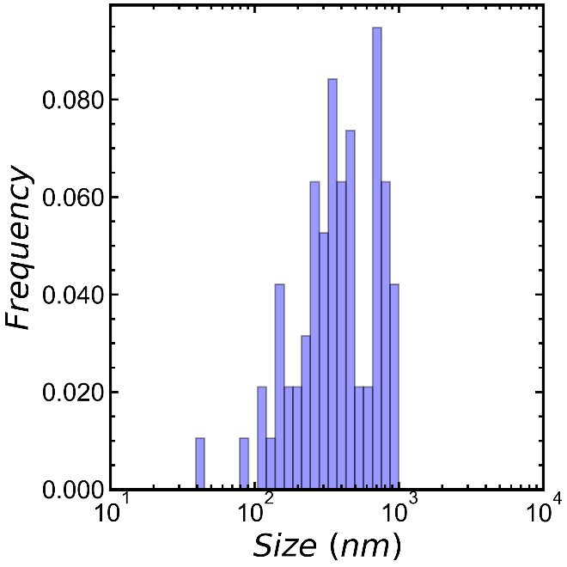
Figure S29: Size distribution measured from TEM images of a dilute sample of PET MNPLs degraded in neutral water for 7 days at 110 °C. This size distribution measures planar objects across their long axis.

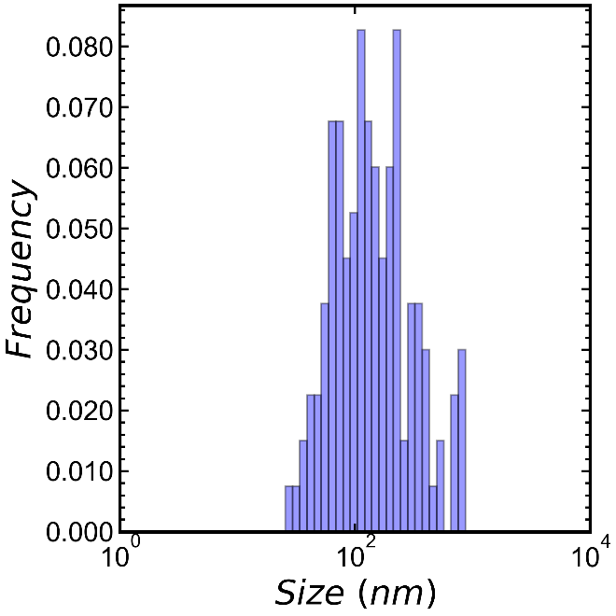
Figure S30: Size distribution measured from SEM images of a dried sample of PET MNPLs degraded in neutral water for 14 days at 110 °C.

Figure S31-32: Characterization of Amorphous PET (prior to recrystallization)
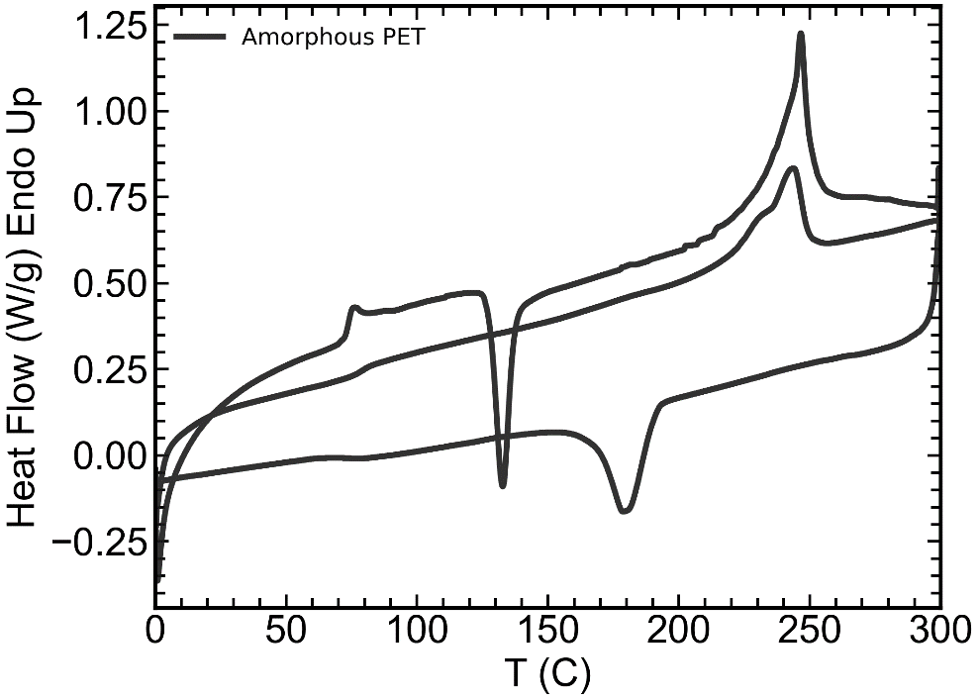
Figure S31: Heat-cool-heat DSC scan of amorphous PET at a ramp rate of 10 °C/min.

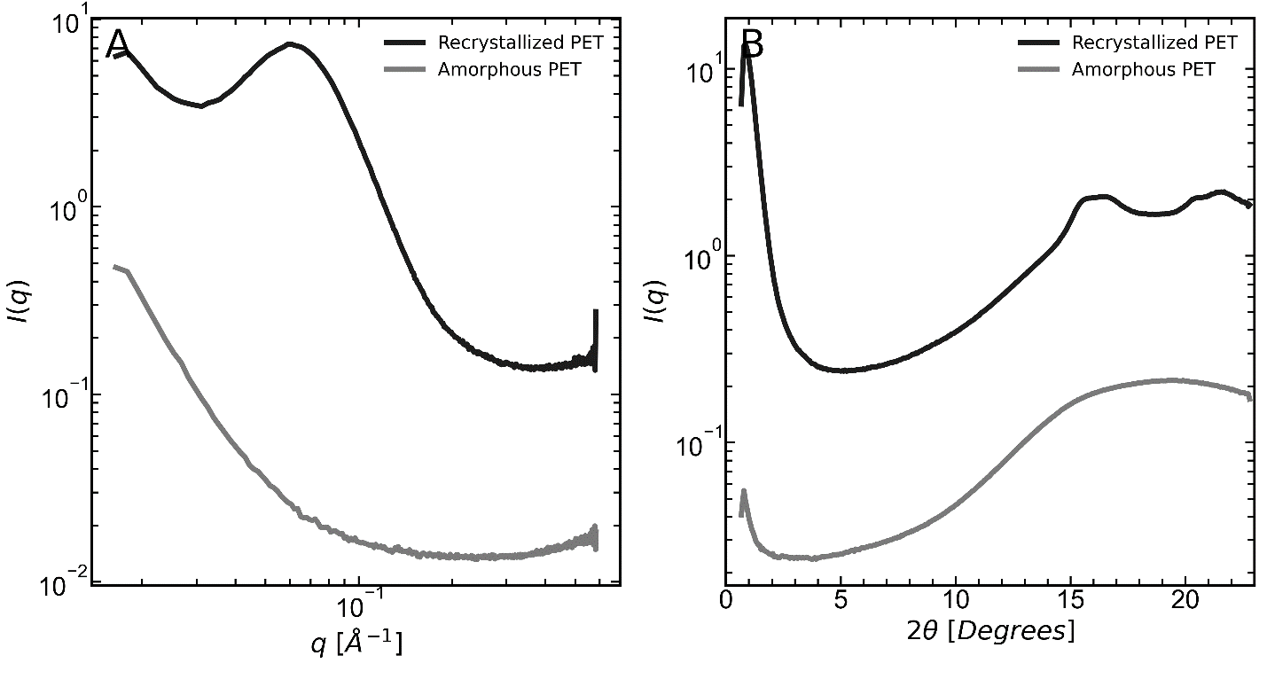
Figure S32: A) SAXS and B) WAXS of amorphous and recrystallized PET. PET was recrystallized at 120 °C for 30 min.

Figure S33: Further details on SEM image analysis
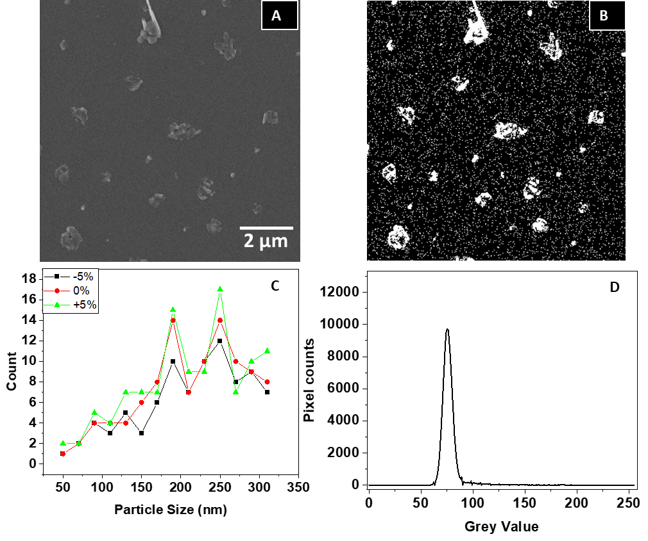Figure S33: A) SEM micrograph of day 2 iPP. B) SEM micrograph after thresholding (threshold value 77). C) Variation in counts with respect to particle size distribution when the threshold is changed by ±5%. We note that the typical change in particle count at any size is less than ±2, and that there is no qualitative change in the shape of the particle size distribution. D) Pixel histogram plot against grey values suggesting the highest pixel counts at 76.580 threshold value, matching with the auto threshold selected.

References
(1) Ronkay, F.; Molnár, B.; Nagy, D.; Szarka, G.; Iván, B.; Kristály, F.; Mertinger, V.; Bocz, K. Melting Temperature versus Crystallinity: New Way for Identification and Analysis of Multiple Endotherms of Poly(Ethylene Terephthalate). Journal of Polymer Research 2020, 27 (12), 372. https://doi.org/10.1007/s10965-020-02327-7.
(2) Rabello, M. S.; White, J. R. Crystallization and Melting Behaviour of Photodegraded Polypropylene — I. Chemi-Crystallization. Polymer (Guildf) 1997, 38 (26), 6379–6387. https://doi.org/10.1016/S0032-3861(97)00213-9.
(3) Nakatani, H.; Ohshima, Y.; Uchiyama, T.; Suguru, M. Degradation and Fragmentation Behavior of Polypropylene and Polystyrene in Water. Scientific Reports 2022 12:1 2022, 12 (1), 1–7. https://doi.org/10.1038/s41598-022-23435-y.
(4) Craig, I. H.; White, J. R.; Kin, P. C. Crystallization and Chemi-Crystallization of Recycled Photo-Degraded Polypropylene. Polymer (Guildf) 2005, 46 (2), 505–512. https://doi.org/10.1016/j.polymer.2004.11.019.
(5) Strobl, G. R.; Schneider, M. Direct Evaluation of the Electron Density Correlation Function of Partially Crystalline Polymers. Journal of Polymer Science: Polymer Physics Edition 1980, 18 (6), 1343–1359. https://doi.org/10.1002/pol.1980.180180614.
(6) Albrecht, T.; Strobl, G. Temperature-Dependent Crystalline-Amorphous Structures in Linear Polyethylene: Surface Melting and the Thickness of the Amorphous Layers; 1995; Vol. 28. https://pubs.acs.org/sharingguidelines.
(7) Albrecht, T.; Strobl, G. Temperature-Dependent Crystalline-Amorphous Structures in Isotactic Polypropylene: Small-Angle X-Ray Scattering Analysis of Edge-Bounded Two-Phase Systems. Macromolecules 1995, 28 (15), 5267–5273.

