Supplemental Material

Aerobic exercise improves ventricular remodeling by promoting macrophages to phagocytose dying cardiomyocytes in heart failure model

Supplemental tables

Supplementary Table S1: Global mapping statistics, such as Estimated Number of Cells, Mean Reads per Cell and Median Genes per Cell for each experimental condition
 | Estimated Number of Cells | Mean Reads per Cell | Median Genes per Cell
CTRL | 19,127 | 41,577 | 1,461
WT-HF | 29,970 | 25,426 | 988
WT-HF-EX | 22,556 | 33,037 | 1,424

Supplemental figures
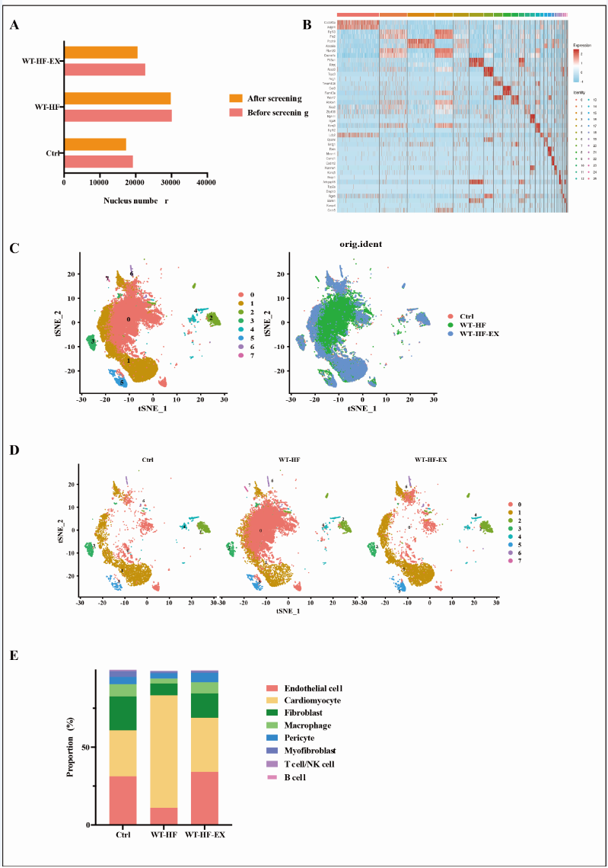

Supplemental Figure S1.A, Information of nuclei used for single-nucleus RNA sequencing. B, Heat map showing differentially expressed genes in each cluster. C, T-Distributed Stochastic Neighbor Embedding (t-SNE) showing the distribution characteristics of cardiomyocytes subsets. D, The distribution characteristics of all cardiomyocytes subsets (display from WT mice after LAD operation, HF mice with AET). E, Histogram showing the proportion of all cell types, including cardiomyocytes, endothelial cells, fibroblasts, macrophages, T cells, B cells, myofibroblasts, and pericytes.

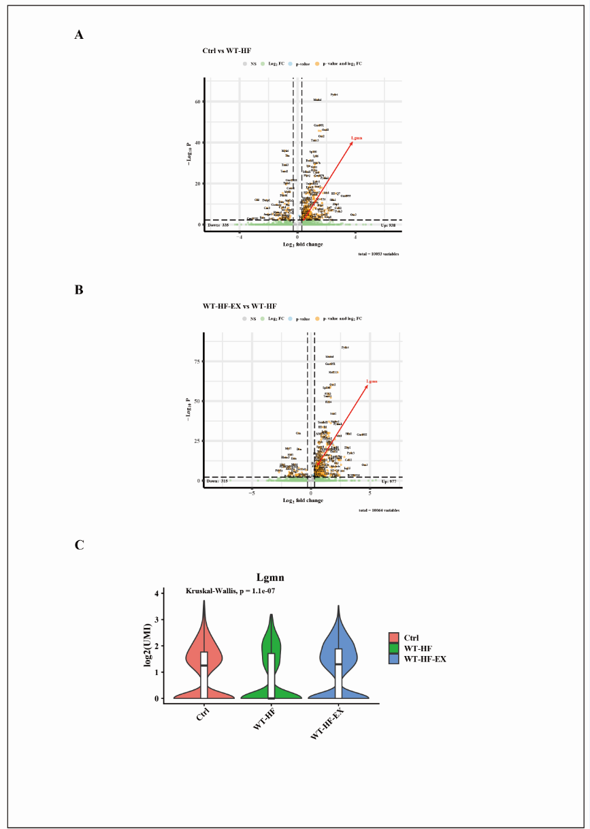

Supplemental Figure S2.A, Volcano map of differentially expressed genes between normal and heart failure groups. B, Volcano map of differentially expressed genes between heart failure and AET groups. C, Expression of Lgmn in WT, HF with or without AET mice showed by violin diagram.

