Supplementary Information for
Width-Dependent Growth of Atomically Thin Quantum Nanoribbons
Xufan Li^{1†}, Samuel Wyss^{2†}, Emanuil Yanev^{3†}, Qing-Jie Li⁴, Shuang Wu¹, Yongwen Sun⁵, Raymond R. Unocic⁶, Joseph Stage², Matthew Strasbourg², Lucas M. Sassi^{1‡}, Yingxin Zhu⁵, Ju Li⁴, Yang Yang⁵, James Hone³, Nicholas Borys², P James Schuck³, Avetik R. Harutyunyan¹*

¹Honda Research Institute USA, Inc., San Jose, CA, 95134, USA.
²Department of Physics, Montana State University, Bozeman, MT, 59717, USA.
³Mechanical Engineering Department, Columbia University, New York, NY, 10025, USA.
⁴Department of Nuclear Science and Engineering and Department of Materials Science and Engineering, Massachusetts Institute of Technology, Cambridge, MA, 02139, USA.
⁵Department of Engineering Science and Mechanics and Materials Research Institute, The Pennsylvania State University, University Park, PA, 16802, USA.
⁶Center for Nanophase Materials Sciences, Oak Ridge National Laboratory, Oak Ridge, TN, 37831, USA.
‡Current address: Department of Physics, National University of Singapore, Singapore, 117551, Singapore.
*Corresponding authors: aharutyunyan@honda-ri.com
†These authors contribute equally.

Supplementary Figures
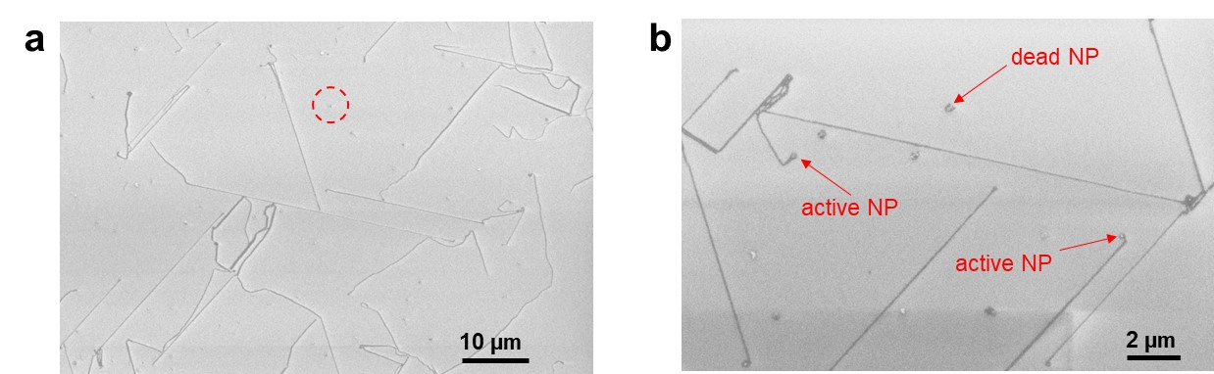
Supplementary Fig. 1. SEM images of MoS₂ NRs grown on F-mica. (a) Low magnification SEM image showing as-grown NRs and seed NPs that did not grow into NRs. (b) Enlarged view SEM image, highlighting as-grown NRs with NPs remaining on the tip after growth (active NP), and NPs that did not grow into NRs (dead NP).

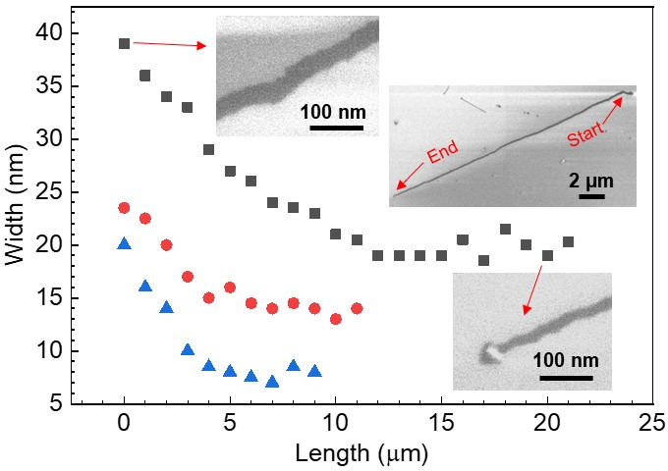
Supplementary Fig. 2. Three typical plots of width change along the length of an individual NR. Inset in the middle is a SEM image of the NR shown by black squares. The start side (upper inset SEM image) is wider than the end part (lower inset SEM image). The NR width reduces as the ribbon grows longer, then keeps approximately unchanged at some point till the end. The initial width is generally ~2 times wider than the final width.
In our growth method, the seed droplet is the only source for Mo atoms, therefore NR growth inevitably leads to reduction of droplet size because of irreversible consumption of Mo atoms from the droplet by grown NR.

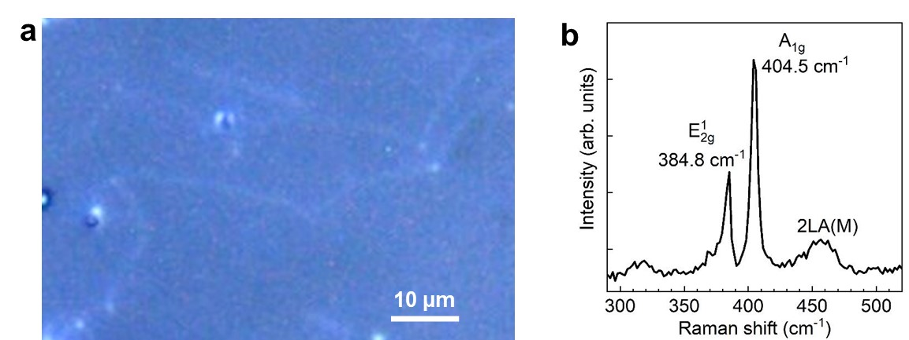
Supplementary Fig. 3. Raman spectrum of MoS₂ NRs grown on F-mica. (a) Optical microscope image of SL MoS2 NRs grown on F-mica. (b) Raman spectrum of the MoS₂ NR shown in (a) excited by 532 nm laser, showing an energy difference of 19.7 cm⁻¹ between A_{1g} and E¹_{2g} mode, characteristic of SL MoS₂.

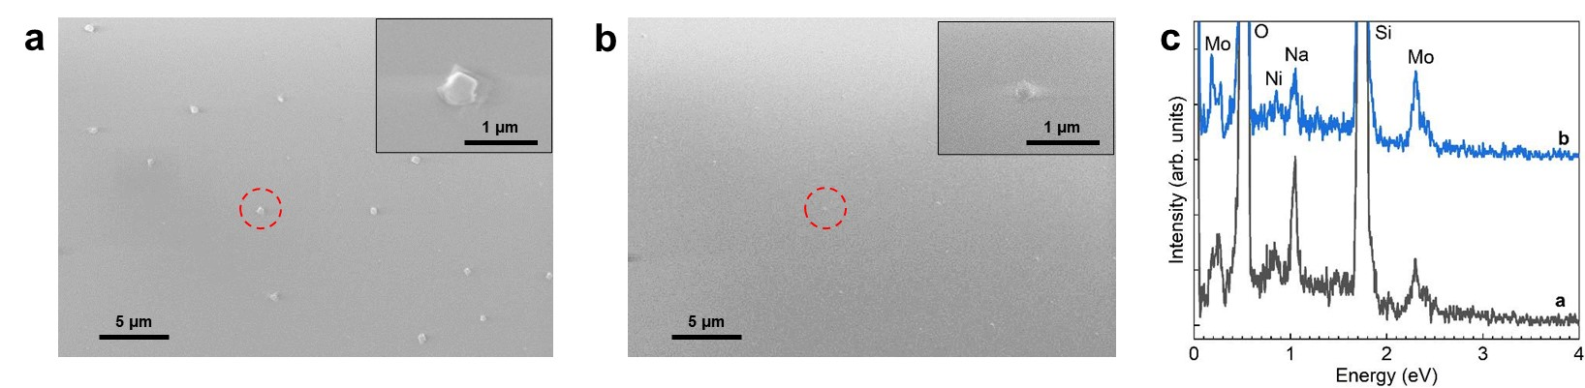
Supplementary Fig. 4. (a) SEM image of seed NPs deposited in step 1. (b) SEM image showing the same area as in (a) after annealing at 750 ºC for 1 minute under Ar flow. Insets are enlarged views of the circled NPs in (a) and (b). (c) EDS spectra of the NPs circled in (a) and (b).
It is clear that without sulfur, after annealing the NPs did not move and there is no precipitation out of the NPs. The NP sizes are reduced due to evaporation during the annealing. The overall composition does not change after annealing. These experimental results confirm that without sulfur, there is no precipitation and no moving of the droplets, even though they are liquified at the annealing temperature, proving the sulfur is the reason for precipitation and therefore moving of the NP.

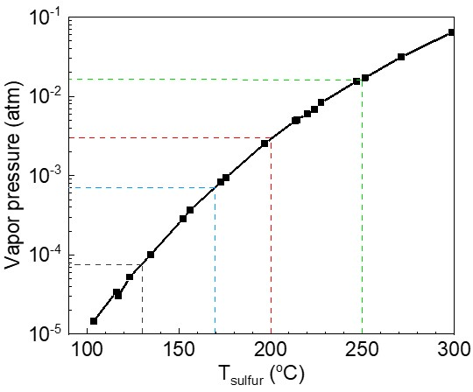
Supplementary Fig. 5. Sulfur vapor pressure (P_{sulfur}) dependence on the temperature (T_{sulfur}).

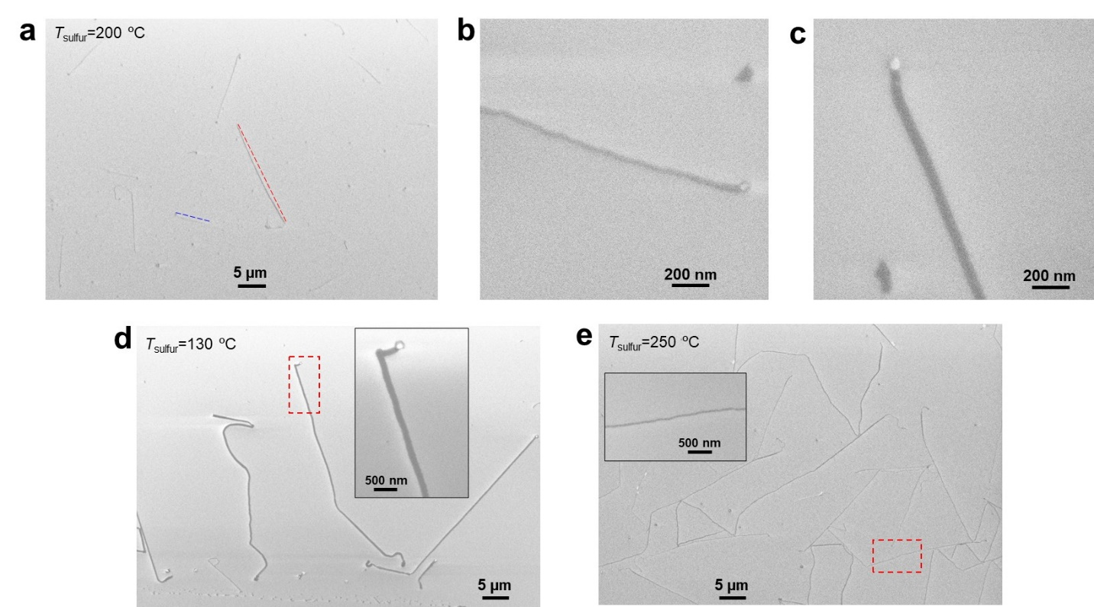
Supplementary Fig. 6. SEM images for NR length (L) vs. width (W) study. (a) A typical SEM image of SL MoS₂ NRs grown at 730 ºC for 180 s with the heating temperature for sulfur powder (T_{sulfur}) at 200 ºC. Dashed lines indicate a longer NR (red) and a shorter NR (blue). (b, c) Enlarged view of the longer, wider NR and the shorter, narrower NR indicated in (a). (d, e) SEM image of SL MoS₂ NRs grown at 730 ºC for 180 s with T_{sulfur} = 130 and 250 ºC, respectively. Insets are enlarged views of the red-boxed areas.

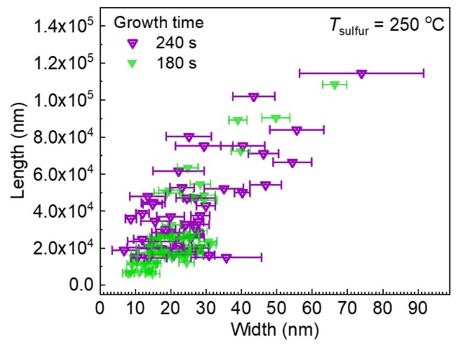
Supplementary Fig. 7. NR L vs. W relation. Statistics on dependence of MoS₂ NR L on W after sulfurization at 730 ºC with T_{sulfur} at 250 ºC for 180 s (green symbols) and 240 s (purple symbols) for comparison. The NRs are generally longer after growth for 240 s than those for 180 s.

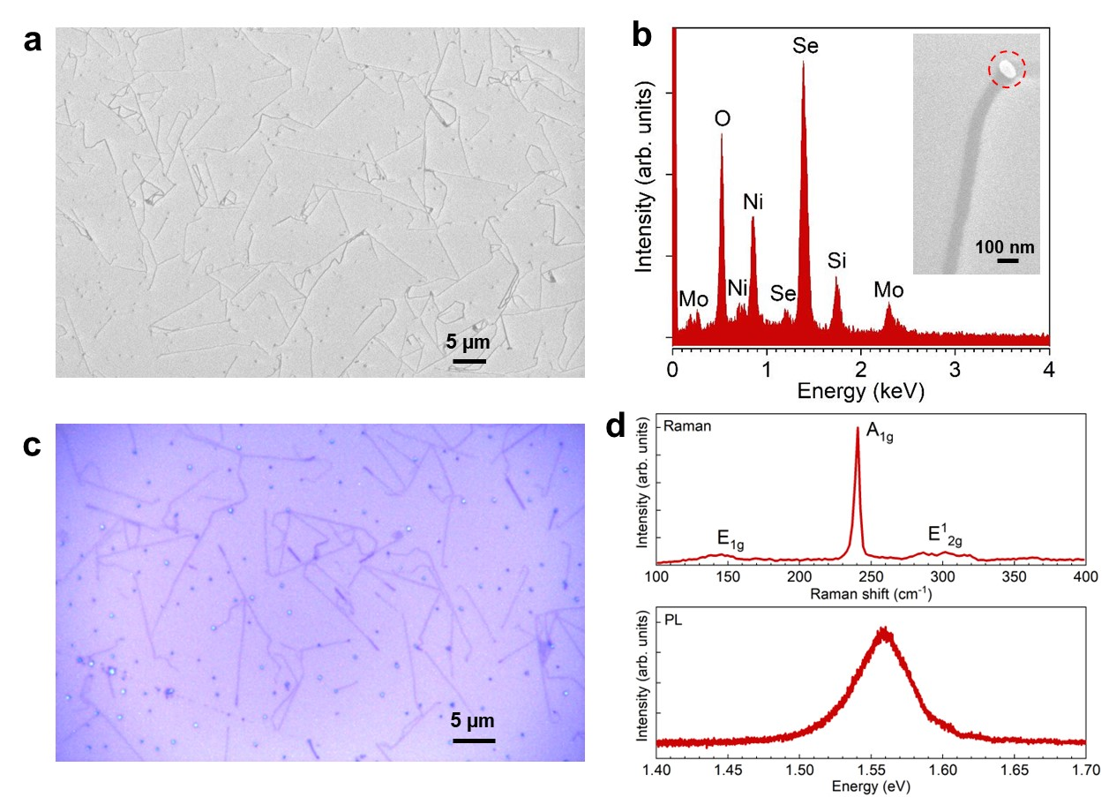
Supplementary Fig. 8. Growth of SL MoSe₂ NRs. (a) SEM image of SL MoSe₂ NRs grown from pre-deposited Na-Mo-Ni-O seed NPs on F-mica. The grown NRs were transferred onto a SiO₂/Si substrate for elemental analysis and optical measurement. (b) EDS spectrum of the tip NP on the grown MoSe₂ NR (inset) transferred on a SiO₂/Si substrate. (c) Optical microscope image of SL MoSe₂ NRs transferred on a SiO₂/Si substrate. (d) Typical Raman (up) and PL (down) spectra of SL MoSe₂ NRs measured from those in (c).
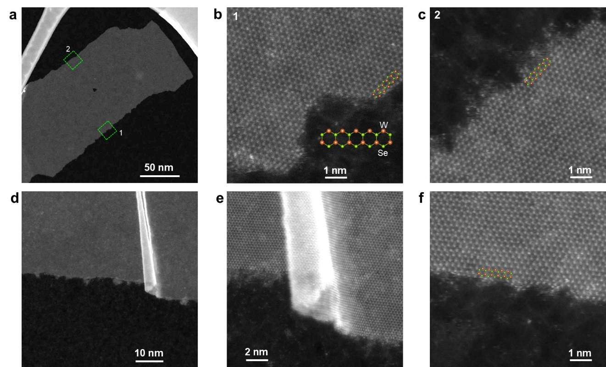
Supplementary Fig. 9. Atomic structure of SL WSe₂ NRs revealed from STEM characterization. (a) Low-magnification STEM image of a WSe₂ NR. (b, c) Atomic resolution HAADF-STEM images showing that one side of the NR has a W-terminated zigzag (W-ZZ) edge (i.e., dashed green box 1), while the other side has a Mo-terminated zigzag (Mo-ZZ) edge (i.e., dashed green box 2). (d) Low-magnification STEM image of a WSe₂ NR with a fold/ripplocation. (e, f) Atomic resolution HAADF-STEM images showing atomic structure around the fold (e) and the Se-ZZ edge (f).

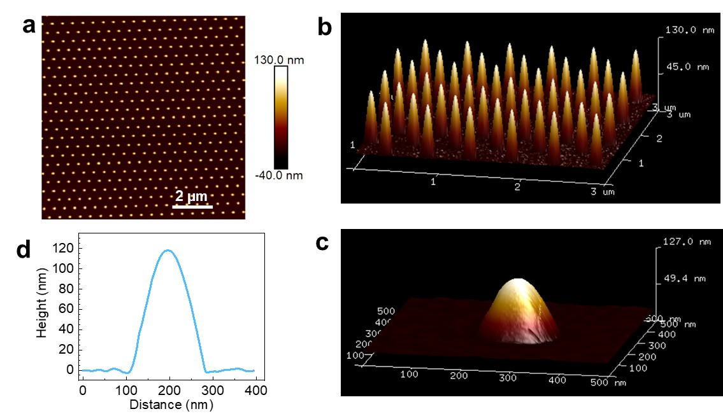
Supplementary Fig. 10. AFM characterization on Au nanocones. (a) AFM image of array of Au nanocones fabricated on a SiO₂/Si substrate. (b, c) 3D vision of AFM images of array and individual Au nanocone. (d) Hight profile of the Au nanocone shown in (c), through the apex.

Supplementary Discussion on the Quantum Emission from Strained SL MoS₂ NR
Although localized strain-induced bright narrowband emissions from QD-like states in SL flakes of WSe₂, WS_{2,} and MoSe₂ at cryogenic temperatures are firmly established by many experimental studies¹⁻⁴, observations of analogous emitters in SL MoS₂ are mostly lacking. So far fewer experimental reports of quantum light emission in SL MoS₂ have relied on the deliberate and precise generation of localized defects with a He ion focused ion beam (FIB)⁵. The strain-induced quantum light emission from SL MoS₂ is for the first time reported in this work. Possible mechanisms revealed in theoretical studies include strain-induced confinement due to nano-wrinkles^{6,7} and hybridization of band-edge defect states with excitons where the energy of the exciton is reduced to that of the defect level by the localized strain⁸. We speculate that in the SL MoS₂ NR here, sufficient localized strain is achieved to realize optically active, strain-induced QD-like states. The localization may be enhanced by the nanoribbon geometry, and we do not observe any signatures of the hybridization with defect states (such as significant line narrowing).

References
1 Palacios-Berraquero, C. et al. Large-scale quantum-emitter arrays in atomically thin semiconductors. Nat. Commun. 8, 15093 (2017).
2 Micevic, A. et al. On-demand generation of optically active defects in monolayer WS₂ by a focused helium ion beam. Appl. Phys. Lett. 121, 183101 (2022).
3 He, Y. M. et al. Single quantum emitters in monolayer semiconductors. Nat. Nanotechnol. 10, 497‒502 (2015).
4 Yu, L. et al. Site-controlled quantum emitters in monolayer MoSe₂. Nano Lett. 21, 2376‒2381 (2021).
5 Klein, J. et al. Site-selectively generated photon emitters in monolayer MoS₂ via local helium ion irradiation. Nat. Commun. 10, 2755 (2019).
6 Carmesin, C. et al. Quantum-dot-like states in molybdenum disulfide nanostructures due to the interplay of local surface wrinkling, strain, and dielectric confinement. Nano Lett. 19, 3182‒3186 (2019).
7 Darlington, T. P. et al. Imaging strain-localized excitons in nanoscale bubbles of monolayer WSe(2) at room temperature. Nat. Nanotechnol. 15, 854-860 (2020).
8 Linhart, L. et al. Localized intervalley defect excitons as single-photon emitters in WSe₂. Phys. Rev. Lett. 123, 146401 (2019).

