Extended Data Figures
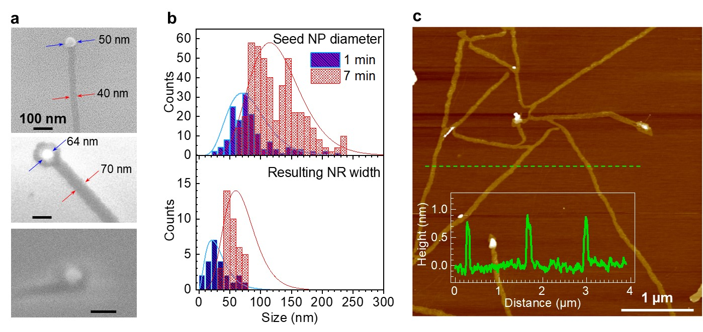
Extended Data Fig. 1. Characterization of SL MoS₂ NRs. (a) SEM images showing grown MoS₂ NRs with different widths correlating to the diameter of tip Ni NPs. (b) Diameter distribution of seed NPs deposited for 1 and 7 minutes (up) and width distribution of corresponding resulting NRs (down). (c) AFM image of SL MoS₂ NRs and height profile along the dashed line, confirming SL NR.

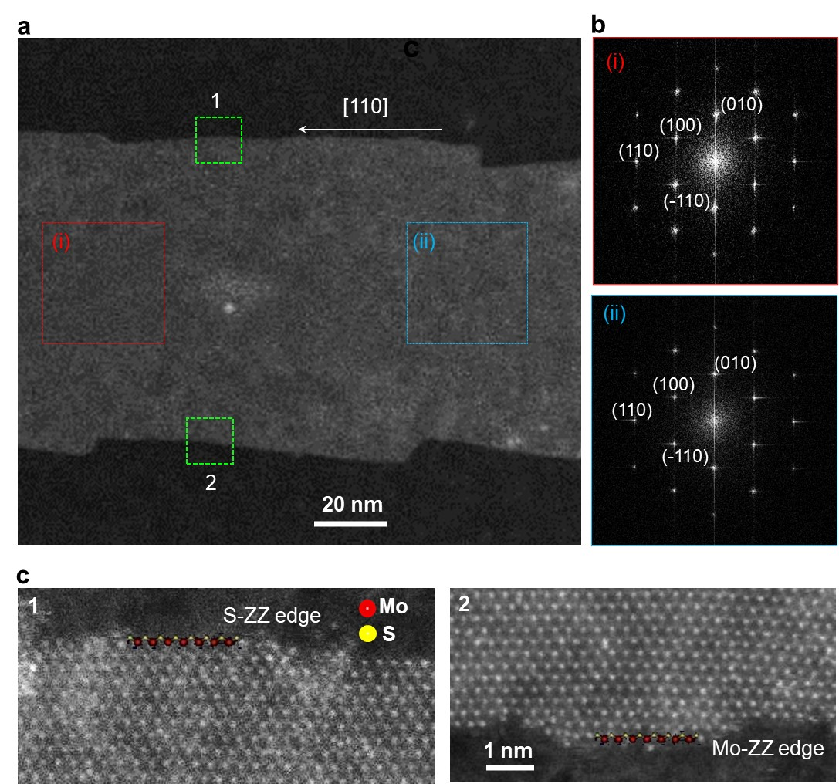

Extended Data Fig. 2. STEM characterization. (a) Low-magnification STEM image of a SL MoS₂ NR. (b) FFT patterns acquired from region (i) and (ii) indicated by the dashed red and blue boxes in (a), indicating the growth axis of this NR along the [110] crystal direction. The good alignment between the NR and diffraction pattern orientation indicates the NR is single crystal. (c) Atomic resolution HAADF-STEM images acquired from region (1) and (2) as indicated by corresponding green dashed boxes in (a), showing that one side of the NR has a S-terminated zigzag (S-ZZ) edge (i.e., dashed green box 1), while the other side has a Mo-terminated zigzag (Mo-ZZ) edge (i.e., dashed green box 2).

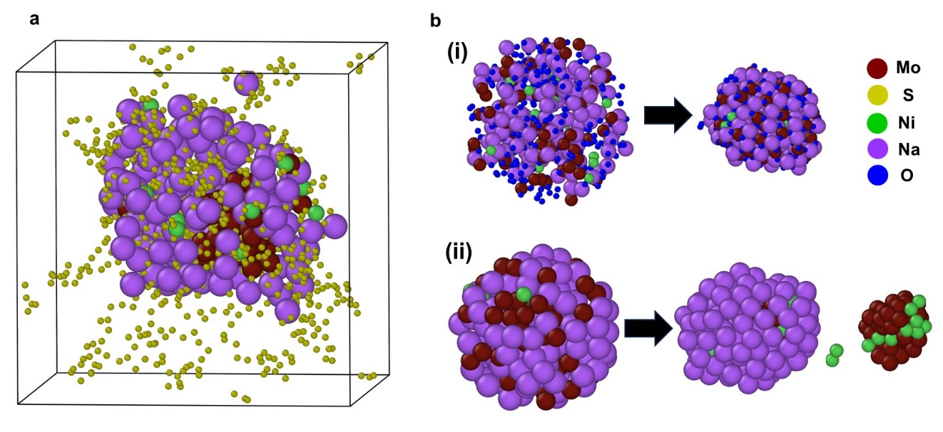
Extended Data Fig. 3. MD simulation. (a) A Na-Mo-Ni nanoparticle (without oxygen) interactions with S atoms, showing that it basically keeps a core-shell structure but with some Ni atoms on surface after the entire system being equilibrated at 650 K for 5 ns. (b) Oxygen effects on element distributions in nanoparticles. (i) nanoparticle with a high concentration of oxygen atoms leads to relatively uniform distribution of various elements after equilibration at 650 K for 1 ns; (ii) nanoparticle without oxygen atoms leads to elements segregations after equilibrated at 300 K for 1 ns: Mo and Ni are mixed in the interior of nanoparticle while Na atoms are separated onto the surface of nanoparticle.

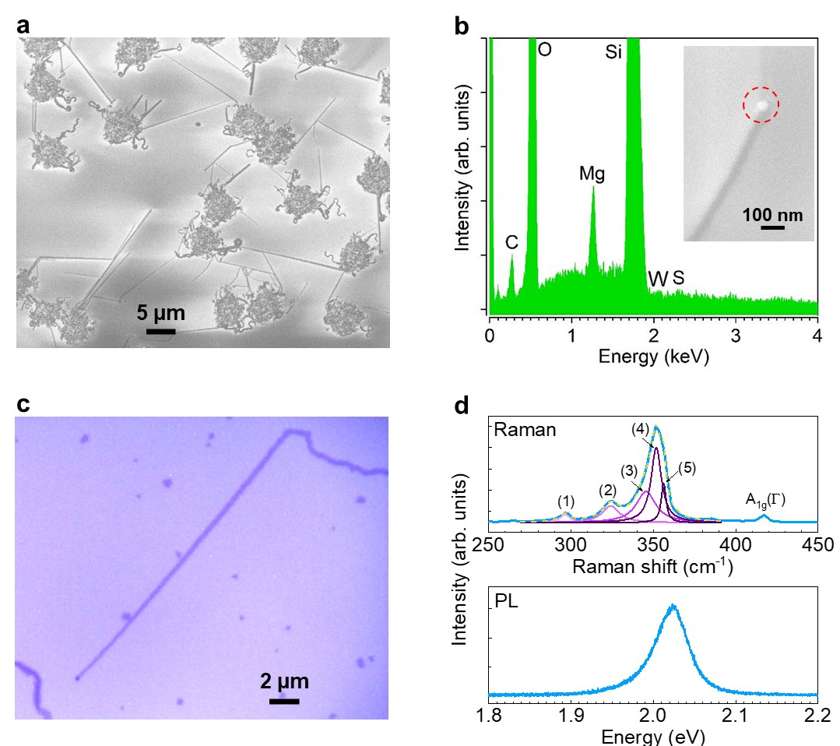

Extended Data Fig. 4. Growth of SL WS₂ NRs. (a) SEM image of SL MoSe₂ NRs grown from pre-deposited Na-W-Mg-O seed NPs on F-mica. The grown NRs were transferred onto a SiO₂/Si substrate for elemental analysis and optical measurement. (b) EDS spectrum of the tip NP on the grown WS₂ NR transferred on a SiO₂/Si substrate. (c) Optical microscope image of a SL WS₂ NR transferred on a SiO₂/Si substrate. (d) Typical Raman (up) and PL (down) spectra of SL WS₂ NRs measured from that in (c). The vibration mode in the Raman spectrum labeled as (1) to (5) correspond to 2LA(M)-2E²_{2g}(Γ), 2LA(M)-E²_{2g}(Γ), E¹_{2g}(M), 2LA(M), and E¹_{2g}(Γ), respectively.

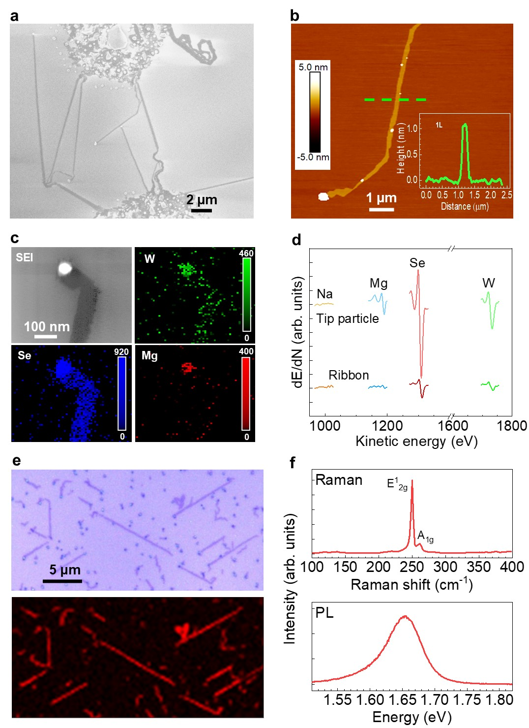

Extended Data Fig. 5. Growth of SL WSe₂ NR. (a) SEM image of WSe₂ NRs grown from pre-deposited Na-W-Mg-O seed particles on F-mica. (b) AFM image of a WSe₂ NR with the tip NP. Inset is the height profile along the dashed green line, indicating single layer. (c) AES elemental mapping of W, Se, and Mg of a SL WSe₂ NR including the tip NP. (d) AES spectra of the tip NP and the NR. For AES measurement, the NRs were transferred onto a SiO₂/Si substrate. (e) (Up) Optical microscope image of WSe₂ NRs transferred on a SiO₂/Si substrate (up) and (down) corresponding mapping on the integrated PL intensity of A-exciton emission band shown in (f). (f) Typical Raman and PL spectra of SL WSe₂ NRs measured from those in (e).

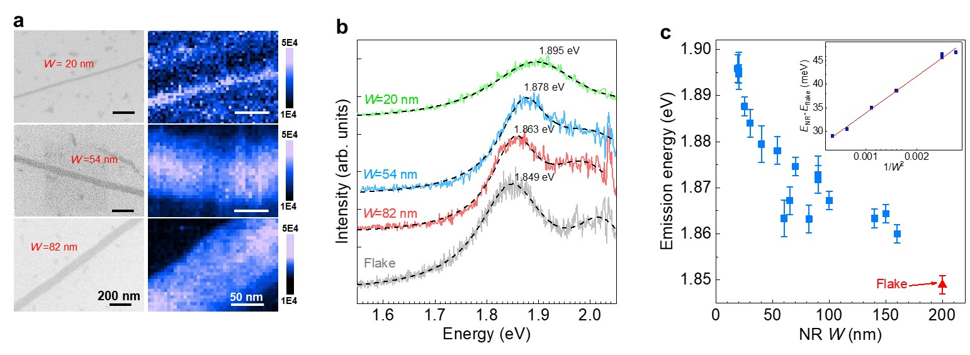

Extended Data Fig. 6. TEPL measurement on SL MoS₂ NRs at room temperature. (a) SEM images (left, scale bars: 200 nm) and corresponding TEPL mapping (right, scale bars: 50 nm) of typical 20 nm, 54 nm, and 82 nm wide MoS₂ SL NRs. The measurements were conducted on NRs on SiO₂/Si substrate through a dry-transfer method. (b) Corresponding TEPL spectra of the NRs. The TEPL spectrum from a CVD-grown SL MoS₂ flake is also shown for comparison. The excitation is 594 nm. The spectra are offset for clarity. (c) Dependence of the A-exciton emission peak energy on the width of SL MoS₂ NRs. The emission energy of the SL flake is also indicated.

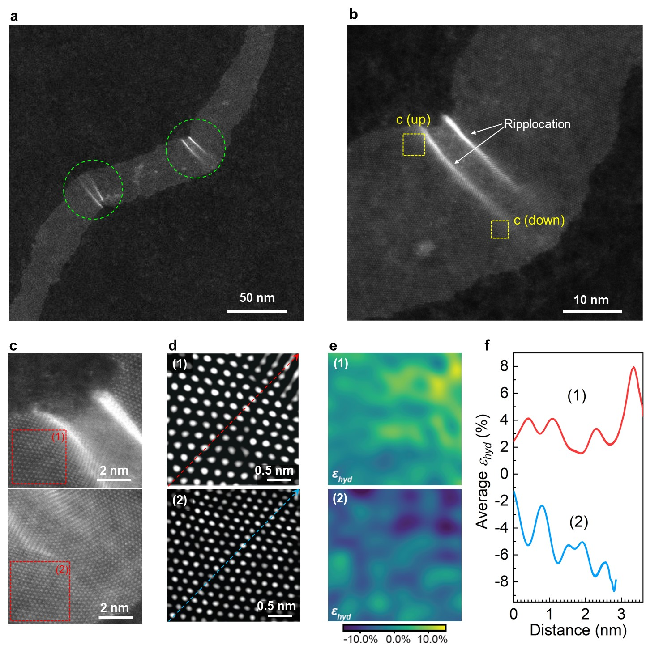

Extended Data Fig. 7. Atomic-resolution characterization of elastic strain in a MoS₂ NR. (a) Low-magnification HAADF-STEM image highlighting a MoS₂ NR with kinks, as indicated by dashed circles. This NR is the one as shown in Fig. 1f. (b) Enlarged view of the region included in the right circle in (a). Two ripplocations in the NR are indicated. (c) Atomic-resolution HAADF-STEM images of the regions contained by corresponding dashed boxes in (b). (d) Filtered high-resolution HAADF-STEM images for box 1 and box 2 in (c), respectively. (e) in-plane hydrostatic strain mapping according to (1) and (2) in (d), respectively. The local elastic strain ranges from -14% to 14%. Notably, this elastic strain approached the theoretical limit⁵³ of elastic strain in MoS₂, suggesting a significant potential for deep elastic strain engineering. (f) Variation of the in-plane hydrostatic strain along the lines in (1) and (2) in (d), revealing a higher magnitude of strain in proximity to the ripplocation.

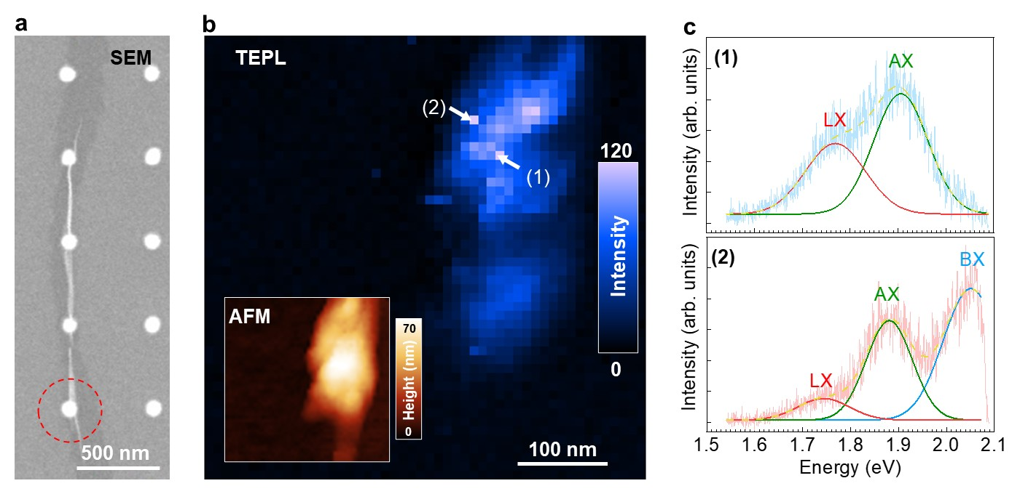

Extended Data Fig. 8. Visualization of hyperlocalized NR emissive states formed on the gold nanocones. (a) SEM image of a SL-MoS₂ NR on gold nanocones. (b) Nearfield TEPL imaging of the ROI indicated in panel (a) of the locally strained SL MoS₂ NR. (c) TEPL spectra extracted from the points indicated in panel (b) indicate that the localized emission is composed of the A exciton (AX) band as well as a low-energy localized exciton (LX) emission band.

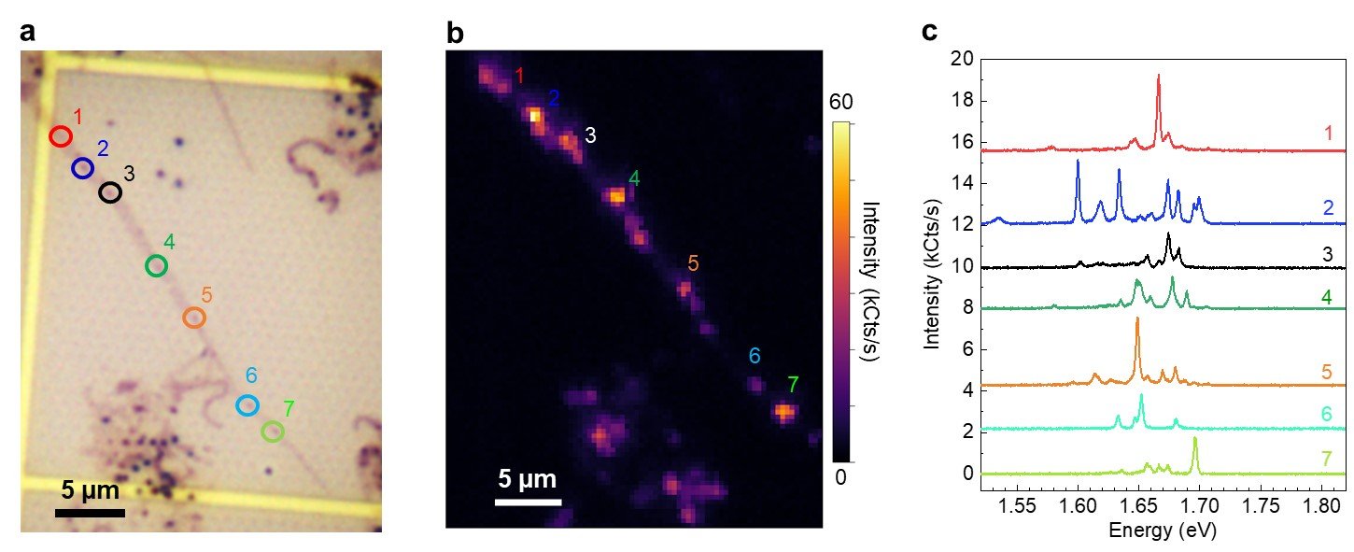

Extended Data Fig. 9. Deterministic quantum light emission from strained SL WSe₂ NR. (a) Optical microscope image of a SL WSe₂ NR transferred on an array of Au nanocones (the same NR as shown in Fig. 4c). (B) Map of integrated PL (at 4 K) intensity from the WSe₂ NR shown in (a). The emitters indicated by colored numbers correspond to the color circled spots in (a). (c) PL spectra of each emitter indicated in (b). Quantum emission appears at each site where the NR is draped over the cones, giving deterministic quantum emission.

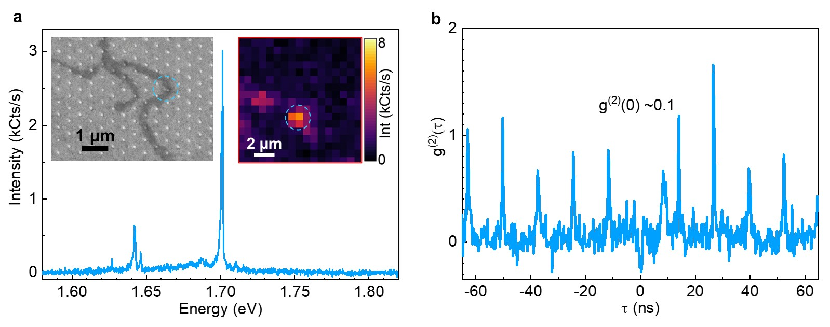

Extended Data Fig. 10. Quantum light emission from strained SL WSe₂ NR. (a) PL spectra of another strained SL WSe₂ NR by Au nanocone. Inset: SEM image of SL WSe₂ NRs transferred on an array of Au nanocones (left) and map of integrated PL intensity from the WSe₂ NR sample near the emitter indicated by the dashed blue circle (right). (b) g⁽²⁾(τ) measurement of the emitter at 1.70 eV using pulsed excitation (rep. rate: 78 MHz). Because the measurement uses pulsed excitation, a peak at every τ~12.8 ns is shown. The absence of the peak at a time delay of τ = 0 ns indicates that the emitter is anti-bunched with a single photon purity of 89%. The broad peak at τ ~ 10 ns is the afterglow from APD.

