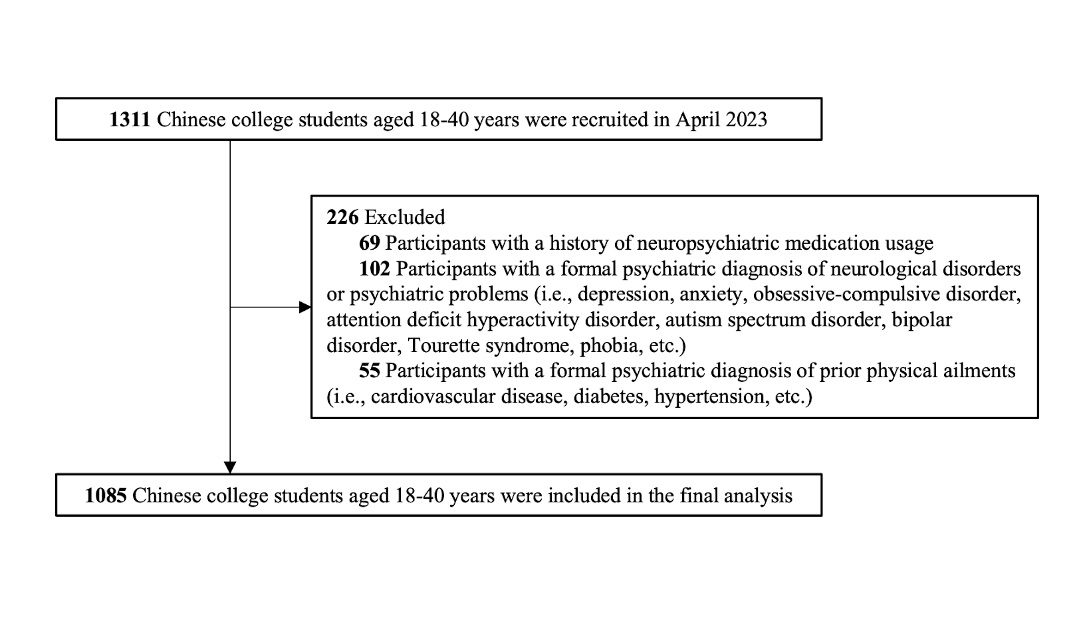
Supplementary Figure 1. Flowchart of participants’ enrollment.

Supplementary Table1. Hierarchical regression results of serial mediating analysis ª.
Dependent Variable | Independent Variable | β | t | R | R² | F
Alexithymia | Autistic Trait | 1.200 | 22.416*** | 0.599 | 0.359 | 100.610
Social camouflaging | Autistic Trait | 0.238 | 2.395* | 0.300 | 0.090 | 15.188
 | Alexithymia | 0.311 | 6.649***
Anxiety | Autistic Trait | 0.342 | 7.611*** | 0.650 | 0.423 | 98.469
 | Alexithymia | 0.332 | 15.465***
 | Social camouflaging | 0.060 | 4.368***
Depression | Autistic Trait | 0.459 | 10.839*** | 0.746 | 0.556 | 168.386
 | Alexithymia | 0.416 | 20.551***
 | Social camouflaging | 0.001 | 0.079
- All of the models were adjusted for participants’ sex, age, education, only-child or not, and monthly family per capita income.
*p<0.05. **p<0.01. ***p<0.001.

Supplementary Table2. Hierarchical regression results of serial mediating analysis in female group ª.
Dependent Variable | Independent Variable | β | t | R | R² | F
Alexithymia | Autistic Trait | 1.050 | 13.875*** | 0.563 | 0.317 | 47.955
Social camouflaging | Autistic Trait | 0.335 | 2.478* | 0.306 | 0.094 | 8.886
 | Alexithymia | 0.276 | 4.110***
Anxiety | Autistic Trait | 0.323 | 5.149*** | 0.616 | 0.379 | 44.856
 | Alexithymia | 0.317 | 10.081***
 | Social camouflaging | 0.050 | 2.465*
Depression | Autistic Trait | 0.462 | 7.702*** | 0.719 | 0.518 | 78.784
 | Alexithymia | 0.398 | 13.218***
 | Social camouflaging | 0.024 | 1.238
- All of the models were adjusted for participants’ sex, age, education, only-child or not, and monthly family per capita income.
*p<0.05. **p<0.01. ***p<0.001.

Supplementary Table3. Hierarchical regression results of serial mediating analysis in male group ª.
Dependent Variable | Independent Variable | β | t | R | R² | F
Alexithymia | Autistic Trait | 1.357 | 17.998*** | 0.639 | 0.408 | 76.725
Social camouflaging | Autistic Trait | 0.107 | 0.723 | 0.308 | 0.095 | 9.742
 | Alexithymia | 0.358 | 5.427***
Anxiety | Autistic Trait | 0.357 | 5.509*** | 0.682 | 0.466 | 69.042
 | Alexithymia | 0.346 | 11.647***
 | Social camouflaging | 0.071 | 3.789**
Depression | Autistic Trait | 0.440 | 7.316*** | 0.762 | 0.581 | 109.822
 | Alexithymia | 0.438 | 15.893***
 | Social camouflaging | -0.020 | -1.131
- All of the models were adjusted for participants’ sex, age, education, only-child or not, and monthly family per capita income.
*p<0.05. **p<0.01. ***p<0.001.

