Supplementary Information Rossi et al BMC Plant Biology
Additional file 1 3D PCA plot of samples belonging to genotype G01 inoculated with the A. cochlioides isolate Ac_01.7.6 and their respective non-inoculated samples at 6 hpi (left) and 30 hpi (right)
Additional file 2 3D PCA plot of samples belonging to genotype G01 inoculated with the A. cochlioides isolate Ac_Arhill2012 and their respective non-inoculated samples at 6 hpi (left) and 30 hpi (right)

Additional file 3 3D PCA plot of samples belonging to genotype G01 inoculated with the A. cochlioides isolate Ac_Hokkaido_01 and their respective non-inoculated samples at 6 hpi (left) and 30 hpi (right)

Additional file 4 3D PCA plot of samples belonging to genotype G17 inoculated with the A. cochlioides isolate Ac_01.7.6 and their respective non-inoculated samples at 6 hpi (left) and 30 hpi (right)

Additional file 5 3D PCA plot of samples belonging to genotype G17 inoculated with the A. cochlioides isolate Ac_Arhill2012 and their respective non-inoculated samples at 6 hpi (left) and 30 hpi (right)

Additional file 6 3D PCA plot of samples belonging to genotype G17 inoculated with the A. cochlioides isolate Ac_Hokkaido_01 and their respective non-inoculated samples at 6 hpi (left) and 30 hpi (right)

Additional file 7 3D PCA plot of samples belonging to genotype G06 inoculated with the A. cochlioides isolate Ac_01.7.6 and their respective non-inoculated samples at 6 hpi (left) and 30 hpi (right)

Additional file 8 3D PCA plot of samples belonging to genotype G06 inoculated with the A. cochlioides isolate Ac_Arhill2012 and their respective non-inoculated samples at 6 hpi (left) and 30 hpi (right)

Additional file 9 3D PCA plot of samples belonging to genotype G06 inoculated with the A. cochlioides isolate Ac_Hokkaido_01 and their respective non-inoculated samples at 6 hpi (left) and 30 hpi (right)

Additional file 10 3D PCA plot of samples belonging to genotype G12 inoculated with the A. cochlioides isolate Ac_01.7.6 and their respective non-inoculated samples at 6 hpi (left) and 30 hpi (right)

Additional file 11 3D PCA plot of samples belonging to genotype G12 inoculated with the A. cochlioides isolate Ac_Arhill2012 and their respective non-inoculated samples at 6 hpi (left) and 30 hpi (right)

Additional file 12 3D PCA plot of samples belonging to genotype G12 inoculated with the A. cochlioides isolate Ac_Hokkaido_01 and their respective non-inoculated samples at 6 hpi (left) and 30 hpi (right)

Additional file 13 Heatmap of the of top 50 differentially expressed genes at 6 hpi in sugar beet samples inoculated with different A. cochlioides isolates and non-inoculated samples at the same time point. Each row represents one of the differentially expressed genes (DEGs) and each column represents a sugar beet sample from the inoculated and non-inoculated dataset

Additional file 14 Heatmap of the of top 50 differentially expressed genes at 30 hpi in sugar beet samples inoculated with different A. cochlioides isolates and non-inoculated samples at the same time point. Each row represents one of the differentially expressed genes (DEGs) and each column represents a sugar beet sample from the inoculated and non-inoculated dataset
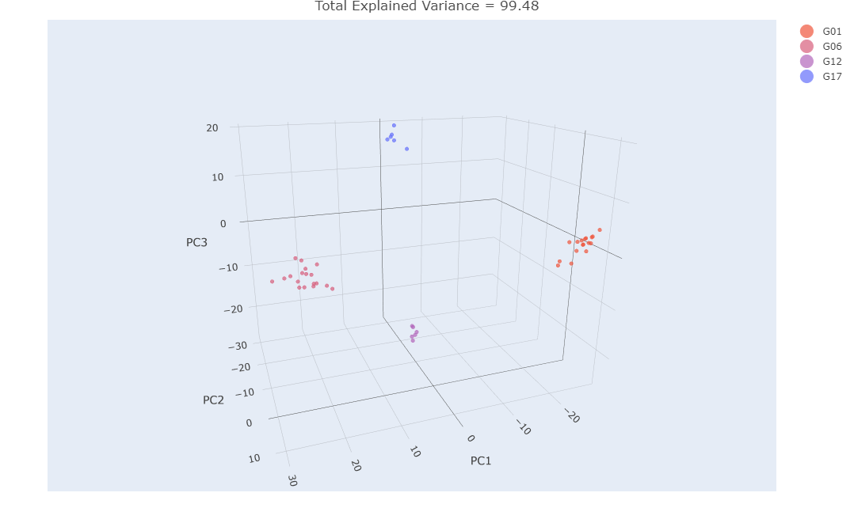 Additional file 15 3D PCA plot of sugar beet non-inoculated samples belonging to different genotypes

