Detection and characterization of colorectal cancer by autofluorescence lifetime imaging: a preliminary study on surgical specimens

Alberto Ignacio Herrando^{1,2,3,*}, Laura M. Fernandez², José Azevedo², Pedro Vieira², Hugo Domingos², Antonio Galzerano⁴, Vladislav Shcheslavskiy^{5,6}, Amjad Parvaiz², Richard J. Heald² Pedro Garcia da Silva¹, Mireia Castillo-Martin⁴, and João L. Lagarto¹

¹ Biophotonics Platform, Champalimaud Foundation, Avenida Brasília, 1400-038 Lisbon, Portugal
² Digestive Unit, Colorectal Surgery, Champalimaud Foundation, Avenida Brasília, 1400-038 Lisbon, Portugal
³ NOVA Medical School, Universidade Nova de Lisboa, Campo Mártires da Pátria 130, 1169-056 Lisbon, Portugal.
⁴ Department of Pathology, Champalimaud Foundation, Avenida Brasília, 1400-038 Lisbon, Portugal
⁵ Becker & Hickl GmbH, Nunsdorfer Ring 7-9, 12277 Berlin, Germany
⁶ Privolzhsky Research Medical University, Minina and Pozharskogo Sq, 10/1, 603005 Nizhny Novgorod, Russia

Channel | Excitation wavelength | Emission range collection | Targeted molecule
1 | 375 nm | 380-420 nm | Collagens
2 | 375 nm | 456-484 nm | NAD(P)H
3 | 375 nm | 500-550 nm | Elastin – NAD(P)H - FAD/FMN
4 | 445 nm | 456-484 nm | FAD/FMN
5 | 445 nm | 500-550 nm | FAD/FMN
Supplementary Table S1. Excitation wavelengths and emission spectral bandwidths collected with our optical setup in correspondence with channel acquisition number and targeted molecule.

Type of Treatment | N° Patients
Previous RT treatment
Prostatectomy + RT (72 Gy) | 1
Neoadjuvant RT ± CT
Short-course RT (30Gy) + Consolidation Chemotherapy (CAPOX x6) | 3
Chemoradiotherapy (RT 50.4 Gy + Concurrent Capecitabine)
• with Consolidation Chemo (CAPOX x6) | 1
• without Consolidation Chemo | 2
Chemoradiotherapy (RT 56 Gy + Concurrent Capecitabine)
• with Consolidation Chemo (CAPOX x6) | 1
• without Consolidation Chemo | 1
Incomplete Chemoradiotherapy (only 30.6 Gy with concurrent Capecitabine) | 1
Adjuvant
Chemoradiotherapy (RT 50.5 Gy + Concurrent Capecitabine) + Aditional Chemotherapy | 1
Total | 11

Supplementary Table S2. Radiation exposure details in our cohort of patients.

 |  | Without Radiation |  |  | With Radiation
 |  | Normal (n= 63) | Tumor (n= 49) | Adenoma (n= 10) | Normal (n= 11) | Tumor (n= 7)
CH1 | 𝜏_{mean} (ns) | 3.21 (0.47) | 2.64 (0.64) | 3.08 (0.35) | 3.24 (0.34) | 2.35 (0.46)
CH2 | 𝜏_{mean} (ns) | 2.85 (0.25) | 2.80 (0.39) | 2.68 (0.30) | 3.03 (0.31) | 2.86 (0.49)
CH2 | a₁ | 0.83 (0.02) | 0.86 (0.03) | 0.84 (0.02) | 0.80 (0.03) | 0.86 (0.02)
CH2 | 𝜏₁ | 0.63 (0.15) | 0.61 (0.16) | 0.59 (0.18) | 0.73 (0.14) | 0.62 (0.08)
CH2 | a₂ | 0.17 (0.02) | 0.14 (0.03) | 0.16 (0.02) | 0.19 (0.03) | 0.14 (0.02)
CH2 | 𝜏₂ | 4.46 (0.37) | 4.74 (0.57) | 4.29 (0.52) | 4.69 (0.38) | 4.80 (0.65)
CH3 | 𝜏_{mean} (ns) | 3.02 (0.33) | 3.00 (0.43) | 2.76 (0.36) | 3.31 (0.46) | 3.15 (0.43)
CH3 | a₁ | 0.83 (0.03) | 0.83 (0.04) | 0.85 (0.04) | 0.79 (0.05) | 0.81 (0.03)
CH3 | 𝜏₁ | 0.73 (0.25) | 0.70 (0.24) | 0.68 (0.26) | 0.87 (0.22) | 0.73 (0.12)
CH3 | a₂ | 0.17 (0.03) | 0.17 (0.04) | 0.15 (0.04) | 0.20 (0.05) | 0.18 (0.02)
CH3 | 𝜏₂ | 4.73 (0.44) | 4.74 (0.62) | 4.48 (0.46) | 5.00 (0.43) | 4.84 (0.59)
CH4 | 𝜏_{mean} (ns) | 3.69 (0.50) | 3.54 (0.38) | 3.46 (0.26) | 3.83 (0.46) | 3.53 (0.57)
CH4 | a₁ | 0.83 (0.07) | 0.82 (0.07) | 0.82 (0.08) | 0.76 (0.14) | 0.78 (0.10)
CH4 | 𝜏₁ | 1.34 (0.40) | 1.14 (0.45) | 0.92 (0.14) | 1.63 (0.71) | 1.72 (0.75)
CH4 | a₂ | 0.17 (0.07) | 0.17 (0.07) | 0.17 (0.08) | 0.24 (0.14) | 0.22 (0.10)
CH4 | 𝜏₂ | 7.35 (1.40) | 7.18 (0.91) | 6.59 (0.66) | 7.50 (1.22) | 7.18 (1.26)
CH5 | 𝜏_{mean} (ns) | 2.51 (0.55) | 2.07 (0.49) | 1.93 (0.37) | 2.73 (0.60) | 2.30 (0.51)
CH5 | a₁ | 0.83 (0.07) | 0.85 (0.06) | 0.87 (0.04) | 0.81 (0.08) | 0.84 (0.06)
CH5 | 𝜏₁ | 0.79 (0.61) | 0.69 (0.47) | 0.60 (0.37) | 1.03 (0.96) | 0.67 (0.42)
CH5 | a₂ | 0.17 (0.07) | 0.15 (0.06) | 0.13 (0.04) | 0.19 (0.08) | 0.16 (0.06)
CH5 | 𝜏₂ | 4.09 (0.59) | 3.56 (0.56) | 3.43 (0.44) | 4.27 (0.71) | 3.77 (0.49)
 | Redox ratio | 0.18 (0.05) | 0.17 (0.08) | 0.28 (0.08) | 0.17 (0.05) | 0.10 (0.04)

Supplementary Table S3. Averaged optical parameters from selected ROIs of each type of tissue of our cohort (N= 74).

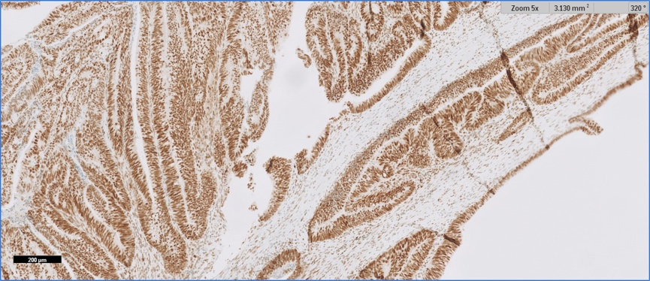
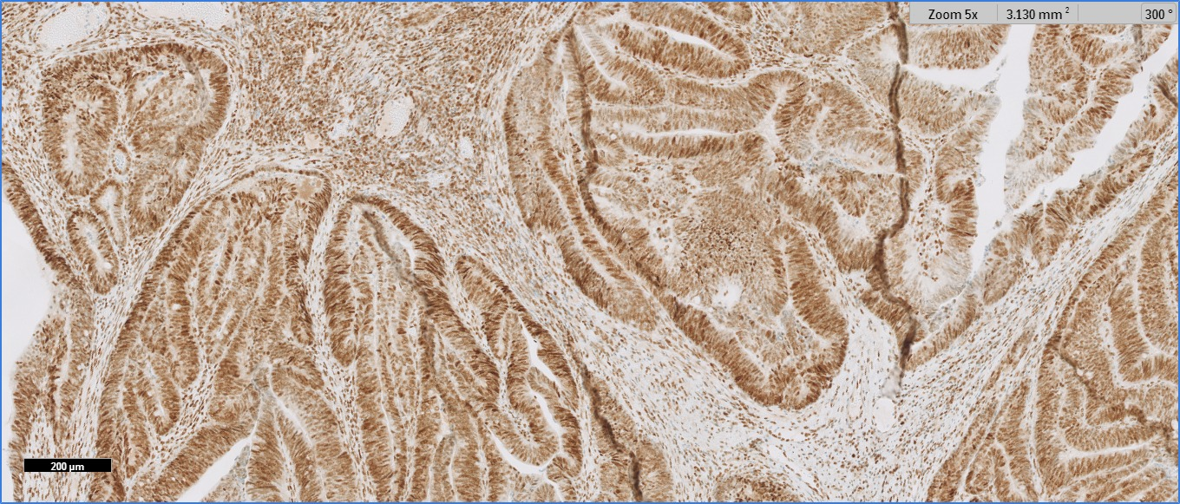
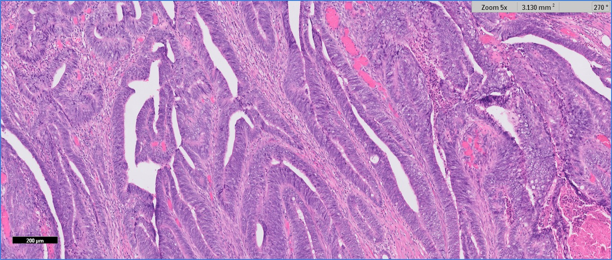
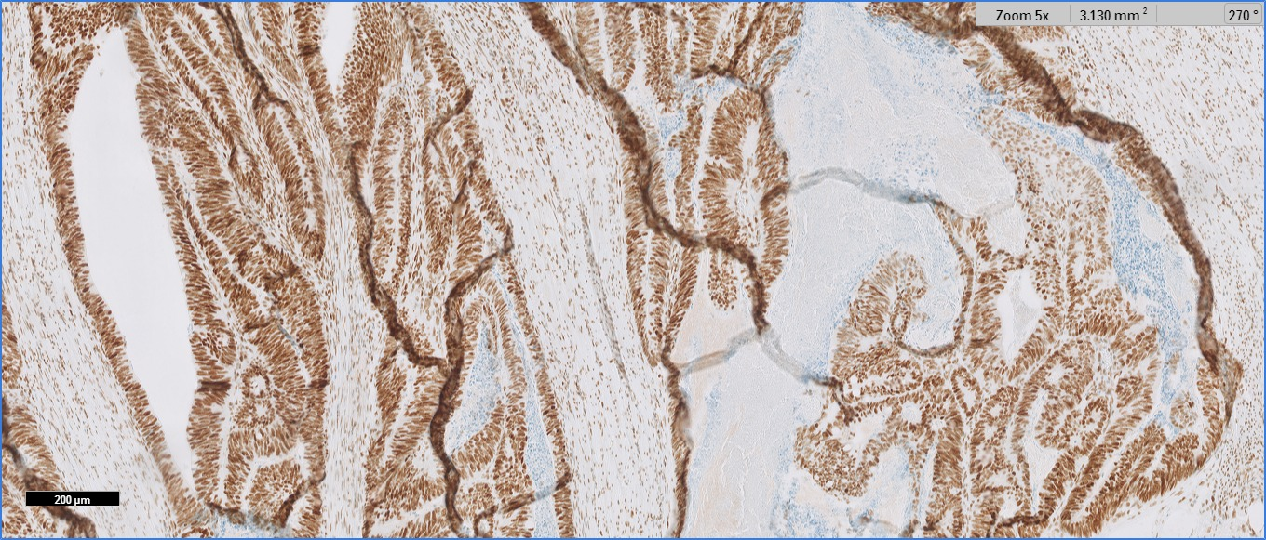
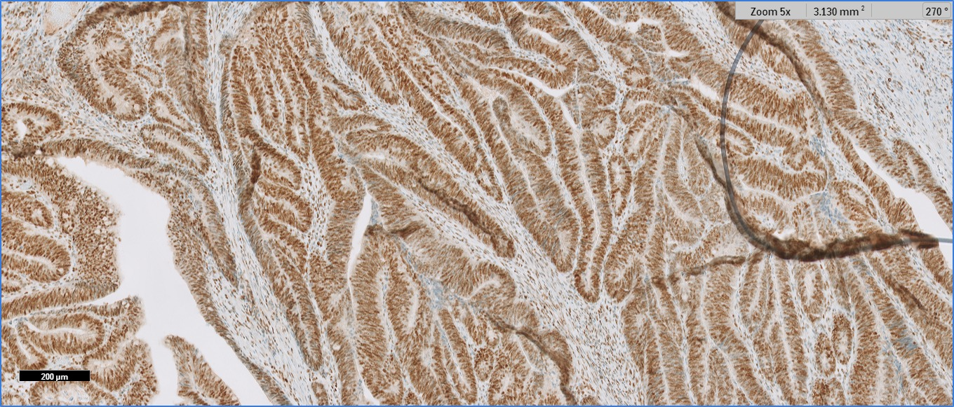
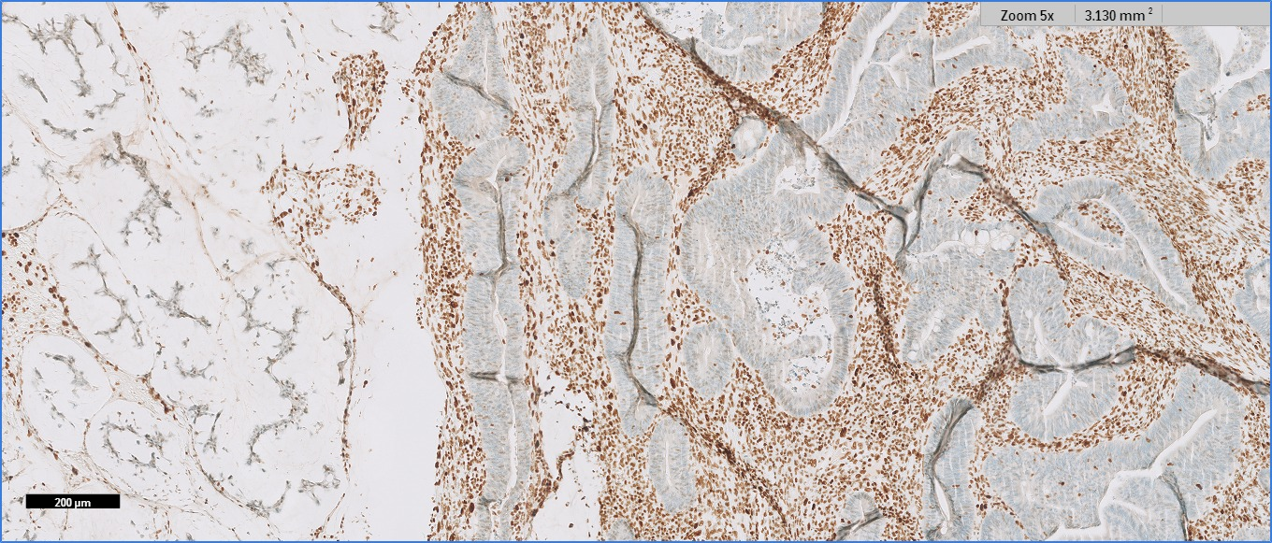
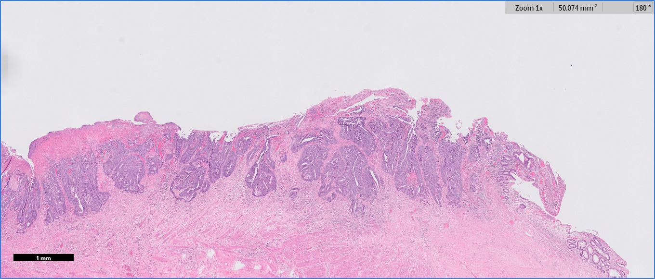
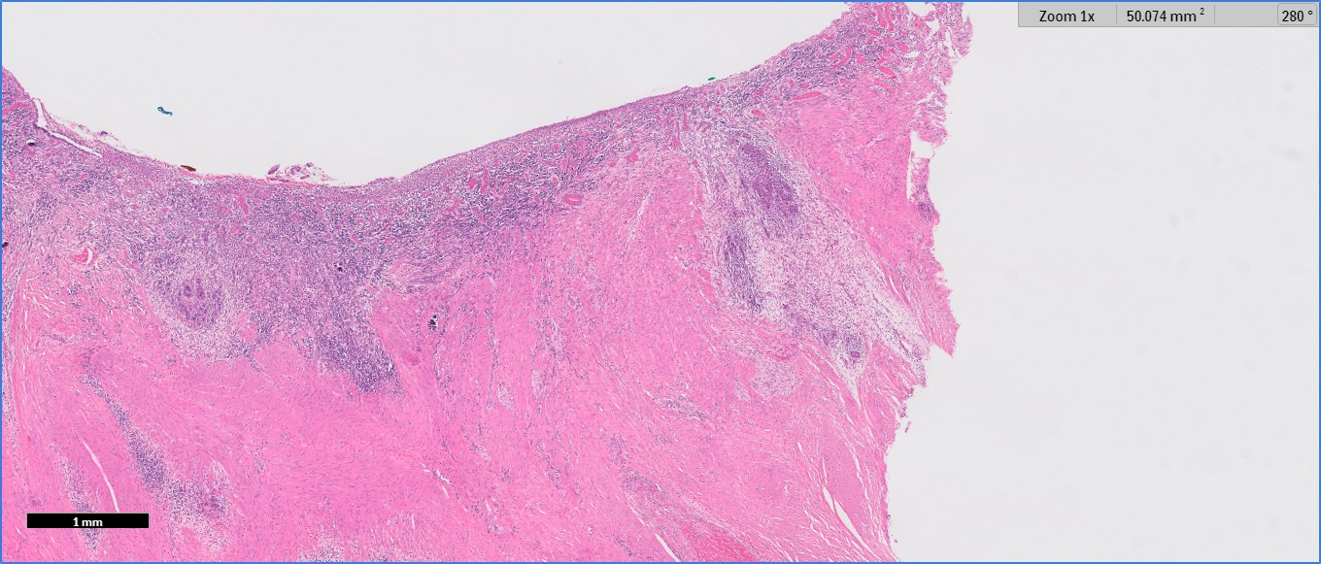
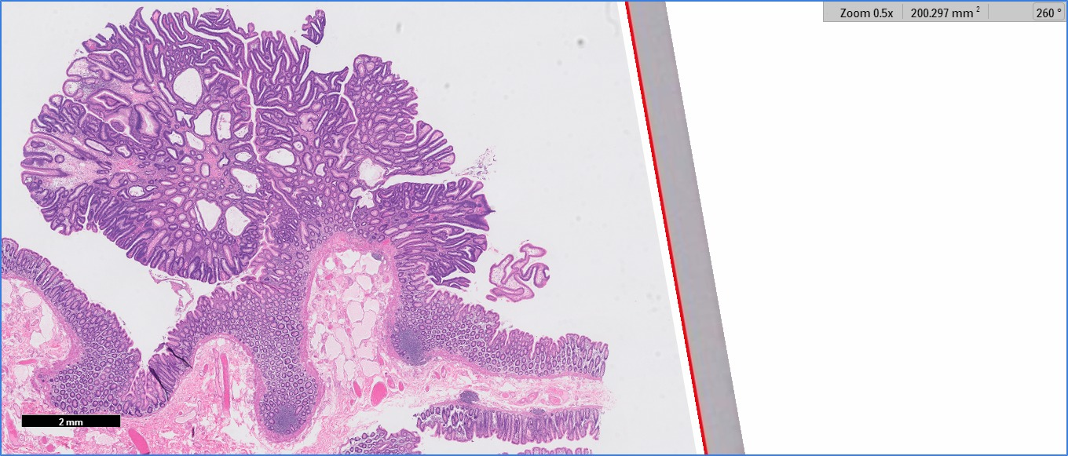
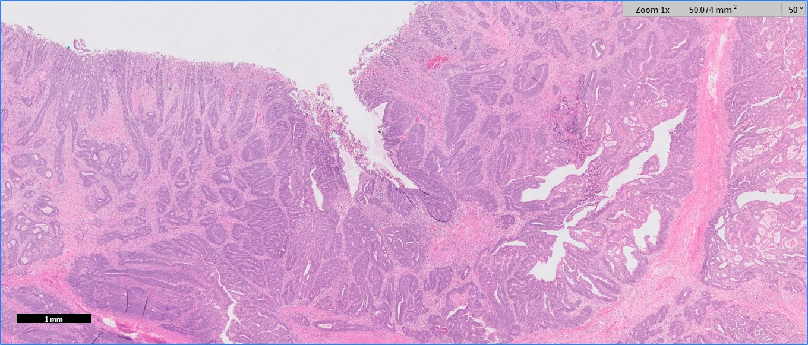
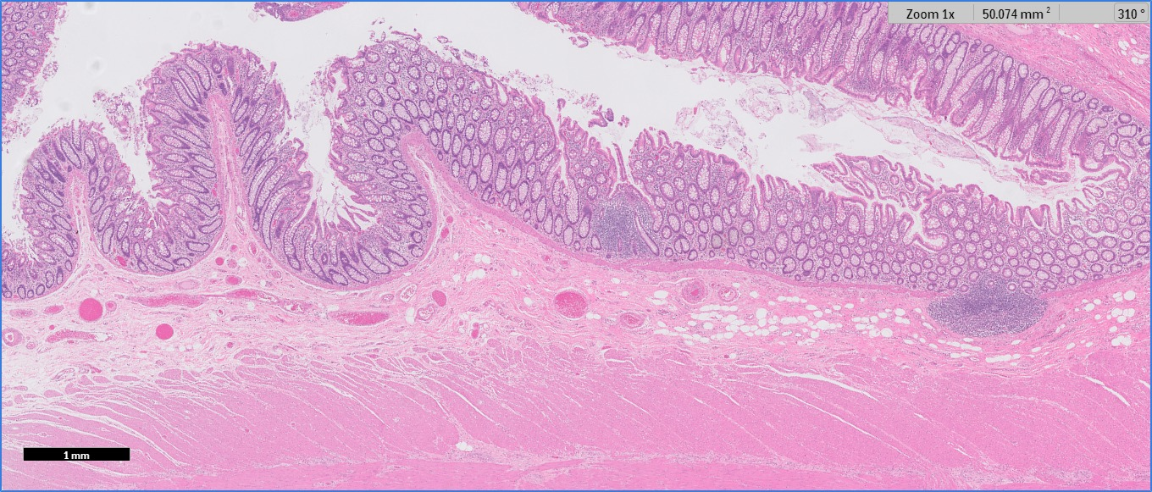
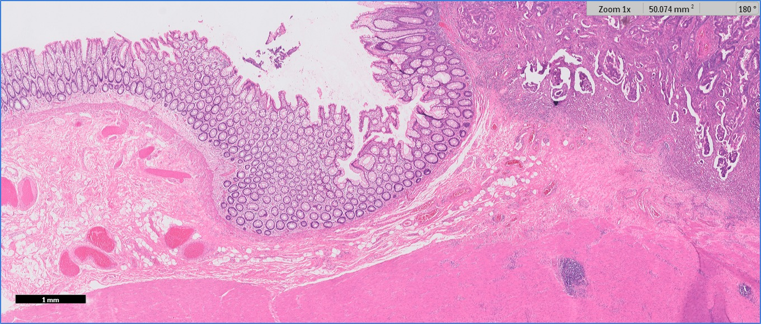
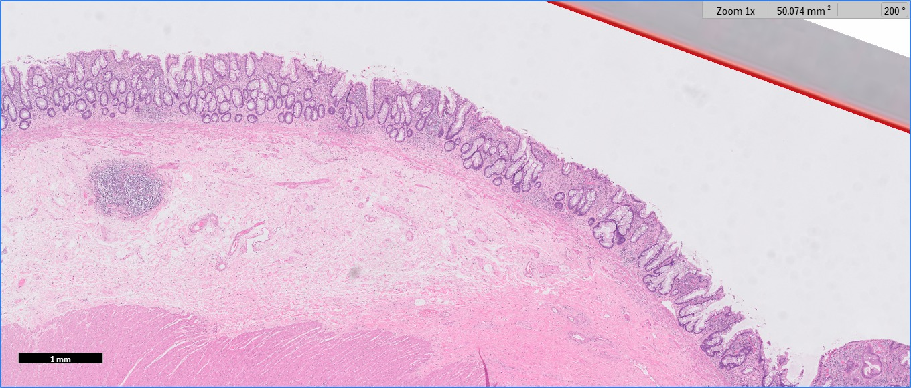
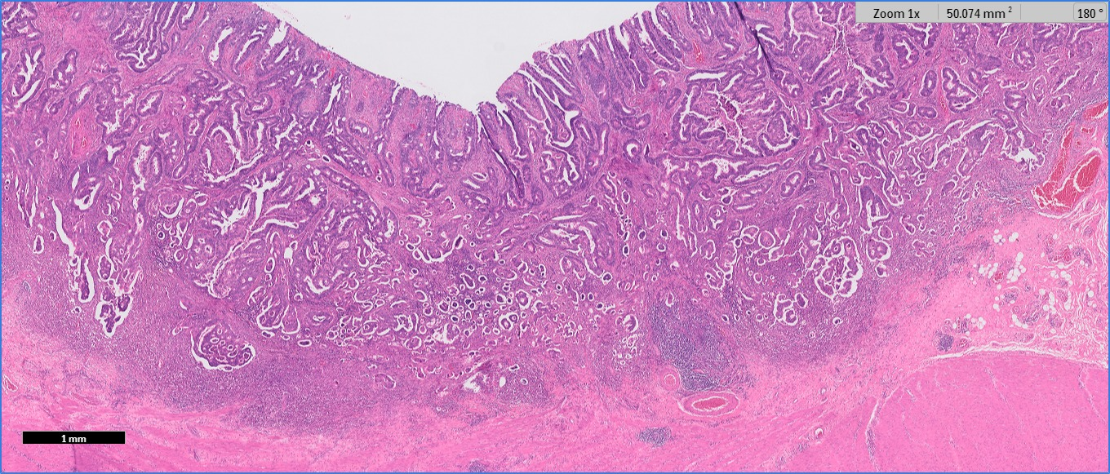
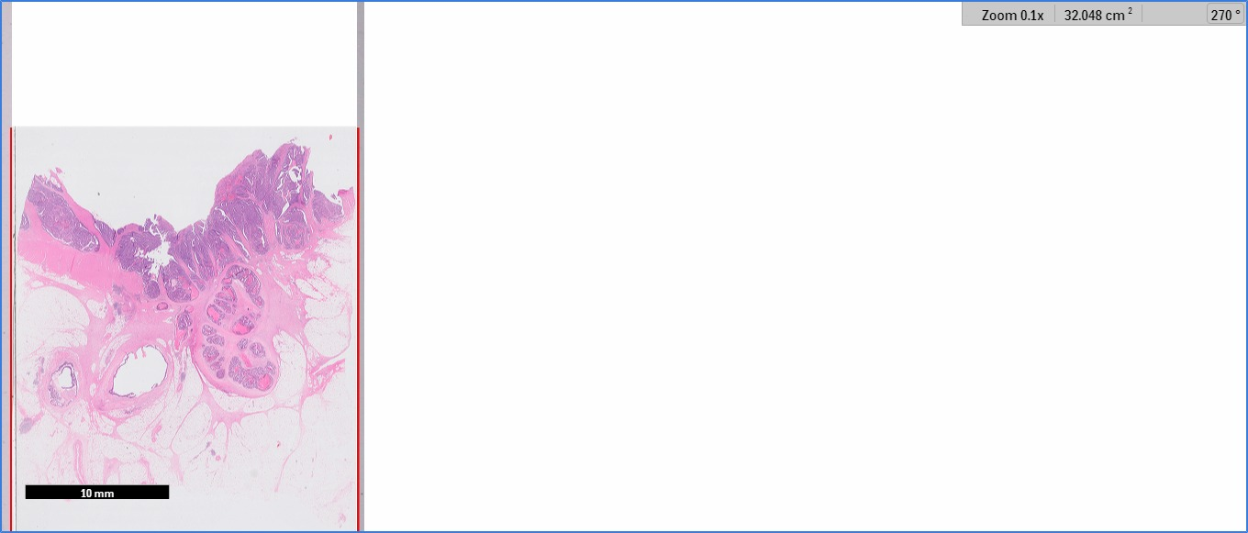
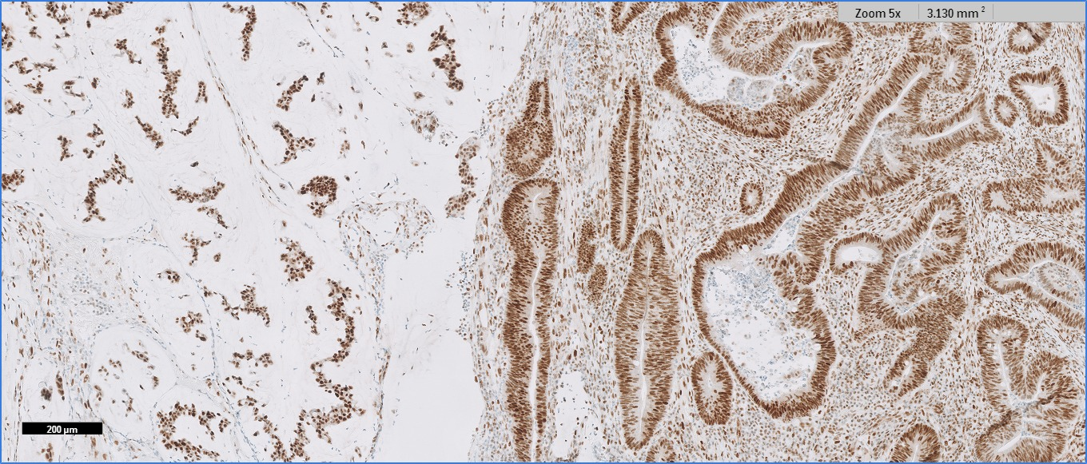
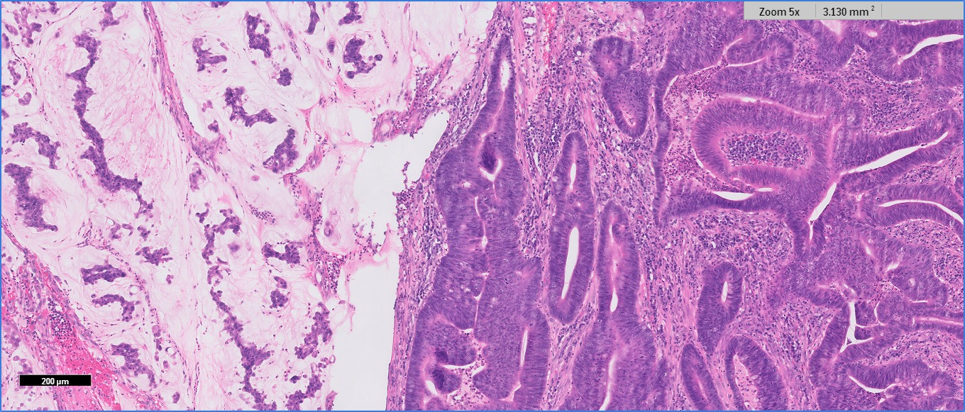
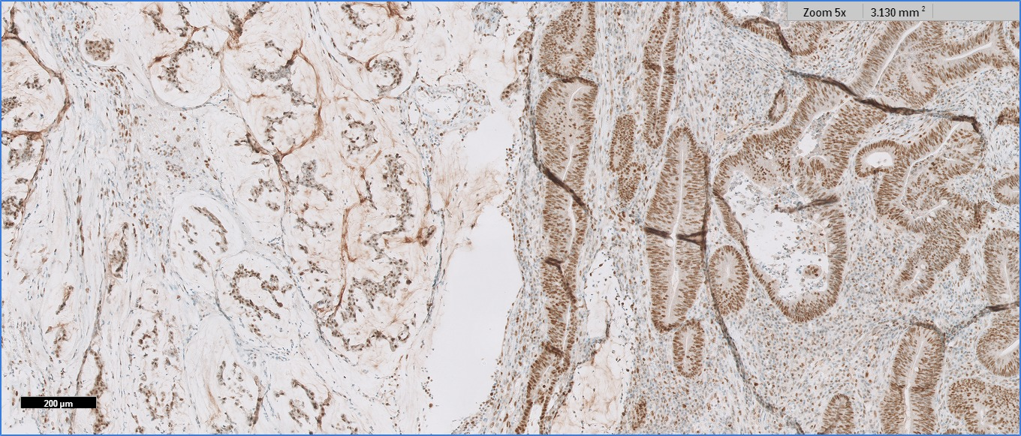
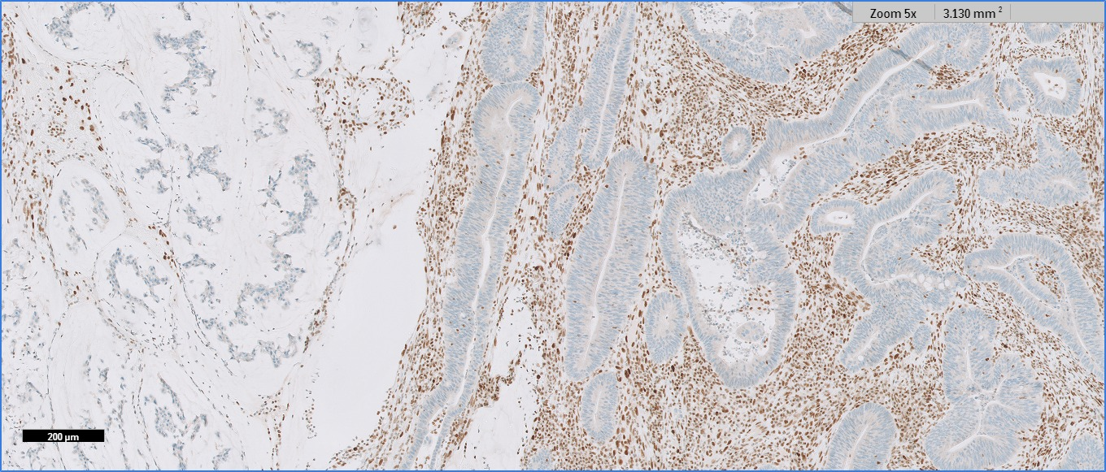
A
B
C
D
E
F
J
K
M
L
N
O
P
R
G
H
I

S
Q

Supplementary Figure S1. Representative images of different histological features. A: Normal colon mucosa. B: Normal rectal mucosa. C: Normal rectal mucosa with radiotherapy. D: Adenomatous polyp with Low Grade Dysplasya. E: Colon adenocarcinoma (ADC). F: Rectum ADC without radiotherapy. G: Rectum ADC with radiotherapy (Tumor Regression grade 3). H: Rectum ADC with radiotherapy (Tumor Regression grade 1). I: ADC with venous invasion. J: Rectum ADC. K: ADC with proficient MMR MLH1. L: ADC with proficient MMR PMS2. M: ADC with proficient MMR MSH2. N: ADC with proficient MMR MSH6. O: Colon ADC. P: ADC with deficient MMR MLH1. Q: ADC with deficient MMR PMS2. R: ADC with deficient MMR MSH2. S: ADC with deficient MMR MSH6.
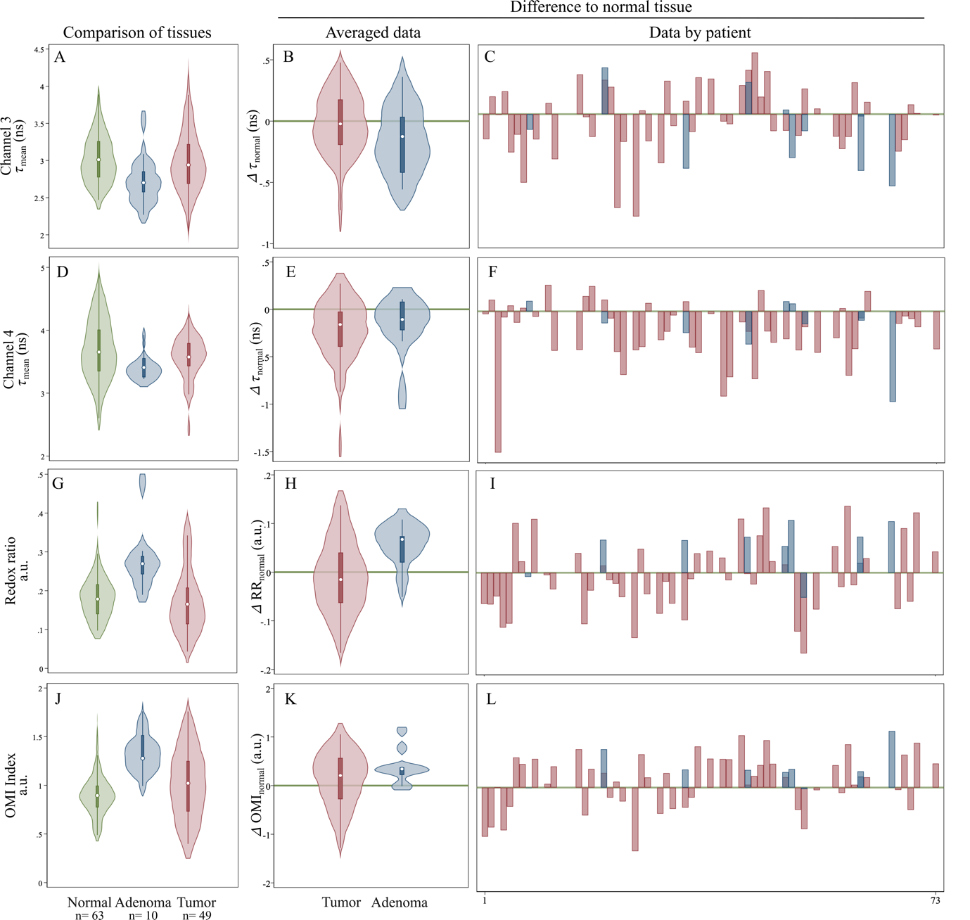

Supplementary Figure S2. A, D: Absolute values and distribution of data from normal (green), adenoma (blue) and tumor (red) tissues obtained from CH3 and CH4, respectively, in non-radiated specimens. G, J: Estimated intensity Redox ratio and OMI (Optical Metabolic Imaging) index calculated with data obtained from CH2 and CH5 are depicted. B, E, H, K: Representation of relative values of adenoma (blue) and tumor (red) tissues respective to their correspondent normal (green line) tissue with data obtained from CH3, CH4, Redox ratio and OMI index respectively. C, F, I, L: Individual relative data across the cohort corresponding to CH3, CH4, Redox ratio and OMI index, respectively.

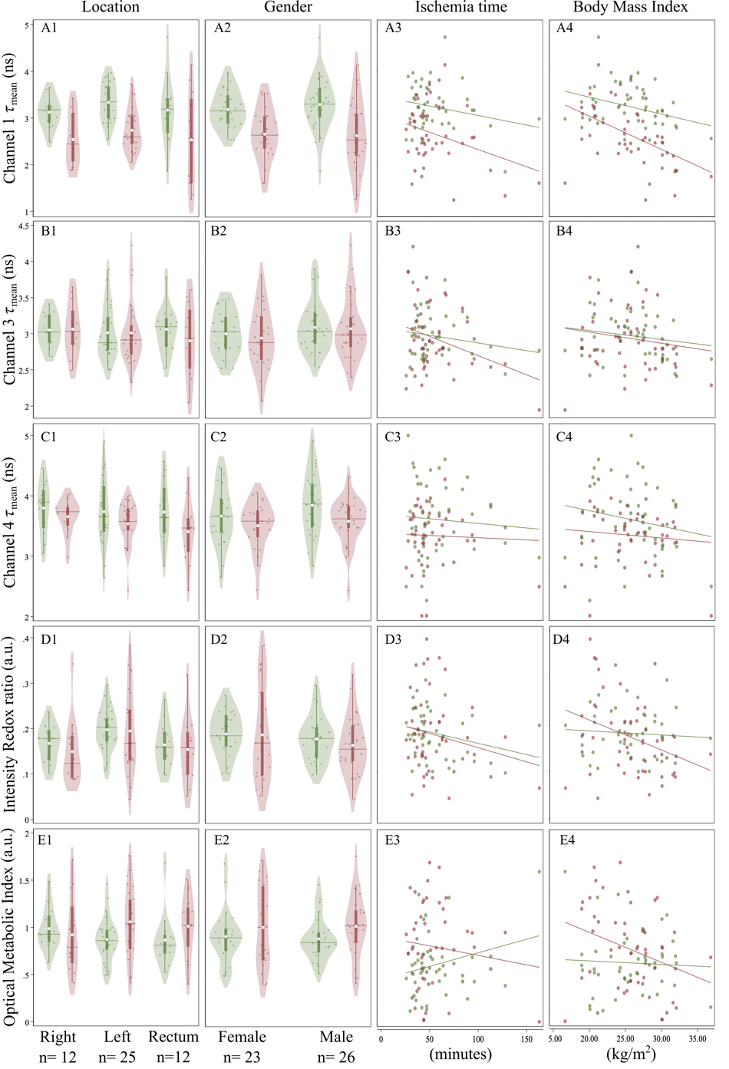
Supplementary Figure S3. Paired optical measurements from normal tissue (green) and tumor tissue (red). Optical parameters measurements (in rows) considering location, gender, ischemia time and Body mass index (in columns). Components of these violin plots are constituted by: white dots representing the mean, darker horizontal lines illustrate the median and vertical bars the interquartile range (IQR). Coloured dots within the shaded clouds are individual measurements.

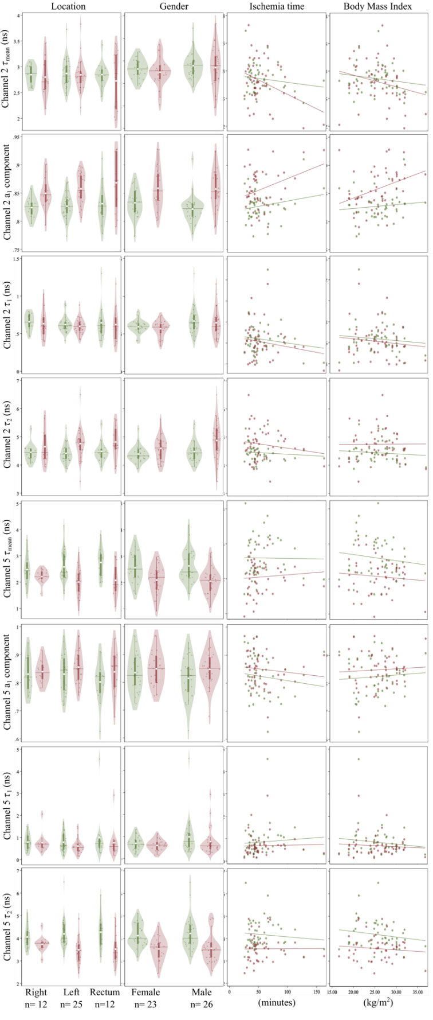
Supplementary Figure S4. Optical measurements from normal tissue (green) and tumor tissue (red). Optical parameters from CH2 and CH5 in detail (rows) considering location, gender, ischemia time and BMI (in columns). Components of these violin plots are constituted by: white dots representing the mean, darker horizontal lines illustrate the median and vertical bars the interquartile range (IQR). Coloured dots within the shaded clouds are individual measurements.

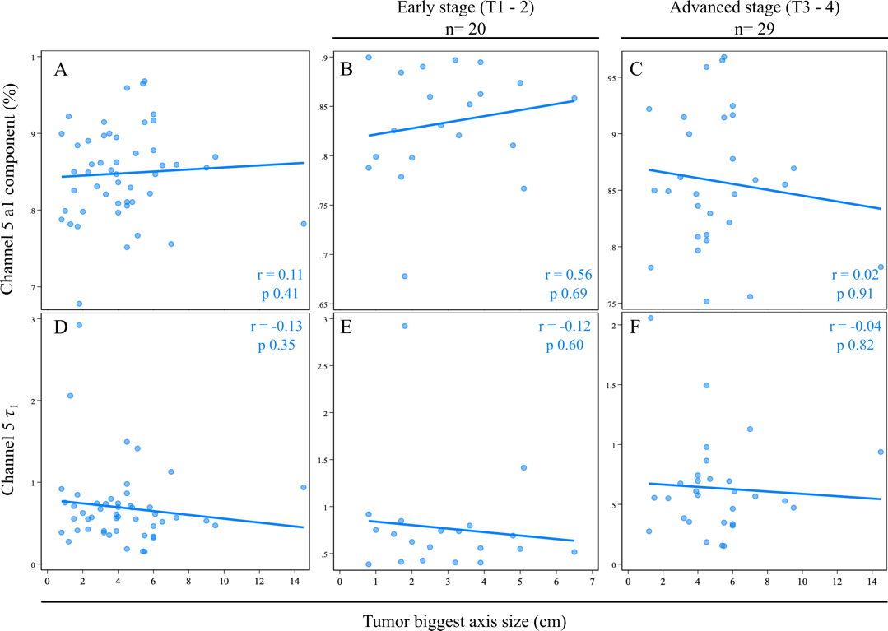
Supplementary Figure S5. Scatter plots correlating CH5 parameters (a1 and CH5 𝜏1) to tumor largest axis size for overall (left column), early (mid column) and advanced tumors (right column), respectively.

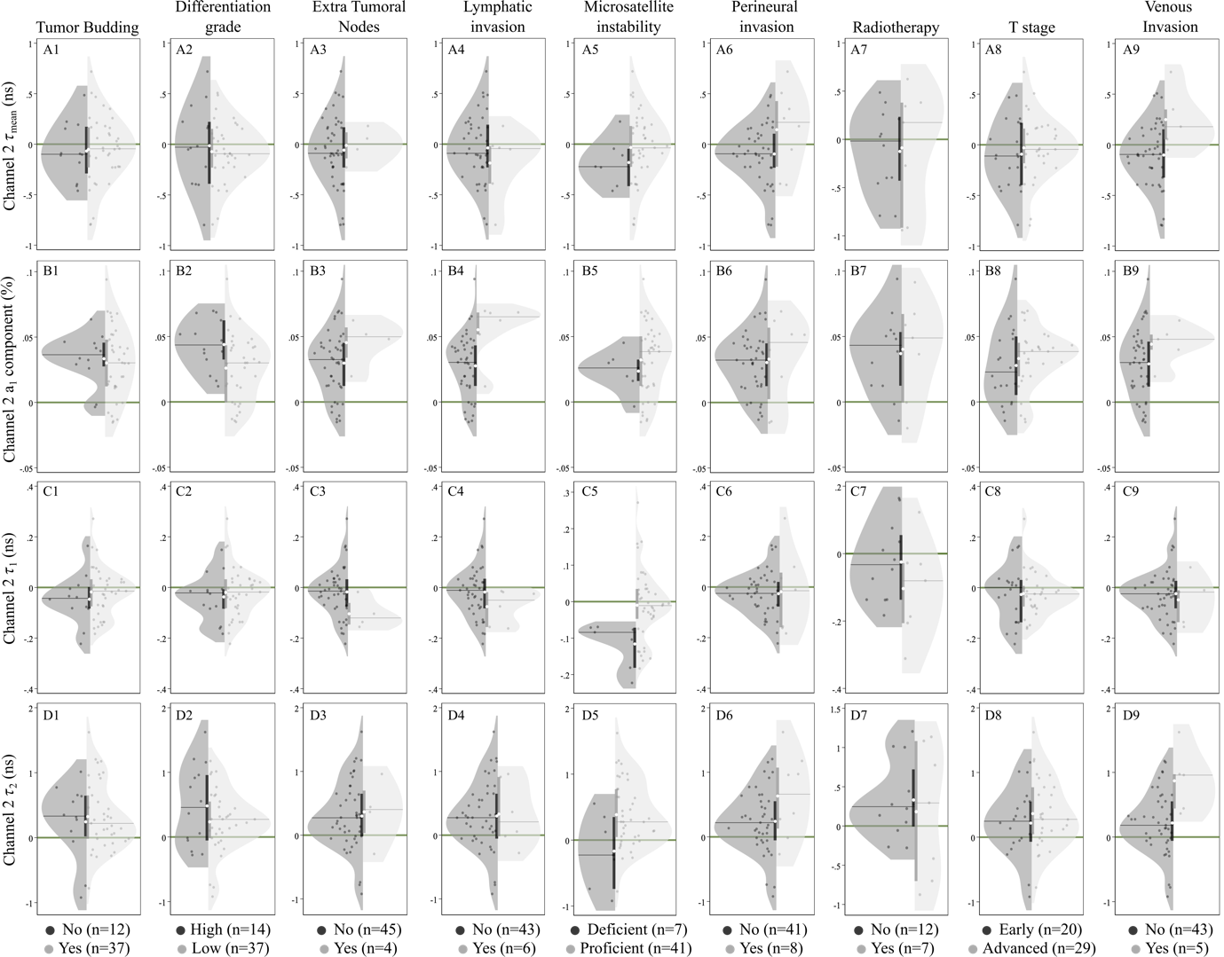
Supplementary Figure S6. Relative (to normal) lifetimes measurements of tumor tissue (rows) of CH2 optical parameters with respect to different histological features (columns). Components of these violin plots are constituted by: white dots representing the mean, darker horizontal lines illustrate the median and vertical bars the interquartile range (IQR). Dots within the shaded clouds are individual measurements.

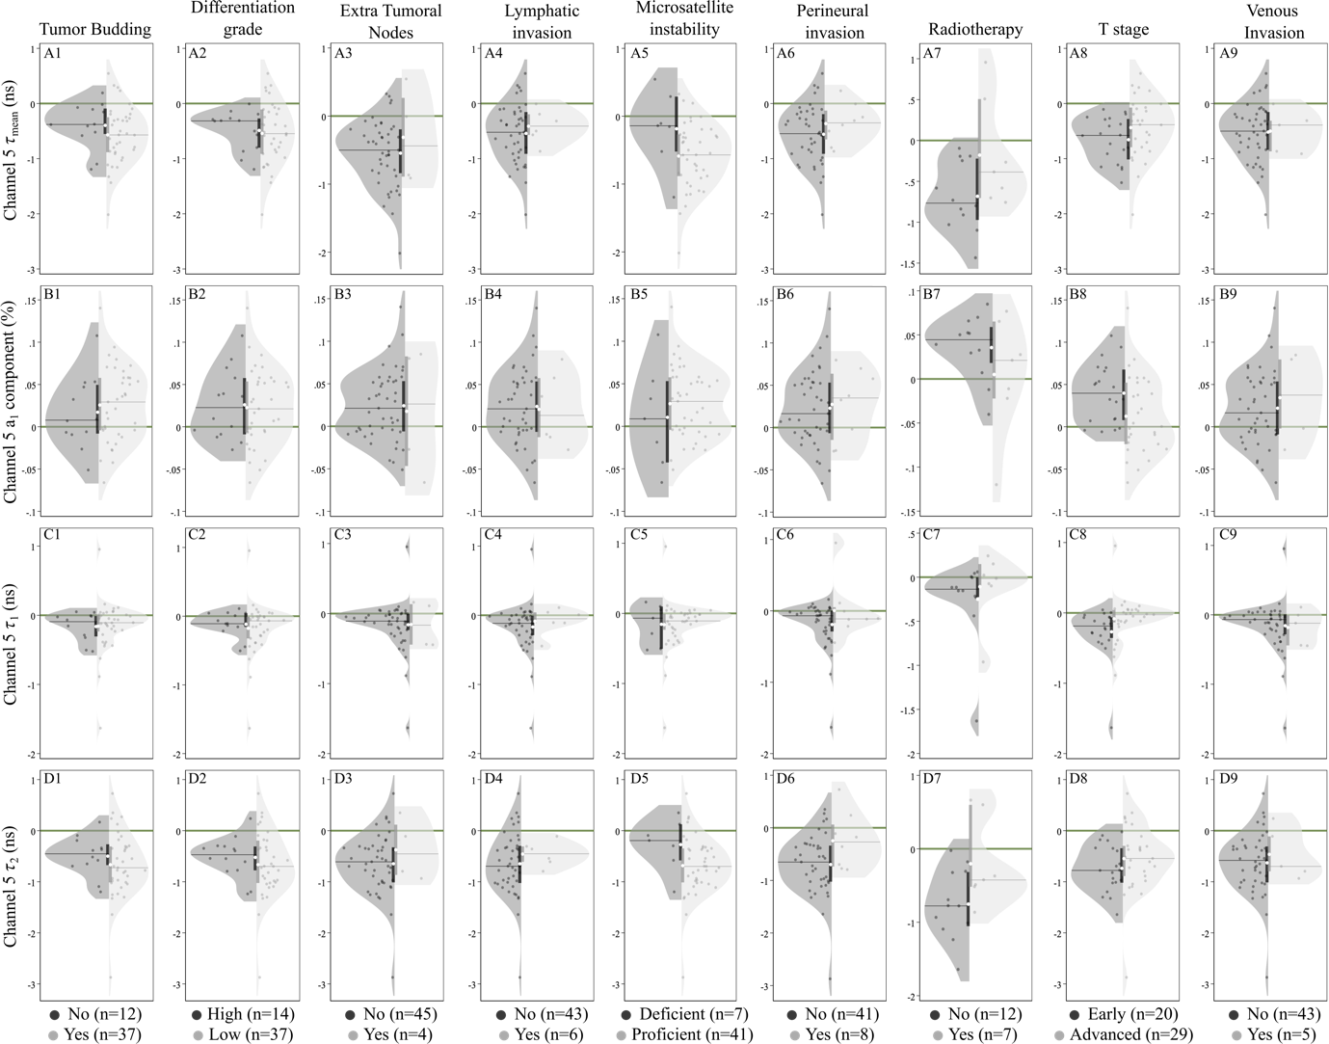
Supplementary Figure S7. Relative (to normal) lifetimes measurements of tumor tissue (rows) of CH5 optical parameters with respect to different histological features (columns). Components of these violin plots are constituted by: white dots representing the mean, darker horizontal lines illustrate the median and vertical bars the interquartile range (IQR). Dots within the shaded clouds are individual measurements.

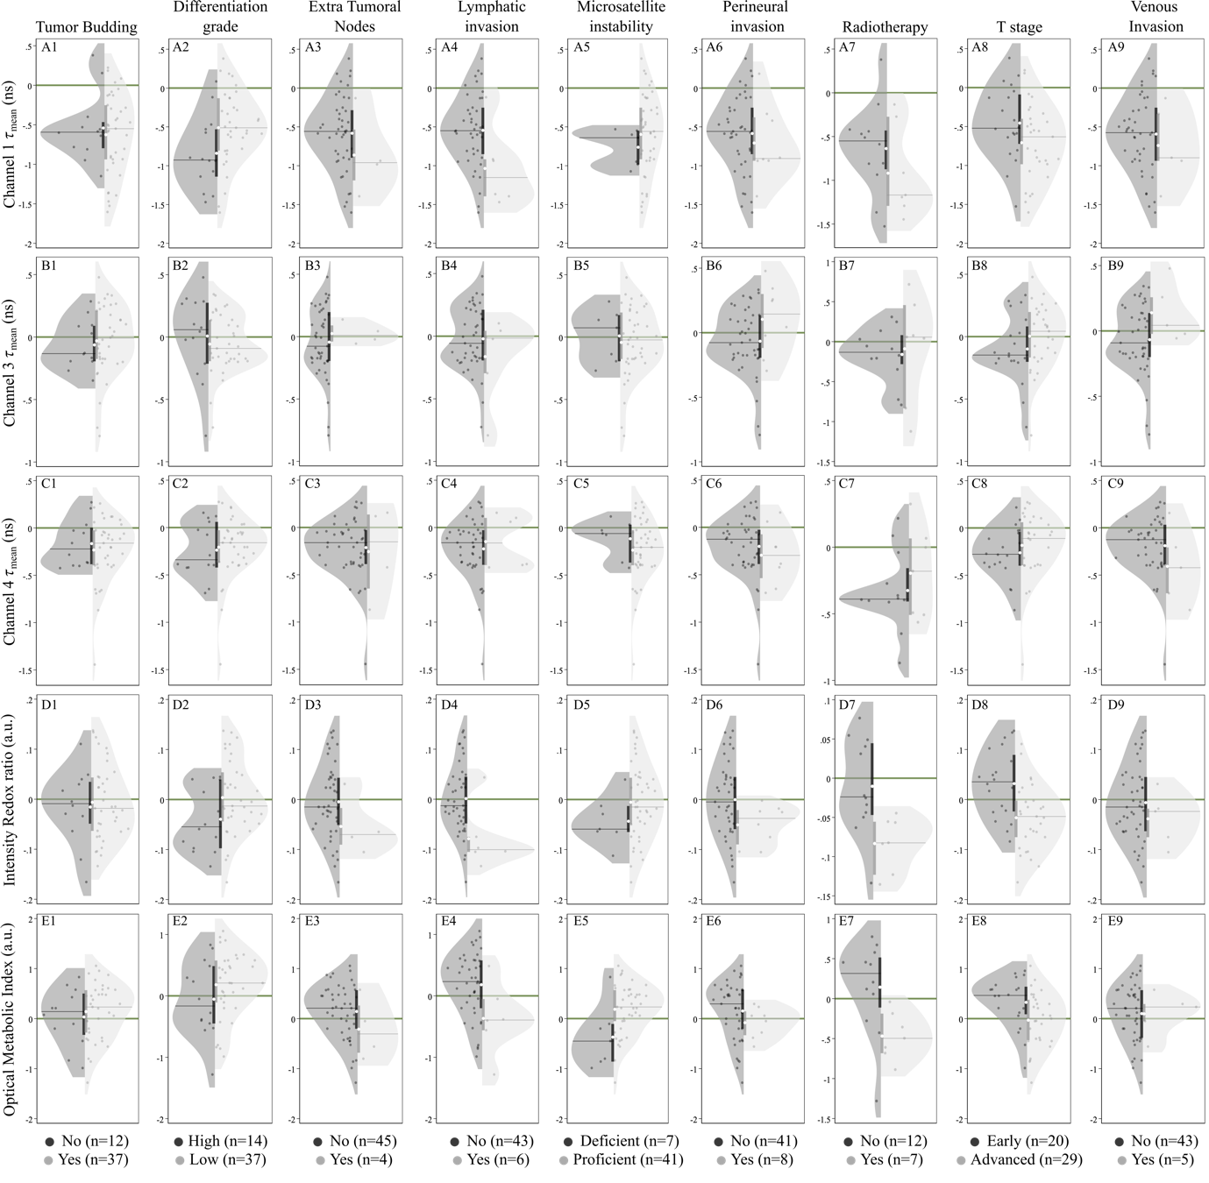

Supplementary Figure S8. Relative (to normal) lifetimes measurements of tumor tissue (rows) with respect to different histological features (columns). Components of these violin plots are constituted by: white dots representing the mean, darker horizontal lines illustrate the median and vertical bars the interquartile range (IQR). Dots within the shaded clouds are individual measurements.
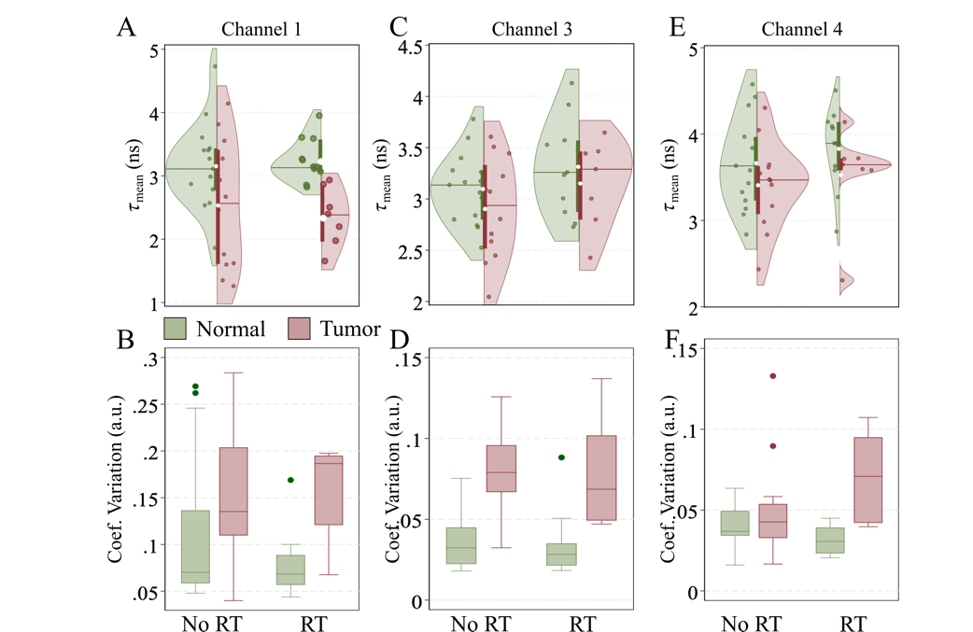

Supplementary Figure S9. Effect of radiotherapy in normal and tumor tissues. Fluorescence lifetimes values obtained from CH1, CH3 and CH4 with their correspondent coefficients of variation in normal and tumor tissue of non-radiated (left) and radiated (right) specimens. Components of violin plots are constituted by: white dots representing the mean, darker horizontal lines that illustrate the median, and vertical bars the interquartile range (IQR).

